MgdDbg
Jim Awe
Autodesk, Inc.
07/14/06

MgdDbg is a program designed with several goals:

- To provide a comprehensive test of the Managed API of AutoCAD
- To provide sample code and utility classes for 3rd Party developers
- To provide “scaffolding” for quick tests of issues when they arise
- To aid my own learning experience on .NET and C#

For developers with an ObjectARX background, it may help you to quickly transition from C++ to C#. For developers with a Visual Basic background, it should provide some example techniques that have not been available to you before. For instance, the exposure of the AcGe library for basic Point and Vector math is a huge addition to the tool set of Visual Basic developers.

Disclaimer: This program will evolve and expand as new APIs are exposed and as my experience with .NET grows. I do not (yet) consider myself an expert in .NET, so I could have some really poor examples in here! Over time, this will all get cleaned up as various people contribute ideas and techniques. So, don’t consider it a finished example, but a starting point that may aid in your own experiments.

Currently, the following commands exist (all accessed from the command line, or by right-clicking and getting the application context menu):

SNOOPENTS

This command allows you to select a set of entities and view all of their properties. There has to be code written to extract all the individual properties of an object. Early versions of MgdDbg will cover all the properties of common base classes such as DBObject and Entity, as well as some simple entities like Line, Arc, and Circle. Later revisions will provide more complete coverage of all the object properties. Because, the properties of an object are obtained in a top-down manner, all object types will at least be able to display common base class properties.

When an item in the data list appears in bold typeface, it means that there is “Drill down” information. Click on that row and a nested Form (Dialog Box) will bring up more detailed information about that data item. For instance, clicking on any item that lists an ObjectId will bring up the full set of properties associated with that referenced object.

NOTE: when “Drilling down”, the Forms will stack on top of each other. You could keep drilling down a long way if you aren’t paying attention. It is up to you to make sure you don’t get lost in all of the stacked up Forms.

The DrillDown information on a Class Separator (the light green lines), will allow you to view information about the given class.

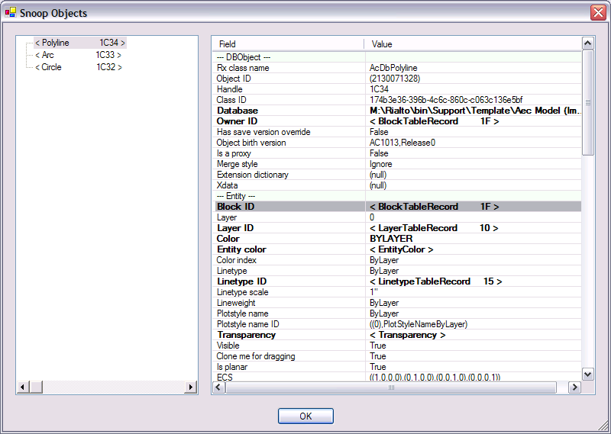

In the left-hand pane, you can right-click on a particular object and get additional information.

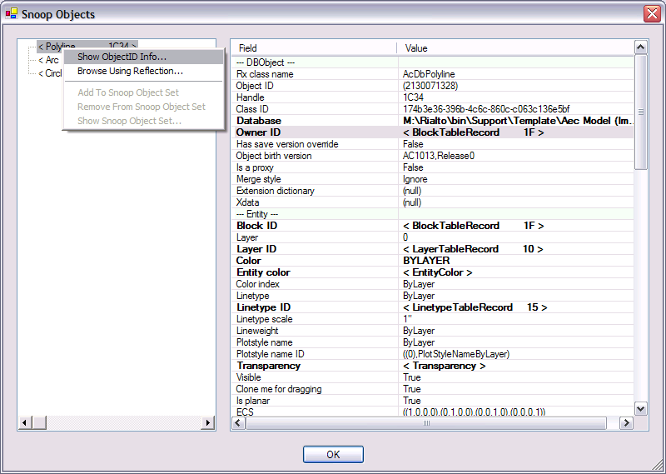

Choosing “Show Object ID information…” will bring up a nested Form with information about the ObjectID itself (as opposed to the object it references).

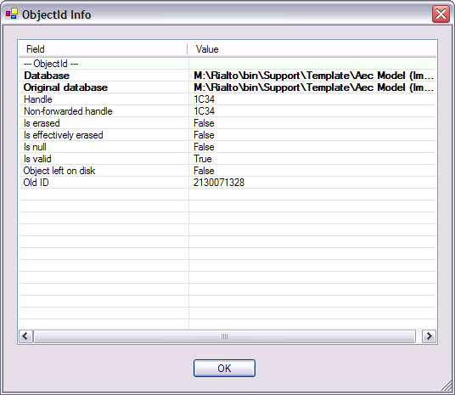

Choosing “Browse Using Reflection…” will bring up a Generic PropertyGrid Form that uses .NET Reflection to browse all the properties. Here, there is no code written specifically in MgdDbg to retrieve, format, and display the properties.

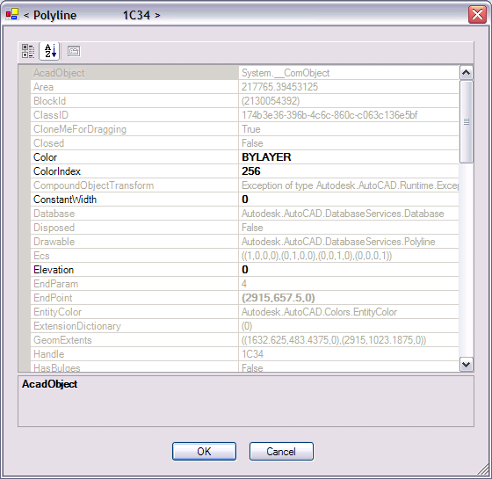

NOTE: Because we have no control over how items are displayed, read-only values appear in Grey, and editable values appear in Bold. This form is not setup to correctly handle edits, so making changes is completely at your own risk.

You can continue to browse generically using Reflection if you right-click on one of the items in the PropertyGrid. You get options to see either the Class info or the Object info.

The other Context Menu options are enabled if the Snoop dialog is brought up when asking the user for an ObjectIdSet. Some test functions (such as Database.Purge) will want the user to specify a set of objects. You can use the Snoop Dialogs to add non-graphic objects to this set.

SNOOPDB

This command will allow you to browse around the database, exploring non-graphic objects such as Symbol Tables and Dictionaries. If you “Drill down” enough, you can pretty much explore the entire DWG database.

This command also shows how to do a simple Tabbed Form.

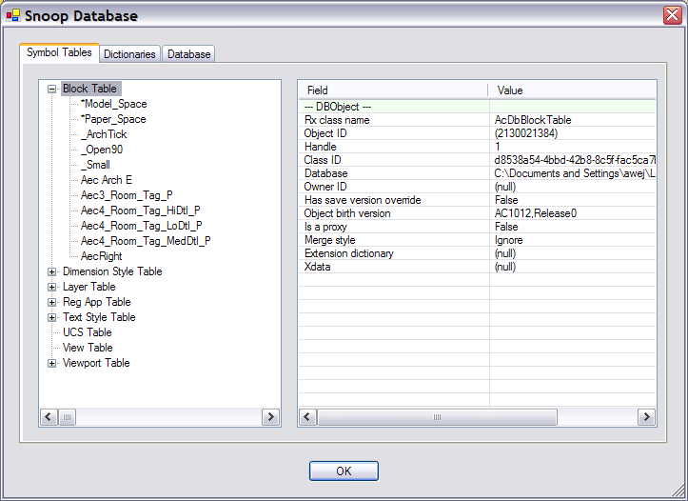

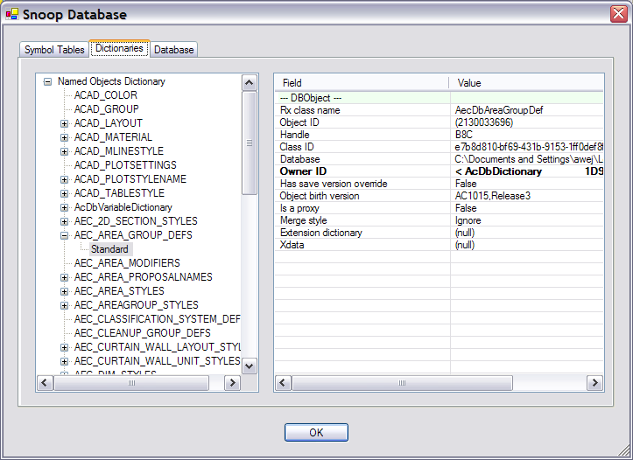

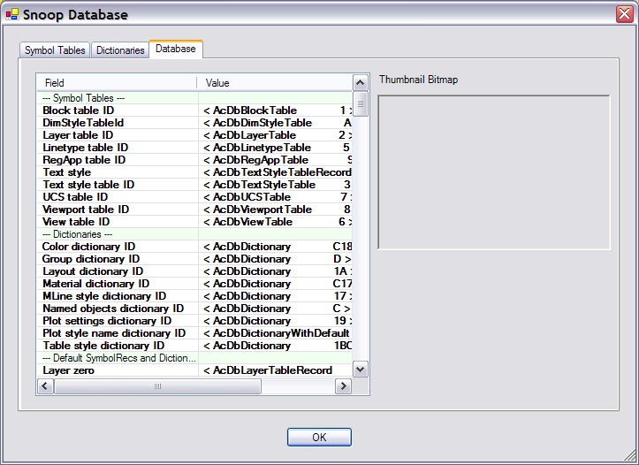
SNOOPED

Will let you snoop the class hierarchy and other Editor and System related classes

NOTE: This command is very slow as it tries to parse the class hierarchy.

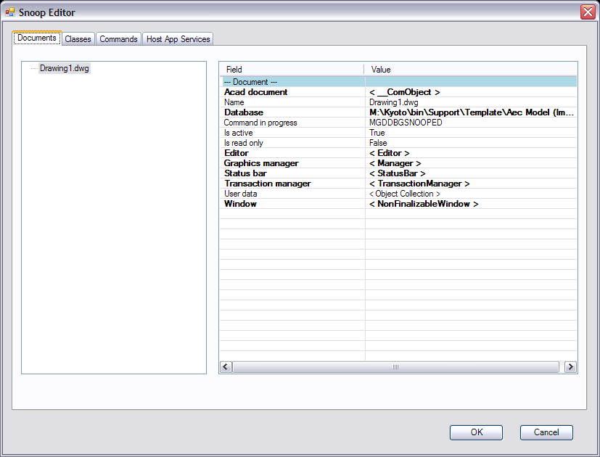

TESTS

This command brings up the test framework. The framework is designed to consolidate and organize all the various tests within the system. Doing so allows you to easily find them and prevents you from having to write any UI infrastructure to add new tests to the system.

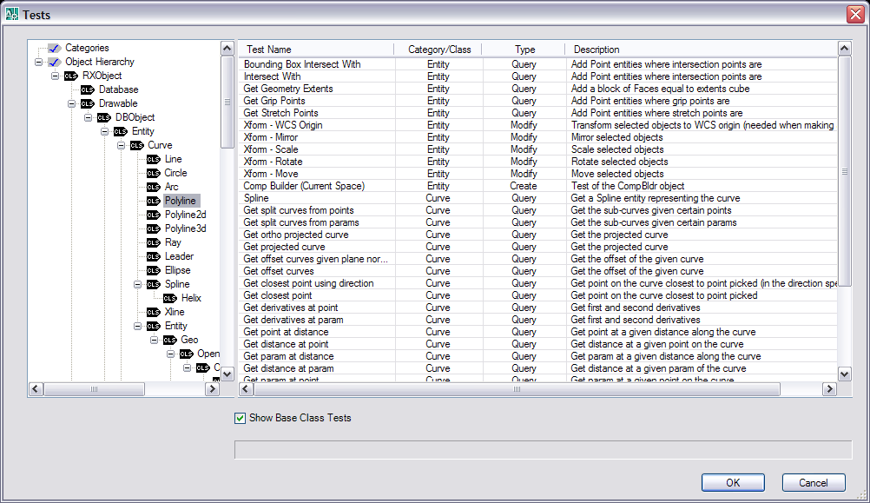

Tests are classified by a type (Create, Query, Modify). So, if you are looking for ways to make a new instance of an object, you would look for Create functions. You can also choose to include tests that apply to only the specific level of the hierarchy, or you can choose to include tests that apply to the current level and all its base classes.

NOTE: the column headers can be clicked to sort the lists.

TESTXML

This command serves as sample code for how to navigate the XML DOM using the .NET Xml classes.

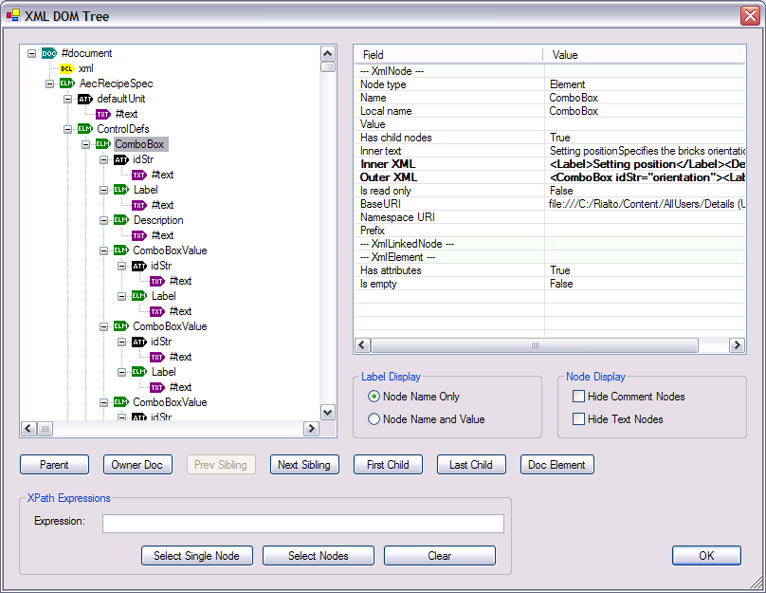

If you type in a valid XPath expression, the matching nodes will be painted Blue. Choosing “Clear” will reset the selected nodes.

TESTPROMPTS

This command exercises all the options of the various prompting classes and lets you quickly see the effects of different settings.

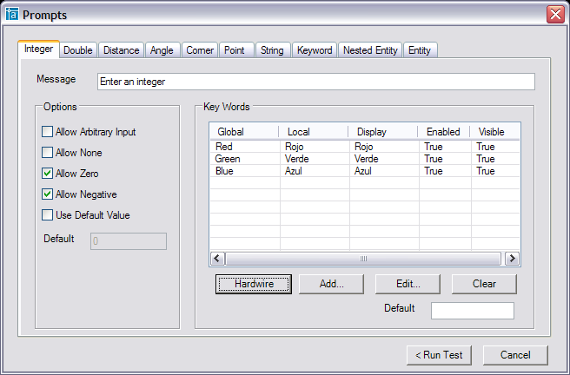

DWGSTATS

This command will search through the entire database and assemble some statistics about each object it finds. It will then export those statistics to an .XML file. You can then run the Browser reports in the directory ./MgdDbg/ReportBrowswer by double-clicking on “ObjCountReport.html” and loading the XML file.

This demonstrates how to search all objects in the drawing, as well as how to write an XML file and have that file translated to HTML.

DWGSTATSBATCH

Same as above, but across multiple files.

General UI

One thing to note for MFC programmers is how much easier WinForms is. If you browse around the code for the UI in MgdDbg, you’ll see that there really isn’t that much there.

Also, note how all the Forms are resize-able without any extra coding work on my part. I never even attempted re-sizing in MFC!

