Optimal Use of New Autodesk
Revit 2011 Programming Features
Jeremy Tammik – Principal Developer Consultant, Autodesk
CP228-2 This class teaches everything you need to know about the new Revit 2011 programming features and how to use them, with code examples making use of all new API features in various types of Revit add-ins. We also present a complete overview of all new Revit 2011 SDK samples. Special attention is paid to Idling, the most exciting new event of all, with examples of powerful uses of this unique possibility to synchronize your Revit add-in with external data sources and applications.
About the Speaker: Jeremy is a member of the AEC workgroup of the Autodesk Developer Network ADN team, providing developer support, training, conference presentations, and blogging on the Revit API.
He joined Autodesk in 1988 as the technology evangelist responsible for European developer support to lecture, consult, and support AutoCAD application developers in Europe, the U.S., Australia, and Africa. He was a co-founder of ADGE, the AutoCAD Developer Group Europe, and a prolific author on AutoCAD application development. He left Autodesk in 1994 to work as an HVAC application developer, and then rejoined the company in 2005.
Jeremy graduated in mathematics and physics in Germany, worked as a teacher and translator, then as a C++ programmer on early GUI and multitasking projects. He is fluent in six European languages, vegetarian, has four kids, plays the flute, likes reading, travelling, theatre improvisation, and carpentry, loves mountains, oceans, sports, and especially climbing.
jeremy.tammik@autodesk.com

Contents
These are the topics that we discuss in this class:
- Revit 2011 API news: renovations versus enhancements
- A first look at the new API: my first Revit 2011 add-in
- Migration of existing add-ins
- New Revit SDK sample applications
- A deeper look at the Idling event
  - RevitWebcam
  - RST live link
  - RME loose connectors
- Learning More

Revit 2011 API News
Here are the most important new product and API features provided by Revit 2011:
- RAC
  - Improved form generation
  - Flexible components
- RME
  - Conduits and cable trays
  - Panel schedules
- RST
  - Concrete joins
  - Improved analytical model
- Platform
  - User interface
  - Performance
  - Reporting parameters
- API
  - Dynamic update
  - Analysis visualization
  - Transactions
  - Iteration
  - Selection

Major API Renovations
A number of very major API renovations have been implemented in addition to completely new features which we will look at later. These renovations affect and will require modification and recompilation of existing applications:
- Add-in manifest instead of Revit.ini
- DLL split and namespace reorganisation
- Transaction mode and regeneration option attributes
- New element iteration interfaces
- New transaction interfaces
- XYZ, UV, and ElementId classes
- Symbol class renamed to ElementType
- Revit exceptions
- AnalyticalModel subclasses removed
- EnergyDataSettings replaces gbXMLParamElem

Pipe to Conduit Converter
In order to quickly get a realistic impression of both the renovations and the completely new features, let’s dive straight into the source code of the pipe to conduit converter or ‘p2c’, my first Revit 2011 add-in. In just two hundred lines of code it illustrates most major API renovations and some new features as well. And source code never lies, unlike comments and the printed or spoken word! Here are the features we can explore using this sample code:
- Revit API assembly split
- Namespace reorganisation
- Command registration manifest, guidize.exe
- External command Execute method and attributes
- Transaction mode
- Regeneration option
- Task dialogues for user messages
- Interactive filtered element selection
- Redesigned element filtering
- New element creation paradigm
- Access to pipe and conduit sizes
The complete Visual Studio solution and documentation are included in the class materials and also available on the web from The Building Coder blog.

Migration Steps
Here are the steps required to migrate an existing add-in for Revit 2010:
- Read What's New section in Revit API help doc
- Consider which command attributes to use
- Update references and namespaces
- Accommodate class changes, e.g. application and document database and user interface split
- Update element filtering code
- Update transaction handling
Some migration samples are included in the class materials, e.g. The Building Coder samples and the Revit API introduction labs.

Major Enhancements
Even more exciting than the renovations affecting existing applications, we also have a large number of extremely important completely new features which fulfil some very long-standing and fundamental developer wishes:
- Dynamic Model Update
- Elements changed event
- Failure API
- Select elements, points on elements, faces and edges
- Pick point on the view active work plane
- Additional ribbon customization options
- Revit-style task dialogues
- Analysis Visualization Framework
- Idling event
- Sun and shadows settings
- MEP demand factor and load classifications
- Panel schedules
- Cable tray and conduit

New and Updated Revit 2011 SDK Samples
Most of these new features are illustrated by the new Revit 2011 SDK samples:
- AnalysisVisualizationFramework
  - DistanceToSurfaces
  - SpatialFieldGradient
- ConceptualDesign
  - DividedSurfaceByIntersects
- ElementFilter
  - ViewFilters
- FindReferencesByDirection
  - FindColumns
  - MeasureHeight
- Massing
  - ParameterValuesFromImage
  - PointCurveCreation
- DirectionCalculation
- DocumentChanged (also known as ChangesMonitor)
- DynamicModelUpdate
- ErrorHandling
- ExternalCommand2011
- MaterialQuantities
- PanelSchedule
- Selections
- SolidSolidCut
In addition, several existing samples were modified to demonstrate the renovated API features:
- HelloRevit
- ImportExport
- TransactionControl

HelloRevit
This simple sample was completely rewritten to fit into the new Revit API framework as well as demonstrate the use of the new task dialogue functionality. It demonstrates:
- How to add an external command to the user interface
- Use Revit task dialogue to provide information to user

ImportExport
ImportExport exports the current project to a number of formats, including dwg, sat, dxf, dwf(x), gbxml, fbx, dgn, image or Civil3D files. It also imports a dwg, image, gbxml or Inventor file into Revit. Some new API methods in this context include:
- DWG can be imported as link: Document.Link()
- Identifies if import instance is a link: ImportInstance.IsLinked
- New methods to export to ifc, dxf, sat, image files
- DWF and DWFX methods were consolidated
- Query DWF and IFC export GUID: ExportUtils.GetExportId()
The new property ACADExportOptions.Colors allows the option of exporting colours matching the AutoCAD colour index, or as 24-bit true colour RGB values.
The new method ElementType.GetPreviewImage extracts the preview image of an Element Type. This image is similar to what is seen in the Revit UI when selecting the type of an element. You can specify the size of the image in pixels.
The four 2010 Document.Export methods for exporting of DWF-2D, DWF-3D, DWFX-2D and DWFX-3D files were consolidated into just two methods, one for exporting to DWF format, another to DWFX format. Both methods can export both 2D views as well as 3D views in one call.
The static method ExportUtils.GetExportId retrieves the GUID representing an element in DWF and IFC export. This id is used in the contents of DWF export and IFC export and it should be used only when cross-referencing to the contents of these export formats. When storing Ids that will need to be mapped back to elements in future sessions, UniqueId must be used instead.

TransactionControl
This sample was completely rewritten from the previous version. It demonstrates the use of transaction group, transaction and sub transaction
- Interactively start, roll back, and commit t-groups and transactions
- Create, move or delete walls inside transaction
- Tree view displays all operations, transactions and t-groups
- T-group and sub-transaction can be nested, transaction cannot

DistanceToSurfaces
DistanceToSurfaces is an external application that reacts to changes in walls, mass elements, and a special sphere object. It reacts to changes in the model using the dynamic model update framework DMU, calculates the distance from the sphere family instance to several points on each face, and displays it graphically using the analysis visualisation framework AVF. It is located in the AnalysisVisualizationFramework subdirectory together with the SpatialFieldGradient sample.
- AVF – display distances in model using analysis visualization framework
- DMU – reacts to changes using dynamic model update
- External application, works with events
- On start-up, register DocumentOpened event, whose handler:
  - Checks for the presence of the sphere family and a 3D view named “AVF”
  - Creates a updater triggered by wall, mass, or family instance geometry changes
- The updater Execute method:
  - Finds the XYZ location of the sphere
  - Gets or creates the spatial field manager object
  - Collects all faces of all walls and masses in the project, including in-place
  - Calculates the distance between the sphere origin and points on each face
  - Updates the spatial field primitive to displays these as analysis results on the faces

SpatialFieldGradient
SpatialFieldGradient displays analysis results in a Revit model. On selection of a face, this sample displays numeric data on that face. It also includes a legend and colour definition. This is a pure analysis visualization framework sample implementing a single external command to display numeric data on a selected face.
- Create AnalysisDisplayColoredSurfaceSettings to show gridlines
- Create AnalysisDisplayColorSettings to set min and max colours
- Create AnalysisDisplayLegendSettings to specify legend settings
- Create analysis display style using these settings and use in active view
- Each data point can store multiple values
- Data can be displayed in multiple units
- Divide the selected face U and V parameterization into 10 segments each
- Create three values based on the U value at each point (U, U + 1, U * 10)
- Update the spatial field primitive to show this data on the face

DividedSurfaceByIntersects
DividedSurfaceByIntersects demonstrates how to add and remove intersection elements such as Level, ReferencePlane, ModelCurve on a DividedSurface.
- ConceptualDesign subdirectory (typo fixed)
- Massing folder in SDK solution file, Families group in RvtSamples
- Demonstrates how to add and remove intersects to DividedSurface
- Intersection elements can be Level, ReferencePlane, ModelCurve, etc.

ViewFilters
ViewFilters demonstrates how to create and modify view filters using the new filtered element collection API, and shows that the API can support more than the three filter maximum imposed by the user interface.
- Create and modify view filters
- Simulate functionality of UI command View > Filters
- Allows adding more than three filter rules
- Sample project contains filter with four rules and some walls fulfilling it
- ElementFilter/ViewFilters

FindColumns
FindColumns demonstrates how to find all walls that have embedded columns in them by shooting a ray along the wall centre. This sample was originally created by Scott Conover at AU 2009 in his presentation on analysing building geometry.
- FindReferencesByDirection example
- Geometric analysis based on wall location line
- Shoot rays 1 foot above wall level along each side of wall
- Determine all columns intersected by ray
- Split curved walls into segments
- Handle all or pre-selected walls
- Select all columns found

MeasureHeight
MeasureHeight is another FindReferencesByDirection by Scott. It demonstrates how to calculate the height of a selected skylight above the ground floor by shooting a vertical ray and detecting its intersection with a certain floor.
- Another FindReferencesByDirection example
- Measure height of skylight window above ground level
- Find a 3D view to use with FindReferencesByDirection
- Check if a roof-hosted window is selected
- Calculate window height above ground floor (hard-coded element id)
- Use window bounding box centre as the ray start point
- Run FindReferencesByDirection using the negative Z direction
- Find the closest reference belonging to the floor
- Report result and create a model curve to show the ray found

ParameterValuesFromImage
ParameterValuesFromImage computes a greyscale value for each pixel in an image file and uses this to set a parameter that changes the model geometry. Originally created by Harry Mattison for his AU 2009 presentation on conceptual design and massing.
- ParameterValuesFromImage and PointCurveCreation massing samples
- Set parameter values based on image data
- Compute a greyscale value for each pixel in an image file
- Each panel's 'Grayscale' parameter is set to the corresponding value
- Geometry is updated based on this

PointCurveCreation
PointCurveCreation implements seven different examples of using equations and external data files to create point, curve and loft form surface massing geometry.
- Massing sample showing reference points and curve by points creation
- Use equations and external data files to create massing geometry
- PointsParabola - create reference points following parabolic arcs, e.g. z = x^2
- PointsOnCurve - create reference points constrained to a model curve, based on PointOnEdge elements, so they maintain their relative position if the curve is modified
- PointsFromExcel - create reference points based on XYZ data in an Excel file
- PointsFromTextFile - create reference points based on comma-delimited text file
- SineCurve - create curve based on points placed using the equation y = cos(x)
- CatenaryCurve - ditto using y=ScalingFactor * CosH(x/ScalingFactor)
- CyclicSurface - create loft form based on curves and points created using the equation z = cos(x) + cos(y)

DirectionCalculation
DirectionCalculation determines south facing walls and windows by geometrical analysis, with and without considering the project location. Originally part of Scott's AU 2009 presentation.
- Identify orientation of building elements
- Find and select all windows and exterior walls facing south
- Optionally take project location into account, else use Y axis
- Find the exterior walls using the wall type Function parameter
- Determine wall direction from location curve
- Optionally transform direction by ActiveProjectLocation rotation angle
- Wall is 'south-facing' if its direction points south +/- 45 degrees
- Windows use FamilyInstance class and OST_Windows built-in category
- Direction can be determined from window instance transform and the FacingFlipped and HandFlipped properties
- Alternatively use FacingOrientation property directly

ChangesMonitor
ChangesMonitor demonstrates how to subscribe to the DocumentChanged event in an external application and log all modified elements in a modeless dialogue. The DocumentChanged event is comparable with the powerful new dynamic model update framework DMU, but much simpler to use and much more limited in functionality.
- Subscribe to the Application.DocumentChanged event
- Raised after every transaction is committed, undone, or redone
- Read-only event unlike dynamic model update
- Important event argument properties and methods
- Operation: the operation associated with this event
- GetDocument: the document associated with this event
- GetAddedElementIds: the set of newly added elements
- GetDeletedElementIds: deleted elements
- GetModifiedElementIds: modified elements
- GetTransactionNames: associated transaction names

DynamicModelUpdate
This sample shows how to use the powerful new dynamic model update framework DMU. It demonstrates how to maintain relative position between elements by moving a section marker to maintain relative position with a window.
- Modify Revit model as a reaction to changes
- Implement an updater, add a trigger, define scope and type
- Scope can be specific element ids or result of an element filter
- Type can be element addition, deletion, modification of geometry, parameters, or any property
- Sample works in AssociativeSection.rvt
- Maintains section view positioned to display a cut through a window and the host wall

ErrorHandling
ErrorHandling implements both a command and an application in the same class to demonstrate how to create failure definition id, failure definition, failure message and how to resolve failures in the failure processing steps.
- Demonstrate use of the new Failure API
  - Simplest use: suppress a specific warning message
- Define and post failures from API
- Respond to failures posted by Revit and API code
- Create failure definition id, failure definition, failure message
  - Different severities and resolution types
  - Create failure message and post it
- Resolve failures in failure processing steps
  - During failure pre-processor
  - In failure processing event
  - During failure processor

ExternalCommand2011
ExternalCommand2011 is implemented as a separate solution not included in SDKSamples2011.sln. It demonstrates how to use the new external command registration and the RevitAddInUtility functionality. It defines an add-in application with two external commands and an external application, as well as a stand-alone installation exe using the Revit add-in utility DLL to read and write a manifest file and analyse the Revit installation.
The ExternalComandRegistration external application demonstrates:
- Visibility mode depends on product and document type, e.g.
- IAvailabilityClass: enable and disable command programmatically
- Define command icon and tooltip
- Localisation resource DLL, e.g. Chinese and English images and text
The RevitAddInUtilitySample standalone executable shows:
- Retrieve Revit product installation information
- Read, create and edit add-in manifest file

MaterialQuantities
MaterialQuantities outputs an analysis of the net and gross material quantities of walls, floors, and roofs to a csv file and displays the output in Excel, demonstrating material quantity data extraction using element properties.
- Materials – list materials within an element
- GetMaterialVolume – volume of a particular material
- GetMaterialArea – area of a particular material
- Algorithm
- Collect all roof elements
- Iterate through each material found in each roof
- Find the net volume and area of the material
- Store the material quantities
- Write the results to the output file
To determine the gross quantities, the samples starts a new transaction, deletes the elements that cut the host (doors, windows, openings), finds the volume and area for each material, stores the material quantities, writes the results to the output file, and then rolls back the transaction.

PanelSchedule
PanelSchedule is a data exchange sample showing shows how to use the Revit MEP Panel Schedule API. It implements three commands:
- PanelScheduleExport retrieves the panel schedule view data via the API and exports it to a CSV file or generates a HTML report from it.
- InstanceViewCreation creates a panel schedule view instance for an electrical panel you selected.
- SheetImport places the panel schedule view(s) on a sheet view.

Selections
Selections demonstrates the new selection operations. It implements four different commands demonstrating how to perform the following selection operations: element, point on wall face for window placement, face to set work plane and draw a circle, and element or point from dialogue.
- Pick elements for deletion
- Pick element or point from dialogue
- Pick face to set work plane and draw a circle
- Pick point on wall face for window placement

SolidSolidCut
SolidSolidCut shows how to use the new SolidSolidCutUtils class in a conceptual mass family to cut and uncut a sphere from a cube. The class provides the following functionality:
- IsAllowedForSolidCut - is element eligible?
- CanTwoElemsHaveSolidSolidCut - can cut be added to two elements?
- AddCutBetweenSolids - create the solid-solid cut for two elements
- GetCuttingSolids - return solids which cut input element
- GetSolidsBeingCut - return solids being cut by input element
- RemoveCutBetweenSolids - uncut, i.e. remove the solid-solid cut
This sample works in conceptual mass family on generic forms, geometry combinations, and family instances. The add-in defines two commands, Cut and Uncut and is to be run on a sample model using hard-coded element ids.

The Idling Event and Samples
The new UIApplication Idling event is raised between user interactions. Within the context of the event handler, it is safe for to access the document through the API, including starting and committing a new transaction. Interactions external applications are possible. The event may be called very frequently, so it is important to ensure that causes an absolutely minimal overhead when it has no serious work to perform. There are no official Revit SDK samples for this event, so I created a couple of my own:
The RevitWebcam sample displays a moving webcam image retrieved in real-time from the Internet on any selected face of a Revit element:
- Select a Revit element face in the model and specify the image source URL
- In the Idling event handler, poll the internet image updates
- Display greyscale results on the face in the Revit model using AVF
The RstLiveLink sample demonstrates how the Idling event can be used create a live link between a Revit model and some external data. The standard RST Link sample exports a Revit Structure model to an external application for analysis and modification, and imports the modified data back into the Revit model. This live link enhances that to automate the import whenever new data becomes available. To implement this, it watches for modifications being applied to the external file linking the Revit model with the external application and automatically updating the model when changes are available:
- Export RST analytical model to external analysis application
- In the Idling event handler, check for updated file timestamp
- Import modified data back into Revit model
The modeless loose connectors navigator demonstrates how a modeless dialogue can interact with the Revit API. Normally, a modeless dialogue cannot make us of the Revit API, since it is not contained within the context of an external command Execute method or other Revit API event notification. This limitation is worked around by implementing an Idling event handler and polling the modeless dialogue for pending tasks, in this case highlighting on the Revit graphics screen an element selected in the form.

RevitWebcam
RevitWebcam demonstrates use of the Idling event and analysis visualisation framework AVF. It is implemented as an external command which prompts you to select a face on a BIM element. It uses the new Revit 2011 selection filter to restrict the selection to valid faces only. It then displays a predefined webcam image polled from the Internet on the element face and updates the image continuously as the webcam produces new data:
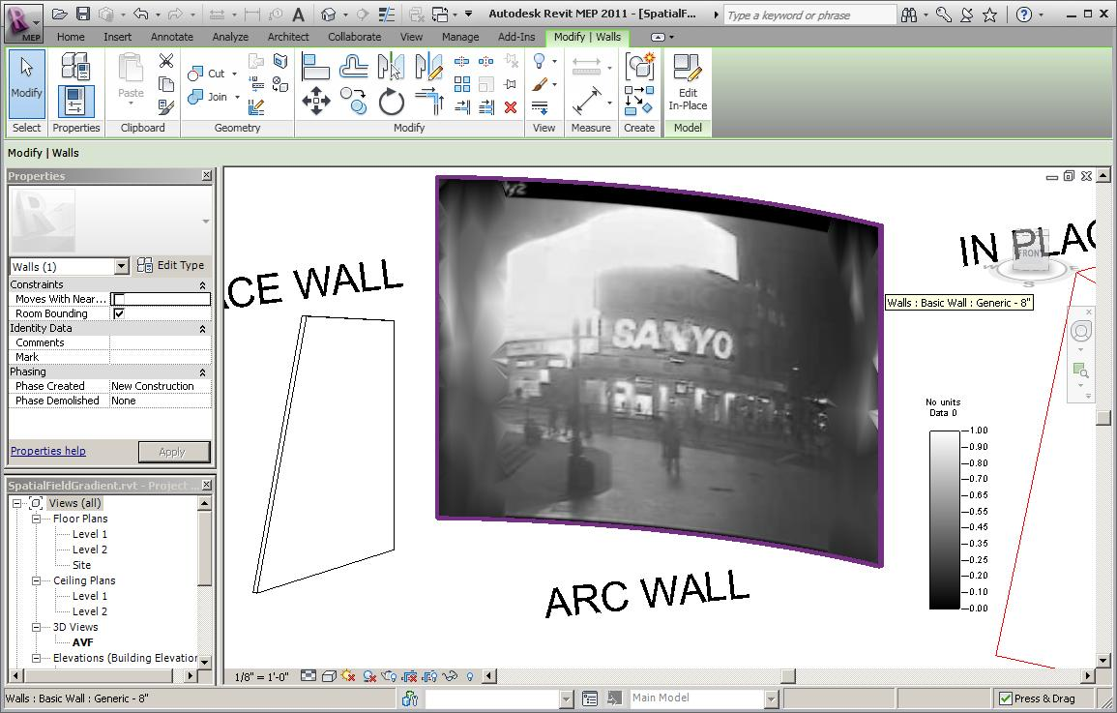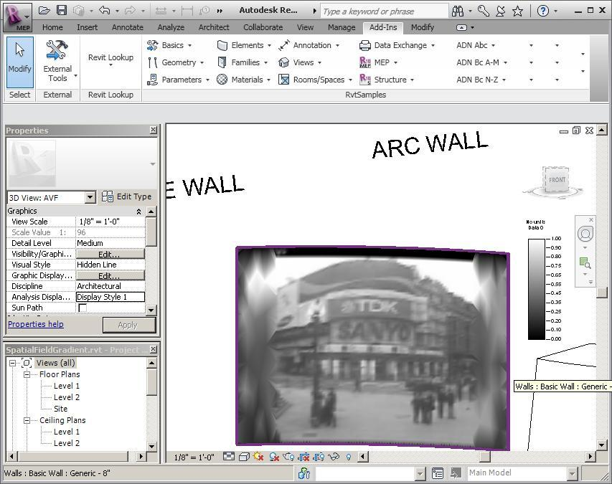
- Set up a spatial field primitive for face
- Set greyscale analysis display style
- Subscribe to Idling event
The Idling event handler performs the following tasks:
- Check minimum elapsed time interval
- Grab current image from URL
- Check whether update required
- Start transaction for write access
- Update spatial field primitive
- Set field points and values

RstLink Dynamic Update
RstLiveLink is an enhancement of the Revit Structure link sample which uses the Idling event to automate importing updates to the Revit model from an external analysis application. RstLink itself exports the structural analytical model to an external application and imports modified results back into Revit:
- Export from Revit to neutral exchange file format
- Import into external analysis application and recreate simplified model
- Edit and export modified model from external analysis application
- Import back into Revit
RstLiveLink automates the synchronisation:
- Export command saves model to external file, remembers timestamp and installs Idling event handler
- Idling handler checks for an updated exchange file, starts transaction, imports updated data, updates timestamp

Modeless Loose Connector Navigation
The modeless loose connectors navigator is the third in our series of Idling samples. It demonstrates how to implement a modeless form which appears to the user to be completely integrated with Revit. The problem with modeless forms is that they are independent of the Revit external command context and continue their activity after the command has returned control to Revit. In this context, they have no access to the Revit API. This sample demonstrates that such a form can submit tasks to a Revit Idling event handler, which does have access to the Revit API. The event handler picks up the pending tasks and executes them. Since it is called so frequently, there is no noticeable lag in performance between e.g. clicking on a row in the modeless form and seeing the update take place on the Revit screen.
This sample is also a Revit MEP API sample. It demonstrates making use of a complex filtered element collector query to retrieve all MEP elements that might possibly have connectors. On these, it determines all unconnected connectors and lists them, once in a text file report and secondly in a modeless dialogue box. The latter can be used to interactively navigate the results.
- Filter for all MEP connectors in project
- Combine all relevant classes and family instance categories
- Check IsConnected property on each connector
- Unable to determine whether a wire is intended to be homerun
- Log results to file and display it to user
- Interactively navigate through results from a modeless dialogue
- Ensure that modeless dialogue remains on top of Revit
- Modeless navigation interacts with Idling event

Materials
- AU10_CP228-2_Revit_2011_API_Features.docx - handout
- AU10_CP228-2_Revit_2011_API_Features.pptx - presentation
- p2c - my first Revit 2011 add-in
- rac_labs and bc - code migration samples
- Guidize - generate client id and populate add-in manifest tags
- RevitWebcam - Idling event and AVF sample
- RstLiveLink - Idling event and RST link sample
- Modeless Loose Connector Navigation - modeless form Idling
- Revit_SDK_Samples.xlsx

Further Reading
- A good starting point for all Revit developers is the resources listed on the Revit Developer Center – http://www.autodesk.com/developrevit. These include:
  - The Revit SDK including the API help file RevitAPI.chm and the Developer Guide "Revit 2011 API Developer Guide.pdf".
  - Training material, recorded presentations, especially the DevTV recordings, and the DevTV Visual Studio Revit add-in templates.
  - Information on joining the Autodesk Developer Network – http://www.autodesk.com/joinadn.
  - Training classes and webcasts – http://www.autodesk.com/apitraining.
  - API course schedule – http://www.adskconsulting.com/adn/cs/api_course_sched.php > Revit API
  - Autodesk discussion groups – http://discussion.autodesk.com > Revit Architecture > Revit API.
- Jeremy Tammik’s Revit API blog The Building Coder – http://thebuildingcoder.typepad.com.
- ADN, The Autodesk Developer Network – http://www.autodesk.com/joinadn
- For ADN partners, there is a wealth of Autodesk API information on the ADN website http://adn.autodesk.com. ADN members can ask unlimited API questions through our DevHelp Online interface.
- Watch out for our regular ADN DevLab events. DevLab is a programmers’ workshop (free to ADN and non-ADN members) where you can come and discuss your AutoCAD programming problems with the ADN DevTech team. They are advertised on our API training schedule accessible from http://www.autodesk.com/apitraining.

