All Systems Go
in Autodesk Revit MEP Programming
Jeremy Tammik – Principal Developer Consultant, Autodesk
Martin J. Schmid, P.E. – Industry Success Manager, Autodesk
CP316-3U This unconference discusses participants’ experiences working with the Revit MEP API. This included the possibilities and optimal use of the Revit API to create, analyze, and modify Revit MEP models programmatically. It addresses all MEP domains including HVAC, electrical, and plumbing. It discusses all MEP model components such as mechanical and electrical systems, ducts, pipes, fittings, connectors, and the new cable trays, conduits, and panel schedules. Topics include in-depth analysis and traversal of systems, automatic splitting of parts, obstruction avoidance, routing automation, and conduit and cable tray layout. We discuss the standard Revit MEP SDK sample applications, as well as custom ones to convert pipes to conduits; lay out cable tray elements and fittings; display electrical system hierarchies in a tree view; and automatically calculate, size, and report performance of an HVAC system that is based on room requirements.
About the Speakers: Martin has worked on-site with customers to implement best practices using AutoCAD MEP and Revit MEP, ranging from engineering firms and manufacturers to 3rd party developers. In his current role as Industry Success Manager, Martin works with product management, product design, and quality assurance teams providing subject matter expertise. In addition, he works with sales and key accounts to help with workflow adoption and to identify technical trends. He has written and presented material on AutoCAD MEP and Revit MEP to co-workers as well as at Autodesk University. Prior to involvement with the development of MEP products, Martin worked in a variety of roles in a number of architecture and engineering firms, including electrical designer, engineering coordinator, and application developer. Martin has a master’s degree in Architectural Engineering from Kansas State University and a master’s in Business Management of Technology from the University of Texas in San Antonio, and is a member of ASHRAE. Martin is a published co-author of books on AutoCAD MEP and Revit MEP. Martin has a beautiful wife and two daughters, and works from his home in San Antonio, TX. Martin has two drum sets which get to use during ‘down time’, and enjoys travelling and reading.
Jeremy is a member of the AEC workgroup of the Autodesk Developer Network ADN team, providing developer support, training, conference presentations, and blogging on the Revit API.
He joined Autodesk in 1988 as the technology evangelist responsible for European developer support to lecture, consult, and support AutoCAD application developers in Europe, the U.S., Australia, and Africa. He was a co-founder of ADGE, the AutoCAD Developer Group Europe, and a prolific author on AutoCAD application development. He left Autodesk in 1994 to work as an HVAC application developer, and then rejoined the company in 2005.
Jeremy graduated in mathematics and physics in Germany, worked as a teacher and translator, then as a C++ programmer on early GUI and multitasking projects. He is fluent in six European languages, vegetarian, has four kids, plays the flute, likes reading, travelling, theatre improvisation, and carpentry, loves mountains, oceans, sports, and especially climbing.
martin.schmid@autodesk.com; jeremy.tammik@autodesk.com

Introduction
This overview of the Revit MEP API discusses the following topics:
Analysis 3
Hierarchical Systems and Connectors 4
Electrical 7
HVAC and Plumbing 7
Sample Applications 9

MEP Application Requirements
Revit MEP is a flavour of Revit for work in the mechanical, electrical and plumbing domains. HVAC, i.e. heating, ventilation and air conditioning, is considered part of the mechanical domain. Efficient work in these areas requires strong model analysis tools in addition to read and write access to the components and data used to model the electrical, HVAC and piping systems in Revit MEP, e.g. access to:
- MEP project information
- Green Building XML, gbXML
- Spaces and zones
- Electrical systems, components, properties and parameters
- Duct and pipe systems, components, properties and parameters
- Element creation and modification
- System traversal and analysis

The Generic Revit API
Most of the Revit API is generic and applies to all three flavours of the Revit product, i.e. Architecture, MEP and Structure. All three flavours of Revit also include the same .NET assembly named RevitAPI.dll providing API access to third-party applications. However, some specific additional features exist for each of the flavours as well, for instance some room-related functionality in Revit Architecture and access to the analytical and MEP models in Revit Structure and MEP respectively.
- Basic Revit API is generic
- All flavours use the same .NET assembly RevitAPI.dll
- Specific additional features exist for each flavour
If API functionality not supported by the currently running flavour is accessed, the call will simply do nothing or return null.
This presentation assumes some basic understanding of the Revit MEP product and the generic Revit API and addresses the API additions and enhancements specific to Revit MEP.

Revit MEP API Evolution
In Revit 2008, no MEP-specific functionality was provided by the API. It was still possible to analyse and manipulate an HVAC system using the generic Revit API methods, for instance by accessing ducts as generic Revit elements and reading and writing their properties using the generic parameter access. This method still works and is demonstrated by the sample application for HVAC air terminal analysis and sizing, first presented at Autodesk University 2007.
Revit 2009 introduced the first MEP-specific API support, including classes for electrical and mechanical equipment, lighting device and fixture, connector, electrical system, space and zone, the MEP model property on family instances, and the ability to create and modify MEP elements.
In Revit 2010, the MEP-specific API was a focal point of the API development and greatly enhanced, especially the support for HVAC and piping systems. Revit MEP 2011 introduced cable trays and conduit elements and electrical panel schedules and consolidated most of the MEP related API classes into the Autodesk.Revit.DB.MEP namespace.

Analysis
Extensive and detailed model analysis tools are required for efficient modelling in all MEP disciplines. Some of the important features include the MEP project information, support for gbXML, the Green Building XML, spaces and zones for MEP-specific building area definition and management, and various model inspection utility methods.

MEP Project Info and gbXML
Revit MEP project info is provided through the EnergyDataSettings element and its properties. It contains settings for gbXML export, heating and cooling load calculations, and project level settings for conceptual energy analysis.
Green Building XML export is initiated by a call to the Document.Export method:
Document.Export( string folder, string name, GBXMLExportOptions );

Spaces and Zones
Revit 2009 added support for an improved workflow between Architecture and MEP. Previously, an MEP user had to Copy/Monitor rooms received from the architect. Architectural rooms are unsuitable for MEP analysis, because they often have the wrong height or are too large for the analysed region. Now one can use spaces instead of rooms, and zones to group spaces. This enables a subdivision of a room into exterior and interior subspaces.
The AddSpaceAndZone SDK sample demonstrates the programmatic creation and management of spaces and zones.
The FamilyInstance class has Room and Space properties to determine in which room or space an instance is located. The latter can be used to determine the location of e.g. an air terminal in Revit MEP:
FamilyInstance fi; // get a family instance
Space space = fi.Space; // query the space in which the instance is located
Space space2 = fi.get_Space( phase ); // family instance space in given phase

Model Inspection Utilities
The Revit 2010 API introduced a number of model inspection utilities which are useful in and targeted at the MEP domain. One group helps determine the relationships between and contents of volumes, rooms and spaces:
- Room.IsPointInRoom determines if a 3D point is in the volume of a room.
- Space.IsPointInSpace determines if a 3D point is in the volume of a space.
- GetRoomAtPoint and GetSpaceAtPoint return the room or space containing a given 3D point.
One example use of these methods is to perform a space adjacency analysis.
The new ray intersection method can be used to determine proximity of elements:
- FindReferencesByDirection returns an array of elements, faces, and references found when moving through the model from a specified point in a specified direction.
The use of FindReferencesByDirection is demonstrated by the AvoidObstruction, FindColumns, MeasureHeight, and RayTraceBounce SDK samples.
Currently these utilities work within the context of the host model, i.e., you cannot use these methods to identify the room at a particular location in a linked model.

Hierarchical Systems and Connectors
Many of the building blocks of an MEP system are represented in Revit by family instances. The generic family instance definition in the Revit API has been enhanced to provide access to additional MEP-specific properties and data, and provide classes to represent systems and connections between system components.

Hierarchical System Structure and MEP Model
The objects dealt with in the MEP domain are organised into hierarchical structures. The top level node in these structures is an MEP system, represented by the MEPSystem class. This is the base class for the derived classes
- ElectricalSystem
- MechanicalSystem
- PipingSystem
The system has properties to access the base equipment or panel, the terminal elements, and the connector manager. The derived classes have many additional domain specific properties.
The Revit 2009 API introduced the MEPModel and Connector classes as fundamentals for programmatically representing and accessing the MEP model. MEPModel is a base class for the derived classes
- ElectricalEquipment
- LightingDevice
- LightingFixture
- MechanicalEquipment
- MechanicalFitting
It is accessed through the FamilyInstance.MEPModel property, and one of its main purposes is to provide access to the connector manager.

Connectors
We have logical and physical connections between MEP components. Logical connections are used in the electrical domain, where wires are annotation elements, and are not intended to represent real-world model representations. Physical connections are used in all MEP domains. In the mechanical and plumbing domains, the connectors actually define and transmit the sizing information from one part to the next.
A physical connector is part of an MEP element such as a duct, pipe, fitting, or piece of equipment. The Connector class is used to represent connectors in the project environment. Individual stand-alone connector elements can be created inside a family; they are represented by the DuctConnector, PipeConnector and ElectricalConnector classes.
The connector defines geometry, e.g. its oval, round or rectangular shape, and dimensions such as width, height and radius. It also maintains a coordinate system and system data such as domain, system type, flow, direction. You are not allowed to access the radius property if the connector shape is not round, so you need to check the shape first before reading the dimensions.
Question: What is the difference between the Connector class versus the DuctConnector, PipeConnector and ElectricalConnector ones? I know one of them is used in the context of family documents only, and the other one is in project context. What is the main difference between them?
Answer: In Revit MEP, we work with different groups of elements, which all live in the project file, such as:
- Equipment
- Pipe and duct
- Fitting
These elements form parts of connected systems and need to be connected to their neighbour elements. This is achieved using connectors. The connectors are not elements, nor family instances, and do not live in the project file. They are contained within the elements that they connect. Therefore, they have to be added to the family definition.
There are different types of connectors for the different types of systems. A single piece of MEP equipment can have none, some or all connector types.
For instance, a piece of HVAC equipment such as a cooler may have electrical connections for power, pipes for cooling water in- and outlets, and ducts for air in- and outlets. All these connectors are defined in the family editor. When the equipment is inserted into the model, the connectors are used to hook it up to neighbouring elements, in this case electrical systems, pipes and ducts.
We thus have one set of classes for defining connectors, which reside in the family document. We have another class to represent the connectors on the resulting family instances, once they have been inserted into a project document. The former are the DuctConnector, PipeConnector and ElectricalConnector classes, the latter the Connector class.
So, when you are inside a family document, building your equipment, you add a DuctConnector class to the model. This is then transformed into some information on the equipment hosting it. When you insert that equipment into the model and query it for its connectors, it returns Connector instances to you.
DuctConnector, PipeConnector and ElectricalConnector are the classes you see and use in the family editor. These objects are the MEP connector definition classes used as a part of the building blocks to define an MEP part:
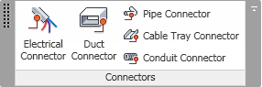
MEP family editor connector definition tools
Once you define a family type and insert it in a Revit project, you have a family instance, for instance this air handler:
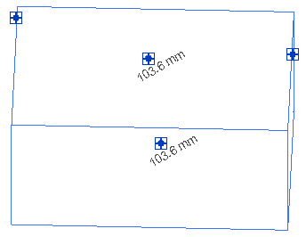
Air handler family instance with connectors in a project file
This instance contains connectors, which are managed by the connection manager and represented by the Connector class:
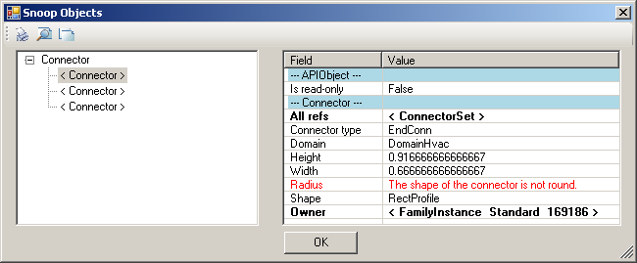
Duct Tee Cross connector class instances in RevitLookup

Electrical
Electrical systems are organised hierarchically in Revit MEP. The root elements are panels. Each panel is connected to a number of systems, also known as circuits. Each system or circuit consists of a number of circuit elements, some of which may be further panels, and so on, recursively.
Cables and wires may not be modelled individually, so the connections between the electrical system components can be defined by logical connectors rather than physical ones.
The Revit 2009 API introduced the classes ElectricalEquipment, LightingDevice, LightingFixture, ElectricalSystem, specialisations of the base MEPModel and MEPSystem classes, to represent electrical components and systems. These elements all have a connector manager, whose Connectors property returns logical as well as physical type connectors:
ElectricalSystem sys;
ConnectorSet connectors = sys.ConnectorManager.Connectors;
In the initial release of Revit 2009, the connector manager did not return logical connectors, so the MEP electrical API sample described below initially performed a complex analysis of various element parameters to determine how the different components of an electrical system are connected together and construct the system hierarchy from that information. From Revit MEP 2010 onwards, this process is much simplified by using the connector manager and querying the logical connections instead of undocumented parameter values.

HVAC and Plumbing
API support for ducts and plumbing was somewhat sparse in Revit 2009, when the MechanicalEquipment class was introduced. Much more support was provided with Revit 2010, which introduced the Autodesk.Revit.MEP namespace containing a wealth of new classes and functionality, as well as moving existing MEP-related classes to the MEP namespace. An overview is provided in the sub-section 'MEP API for ducts and pipes' in the 'What's New' section of the Revit API help file.
The main components in HVAC and piping hierarchy are the top level systems, ducts, pipes, fittings and the connectors:
- Systems to manage the top level system properties.
- Ducts and pipes to define the main flow elements.
- Fittings to implement bends and branches in the system.
- Connectors to hook up the ducts, pipes and fittings.
The following sections present a top-down hierarchical introduction to these classes and their functionality.

Systems
The classes MechanicalSystem and PipingSystem were introduced in Revit 2010 and provide the following top-level system functionality:
- Access to equipment, connectors and system type.
- Access to system properties such as flow and static pressure.
- Analysis of system contents through the DuctNetwork or PipeNetwork property.
The elements contained within a system are not automatically returned in the flow direction. The TraverseSystem SDK sample demonstrates how to query the connector managers to implement traversal in direction of flow for a given system.

Duct and Pipes
The ducts and pipes are represented by the classes Duct, FlexDuct, Pipe and FlexPipe, derived from the MEP curve type. They provide the following functionality:
- Read access to duct properties, types, and geometry.
- Change duct or pipe type.
- Move or layout duct or pipe.
The layout functionality can be driven by two points, one point and a connector, or two connectors.

Fittings
The fittings are represented by family instances, which are created with dedicated New*Fitting methods on the Autodesk.Revit.Creation.Document class, where * can be replaced by Elbow, Tee, Cross, Takeoff, Transition, and Union. The fitting properties and their shape and dimensions can be accessed through the FamilyInstance.MEPModel property.

Connectors
Connectors limited to the electrical realm were introduced in Revit 2009. In Revit 2010, we have connectors for the mechanical and piping domains as well. The connector is an item that is a part of another element such as a duct, pipe, fitting, or equipment.
The basic features of connectors and the different classes used to represent them in the family and project contexts were discussed above. The additional HVAC-specific connector features include properties to read the flow, coefficient and demand. They also provide access to physical properties like Origin, Angle, Height, Width and Radius.
We have read and write access to so-called assigned connector properties. These are connector properties that can be overridden by the user and are dependent on the overall network condition, including characteristics like Flow, Flow Config, Coefficient, Loss etc. These depend on the system being well connected, the configuration of the family within the system, and how the family is constructed.
Connector size and location can be modified. Connectors can be disconnected to insert a new fitting into a network or connect two ducts into a transition.
- The family connector elements define Flow, Flow Configuration, Coefficients, and Loss Method.
- Read duct, pipe, and fitting connector properties such as Flow, Coefficient, and Demand.
- Access physical connector properties e.g. Origin, Angle, Height, Width, Radius.
- Change connector size and location.
- Connect and disconnect.

Element Creation
The creation document provides a number of methods for the creation of HVAC and plumbing elements within the project environment:
- New*System to create a new mechanical or piping system.
- NewDuct, NewFlexDuct, NewPipe and NewFlexPipe to create new elements.
- New*Fitting to create new fittings, * being one of Cross, Elbow, TakeOff, TeeFitting, Transition, Union.
In the context of a family, different types of connectors are represented by elements and created by the FamilyItemFactory class accessed through the Document.FamilyCreate property, which provides the following methods:
- NewDuctConnector
- NewPipeConnector
- NewElectricalConnector

Sample Applications
The MEP-specific sample applications include both those provided in the standard Revit SDK as well as a couple of non-SDK ones created by the ADN DevTech developer support team for this presentation on the RME API.
The Revit SDK includes the following MEP specific samples:
- AddSpaceAndZone: handling space and zone elements.
- AutoRoute: route a set of ducts and fittings between a source and two sinks, the air supply equipment and two air outlet terminals.
- AvoidObstruction: Detect and resolve obstructions between ducts, pipes, and beams.
- CreateAirHandler: create a family representing an air handler and its connectors.
- PanelSchedule: demonstrate use of the Revit 2011 electrical panel schedule API.
- PowerCircuit: manipulation of electrical power circuits.
- TraverseSystem: Traverse a well-connected mechanical or piping system in the direction of flow.
The main non-SDK sample application is named ‘mep’. It implements some HVAC oriented commands making use of the generic Revit API to analyse and manipulate duct elements for automatic air terminal sizing. Others implement an electrical sample for analysis and display of an electrical system in a tree view reproducing the Revit system browser structure or showing the full connection hierarchy tree:
- HVAC air terminal analysis and sizing.
- Electrical system connectivity analysis and hierarchical display.

AddSpaceAndZone
This 2009 sample creates the spaces and zones required for HVAC analysis, and implements the following main features:
- Retrieve and list all existing spaces and zones in a specified level using an element filter.
- Create new spaces for each closed wall loop or space separation with the NewSpaces method.
- Create a new zone element in a specified level and phase.
- Add and remove spaces in a zone using the AddSpaces and Remove methods.
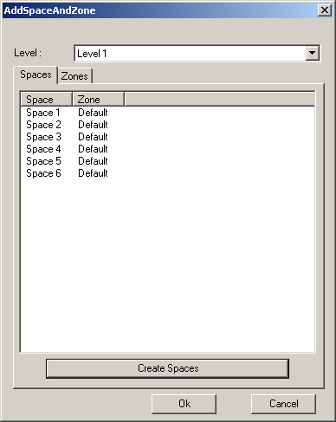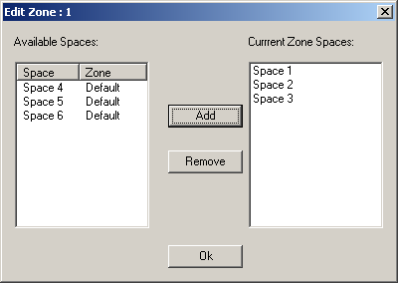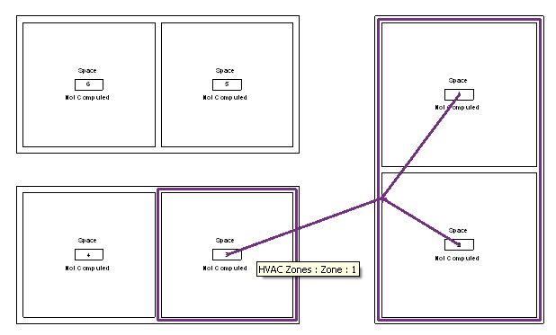

AutoRoute
Automatically create and route a set of ducts and fittings between a source, the air supply equipment, and the sink, two air outlet terminals. It creates a new mechanical system, ducts, fittings and connections using the methods NewMechanicalSystem, NewDuct, NewElbowFitting, NewTeeFitting and Connector.ConnectTo. The routing between the source and sink objects is automatically defined, so these can be moved freely prior to executing the command. To define the route, it first determines the bounding box of all the three elements, then uses the middle line or quarter lines on the X and Y axes as the trunk with a series of ducts that will be connected to the elements with fittings and ducts. This sample also demonstrates use of the .NET framework Trace class to create a log file AutoRoute.log.
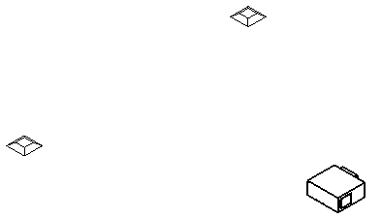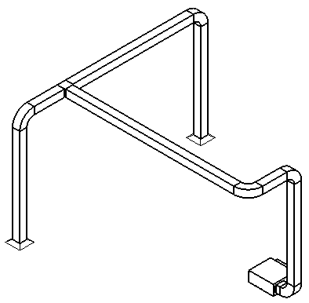

AvoidObstruction
Detect and resolve obstructions between ducts, pipes, and beams. This sample uses the new ray casting intersection analysis method FindReferencesByDirection. Only the pipe centre line is used to detect obstructions, the radius is ignored. Only pipes are modified, none of the other elements. The pipe’s original direction remains unchanged. It is split into several segments according to the obstructions detected, and elbows are inserted to reroute it around the obstruction. The example project included with the sample demonstrates the following types of collisions which are automatically resolved:
- Obstruction between pipes and beams
- Pipes intersected together
- Pipe loop intersection
- Obstruction between pipes and ducts
- Obstruction between a pipe and a duct
- Obstruction between two pipes
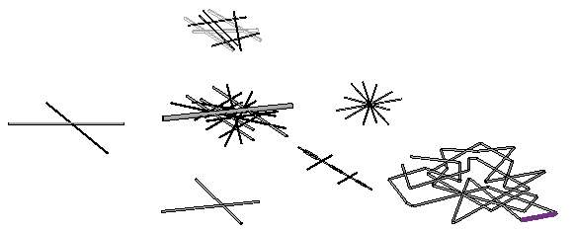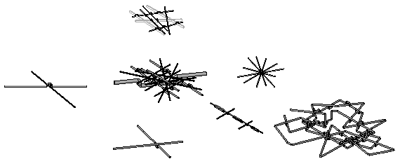

CreateAirHandler
Use the family API in the family editor context to create an air handler and add connectors.
The sample first checks the family template type using the OwnerFamily.FamilyCategory property. It creates the geometrical shape of the air handler using the NewExtrusion method on the FamilyItemFactory class in the Autodesk.Revit.Creation namespace. The extrusions are united by the method Cocument.CombineElements. The methods NewPipeConnector and NewDuctConnector are used to create the connectors. Their parameters are defined by setting the duct properties.
- Create an air handler with its geometry and its pipe and duct connectors
- Check the template family category to verify valid starting point
- Use FamilyItemFactory class methods NewExtrusion, NewPipeConnector, NewDuctConnector
- Set proper connector parameters and use Document.CombineElements to join the extrusions
The geometric shape creation is obviously generic, and only the addition of the connectors is MEP specific. In spite of this, this sample runs in any flavour of Revit, which means that the creation of connectors in the family API is not restricted to the MEP flavour of Revit.

PanelSchedule
The Revit 2011 SDK includes one new MEP specific sample application named PanelSchedule. It defines three external commands to demonstrate the use of the new panel schedule API:
- PanelScheduleExport – retrieve the panel schedule view data and export to CSV file or HTML.
- InstanceViewCreation – create a panel schedule view instance for a selected electrical panel.
- SheetImport – place panel schedule views on a sheet view.

PowerCircuit
This RME electrical sample provides functionality similar to the legacy RME Circuit Editor toolbar. It shows how to operate power circuits, as well as how to handle interactive element selection in Revit, implement a toolbar user interface for an external command, and use the .NET ResourceManager class to manage the images and localisable string resources. It mainly exercises classes from the Autodesk.Revit.MEP namespace and the MEPModel and ElectricalSystem classes. It provides the following functionality:
- Create a power circuit with selected elements.
- Edit a power circuit, or add or remove an element to or from a circuit.
- Select a panel for a circuit, or disconnect panel from a circuit if the circuit has a panel.
Creating a new circuit is achieved by the creation document method NewElectricalSystem, passing in a list of circuit elements and an electrical system type from the ElectricalSystemType enumeration, which can currently be one of Data, PowerCircuit, Telephone, Security, FireAlarm, NurseCall, Controls, and Communication.
For editing the circuit, the elements make use of the FamilyInstance MEPModel property, which provides access to its connector manager and electrical systems. The elements to be added to a circuit should have unused electrical connectors with same voltage definition and pole numbers. The entire user interface is presented by two toolbars with buttons representing the operations listed above.
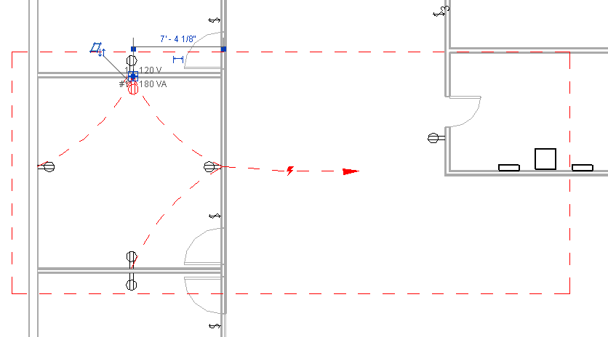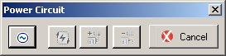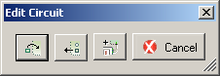

TraverseSystem
Traverse a well-connected mechanical or piping system in the direction of flow and dump the traversal into an XML file. The MEP electrical sample presented below demonstrates a similar traversal of electrical systems.
The TraverseSystem sample defines two classes TreeNode and TraversalTree. A TreeNode object represents an element in the system and contains traversal connection clues. The class TraversalTree traverses the specified system in the direction of flow by generating a tree-like structure of TreeNode objects.
A connected mechanical or piping system is retrieved from a selected element which can be the system itself or any of its elements. If the selected element belongs to more than one well-connected system, the system with the most elements will be chosen. The traversal begins at the system base equipment, if found. If the system has no base equipment, it will have an open connector which is the only point that can connect to a base equipment. The owner of the open connector will be chosen as the starting point. The connected elements relationships in the system are analysed by their connectors’ flow directions and generate the traversal tree-like structure.
How is the system retrieved? If the selected element is the system itself, it is either a MechanicalSystem or PipingSystem instance, both derived from the MEPSystem class. Otherwise, it may be a fitting, such as a T join or elbow, represented by a family instance, or a duct or pipe, represented by a MEPCurve instance. Both fittings and MEP curves have an associated connector manager,
The well-connectedness is reported by the MechanicalSystem IsWellConnected property, the number of elements in a system by Elements.Size, and the base equipment through BaseEquipment. If base equipment is null, an open connector is searched for by starting at an arbitrary element and recursively iterating through all its connectors and neighbouring system elements. Once the starting element has been defined, the traversal tree is built by a second recursive iteration through all connectors, neighbouring elements, their connectors, etc.

MEP Sample
This non-SDK sample implements a number of external commands addressing HVAC air terminal analysis and sizing as well as the hierarchical display of an electrical system. Some aspects of the sample not directly related to the MEP API are the external application implementation, about box, and progress bar.
The HVAC part of the MEP sample was originally implemented based on Revit 2008. Later the electrical part and an external application to define a custom user interface to access the sample commands was added:
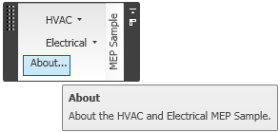
The application includes an about box command presenting the application description and version number. The version number and description displayed in the form is queried from the executing .NET assembly:
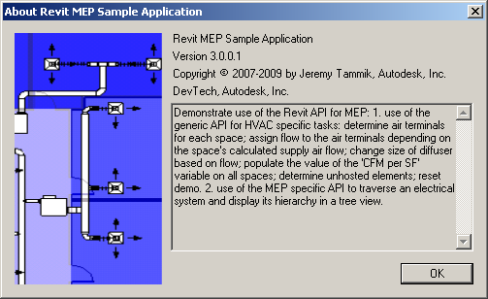
The HVAC sample implements a progress bar, since the processing of a large number of elements may take a noticeable amount of time:
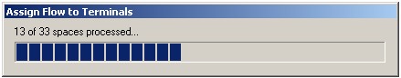
The application resides in the assembly mep.dll and defines the namespace mep. Its external commands can either be accessed by installing the external application interface defining the custom ribbon panel, or by setting up command buttons in the Revit ribbon to access them individually.

MEP Electrical Sample
The MEP electrical sample determines and displays the hierarchical structure of the electrical systems in the model in several different ways. Its focus is to:
- Traverse the electrical system
- Reproduce the system browser data structure in a tree view
- Determine and display the complete connection hierarchy in a tree view
The standard RME system browser displays electrical components in a three-level flat list, and the complete hierarchical structure of the connection tree is not immediately apparent. This sample inspects the electrical systems and reproduces the structure and information displayed by the system browser as well as the full connection hierarchy. It implements the following commands:
- CmdElectricalConnectors
- CmdElectricalSystemBrowser
- CmdUnhostedElements
The first two analyse the electrical system hierarchical structure and present it to the user in a tree view in a modeless dialogue. Being modeless, it remains visible and can be navigated after the command has terminated. You can leave the form open and switch back and forth between it and Revit to explore the electrical system simultaneously from both points of view. Note, however, that updates to the model will not be reflected in the dialogue until the command is re-executed. A sample model elec_project.rvt is provided.

Connection Hierarchy Tree
CmdElectricalConnectors determines this structure using the connectors and electrical system properties to determine how the panels are connected to a group of systems or circuits, and these in turn manage a set of electrical elements, some of which may in again be panels connected to new circuits, and so on, recursively. This is analogous to the approach used by the TraverseSystem SDK sample to traverse mechanical systems.
It selects all electrical equipment and populates a dictionary mapping parent nodes to its child elements in two steps. The first step determines which equipment has a parent. The remaining ones represent root nodes. The second step actually populates the dictionary.
Each piece of equipment is represented by a family instance. Its connector manager is available through the MEP model property and provides access to all connected elements, which are electrical systems. Each system is queried for all its elements. These elements are all family instances, some of which are electrical equipment, which completes the recursive structure.
Once the dictionary has been populated, it is displayed by the modeless form in a tree view.

Obsolete pre-connector approach
The CmdElectricalSystemBrowser command demonstrates a less direct approach using the parameter values on each element to determine their connectivity. This approach was required in the early stages of Revit 2009, because the connector manager did not return logical connectors. The advantage of using parameters instead of the connector manager is that it can be used in other flavours of Revit, where the MEP model and thus the connector manager are not available.
Two obsolete commands CmdElectricalHierarchy2 and CmdElectricalHierarchy are also still present in the source code. They display the same full tree-like connection hierarchy as CmdElectricalConnectors, also using the parameter data instead of connectors to determine the hierarchical structure of the electrical system.
CmdElectricalSystemBrowser reproduces the Revit electrical system browser three-tier structure. All three use the same approach:
- Collect the relevant Revit elements
- Determine their relationships from child to parent
- Sort this data into a dictionary
- Determine the inverted relationship from parent to children
- Display the hierarchical structure in a modeless form tree view
- Display additional nodes listing the electrical loads
The early versions of the Revit MEP API did not provide a top down access for traversing the electrical system elements. Instead, one had to collect all the candidate leaf node elements, and determine the parent element for each child element from its properties and parameter values. The method to select the relevant elements and to determine the parent node varies for different element types. Once the relationship from child to parent has been determined, it is added to a dictionary with a key entry for each parent associated with a value listing all of its children. This is similar to the algorithm used in the MEP HVAC sample application for inverting the relationship between the spaces of a building and the air terminals located within each one, or the wall host elements and the doors and windows hosted by them.

System Browser Structure
The Revit system browser displays three levels of nodes, panel > system > element. System is a synonym for circuit in Revit. We use the filtering API to retrieve the Revit elements associated with these nodes using two different data sources:
- Electrical equipment
- Circuit elements
Electrical equipment always has a system name and is either unassigned or also has a panel name. These elements can be retrieved by filtering for the ElectricalEquipment type. The circuit elements have a non-empty circuit number parameter value, so they can be retrieved by filtering for RBS_ELEC_CIRCUIT_NUMBER.
It is possible to determine the hierarchical connection structure between the elements from properties and parameters. These values are present on the child elements and can be used to deduce the respective parent element. In Revit 2010, the inverse relationship is immediately available and much more accessible by querying the connection managers, as demonstrated by the CmdElectricalConnectors command.

Find Unhosted Elements
This command interrogates the model to find unhosted elements. This is useful to MEP designers to find elements that are no longer associated with architectural elements. For example, if a hosted element such as a receptacle, air terminal, plumbing fixture or sprinkler is placed on a wall, and the wall is later shortened or deleted, the receptacle may be orphaned, i.e. unhosted. This command helps the designer detect such situations so they may be addressed.
Unhosted elements are identified by searching for family instances with a built-in parameter INSTANCE_FREE_HOST_PARAM whose value is "<not associated>" or "None" using the element filtering API. The previous obsolete implementation is also still available for comparison purposes.
The resulting element ids of unhosted elements are displayed in a dialogue and can be copied to the clipboard for further analysis, for instance to highlight and zoom in to them using the Revit Select by ID functionality.

MEP HVAC Sample
The MEP HVAC sample supports a typical HVAC engineering workflow including the following tasks:
- Placement and sizing of air distribution ducts and terminals
- Analysis and verification of results
In a little more detail, the workflow might look like this:
- Manually lay out air terminals
- Run heating and cooling load analysis
- Based on load analysis, assign flow to terminals
- Based on terminal flow, size air terminals
- Validate design; a common check figure uses air flow per surface area
In HVAC design, a common check figure to validate design is the flow density, or air flow per floor area, i.e. the total amount of supply air divided by the size of the room. In the US, this is typically measured in cubic feet per minute per square foot, or CFM / SF. There are common rules of thumb based on the room type on the result expected from such a calculation. Anomalies can be quickly identified, both in a schedule, as well as in a colour fill. A schedule can calculate the CFM/SF, but this computation is not available to a colour fill, which is one reason for this example application.
Revit MEP maintains several different values related to the air flow through a room. The calculated value can be imported from gbXML or set by using the IES heating and cooling loads calculation. After the calculation, the 'specified' value is set equal to the 'calculated' one. The engineer can then adjust manually if necessary.
Revit MEP includes the IES Virtual Environment as a built-in module. It also supports export to IES VE, and import and export to other calculation applications via gbXML, the Green Building XML format.
An interesting thing to note is that although this sample does modify the MEP duct system, it only makes use of generic Revit API functionality to modify the parameters and types of the duct system elements. Therefore, it can be run in Revit Architecture as well as in Revit MEP. Furthermore, it runs significantly faster in the Architecture flavour of Revit than in the MEP flavour, because there is no MEP machinery running in the background cleaning up and recalculating the duct system every time the application modifies something.
The MEP HVAC sample was originally implemented for Revit 2008 and based on room elements, since spaces had not yet been introduced. It was modified for RME 2009 to use spaces. It implements the following four commands to support the HVAC engineering workflow described above. The first three support the actual workflow itself, the fourth cleans up and resets the data manipulated by the first three:
- Assign flow to terminals
- Change air terminal size
- Verify design by air flow per surface area
- Reset demo

Assign Flow to Terminals
The first command in the sequence assigns flow to terminals. Before it is executed, we assume that the air terminal layout has been completed, so as a starting point all air terminals have been arranged in the building model for a uniform air distribution. The application then automatically assigns the appropriate flow to the terminals by performing the following steps:
- Calculate required air flow in each space
- Determine air terminals for each space
- Assign the flow to the terminals
The required air flow in each space can be calculated using an analysis tool, which populates the calculated supply airflow on each space.
To determine the air terminals for each space, the command can proceed as follows: the spaces do not maintain a list of the terminals they contain, but the terminals do know which space they live in. Therefore, we can determine this child-parent relationship and invert it to obtain the parent-child one. This is similar to the algorithm for inverting the relationship between the wall host elements and the doors and windows hosted by them. The implementation is simple:
- Define a dictionary mapping each space number to list of air terminals contained by that space
- Select all air terminals in the model
- For each terminal, determine its space number and add it to the dictionary
To assign flow to its terminals, we can iterate over the spaces in the model, or just the spaces with an entry in the dictionary, determine the required air flow of that space, divide it by the number of terminals in the space, and distribute the space's required air flow evenly across all contained terminals. Both steps make use of Revit filtering to select all air terminals and all spaces in the model respectively.
An issue that requires some attention here is the unit conversion. In Revit, the required air flow in each space is stored as cubic feet per second, whereas in the US, the convention is to display the value in CFM, cubic feet per minute. Also, per convention, it is rounded up to nearest multiple of 5 CFM.
Generally speaking, this sample demonstrates how to find instances of a particular family category in a room or space and how to assign a value to a family instance parameter. Here is an overview of the steps in detail:
- Calculate required air flow in each space using analysis tool
- This populates the calculated supply airflow on each space
- Determine air terminals for each space
- Build a dictionary mapping space number to list of air terminals
- For each terminal in the model, determine its space number and add it
- For each space in the model, assign flow to its terminals
- Distribute space's required air flow evenly across all contained terminals
- Handle unit conversions

Size Air Terminals
Once the required air flow has been determined for each individual air terminal in the first step, the air terminals can be sized appropriately. Air terminals are commonly sized based on a table of air flows. The greater the flow required, the larger the neck size of the air terminal. Selecting a different neck size for an air terminal family instance is equivalent to determining which symbol to use from the air terminal family. Within the family, each air terminal symbol has been assigned parameter values specifying the maximum and minimum air flow it is suited for.
A completely different approach would be to implement a much more complex family definition making use of a set of nested if-then statements which can switch its neck sizes depending on the flow assigned, without a need to select a different symbol. Besides being complex, an additional problem with such an approach is that to manually override the selection for any reason would require additional complexity in the family definition.
This sample demonstrates the first approach, interrogating the min and max flow characteristics of each type, and then assigning the proper size based on the required flow. In this case, overriding the selection is a simple matter of selecting an alternate type.
The application sets up a table mapping the various ranges of air flow to specific air terminal type to use for that range. It does so by iterating over selected air terminal families. These are identified within the Revit database by their category, which is BuiltInCategory.OST_DuctTerminal. All such families are identified and presented to the user to select which of them to process. For each family, a list of all its types specifying its min and max flow is constructed.
Once the families have been selected and their lists of flow ranges with associated types are set up, we can iterate over all air terminal family instances. For each terminal, we retrieve its flow and find and assign a symbol from the list whose range matches the required flow.
This sample thus demonstrates how to swap a family type based on user input, the flow, and characteristics of the type, the min and max flow. To summarise, the following steps are executed:
- Retrieve all air terminal families.
- User selection of families to process.
- Set up list of symbols with min to max flow ranges.
- Retrieve all supply air terminal instances.
- For each terminal, set the appropriate type so that its required flow falls within the symbol's min/ and max flow range.
From the Revit product side, a schedule can be set up as a powerful tool to simplify checking whether all terminals indeed have been assigned the correct type. By comparing the required air flow with the min and max range assigned to the type, invalid values falling outside the type range can be automatically highlighted.
Once these two steps have been executed, the design is basically complete: the air terminals have been assigned a suitable required flow based on the space requirements, and then assigned a suitable symbol based on that required flow. The next step serves to validate the design.

Calculate and Display Flow Density Colour Fill
To validate the design, we create a colour fill displaying the flow per area:
- Retrieve all space elements
- Retrieve area and actual supply air flow parameter data
- Calculate flow per area and set custom parameter
- Populate the project parameter "CFM per SF"
- We can also use the "Calculated Supply Airflow per area" built-in parameter ROOM_CALCULATED_SUPPLY_AIRFLOW_PER_AREA_PARAM
- Define area fill based on this parameter
This sample demonstrates how to assign a calculated value parameter representing the total amount of supply air divided by the size of the room in CFM/SF to a built-in family, in this case, a space. There are common rules of thumb based on the room type specifying expected values from such a calculation. Anomalies can be quickly identified, both in a schedule and in a colour fill. A schedule can calculate the CFM/SF, but this computation is not available to a colour fill, thus the reason for this example.

MEP HVAC Demo Steps
- Open the sample model provided in hvac_project.rvt.
- We are interested in the following view and four schedules:
  - Level 1 Mechanical - CFM per SF Colour Fill
  - 1 - Assign Flow to Terminals
  - 2 - Air Terminal Type Quantities
  - 3 - Size Air Terminals
  - 4 - Space Info
- Initially, the schedules show that no flow is yet assigned to the air terminals, they are all of the same type and size, their assigned flow does not match the spec, and our custom shared parameter CFM per SF on the spaces is not populated.
- Switch to the level 1 view and run the command MEP Sample > HVAC > Assign flow to terminals.
- Note that in schedule 1, the values have been updated. In schedules 2 and 3, all terminals still have the same size, and their assigned flow is undefined.
- Switch to the view and launch MEP Sample > HVAC > Change size.
- Look at the schedules and note the terminals now have different sizes and the flow has been assigned. In schedule 4, our shared parameter CFM per SF on the spaces is not yet populated, so no colour fill is displayed yet.
- Switch to the view and launch MEP Sample > HVAC > Populate CFM per SF on spaces.
- The schedule is updated, and the predefined colour fill provides immediate visual feedback to help validate the design.

Further Reading
- A good starting point for all Revit developers is the resources listed on the Revit Developer Center – http://www.autodesk.com/developrevit. These include:
  - The Revit SDK including the API help file RevitAPI.chm and the Developer Guide "Revit 2011 API Developer Guide.pdf".
  - Training material, recorded presentations, especially the DevTV recordings, and the DevTV Visual Studio Revit add-in templates.
  - Information on joining the Autodesk Developer Network – http://www.autodesk.com/joinadn.
  - Information on training classes and webcasts – http://www.autodesk.com/apitraining.
  - Links to the Autodesk discussion groups – http://www.autodesk.com/discussion. (Click on the AutoCAD link from there to access the AutoCAD API discussion groups).
- Jeremy Tammik’s Revit API blog The Building Coder – http://thebuildingcoder.typepad.com.
- If you’re an ADN partner, there is a wealth of Autodesk API information on the members-only ADN website – http://adn.autodesk.com. ADN members can ask unlimited API questions through our DevHelp Online interface.
- Watch out for our regular ADN DevLab events. DevLab is a programmers’ workshop (free to ADN and non-ADN members) where you can come and discuss your AutoCAD programming problems with the ADN DevTech team. They are advertised on our API training schedule accessible from http://www.autodesk.com/apitraining.

Acknowledgement
I am grateful to Martin Schmid, Autodesk, who provided inspiration and support for the analysis and design of the HVAC and electrical sample applications. And as always to my fellow colleagues in DevTech and especially in the AEC workgroup for being such a great team to work with.

