Putting the "I" in BIM: Parameters in the Autodesk® Revit® API
Matt Mason – IMAGINiT Technologies (merged with Avatech Solutions)
CP231-2 Parameters represent one of the core aspects of Autodesk Revit and the Autodesk Revit API, and are largely responsible for delivering the "Information" in "Building Information Modeling". This class will look both broadly and in-depth at how Parameters can be used with the Autodesk Revit API. It will cover topics including finding information, what is editable, driving graphical changes, hiding information, and more.

About the Speaker:
Matt is the Director of Software Development at IMAGINiT Technologies (recently merged with Avatech Solutions). He has been working on software development in the CAD and PDM world for 18 years. He has worked on both packaged software and company-specific software in manufacturing, facilities management, and architecture firms. Matt holds a B.S.E. in Aerospace Engineering from University of Michigan.
E-mail: mmason@rand.com
Blog: http://cadappdev.blogspot.com
Website: http://imaginit.rand.com

Introduction
Within Revit, parameters were the first capability of the API – and I would argue that they are STILL the most powerful capability of the API. This is not so much because of the API, but the nature of Revit itself – the most useful part of BIM is the “I” – the information.

In this 60-minute class, we will cover the following areas:
- Parameter Fundamentals
- Parameter API Fundamentals
- The Parameter API in depth:
  - Reading
  - Setting
  - Creating
  - Hiding
- Parameters and Families
- Things to Do With Parameters
  - Importing and Exporting Data
  - Reporting
  - Validation and Cleaning Up

Parameter Fundamentals
It is worth covering some quick Parameter Fundamentals (since this is a diverse audience in terms of their Revit experience).

Where do parameters come from?
Parameters are ALWAYS associated with a particular element within Revit – a wall, a door, a pipe. Even “project parameters” are actually associated to a “ProjectInformation” element.

Which parameters will be on a certain kind of element?
Whether the parameters are built-into Revit or customized by a user, parameter definitions are always “bound” to one or more Categories within Revit. Furthermore, parameters are bound to EITHER instances or types of a particular category.
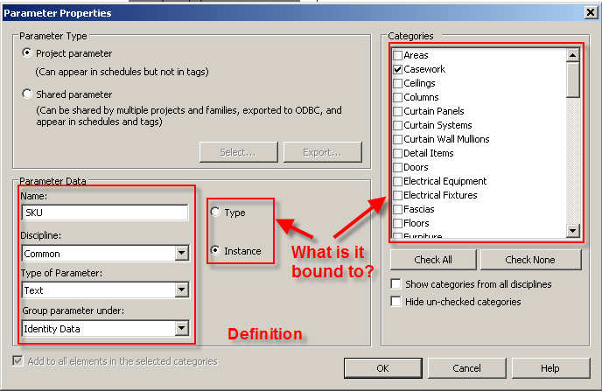

What is a “Shared” parameter?
Let’s imagine that you have two different Revit family files – both specialty equipment. One of them (created by someone else) has a parameter called “Surface Area”, and you’d like to add something like that to your other family file.
When you do this, how would Revit know for certain that the two parameters are really the same thing (Revit doesn’t just trust that because the names are the same, they should be the same). So when you schedule the equipment, or tag it, or anything else where Revit wants to definitively know that you’re talking about the same parameter – you must use a Shared parameter.
Shared parameters are defined at the Application level in a shared parameter file – a file that needs to be maintained across all of your machines (by default):
# This is a Revit shared parameter file.
# Do not edit manually.
*META VERSION MINVERSION
META 2 1
*GROUP ID NAME
GROUP 1 test
*PARAM GUID NAME DATATYPE DATACATEGORY GROUP VISIBLE
PARAM ebe91ef6-0ec6-4e1a-aec0-5344a0556bbc SurfaceArea AREA 1 1

Note the “GUID” a unique identifier for this parameter. Whenever your parameter is used from here on out, this GUID makes it unique - if it runs into a similarly named parameter in the future, Revit will compare the GUIDs to determine if they are actually the same.

Parameter API Fundamentals
The object diagram of parameters within the Revit API looks like this:

From Element to Parameters
The easiest way to get from an Element to parameters is via the Parameters collection:
// get our active document
Document doc = commandData.Application.ActiveUIDocument.Document;

// get the element we care about. In this case, the project info:
Element projInfo = doc.ProjectInformation;

// go through all of the parameters and show them individually:
foreach (Parameter p in projInfo.Parameters)
{
TaskDialog.Show("Parameters", p.Definition.Name + ": " + p.AsString());
}

The parameters collection has all VISIBLE parameters on an element (roughly equivalent to choosing the “Properties” for the given element in Revit). Also note – the parameter “names” shown will be the “localized” names (i.e. in the French version of Revit, the parameter names will be in French).

The Parameter API in Depth

How to Get Values?
Once you have your Parameter object, the next step is usually to get the value out of it. Parameters have 5 different “StorageTypes” – meaning what kind of data is stored inside of them:
- String (Text)
- Double (Number)
- Integer (Whole Number)
- ElementId
- None/Invalid (Usually used for “internal” parameters which are not really exposed to the API
Based on which StorageType the parameter is – you retrieve the values with different methods for the parameter object:
- AsString() - Text
- AsInteger() – Integer (although sometimes used for “options”).
- AsDouble() – Numeric Value (usually in Revit’s internal units – i.e. decimal feet for length)
- AsValueString() – dimensional values in text format (i.e. instead of 2.500, you would get 2’ 6”)
private string getParameterText(Parameter p)
{
switch (p.StorageType)
{
case StorageType.String:
return p.AsString();

case StorageType.Integer:
return p.AsInteger().ToString();

case StorageType.Double:
// check to see if there's a value string first!
if (p.AsValueString() != null) return p.AsValueString();
return p.AsDouble().ToString();

case StorageType.ElementId:
ElementId eid = p.AsElementId();
if (eid.IntegerValue < 0) return "(none)"; // blank
// get the element, return the name
Element eObj = p.Element.Document.get_Element(eid);
return eObj.Name;

default:
return "N/A";
}
}

Quick Note: Some people had asked prior to the meeting about Schedule Keys – these are “drop-down-list” type values which can be created for a particular parameter in Revit. These are implemented as ElementId parameters in Revit (Revit creates an Element for each schedule key answer).

BuiltInParameters
BuiltInParameters are parameters which come “out of the box” from Revit. There are currently about 3000 of them (although some percentage of them are legacy parameters that are no longer in active usage in 2011).
BuiltInParameters are important to understand for two key reasons:
- The parameters may not be visible in the parameter list.
- If your users are working in a foreign Revit, it is better to ask for the parameter by its BuiltIn name.
// get our active document
Document doc = commandData.Application.ActiveUIDocument.Document;

// get the element we care about. In this case, the project info:
Element projInfo = doc.ProjectInformation;

// get the builtin parameter
Parameter p = projInfo.get_Parameter(BuiltInParameter.PROJECT_NAME);
TaskDialog.Show("Project", "The project name: " + p.AsString());

What Can We Change?
One of the great undocumented mysteries of working with the Revit API is – what can we modify. Like many things within Revit – this is usually determined by experimentation as much as anything. But there is a short cut to figuring it out – the Parameter.IsReadOnly flag tells you whether the API is allowed to set the value of that parameter.
For example, with a typical wall element:
Read-Only Parameters | Writable Parameters
Area, Base Extension Distance*, Base is Attached *, Length, Related To Mass, Top Extension Distance *, Top is Attached *, Unconnected Height *, Volume | Base Constraint, Base Offset, Comments, Location Line, Mark, Phase Created, Phase Demolished, Room Bounding, Structural Usage, Top Constraint, Top Offset,
* These may be writable depending on other parameters/situations

Type Parameters vs. Instance Parameters
So far, in the examples we’ve shown, all of the parameters retrieved have been from “Instance” parameters – parameters retrieved directly from the element in question. So where are the “Type” parameters? We need to navigate from the “instance” to the “type” element – and then retrieve the parameters that are there:
private void getParameters(Element elem)
{
// get both the instance parameters and type parameters
string msg = "Instance Parameters: " + Environment.NewLine;

foreach (Parameter p in elem.Parameters)
{
msg += p.Definition.Name + ": " + getParameterText(p)
+ Environment.NewLine;
}

// now get the type parameters:
msg += "Type Parameters: " + Environment.NewLine;

Element typeElem = elem.Document.get_Element(elem.GetTypeId());

foreach (Parameter tp in elem.Parameters)
{
msg += tp.Definition.Name + ": " + getParameterText(tp)
+ Environment.NewLine;
}

TaskDialog.Show("Parameters", msg);
}
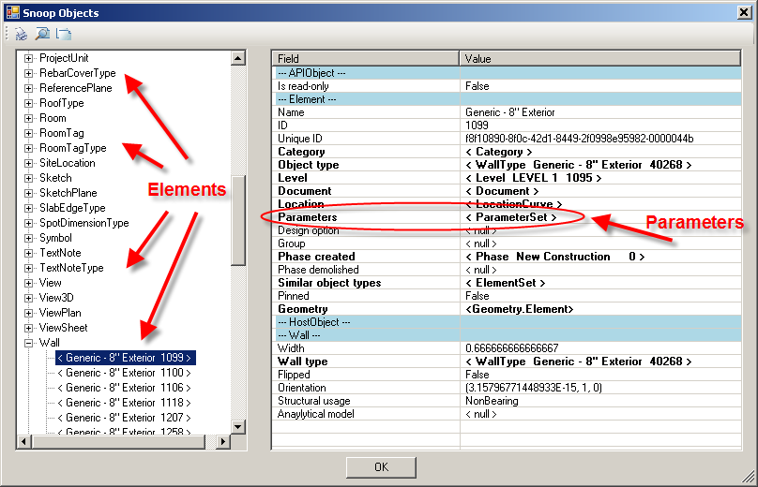

Snooping Parameters
The documentation of what parameters exist for each element category and what each parameter does is, to put it bluntly, almost non-existent. As such, the only good way to gain understanding of what you can do with parameters is by “snooping” them, using the RevitLookup tool (now part of the Revit SDK).
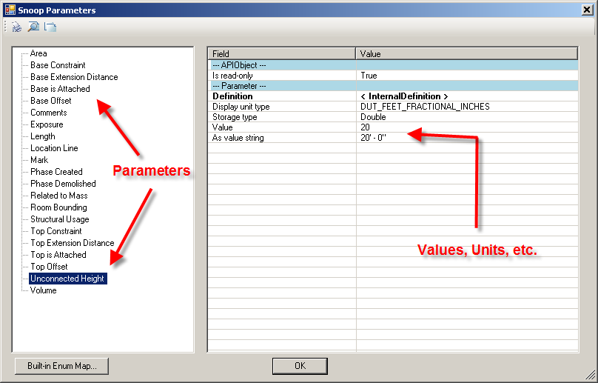

In the image below, RevitLookup tests all 3000 built-in parameters to determine which ones exist on the current element.
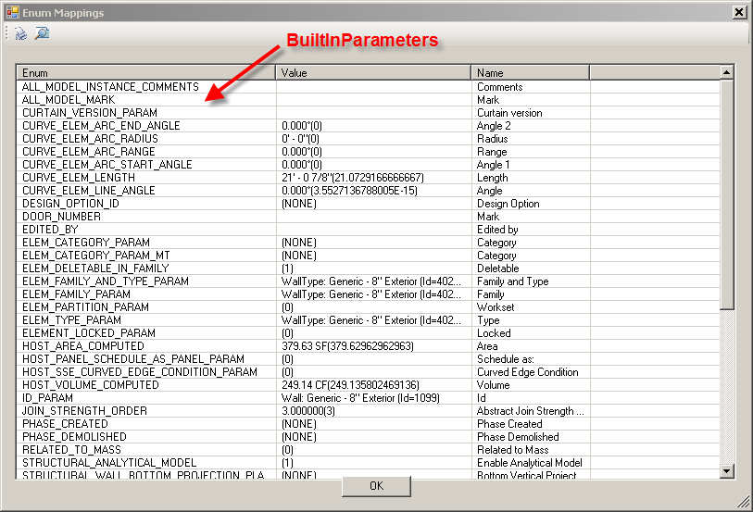

Setting Parameters
Similar to getting the parameter values, setting parameters is done based on the parameter storage type:
- Set (String): text
- Set (Double): number (usually in Revit’s internal units)
- Set (Integer)
- Set (ElementId): The ElementId (or an ElementId with an IntegerValue of -1 for blank).
Also – the SetValueString() method lets you pass in a dimension or other value in “user units”… rather than Revit’s internal units for parameter types such as “Length”.
Parameter param myWall.get_Parameter(BuiltInParameter.WALL_USER_HEIGHT_PARAM);

// setting the parameter by internal value
param.Set( 20.5 );

// setting the parameter by the Display Value
param.SetValueString( "20' 6\"" );

Creating Parameters
Creating External (Shared) Parameters is straightforward, but needs to be done through the DefinitionFile class
// get the shared parameter file
DefinitionFile file = app.OpenSharedParameterFile();

// if our group is not there, create it
DefinitionGroup group = file.Groups.get_Item("Room");
if (group == null) group = file.Groups.Create("Room");

// add our parameter to the group
Definition def =
group.Definitions.Create("Target Area", ParameterType.Area, true);

// now if we want it in the project, we need to bind it to categories
CategorySet cats = app.Create.NewCategorySet();
cats.Insert( doc.Settings.Categories.get_Item(BuiltInCategory.OST_Rooms));

// create a binding - instance or type:
InstanceBinding bind = app.Create.NewInstanceBinding(cats);
doc.ParameterBindings.Insert(def, bind, BuiltInParameterGroup.PG_AREA);

Hiding Parameters
When created, shared parameters can be marked as “Hidden” – that is, they will not be visible to the end-user (They WILL be visible to anyone using the API). This is a handy capability to be able to store hidden information with a particular kind of element.
Quick Note: The hidden parameter stays hidden – even if later users do not have the shared parameter configured.
// create a new hidden marker parameter and apply it
// get the shared parameter file
DefinitionFile file = app.OpenSharedParameterFile();

// if our group is not there, create it
DefinitionGroup group = file.Groups.get_Item("ID");
if (group == null) group = file.Groups.Create("ID");

// add our parameter to the group
Definition def =
group.Definitions.Create("Copyright", ParameterType.Text, false);

CategorySet cats = app.Create.NewCategorySet();
cats.Insert(doc.Settings.Categories.get_Item(BuiltInCategory.OST_Levels));
InstanceBinding bind = app.Create.NewInstanceBinding(cats);

doc.ParameterBindings.Insert(def, bind);

Parameters and Families
It is worth noting that the API works slightly differently with parameters when you’re talking about the definition of Family Type parameters within a family (once the family is loaded within a project, then all of the above approaches apply).
All of the manipulation of Family Type parameters is done with the FamilyManager class, which can be retrieved from the document of a given family:
if (doc.IsFamilyDocument)
{
FamilyManager manager = doc.FamilyManager;

TaskDialog.Show("Family",
"There are " + manager.Types.Size.ToString() + " sizes");
}

Within the Family Manager, there are a variety of methods which are similar (but in some cases better) than the mechanisms in the project environment:
- Add Parameter (add a family parameter or a shared parameter)
- Swap Instance/Type parameter definition
- Set
- SetValueString
- SetFormula
- MakeReporting / MakeNonReporting
private void setFamilyParams(Document doc)
{
FamilyManager manager = doc.FamilyManager;

// lookup the family parameters
FamilyParameter manufacturer = lookupFamilyParam(manager, "Manufacturer");
FamilyParameter partNumber = lookupFamilyParam(manager, "Model");

// set them
manager.Set(partNumber, "BR18054-1");
manager.SetFormula(manufacturer, "\"VIKING\"");

}

private FamilyParameter lookupFamilyParam(FamilyManager fm, string name)
{
// lookup the family parameter
foreach (FamilyParameter fp in fm.Parameters)
{
if (fp.Definition.Name.ToUpper() == name.ToUpper()) return fp;
}

throw new ApplicationException("Unable to find parameter: " + name);

}

Things to Do With Parameters
The above sections cover in depth everything that you can do with parameters in the Revit API. Now, we will look at some examples of how you can take these tools and apply them to solving interesting problems, with examples in:
  - Importing and Exporting Data
  - Reporting
  - Validation and Cleaning Up

