Analyze Geometry of Buildings Using the Autodesk® Revit® API
Scott Conover – Autodesk
CP319-1 Learn tips and techniques to extract geometric and measurement data from Revit models using the Revit API. You will learn how to analyze the geometry of various elements, including walls, floors, roofs and structural framing. You will learn techniques for measuring quantities related to the building construction, including areas, volumes, and material usage. You will also see how ray-tracing utilities can assist with analysis of the physical relationships between elements in the Revit model. You will see how new 2011 APIs can make it easier to find elements located at particular coordinates within the model.

About the Speaker:
Scott is a Software Development Manager for Autodesk, leading the effort to expand the Autodesk® Revit® API. For 12 years, he has used customization interfaces to parametric 3D CAD systems in order to automate repetitive tasks, extend the application user interface, and transfer data between the CAD application and different data formats. Since joining Autodesk, he has worked on the design, implementation, and testing of Revit APIs; including most recently, on the design of the 2011 element iteration and filtering, Dynamic Model Update, and External Command improvements. Scott holds a Master of Computer Systems Engineering degree from Northeastern University with a concentration on CAD/CAM/CAE.

Scott.Conover@autodesk.com

This course covers some tips and techniques to extract geometric and measurement data from Revit models using the Revit API. You will learn how Revit parameterizes 2D and 3D geometry of various building elements, including walls, floors, roofs and structural framing. You will learn techniques for measuring quantities related to the building construction, including areas, volumes, and material usage. You will also see how ray-tracing utilities can assist with analysis of the physical relationships between elements in the Revit model.

Geometry extraction
Before we discuss the details of what you get when you extract geometry from an element in Revit, let’s discuss the geometry extraction process.
Geometry options
Geometry is typically extracted from the indexed property Element.Geometry. (Element.get_Geometry() in C#) This property accepts an options class which you must supply. The options class customizes the type of output you receive:
- ComputeReferences – this flag sets Revit to make the GeometryObject.Reference property active for each geometry object extracted. When this is false, the property will be null. Remember that the default is false, you must turn this on or your reference will not be accessible
- DetailLevel – this sets the detail level for the extracted geometry. Note that the default for this is “medium”.
- View – this sets the view that governs the extracted geometry. Note that the detail level for this view will be used in place of “DetailLevel” if a view is assigned (so you will need to change the view’s detail level depending on your desired output). Set the view when you want to extract view-specific geometry not normally visible in the default 3D view.
- IncludeNonVisibleObjects –this flag sets Revit to also return geometry objects which are not visible in a default view. Most of this non-visible geometry is construction and conditional geometry that the user sees when editing the element (for example, the center plane of a window family instance). So, typically you would set this to false (the default) as you don’t want to include such information in your output. However, some of this conditionally visible geometry represents real-world objects, and in certain situations, you should extract it. One such example is the geometry of insulation surrounding ducts in Revit MEP.
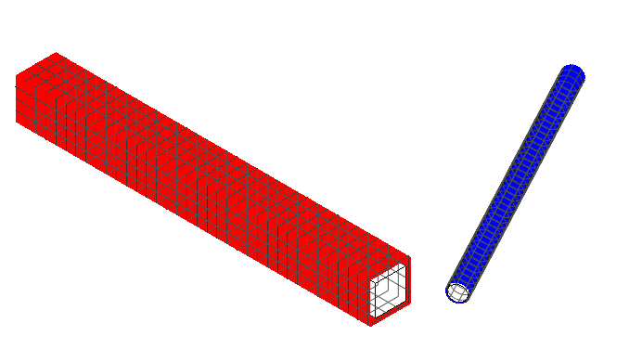
Insulation geometry found via “IncludeNonVisibleObjects” option

Contents of the extracted geometry
The extracted geometry is returned to you as a Autodesk.Revit.DB.GeometryElement. You can look at the geometry members of that element by iterating the .Objects property. Typically, the objects returned at the top level of the extracted geometry will be one of:
- Solid – a boundary representation made up of faces and edges
- Curve – a bounded 3D curve
- Instance – an instance of a geometric element, placed and positioned within the element
An instance offers the ability to read its geometry through the GetSymbolGeometry() and GetInstanceGeometry() methods. These methods return another Autodesk.Revit.DB.GeometryElement which can be parsed just like the first level return from get_Geometry():
- GetSymbolGeometry() returns the geometry represented in the coordinate system of the family. Use this, for example, when you want a picture of the “generic” table without regards to the orientation and placement location within the project.
- GetInstanceGeometry() returns the geometry represented in the coordinate system of the project where the instance is placed. Use this, for example, when you want a picture of the specific geometry of the instance in the project (for example, ensuring that tables are placed parallel to the walls of the room).
- There are also overloads for both methods that transform the geometry by any arbitrary coordinate system.
In some cases, instances may be nested many levels deep. (For example, a baluster in a railing placed in a document, or any other example of nested family instances). We’ll discuss transformations and their relationship to instance geometry later in this course.

Other sources of geometry
Geometry can also be obtained from a variety of other properties and methods:
- LocationCurve – curve driven elements like walls and beams report their profile through this interface
- References of dimensions – the references contain information regarding the geometry they point to
- Structural AnalyticalModel – returns curves and faces representing the analytical model of structural elements
- FindReferencesByDirection() – discussed later in this course

Curve parameterization
Curves in the Revit API can be described as mathematical functions of an input parameter “u”, where the location of the curve at any given point in XYZ space is a function of “u”. In Revit, the parameter can be represented in two ways:
- A ‘normalized’ parameter. The start value of the parameter is 0.0, and the end value is 1.0. This makes evaluation of the curve along its extents very easy, for example, the midpoint is at parameter 0.5. This is the typical way of addressing curve locations.
- A ‘raw’ parameter. The start and end value of the parameter can be any value. For a given curve, the value of the minimum and maximum raw parameter can be obtained through Curve.get_EndParameter(int) (C#) or Curve.EndParameter(int) (VB.NET). Raw parameters are useful because their units are the same as the Revit default units (feet). So to obtain a location 5 feet along the curve from the start point, you can take the raw parameter at the start and add 5 to it. Raw parameters are also the only way to evaluate unbound and cyclic curves.
The methods Curve.ComputeNormalizedParameter() and Curve.ComputeRawParameter() automatically scale between the two parameter types. The method Curve.IsInside() evaluates a raw parameter to see if it lies within the bounds of the curve.
You can use the parameter to evaluate a variety of properties of the curve at any given location:
- The XYZ location of the given curve. This is returned from Curve.Evaluate(). Either the raw or normalized parameter can be supplied. If you are also calling ComputeDerivatives(), this is also the .Origin property of the Transform returned by that method.
- The first derivative/tangent vector of the given curve. This is the .BasisX property of the Transform returned by Curve.ComputeDerivatives().
- The second derivative/normal vector of the given curve. This is the .BasisY property of the Transform returned by Curve.ComputeDerivatives().
- The binormal vector of the given curve, defined as the cross-product of the tangent and normal vector. This is the .BasisZ property of the Transform returned by Curve.ComputeDerivatives().
All of the vectors returned are non-normalized (but you can normalize any vector in the Revit API with XYZ.Normalize()). Note that there will be no value set for the normal and binormal vector when the curve is a straight line. You can calculate a normal vector to the straight line in a given plane using the tangent vector.
The API sample “DirectionCalculation” uses the tangent vector to the wall location curve to find exterior walls that face south.
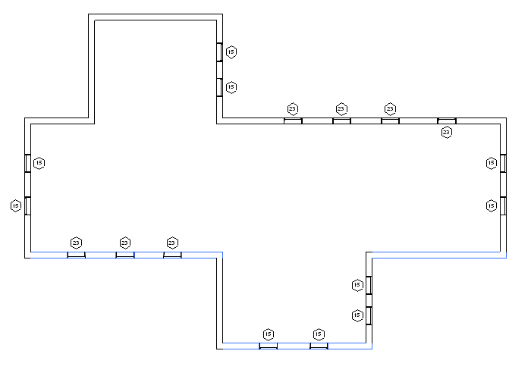
Finding and highlighting south facing exterior walls

Curve types
Revit uses a variety of curve types to represent curve geometry in a document. These include:
Curve type | Revit API class | Definition | Notes
Bound line | Line | A line segment defined by its endpoints. | Obtain endpoints from Curve.get_Endpoint()
Unbound line | Line | An infinite line defined by a location and direction | Identify these with Curve.IsBound.  Evaluate point and tangent vector at raw parameter= 0 to find the input parameters for the equation of the line.
Arc | Arc | A bound circular arc | Begin and end at a certain angle. These angles can be obtained by the raw parameter values at each end of the arc.
Circle | Arc | An unbound circle | Identify with Curve.IsBound.  Use raw parameter for evaluation (from 0 to 2π)
Elliptical arc | Ellipse | A bound elliptical segment
Ellipse | Ellipse | An unbound ellipse | Identify with Curve.IsBound. Use raw parameter for evaluation (from 0 to 2π)
NURBS | NurbSpline | A non-uniform rational B-spline | Used for splines sketched in various Revit tools, plus imported geometry
Hermite | HermiteSpline | A spline interpolate between a set of points | Used for tools like Curve by Points and flexible ducts/pipes, plus imported geometry

Mathematical representations of all of the Revit curve types can be found in Appendix A.

Curve analysis and processing
There are several Curve members which are tools suitable for use in geometric analysis. In some cases, these APIs do more than you might expect by a quick review of their names.

Intersect()
The Intersect method allows you compare two curves to find how they differ or how they are similar. It can be used in the manner you might expect, to obtain the point or point(s) where two curves intersect one another, but it can also be used to identify:
- Collinear lines
- Overlapping lines
- Identical curves
- Totally distinct curves with no intersections
The return value identifies these different results, and the output IntersectionSetResult contains information on the intersection point(s).

Project()
The Project method projects a point onto the curve and returns information about the nearest point on the curve, its parameter, and the distance from the projection point.

Tessellate()
This splits the curve into a series of linear segments, accurate within a default tolerance. For Curve.Tessellate(), the tolerance is slightly larger than 1/16”. This tolerance of approximation is the tolerance used internally by Revit as adequate for display purposes.
Note that only lines may be split into output of only two tessellation points; non-linear curves will always output more than two points even if the curve has an extremely large radius which might mathematically equate to a straight line.

Faces
Faces in the Revit API can be described as mathematical functions of two input parameters “u” and “v”, where the location of the face at any given point in XYZ space is a function of the parameters. The U and V directions are automatically determined based on the shape of the given face. Lines of constant U or V can be represented as gridlines on the face, as shown in the example below:
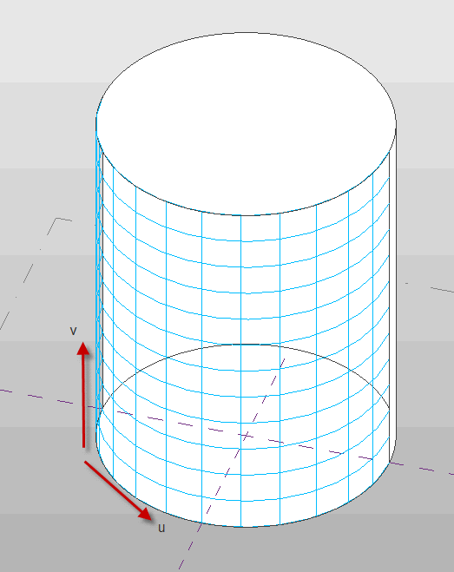
U and V gridlines on a cylindrical face
You can use the UV parameters to evaluate a variety of properties of the face at any given location:
- Whether the parameter is within the boundaries of the face, using Face.IsInside()
- The XYZ location of the given face at the specified UV parameter value. This is returned from Face.Evaluate(). If you are also calling ComputeDerivatives(), this is also the .Origin property of the Transform returned by that method.
- The tangent vector of the given face in the U direction. This is the .BasisX property of the Transform returned by Face.ComputeDerivatives()
- The tangent vector of the given face in the V direction. This is the .BasisY property of the Transform returned by Face.ComputeDerivatives().
- The normal vector of the given face. This is the .BasisZ property of the Transform returned by Face.ComputeDerivatives().
All of the vectors returned are non-normalized.

Edges and face parameterization
Edges are boundary curves for a given face.
Iterate the edges of a Face using the EdgeLoops property. Each loop represents one closed boundary on the face. Edges are always parameterized from 0 to 1.
An edge is usually defined by computing intersection of two faces. But Revit doesn’t recompute this intersection when it draws graphics. So the edge stores a list of points - end points for a straight edge and a tessellated list for a curved edge. The points are parametric coordinates on the two faces. These points are available through the TessellateOnFace() method.
Sections produce “cut edges”. These are artificial edges - not representing a part of the model-level geometry, and thus do not provide a Reference.

Edge direction
Direction is normally clockwise on the first face (first representing an arbitrary face which Revit has identified for a particular edge). But because two different faces meet at one particular edge, and the edge has the same parametric direction regardless of which face you are concerned with, sometimes you need to figure out the direction of the edge on a particular face.
The figure below illustrated how this works. For Face 0, the edges are all parameterized clockwise. For Face 1, the edge shared with Face 0 is not re-parameterized; thus with respect to Face 1 the edge has a reversed direction, and some edges intersect where both edges’ parameters are 0 (or 1).
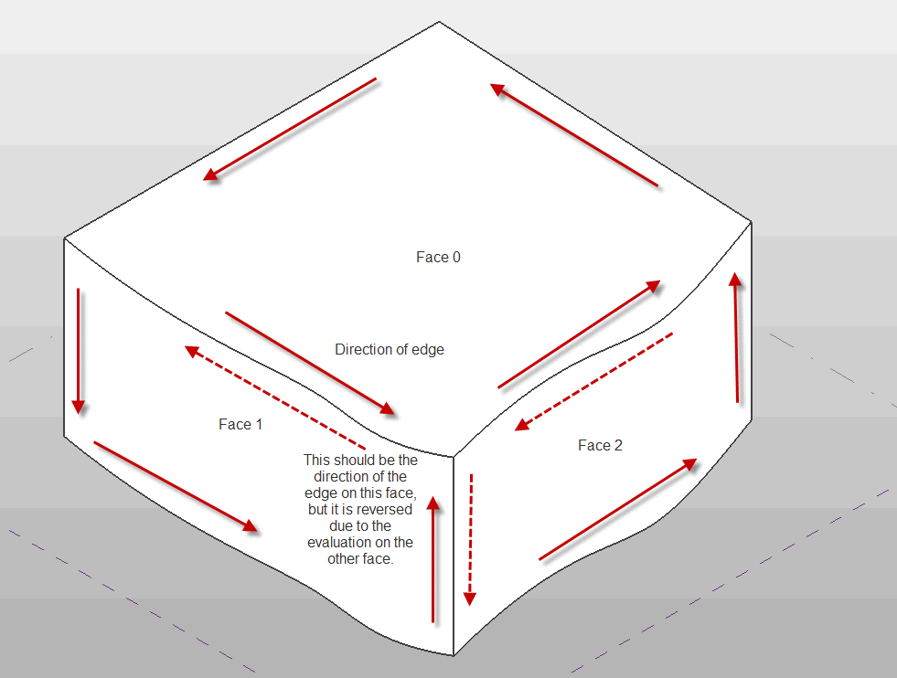
Edge parameterization
The API sample “PanelEdgeLengthAngle” shows how to recognize edges that are reversed for a given face. It uses the tangent vector at the edge endpoints to calculate the angle between adjacent edges, and detect whether or not to flip the tangent vector at each intersection to calculate the proper angle.
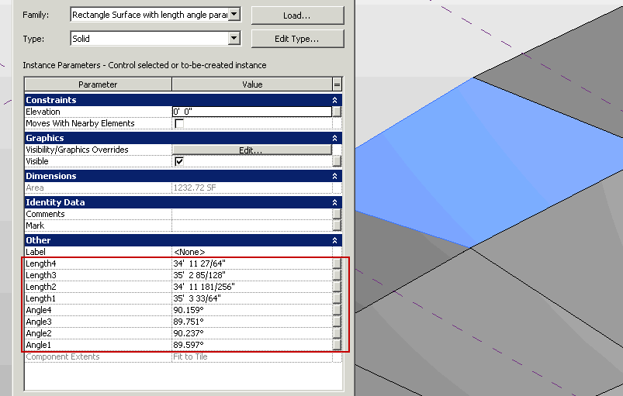
PanelEdgeLengthAngle results

Face types

Revit uses a variety of curve types to represent face geometry in a document. These include:
Face type | Revit API class | Definition | Notes
Plane | PlanarFace | A plane defined by the origin and unit vectors in U and V.
Cylinder | CylindricalFace | A face defined by extruding a circle along an axis. | .Radius provides the “radius vectors” – the unit vectors of the circle multiplied by the radius value.
Cone | ConicalFace | A face defined by rotation of a line about an axis. | .Radius provides the “radius vectors” – the unit vectors of the circle multiplied by the radius value.
Revolved face | RevolvedFace | A face defined by rotation of an arbitrary curve about an axis. | .Radius provides the unit vectors of the plane of rotation, there is no “radius” involved.
Ruled surface | RuledFace | A face defined by sweeping a line between two profile curves, or one profile curve and one point. | Both curve(s) and point(s) can be obtained as properties.
Hermite face | HermiteFace | A face defined by Hermite interpolation between points.

Mathematical representations of all of the Revit face types can be found in Appendix B.

Face analysis and processing
There are several Face members which are tools suitable for use in geometric analysis.

Intersect()
The Intersect method computes the intersection between the face and a curve. It can be used in to identify:
- The intersection point(s) between the two objects
- The edge nearest the intersection point, if there is an edge close to this location
- Curves totally coincident with a face
- Curves and faces which do not intersect

Project()
The Project method projects a point on the input face, and returns information on the projection point, the distance to the face, and the nearest edge to the projection point.

Triangulate()
The Triangulate method obtains a triangular mesh approximating the face. Similar to Curve.Tessellate(), this mesh’s points are accurate within the input tolerance used by Revit (slightly larger than 1/16”).

Coordinate Transformations
Revit and the Revit API use coordinate transformations in a variety of ways. In most cases, transformations are represented in the API as Transform objects. A transform object represents a homogenous transformation combining elements of rotation, translation, and less commonly, scaling and reflection:
$$\left[M\right]=\left[\begin{matrix}\left(\begin{matrix}r_{xx} & r_{yx} & r_{zx} \\ r_{xy} & r_{yy} & r_{zy} \\ r_{xz} & r_{yz} & r_{zz}\end{matrix}\right) & \left(\begin{matrix}T_{x} \\ T_{y} \\ T_{z}\end{matrix}\right) \\ \left(\begin{matrix}0 & 0 & 0\end{matrix}\right) & 1\end{matrix}\right]$$
In this matrix, the 3 x 3 matrix represents the rotation applied via the transform, while the 1 x 3 matrix represents the translation. Scaling and mirror properties, if applied, show up as multipliers on the matrix members. Mathematically, a transformation of a point looks like this:
$$P_{trans}=M ×P_{0}= \left[\begin{matrix}\left(\begin{matrix}r_{xx} & r_{yx} & r_{zx} \\ r_{xy} & r_{yy} & r_{zy} \\ r_{xz} & r_{yz} & r_{zz}\end{matrix}\right) & \left(\begin{matrix}T_{x} \\ T_{y} \\ T_{z}\end{matrix}\right) \\ \left(\begin{matrix}0 & 0 & 0\end{matrix}\right) & 1\end{matrix}\right] ×\left[\begin{matrix}\begin{matrix}P_{x} \\ P_{y}\end{matrix} \\ \begin{matrix}P_{z} \\ 1\end{matrix}\end{matrix}\right]$$
In the Transform class you have direct access to the members of the transformation matrix:
- The properties BasisX, BasisY, and BasisZ are the unit vectors of the rotated coordinate system.
- The Origin property is the translation vector.
Use the Transform.OfPoint() and Transform.OfVector() methods to apply the transformation to a given input point or vector. You can also use the Transformed indexed properties (on Curve, Profile, and Mesh) to transform geometry you extracted from Revit into an alternate coordinate system.
You obtain a transform from a variety of operations:
- From the GeometryInstance class (the transformation applied to the instance)
- From a Reference containing an GeometryInstance
- From a Panel (curtain panel) element
- From a 3D bounding box
- From static properties on Transform (.Identity, .Reflection, .Rotation, .Translation)
- By multiplying two Transforms together (Transform.Multiply())
- By scaling a transform (and possibly its origin) (Transform.ScaleBasis() and Transform.ScaleBasisAndOrigin())
- By constructing one from scratch (Transform constructor)
Typically Transforms are right-handed coordinate systems, but mirror operations will produce left-handed coordinate systems. Note that Revit sometimes produces left-handed coordinate systems via flip operations on certain elements.

Transformation of Instances
The Instance class stores geometry data in the SymbolGeometry property using a local coordinate system. It also provides a Transform instance to convert the local coordinate system to a world coordinate space. To get the same geometry data as the Revit application from the Instance class, use the transform property to convert each geometry object retrieved from the SymbolGeometry property.
In this example, we use the transform of the Instance stored in a window FamilyInstance to find south facing windows. The Y direction of the transform is the facing direction; however, the flipped status of the window affects the result. If the window is flipped in X and not in Y (“FlippedHand”), or flipped in Y but not in X (“FlippedFacing”), the result must be reversed.
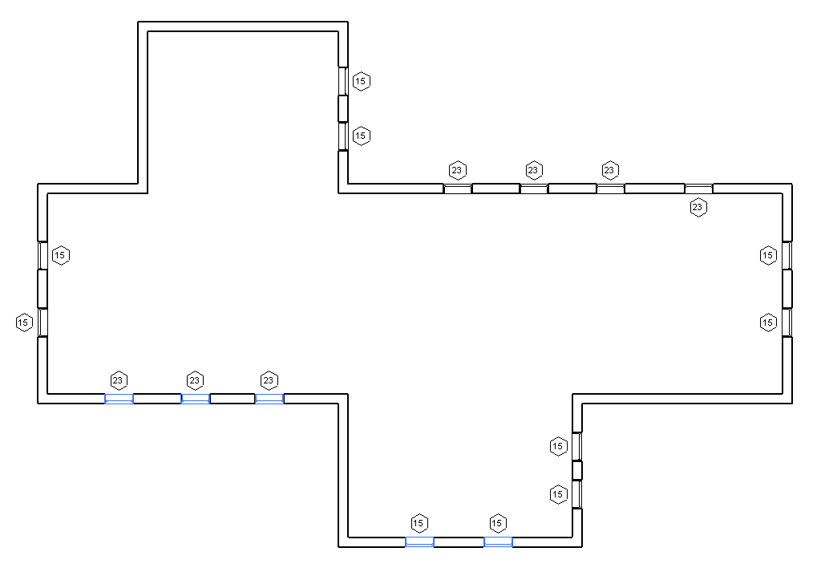
Example – find south facing windows
Because the need to perform this operation on instances is so common, the Revit API exposes this calculation directly as the FacingOrientation property.

Nested instances
Note that instances may be nested inside other instances. Each instance has a Transform which represents the transformation from the coordinates of the symbol geometry to the coordinates of the instance. In order to get the coordinates of the geometry of one of these nested instances in the coordinates of the document, you will need to concatenate the transforms together using Transform.Multiply().

Project location coordinates
Revit projects have another default coordinate system to take into account: the project location. The Document.ActiveProjectLocation provides access to the active ProjectPosition object, which contains:
- EastWest – east/west offset (X offset)
- NorthSouth – the north/south offset (Y offset)
- Elevation – the difference in elevation (Z offset)
- Angle – the angle from true north
You can use these properties to construct a transform between the default Revit coordinates and the actual coordinates in the project:
//Obtain a rotation transform for the angle about true north
Transform rotationTransform = Transform.get_Rotation(
XYZ.Zero, XYZ.BasisZ, pna );

//Obtain a translation vector for the offsets
XYZ translationVector = new XYZ(projectPosition.EastWest, projectPosition.NorthSouth, projectPosition.Elevation);

Transform translationTransform = Transform.get_Translation(translationVector);

//Combine the transforms into one.
Transform finalTransform = translationTransform.Multiply(rotationTransform);

In the “DirectionCalculation” sample there is an option to deal with a project where true north is not aligned with the Revit coordinate system. The facing vectors are rotated by the angle from true north before the calculation is run.
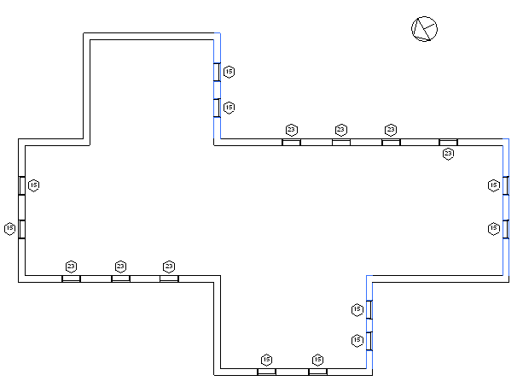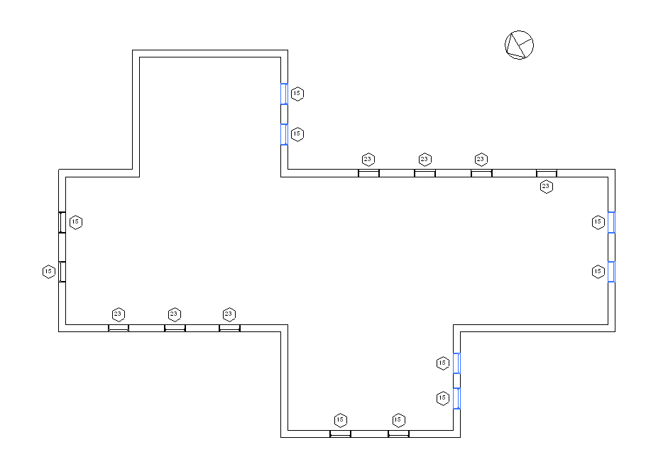
Example – find south facing walls and windows using project location

FindReferencesByDirection
This new method introduced in Revit 2010 allows you to use Revit’s picking tools to find elements and geometry. With this method, a ray is projected from a point in a specified direction. The geometry that is hit by the ray is returned by the method.
Here is the interface for the method:
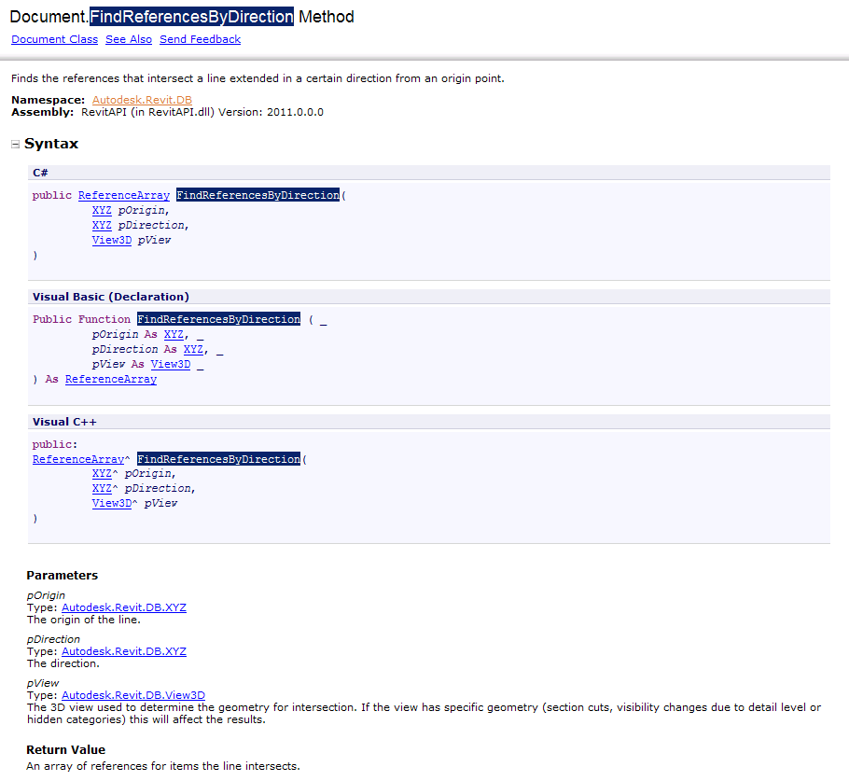
Notes:
- The method intersects 3D geometry only and requires a 3D view as input. It is possible to use a 3D view which has been cut by a section box, or which has view-specific geometry and graphics options set, to find intersections which would not be found in the uncut and uncropped 3D model.
- This method finds both elements and geometric references which intersect the ray. Some element references returned will not have a corresponding geometric object which is also intersected (for example, rays passing through openings in walls will intersect the wall and the opening element). If you are interested only in true physical intersections you should discard all references whose GeometryObject is of type Element, leaving behind only intersections with faces.
- References will be found and returned only for elements that are in front of the ray.
- This method will not return intersections in linked files.
- This method will not return intersections with elements which are not in the active design option.

Find elements near elements
One major use for this tool is to find elements in close proximity to other elements. This allows you to use the tool as your application’s “eyes” and determine relationships between elements which don’t have a built-in relationship already.
In the “FindReferencesByDirection/FindColumns” SDK sample, the ray-tracing capability is used to find columns embedded in walls. As columns and walls don’t maintain a relationship directly, this utility allows us to find potential candidates by tracing rays just outside the extents of the wall, and looking for intersections with columns. The implementation covers flat walls (where only two rays, one for either side, are necessary), as well as curved walls, where the rays are traced tangent to the walls at incremental distances, and only matches in close proximity are accepted.
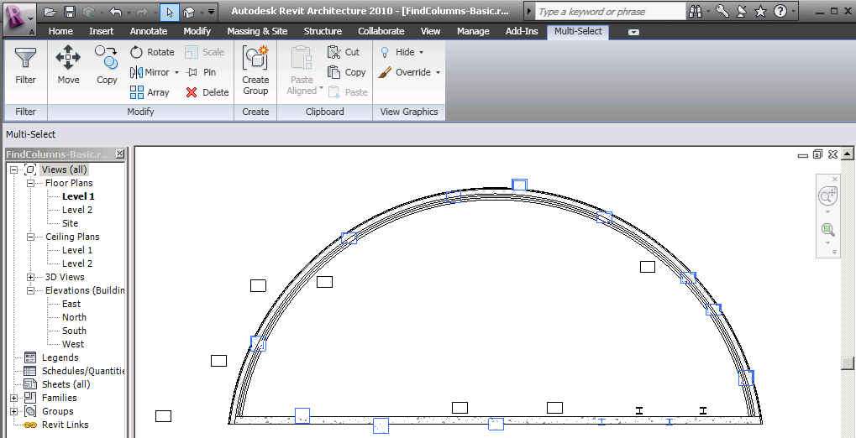
Example: find columns embedded in walls

Measure distances
The results of the FindReferencesByDirection are an array of Reference objects intersected by the ray. When the References are obtained from this method, the References’ ProximityParameter will be set. This is the distance between the origin of the ray and the intersection point. You can use this distance to exclude items too far from the origin for a particular geometric analysis. You can also use this distance to take on some interesting problems involving analyzing the in place geometry of the model.
The SDK sample “FindReferencesByDirection/MeasureSkylightHeight” measures the vertical distance from a skylight to a preselected floor. Yes, this could be obtained through geometric tools as well (Face.Project()), but with the ray-tracing tool, we don’t have to examine the floor to find its top face(s), nor deal with sloped slabs or other problematic details. We just look at all the intersections with the floor, pick the closest one, and thus have found our distance and intersection point.

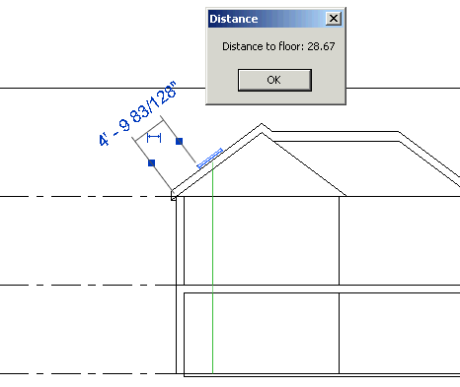
Example: measure with FindReferencesByDirection()

Ray bouncing/analysis
The references returned by FindReferencesByDirection also include the intersection point on the geometry. Knowing the intersection point on the face, the face’s material, and the ray direction allows you analyze reflection and refraction within the building. The SDK sample “FindReferencesByDirection/RaytraceBounce” demonstrates the use of the intersection point to reflect rays intersected by model elements; model curves are added to represent the path of each ray.
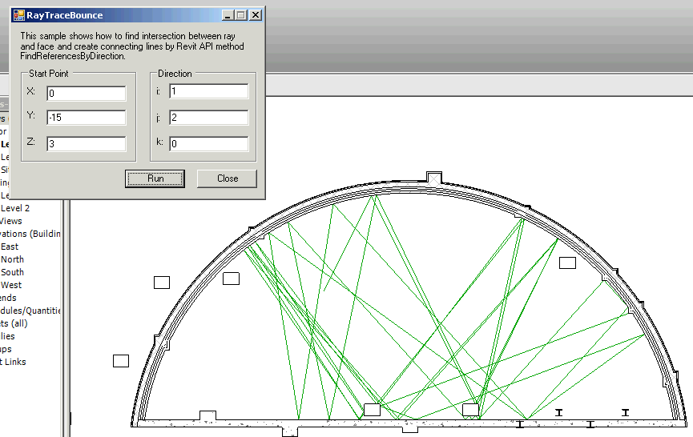
Example: Rays bouncing off intersected faces

Find intersections/collisions
The SDK sample “AvoidObstruction” demonstrates the use of the FindReferencesByDirection() utility to detect intersections (in this case, beams or pipes) which intersect/interference with the centerline of a given beam or pipe. Automatic logic is applied to reroute the pipe around the obstruction.
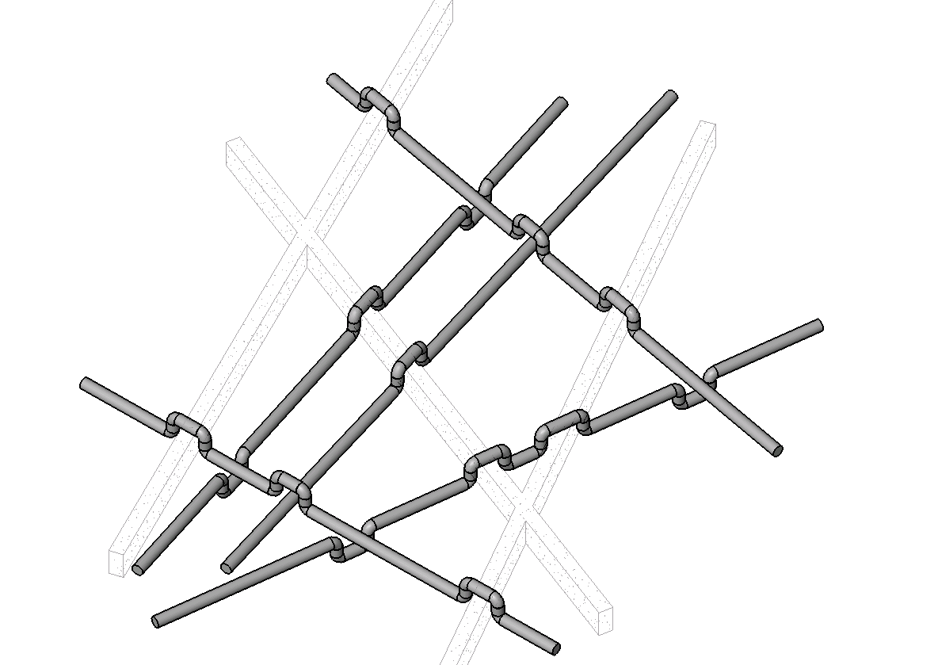
Example: Reroute elements around interferences

Material quantity extraction
One common analytical requirement is to extract material quantities of elements in the document. There are methods to directly obtain the material volumes and areas computed by Revit for material takeoff schedules:
- Element.Materials – obtains a list of materials within an element
- Element.GetMaterialVolume() – obtains the volume of a particular material in an element
- Element.GetMaterialArea() – obtains the area of a particular material in an element
The methods apply to categories of elements where Category.HasMaterialQuantities property is true. In practice, this is limited to elements that use compound structure, like walls, roofs, floors, ceilings, a few other basic 3D elements like stairs, plus 3D families where materials can be assigned to geometry of the family, like windows, doors, columns, MEP equipment and fixtures, and generic model families. Note that within these categories there are further restrictions about how material quantities can be extracted. For example, curtain walls and curtain roofs will not report any material quantities themselves; the materials used by these constructs can be extracted from the individual panel elements that make up the curtain system.
Note that the volumes and areas computed by Revit may be approximate in some cases. For example, for individual layers within a wall, minor discrepancies might appear between the volumes visible in the model and those shown in the material takeoff schedule. These discrepancies tend to occur when you use the wall sweep tool to add a sweep or a reveal to a wall, or under certain join conditions.
These methods allow you to extract the material quantities for an as-modeled Revit project. But what if you need to extract gross material quantities of layered elements like walls, floors, and roofs, where the quantities are extracted before they are cut or modified by other elements?

Temporary element suppression
What is needed to extract gross material quantities is a way to remove elements that cut other elements. In fact, this capability exists in the Revit API, but it may not be obvious: it is the temporary use of the Delete() method. When you delete elements that cut other elements, the cut element’s geometry is restored to its original state.
Note that Hide() is not sufficient for this; Hide() will remove display of the cutting elements but the holes left behind are still present.
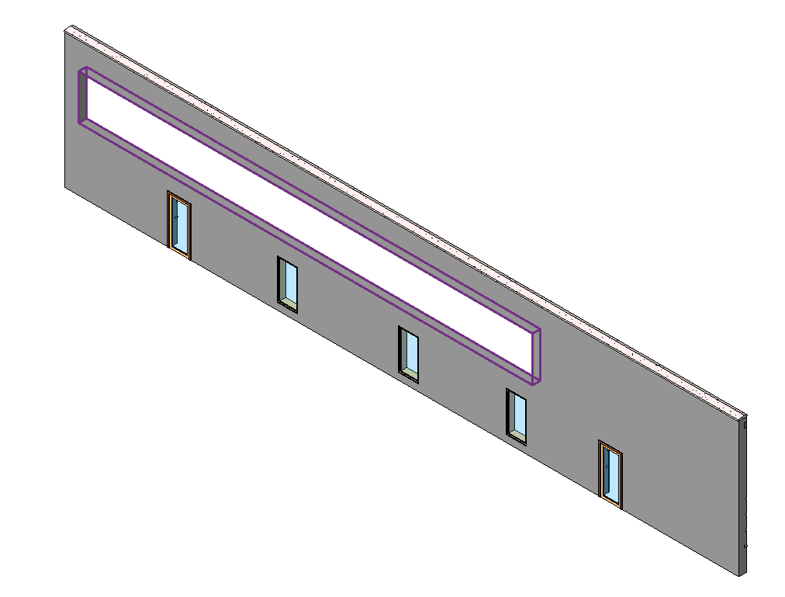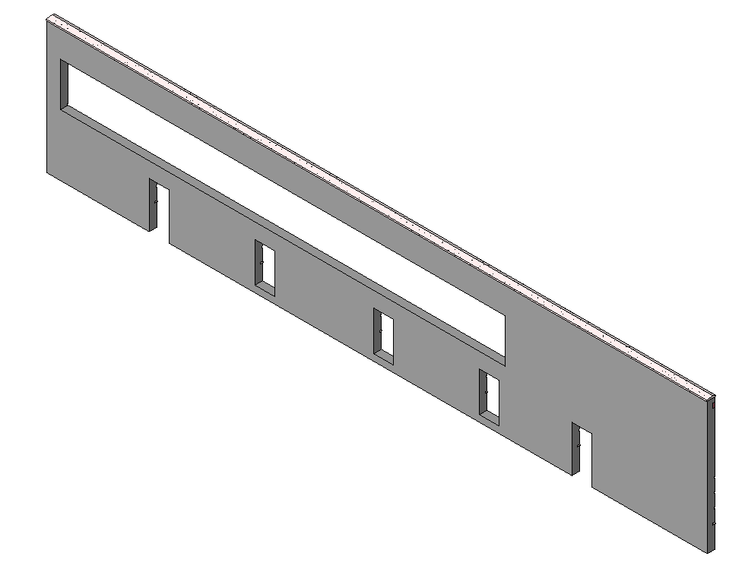
Wall before and after hide of cutting elements
Instead of hide, you will want to make a temporary deletion: this can be done by creating a Transaction or SubTransaction, executing the deletion, extracting the needed quantities, and then rolling back the Transaction or SubTransaction.
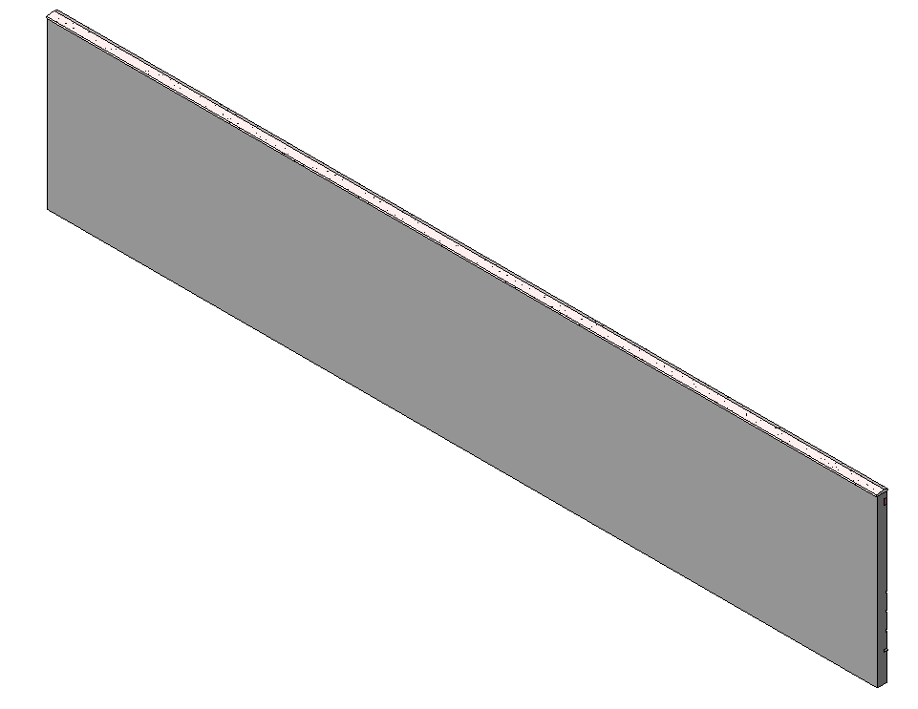
Wall after elements are deleted
The SDK sample “MaterialQuantities” combines both the material quantity extraction tools and temporary suppression of cutting elements (opening, windows, and doors) to extract both gross and net material quantities.
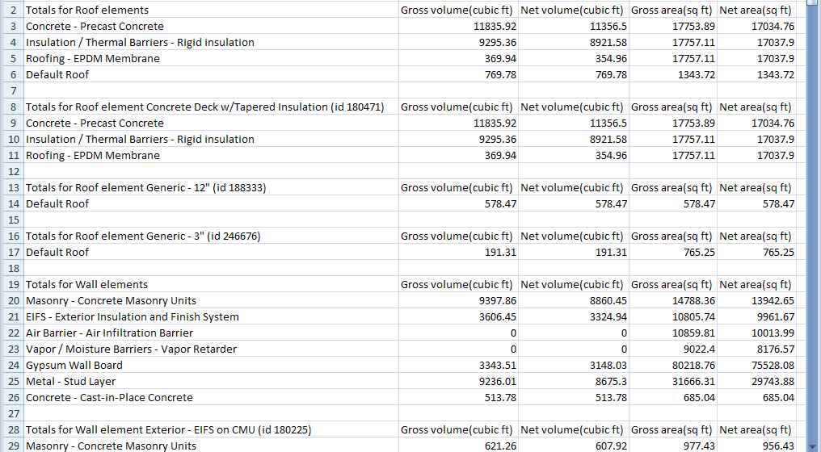
Example: extraction of gross & net material quantities

BoundingBox filters (new in 2011)

The new BoundingBox filters:
- BoundingBoxIsInsideFilter
- BoundingBoxIntersectsFilter
- BoundingBoxContainsPointFilter
help you find elements whose bounding boxes meet a certain criteria. You can check if each element’s bounding box is inside a given volume, intersects a given volume, or contains a given point. You can also reverse this check to find elements which do not intersect a volume or contain a given point.
BoundingBox filters use Outline as their inputs. Outline is a class representing a right rectangular prism whose axes are aligned to the Revit world coordinate system.
These filters work best for shapes whose actual geometry matches closely the geometry of its bounding box. Examples might include linear walls whose curve aligns with the X or Y direction, rectangular rooms formed by such walls, floors or roofs aligned to such walls, or reasonably rectangular families. Otherwise, there is the potential for false positives as the bounding box of the element may be much bigger than the actual geometry. (In these cases, you can use the actual element’s geometry to determine if the element really meets the criteria).
In this example, intersections between air terminals and ceilings are calculated. If the terminal intersects none of the ceiling bounding boxes, the terminal is misplaced and should be corrected:
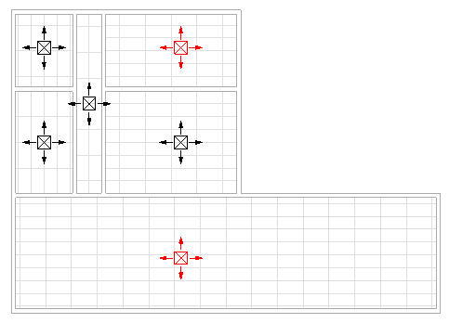
Example: find terminals which are not correctly placed in ceilings

Appendix A: Curve types
This section describes the curve types encountered in Revit geometry, their properties, and their mathematical representations.

Bound lines
Bound lines are defined by their endpoints. In the Revit API, obtain the endpoints of the line from the Curve-level get_EndPoint() method.
The equation for a point on a bound line in terms of the normalized parameter “u” and the line endpoints is
$$P\left(u\right)=P_{1}+u{(P}_{2}-P_{1})$$

Unbound lines
Unbound lines are handled specially in the Revit API. Most curve properties cannot be used, however, Evaluate() and ComputeDerivatives() can be used to obtain locations along the curve when a raw parameter is provided.
The equation for a point for an unbound line in terms of the raw parameter “u” and the line origin and normalized direction vector is
$$P\left(u\right)=P_{0}+uV$$

Arcs and Circles
Arcs and Circles are represented in the Revit API by the Arc class. They are defined in terms of their radius, center and vector normal to the plane of the arc, which are accessible in the Revit API directly from the Arc class as properties.
Circles have the IsBound property set to true. This means they can only be evaluated by using a raw parameter (range from 0 to 2π), and the equation for a point on the circle in terms of the raw parameter is
$$P\left(u\right)=C+r(n_{x}\cos{u+n_{y}\sin{u)}}$$
where the assumption is made that the circle lies in the XY plane.
Arcs begin and end at a certain angle. These angles can be obtained by the raw parameter values at each end of the arc, and angular values between these values can be plugged into the same equation as above.

Ellipse and elliptical arcs
Ellipses and elliptical arcs segments are represented in the Revit API by the Ellipse class. Similar to arcs and circles, they are defined in a given plane in terms of their X and Y radii, center, and vector normal to the plane of the ellipse.
Full ellipses have the IsBound property set to true. Similar to circles, they can be evaluated via raw parameter between 0 and 2π:
$$P\left(u\right)=C+n_{x}r_{x}\cos{u+n_{y}r_{y}\sin{u}}$$

NurbSpline
NURBS (nonuniform rational B-splines) are used for spline segments sketched by the user as curves or portions of 3D object sketches. They are also used to represent some types of imported geometry data.
The data for the NurbSpline include:
- The control points array, of length n+1
- The weights array, also of length n+1
- The curve degree, whose value is equal to one less than the curve order (k)
- The knot vector, of length n + k +1
$P\left(u\right)=\frac{\sum_{i=0}^{n}{P_{i}w_{i}N_{i,k}(u)}}{\sum_{i=0}^{n}{w_{i}N_{i,k}(u)}}, 0≤u≤u_{max}$
NurbSplines as used in Revit’s sketching tools can be generated from the control points and degree alone using an algorithm. The calculations performed by Revit’s algorithm can be duplicated externally, see this sample below:
NurbSpline spline = curve.GeometryCurve as NurbSpline;

DoubleArray knots = spline.Knots;
// Convert to generic collection

List<double> knotList = new List<double>();

for (int i = 0; i < knots.Size; i++)
{
knotList.Add(knots.get_Item(i));
}

// Preparation - get distance between each control point

IList<XYZ> controlPoints = spline.CtrlPoints;
int numControlPoints = controlPoints.Count;
double[] chordLengths = new double[numControlPoints - 1];

for (int iControlPoint = 1; iControlPoint < numControlPoints; ++iControlPoint)
{
double chordLength = controlPoints[iControlPoint].DistanceTo(controlPoints[iControlPoint - 1]);
chordLengths[iControlPoint - 1] = chordLength;
}

int degree = spline.Degree;
int order = degree + 1;

int numKnots = numControlPoints + order;
double[] computedKnots = new double[numKnots];
int iKnot = 0;

// Start knot with multiplicity degree + 1.
double startKnot = 0.0;
double knot = startKnot;
for (iKnot = 0; iKnot < order; ++iKnot)
{
computedKnots[iKnot] = knot;
}

// Interior knots based on chord lengths

double prevKnot = knot;
for (/*blank*/; iKnot <= numControlPoints; ++iKnot) // Last loop computes end knot but does not set interior knot.
{
double knotIncrement = 0.0;
for (int jj = iKnot - order; jj < iKnot - 1; ++jj)
{
knotIncrement += chordLengths[jj];
}
knotIncrement /= degree;

knot = prevKnot + knotIncrement;
if (iKnot < numControlPoints)
computedKnots[iKnot] = knot;
else
break; // Leave "knot" set to the end knot; do not increment "ii".
prevKnot = knot;
}

// End knot with multiplicity degree + 1.
for (/*blank*/; iKnot < numKnots; ++iKnot)
{
computedKnots[iKnot] = knot;
}

HermiteSpline
Hermite splines are used for curves which are interpolated between a set of control points, like Curve by Points and flexible ducts and pipes in MEP. They are also used to represent some types of imported geometry data. In the Revit API, the HermiteSpline class offers access to the arrays of points, tangent vectors and parameters through the ControlPoints, Tangents, and Parameters properties.
The equation for the curve between two nodes in a Hermite spline is
$$P\left(u\right)=h_{00}\left(u\right)P_{k}+(u_{k+1}-u_{k})h_{10}\left(u\right)M_{k}+h_{01}\left(u\right)P_{k+1}+(u_{k+1}-u_{k})h_{11}\left(u\right)M_{k+1}$$
where P_{k} and P_{k+1} represent the points at each node, M_{k} and M_{k+1} the tangent vectors, and u_{k} and u_{k+1} the parameters at the nodes, and the basis functions are:
$$h_{00}\left(u\right)= 2u^{3}-3u^{2}+1$$
$$h_{10}\left(u\right)= u^{3}-2u^{2}+u$$
$$h_{01}\left(u\right)= -2u^{3}+3u^{2}$$
$$h_{11}\left(u\right)= u^{3}-u^{2}$$

Appendix B: Face types
This section describes the face types encountered in Revit geometry, their properties, and their mathematical representations.

PlanarFace
A plane defined by origin and unit vectors in U and V. Its parametric equation is
$$P\left(u,v\right)=P_{0}+{un}_{u}+vn_{v}$$

CylindricalFace
A face defined by extruding a circle along an axis. The Revit API provides the following properties:
- The origin of the face.
- The axis of extrusion.
- The “radius vectors” in X and Y. These vectors are the circle’s unit vectors multiplied by the radius of the circle. Note that the unit vectors may represent either a right handed or left handed control frame.
The parametric equation for this face is:
$$P\left(u,v\right)=P_{0}+r_{x}\cos\left(u\right)+r_{y}\sin\left(u\right)+vn_{axis}$$

ConicalFace
A face defined by rotation of a line about an axis. The Revit API provides the following properties:
- The origin of the face.
- The axis of the cone.
- The “radius vectors” in X and Y. These vectors are the unit vectors multiplied by the radius of the circle formed by the revolution. Note that the unit vectors may represent either a right handed or left handed control frame.
- The half angle of the face.
The parametric equation for this face is:
$$P\left(u,v\right)=P_{0}+v\left[sin⁡(α)\left(r_{x}\cos\left(u\right)+r_{y}\sin\left(u\right)\right)+cos⁡(α)n_{axis}\right]$$

RevolvedFace
A face defined by rotation of an arbitrary curve about an axis. The Revit API provides the following properties:
- The origin of the face
- The axis of the face
- The profile curve
- The unit vectors for the rotated curve (incorrectly called “Radius”)
The parametric equation for this face is:
$$P\left(u,v\right)=P_{0}+C(v)\left[r_{x}\cos\left(u\right)+r_{y}\sin\left(u\right)+n_{axis}\right]$$

RuledFace
A ruled surface is created by sweeping a line between two profile curves or between a curve and a point. The Revit API provides the curve(s) and point(s) as properties.
The parametric equation for this surface is:
$$P\left(u,v\right)=C_{1}\left(u\right)+v\left(C_{2}\left(u\right)-C_{1}\left(u\right)\right)$$
if both curves are valid. If one of the curves is replaced with a point, the equations simplify to one of:
$$P\left(u,v\right)=P_{1}+v\left(C_{2}\left(u\right)-P_{1}\right)$$
$$P\left(u,v\right)=C_{1}\left(u\right)+v\left(P_{2}-C_{1}\left(u\right)\right)$$
A ruled face with no curves and two points is degenerate and will not be returned.

HermiteFace
A cubic Hermite spline face. The Revit API provides:
- Arrays of the u and v parameters for the spline interpolation points
- An array of the 3D points at each node (the array is organized in increasing u, then increasing v)
- An array of the tangent vectors at each node
- An array of the twist vectors at each node
The parametric representation of this surface, between nodes (u1, v1) and (u2, v2) is:
$$P\left(u,v\right)=U^{T}\left[M_{H}\right]\left[B\right]{\left[M_{H}\right]}^{T}V$$
Where $U={\left[u^{3} u^{2} u 1\right]}^{T}$, $V={\left[v^{3} v^{2} v 1\right]}^{T}$, M_{H} is the Hermite matrix:
$$\left[M_{H}\right]=\left[\begin{matrix}\begin{matrix}2 & -2 \\ -3 & 3\end{matrix} & \begin{matrix}1 & 1 \\ -2 & -1\end{matrix} \\ \begin{matrix}0 & 0 \\ 1 & 0\end{matrix} & \begin{matrix}1 & 0 \\ 0 & 0\end{matrix}\end{matrix}\right]$$
And B is coefficient matrix obtained from the face properties at the interpolation points:
$$\left[B\right]=\left[\begin{matrix}\begin{matrix}P_{u_{1}v_{1}} & P_{u_{1}v_{2}} \\ P_{u_{2}v_{1}} & P_{u_{2}v_{2}}\end{matrix} & \begin{matrix}{P'}_{{v(u}_{1}v_{1})} & {P'}_{{v(u}_{1}v_{2})} \\ {P^{'}}_{v(u_{2}v_{1})} & {P'}_{{v(u}_{2}v_{2})}\end{matrix} \\ \begin{matrix}{P'}_{{u(u}_{1}v_{1})} & {P'}_{{u(u}_{1}v_{2})} \\ {P^{'}}_{u(u_{2}v_{1})} & {P'}_{{u(u}_{2}v_{2})}\end{matrix} & \begin{matrix}{P'}_{{uv(u}_{1}v_{1})} & {P'}_{{uv(u}_{1}v_{2})} \\ {P^{'}}_{uv(u_{2}v_{1})} & {P'}_{{uv(u}_{2}v_{2})}\end{matrix}\end{matrix}\right]$$

