Diary of a Wimpy BIM Manager: Tales of In-House Revit® API Development for Architects
Iffat Mai – Perkins & Will
CP430-1
To meet the demands of her custom tool-thirsty, boundary-pushing Revit users, a wimpy (ex-CAD) BIM manager dives into the cryptic scrolls of the Revit API Bible, and emerges gloriously with a set of tools that are handy for her most demanding Revit users. She will share her story of relearning a new "foreign" language, VB.NET and C#, discovering the unfortunate limitations of the Revit API, cartooning her solution logic, and translating English into the secret language of Revit API. Learn how you can take advantage of the sample programs that came with the SDK kit, and develop your own tools to meet your firm's BIM project needs. If a wimpy BIM manager can do it, you can do it too!

About the Speaker:
With over 20 years of experience supporting digital design technology ranging from Arris, AutoCAD® to Revit®, Iffat has managed and trained hundreds of users in some of the most prestigious architectural firms in New York city. Her expertise is in developing custom tools and solutions to automate and streamline everyday process and improve project productivity and efficiency. Before re-joining Perkins and Will as their firmwide Practice Application Development Manager, Iffat held the position of Senior Research and Development Manager at SOM. Iffat holds a B.S. in Architecture from M.I.T.
iffat.mai@perkinswill.com

Why Customize Revit?
Autodesk Revit is a Building Information Modeling (BIM) tool. The purpose of using a BIM tools is to consolidate all project relevant data and store them or link them directly with all the objects inside the model. Despite the fact that Revit has built-in discipline specific tools (Architecture, Structural & MEP tools), one is bound to find it tedious and cumbersome to coordinate and manage the ever growing amount of information manually. Sooner or later, one will pause and wonder, is there a better way to do this? Luckily, the answer to that is yes, there is Revit API!
Autodesk Revit API (Application Programming Interface) is the interface provided to develop tools and applications for Revit products. One can use Revit API to develop tools that can streamline one's workflow, automate repetitive tasks, import and export data and even synchronize data with external databases. According to the API Developer's guide, Revit API can be used for the following tasks:
- Gain access to model graphical data.
- Gain access to model parameter data.
- Create, edit, and delete model elements like floors, walls, columns, and more.
- Create add-ins to automate repetitive tasks.
- Integrate applications into Revit-based vertical products. Examples include linking an external relational database to Revit or sending model data to an analysis application.
- Perform analysis of all sorts using BIM.
- Automatically create project documentation.

Overview of Revit API
Autodesk Revit platform (Architecture, Structural, MEP) offers Revit API for developers to create applications that can interact with the Revit product via the back door, i.e. programmatically. Compared to AutoCAD products, Autodesk Revit products are relatively young. The first few versions of Revit did not have any kind of API at all. It was not until Revit 8 (in 2005) that Autodesk introduced the first sets of Revit API. Then later in 2007, Autodesk finally released the Software Development Kit (SDK) for Revit API. Ever since then, the scope of Revit API has doubled in size for every release of the product. Autodesk Revit API has come a long way, and has matured to the point that 90% of the elements are now exposed, and it is starting to have a decent amount of trainings, documentations and resources available for developer to learn and create Revit API apps.

Revit API DLL and Namespaces
The Autodesk Revit API is installed automatically with the Autodesk Revit application under the program folder. Based on Microsoft .Net 3.5 framework, the Revit API consists of two DLL files, RevitAPI.dll and Revit APIUI.dll. For Autodesk Revit 2011, Autodesk made some major changes in the API's namespace structure. The Autodesk Revit API platform now contains three main namespace divisions:
- Autodesk.Revit.ApplicationServices - contains classes accessing settings and options for the main Revit application
- Autodesk.Revit.DB - contains classes accessing data from the Revit file
- Autodesk.Revit.UI - contains classes accessing or customizing the Revit user interface

Under the Autodesk.Revit.DB, there are subdivisions for each of the disciplines for Architecture, Structural, Mechanical, Electrical and Plumbing as well.

Dot Net vs. VSTA
Presently, there are two main methods to customize Autodesk Revit Product. One method is using .Net, and the other is VSTA. Using .Net requires one to use an external editor, such as Microsoft Visual Studio or the free version, Microsoft Visual Studio Express. (http://www.microsoft.com/express/Downloads)
The second method is using VSTA (Visual Studio Tools for Application), which is the latest incarnation of VBA. Even though VSTA offers a built-in editor inside Revit, making the macro development process one step easier, it is limited by the fact that the macros must reside inside the document and making their distribution and deployment somewhat limiting. For serious developer, .Net is the way to go. If one have to learn a new language and work in an entirely new environment (IDE), one might as well go full force, and work in .Net.

Parlez Vous C Sharp?
VB.net and C# (pronounced as C sharp) are the two languages most commonly used for Revit API development. These two languages are very similar. Knowing the similarity and differences of the two languages will help you understand the sample codes in the SDK better. Ideally, one should be able to program in both languages. But if you have to choose just one language to start with, then learning C# would take priority, as most of the SDK samples are written in C#. Performance wise, codes written in either language compiles and runs at the same speed, so there is no performance difference between the two. Compiled DLL, doesn't matter what language it was written in, can also be referenced directly into your application, making it easy enough to develop in either language. Personally, I find VB.NET the easier language to read and write. As I already have many years of VBA programming background. VB. NET is also easier to debug since it is not case sensitive like C# is. Taking a C# sample program and rewriting it in VB.NET actually helps me understand the codes better. If I need help translating, I often utilize many of the online translation sites that convert codes from C# to VB. NET or vice versa. (http://www.developerfusion.com/tools/convert/csharp-to-vb/). Thus you will find that most of the codes in this handout will be in VB.NET.

Autodesk Revit API SDK
Before you get started with your tool development, install or download the Revit API SDK either from your installation disk or from the Autodesk Developer Center website. (http://usa.autodesk.com/adsk/servlet/index?siteID=123112&id=2484975).
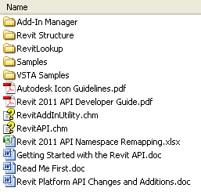
The SDK is basically a folder that contains sample codes, documentation and essential tools that are critical to your application development. Here are a few of the most useful items in the SDK folder:
- Add In Manager
- Revit Lookup
- Samples
- RevitAPI.chm
- Revit 2011 API Developer Guide.pdf

Add In Manager
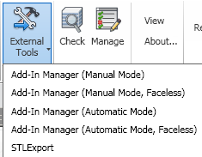
The Add In Manager is a tool that simplifies the Add in tools and applications' loading process without having to close your Revit session to update its Revit.ini (pre Revit 2011 method). Even though in Revit 2011, you can register applications by adding the .addin manifest files into the addin folder, the Add In manager is still a useful tool for developer that want to load and test the tools quickly. For more details about the Add In Manager, visit Matt Mason's blog about the Add In Manger. (http://cadappdev.blogspot.com/2010/04/revit-api-2011-revit-addin-manager.html)

Revit Lookup
Revit Lookup is a testing and snooping tool that helps you to dig into the Revit database and find out all the properties and parameters of the elements. You can explore the Revit database by selecting a particular object, or by browsing through the entire Revit DB. To load Revit Lookup application, you can either use the Add In Manager to load the DLL file (\RevitLookup\CS\bin\Debug\ RevitLookup.dll) into Revit, or register the addin application by copying the RevitLookup.addin file into one of the designated Revit addin locations (see appendix A).

Samples
The Samples folder contains sample applications that you can load up using the Add In manager. Open the codes and see how it is written. Run the codes in debug mode with break points, and you can trace the program and explore the objects that are being handled by the program. To build the sample codes, make sure your Revit is installed in the default locations, otherwise, you will need to update your DLL path using the RevitAPIDllsPathUpdater.exe file. Open the SamplesReadMe.htm and you will find the samples organized and indexed by Category, by Skill Level, by Version and by Name. By Category listing is useful, if you are looking for an application that is dealing with a particular category. By Skill Level listing is helpful especially if you are a beginner, you can explore the applications from the beginner level and move your way up to the advanced, and not get too frustrated if you are completely lost in an advanced level codes, knowing that it is not you, but rather it’s the code that is tough to understand. By Version is handy for people that have been working with the SDK previously, and makes looking for the new stuff a little easier.Within each sample folder, there is usually a readme file (ReadMe_ApplicationName.rtf) that gives you an overview of what the app does. If a sample code specifies a particular Revit platform (ex. Structure or MEP), then the application will only work with that discipline of Revit product (i.e. Revit Structure or Revit MEP).
As Autodesk Revit API 2011 had so many changes in the Namespace structure, you might find a few of the older codes in the samples folder not working quite as well as it should be. The Revit API team had done a good job updating the old codes to the point that most of them will compile cleanly. However, you might stumble across a few that still have a glitch or two. Think of it as an opportunity for a good debugging exercise.

Reference Guides
RevitAPI.chm and Revit 2011 API Developer Guide.pdf are the two documents that I find myself constantly referring to when I am developing an app. I consider them the Bible for Revit API developer. Read the Developer Guide to understand the general concept of Revit API and all the different object’s behavior, then search through the RevitAPI.chm to see all the methods and properties that is related to a particular object.

Tool Development Process
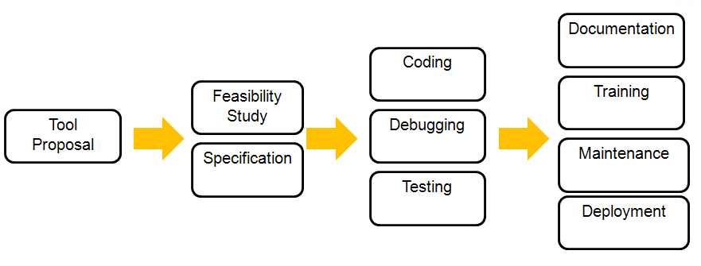

Tool Proposal
The first step in developing tools is formulating the ideas for the tools. Ideas could come from many sources: end users, Design Application Managers or Technical Directors. End users are the one that spend the most time working with the Revit application, and whenever they see a repetitive tasks pattern that is time consuming, or a challenging task that has logical sequences but complicated steps, they automatically come up with ideas for apps that are task specific. Design Application Managers are the ones that support many end users. They will often encounter the same issues or problems that affect different users. They can suggest tools that could help with common issues for most users. Technical Directors oversees the projects at a higher level, and are concerned with quality control, standard enforcement and code compliance issues. They can come up with great ideas for tools that can streamline project development process and project standard enforcement. The trick is to know how to harness their ideas and turn them into useful tool proposals. Always establish an open channel for people to send ideas to you, and frequently showcase new tools that you have developed to entice them with your expertise and the possibilities that you can make their life easier with your Revit API tools.

Feasibility Study
The three main questions for a tool feasibility study are:
- Can this be done using Revit API?
- How long will it take to develop the tool?
- What is my ROI (Return On Investment)?

Can this be done using Revit API?
Even though Revit API has evolved tremendously, it will always be one step behind the latest release. New elements or new features that are available in the latest release through the UI, may or may not be accessible via the API. Even for objects that are accessible through the API, the object parameters that you need may not be exposed or they could be read-only and are not editable via the API. It is important to always check and make sure that what your tools need to do is actually possible through Revit API.
- Can the steps be done manually via the User Interface?
- Use Revit LookUp tool to trace the object
- Check with RevitAPI.CHM reference to see what properties and methods are available
- Review the Revit API Developer’s Guide.
- Look at the SDK sample folder for similar application
- Search Revit API blogs and Forum on the internet
- Verify with ADN support that it can be done

How long will it take to develop the tool?
The second most frequently asked question is how long will it take to develop the tool? The answer to the question is closely tied to your programming skill, your familiarity with Revit API, the complexity of the tool and the availability of sample application that relates to the object of interest. After taking all these things into consideration, the reality is you will probably want to multiply that estimate by three to buffer in any debugging and redesign time required.

What is my ROI?
After confirming that the tool is possible to develop through the API, and can be developed within the time needed, the last question is what kind of return on investment will this tool have? The return on investment depends on two things:
- How often will they use the tool on this project?
  - One time only
  - Only during one phase
  - Used throughout the entire project
- Can this tool be used on other projects?
  - Not at all
  - If parameter and variable are customizable
  - Yes, all the time!
Ideally, you want to develop an application with high ROI which has frequent usage by all the team members throughout the entire span of the project lifetime, and it can be generalized to apply to all other projects as well.

Specification
When writing the specification of a proposed tool, the specification should have a clear description of the input data, as well as the output result of the application. The specification should also spell out the scope of the application, and a detailed description of all the functions the application is designed to do. The hardest part of this phase is to work out all the program logic. Sketching out a flow chart will help you visualize the flow of the program.

Coding, debugging & Testing
The coding, debugging and testing stage will take up the bulk of your development time. Start your application by using one of the Revit API templates or use any of the existing SDK sample application that has similar functionality as your starting point. Break up your codes into small manageable module, and test each function as you go. Don’t get too ambitious by trying to code the entire program before testing the codes. Create a small Revit project file (.RVT) as your test file, keep it simple and insert only the elements that you need in the model. Do remember to place all the different conditions of the element that you are trying to test so you don’t miss a condition that could potentially cause your program to crash or fail. Setup your Microsoft Visual Studio Debug properties to start an external program (Revit.exe) every time you go into debug mode. You can even specify in the Start Options Command line arguments with the full path of the test filename, and Revit will automatically load up the test file when you enter debug mode. Once your application is fully compiled without any errors and is ready for phase two testing, get a copy of an actually project, and test your application against the project. This testing will often take much longer and may produce some unexpected results. Finally, solicit project users to test the application on copies of their active project(s), use their feedback to refine your application’s interface as well as the performance.
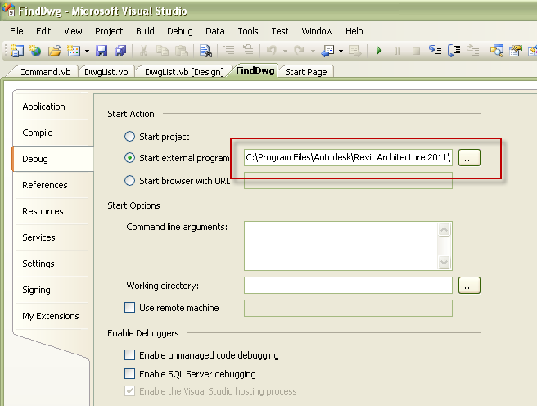

Documentation, Training and Maintenance
Documentation within the codes is important not only for the creator, but also for the ones who will be updating the codes for future maintenance. With just a few lines of comments, an application’s codes can be so much easier to read and comprehend. User guide documentation is also important, if people knew how to use your application, they will be more likely to try and use the tool. Add a Help button for your documentation, so your users can get to the documentation without having to hunt for it. Create individual training video snippet for each application, so users can learn by watching a short video of the tools they need to use. Maintenance for Revit API tools is typical needed on a version by version basis. With every new release of Autodesk Revit API, you will need to update and recompile the codes to follow the latest changes in the API.

Deployment
The easiest way to deploy the Revit API tools is to consolidate all the tools into a single external application with its own ribbon of buttons. Copy all your DLL into one single folder and have the ribbon buttons reference the DLL in that folder. It is best to have the DLL copied locally into each computer. Otherwise you will need to deal with security issues of executing a DLL from a network location. Subdivide your tools folder with version subfolders, since you will most likely need to support more than one version of Autodesk Revit product at the same time. Keep a separate Icons folder for all the bitmap images for your buttons. They have a tendency to multiply very quickly, since you need two sizes of the same image file for each button. The Addins folder contains the application’s addin manifest files, and they will need to be copied to the designated addins folder (see appendix A).
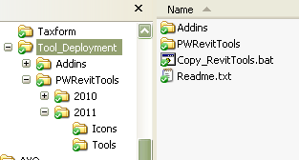
Here is a sample of the basic .addin file for one ExternalApplication:
<?xml version="1.0" encoding="utf-8" standalone="no"?>
<RevitAddIns>
<AddIn Type="Application">
<Name>PW_RevitTools</Name>
<Assembly>C:\Program Files\PWRevitTools\2011\Ribbon.dll</Assembly>
<AddInId>d01ec701-a491-4998-b80b-28bbe452d3e6</AddInId>
<FullClassName>PW.Ribbon</FullClassName>
</AddIn>
</RevitAddIns>

SDK Samples Category
Basics | The category Contains samples related to the ExternalCommand framework, transactions, and event registration.
Geometry | Contains samples related to read and analysis of element geometry including curves and reference planes.
Parameters | Contains samples related to creation, modification and read of element and shared parameters.
Elements | Contains samples related to Revit basic elements such as walls, roofs, floors, levels, grids.
Families | Contains samples related to family creation and family instances.
Materials | Contains samples related to materials and units.
Annotation | Contains samples related to annotations such as notes, detail curves, dimensions and tags.
Views | Contains samples related to view creation and view properties.
Rooms/Spaces | Contains samples related to rooms, spaces and areas.
Data Exchange | Contains samples related to import, export, or print of Revit documents.
MEP | Contains MEP-specific samples.
Structure | Contains structure-specific samples. Types of tools for Architects

Tools Demo
- Data manipulations Tools: Drawing List tools that can import and export Drawing List to Excel, as well as automatically create new sheets from Excel.
- Design Tools: Sample from SDK > Samples>Massing>MeasurePanelArea
- Batch Tools: Update door numbers to match with room number
- Utility Tools: Find AutoCAD drawing files linked and imported into the Revit Model

Walk through some codes
Using Find Dwg tools as an example, we examine the code in details to go through the process of a tool development.
As the user presented a problem that AutoCAD drawings are linked and imported into the drawings, and very often they are lost in the drawing. How can one find it? View it? And if possible delete it?
To investigate if it is possible to do this in Revit, first we use the snoop tool to see what a dwg is. Create a sample test file that contains an imported and linked dwg files. Then use the Revit Lookup Tool and select the tool to see what properties are exposed.
Once we know that we are able to find the dwg as Import Instances, and we can use the Show Element method to open the view that contains the drawing, and we are able to delete it by ElementID. We then proceed to sketch out the input and output screens.
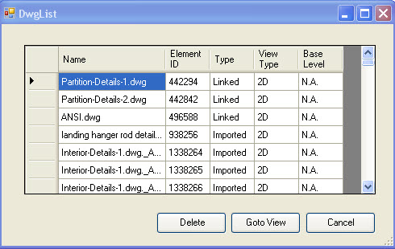

We will create the Command.vb as our entry point to the FindDwg application. Command.vb will call the DwgList.vb which is our input form with the listing of the AutoCAD drawings in a DataGrid View. The codes inside DwgList will gather all the import instances it finds inside Revit, and creates a new DwgObj out of each one. Then add the new DwgObj into the array of DwgObj that we created. We then bind that array of DwgObj with our DataGridView to display them on the screen.
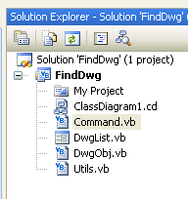

First, we must remember to add in the reference to the Revit API assemblies:
- C:\Program Files\Autodesk\Revit Architecture 2011\Program\RevitAPI.dll
- C:\Program Files\Autodesk\Revit Architecture 2011\Program\RevitAPIUI.dll
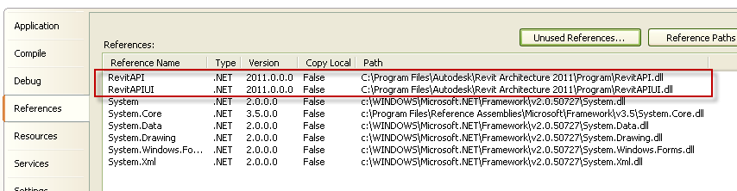
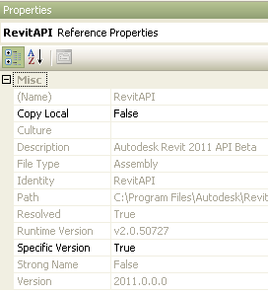

Set property of the dll to:
  - Copy Local = False
  - Specific Version = True

Command.vb
The Command file is the entrance point of the Find Dwg tool. It implements the IExternalCommand and passes the CommandData of the Revit Database as an argument into the DwgList form.
Imports Autodesk.Revit
Imports Autodesk.Revit.UI
Imports System.Windows.Forms

<Autodesk.Revit.Attributes.Transaction(Autodesk.Revit.Attributes.TransactionMode.Automatic)> _
<Autodesk.Revit.Attributes.Regeneration(Autodesk.Revit.Attributes.RegenerationOption.Automatic)> _
<Autodesk.Revit.Attributes.Journaling(Autodesk.Revit.Attributes.JournalingMode.NoCommandData)> _
Public Class Command
Implements IExternalCommand
Private m_revit As Autodesk.Revit.UI.UIApplication
Public Function Execute(ByVal commandData As Autodesk.Revit.UI.ExternalCommandData, ByRef message As String, ByVal elements As Autodesk.Revit.DB.ElementSet) _
As Autodesk.Revit.UI.Result Implements Autodesk.Revit.UI.IExternalCommand.Execute
m_revit = commandData.Application

Dim displayForm As New DwgList(commandData)

Using (displayForm)
If displayForm.ShowDialog() <> DialogResult.OK Then
Return Autodesk.Revit.UI.Result.Cancelled
End If
End Using
displayForm.Dispose()
Return Autodesk.Revit.UI.Result.Succeeded
End Function

Protected Overrides Sub Finalize()
MyBase.Finalize()
End Sub

End Class

Dwglist.vb
The Dwglist.vb form contains the code that finds the drawings (Import Instances), then it creates new custom drawing objects (DwgObj) out of them. Finally it adds them to our array of drawing objects, and display them on the screen for user input.
Imports Autodesk.Revit
Imports Autodesk.Revit.UI
Imports Autodesk.Revit.DB
Imports Autodesk
Imports System.Windows.Forms
Imports System.Collections
Imports System.Diagnostics
Imports System.ComponentModel.Component
<Autodesk.Revit.Attributes.Transaction(Autodesk.Revit.Attributes.TransactionMode.Automatic)> _
<Autodesk.Revit.Attributes.Regeneration(Autodesk.Revit.Attributes.RegenerationOption.Automatic)> _
<Autodesk.Revit.Attributes.Journaling(Autodesk.Revit.Attributes.JournalingMode.NoCommandData)> _
Public Class DwgList
'a reference to the external command data.
Private m_commandData As ExternalCommandData
''' <summary>
''' Constructor
''' </summary>
''' <param name="commandData">the external command data</param>
Public Sub New(ByVal commandData As ExternalCommandData)
MyBase.New()
InitializeComponent()
m_commandData = commandData
Initialize()
End Sub

Private Sub Initialize()
'add Titlesheets to combo box Titlesheet Combobox
Dim app As Autodesk.Revit.UI.UIApplication = m_commandData.Application
Dim doc As DB.Document = m_commandData.Application.ActiveUIDocument.Document
'find all instances of IMPORTINSTANCE (which will get all DWG linked and Imported)
'Dim filterType As Autodesk.Revit.Filter
Dim iter As IEnumerator
Dim sym As Autodesk.Revit.DB.ImportInstance
Dim sym_name As String
Dim ins_id As ElementId
Dim DwgObjList As New ArrayList()
Dim Linked As Boolean = False
Dim LinkedType As String
Dim viewname As String
Dim baselevel As String
Dim ins_size As Integer

Const csParamToFind As String = "Base Level"
Const csParam2D As String = "Draw Layer"
'Const csParamLink As String = "Shared Location"
Dim ImpSymName As DB.BuiltInParameter = BuiltInParameter.IMPORT_SYMBOL_NAME
Dim parByName As DB.Parameter
Dim Is2D As DB.Parameter
Dim LevelID As DB.ElementId

Dim ImportInstanceFilter As New ElementClassFilter(GetType(DB.ImportInstance))
iter = New FilteredElementCollector(doc).WherePasses(ImportInstanceFilter).GetElementIterator()

'Move to the first instance symbol
iter.Reset()
'Create a array of DwgObjList
Do While iter.MoveNext
If (Not (iter.Current) Is Nothing) Then
sym = iter.Current
sym_name = sym.Parameter(ImpSymName).AsString
ins_id = sym.Id
ins_size = sym.Parameters.Size

parByName = iter.Current.Parameter(csParamToFind)
Is2D = iter.Current.Parameter(csParam2D)
Linked = sym.IsLinked
LinkedType = "N.A."
viewname = "N.A."
baselevel = "N.A."

If Is2D Is Nothing Then
viewname = "3D"
Else
viewname = "2D"
End If

If Linked = False Then
LinkedType = "Imported"
Else
LinkedType = "Linked"
If Not (parByName Is Nothing) Then
LevelID = parByName.AsElementId
baselevel = doc.Element(LevelID).Name
End If

End If
DwgObjList.Add(New DwgObj(sym_name, ins_id, LinkedType, viewname, baselevel))
End If
Loop

'' Set Control on UI
'Cell(0)
Dim DwgName = New DataGridViewTextBoxColumn()
DwgName.HeaderText = "Name"
DwgName.Width = 120
'Cell(1)
Dim DwgID = New DataGridViewTextBoxColumn()
DwgID.HeaderText = "Element ID"
DwgID.Width = 55

Dim LinkStatus = New DataGridViewTextBoxColumn()
LinkStatus.HeaderText = "Type"
LinkStatus.Width = 55

Dim ViewType = New DataGridViewTextBoxColumn()
ViewType.HeaderText = "View Type"
ViewType.Width = 55

Dim Blevel = New DataGridViewTextBoxColumn()
Blevel.HeaderText = "Base Level"
Blevel.Width = 55

DataGridView1.Columns.AddRange(New DataGridViewColumn() {DwgName, DwgID, LinkStatus, ViewType, Blevel})
BindingSource1.DataSource = GetType(DwgObj)
DataGridView1.AutoGenerateColumns = False
DataGridView1.DataSource = BindingSource1
DwgName.DataPropertyName = "Name"
DwgID.DataPropertyName = "Id_Text"
LinkStatus.DataPropertyName = "Linked"
ViewType.DataPropertyName = "ViewType"
Blevel.DataPropertyName = "BaseLevel"

'BindingSource1.DataSource = m_objectReference.SysLevelsDatum
BindingSource1.DataSource = DwgObjList

End Sub

Private Sub Button1_Click(ByVal sender As System.Object, ByVal e As System.EventArgs) Handles Button1.Click
Dim doc As UIDocument = m_commandData.Application.ActiveUIDocument

Dim ins2 As DwgObj = TryCast(BindingSource1.Current, DwgObj)
If Not (ins2) Is Nothing Then
doc.ShowElements(ins2.Id)
Else
MsgBox("There are no Drawing files(dwg) in this project")
End If

End Sub

Private Sub Delete_Click(ByVal sender As System.Object, ByVal e As System.EventArgs) Handles Delete.Click
Dim doc As Document = m_commandData.Application.ActiveUIDocument.Document
Dim ins2 As DwgObj = TryCast(BindingSource1.Current, DwgObj)
Dim response As Integer

If Not (ins2) Is Nothing Then
response = MsgBox("Are you sure you want to delete this", MsgBoxStyle.Critical)
If response = 1 Then
doc.Delete(ins2.Id)
End If

Else
MsgBox("There are no Drawing files(dwg) selected to be deleted")
End If
End Sub
End Class

DwgObj.vb
The DwgObj.vb is the definition of our custom object created to hold the information that we need to display the drawings in our DataGridView.
Imports System
Imports System.Windows.Forms
Imports System.Drawing
Imports System.Collections
Imports Autodesk.Revit

Public Class DwgObj
Private m_Name As String
Private m_Id As ElementId
Private m_Link As String
Private m_view As String
Private m_baselevel As String

Public Sub New(ByVal strName As String, ByVal strId As ElementId, ByVal strLink As String, ByVal strView As String, ByVal strBLevel As String)
Me.m_Name = strName
Me.m_Id = strId
Me.m_Link = strLink
Me.m_view = strView
Me.m_baselevel = strBLevel
End Sub 'New

Public ReadOnly Property Name() As String
Get
Return m_Name
End Get
End Property

Public ReadOnly Property Id() As ElementId
Get
Return m_Id
End Get
End Property
Public ReadOnly Property Id_Text() As String
Get
Return m_Id.IntegerValue.ToString
End Get
End Property
Public ReadOnly Property Linked() As String
Get
Return m_Link
End Get
End Property
Public ReadOnly Property ViewType() As String
Get
Return m_view
End Get
End Property
Public ReadOnly Property BaseLevel() As String
Get
Return m_baselevel
End Get
End Property
'Public Overrides Function ToString() As String
' Return Me.m_Name + " - " + Me.m_Id.ToString
'End Function 'ToString
End Class

Resources

Blogs
- Bolt Out Of The Red – Guy Robinson - http://redbolts.com/blog/
- Revit Programming – Ed Pitt - http://revit-programmer.blogspot.com/
- The Building Coder – Jeremy Tammik - http://thebuildingcoder.typepad.com/blog/
- CAD Application Development – Matt Mason - http://cadappdev.blogspot.com/
- Rod Howarth – Rod Howarth - http://roddotnet.blogspot.com/

- Revit Resource Guide – by Rod Howarth
(http://blog.rodhowarth.com/2010/03/revit-api-resource-guide-free-download.html)

Appendix A
(source: Revit 2011 API Developer’s Guide)

Manifest Files
Starting with Revit 2011, the Revit API offers the ability to register API applications via a .addin manifest file. Manifest files are read automatically by Revit when they are placed in one of two locations on a user's system:

• In a non-user specific location in "application data"
- For Windows XP - C:\Documents and Settings\All Users\Application Data\Autodesk\Revit\Addins\2011\
- For Vista/Windows 7 - C:\ProgramData\Autodesk\Revit\Addins\2011\

• In a user specific location in "application data"
- For Windows XP - C:\Documents and Settings\<user>\Application Data\Autodesk\Revit\Addins\2011\
- For Vista/Windows 7 - C:\Users\<user>\AppData\Roaming\Autodesk\Revit\Addins\2011\

All files named .addin in these locations will be read and processed by Revit during startup. All of the files in both the user-specific location and the all users location are considered together and loaded in alphabetical order. If an all users manifest file shares the same name with a user-specific manifest file, the all users manifest file is ignored. Within each manifest file, the external commands and external applications are loaded in the order in which they are listed.

