Building Advanced Microsoft® .NET User Interfaces for Use in Autodesk® Products
Mike King – Odeh Engineers, Inc.

CP430-3
So you're building .NET add-ons for your Autodesk applications? Perhaps you're working with AutoCAD® 2011, or Autodesk® Revit® 2011? This class will show you what you can do to improve your applications using Windows Presentation Foundation (WPF). We will use the most up-to-date tools, such as Microsoft Expression Blend® and Microsoft Visual Studio®, and will provide information on where to get trial or even free versions of these tools. Autodesk style and design guides will be covered along with how to integrate your applications into the new product ribbons

About the Speaker:
Mike King is a software engineer proficient in Microsoft® .NET technology. He has a background in civil/structural engineering and significant experience in .NET development of all types. He has worked to customize AutoCAD® from Visual LISP and VBA to ObjectARX® and .NET and has recent experience with the Revit® Structure API. At Odeh Engineers, Inc., he has developed both line-of-business applications such as a corporate intranet that incorporates CMS, CRM, and PM functionality, and specific needs applications such as custom tablet PC tools for documenting field conditions. Recent work has focused on building Structural Engineering tools for the Autodesk Revit Extensions suite.
mike.king@odehengineers.com
Who is this class for, and what will you get out of it?
This class will be about 60% Windows Presentation Foundation (WPF) and 40% Autodesk integration. To get the most out of it, attendees should already be familiar with some programming (preferably using Microsoft’s .NET framework). Since this is a very short class, we are going to move pretty quickly and cover only the basics of WPF. We’ll then demonstrate creating a WPF based extension for Revit and AutoCAD. If you are already an experienced WPF developer, this class will probably be too slow for you.
I’m going to focus on showing and leading because we can’t cover everything in depth. You will get enough information and inspiration to send you in the right direction as you work on your own applications in the future. I’ll send you home with references to the tools you need, more in depth tutorials and instructions and a couple sample applications to get you started.

After the class
Once this class is over, you can download this handout, the accompanying presentation and the sample applications created during the class from AU online. You can feel free to contact me at the provided e-mail address anytime with questions related to anything covered in this course, or development in general, with feedback on the class or just to say hello.

What’s the message?
We live in a world of tight schedules where productivity is king. Despite that, there has been a recent and worthwhile emphasis on creating strong user experiences. It’s no longer enough for your programs to be functional; they should also be easy to use, attractive and engaging. No tool or technology can turn you into a design expert. WPF is intended to help a designer realize their dream without creating impossible demands on the developer. Improved tool support also makes it much easier to experiment with user experiences that would simply have been out of reach before under normal schedules and pressures.

Introduction
Before WPF, the most common way to build interactive desktop applications was Windows Forms. Anyone who has develops with Windows Forms knows how productive it is, assuming you like the defaults. Windows Forms applications are fast and simple to create and the results are generally good, if good means easy to use with consistent look and feel. Windows Forms begins to struggle, however, when something outside the conventional is desired. Embedding rich text documents with images, flow layouts, tables and more requires a separate component such as PDF support. Adding 2d graphics requires knowledge of GDI+, 3d graphics requires DirectX, customizing the appearance of controls is a complex process requiring manually handling paint events. Use of overlapping controls, transparency, glow effects and animation is complicated enough to be considered impractical for business applications. The end result is bland, consistent interfaces that do little to excite or engage the user. It’s no longer enough.
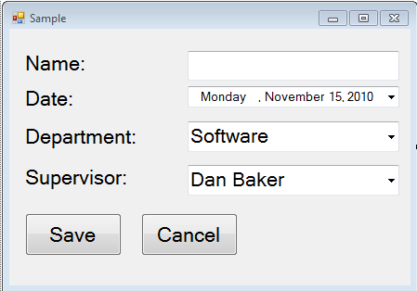
This sample application shows the basic boxy look typical of Windows Forms applications. It’s not bad, but if it’s a choice between this and something more dynamic and engaging, it’s not going to win.

The sample image shown below is from an internal application created at Odeh Engineers. This tool makes use of custom controls, web content, videos, graphics, subtle animated transitions, custom themes and more. The end result is something that’s a joy to use and experiment with without increasing development time. In fact, there are tools we build and use within our organization that simply wouldn’t have been considered for Windows Forms because of the time required for the result obtained. WPF applications can incorporate rich interactive graphics, documents, 3d content, video, web content and much more using the same tools all around.
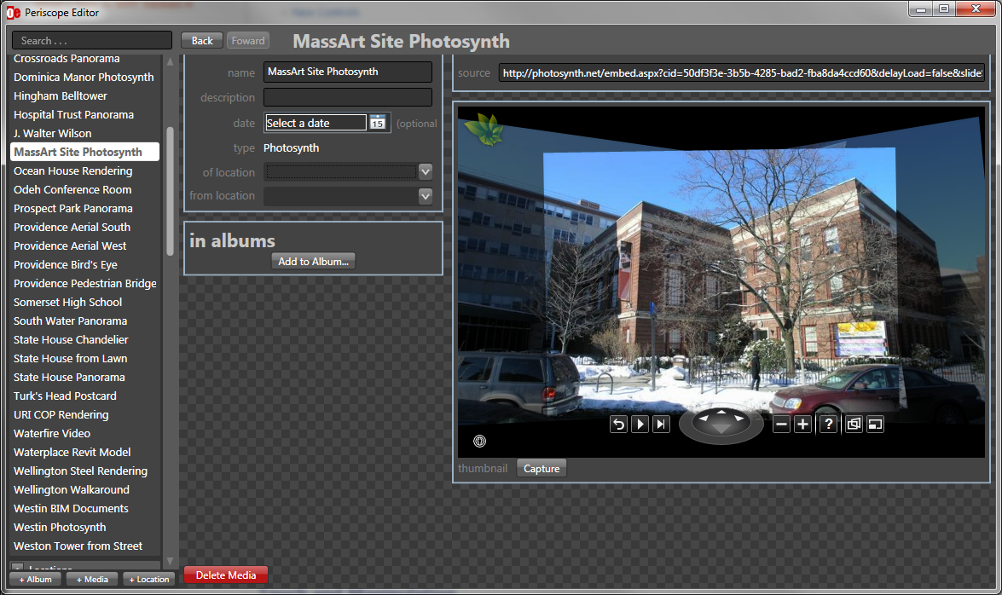
Screen Shot from Periscope (Created at Odeh Engineers by Henry Jackson)

One of Microsoft’s biggest accomplishments with WPF was to truly achieve a separation of the hierarchical user interface definition from the procedural code used to drive business logic and functionality. This is done by drawing inspiration from a very old concept, known as markup. Back in 1990, Time Berners-Lee defined a language he called Hyper Text Markup Language (HTML) and created browser and server software to consume it. The term markup language, which obviously predates HTML, originally referred to any structured language used to annotate text (although it has certainly been extended beyond that meaning).
The use of HTML to define and layout user interfaces was so successful; it has become the most ubiquitous user interface technology available today driving almost every web site in the world and still under active development. In 2004, drawing some inspiration from HTML a more structured yet more general language was specified by the World Wide Web Consortium (W3C) called the Extensible Markup Language (XML). XML is a flexible text format designed to be human and machine readable, self-describing and fully extensible. Both languages are hierarchical sets of nested tags. Building on the success of HTML for describing user interfaces and of XML for describing hierarchical data in general in 2006 Microsoft published a pair of specifications (see References section) defining a new markup language they called Extensible Application Markup Language (XAML).

“The [MS-XAML]: XAML Object Mapping Specification 2006 defines a way to describe types, a way to hold objects and a system for mapping between objects and XML.”
“The [MS-WPFXV]: WPF XAML Vocabulary specification 2006 is the detailed definition of the WPF Vocabulary of Types.”
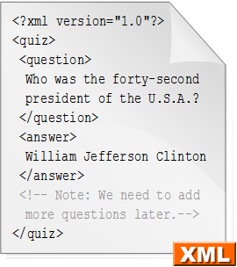
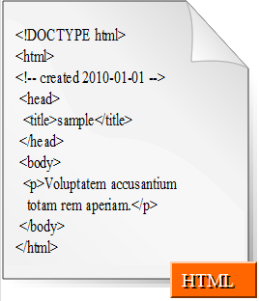

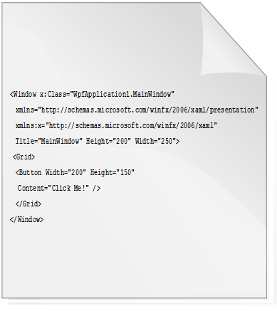
XAML

The core XAML Object Mapping Specification defines the XAML markup language in general. This language is XML used, as it states, to describe a system of objects and their relationships. Objects, in this sense, refer to .NET objects which are instantiated at runtime. The relationships are generally based on property values with most elements having either a Content property able to accept an instance of another object as a child or a Children property which can be set to any number of child elements, generally for layout purposes. This ability to combine and nest elements provides a natural way to describe user interfaces which combines the best of XML and HTML with significant extension to utilize the full capabilities of the .NET Framework running on DirectX.
Although the tools are available to provide excellent structure separating UI design in XAML from procedural code, this model need not be followed. It’s possible to completely generate your user interface from code. It’s also possible to jam a surprising amount of functionality into the markup. Neither is generally a good idea, although every circumstance is unique. If you do respect this paradigm you’ll reap some worthwhile rewards, however. The use of XAML to generate user interfaces rather than procedural code like C# or VB.NET allows for several advantages:
- Improved tool support, XAML is an XML based language and can be easily parsed and manipulated by all sorts of programs
- No more “designer generated code, touch it and die!” files lying around your projects
- Easy for designers and developers to work in parallel on the same projects
- Declarative, hierarchical language maps much more naturally to user interface than procedural code does

I’m definitely a believer in WPF, and use it in place of Windows Forms almost exclusively. Despite that, there are very good reasons why Microsoft hasn’t killed or even deprecated Windows Forms. There are a lot of very talented Windows Forms developers out there. It may be much harder to find developers of the same caliber to work on WPF applications. Windows Forms is also very focused on business applications, it’s functional and efficient. The flexibility allowed by WPF can also allow for some bad judgment. Just because it’s trivially easy to make the OK button shrink and scoot out of the way when you go to click it doesn’t mean users will thank you. Flashing lights and constant motion are almost always the wrong answer and no technology can enforce good taste. There’s also a temptation with WPF to try to make everything pixel perfect. The line between good enough and exceptional gets blurred. It’s important to always keep in mind the time budget for your project and ensure that features and functionality are not sacrificed purely for aesthetics.

Get the Tools
You’ll need a few things to get going with WPF development for Windows. Visual Studio 2010 will make your life so much easier I’m just going to call it essential. The expression version is sufficient, although there are some caveats when debugging external applications like Revit and AutoCAD (see Appendix 1). You’ll also want a tool to quickly prototype XAML, such as Kaxaml. Finally, I’d recommend you at least download a trial of Microsoft Expression Blend. It’s going to feel a little strange at first, but give it some time and you might be surprised at how useful it is in turning your ideas into reality.

- Visual Studio 2010 (express is OK)
  - http://www.microsoft.com/express/Downloads/
- Expression Blend 4
  - http://www.microsoft.com/expression/try-it/
- Kaxaml
  - http://kaxaml.com/
- Autodesk SDK’s
  - AutoCAD: http://usa.autodesk.com/adsk/servlet/index?siteID=123112&id=773204
  - Revit:
http://usa.autodesk.com/adsk/servlet/index?siteID=123112&id=2484975

WPF Basics
The two main components of a WPF application are the XAML based markup, which defines the user interface, and the code behind which defines the behavior. Code behind can be written in any .NET language (most commonly C# or VB.NET). The key to understanding XAML is to realize that user interfaces are really just nested elements, a label within a button within a grid within a form within a window. Each object is represented by a .NET object at run time, and that relationship is defined using the hierarchical XML language called XAML. Interestingly, XAML is also the user interface language of Silverlight, Microsoft’s portable light weight runtime used in a variety of web browsers and on Windows Phone 7 devices.
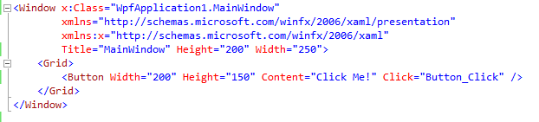
XAML snippet defining the properties of a button in a grid

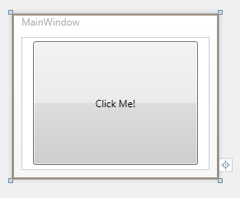
Resulting User Interface

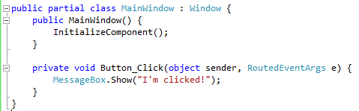
Code Behind Sample

Layout is another area in which WPF differentiates itself from competing UI technologies. In Windows Forms there is essentially one layout type, absolutely positioned elements on a canvas. There is a Canvas option in WPF as well, which allows elements to be positioned according to coordinates, but it is rarely used for general application interface definition. More flexible layout options like the Dock Panel, Stack Panel, Wrap Panel and Grid exist to help make interfaces behave more naturally in a variety of situations. All are capable of dynamically sizing and positioning content based on window size, resolution and DPI to create a logical and consistent view.

Dock Panel
DEFAULT PANE
LEFT PANE
TOP PANE
Dock panels make an excellent top level layout tool since it very naturally accommodates menus, button strips, navigation controls, etc. with a main area sized to fill all remaining space.

STACK PANEL WRAP PANEL
ITEM 2
ITEM 1
Stack Panels, which can be either vertical or horizontal, automatically arrange their contents end-to-end accounting for each elements size making them useful when contents vary in size or number
ITEM 1
Wrap panels arrange items horizontally until they reach the edge, and then start a new line.
ITEM 5
ITEM 4
ITEM 3
ITEM 2
ITEM 1
ITEM 4
ITEM 5
ITEM 3
ITEM 5
ITEM 4
ITEM 3
ITEM 2
Data Binding isn’t new to WPF, but it is implemented well and consistently. From a high level Data Binding refers to declaratively mapping logical or business objects to user interface elements. In practice, any Dependency Object derived object (nearly all WPF elements) can be a data binding target and any .NET object can be the source. User interface elements can also be bound to each other. In the example given below the XAML markup defines a simple grid with three properties related to a Person object. The code behind shows how a person object, which could be retrieved from a database, read off the disc, serialized over the network, etc. can be assigned to this window as the Data Context. Any changes made to the user interface will also be copied back to the business object, in the default two way binding situation. The Data Context is just the default object to which binding occurs.

XAML User Interface Definition
<Window x:Class="WpfApplication1.MainWindow"
xmlns="http://schemas.microsoft.com/winfx/2006/xaml/presentation"
xmlns:x="http://schemas.microsoft.com/winfx/2006/xaml"
Title="MainWindow" Height="200" Width="250">
<Grid>
<Grid.RowDefinitions>
<RowDefinition />
<RowDefinition />
<RowDefinition />
</Grid.RowDefinitions>
<Grid.ColumnDefinitions>
<ColumnDefinition Width="200" />
<ColumnDefinition />
</Grid.ColumnDefinitions>
<Label Grid.Column="0" Grid.Row="0" Content="Name" />
<Label Grid.Column="0" Grid.Row="1" Content="Job Title" />
<Label Grid.Column="0" Grid.Row="2" Content="Department" />
<TextBox Grid.Column="1" Grid.Row="0" Text="{Binding Path=Name}" />
<TextBox Grid.Column="1" Grid.Row="1" Text="{Binding Path=JobTitle}" />
<TextBox Grid.Column="1" Grid.Row="2" Text="{Binding Path=Department}" />
</Grid>
</Window>

Person business object
class Person {

public Person() {
Name = "Jon Doe";
JobTitle = "Drone";
Department = "Corporate Accounts Payable";
}

public string Name { get; set; }
public string JobTitle { get; set; }
public string Department { get; set; }
}

public partial class MainWindow : Window {
public MainWindow() {
InitializeComponent();
DataContext = new Person();
}
}

Data Context assignment

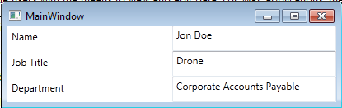
Resulting user interface

In addition to support for layout and standard controls, WPF provides declarative syntax in XAML for creating 2d graphics (as well as 3d, although outside the scope of this paper). Like all WPF user interface elements, 2d graphics are vector based rather than raster based. This means that they can be zoomed to any level without becoming pixelated or using excessive amounts of memory. A standard set of brushes allows shapes to be filled with solid colors, gradients, images or even videos. With out of the box support for many common shapes, you will usually be able to just declare what you need. In the event that some more esoteric shape is required a powerful, if somewhat complicated, path element is supplied to define nearly any 2d geometry you can visualize. Most importantly, graphics in WPF need not be simply visual elements; they have full support for user interface events like focus, mouse over, clicks and even keyboard events. This makes it very simple to create whatever elements you want graphically and treat them like any other button or standard control.

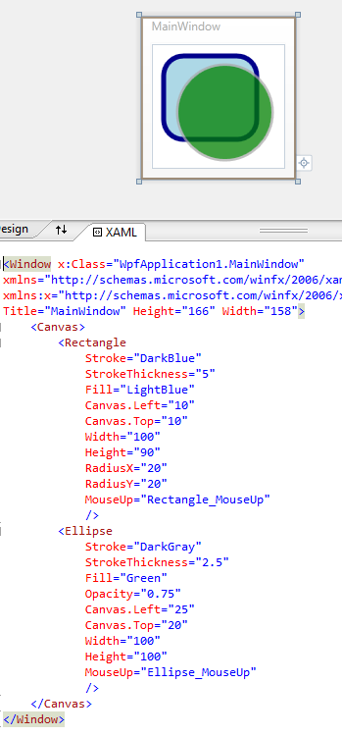
The WPF sample at left shows XAML for defining a simple rectangle and ellipse. Notice that the WPF engine easily handles transparency and overlapping elements. Also note that these graphical elements are wired up to MouseUp event handlers which can provide any programmatic functionality the developer desires.

Going beyond static user interfaces engages your user and communicates with them in a way that no other medium can. Using a computer isn’t and shouldn’t be like looking at a magazine or reading a book, it should interact with you as much as you interact with it. If something is important, let it grow a bit, if it requires attention, let it bounce, if it can be clicked on, let it react to the mouse. These are things that user interface designers have known and been doing for many years, but WPF puts them within the reach of every day line of business development. Animations are created with storyboards, generally using a tool like Expression Blend, and describe how an element’s properties should change over time. They can be activated programmatically using code behind or declaratively using Triggers. Triggers are XAML elements that link .NET events to actions. The code sample below describes a button that will grow when the mouse moves over it, and shrink back to size when it leaves. No procedural code at all is required to achieve this effect.

Activates the OnMouseEnter1 storyboard when the MouseEnter event of the button element is fired
Animates the button element’s Height property to a value of 80 over 0.5 seconds
Button definition
<UserControl x:Class="WpfApplication2.GrowButton"
xmlns="http://schemas.microsoft.com/winfx/2006/xaml/presentation"
xmlns:x="http://schemas.microsoft.com/winfx/2006/xaml"
xmlns:mc="http://schemas.openxmlformats.org/markup-compatibility/2006"
xmlns:d="http://schemas.microsoft.com/expression/blend/2008" >
<UserControl.Resources>
<Storyboard x:Key="OnMouseEnter1">
<DoubleAnimationUsingKeyFrames
Storyboard.TargetProperty="(FrameworkElement.Width)"
Storyboard.TargetName="button">
<EasingDoubleKeyFrame KeyTime="0:0:0.5" Value="120"/>
</DoubleAnimationUsingKeyFrames>
<DoubleAnimationUsingKeyFrames
Storyboard.TargetProperty="(FrameworkElement.Height)"
Storyboard.TargetName="button">
<EasingDoubleKeyFrame KeyTime="0:0:0.5" Value="80"/>
</DoubleAnimationUsingKeyFrames>
</Storyboard>
<Storyboard x:Key="OnMouseLeave">
<DoubleAnimationUsingKeyFrames
Storyboard.TargetProperty="(FrameworkElement.Width)"
Storyboard.TargetName="button">
<SplineDoubleKeyFrame KeyTime="0:0:0.5" Value="100"/>
</DoubleAnimationUsingKeyFrames>
<DoubleAnimationUsingKeyFrames
Storyboard.TargetProperty="(FrameworkElement.Height)"
Storyboard.TargetName="button">
<SplineDoubleKeyFrame KeyTime="0:0:0.5" Value="60"/>
</DoubleAnimationUsingKeyFrames>
</Storyboard>
</UserControl.Resources>
<UserControl.Triggers>
<EventTrigger RoutedEvent="Mouse.MouseEnter"
SourceName="button">
<BeginStoryboard x:Name="OnMouseEnter1_BeginStoryboard"
Storyboard="{StaticResource OnMouseEnter1}"/>
</EventTrigger>
<EventTrigger RoutedEvent="Mouse.MouseLeave"
SourceName="button">
<BeginStoryboard x:Name="OnMouseLeave_BeginStoryboard"
Storyboard="{StaticResource OnMouseLeave}"/>
</EventTrigger>
</UserControl.Triggers>
<Button x:Name="button"
FontSize="18" FontFamily="Arial"
Content="Click Me!" Width="100" Height="60" />
</UserControl>

WPF in Revit
When working in Revit WPF windows can be used directly from Revit defined ExternalCommands and ExternalApplications. As with any Revit extension, start out by creating a new ClassLibrary project in Visual Studio 2010. Add references to the RevitAPI.dll and RevitAPIUI.dll assemblies located in the Revit program folder. You then need to implement either the IExternalCommand interace or the IExternalApplication interace. For this example, I’ll be working from the HelloRevit project in the Revit 2011 SDK.
- Open the HelloRevit sample project from the Revit 2011 SDK
- Add a new WPF Window to the project
- Create a button control on the window
<Window x:Class="Revit.SDK.Samples.HelloWorld.CS.SampleRevitWPF"
xmlns="http://schemas.microsoft.com/winfx/2006/xaml/presentation"
xmlns:x="http://schemas.microsoft.com/winfx/2006/xaml"
xmlns:mc="http://schemas.openxmlformats.org/markup-compatibility/2006"
xmlns:d="http://schemas.microsoft.com/expression/blend/2008"
Width="200" Height="100">
<Grid>
<Button Content="Click Me!" />
</Grid>
</Window>

- Launch the window from the IExternalCommand as a modal dialog box
public Autodesk.Revit.UI.Result Execute(ExternalCommandData commandData,
ref string message, Autodesk.Revit.DB.ElementSet elements)
{
new SampleRevitWPF().ShowDialog();

return Autodesk.Revit.UI.Result.Succeeded;
}

Appendix 1: Debugging with Visual Studio Express
Visual Studio Express edition doesn’t provide the ability to attach to an external process by default. This is pretty trivial to work around, however. Start by creating a Class Library project for your target application (e.g. Revit or AutoCAD) with the appropriate references as you normally would (see the SDK for these products). Once you have the project setup in Visual Studio, you can right click on the Solution name in the Solution Explorer window and select “Open Folder in Windows Explorer.”
Once you have the solution folder open in explorer, find the .csproj (or .vbproj) file that accompanies the solution (this is the project file). Use notepad or a similar text editor to open this file. You should find an XML file which describes the project. You’ll need to insert a new PropertyGroup item at the top of the file similar to what is shown below:
<?xml version="1.0" encoding="utf-8"?>
<Project ToolsVersion="3.5" DefaultTargets="Build" xmlns="http://schemas.microsoft.com/developer/msbuild/2003">
<PropertyGroup Condition=" '$(Configuration)|$(Platform)' == 'Debug|AnyCPU' ">
<StartAction>Program</StartAction>
<StartProgram> c:\Program Files\Autodesk\Revit Structure 2011\Program\revit.exe</StartProgram>
</PropertyGroup>
<PropertyGroup>…</PropertyGroup>
…
</Project>

You may need to change the StartProgram element to reflect the location of the application & version you are using. Once this is done, you should be able to debug the project by pressing F5, which will automatically start the selected application with the debugger attached.

Resources

- Introduction to WPF
http://msdn.microsoft.com/en-us/library/aa970268.aspx

- WPF Overview
http://msdn.microsoft.com/en-us/library/ms754130.aspx

- “XAML Object Mapping Specification” and “WPF XAML Vocabulary Specification” docs
http://msdn.microsoft.com/en-us/library/dd361847(v=PROT.10).aspx

- Visual Studio 2010 Express Download
http://www.microsoft.com/express/Downloads/

- Expression Studio 4 Trial
http://www.microsoft.com/expression/try-it/

- AutoCAD ARX SDK
http://usa.autodesk.com/adsk/servlet/index?siteID=123112&id=773204

- AutoCAD® .NET: UI Design Featuring WPF, Parts 1&2 by Fenton Webb, AU 2009 (CP114-5, CP118-2)

http://en.wikipedia.org/wiki/HTML
http://www.w3.org/XML/Core/#Publications
http://msdn.microsoft.com/en-us/library/dd361847(v=PROT.10).aspx

