Storing Complex Custom Per-Document and Per-Instance Data with Revit® API
Miroslav Schonauer – Autodesk
CP433-1 Ever wondered how to store AutoCAD®-like custom objects dictionary data in an Autodesk® Revit BIM-consistent manner using the Revit API? If the answer is yes and you thought this was not possible due to the perceived lack of classes and concepts in Revit API and the Revit user interface, then this class is for you! We will demonstrate how Revit Shared Parameters of the string type can be used in conjunction with the advanced .NET serialization and string-encoding techniques. Helper classes will be explained and shared with you to simplify the workflow in your everyday development tasks. Finally, we will show some powerful complex practical examples and provide a live demonstration of a smaller example.

About the Speaker:
Miro has an extensive combined engineering and IT background, with a Dipl.Ing. degree in Civil and Structural Engineering (Split, Croatia), Ph.D. in Numerical Methods in Engineering (Swansea, Wales) and 20+ years experience in commercial engineering software development. He's been with Autodesk for over ten years, initially as Developer Consulting Specialist and currently as Solution Architect within the AEC Practice of Autodesk Consulting. His specialty is APIs for all Autodesk® AEC products, a topic on which he has conducted numerous training sessions, given many conference talks and provided direct technical support. For the last five years, he's been applying the API knowledge to architecting and developing consulting solutions that extend the functionality of Autodesk products.
miroslav.schonauer@autodesk.com

Introduction
One of the typical challenges with the advanced, specialized or customized usage of any CAD and especially BIM product, is to store additional data (speaking in a very broad sense) associated with the file/model objects (per-instance data) or with the very file/model (per-document data). The complexity of such data ranges from simple singular and type-specific data-items (eg in a case of a BIM Door instance, a single string representing Description, a single floating number representing Cost, a single integer representing Mark, etc) to very complex data-structures containing structured collections of mixed data-types with the varying number of items and their hierarchy/relations.
Revit provides very useful and extensively used out-of-the-box functionality to handle the former simple cases via user-customizable Parameters, most of which is also fully exposed to API. However, the latter complex cases would be practically impossible to efficiently implement in some kind of out-of-the-box functionality, due to the UI complexities and required flexibility involved in defining/creating such data-structures, not to mention editing them. It is natural to expect that such cases should be handled with advanced API customization on per-requirement basis.
Since there is no “silver bullet” API solution in this respect, the author has been continuously researching and improving some generic techniques to handle such cases. The first results and hints to developers have been presented in the end-user oriented AU 2007 class “Expanding BIM With The Revit® API” (co-presented with main speaker Emile Kfouri). While working on a few Autodesk Consulting projects involving Revit API customization, the concepts have been constantly refined within a set of evolving helper classes, now encapsulated in the provided C# project. Hence the inspiration for this very developers-centric class with the aim of sharing the conclusions and code, hopefully further contributing to the democratization of Revit API, number and quality of 3rd party applications, and consequently the scope of usage of Revit!

Revit Parameters
The assumption is that attendees are familiar with the very product/UI concepts of adding Parameters, be them Project or Shared ones, to Revit elements. If not, there are very good sections in Revit online help, as well as many other resources, including dedicated AU classes on this topic.
As far as API aspects of Parameters are concerned, there are also a lot of materials including the SDK Samples, API Developer Guide and postings on Jeremy Tammik’s blog. Actually, there seems to be another AU class this year (CP231-2 Putting the "I" in BIM: Parameters in the Autodesk® Revit® API by Matt Mason; Tuesday 3:30pm - 4:30pm) which sounds like a comprehensive overview of standard API Parameters’ features and an ideal introduction to the rather specialized coverage in the current presentation.

API Exposure
Once the parameters are bound to specific categories, the API provides full access to their values on element instances or types (depending on parameter definition) of that category.
However, the very capability of creating/manipulating the parameters and binding them to specific categories is exposed only for Shared and not for Project parameters, which obviously limits the developer’s choice. Fortunately, Shared parameters are slightly more generic and functional than Project ones, so this restriction does not really represent API utilization limitation.

Per-Instance vs Per-Document data
Revit parameters are designed to be available on all Instances (assuming Instance-binding as opposed to Type-binding which is irrelevant in the current context) of elements belonging to a category that given parameter is bound to. This allows users to have per-instance parameters (including our special, invisible string-encoded ones) on eg all Doors, Windows, Walls, etc. elements in RVT.
There is however a special category, “Project Information”, which is guaranteed to have a singleton “Project Info” element available via Autodesk.Revit.DB.Document.ProjectInformation. This singleton instance, also available in UI via “Project Information” command, is therefore a perfect vehicle to use for manipulating de-facto per-document data in exactly the same manner as for per-instance cases.

Other Techniques for Storing Complex Data
Before presenting what author believes to be most comprehensive solution given the current exposure in the Revit API and .NET Framework capabilities, let’s shortly review some other techniques that have been used by developers.

Multiple Simple Parameters
The ‘first-thought’ solution is typically to bind as many single parameters of the specific type as the expected required maximum would be. The drawbacks are obvious in that:
- one may need to bind 100s of parameters, many potentially unused on most instances
- the upper bound may not be know in advance or limited at all
- there is no possibility to “nest” the data, or more generically to impose any kind of relationship/structure on it

External Data Storage
The idea here is to have external (ie data is outside RVT model) files/databases loosely linked to Revit elements via its Ids:
- ElementId (via Element.Id property) which are not really guaranteed to remain the same if “Save to central” and similar model-sharing workset features are used.
- String GUID (via Element.UniqueId property) which is always guaranteed to be unique and preserved on an element, so a better approach.
This seems to be most widely used technique and it is probably the most appropriate with big data-sets when neither of the following cons is relevant in the user requirements:
- Data must be stored in RVT model (for whatever reason, typically the compactness)
- Any changes in data must be in sync with standard Revit’s Undo/Redo mechanism.
If either of these conditions is required, another approach must be used…

String-encoded Serialized Object Parameters
Author’s proposed solution can be summarised in the above title, or shortly as “Object Parameters”. In a nutshell, the solution is based on the following steps using a combination of Revit API and .NET techniques:
- Design a data-storage [Serializable()] .NET class of any desired complexity.
- Utilize BinaryFormatter to serialize/deserialize its instances into/from binary MemoryStream.
- Encode such binary chunk into/from String using Convert.ToBase64String/ FromBase64String.
- Store/Retrieve such string into/from a hidden (invisible) string-type Revit Parameter using Parameter. Set /AsString.

Parameter Identification: by-Name vs. by-GUID
Revit usage guidelines strongly suggest that any 3rd-party shared parameters should be always utilized from a provided Shared Params File, in order to ensure that the GUID associated with it is always the same and unique (note that it is the GUID and NOT the name which Revit uses to identify the parameters!).
However, we use Shared Parameters simply because the Project ones (which would’ve been sufficient for our “invisible” concept which is NOT really utilized in the “standard” Shared Params manner) are not exposed to API. Therefore, in the current context, that rule would impose additional complexity of a shared params txt file that needs to be re-distributed with each 3rd party app. In our case, to be more practical for end-users, it is justifiable to ignore this rule and just to ensure that the hidden parameter has rather unique name (eg "AU_Param_Element_Files_Tree" in one of the samples). Such name-identification enables that our parameters can be gotten-or-created “on the fly” (see the helper methods later) and fully transparently for end-users – the end which justify the means.
If one is concerned with the uniqueness of the name, the string value of a GUID itself (to completely confuse you now ;-) can be used as the name.

Sample Code
The sample code provided in Additional Class Materials consists of two C# projects:
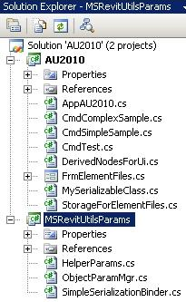
MSRevitUtilsParams project has been designed to provide all the utilities and classes to be reused in your specific client implementations, either on as-is basis or as a starting point if the code needs to be refined in any respect.
AU2010 project demonstrates the usage from two practical commands, one simple and one complex implementation, in CmdSimpleSample and CmdComplexSample files respectively.
Let’s examine these projects in more details and point out the most important aspects.

Helper Classes in MSRevitUtilsParams Project
This project contains 3 major helper classes:

SimpleSerializationBinder
This System.Runtime.Serialization.SerializationBinder-derived class is used only to resolve the problem of de-serializing an object whose defining DLL is not in the same folder as the running EXE (very likely case with add-ons deployment). Without it, de-serialization would fail in such cases (see the code comments within ObjectParamMgr::GetFromElement client usage)

HelperParams
This static class provides many Shared Parameters specific API helper methods, valuable in their own right, but in the current context primarily utilized by the ultimate “single-stop” template class, ObjectParamMgr<T>.
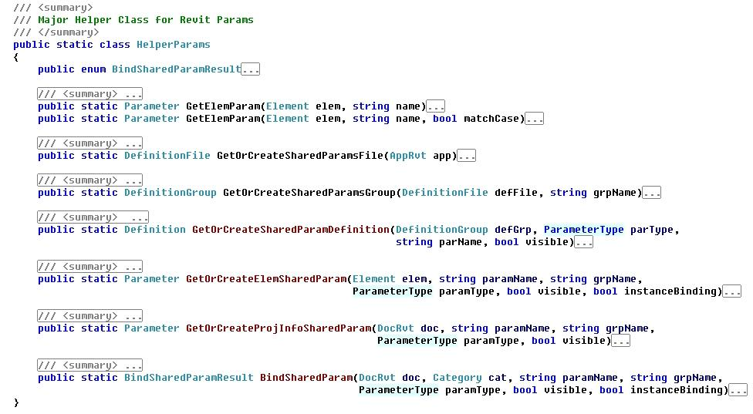
Most of the methods are self-explanatory from their names and arguments list, with further code comments in the fully expanded class-code.

ObjectParamMgr<T>
This template class is the sole and ultimate one required in client-usage. It performs all the background work concerning getting/setting your data-storage objects from/onto specific parameters.
The client samples clearly demonstrate the convenience and high level of Object-Orientation in using this helper class – the ONLY 3 things you need to do is:
- Instantiate it only once using your data-storage class as T and provide parameter details (Name, Group Name) in the constructor. Eg:
ObjectParamMgr<MySerializableClass> mgrMyObject = new ObjectParamMgr<MySerializableClass>("AU_Param_InVisible", "AUGroup");
- Use its GetFromElement method to get your object from the Revit element’s param. Eg:
MySerializableClass obj = mgrMyObject.GetFromElement(el, true);
- Use its SetOnElement method to set your object into the Revit element’s param. Eg, after obj has been modified:
mgrMyObject.SetOnElement(el, obj);

AU2010 Project
This project contains a typical implementation of Revit Add-on Application Interface (IExternalApplication) within AppAU2010 class. The app adds its Ribbon with two simple push-buttons:
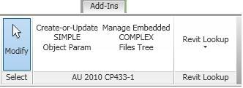
The best way to register the application with Revit is via novel 2011 API “addin” XML config file mechanism, using the provided “CP433-1 AU2010.addin“file:
<?xml version="1.0" encoding="utf-8" standalone="no"?>
<RevitAddIns>
<AddIn Type="Application">
<Assembly>AU2010.dll</Assembly> <!-- Please edit this path unless you provide the DLL in the same folder as this very .addin file -->
<ClientId>CC7232A6-1377-45da-AA44-EB49435E3D58</ClientId>
<FullClassName>MS.Revit.AU2010.AppAU2010</FullClassName>
<Name>MS AU2010</Name>
</AddIn>
</RevitAddIns>
Two commands provided in the project demonstrate the usage of our helper template class for storing complex data structures. They will be fully demonstrated during the presentation.

Simple Sample in CmdSimpleSample
This sample demonstrates the basic aspect of ObjectParamMgr usage in conjunction with a simple data-storage class:
/// <summary>
/// Simple class to demonstrate serializable storage in Revit Params
/// </summary>
[Serializable()]
class MySerializableClass
{
// public member data
public int mInt;
public double mDouble;
public string mString;

//c-tor
public MySerializableClass()
{
mInt = 0;
mDouble = 0.0;
SetStringToDateTimeNow();
}

// helper to set string to the current time, including milliseconds
public void SetStringToDateTimeNow()
{
mString = string.Format("{0:dd/MM/yyy hh:mm:ss.fffF}", DateTime.Now);
}

// helper to report the member data
public override string ToString()
{
return string.Format("mInt={0}, mDouble={1}, mString={2}", mInt, mDouble, mString);
}
}
The command can be run by firstly pre-selecting any number on elements and then selecting “Create-or-Update Simple Object Param” in the AU2010 app ribbon pull-down. For every element in the pre-selection set, the code will:
- Firstly check if the element category allows bound parameters and report if not with the relevant element skipped in such case.
- Get-or-create our hidden param string-encoded value containing the serialized object
- Increment the integer and double member data and set the string one to the current date-time and store the updated object into the param
- Report on the selected element, including its old and new data-storage object values:
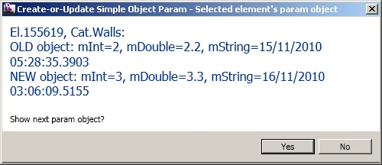
If too many elements are selected, reporting may be omitted by selecting No in the Task Dialog.

Complex Sample in CmdComplexSample
This example can be run by pre-selecting a single element of a category that allows params-binding (eg a Wall, Door, Window, etc) and then selecting “Element’s Embedded File Tree” in the AU2010 app ribbon pull-down.
An explorer-style dialog will be displayed with the Revit element as a “root folder”, to which further sub-folders and selected files can be respectively attached as recursive branches and leaves:
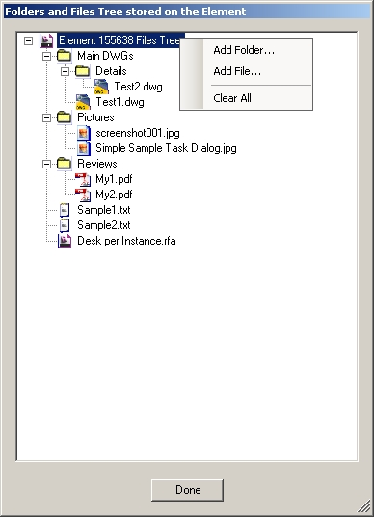
Right-click context menu should be used on nodes to perform tasks after each one the stored object gets automatically updated in the given param (ie RVT file). The contents of selected files will be fully binary copied within the member data of our storage-classes, hence fully “embedded” within the RVT file! When “View/Edit” is selected (or double-clicking) on an embedded file node, a temporary file will be created from the appropriate binary chunks in our storage objects and associated Windows application automatically launched, enabling the user to view the document and/or “Save As” in the given application native file formats.
Despite the fact that the parameter value is updated after every change in UI, the performance seem be instantaneous. Of course, manipulating very big files (particularly adding them) may be noticeable, but the performance is practically the same as when manipulating (copy, open, etc…) the same files directly in the OS file system, indicating that the very overheads of our additional techniques are relatively small if noticeable at al.
The code for this sample is fully available across the command class, form class, derived UI classes and custom data storage classes. It will be “walked-through” in more detail during the presentation…

TIP: Revit Lookup
Of course, one cannot see our invisible parameters in UI, but Revit Lookup tool (full source code available in the SDK) which uses reflection to explore the API can reveal them when eg ‘Snoop Current Selection…’ is used:
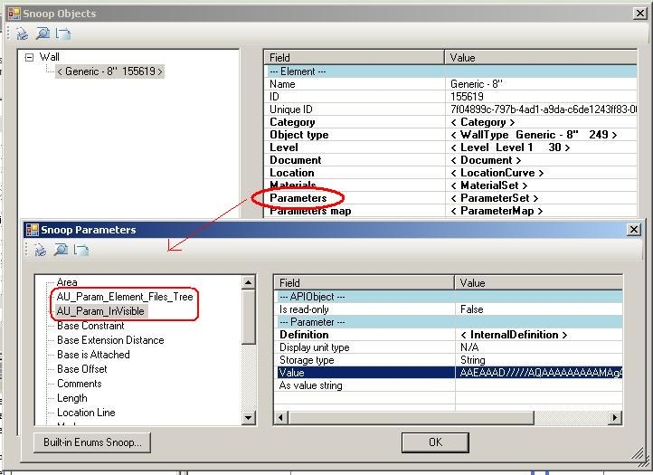
You can right-click on the ‘Value’ content, Copy it and then Paste in eg Notepad to see the full “string-value” of out parameter. If your brain can think in binary + string-encoding mode you may even make some sense of it ;-)

