Overview:
”Effective Folder Permissions” shows a simplified view of each user’s permissions on a set of folders.
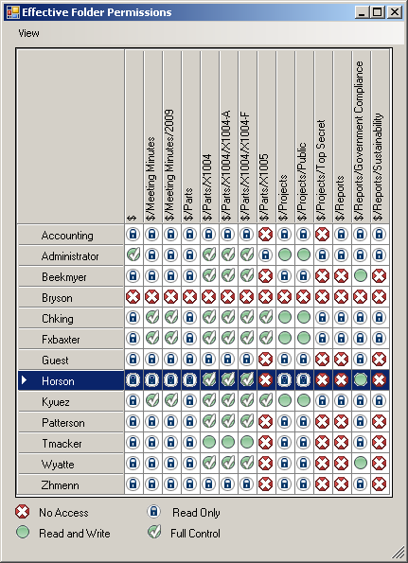
There is also a bonus feature which lists all the user’s with administrative permissions.
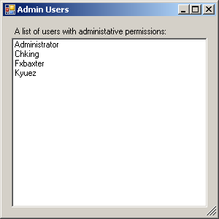

Requirements:
Vault 2010 (all versions)
Introduction:
Not only am I a programmer, but I’m an administrator of the Vault we use for internal documents. Yes, we do use our own product. So I decided to write a program to make things a bit easier for us admins. It also gave me a chance to put in practice some concepts that I previously went over: The Vault security model and Windows Authentication.
The result is a program that runs through all the factors that determine a user’s access level. It takes into account user permissions, ACL information, the ‘Active’ status of the user and whether or not the user has access to the Vault. All groups information is taken into account as well.
Lastly, I provided a simple list of all the administrators. I recommend that every admin run this check. You never know when somebody might accidently be given admin permissions.
Click here to download the application
Click here to download the source code
Enjoy

