Sometimes the Advanced Find feature in Vault is not enough. You need something more advanced, specifically something that supports OR based searches. With that in mind, I created the Advanced Advanced Find dialog.
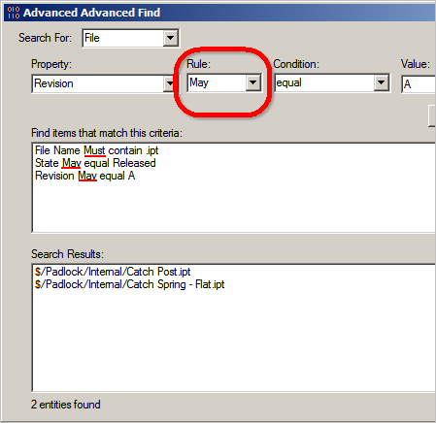
Overview:
The dialog works similar to the Advanced tab in the regular Find dialog. However there is one new thing, the Rule parameter. This can be either Must or May. Must is the default behavior and means that the search condition must be met in order for the object to show up in the search results. The May option means that an object will show up if it satisfies at least 1 of the conditions.
Requirements:
Vault Workgroup/Collaboration/Professional 2011
Click here to download the application
Click here to download the source code
Author's Note:
Yes, I know that the standard Find dialog does many things that my dialog doesn't (saved searches, reports, that animated hourglass icon, etc), but "Find Dialog That Is Advanced In One Specific Way" was too long of a title.

