Sorry but there was a problem with the intellesense for the Vault 2013 SDK. When you are calling a web service function in Visual Studio, you should be seeing documentation appear as you code. That’s what those XML files are in the BIN folder of the SDK.
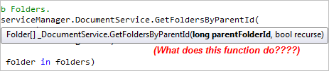
To fix this, I am posting the corrected XML file. Just overwrite the existing Autodesk.Connectivity.WebServices.XML and you will see full documentation as you code.
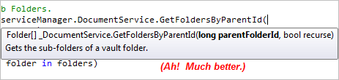
Unfortunately only the functions themselves are documented. The parameter descriptions didn’t get exported for some reason.

