**Assignment II – Cache Design**



a.

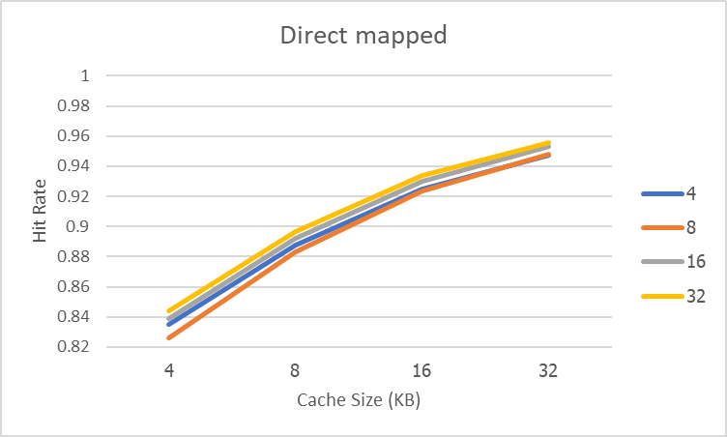

We can see that either cache size or block size increase, both make hit rate increase. But the rate of increase is decreasing. So, if we keep increasing cache size or block size at some point hit rate will almost certainly which not worth to increase these parameters. And 8 byte of block size is lowest hit rate which it’s halfway between small block fast access and big block advantage in area, but it is worst?? Some reason might be it’s bigger but not enough so some space that it allocates is not efficiency.

From this result can conclude that keeping increasing cache size or block size makes hit rate increase with decreasing rate and from we known that bigger memory takes more time to access. At this point we must consider that is it worth to increase cache size and must beware that increasing block size too much can rise penalty because of writing time. So, bigger cache size is better and bigger block size also better, but both shouldn’t be too big.



b.

We can see that the trend of this graph is almost the same as directed map’s graph. Increasing cache size results in increasing hit rate but in decreasing rate. If we compare LRU and RR we will find that LRU is higher hit rate than RR and significantly in small cache size and come closer to each other in bigger cache size. So, if we want to build fast access cache LRU may be better in cost of more complex. But when we want bigger cache hit rate of LRU and RR aren’t significantly away which means that in bigger cache size, RR will be better choice in term of less complex. And if we compare 2 ways and 4 ways associative 4 way is completely higher hit rate.

Therefore, RR for small cache. LRU for big cache. And using 4 ways set associative architecture all the way.