**Question 1:**

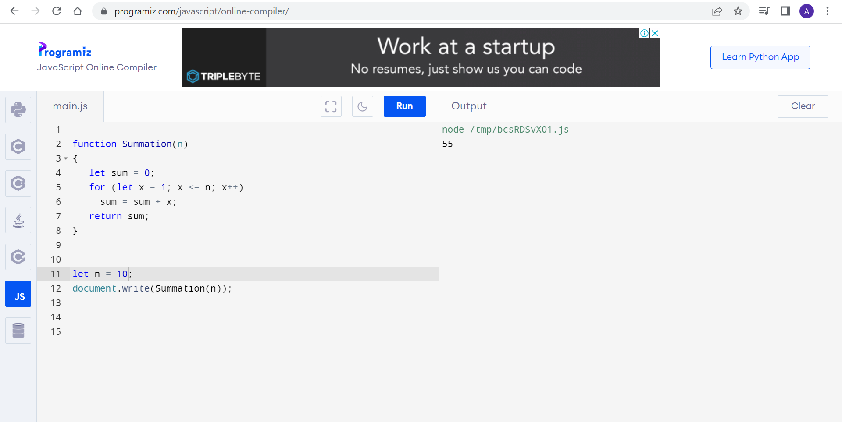

**Code:**

function Summation(n)

{

let sum = 0;

for (let x = 1; x <= n; x++)

sum = sum + x;

return sum;

}

let n = 10;

document.write(Summation(n));

**Question2:**

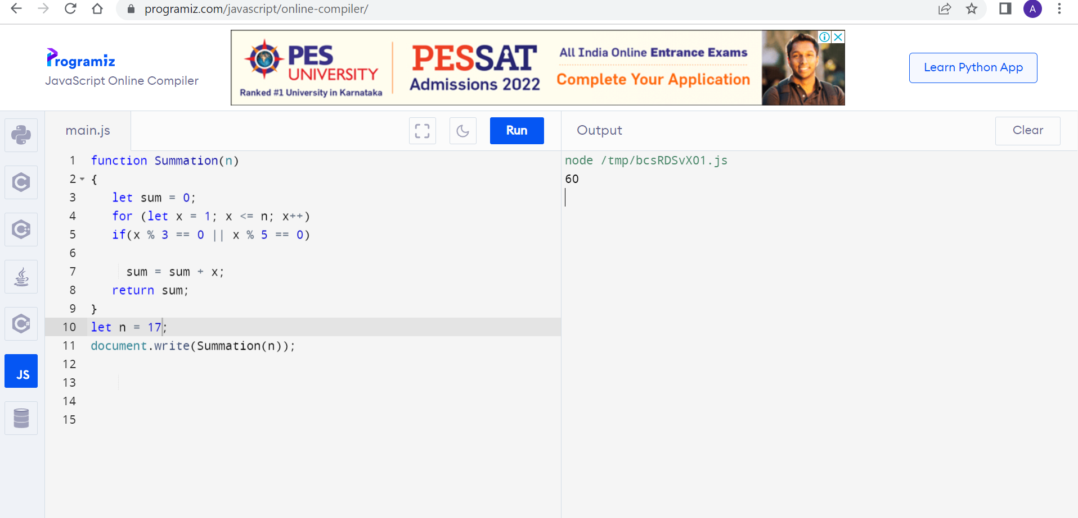

**Code:**

function Summation(n)

{

let sum = 0;

for (let x = 1; x <= n; x++)

if(x % 3 == 0 || x % 5 == 0)

sum = sum + x;

return sum;

}

let n = 17;

document.write(Summation(n));

**Question 3:**

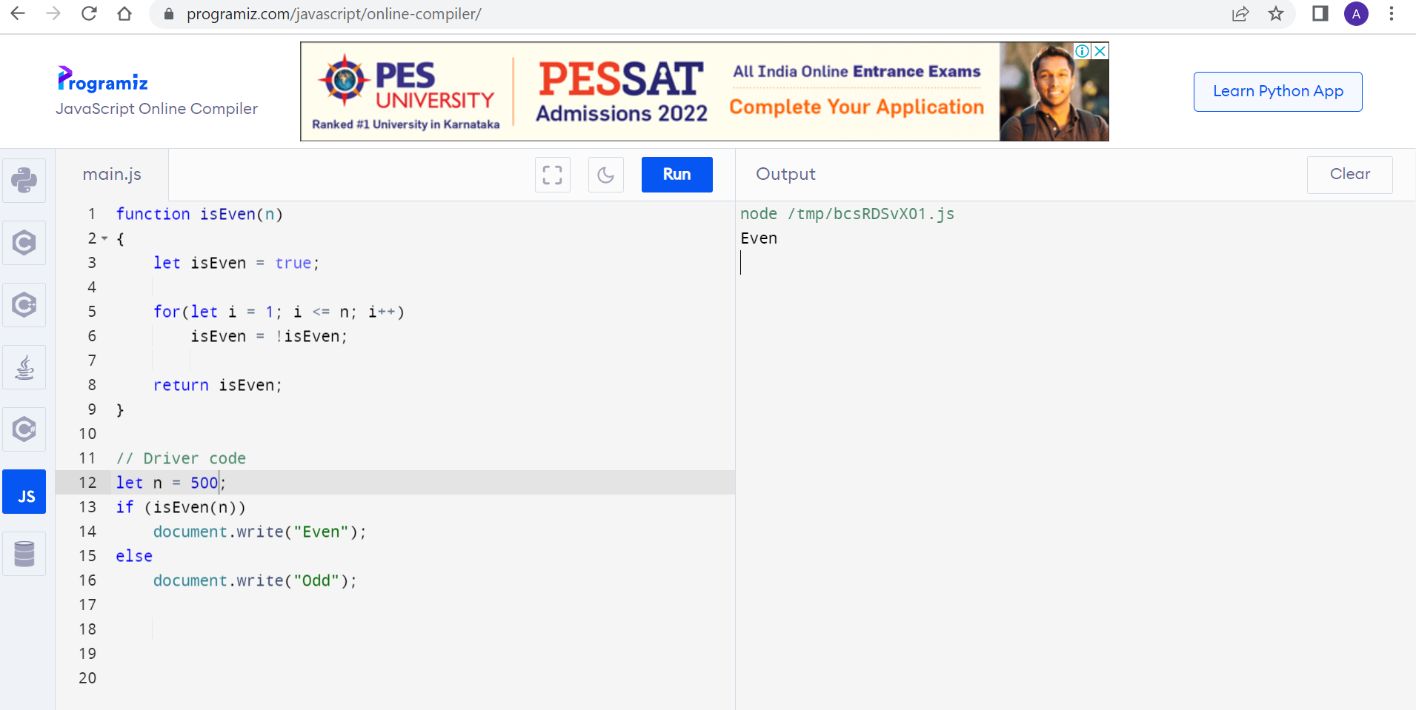

**Code:**

function isEven(n)

{

let isEven = true;

for(let i = 1; i <= n; i++)

isEven = !isEven;

return isEven;

}

// Driver code

let n = 500;

if (isEven(n))

document.write("Even");

else

document.write("Odd");

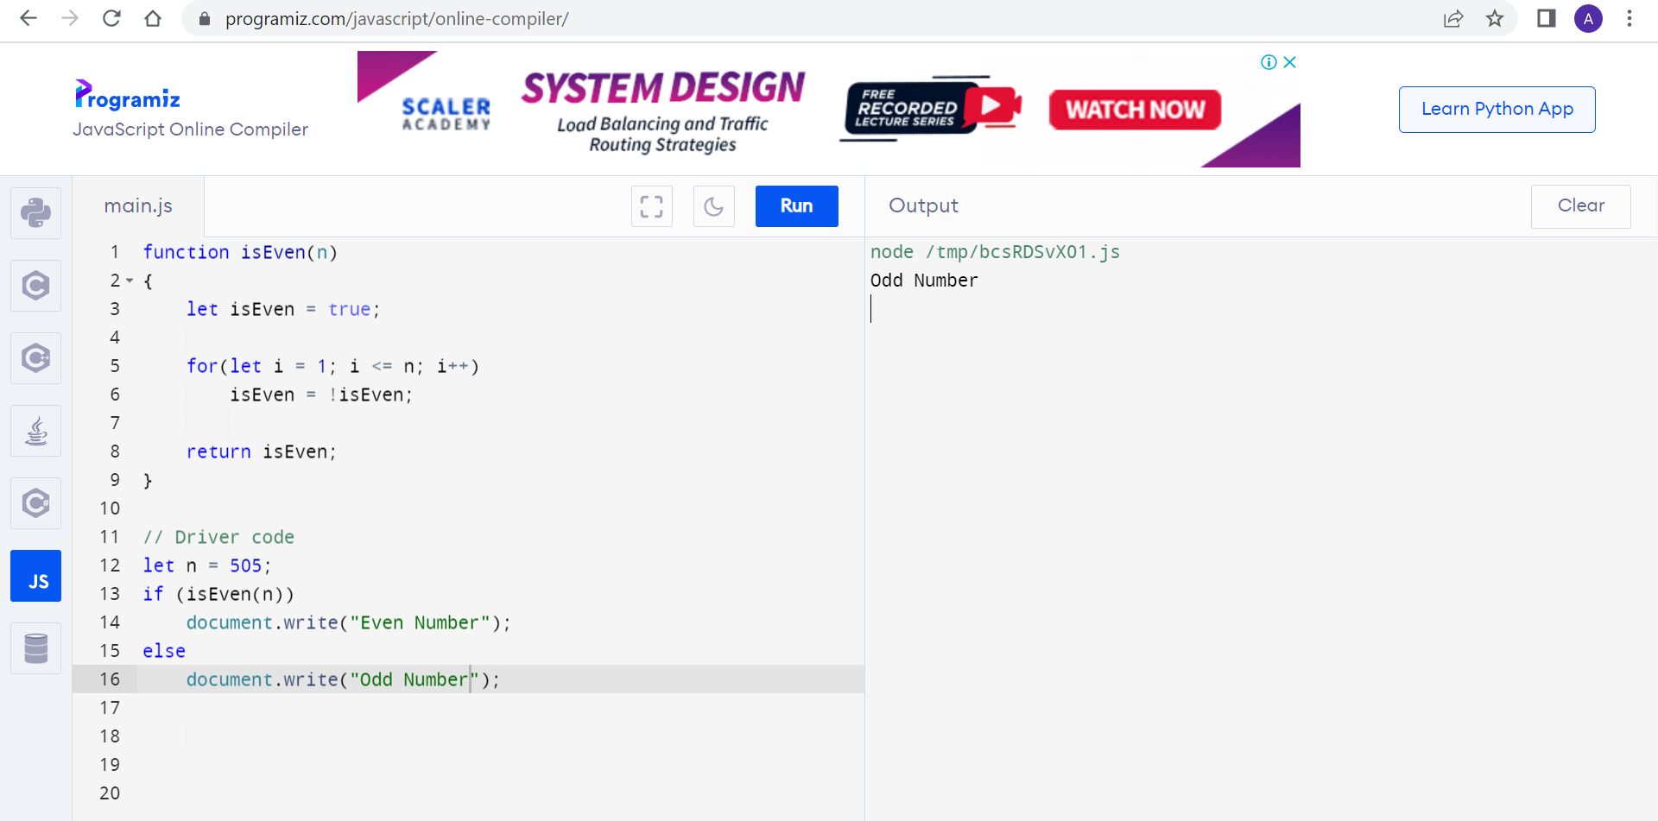

**Code:**

function isEven(n)

{

let isEven = true;

for(let i = 1; i <= n; i++)

isEven = !isEven;

return isEven;

}

// Driver code

let n = 505;

if (isEven(n))

document.write("Even Number");

else

document.write("Odd Number");

**Question 4:**

**Question 5:**

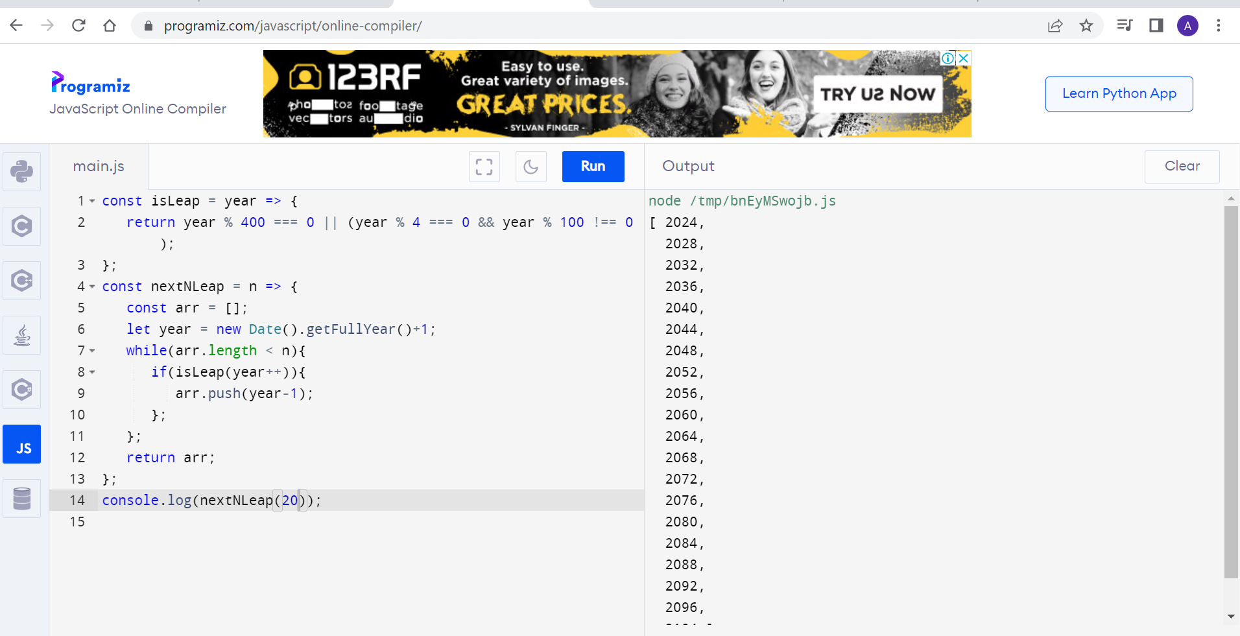

**Code:**

const isLeap = year => {

return year % 400 === 0 || (year % 4 === 0 && year % 100 !== 0);

};

const nextNLeap = n => {

const arr = [];

let year = new Date().getFullYear()+1;

while(arr.length < n){

if(isLeap(year++)){

arr.push(year-1);

};

};

return arr;

};

console.log(nextNLeap(20));

**Question 6:**

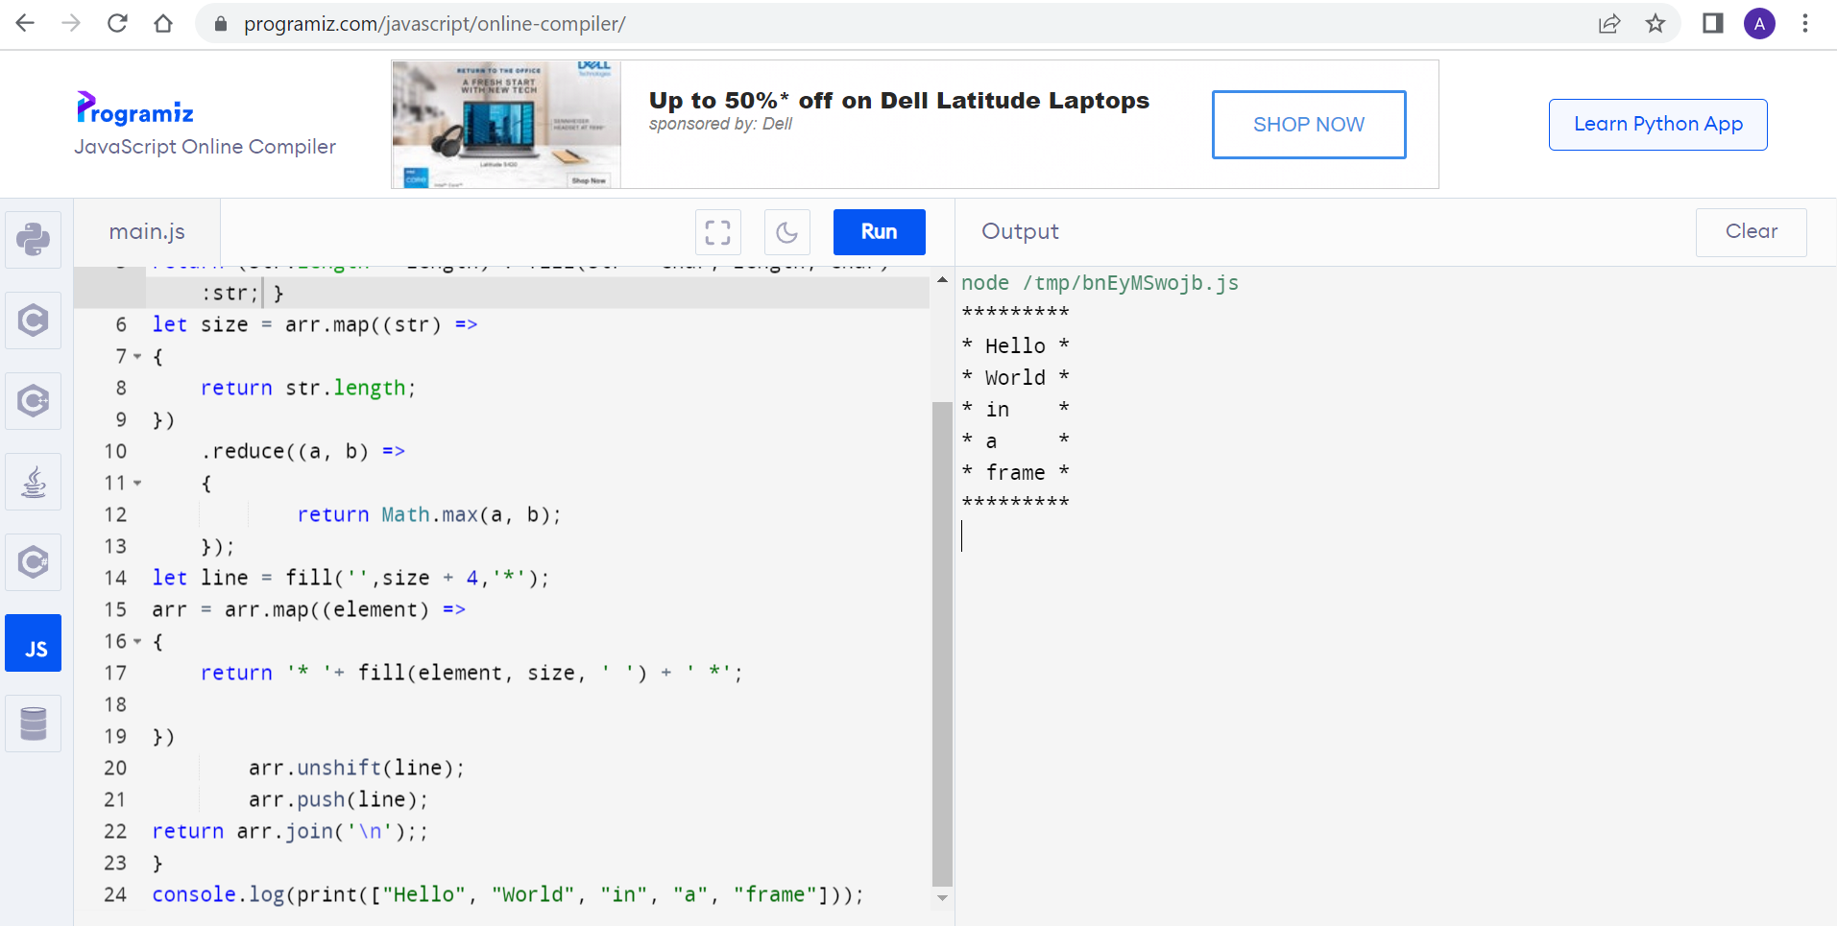

***Code:***

function print(arr)

{

function fill (str, length, char)

{

return (str.length < length) ? fill(str + char, length, char) :str; }

let size = arr.map((str) =>

{

return str.length;

})

.reduce((a, b) =>

{

return Math.max(a, b);

});

let line = fill('',size + 4,'*');

arr = arr.map((element) =>

{

return '* '+ fill(element, size, ' ') + ' *';

})

arr.unshift(line);

arr.push(line);

return arr.join('\n');;

}

console.log(print(["Hello", "World", "in", "a", "frame"]));