**Instructions for using the transport module cmd app**

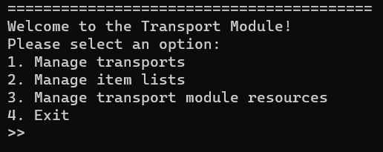

The main menu is:

We use an intuitive multiple choice menu for reaching all the app's functionality. in order to enter a menu, enter the number and click enter.

The menus for managing transports and item lists are available from the main menu. however, in order to reach the menus to manage sites, drivers and trucks you will need to go into the "Manage transport module resources" menu, which will reveal further menus which are nearly identical to the other managing menus:

There are explanations printed in place for every functionality that requires user input.

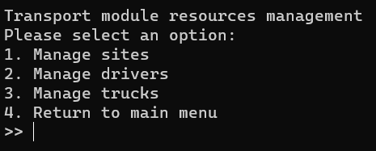

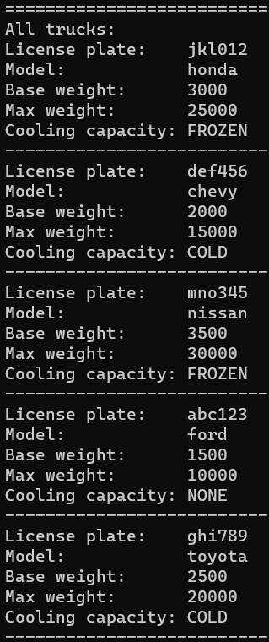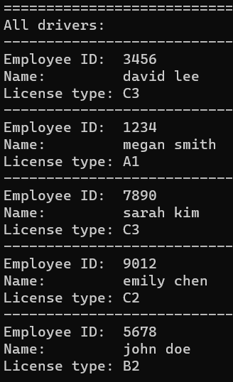**Data present in the system when launching:**

**Trucks**

**Sites**

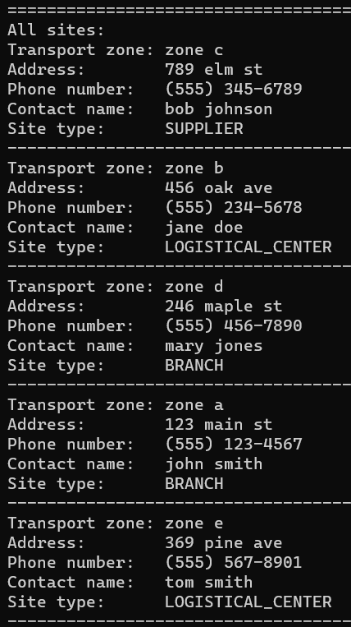

**Drivers**

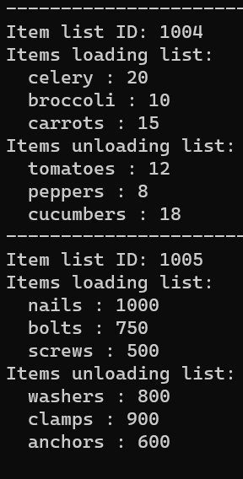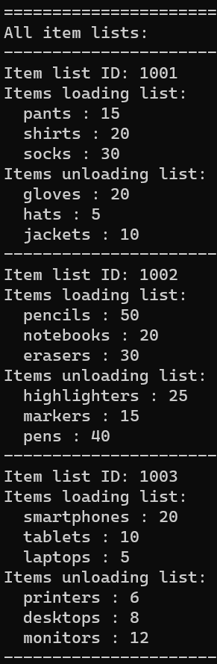

**Item Lists:**

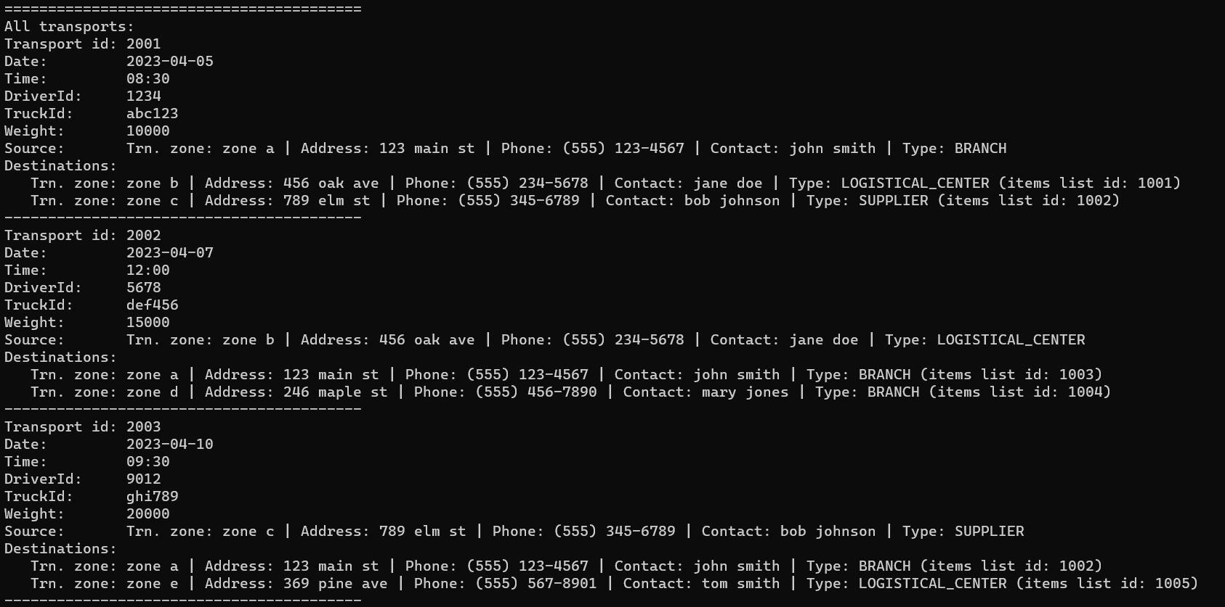

**Transports part 1:**

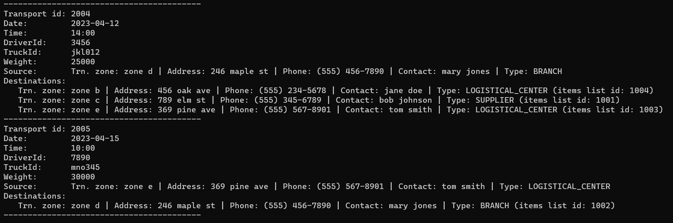

**Transports part 2:**