**Instructions for using the transport-employee module cmd app**

The system will let the users to manage employees, shift scheduling, eliciting information and more based on authorizations of the user. The system will require a user to login prior to using it's primary features. After every performed command, the system will show a text regarding the last operation (for example stating if it was successful or there was an error) and the user will be presented the current available commands he has that he can choose from. The commands will be numbered, described, and will present it's structure enclosed with apostrophes ('…'). Some commands will require case specific information. In the command structure the information should be given by the user instead of the text enclosed by: <…> , omitting the '<' and '>' as well.

In the initial run, the system will present the following text:

Please log in to the system.

1. Login command: `login <username> <password>`

2. Generate initial data: `generate_data`

3. Exit command: `exit`

The user can choose one of the numbered commands, which are either Login, Generate Data or Exit.

The system will contain one default administrative user, its username is: 'admin123' and password is: '123'. In order to login, the user should type in the following:

login admin123 123

**Admin User**

Administrative user is authorized as an HR manager, meaning this user details should be handed to the HR manager of the company, and only him. This account is allowed to recruit employees, create shifts and make them available for employees to sign up to them, decide which of the employees' requests for shifts to approve, and finally verifying a shift, certifying an employee to a specific role (and as a consequence, his respective user will get the respective authorizations in the system), updating an employee's salary and more. When an employee is recruited through an admin, the system automatically registers a new user that is ought to be the employee's.

**Non-admin User**

Additionally the system contains 1 employee with id: 111, username: 111, and password: 1234 that is certified to be a shift manager and store keeper.

An employee's user username is always he's ID.

Such user is considered an employee's user who should request registering to shifts that the admin made available (by creating them). He can do so by choosing a role, branch, date and time of a shift, and only if such undertaking will not contradict one of his constraints. The user must wait for the admin (HR manager) to approve his request or decline his request to take part in the shift. If the request is approved, he is scheduled to that shift and will be able to see it with 'my_shifts' command.

**Transport Manager User**

We use an intuitive multiple choice menu for reaching all the app's functionality. in order to enter a menu, enter the number and click enter.

To enter the transport module you need to log in with the user of the transport manager in the following way:

login transport 123

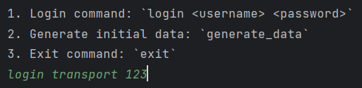

And so the main screen of the transport module looks like:

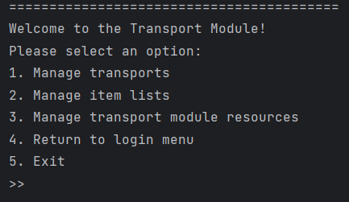

The menus for managing transports and item lists are available from the main menu. however, in order to reach the menus to manage sites, drivers and trucks you will need to go into the "Manage transport module resources" menu, which will reveal further menus which are nearly identical to the other managing menus:

There are explanations printed in place for every functionality that requires user input.

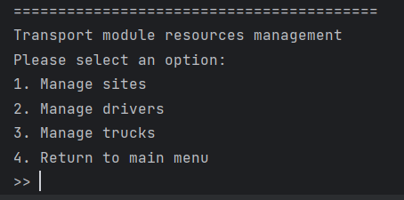

**Generated data:**

**Trucks**

**Drivers**

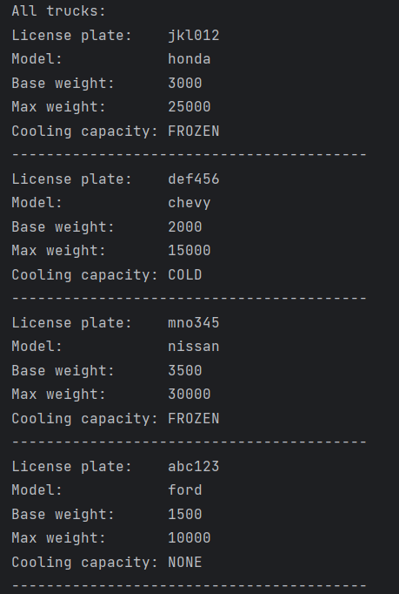

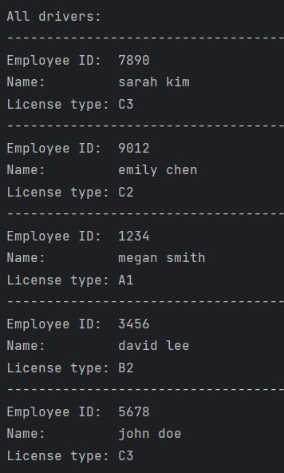

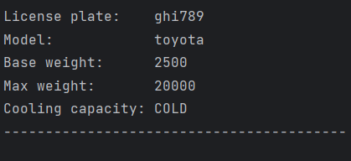

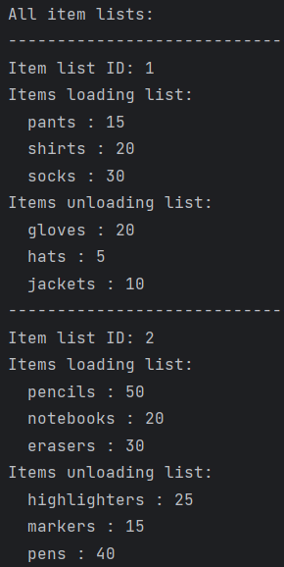

**Item Lists:**

**Transports:**

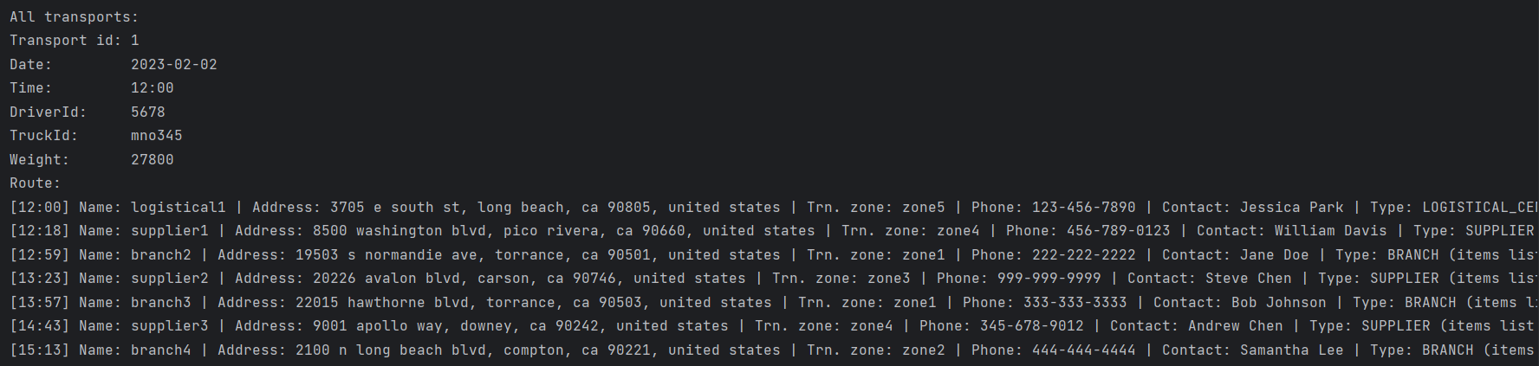

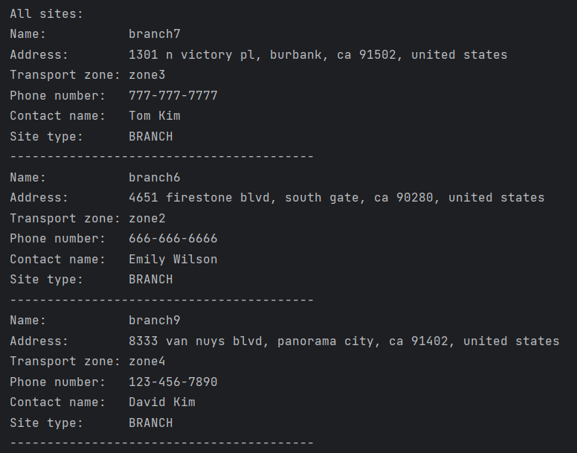

**Sites**