**Title of the Project:**

Natural Language Processing Tasks Performer.

**Problem Statement:**

To design and build a System/Performer with simple GUI for Natural Processing Language Tasks such as:

1. Sentiment analysis.
2. Tokenization**.**
3. EntityRecognition**.**

**Requirements:**

Python 64bit, TextBlob, Tkinter, SpaCy, english-core-web model of SpaCy.

**Objective:**

The objective of this project is to build a GUI to perform some of the NLP tasks such as sentiment analysis, entity recognition, tokenization.

To understand and learn some basic Natural Processing Language tasks mentioned above.

**Abstract:**

With the ongoing growth of the WORLD WIDE WEB and social media, there is a drastic increase in online data. As the amount of data increases the mechanism to process these unstructured data and to extract meaningful information from it becomes more challenging it will be very difficult to find a specific piece of information from a large knowledge base. These challenges and difficulties can be overcome with the NLP techniques.

The application will allow user to perform various NLP tasks such as:

1.Sentiment analysis of a sentence,

2.Tokenization of a sentence,

3.Recognizing Entities from the sentence.

The application is built with very simple and straight forward GUI to make it simple for user to understand and use it. The user has to enter a text, say sentence like ‘the phone is great’ and can perform various NLP tasks provided in the application by just simply clicking on the buttons. Hence it shows that the application is very user-friendly.

**Introduction:**

Natural Language Processing (NLP) is an area of computer science and artificial intelligence concerned with the interactions between computers and human (natural) languages, in particular how to program computer to process and analyse large amount of natural language data. It is the branch of machine learning which is about analysing any text and handling predictive analysis

The NLP techniques are very useful for Sentiment Analysis. It helps to identify the sentiments among several online posts and comments. The business firms make use NLP techniques to know about the customer’s opinion about their product and services from the online reviews.

Tokenization is the first step to proceed with NLP. And, it is important because by this words are identified, demarcated and classified. This only permit to further step in processing but also allows the computer to deal with words in much manageable form.

Named Entity Recognition can automatically scan entire article and reveal which are the major people, organization and places discussed in them.

**System Design:**

In this phase, a logical system is built which fulfils the given requirements. Design phase of software development deals with transforming the customer’s requirements into a logically working system. Normally, design is done in two phases.

**Primary Design Phase:** In this phase, the system is designed at block level. The blocks are created on the basis of analysis done in the problem identification phase. Different blocks are created for different functions emphasis is put on minimising the information flow between blocks. Thus, all activities which require more interaction are kept in one block.

**Secondary Design Phase:** In the secondary phase the detailed design of every block is performed.

**The general tasks involved in the design process are the following:**

1. Design various blocks for overall system process.
2. Design smaller, compact and workable modules in each block.
3. Specify details of program to achieve desired functionality.
4. Design the form of inputs, and outputs of system.
5. Perform documentation of system.
6. System reviews.

**User Interface Design:**

User Interface Design is concerned with the dialogue between a user and the computer. It is concerned with everything from starting the system or logging into the system to the eventually presentation of desired inputs and outputs. The overall flow of screens and messages is called a dialogue.

**Inputs and Output Screens:**

**Home TAB**

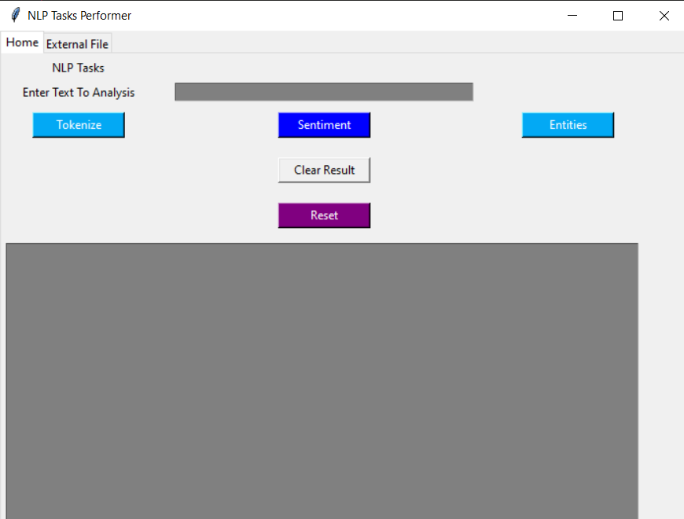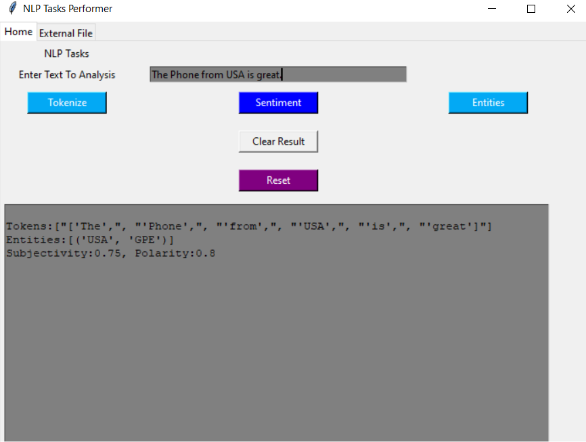

**External File TAB**

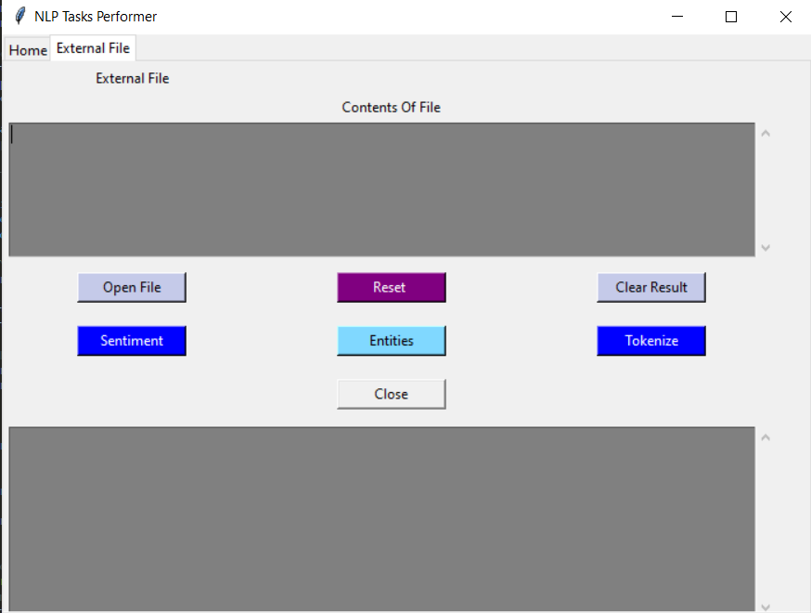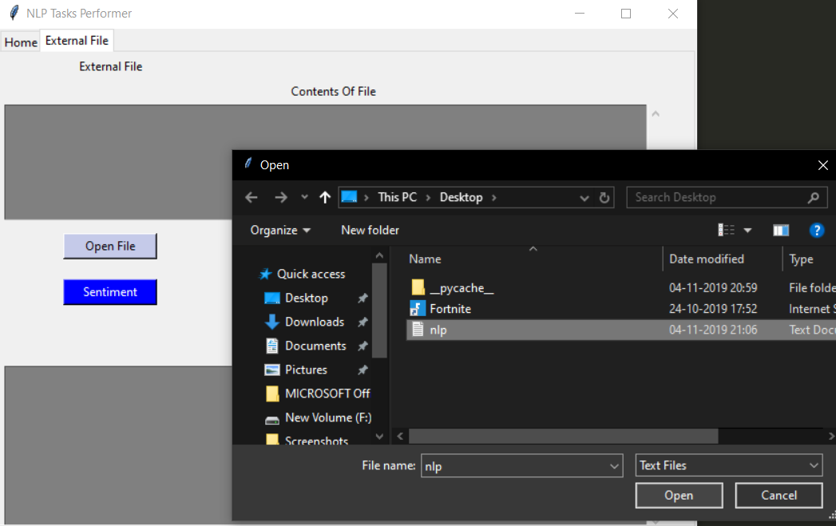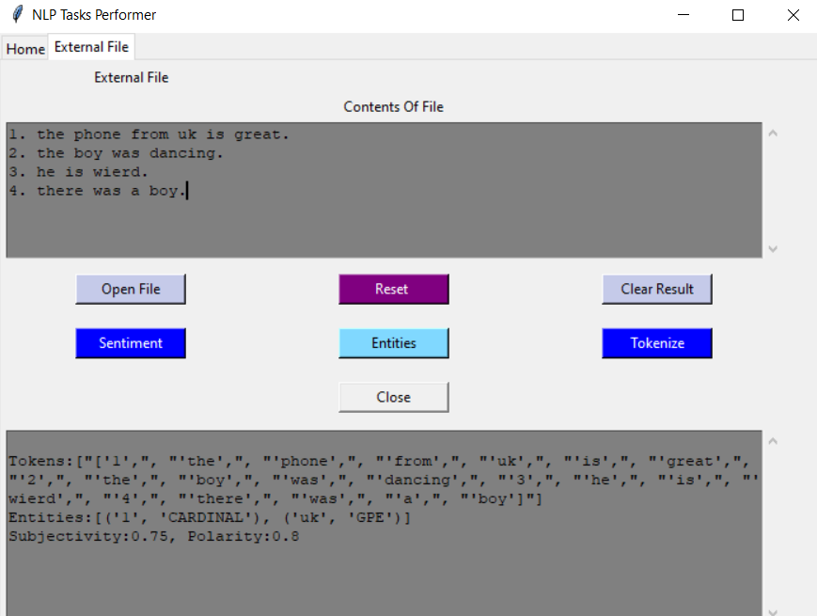

**Conclusion:**

The project “Natural Language Processing Tasks Performer” is for computerizing the working in an organization. It is a great improvement over manual system. The computerized of the system has speed up the process. This system was checked with dummy data and thus is found very reliable.

**References:**

1. Introduction to NLP.

<https://www.google.co.in/amp/s/www.geeksforgeeks.org/introduction-to-natural-language-processing/amp/>

1. Introduction to TextBlob.

<https://textblob.readthedocs.io/en/dev>

1. Introduction to SpaCy.

<https://spacy.io/usage>

1. Introduction to Tkinter.

<https://tkdocs.com/tutorial/intro.html>

1. Guide to understand and implement NLP codes in python.

<https://www.analyticsvidhya.com/blog/2017/01/ultimate-guide-to-implement-understand-natural-language-processing-codes-in-python/>