Switch Led code
module sw_led(input [7:0] sw, output reg [7:0] led);
genvar i;
generate for(i=0;i<8;i=i+1)
begin
always@(sw)
begin
if(sw[i])
led[i]=1;
else
led[i]=0;
end
end
endgenerate
endmodule

TESTBENCH
module sw_tb();
reg [7:0]sw;
wire [7:0]led;
sw_led inst1(.sw(sw),.led(led));
initial
begin
sw=8'b11110000;
#20
sw=8'b00001111;
#20
sw=8'b10101010;
#20
sw=8'b11000110;
$finish;
end
endmodule

SIMULATION CAPTURE

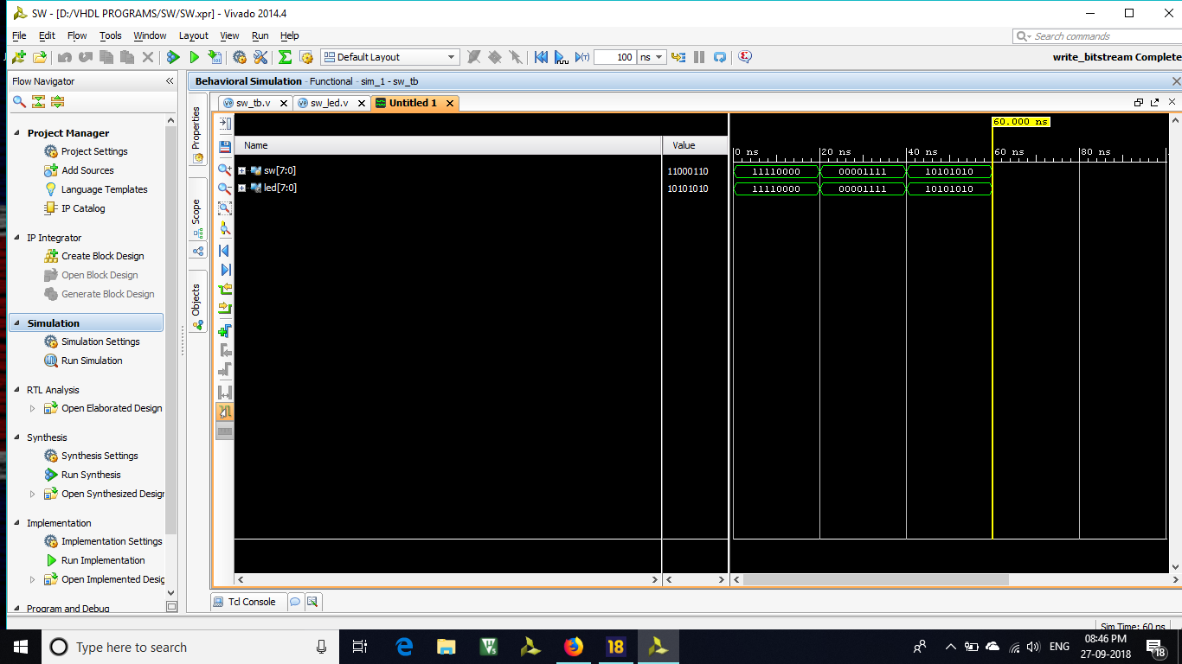

IMPLEMENTATION
