SPF - Stress ProDOS Filesystem

The purpose of SPF is simple: to stress-test the ProDOS filesystem. It can do that in two ways:
- Writes, reads and verifies every byte of a volume
- Benchmarks the time to read and write files and complete volume block-by-block reads

SPF comes on a virtual disk image that can be reconstituted to a physical floppy via ADTPro, or mounted as a virtual floppy disk image on the CFFA3000. The disk a bootable ProDOS volume, and will start up with a simple menu that lets you either start SPF, or quit to Applesoft BASIC:
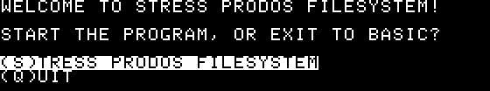

Pressing the S key on the Apple II keyboard will bring up the main menu of SPF:
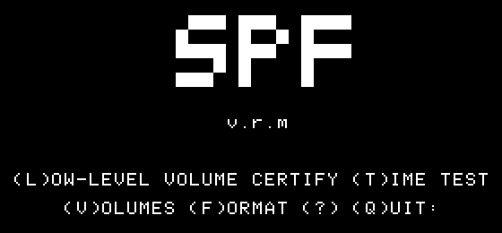

From the main menu of SPF, you can choose any of several options with the Apple II keyboard:
- L - Perform a low-level certification test of a volume
- T - Perform timed benchmarking on a volume
- V - View the volumes currently online in the system
- F - Format a volume
- ? - See the ‘about’ text
- Q - Quit to the ProDOS program selector

Sections on Low-level certification and timed benchmarking follow. Importantly, the low-level certification is a destructive process; it overwrites an entire volume. The timed benchmarking is not destructive.

Low-Level Volume Certify
Hitting the L key on the Apple II, you are presented with a list of available volumes to test:
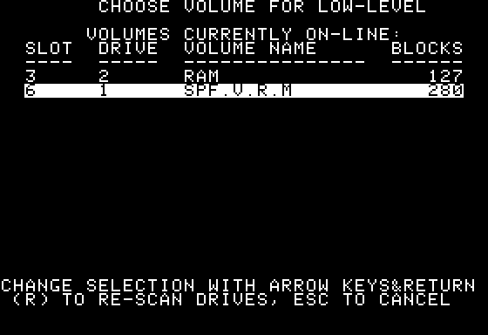

From the low-level volume selection screen, you can choose a volume to test. Note that testing the 127-block RAM disk does not work; but any other real or emulated volume should. Choosing to test the disk in slot 6, drive 1 would of course overwrite and destroy the contents of the SPF diskette itself - but that’s what we’ll test with in this demonstration. When making a selection, you are asked twice to verify that you want to proceed. This is important because all data on the selected volume will be irreparably destroyed.
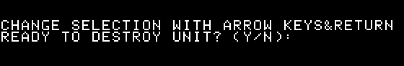

Once testing commences, data will be repeatedly written and read from the chosen volume. The first pass will write the hexadecimal byte $AA (10101010 in binary) to every byte in every block of the volume. Once every byte is read back and verified that it matches, the hexadecimal byte $55 (01010101 in binary) is then written to every byte on the volume, and that is read back and verified too. Once complete, the cycle goes back to $AA bytes, and so on until stopped with the escape key.

On-screen, there will be status updates from time to time: the number of blocks read so far (only updated every 256 blocks), the total number of blocks in the volume under test, and the number of complete “passes” so far - the number of times the entire volume has been filled with a value and read/confirmed that the value was present in every byte. A typical screen might look like this, with the elements identified above circled in yellow:
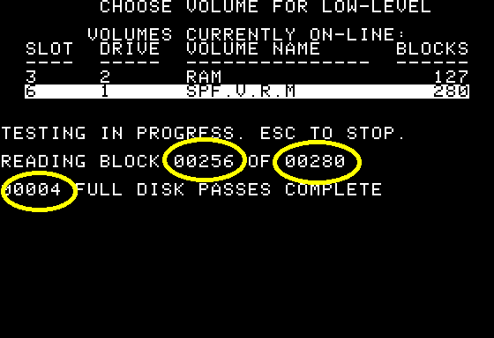

If there are problems with ProDOS read or write MLI calls, that will be indicated on the screen. It will identify whether the read or write operation failed, which block it failed on, and the ProDOS MLI error code associated with the failing call:
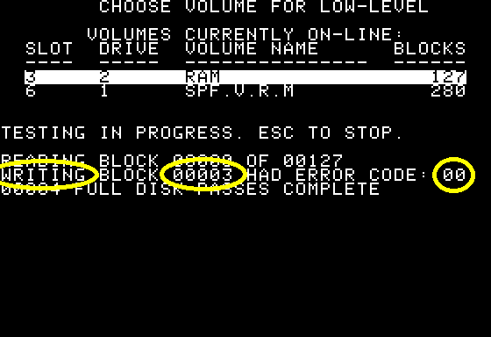

Similarly, if the validation of a byte fails to compare correctly with what was originally written, the message will indicate that the operation was “VRFYING,” and it will include the failing block as well as the value discovered there when either $AA or $55 was expected:

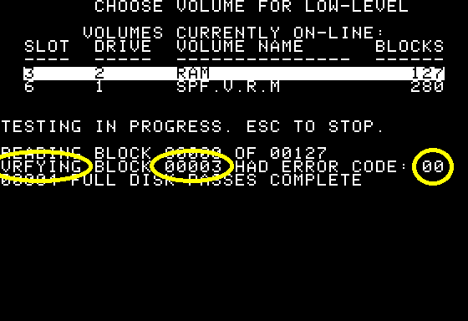

Time Test
Hitting the T key on the Apple II, you are presented with a list of available volumes to test:
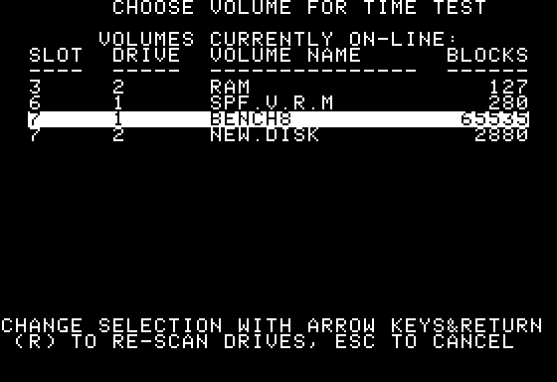

By choosing a volume with the Return key, a non-destructive test will commence. As results are computed, a table will be filled out on the screen:
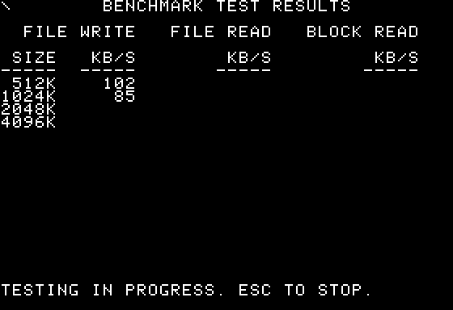

The tests start with writing files of increasing sizes. As the file sizes get larger, the timing gets a little more accurate. If the volume being timed will not hold files of the designated sizes, the write test will stop with the last file that could produced.

The second set of tests is file read timing. Whichever files were able to be created are then read back and timed. Finally, a block-by-block whole-volume read is timed. That way, even if a volume could not hold a file of any given size, it can be timed for read performance.

As the file operations are in progress, a “spinner” is animated in the upper-left corner of the screen to let you know it is working. The operations can be interrupted and canceled at any time with the escape key.

At the completion of all timing runs, the screen pauses to display the final results:
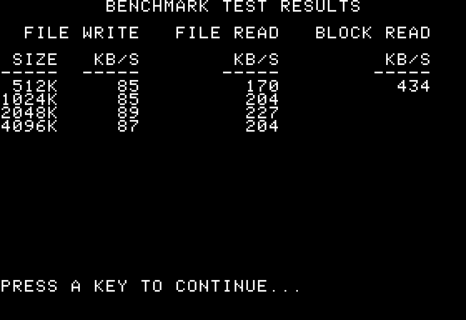

The timing mechanism is not particularly precise; it only operates at the accuracy of within one second.

SPF timing tests will work under ProDOS 8. It supports the built-in clock in the Apple IIGS, the Thunderclock card, and the No-Slot Clock for timing operations.

