Part-A
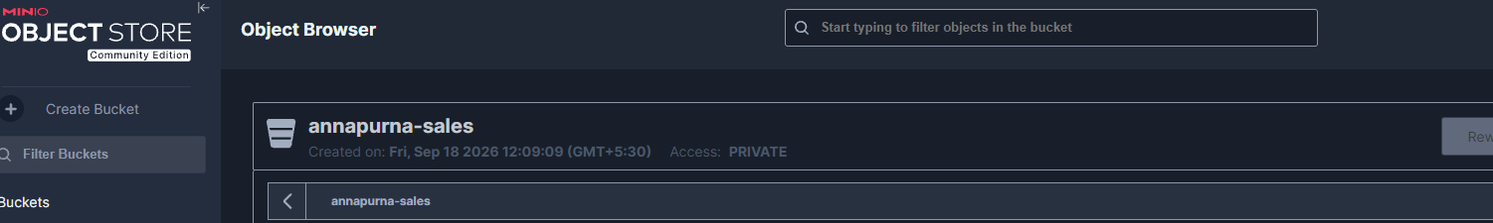
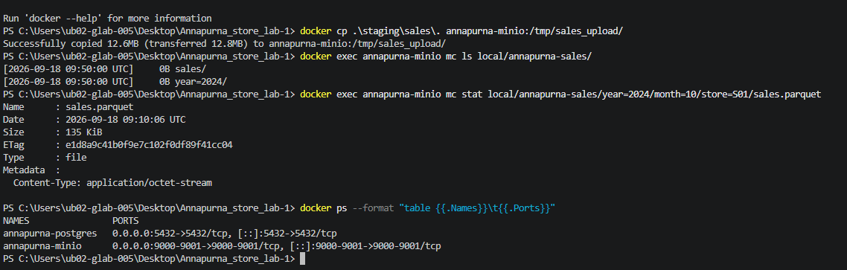

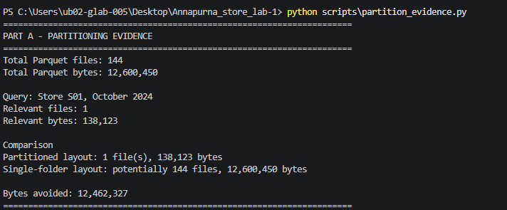
Part-B
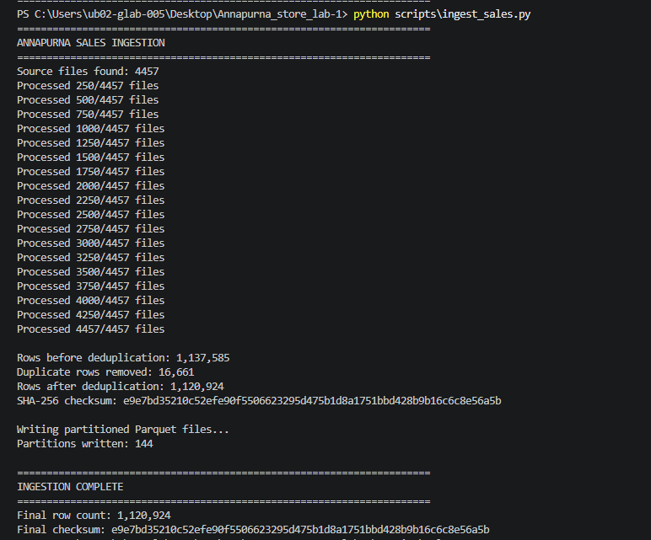

Part-c
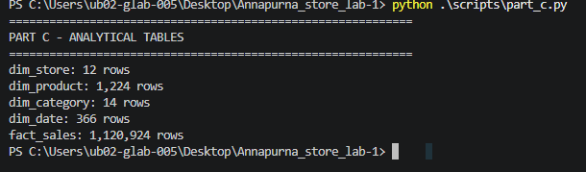
Analytical schema: A dimensional model was created in Duck DB consisting of dim_store, dim_product, dim category, dim_date, and fact_sales. The fact table stores sales transactions using surrogate/dimension keys rather than repeating store and product descriptive information. Only revenue-producing line types are used for revenue analysis, while product identification uses the product's valid date/version rather than product_code alone.

Part-d:
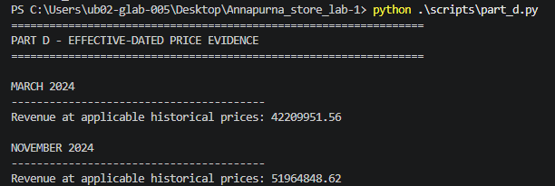
PART -e:
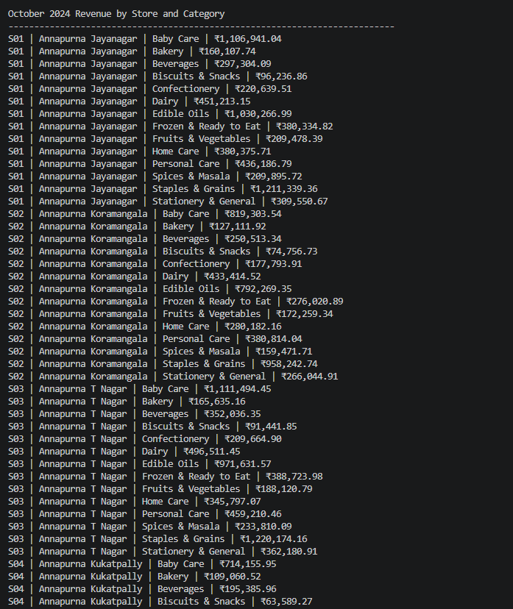
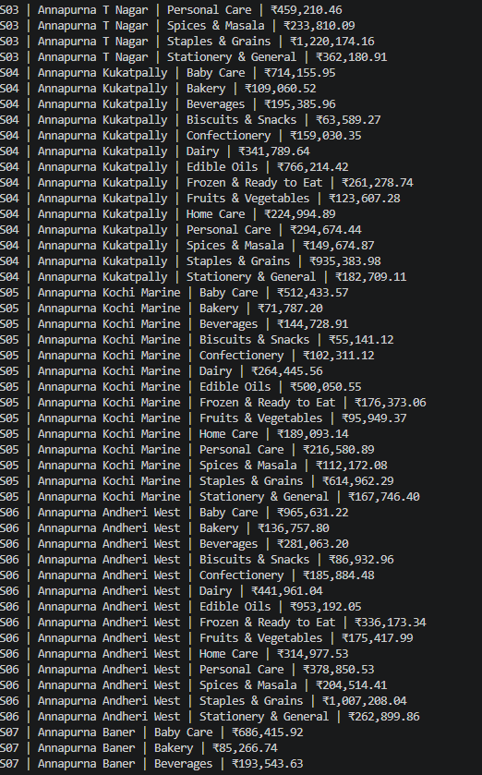

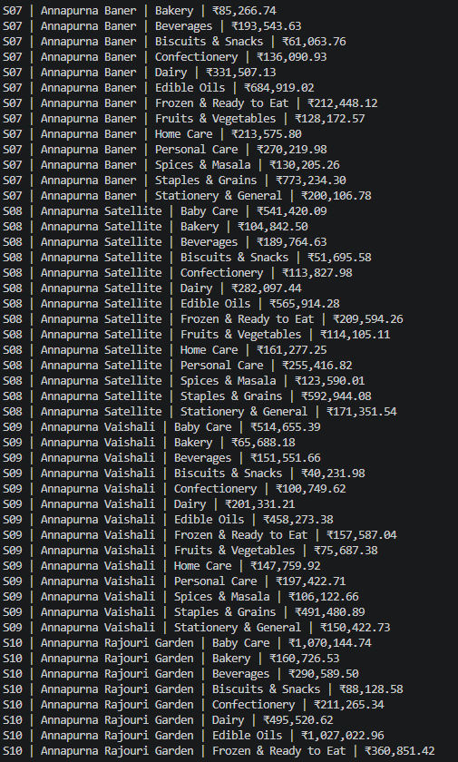

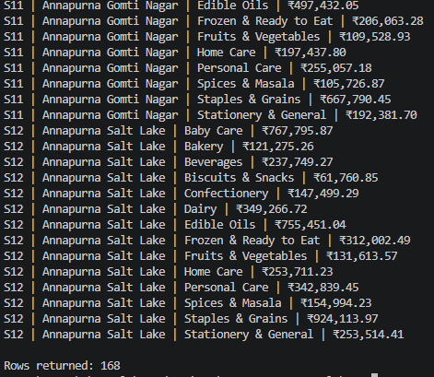
Part e Explain:
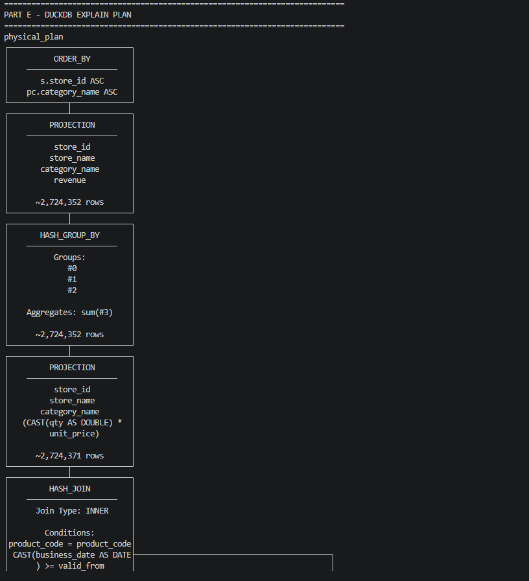
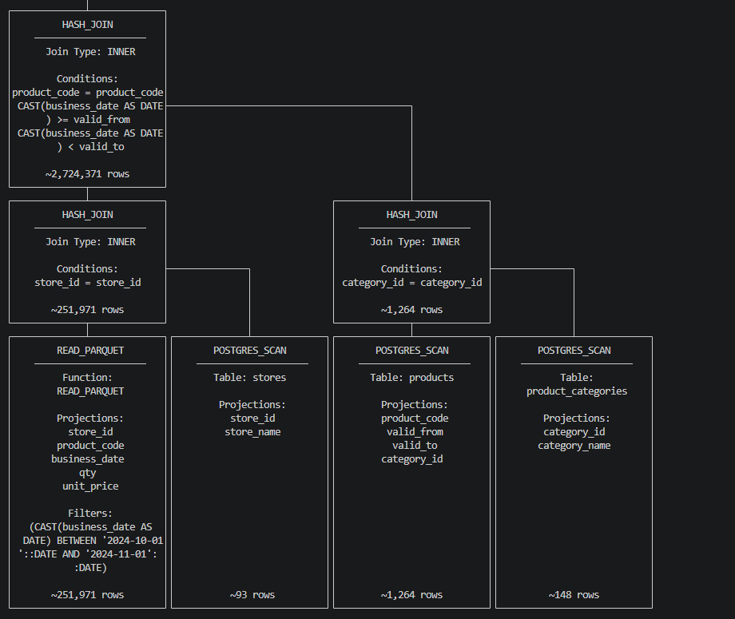

Part F reconciles monthly revenue calculated from the cleaned sales transaction data against the official Finance revenue records, applying the specified transaction-type rules and reporting matches or discrepancies for each month.

