User Guide for using mfgtool

Step 1
For different Projects,we must set switch as below
- Rom-5420
  - Set the correct boot mode, then power on
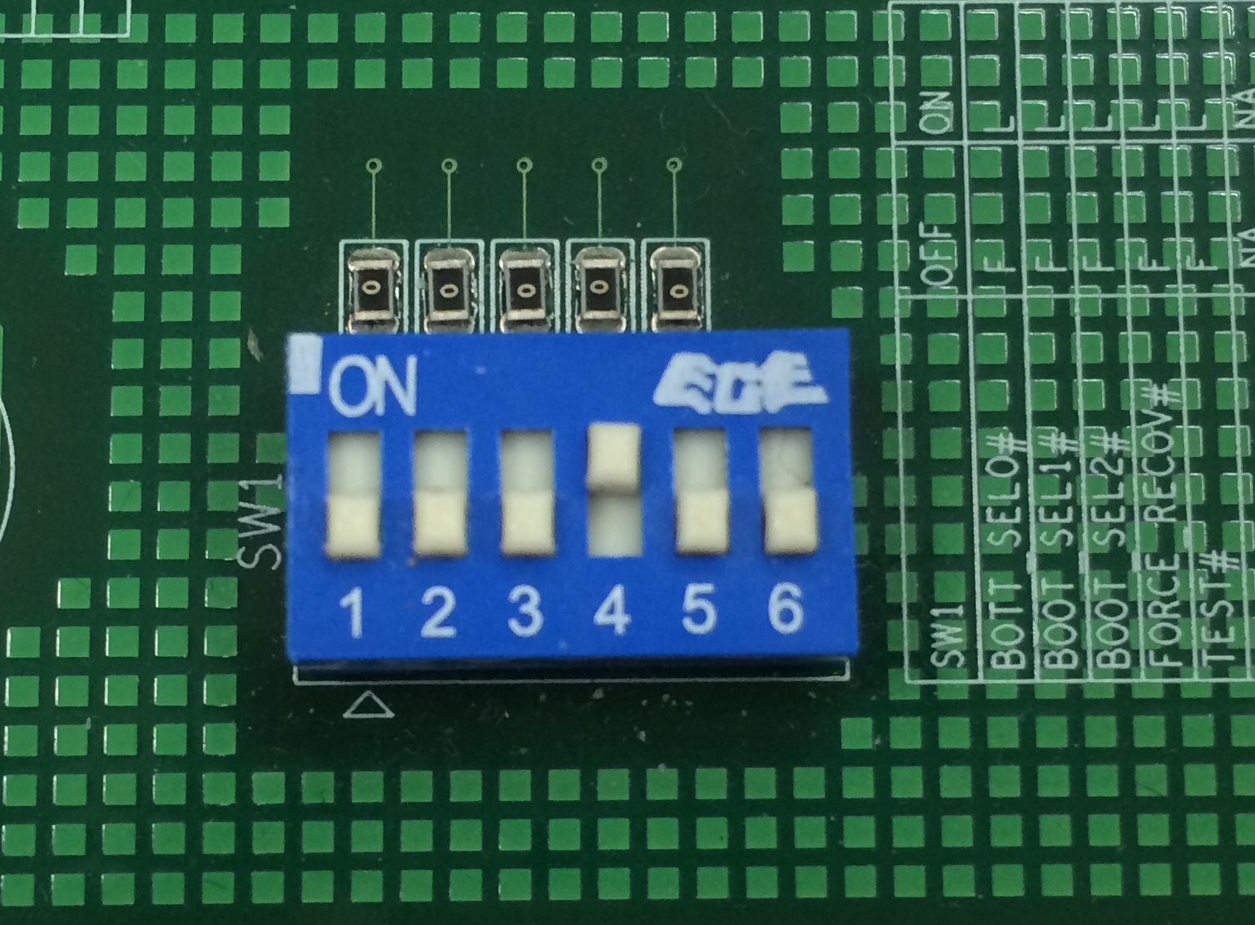
- Rom-3420
  - ATX mode
    - In power off state,press power key for 5 secs and release
  - AT mode
    - Press power key ,then plug AC adapter,release power key after 5 secs
- EBC-RS03
  - 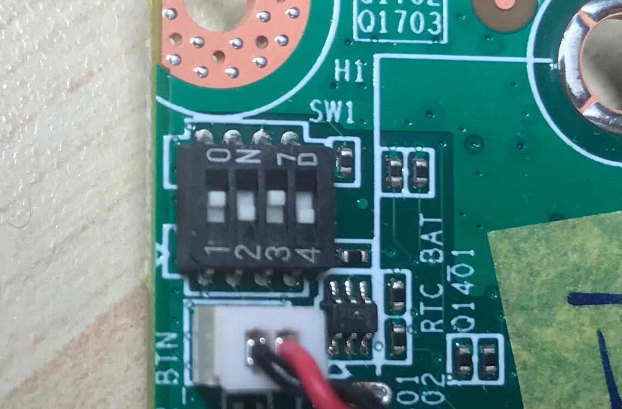
- Other Projects
  - Set end mode,then power on(1-off,2-on)
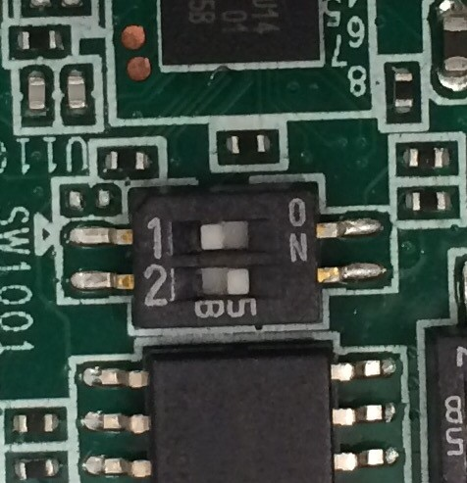
- Connect the OTG to the PC
After connecting to PC, a HID-compliant device will be shown in the Device Manager as shown below:

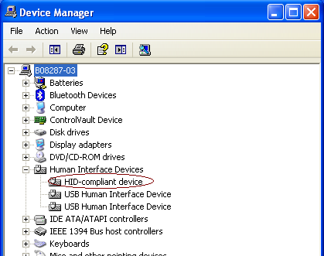

Step 2
- Modify cfg.ini
path: mfgtools/cfg.ini
[profiles]
chip = Linux

[platform]

[LIST]
name = ADV adv-loader & Image

#Projects
imx6q-epcrs200-a1 1G
imx6dl-ebcrs03-a1 1G
imx6dl-ubc220-a1 1G
imx6q-ubc220-a1 1G
imx6q-ebcrb01-a1 1G
imx6q-ebcrs03-a1 2G
imx6qp-rom7421-a1 1G
imx6qp-rom7421-a1 2G
imx6q-rom3420-a1 1G
imx6q-rom3420-a1 2G
imx6q-rom5420-a1 1G
imx6q-rom5420-a1 2G
imx6q-rom5420-b1 1G
imx6dl-rom5420-b1 1G

imx6dl-rom5420-b1 2G
imx6q-rom5420-b1 2G
imx6q-rom7420-a1 1G
imx6q-rom7420-a1 2G
imx6q-rsb4410-a1 1G
imx6q-rsb4410-a2 1G
imx6q-rsb4411-a1 1G
imx6q-epcrs200-a1 1G
imx6q-rsb4411-a1 2G
imx6dl-rom5420-b1 512M
imx6dl-rom7421-a1 1G
imx6dl-rom7421-a1 512M

[variable]
DDR = 1G
board = imx6q-rsb4411-a1
mmc = 0
image = fsl-image-qt5-imx6qrsb4411-20141218174618.rootfs.sdcard

[LIST]
name = (which operation you want to do)
ADV adv-loader & Image adv-loader & Image
ADV kernel update zImage and dtb file
ADV u-boot update u-boot
ADV adv-loader update adv-loader

[variable]
- DDR = (size of memory)
- board= (name of projects)
- mmc = ( “0” means “emmc” ,”1” means “SD Card” .)
- image = (If you want to update whole image,fill the image file name )

Step 3
Copy update file for MFG
- Copy update file(e.g.,SPL、zImage…) to mfgtools\Profiles\Linux\OS Firmware\files\imx6qrsb4411a1-1G\

Step 4
running the MfgTool2.exe and update
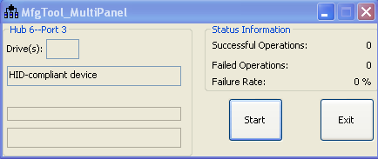
- If you can’t running mfgtool2.exe, you can check MfgTool.log.
- Click “Start”,you can get information form debug console
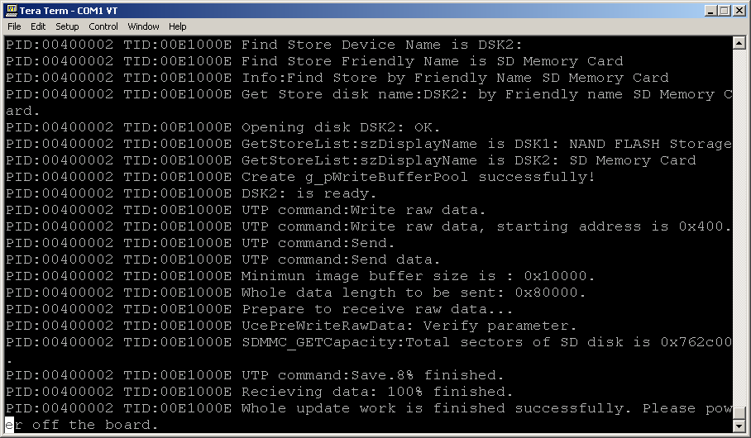
- After update finish,it will be shown below
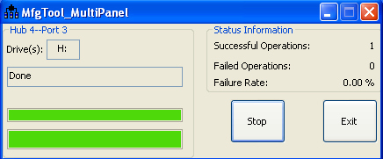
Click “Exit” to terminate the application.

