

i.MX7 [EBC-RM01]
EMI Test User Guide

Released Version:V1.00
Released Date: 2019.01.24

Advantech Co., Ltd.
http://www.advantech.com/
No.33, Lane 365, Yang Guang Street, Neihu District, Taipei, Taiwan 11468,R.O.C.

Advantech Co., Ltd
Risc Embedded Computing Division
http://www.advantech.com/risc

ABSTRACT
This document describes EMI test step for EBC-RM01.

Copyright Notice
This document is copyrighted, 2019, by Advantech Co., Ltd. All rights are reserved. Advantech Co., Ltd. reserves the right to make improvements to the products described in this manual at any time. Specifications are thus subject to change without notice.

No part of this manual may be reproduced, copied, translated, or transmitted in any form or by any means without the prior written permission of Advantech Co., Ltd. Information provided in this manual is intended to be accurate and reliable. However, Advantech Co., Ltd., assumes no responsibility for its use, or for any infringements upon the rights of third parties which may result from its use.

All the trade mark of products and companies mentioned in this data sheet belong to their respective owners.

Copyright © 1983-2019 Advantech Co., Ltd. All Rights Reserved

For more information on this and other Advantech products please visit our website at：
http://www.advantech.com

Part No.
Version: 1.0

Version History
Date | Version | Part no | Remark
2019-01-24 | 1.0 | Alex Cheng | Initial Release
Table of Contents
Advantech Co., Ltd 1
1. Setup Environment Description 5
2. EMI Test Steps 9

Setup Environment Description
  - 電源孔旁邊有一個micro OTG port. 將micro OTG cable的一邊插入USB disk, 另一邊插入OTG port.
  - 最靠近OTG port旁邊有兩個USB port,將兩個USB disk分別插入USB port.
  - 靠近UART port的兩個USB port並不支援.
  - 最靠近OTG port旁邊有兩個USB port的上方LAN port為eth0. Default IP: 192.168.0.1
  - 另一個LAN port為eth1. Default IP: 192.168.1.1
  - 將power cable line(12V)一邊插入測試device,一邊插入電源.當電源開啟後,系統會開始自動開機.
  - 設備連線方式的範例及步驟如下:
    - 準備一台Windows 7 OS的NB和一台Ethernet Hub or 沒有DHCP功能的Ethernet Switch.
    - 準備三條網路線. 插入方式如下:
      - 第一條網路線: 一邊插入NB,另一邊插入Ethernet Hub or 沒有DHCP功能的Ethernet Switch.
      - 第二條網路線: 一邊插入設備的網路孔,另一邊插入Ethernet Hub or 沒有DHCP功能的Ethernet Switch.
      - 第三條網路線: 一邊插入設備的另一個網路孔,另一邊插入Ethernet Hub or 沒有DHCP功能的Ethernet Switch.
  - 將NB的IP設定為支援兩個固定IP: 192.168.0.100 and 192.168.1.100. 設定方式如下圖示:

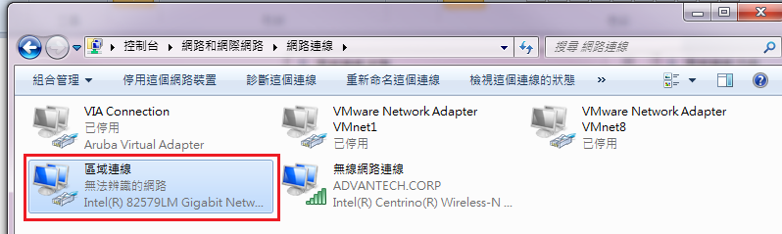

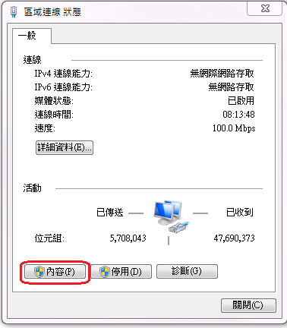

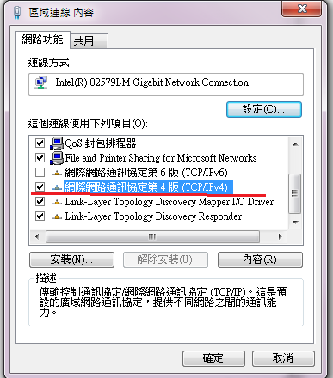

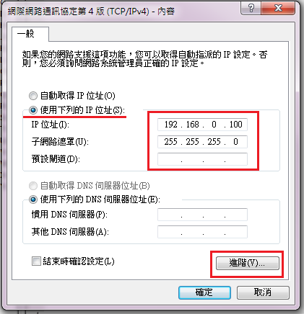

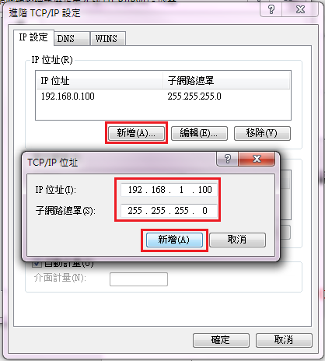

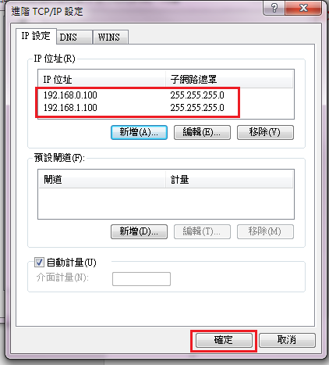

  - 當NB可以成功ping到device的IP(192.168.0.1 and 192.168.1.1)時,便可以開始做EMI測試.
  - 下ㄧ章節為敘述如何執行EMI測試的測試步驟.

EMI Test Steps
  - 當完成上一章節的所有步驟後,可以使用"PuTTY" tool中的SSH方式登入device. 如下圖所示:
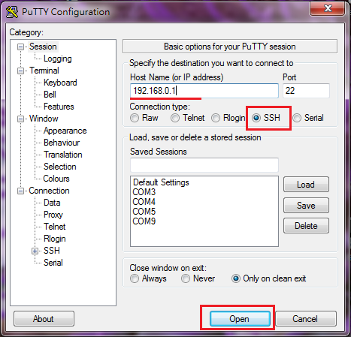

  - 當出現"login as後, Type "root" command and press "Enter" key後,即可登入測試device. 如下圖所示:
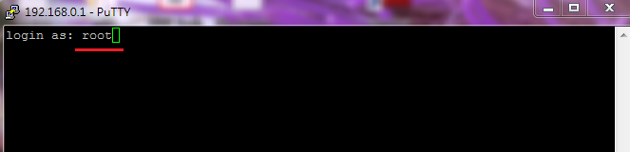
  - 當進入device後, type following command and press "Enter" key後,即可進入tools目錄
    - cd /tools/
  - Type "ls" command後會列出所有檔案
    - emi_otg.sh emi_run emi_usb.sh ppp usb_mount
  - Type following command and press "Enter" key後,即開始做EMI測試
    - ./emi_run

