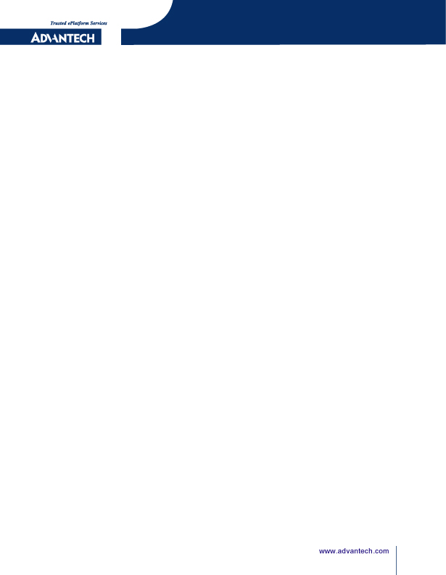

i.MX6 [RSB-3430]
EMI Test User's Guide

Released Version:V1.00
Released Date: 2019.05.09

Advantech Co., Ltd.
http://www.advantech.com/
No.33, Lane 365, Yang Guang Street, Neihu District, Taipei, Taiwan 11468,R.O.C.

Advantech Co., Ltd
Risc Embedded Computing Division
http://www.advantech.com/risc

ABSTRACT
This document describes EMI test steps for RSB-3430.

Copyright Notice
This document is copyrighted, 2019, by Advantech Co., Ltd. All rights are reserved. Advantech Co., Ltd. reserves the right to make improvements to the products described in this manual at any time. Specifications are thus subject to change without notice.

No part of this manual may be reproduced, copied, translated, or transmitted in any form or by any means without the prior written permission of Advantech Co., Ltd. Information provided in this manual is intended to be accurate and reliable. However, Advantech Co., Ltd., assumes no responsibility for its use, or for any infringements upon the rights of third parties which may result from its use.

All the trademark of products and companies mentioned in this data sheet belong to their respective owners.

Copyright © 1983-2019 Advantech Co., Ltd. All Rights Reserved

For more information on this and other Advantech products please visit our website at：
http://www.advantech.com

Part No.
Version: 1.0

Version History
Date | Version | Part no | Remark
2019-05-09 | 1.0 | Daniel Hung | Initial Release
Table of Contents
Advantech Co., Ltd 1
1. Description 5
2. EMI FCC Test Steps 7
3. EMI CE Test Steps 8

Description

1.1 將周邊的介面接上對應的裝置

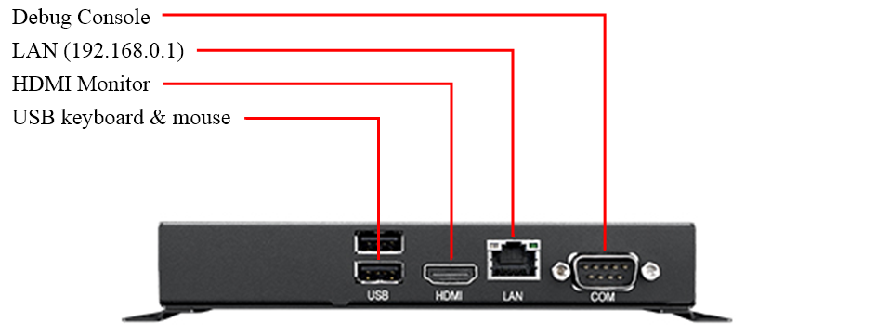

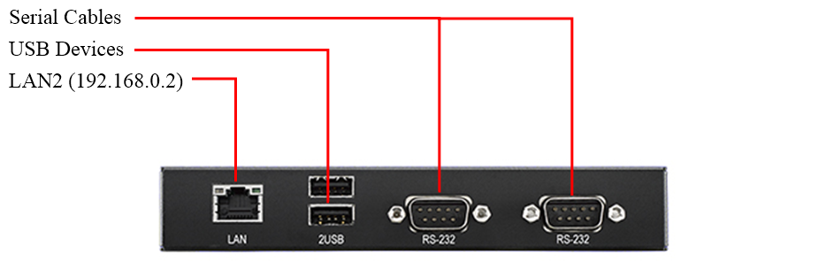

1.2 插入電源線(12V), 系統會立即開機, 接著停在Yocto LOGO畫面

1.3 準備一台NB, 將此NB的IP設為固定IP: 192.168.0.100. 然後準備Hub和網路線, 將NB與待測物的兩個Ethernet Port連接, 並執行 ping 192.168.0.1 和 ping 192.168.0.2 來測試

1.4 EMI測試有分FCC和CE兩種測試項目. 當一種測試項目測試完畢後,必須要重新開機後,再重新測試另一項測試項目. 下面分別敘述FCC和CE兩種測試項目的測試步驟.

EMI FCC Test Steps

- 從Debug Console看到登入提示後, 輸入 root 登入
Freescale i.MX Release Distro 4.1.15-2.1.0 Yocto 2.1 (krogoth) imx6qrsb3430a1 /dev/ttymxc1
imx6qrsb3430a1 login: root

- 切換到 /tools 目錄
root@imx6qrsb3430a1:~# cd /tools/

- 執行以下程式後, 即開始FCC測試
root@imx6qrsb3430a1:/tools# ./emi_run_fcc
dev tty
Console: switching to colour frame buffer device 240x67
console to monitor
pop string

PS. 如果畫面還是維持在 Yocto LOGO圖案, 請用連接於待測物上的鍵盤, 按下 Ctrl + Alt + F1 的組合鍵切換到 framebuffer console畫面

EMI CE Test Steps

  - 從Debug Console看到登入提示後, 輸入 root 登入
Freescale i.MX Release Distro 4.1.15-2.1.0 Yocto 2.1 (krogoth) imx6qrsb3430a1 /dev/ttymxc1
imx6qrsb3430a1 login: root

  - 切換到 /tools 目錄
root@imx6qrsb3430a1:~# cd /tools/

  - 執行以下程式後, 即開始CE測試
root@imx6qrsb3430a1:/tools# ./emi_run_ce
**********************Video play*********************
mxc_v4l2_output v4l2_out: Bypass IC.
mxc_v4l2_output v4l2_out: Bypass IC.

