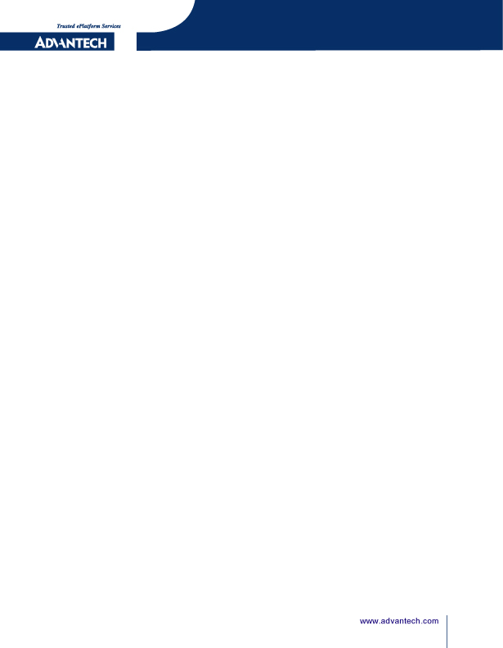

i.MX6 [EBC-RS03]
EMI Test_User's_Guide

Released Version:V1.00
Released Date: 2018.04.13

Advantech Co., Ltd.
http://www.advantech.com/
No.33, Lane 365, Yang Guang Street, Neihu District, Taipei, Taiwan 11468,R.O.C.

Advantech Co., Ltd
Risc Embedded Computing Division
http://www.advantech.com/risc

ABSTRACT
This document describes EMI test step for EBC-RB01.

Copyright Notice
This document is copyrighted, 2017, by Advantech Co., Ltd. All rights are reserved. Advantech Co., Ltd. reserves the right to make improvements to the products described in this manual at any time. Specifications are thus subject to change without notice.

No part of this manual may be reproduced, copied, translated, or transmitted in any form or by any means without the prior written permission of Advantech Co., Ltd. Information provided in this manual is intended to be accurate and reliable. However, Advantech Co., Ltd., assumes no responsibility for its use, or for any infringements upon the rights of third parties which may result from its use.

All the trade mark of products and companies mentioned in this data sheet belong to their respective owners.

Copyright © 1983-2017 Advantech Co., Ltd. All Rights Reserved

For more information on this and other Advantech products please visit our website at：
http://www.advantech.com

Part No.
Version: 1.0

Version History
Date | Version | Part no | Remark
2018-04-13 | 1.0 | Tim Liang | Initial Release
Table of Contents
Advantech Co., Ltd 1
1. Description 5
2. EMI FCC Test Steps 6
3. EMI CE Test Steps 7

Description
- 將HDMI cable插入測試device的HDMI port.
- 插入usb disk.
- 靠RS-485的一個LAN port. Default IP: 192.168.0.1
- 另一個LAN port. Default IP: 192.168.1.1
- 將power cable line(24V)一邊插入測試device,一邊插入電源.系統會開始開機.
  - 當系統開機之後,HDMI螢幕上會出現和停留在白色為底,有圖案和灰階bar的QT畫面.
- 準備一台NB,將此NB的IP設為固定IP: 192.168.0.100. 然後準備一條網路線,一邊插入NB,另一邊插入測試device中最靠近RS-485 port的LAN port (Default IP: 192.168.0.1).
- EMI測試有分FCC和CE兩種測試項目. 當一種測試項目測試完畢後,必須要重新開機後,再重新測試另一項測試項目.
- 下面分別敘述FCC和CE兩種測試項目的測試步驟.

EMI FCC Test Steps
- 當系統重新開機之後,HDMI螢幕上會出現和停留在白色為底,有圖案和灰階bar的QT畫面
- NB ping通測試device後,利用telnet的方式登入device. EX:開啟Dos視窗,type command:
  - telnet 192.168.0.1
- 當出現"imx6qebcrs03 login"訊息後, Type following command and press "Enter"後,即可登入測試device
  - root
- Type following command and press "Enter"後,即可進入tools目錄
  - cd /tools/
- Type "ls" command後會列出所有檔案
  - ls
- Type following command and press "Enter"後,即開始做FCC測試
  - ./emi_run_fcc

EMI CE Test Steps
- 當系統重新開機之後,HDMI螢幕上會出現和停留在白色為底,有圖案和灰階bar的QT畫面
- NB ping通測試device後,利用telnet的方式登入device. EX:開啟Dos視窗,type command:
  - telnet 192.168.0.1
- 當出現"imx6qebcrs03 login"訊息後, Type following command and press "Enter"後,即可登入測試device
  - root
- Type following command and press "Enter"後,即可進入tools目錄
  - cd /tools/
- Type "ls" command後會列出所有檔案
  - ls
- Type following command and press "Enter"後,即開始做CE測試
  - ./ emi_run_ce

