IKS Book Studio

Source-Grounded Publishing

STATUS  Approved |  | OWNER  IKS Book Studio |  | LAST UPDATED  September 2, 2026

Authors | Gaurav Gupta
Reviewers | Engineering · publishing operations
Related docs | README.md · LOCAL_SETUP.md · hosting.json
Scope | Production architecture, safety boundaries, and hardening plan.

1. Abstract
IKS Book Studio is a single-application publishing workflow that turns PDF, DOCX, TXT, or Markdown sources into structured, editable adaptations for readers aged 7–15. A React/Vinext interface talks to one Cloudflare Worker that owns source ingestion, source intelligence, chapter generation, assets, versioning, and exports. D1 stores project metadata and snapshots; R2 stores source chunks and media; OpenRouter supplies Nemotron generation and OCR when required.
The design prioritizes source traceability, resumable work, explicit publication gates, and preservation of completed chapters when external AI calls fail. It supports one owner-scoped workspace per authenticated email (with a development fallback), deploys through OpenAI Sites on Cloudflare bindings, and intentionally keeps high-fidelity PDF composition in the browser. It does not promise semantic-text PDFs, multi-user real-time editing, or fully automatic factual verification.

2. Goals and Non-Goals
Goals | Non-goals
Preserve source structure and bounded chapter evidence. | Automatic verification of every factual claim.
Resume safely after provider, quota, or network failure. | Real-time multi-user editing or approval workflows.
Keep projects, versions, sources, and assets owner-scoped. | Native semantic-text PDF composition in this phase.
Block publication when required content or artwork is incomplete. | Unbounded retries or silent fallback between AI models.

3. Background and Problem Statement
A book adaptation crosses several failure-prone boundaries: large or scanned source files, model quotas, long-running chapter generation, editable page design, and print export. Treating this as one opaque generation request would make failures destructive and provenance hard to inspect. The current code instead stores sources in page-aware chunks, caches completed OCR, generates selected chapters, saves projects and checkpoints, and separates draft proofs from publication-ready output.
The browser owns interaction, page design, preview layout, and canvas-based PDF capture. The Worker owns trust-boundary validation, owner scoping, durable persistence, file parsing, AI calls, and server-side DOCX creation. D1 is authoritative for project JSON and checkpoints; R2 is authoritative for uploaded sources and binary assets. A central invariant guides the system: never replace approved or completed work unless the user explicitly requests a new revision and the replacement passes its validation gate.

4. Proposed Architecture

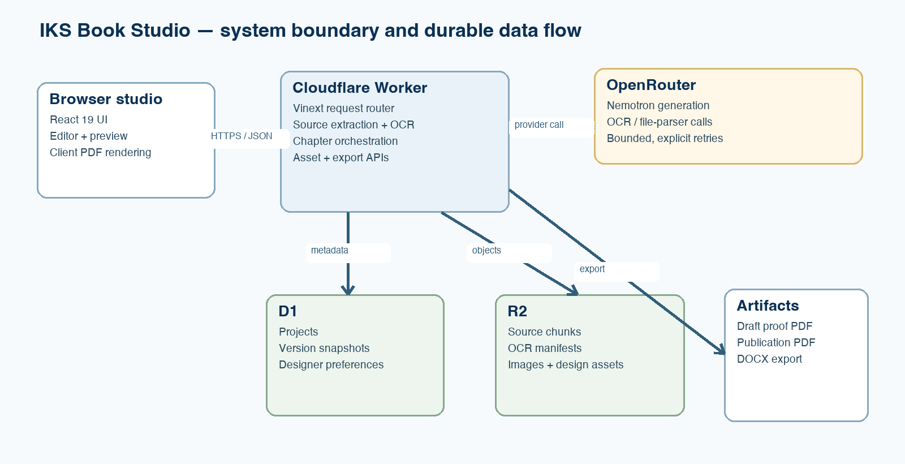
Figure 1. IKS Book Studio deployment and durable data flow.

Core components

Component | Responsibility | Primary storage | Failure behavior
React studio | Workflow, editing, preview, client PDF capture | Browser state + D1 through API | Keeps unsaved UI state; reports API/export failure
Vinext Worker | Routing, validation, orchestration, exports | Cloudflare runtime | Typed status/error response; fail closed
Source intelligence | Parse, chunk, OCR, outline, chapter evidence | R2 manifest + chunks | Resume cached batches; preserve prior output
Project service | Projects, snapshots, preferences, ownership | Cloudflare D1 | No downstream work after required write failure
AI adapter | Nemotron generation and OCR via OpenRouter | No provider payload store | Explicit auth/quota/retryable terminal errors

5. Request Lifecycle
- A user uploads a supported source or opens an existing project. The browser sends an owner header and the source, project identifier, audience, language, adaptation mode, and selected chapter scope.
- The Worker resolves the owner from the authenticated email header (or the explicit studio header in local use), validates method, type, size, key prefix, and required fields, then normalizes source and project inputs.
- Source objects and manifests are loaded from R2; project JSON, versions, and designer preferences are loaded from D1. The selected BookPersona and source-intelligence plan determine chapter context and page budgets.
- Text sources are parsed locally; scans are processed in cached page batches. Nemotron receives only bounded source evidence for the selected chapter and returns structured teaching content that is normalized and scored locally.
- Uploaded source chunks, OCR results, images, and project snapshots are written before later stages depend on them. Completed OCR batches and chapters remain available for resume after quota or network failures.
- Provider calls use fixed token budgets and explicit error classes. Authentication and quota errors stop immediately; temporary network/provider errors are marked retryable, with no hidden unbounded retry loop.
- The browser merges accepted results, saves the project, and exposes preview and export. Draft PDFs remain available with a watermark; publication PDFs are unlocked only when publication blockers are clear.

6. API and Data Contracts

Primary data contract

Field | Type | Required | Description
id | string | Yes | Stable project identifier; owner-scoped in D1.
sourceObjectKey | string | Yes* | Owner-prefixed R2 manifest/object for imported sources.
bookPersona | object | Yes | Audience, writing mode, language, and design choices.
chapters | array | Yes | Ordered source ranges, page plans, content, and approval state.
generation | object | No | Resume state, usage, provider status, and last failure.
designerPages | array | No | Page overrides, history, watermarks, and visibility.
canvaPages | array | No | Returned manual page assets and active/history state.

Contract guarantees

- The Worker validates ownership and required input before reading or writing an owner-scoped object or record.
- Projects, versions, uploads, and assets receive stable project IDs or UUID-based keys; source manifests preserve physical page order and chunk boundaries.
- Saved project JSON captures persona, source reference, chapters, approvals, design overrides, generation state, and asset references needed to resume or inspect the book.
- D1 project JSON is the durable editing source of truth; R2 is the binary/source object store. Rendered previews and exports are derived artifacts, not authoritative content.
The executable contract is maintained in worker/index.ts, db/schema.ts, and the domain modules under lib/.
Contract changes must update those modules, migrations where applicable, and the matching node:test coverage in tests/.

7. Consistency, Idempotency, and Replay

Project saves use an upsert keyed by project ID and owner; named checkpoints are append-only version rows. R2 keys are owner-prefixed, and OCR batches return cached results when the requested engine already completed that chunk. Chapter generation is resumable rather than transactionally atomic across the whole book: a failed chapter does not erase earlier completions. Mid-request provider/model configuration is read once from the Worker environment; saved book inputs remain authoritative for later resumes.
Scenario | Expected behavior | Reasoning
Repeated OCR batch | Return the cached batch for the same engine. | Avoid duplicate provider cost and preserve page order.
D1/R2 write fails | Return an error before dependent processing. | Later work must not rely on missing durable state.
Provider quota/network error | Stop or mark retryable; keep completed chapters. | Resume is safer than regenerating the whole book.
Configuration changes | Current request keeps its captured inputs; resume uses saved project state. | Prevents silent changes to accepted chapters.

8. Security and Privacy Considerations

- Use the platform-provided authenticated email as the owner key; enforce owner predicates on D1 reads/writes and owner-prefixed checks on stored sources.
- Send only the selected, bounded source pages to the provider. Never place source text, API keys, private object keys, or full provider payloads in client logs or user-facing errors.
- OPENROUTER_API_KEY and optional model configuration are Worker secrets. The browser receives connectivity status and usage metadata, never the credential.
- Fail closed for owner mismatch, unsupported files, oversized images, malformed model output, and publication blockers. Preserve completed work for retry and recovery.
- The current repository does not define an automated retention or erasure policy. Before broader use, specify source/asset retention, project deletion semantics, audit needs, and regional requirements.

9. Operational Readiness
Signal | SLO or alert | Owner | Launch gate
Project save success | Baseline p95 and error rate; alert on sustained 5xx | Engineering | Required
Source/OCR completion | Track batch duration, cached ratio, terminal failures | Engineering | Required
Chapter generation | Success, retryable, quota, malformed-output by chapter | Product + engineering | Required
Publication blockers | Zero blockers before publication export | Publishing operations | Required
Export integrity | Sample page count, dimensions, overflow, and filename mode | Publishing operations | Required
Rollout constraint: baseline the existing owner workflow first; canary policy, retention rules, export limits, rollback steps, and alert ownership must be documented before adding collaborators or broader production traffic.

10. Alternatives Considered

Alternative | Why it was considered | Why it was not selected
Browser-only persistence | Simplest prototype and offline editing. | Weak durability, no cross-device recovery, poor source/asset scale.
One monolithic AI request | Minimal orchestration code. | Unsafe for large sources, quota failures, provenance, and resume.
Server-render every PDF page | Centralized rendering and repeatability. | Large implementation shift; current Designer uses browser DOM/CSS.
Separate microservices now | Independent scaling and ownership. | Premature operational complexity for the current workload.

11. Open Questions
- What retention period and deletion workflow should apply to R2 sources, OCR caches, images, and D1 version snapshots?
- Should production remain on the free Nemotron route, or adopt a paid model/SLA with explicit cost budgets and fallback policy?
- Which browser/device matrix and maximum practical book size define the supported client-side PDF export envelope?
- When collaboration is added, who may edit, approve, publish, restore versions, or delete source material within a project?

12. Decision and Next Steps
Retain the Cloudflare Worker + D1 + R2 boundary and the source-grounded, resumable generation model. Before expanding beyond the owner workflow, formalize retention, instrument existing error classes, measure browser export limits, and design versioned roles for publication approval. Start with operational baselining without changing generation semantics.
Milestone | Deliverable | Exit criteria
M1 | Telemetry baseline | Errors and export outcomes are measurable
M2 | Retention policy + recovery drill | Owner data removes without orphaned objects
M3 | Export compatibility matrix | Supported limits pass visual/integrity checks
M4 | Versioned authorization design | Roles, approval, audit, and rollback reviewed

Use footnotes for definitions, assumptions, or terms that need precision without interrupting the main narrative.

