RT/NRT-O.System-Programming

What is a Process?
A process is the execution of a program that allows you to perform the appropriate actions specified in a program. The OS helps you to create, schedule, and terminates the processes which is used by CPU. The other processes created by the main process are called child process.
The process concept is associated by the thread, which is a execution position of the program. A process has always one thread at least, but in some case it can have more threads running in parallel (multitheard).
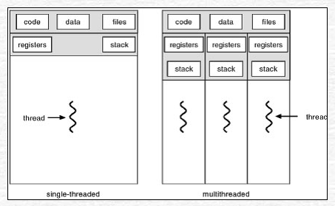

A program has built by compiling the source code getting the object code. It is static entity and doesn’t change during the execution. A process,instead, is a dynamic entity that depends from elaborated data and operations executed on them.
The process is characterized by the executable code and the overall informations that define its state. Every process is represented by the Operating System using a process descriptor called process control block PCB. You can consider it as the brain of the process, which contains all the crucial information related to processing like process id, priority, state, and contents CPU register, etc.
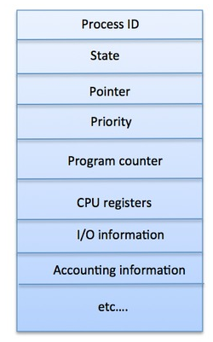

1) Process State: One process changes its state during the execution:
  - new: Process is created.
  - running: The process instructions are executed.
  - waiting : The process is waiting of an event.
  - ready: The process is ready to be executed.
  - terminated : Process completed.
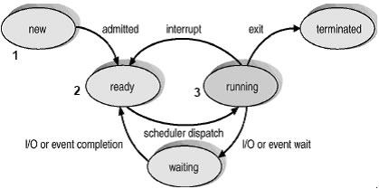

- Program counter: It has address of the next instruction.
- CPU registers: When the CPU interruption occurs, all informations into the registers must be saved in order to restart the process in the proper way .
- CPU Scheduling information: These informations are the priority of the processes and other parameters for the scheduling.
- I/O State: Informations related on I/O devices assigned to a specific process.
When the CPU pass into another process, the system has to save the state of old process (PCB0) and load the new process(PCB1).
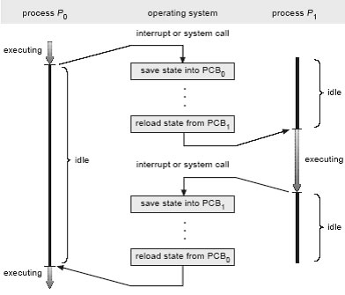
This phase is called context switch. Summarizing, during the context switch, it’s necessary to save the computation state of the process which is in execution state, including also program counter and registers, in order to restart correctly the process in the future. These state informations are saved into the PCB. After, the scheduler will decide a process into the ready process queue based on scheduling policy, and will use the PCB to restart its state into the process in opposite manner explained before.

What is Thread?
As we said a process has the follow information and data:
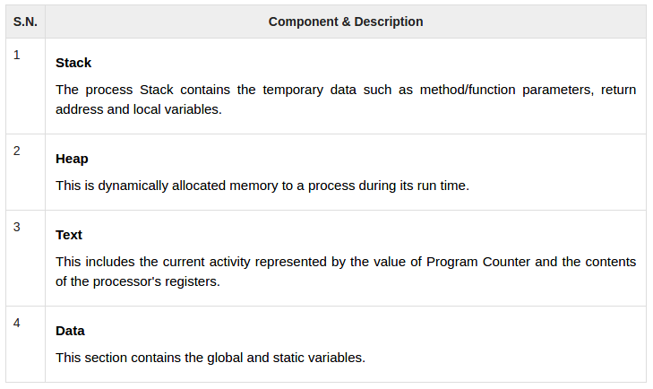
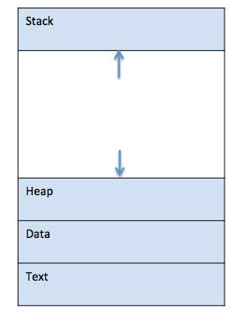

Moreover the file opened and the CPU registers content.
Lets considering to use two process using the same data, How can they share data since they have the own data area?
The data could be exchanged using messages, shared memory or files (Pipes) those mechanism are called inter process communication. In any case could be useful to have process that can work using the same data, considering also that context switch mechanism is heavy. Then the thread concept was born to satisfy to overcome these problems. A normal process has a unique control Thread (filo) that represents the execution instructions of the program that obviously can change between execution depending, for instance, of the input data.
Every thread has its computational state:
- a)Program Counter.
- b)CPU registers.
- c)Stack.
- d)Can share, code, data, file

Sharing the same data e address space, the threads of the same process can see and modify that variables. If one thread modifies a specific variable the others can see the changing. The context switch appends using the threads too in a specific task/process but in this case only the CPU registers and the stack should be saved and restarted which are the only different elements between threads. Code, data and file opened are the same for all threads, should not be changed the the context switch is faster. For this reason, the normal processes are often called heavy-weight process (HWP), while for a single thread is used the light-weight process (LWP) terminology. In order to distinguish which part of the code the thread is performing the system calls are used, allowing the thread creation, synchronization and understand which piece of code the thread is executing.
There are different scheduling policy for thread:
- User-level threads: The OS doesn’t know about the user threads. The exist only in the user level. The context switch is done by libraries called inside the threads. When a thread should be stopped, it will specify who will be the next one. The OS sees the task done by multiple thread like a normal process and it assigns the CPU using the scheduling criteria adopted for the overall system.
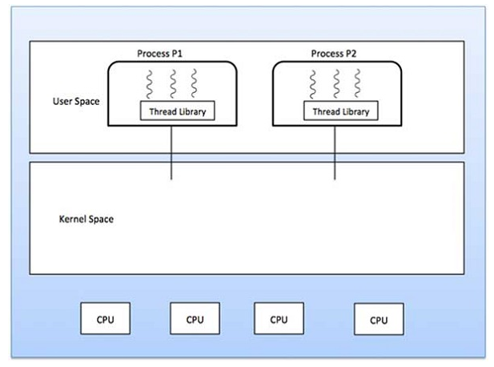
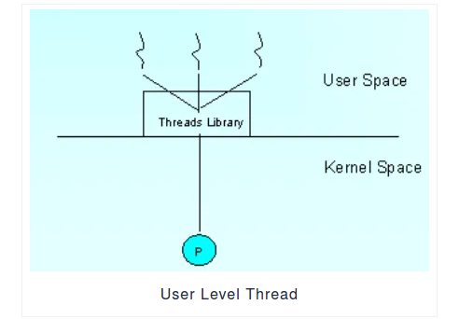

- Kernel-level threads: In this case the OS should manage the data structures for both normal process and peer thread of the a specific task. When a thread terminates the time quantum, the OS is responsible to assign the CPU to another thread of the same task, or another thread of another task or to another normal process. Then, it’s OS that manages a single thread using the time-sharing model.
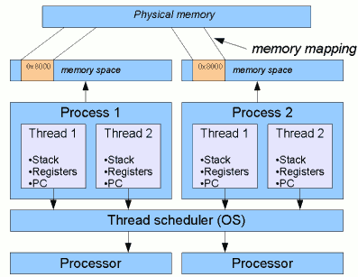
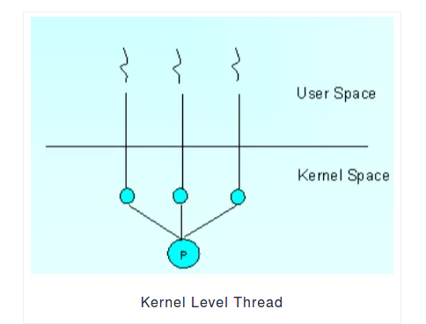

- Hybrid threads.

Properties of Process
Here are the important properties of the process:
- Creation of each process requires separate system calls for each process.
- It is an isolated execution entity and does not share data and information.
- Processes use the IPC(Inter-Process Communication) mechanism for communication that significantly increases the number of system calls.
- Process management takes more system calls.
- A process has its stack, heap memory with memory, and data map.

Properties of Thread
Here are important properties of Thread:
- Single system call can create more than one thread
- Threads share data and information.
- Threads shares instruction, global, and heap regions. However, it has its register and stack.
- Thread management consumes very few, or no system calls because of communication between threads that can be achieved using shared memory.

IPC: Inter Process Communication

1 Named (FIFO)and Anonymous PIPE

1.1 Anonymous pipe
A unidirectional data channel using standard input and output. Data written to the write-end of the pipe is buffered (around 5K dimension) by the operating system until it is read from the read-end of the pipe. Two-way communication between processes can be achieved by using two pipes in opposite "directions".

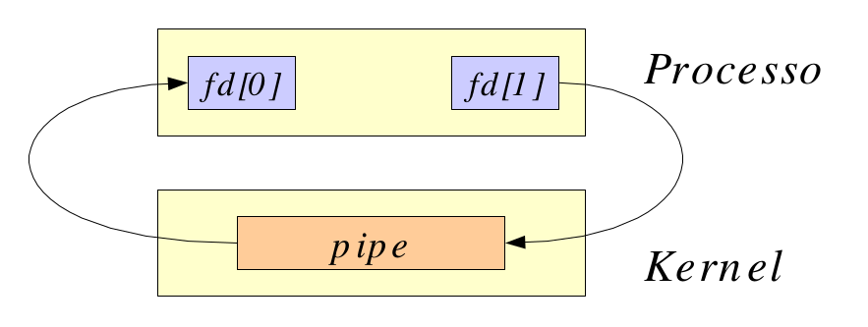

Typical flow of anonymous pipe:

- One process creates a pipe: pipe().
- The process creates a child: fork().
- The writer process close the read pipe end and the reader close the write pipe
end: close().
- The process communicates using write() and read().
- Every process closes its file descriptor when they finish: close().

Note: When a writer process sends a variable length message a communication protocol should be defined for the reader process to identity the end of single message. One possibility is to send the length of the message before sending. Other one is ending the message with a special character like NULL or newline.

1.2 Named (FIFO) pipe

A pipe that is treated like a FIFO file. Instead of using standard input and output as with an anonymous pipe, processes write to and read from a named pipe, as if it were a regular file.
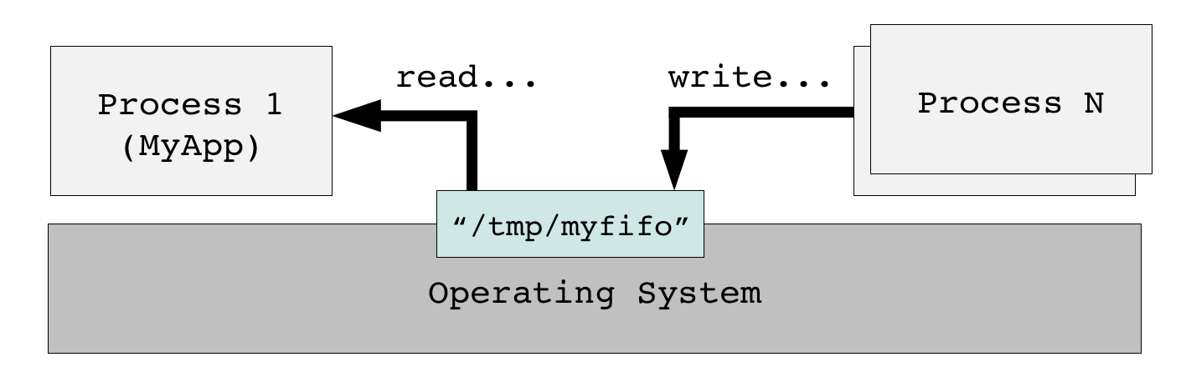

The named pipe are more flexible:
- A special file into the file system is created.
- Theirs usage is not limited only with common ancestor processor. This pipe can be used by any process that knows the name of the file.
- They exist until are not deleting explicitly.
- Their capacity of buffering is up to 40K (macro PIPE_BUF in limits.h);

They are special file that can be create by:
- utility UNIX mknod;
- system call mkfifo();
mknod [-m mode] name p
mknod -m 0660 prova p

Name Pipe Flow:
int mkfifo (const char *path, mode_t mode): create a named pipe.
int open (const char *pathname, int flags): Open a named pipe like a regular pipe.
ssize_t read (int fd, void *buf, size_t count): Read on a named pipe like a regular file.
ssize_t write (int fd, const void *buf,size_t count): Write on a named pipe like a regular file.
int close (int fd): close named pipe.
int unlink (const char *filename): delete named pipe.

2 Shared memory

Shared memory in Linux/UNIX operating systems is based on the concept of memory mapping
Multiple processes are given access to the same block of memory which creates a shared buffer for the processes to communicate with each other.

A POSIX standard has been defined to implement memory mapping application
program interfaces:

shm_open() – opening/creation of a shared memory segment referenced by a
name
- A special file will appear in the file-system under “/dev/shm/” with the provided name.
- The special file represents a POSIX object and it is created for persistence.
- ftruncate(...) function resize to memory region to the correct size.
mmap() – mapping of the memory segment referenced by the file descriptor
returned by shm_open().

munmap() – unmapping of the memory segment

shm_unlink() – removal of shared memory segment object if nobody is
referencing it

Link to POSIX real-time extension library to build (gcc ... -lrt)

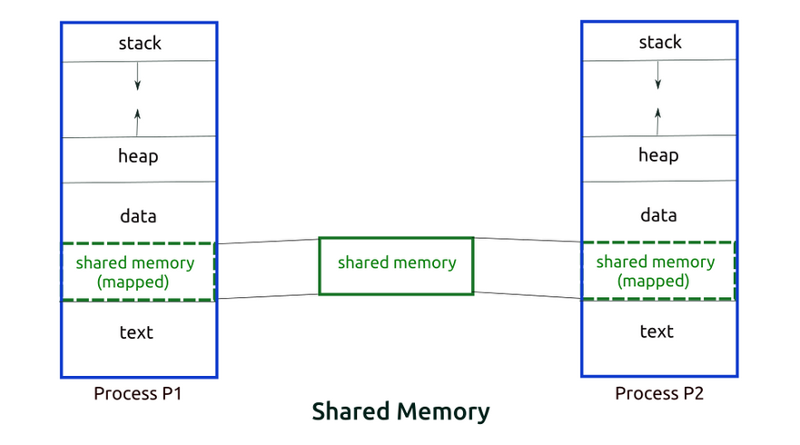

Semaphores

- Concurrency in multi-tasking applications may introduce race conditions we need to protect shared resource.
- Semaphores are examples of structure aiming at solving such a problem in multi-process applications.
- Semaphores are usually system objects managed by the OS kernel.
- Semaphores can be thought as counters that we can manipulate by performing two actions: wait and post.

- If counter value > 0, wait decrements the counter and allows the task to
enter the critical section.
- If counter value = 0, wait blocks the tasks in a waiting list.
- post increments the counter value
  - If the previous value was 0, a task is woken up from the waiting list.

POSIX semaphores
sem_open() – opening/creation of a named semaphore.
Useful for synchronization among unrelated processes.
sem_wait() – Decrement the counter and lock if counter = 0.
Initial counter value can be set to > 1.
sem_post() – Increment the count and unlock the critical section if counter > 0.
sem_close() – Close all the references to the named semaphore.
sem_unlink() – Destroy semaphore object
if all the references have been closed.
Link to POSIX real-time and threads extension library to build (gcc ... -lrt -pthread)

3 Socket

3.1 Internet Socket

Data sent over a network interface, either to a different process on the same computer or to another computer on the network. Stream-oriented (TCP; data written through a socket requires formatting to preserve message boundaries) or more rarely message-oriented (UDP,SCTP).

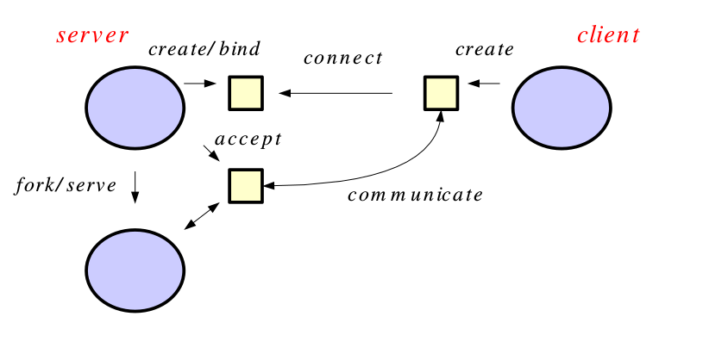

3.2 Unix domain socket

Similar to an internet socket, but all communication occurs within the kernel. Domain sockets use the file system as their address space. Processes reference a domain socket as an inode, and multiple processes can communicate with one socket.

The socket communication is based on client-server model.
The server process creates a socket which name is known by the client process.
The client process communicates with the server using the socket.
The client creates an anonymous socket and does a connection request to the server. If this has success the process give back a file descriptor to the server and client where is possible to read and write on the channel.
Once the connection is stabilised with the client, typically the server creates a child that manages the connection while the original process will continue to accept other clients.

Socket typical flow:

int socket (int domain, int type, int protocol)

Domain:

Identify where the client and server are:

AF_UNIX: client and server are in the same machine.
AF_INET: client and server are somewhere on Internet.

Type:
Communication type between client and server:
SOCK_STREAM: reliable, it preserves the order of the data, specifies on stream of byte and of variable length. When the session is closed the socket will be closed and deleted from the system.
SOCK_DGRAM: unreliable, without a fixed connection, based on variable length messages.
The socket is created for a single communication between processes and
it does not exist before or after the communication. Further communication between the same processes requires a new socket.
Protocol:
It specifies the which low level should be used to implement the socket.
Every socket can use different protocol for the communication:

Stream protocol: like TCP/IP, which ensures the data receiving checking the order of transmission.

Datagram protocol ,like UDP, which doesn’t ensure the reliability of the communication.

Typically is possible to set to zero this parameter to automatically setup the right protocol.

Message queue (MailBox)
A data stream similar to a socket, but which usually preserves message boundaries. Typically implemented by the operating system, they allow multiple processes to read and write to the message queue without being directly connected to each other.

Real Time Inter Process Communication (RTipc)

Cross-Domain Datagram protocol (XDDP)

Cross-domain datagram protocol or XDDP is a type of RT inter- process communication (RTIPC) mechanism offered by Xenomai. It is a message-passing interface based on the RTDM that exports a socket interface and allows a two-way channel communication to exchange datagrams between Xenomai RT tasks and standard Linux threads/processes using regular file operations for simplicity. It connects a socket to a pseudo device file in the standard Linux located in the root filesystem device (/dev) directory.

* XDDP stands for "cross-domain datagram protocol", i.e. to exchange datagrams between the Xenomai (primary) real-time domain, and the Linux realm. This is what the message pipe fans may want to have a look at. Basically, it connects a real-time RTDM socket to one of the /dev/rtp* pseudo-devices. The network port used on the socket side matches the minor device number used on the non RT side. The added bonus of XDDP is that people relying on the POSIX skin may now have access to the message pipe feature, without dragging in bits of the native skin API for that
purpose.

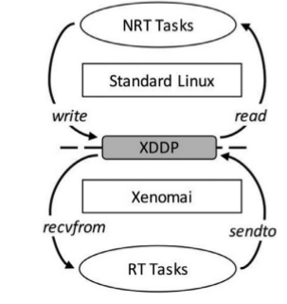

Intra-domain datagram protocol (IDDP)

* IDDP stands for "intra-domain datagram protocol", i.e. a
Xenomai-to-Xenomai real-time datagram channel. This protocol may not be as flexible as POSIX message queues (does not support message priority but does out-of-bound sending though), but exports a socket interface, which is surely better for your brain than mq_*() (ask Gilles). The basic idea behind it is that anything you could do based on AF_UNIX sockets in the Linux realm, should be (mostly) doable with AF_RTIPC+IDDPin the Xenomai domain. However, we use numeric port numbers or label strings, and not socket paths to bind sockets in the Xenomai namespace.

Buffer protocol BUFP

* BUFP stands for "buffer protocol", probably the most naive of all, but likely the best fit when you don't care for message boundaries, and just want an efficient IPC to send a byte stream from a producer to a consumer thread, without leaving the Xenomai domain. This protocol is the exact equivalent of the RT_BUFFER API that came to light earlier in the 2.5.x series, but again, exporting a socket interface to the real-time application.

