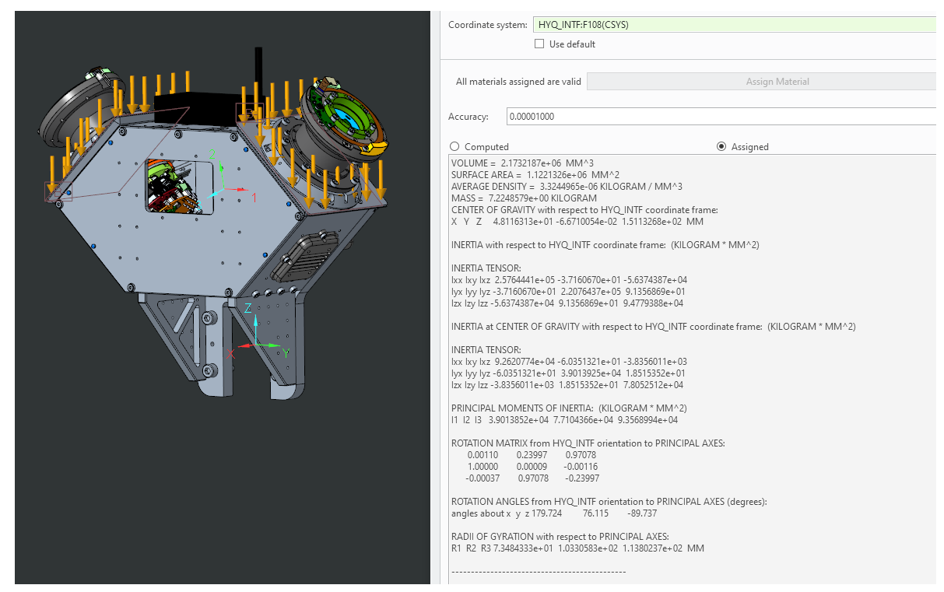

VOLUME = 2.1732187e+06 MM^3

SURFACE AREA = 1.1221326e+06 MM^2

AVERAGE DENSITY = 3.3244965e-06 KILOGRAM / MM^3

MASS = 7.2248579e+00 KILOGRAM

CENTER OF GRAVITY with respect to HYQ_INTF coordinate frame:

X Y Z 4.8116313e+01 -6.6710054e-02 1.5113268e+02 MM

INERTIA with respect to HYQ_INTF coordinate frame: (KILOGRAM * MM^2)

INERTIA TENSOR:

Ixx Ixy Ixz 2.5764441e+05 -3.7160670e+01 -5.6374387e+04

Iyx Iyy Iyz -3.7160670e+01 2.2076437e+05 9.1356869e+01

Izx Izy Izz -5.6374387e+04 9.1356869e+01 9.4779388e+04

INERTIA at CENTER OF GRAVITY with respect to HYQ_INTF coordinate frame: (KILOGRAM * MM^2)

INERTIA TENSOR:

Ixx Ixy Ixz 9.2620774e+04 -6.0351321e+01 -3.8356011e+03

Iyx Iyy Iyz -6.0351321e+01 3.9013925e+04 1.8515352e+01

Izx Izy Izz -3.8356011e+03 1.8515352e+01 7.8052512e+04

PRINCIPAL MOMENTS OF INERTIA: (KILOGRAM * MM^2)

I1 I2 I3 3.9013852e+04 7.7104366e+04 9.3568994e+04

ROTATION MATRIX from HYQ_INTF orientation to PRINCIPAL AXES:

0.00110 0.23997 0.97078

1.00000 0.00009 -0.00116

-0.00037 0.97078 -0.23997

ROTATION ANGLES from HYQ_INTF orientation to PRINCIPAL AXES (degrees):

angles about x y z 179.724 76.115 -89.737

RADII OF GYRATION with respect to PRINCIPAL AXES:

R1 R2 R3 7.3484333e+01 1.0330583e+02 1.1380237e+02 MM

T matrix **Hyq INTF** to **left Shoulder YAW**

