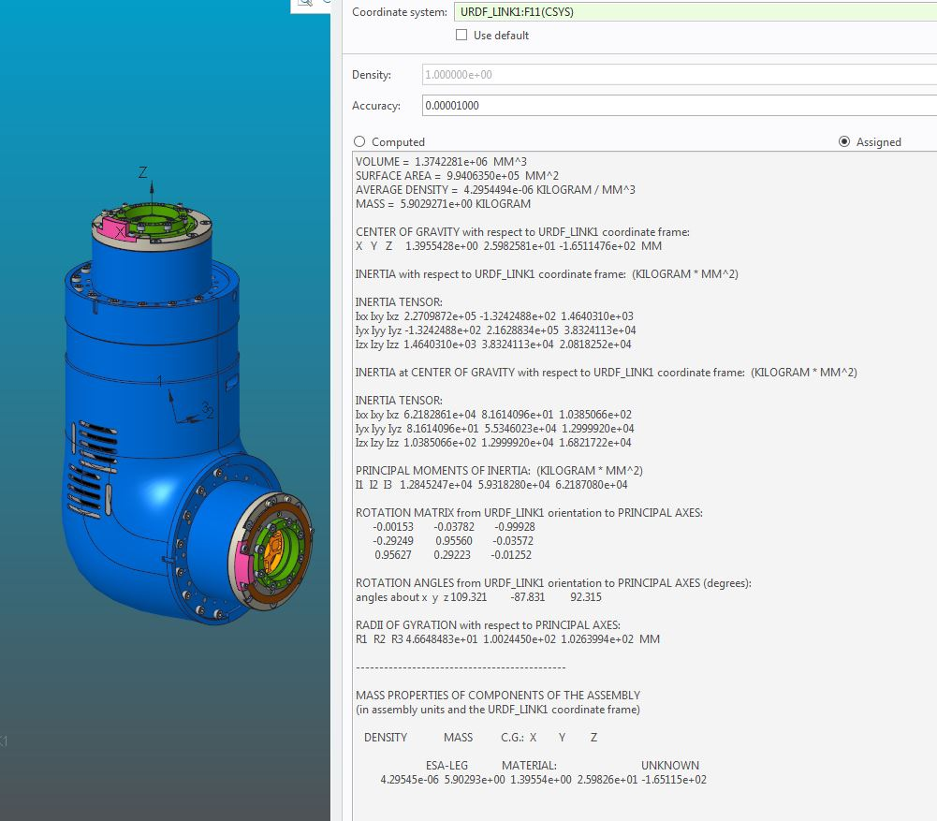VOLUME = 1.3742281e+06 MM^3

SURFACE AREA = 9.9406350e+05 MM^2

AVERAGE DENSITY = 4.2954494e-06 KILOGRAM / MM^3

MASS = 5.9029271e+00 KILOGRAM

CENTER OF GRAVITY with respect to URDF_LINK1 coordinate frame:

X Y Z 1.3955428e+00 2.5982581e+01 -1.6511476e+02 MM

INERTIA with respect to URDF_LINK1 coordinate frame: (KILOGRAM * MM^2)

INERTIA TENSOR:

Ixx Ixy Ixz 2.2709872e+05 -1.3242488e+02 1.4640310e+03

Iyx Iyy Iyz -1.3242488e+02 2.1628834e+05 3.8324113e+04

Izx Izy Izz 1.4640310e+03 3.8324113e+04 2.0818252e+04

INERTIA at CENTER OF GRAVITY with respect to URDF_LINK1 coordinate frame: (KILOGRAM * MM^2)

INERTIA TENSOR:

Ixx Ixy Ixz 6.2182861e+04 8.1614096e+01 1.0385066e+02

Iyx Iyy Iyz 8.1614096e+01 5.5346023e+04 1.2999920e+04

Izx Izy Izz 1.0385066e+02 1.2999920e+04 1.6821722e+04

PRINCIPAL MOMENTS OF INERTIA: (KILOGRAM * MM^2)

I1 I2 I3 1.2845247e+04 5.9318280e+04 6.2187080e+04

ROTATION MATRIX from URDF_LINK1 orientation to PRINCIPAL AXES:

-0.00153 -0.03782 -0.99928

-0.29249 0.95560 -0.03572

0.95627 0.29223 -0.01252

ROTATION ANGLES from URDF_LINK1 orientation to PRINCIPAL AXES (degrees):

angles about x y z 109.321 -87.831 92.315

RADII OF GYRATION with respect to PRINCIPAL AXES:

R1 R2 R3 4.6648483e+01 1.0024450e+02 1.0263994e+02 MM

---------------------------------------------

MASS PROPERTIES OF COMPONENTS OF THE ASSEMBLY

(in assembly units and the URDF_LINK1 coordinate frame)

DENSITY MASS C.G.: X Y Z

ESA-LEG MATERIAL: UNKNOWN

4.29545e-06 5.90293e+00 1.39554e+00 2.59826e+01 -1.65115e+02