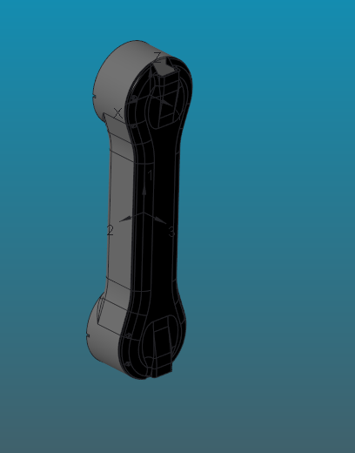

VOLUME = 8.3559404e+05 MM^3

SURFACE AREA = 4.7816149e+05 MM^2

AVERAGE DENSITY = 2.3922685e-06 KILOGRAM / MM^3

MASS = 1.9989653e+00 KILOGRAM

CENTER OF GRAVITY with respect to URDF_LINK2 coordinate frame:

X Y Z 0.0000000e+00 -7.1720374e+00 -2.0000694e+02 MM

INERTIA with respect to URDF_LINK2 coordinate frame: (KILOGRAM * MM^2)

INERTIA TENSOR:

Ixx Ixy Ixz 1.2965653e+05 -2.8293640e-02 2.3464411e+02

Iyx Iyy Iyz -2.8293640e-02 1.3107575e+05 -2.8666533e+03

Izx Izy Izz 2.3464411e+02 -2.8666533e+03 4.1731209e+03

INERTIA at CENTER OF GRAVITY with respect to URDF_LINK2 coordinate frame: (KILOGRAM * MM^2)

INERTIA TENSOR:

Ixx Ixy Ixz 4.9589547e+04 -2.3822174e-02 2.3476881e+02

Iyx Iyy Iyz -2.3822174e-02 5.1111593e+04 7.7698490e-01

Izx Izy Izz 2.3476881e+02 7.7698490e-01 4.0702979e+03

PRINCIPAL MOMENTS OF INERTIA: (KILOGRAM * MM^2)

I1 I2 I3 4.0690871e+03 4.9590758e+04 5.1111593e+04

ROTATION MATRIX from URDF_LINK2 orientation to PRINCIPAL AXES:

-0.00516 0.99999 -0.00001

-0.00002 0.00001 1.00000

0.99999 0.00516 0.00002

ROTATION ANGLES from URDF_LINK2 orientation to PRINCIPAL AXES (degrees):

angles about x y z -89.999 0.000 -90.295

RADII OF GYRATION with respect to PRINCIPAL AXES:

R1 R2 R3 4.5117587e+01 1.5750623e+02 1.5990317e+02 MM

---------------------------------------------

MASS PROPERTIES OF COMPONENTS OF THE ASSEMBLY

(in assembly units and the URDF_LINK2 coordinate frame)

DENSITY MASS C.G.: X Y Z

ESA-LEG MATERIAL: UNKNOWN

2.39227e-06 1.99897e+00 -3.11890e-04 -7.17204e+00 -2.00007e+02