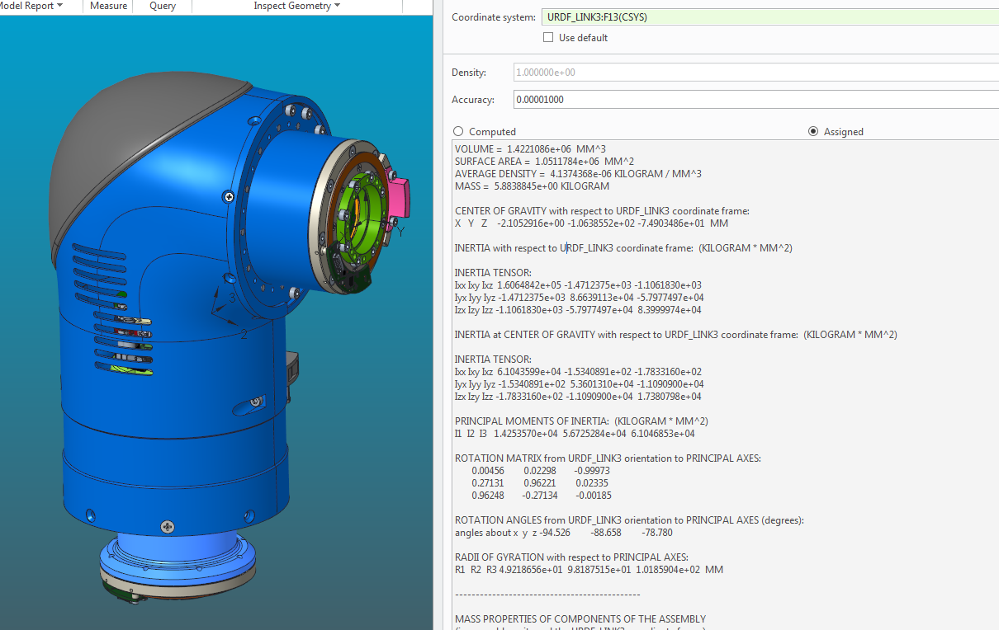VOLUME = 1.4221086e+06 MM^3

SURFACE AREA = 1.0511784e+06 MM^2

AVERAGE DENSITY = 4.1374368e-06 KILOGRAM / MM^3

MASS = 5.8838845e+00 KILOGRAM

CENTER OF GRAVITY with respect to URDF_LINK3 coordinate frame:

X Y Z -2.1052916e+00 -1.0638552e+02 -7.4903486e+01 MM

INERTIA with respect to URDF_LINK3 coordinate frame: (KILOGRAM * MM^2)

INERTIA TENSOR:

Ixx Ixy Ixz 1.6064842e+05 -1.4712375e+03 -1.1061830e+03

Iyx Iyy Iyz -1.4712375e+03 8.6639113e+04 -5.7977497e+04

Izx Izy Izz -1.1061830e+03 -5.7977497e+04 8.3999974e+04

INERTIA at CENTER OF GRAVITY with respect to URDF_LINK3 coordinate frame: (KILOGRAM * MM^2)

INERTIA TENSOR:

Ixx Ixy Ixz 6.1043599e+04 -1.5340891e+02 -1.7833160e+02

Iyx Iyy Iyz -1.5340891e+02 5.3601310e+04 -1.1090900e+04

Izx Izy Izz -1.7833160e+02 -1.1090900e+04 1.7380798e+04

PRINCIPAL MOMENTS OF INERTIA: (KILOGRAM * MM^2)

I1 I2 I3 1.4253570e+04 5.6725284e+04 6.1046853e+04

ROTATION MATRIX from URDF_LINK3 orientation to PRINCIPAL AXES:

0.00456 0.02298 -0.99973

0.27131 0.96221 0.02335

0.96248 -0.27134 -0.00185

ROTATION ANGLES from URDF_LINK3 orientation to PRINCIPAL AXES (degrees):

angles about x y z -94.526 -88.658 -78.780

RADII OF GYRATION with respect to PRINCIPAL AXES:

R1 R2 R3 4.9218656e+01 9.8187515e+01 1.0185904e+02 MM

---------------------------------------------

MASS PROPERTIES OF COMPONENTS OF THE ASSEMBLY

(in assembly units and the URDF_LINK3 coordinate frame)

DENSITY MASS C.G.: X Y Z

ESA-LEG MATERIAL: UNKNOWN

4.13744e-06 5.88388e+00 -2.10529e+00 -1.06386e+02 -7.49035e+01