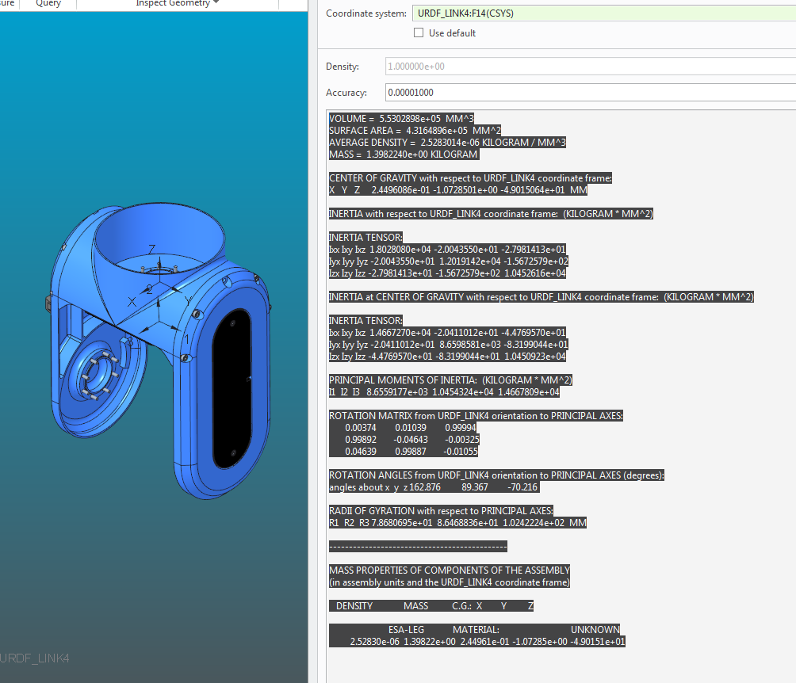VOLUME = 5.5302898e+05 MM^3

SURFACE AREA = 4.3164896e+05 MM^2

AVERAGE DENSITY = 2.5283014e-06 KILOGRAM / MM^3

MASS = 1.3982240e+00 KILOGRAM

CENTER OF GRAVITY with respect to URDF_LINK4 coordinate frame:

X Y Z 2.4496086e-01 -1.0728501e+00 -4.9015064e+01 MM

INERTIA with respect to URDF_LINK4 coordinate frame: (KILOGRAM * MM^2)

INERTIA TENSOR:

Ixx Ixy Ixz 1.8028080e+04 -2.0043550e+01 -2.7981413e+01

Iyx Iyy Iyz -2.0043550e+01 1.2019142e+04 -1.5672579e+02

Izx Izy Izz -2.7981413e+01 -1.5672579e+02 1.0452616e+04

INERTIA at CENTER OF GRAVITY with respect to URDF_LINK4 coordinate frame: (KILOGRAM * MM^2)

INERTIA TENSOR:

Ixx Ixy Ixz 1.4667270e+04 -2.0411012e+01 -4.4769570e+01

Iyx Iyy Iyz -2.0411012e+01 8.6598581e+03 -8.3199044e+01

Izx Izy Izz -4.4769570e+01 -8.3199044e+01 1.0450923e+04

PRINCIPAL MOMENTS OF INERTIA: (KILOGRAM * MM^2)

I1 I2 I3 8.6559177e+03 1.0454324e+04 1.4667809e+04

ROTATION MATRIX from URDF_LINK4 orientation to PRINCIPAL AXES:

0.00374 0.01039 0.99994

0.99892 -0.04643 -0.00325

0.04639 0.99887 -0.01055

ROTATION ANGLES from URDF_LINK4 orientation to PRINCIPAL AXES (degrees):

angles about x y z 162.876 89.367 -70.216

RADII OF GYRATION with respect to PRINCIPAL AXES:

R1 R2 R3 7.8680695e+01 8.6468836e+01 1.0242224e+02 MM

---------------------------------------------

MASS PROPERTIES OF COMPONENTS OF THE ASSEMBLY

(in assembly units and the URDF_LINK4 coordinate frame)

DENSITY MASS C.G.: X Y Z

ESA-LEG MATERIAL: UNKNOWN

2.52830e-06 1.39822e+00 2.44961e-01 -1.07285e+00 -4.90151e+01