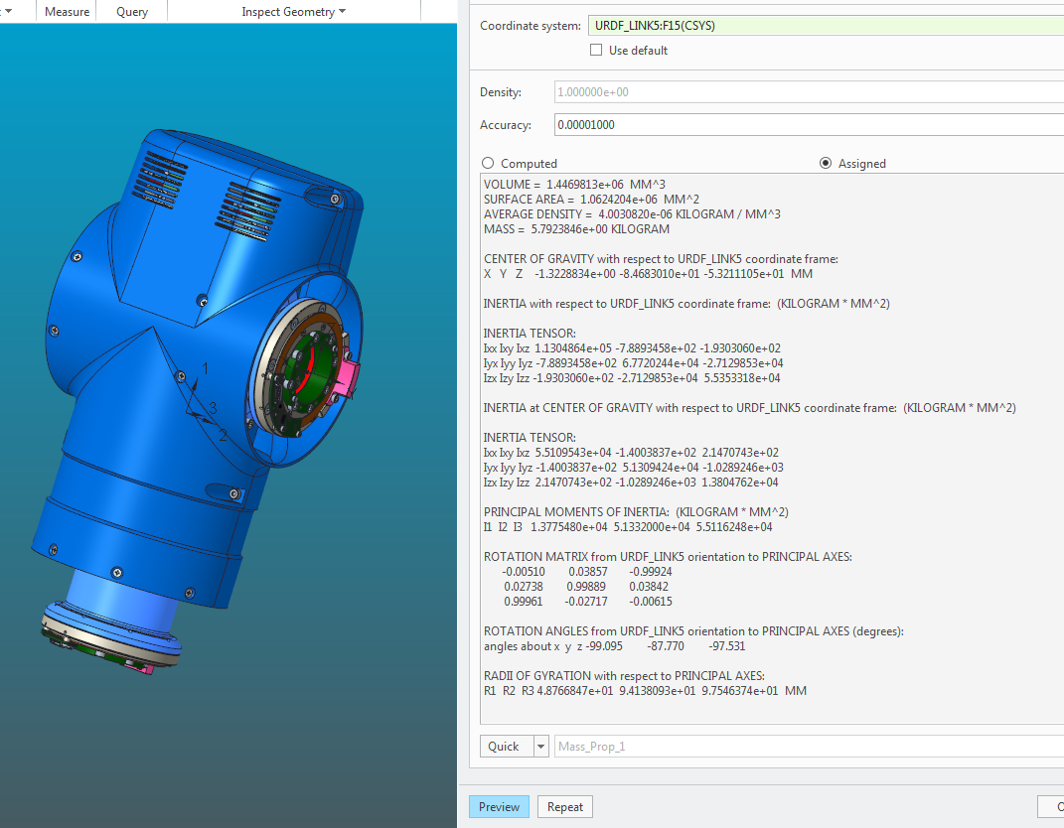VOLUME = 1.4469813e+06 MM^3

SURFACE AREA = 1.0624204e+06 MM^2

AVERAGE DENSITY = 4.0030820e-06 KILOGRAM / MM^3

MASS = 5.7923846e+00 KILOGRAM

CENTER OF GRAVITY with respect to URDF_LINK5 coordinate frame:

X Y Z -1.3228834e+00 -8.4683010e+01 -5.3211105e+01 MM

INERTIA with respect to URDF_LINK5 coordinate frame: (KILOGRAM * MM^2)

INERTIA TENSOR:

Ixx Ixy Ixz 1.1304864e+05 -7.8893458e+02 -1.9303060e+02

Iyx Iyy Iyz -7.8893458e+02 6.7720244e+04 -2.7129853e+04

Izx Izy Izz -1.9303060e+02 -2.7129853e+04 5.5353318e+04

INERTIA at CENTER OF GRAVITY with respect to URDF_LINK5 coordinate frame: (KILOGRAM * MM^2)

INERTIA TENSOR:

Ixx Ixy Ixz 5.5109543e+04 -1.4003837e+02 2.1470743e+02

Iyx Iyy Iyz -1.4003837e+02 5.1309424e+04 -1.0289246e+03

Izx Izy Izz 2.1470743e+02 -1.0289246e+03 1.3804762e+04

PRINCIPAL MOMENTS OF INERTIA: (KILOGRAM * MM^2)

I1 I2 I3 1.3775480e+04 5.1332000e+04 5.5116248e+04

ROTATION MATRIX from URDF_LINK5 orientation to PRINCIPAL AXES:

-0.00510 0.03857 -0.99924

0.02738 0.99889 0.03842

0.99961 -0.02717 -0.00615

ROTATION ANGLES from URDF_LINK5 orientation to PRINCIPAL AXES (degrees):

angles about x y z -99.095 -87.770 -97.531

RADII OF GYRATION with respect to PRINCIPAL AXES:

R1 R2 R3 4.8766847e+01 9.4138093e+01 9.7546374e+01 MM

---------------------------------------------

MASS PROPERTIES OF COMPONENTS OF THE ASSEMBLY

(in assembly units and the URDF_LINK5 coordinate frame)

DENSITY MASS C.G.: X Y Z

ESA-LEG MATERIAL: UNKNOWN

4.00308e-06 5.79238e+00 -1.32288e+00 -8.46830e+01 -5.32111e+01