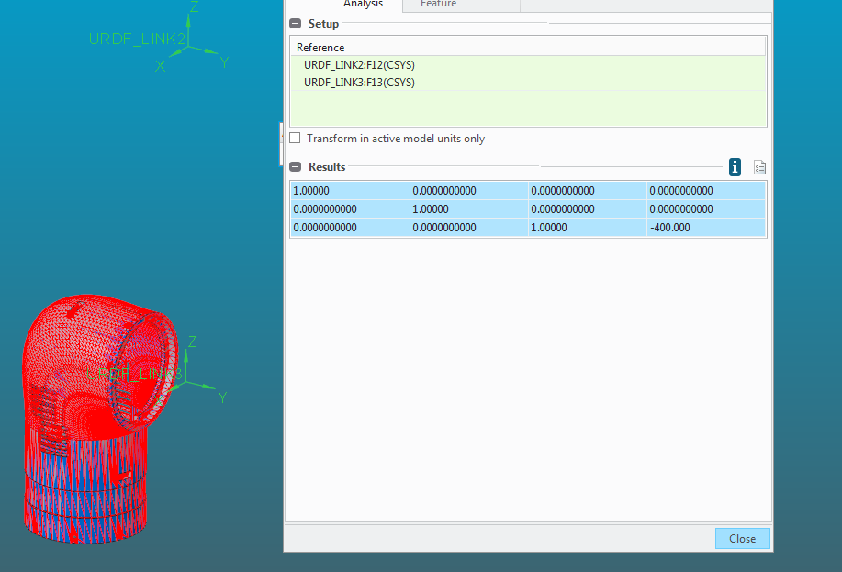1.00000 0.0000000000 0.0000000000 0.0000000000

0.0000000000 1.00000 0.0000000000 0.0000000000

0.0000000000 0.0000000000 1.00000 -400.000