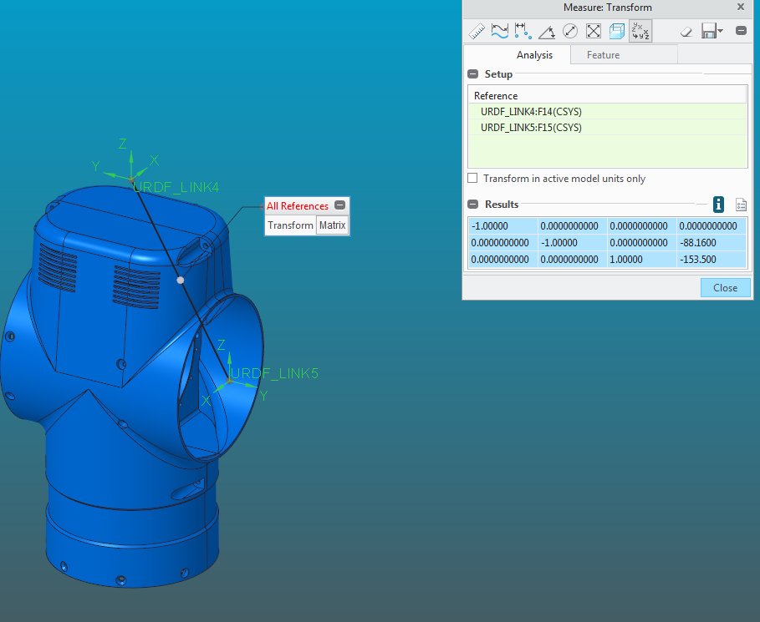-1.00000 0.0000000000 0.0000000000 0.0000000000

0.0000000000 -1.00000 0.0000000000 -88.1600

0.0000000000 0.0000000000 1.00000 -153.500