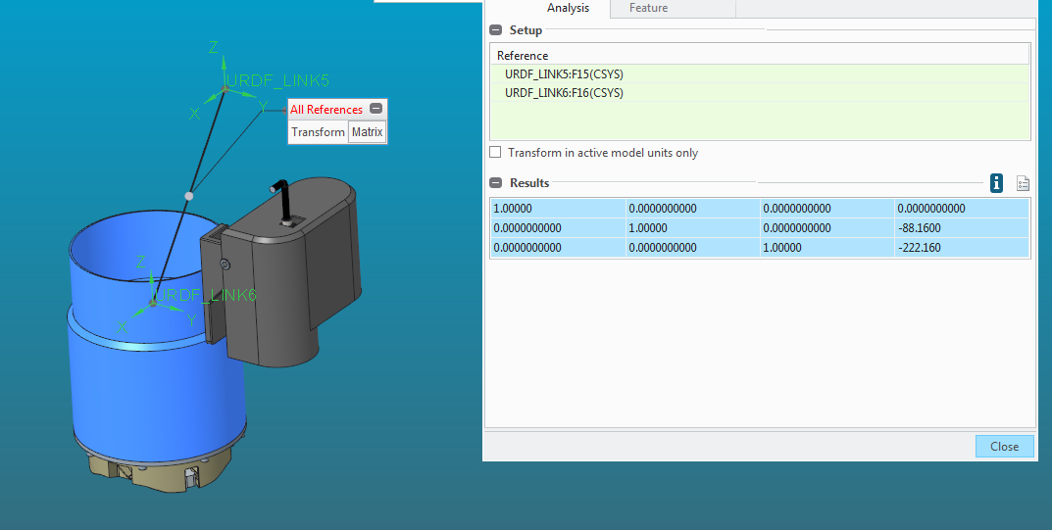1.00000 0.0000000000 0.0000000000 0.0000000000

0.0000000000 1.00000 0.0000000000 -88.1600

0.0000000000 0.0000000000 1.00000 -222.160

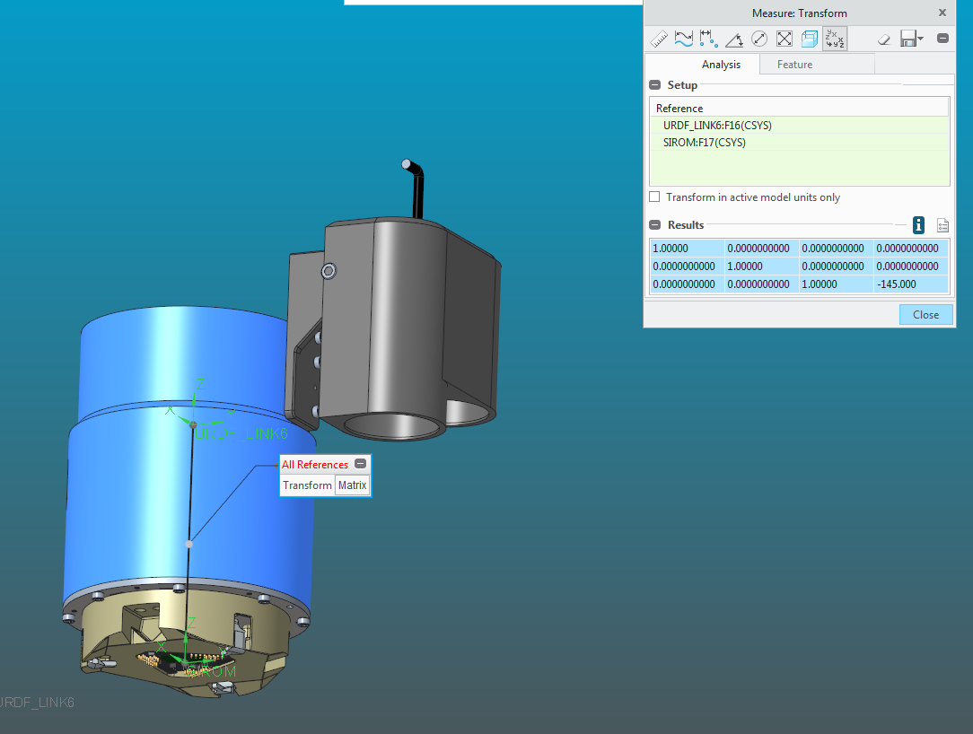

1.00000 0.0000000000 0.0000000000 0.0000000000

0.0000000000 1.00000 0.0000000000 0.0000000000

0.0000000000 0.0000000000 1.00000 -145.000