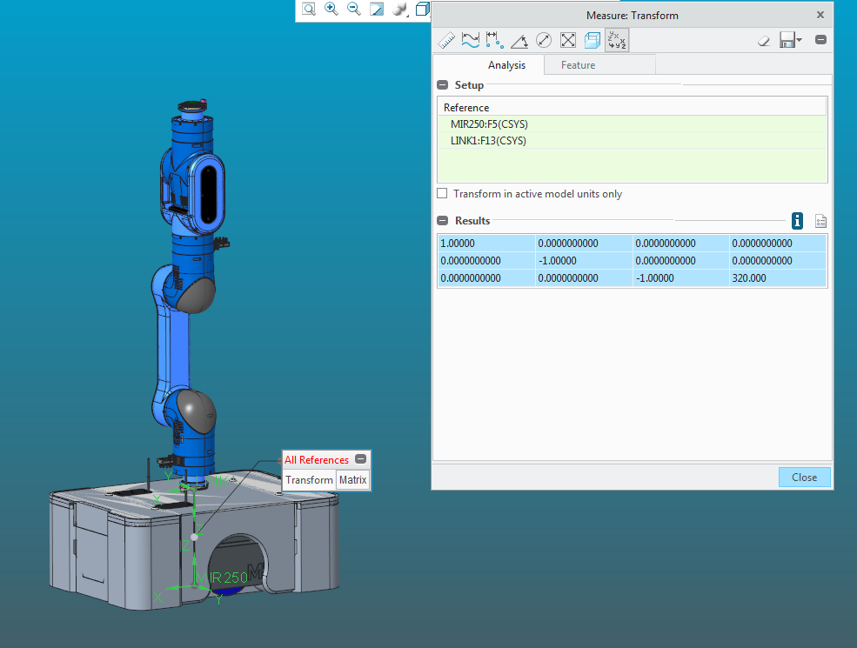1.00000 0.0000000000 0.0000000000 0.0000000000

0.0000000000 -1.00000 0.0000000000 0.0000000000

0.0000000000 0.0000000000 -1.00000 320.000