Sequence Diagrams

目录
Sequence Diagrams ........................ 2
1. Customer Booking a Service ........................ 3
2. Provider Submitting a New Business ........................ 4
3. Admin Approving a Business ........................ 5
4. User Authentication Flow ........................ 6
5. Role-Based Access Control Sequence ........................ 7
[在Microsoft Word中，您可以右键点击上方目录区域并选择'更新域'来自动生成准确的页码]

Sequence Diagrams
This document provides Sequence Diagrams that illustrate the step-by-step interactions between users and various system components for key processes. These diagrams are based on an analysis of the codebase and use the correct, validated Mermaid syntax.

1. Customer Booking a Service
This diagram shows the sequence of events when a customer books a service. The interaction flows from the customer’s browser to the Next.js server, which then interacts with the MongoDB database.
mermaid

sequenceDiagram
actor Customer
participant Browser
participant Next.js Server
participant MongoDB
participant Email Service

Customer->>Browser: Selects date and time, clicks 'Book'
activate Browser

Browser->>Next.js Server: POST /api/bookings
activate Next.js Server

Next.js Server->>Next.js Server: Validate booking data

alt Validation successful
Next.js Server->>MongoDB: `Booking.create(bookingData)`
activate MongoDB

MongoDB-->>Next.js Server: Returns created booking document
deactivate MongoDB

Next.js Server->>Email Service: Send booking confirmation
activate Email Service
Email Service-->>Next.js Server: Confirmation sent
deactivate Email Service

Next.js Server-->>Browser: API Response (200 OK)
deactivate Next.js Server

Browser->>Customer: Display 'Success' toast notification
else Validation failed
Next.js Server-->>Browser: API Response (400 Bad Request)
deactivate Next.js Server

Browser->>Customer: Display validation error message
end

deactivate Browser

Description:
1. The Customer initiates the booking from the BookingSection.jsx component in their Browser.
2. The browser sends a POST request to the Next.js Server’s/api/bookings route.
3. The server validates the booking data to ensure all required fields are present and valid.
4. If validation is successful, the server-side logic uses the Booking Mongoose model to create a new document in the MongoDB database.
5. MongoDB confirms the write operation and returns the new document.
6. The server sends booking confirmation emails to both the customer and service provider.
7. The success response is propagated back to the browser, which then shows a confirmation toast to the customer.
8. If validation fails, an error response is returned and displayed to the user.

2. Provider Submitting a New Business
This diagram illustrates the workflow for a service provider submitting their new business registration, including document uploads to Cloudinary.
mermaid

sequenceDiagram
actor Provider
participant Browser
participant Cloudinary
participant Next.js Server
participant MongoDB

Provider->>Browser: Fills out ProviderRegistrationForm.jsx
activate Browser

loop For each required document
Provider->>Browser: Uploads a file (e.g., ghana_card.jpg)

Browser->>Next.js Server: POST /api/cloudinary/upload
activate Next.js Server

Next.js Server->>Cloudinary: Upload API call with file
activate Cloudinary

Cloudinary-->>Next.js Server: Returns secure image URL
deactivate Cloudinary

Next.js Server-->>Browser: API Response (200 OK) with URL
deactivate Next.js Server

Browser->>Provider: Shows uploaded document in UI
end

Provider->>Browser: Clicks 'Submit Complete Registration'

Browser->>Next.js Server: POST /api/businesses
activate Next.js Server

Next.js Server->>Next.js Server: Validate business data

alt Validation successful
Next.js Server->>MongoDB: `Business.create(businessData)`
activate MongoDB

note right of Next.js Server: Business is created with 'PENDING' approvalStatus

MongoDB-->>Next.js Server: Returns created business document
deactivate MongoDB

Next.js Server-->>Browser: API Response (200 OK)
deactivate Next.js Server

Browser->>Provider: Display 'Registration Submitted' toast
else Validation failed
Next.js Server-->>Browser: API Response (400 Bad Request)
deactivate Next.js Server

Browser->>Provider: Display validation errors
end

deactivate Browser

Description:
1. The Provider fills out the multi-tab registration form in their Browser.
2. For each document, the browser makes a separate API call to the /api/cloudinary/upload endpoint on the Next.js Server.
3. The server securely uploads the file to Cloudinary and receives a URL in return.
4. Once all data is entered and documents are uploaded, the final submission triggers a POST request to the /api/businesses route.
5. The server validates the business data to ensure all required fields and documents are present.
6. The Next.js Server uses a Mongoose model to create a new business document in MongoDB, ensuring the new business is saved with a PENDING approval status, queuing it for admin review.
7. If validation fails, error messages are returned and displayed to the provider.

3. Admin Approving a Business
This diagram shows the sequence for an administrator reviewing and approving a pending business application.
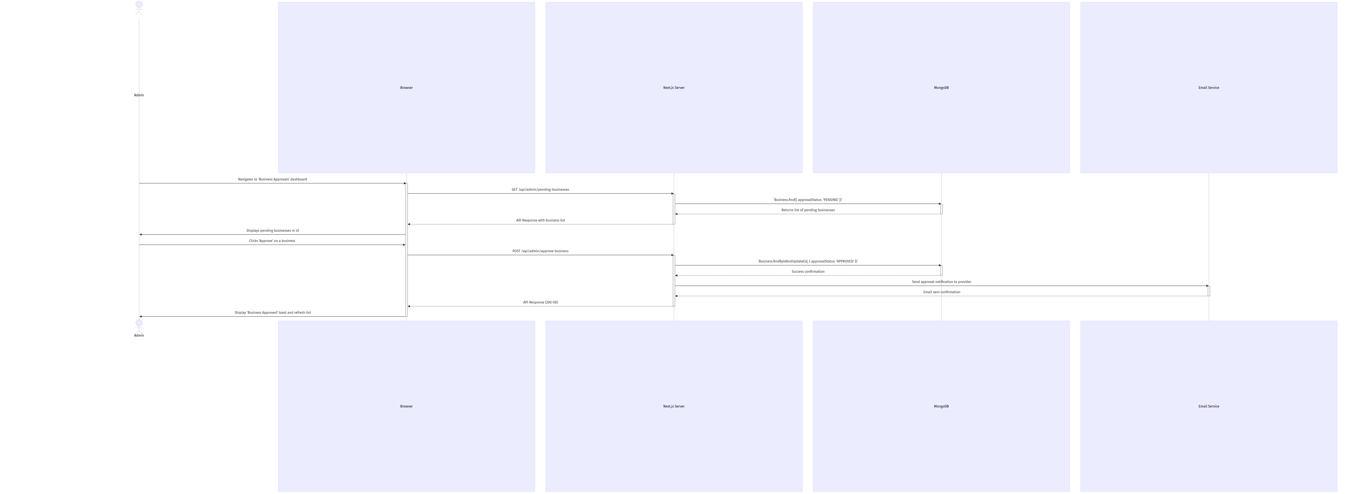
mermaid chart
Description:
1. The Admin loads the approval dashboard in their Browser, which triggers a request to the Next.js Server.
2. The server queries the MongoDB database for all businesses where the approvalStatus is PENDING.
3. The list is displayed to the Admin. When the Admin clicks ‘Approve’, a POST request is sent to the /api/admin/approve-business endpoint.
4. The Next.js Server finds the relevant document in the MongoDB and updates its approvalStatus to APPROVED.
5. The server sends an email notification to the provider informing them of the approval.
6. Upon success, the browser notifies the Admin and refreshes the list, removing the approved business from the pending queue.

4. User Authentication Flow
This diagram illustrates the authentication process when a user logs in to the system.
mermaid

sequenceDiagram
actor User
participant Browser
participant Next.js Server
participant NextAuth
participant MongoDB
participant JWT Service

User->>Browser: Enters email/password and clicks 'Login'
activate Browser

Browser->>Next.js Server: POST /api/auth/signin
activate Next.js Server

Next.js Server->>NextAuth: Call authorize() function
activate NextAuth

NextAuth->>MongoDB: Database.healthCheck()
activate MongoDB

MongoDB-->>NextAuth: Connection status
deactivate MongoDB

alt Database connection healthy
NextAuth->>MongoDB: User.validatePassword(email, password)
activate MongoDB

MongoDB-->>NextAuth: User document or null
deactivate MongoDB

alt Valid credentials
NextAuth->>NextAuth: Check emailVerified flag

alt Email verified
NextAuth->>JWT Service: Create JWT with user role
activate JWT Service

JWT Service-->>NextAuth: JWT token
deactivate JWT Service

NextAuth-->>Next.js Server: Authentication success
deactivate NextAuth

Next.js Server-->>Browser: Session with user data and role
deactivate Next.js Server

Browser->>Browser: Redirect based on user role
Browser->>User: Display authenticated UI
else Email not verified
NextAuth-->>Next.js Server: Email not verified error
deactivate NextAuth

Next.js Server-->>Browser: Authentication error
deactivate Next.js Server

Browser->>User: Display "Email not verified" message
end
else Invalid credentials
NextAuth-->>Next.js Server: Invalid credentials error
deactivate NextAuth

Next.js Server-->>Browser: Authentication error
deactivate Next.js Server

Browser->>User: Display "Invalid email or password" message
end
else Database connection failed
NextAuth-->>Next.js Server: Database connection error
deactivate NextAuth

Next.js Server-->>Browser: Authentication error
deactivate Next.js Server

Browser->>User: Display "Service unavailable" message
end

deactivate Browser

Description:
1. The User enters their email and password in the login form and submits it.
2. The Browser sends a POST request to the NextAuth signin endpoint.
3. The Next.js Server passes the request to NextAuth which handles the authentication process.
4. NextAuth first checks if the database connection is healthy using the Database.healthCheck() method.
5. If the connection is healthy, NextAuth validates the user credentials against the database using the User.validatePassword() method.
6. If the credentials are valid, NextAuth checks if the user’s email is verified.
7. If the email is verified, NextAuth creates a JWT token with the user’s role and returns a successful authentication response.
8. The browser receives the session data, redirects the user based on their role, and displays the authenticated UI.
9. If any step fails (database connection, invalid credentials, or unverified email), an appropriate error message is displayed to the user.

5. Role-Based Access Control Sequence
This diagram shows how the system enforces role-based access restrictions when a user attempts to access a protected route.
mermaid

sequenceDiagram
actor User
participant Browser
participant Next.js Middleware
participant Protected Route
participant UI Components

User->>Browser: Attempts to access protected route
activate Browser

Browser->>Next.js Middleware: Request with JWT token
activate Next.js Middleware

Next.js Middleware->>Next.js Middleware: Extract token from request
Next.js Middleware->>Next.js Middleware: Validate token

alt Token valid
Next.js Middleware->>Next.js Middleware: Extract user role

alt Route requires specific role
Next.js Middleware->>Next.js Middleware: Check if user has required role

alt User has required role
Next.js Middleware->>Protected Route: Allow access
activate Protected Route

Protected Route->>UI Components: Render with role-specific elements
activate UI Components

UI Components-->>Browser: Return rendered page
deactivate UI Components

deactivate Protected Route

Browser->>User: Display protected content
else User lacks required role
Next.js Middleware->>Browser: Redirect to error page
deactivate Next.js Middleware

Browser->>User: Display access denied message
end
else Route doesn't require specific role
Next.js Middleware->>Protected Route: Allow access
activate Protected Route

Protected Route->>UI Components: Render with role-specific elements
activate UI Components

UI Components-->>Browser: Return rendered page
deactivate UI Components

deactivate Protected Route

deactivate Next.js Middleware

Browser->>User: Display protected content
end
else Token invalid or missing
Next.js Middleware->>Browser: Redirect to login page
deactivate Next.js Middleware

Browser->>User: Display login page
end

deactivate Browser

Description:
1. The User attempts to access a protected route in the application.
2. The Browser sends the request with the JWT token to the Next.js Middleware.
3. The middleware extracts and validates the token from the request.
4. If the token is valid, the middleware extracts the user’s role and checks if the route requires a specific role.
5. If the route requires a specific role, the middleware checks if the user has that role.
6. If the user has the required role, the middleware allows access to the protected route.
7. The protected route renders with role-specific UI elements based on the user’s role.
8. If the user lacks the required role, they are redirected to an error page with an access denied message.
9. If the token is invalid or missing, the user is redirected to the login page.
10. This implementation is handled primarily in the middleware.js file and the various layout components that check for role-based access.

