4. Project Design

目录
4. Project Design ........................ 2
I. Architectural Design ........................ 3
1. Architectural Model ........................ 4
2. Architectural Patterns ........................ 5
3. Subsystem Decomposition ........................ 9
4. Component and Connector View ........................ 19
5. Deployment Architecture ........................ 21
6. Data Architecture ........................ 22
7. Architectural Strategies ........................ 23
8. Architectural Decisions ........................ 28
9. Quality Attribute Analysis ........................ 29
10. Architecture Evolution ........................ 30
[在Microsoft Word中，您可以右键点击上方目录区域并选择'更新域'来自动生成准确的页码]

4. Project Design

I. Architectural Design
This document outlines the architectural design of the ArtisanConnect platform following Ian Sommerville’s approach to software architecture. The design is presented with clarity and simplicity to ensure understanding of the system’s structure and components.

1. Architectural Model
The ArtisanConnect platform follows a layered architecture with client-server pattern, implemented using the Next.js App Router framework. This architecture separates concerns while enabling both server-side and client-side rendering for optimal performance and SEO.
mermaid

flowchart TD
subgraph "Client Layer"
UI["UI Components"]
Hooks["React Hooks"]
ClientUtils["Client Utilities"]
end

subgraph "Server Layer"
AppRouter["Next.js App Router"]
ServerComponents["Server Components"]
APIRoutes["API Routes"]
Middleware["Middleware"]
end

subgraph "Service Layer"
GlobalAPI["Global API Service"]
AuthService["Authentication Service"]
EmailService["Email Service"]
MongoAPI["MongoDB API"]
end

subgraph "Data Layer"
MongoDB["MongoDB"]
HygraphCMS["Hygraph CMS"]
Cloudinary["Cloudinary Storage"]
end

UI <--> Hooks
UI <--> ClientUtils
Hooks <--> AppRouter
ClientUtils <--> AppRouter

AppRouter <--> ServerComponents
AppRouter <--> APIRoutes
AppRouter <--> Middleware

ServerComponents <--> GlobalAPI
APIRoutes <--> GlobalAPI
APIRoutes <--> AuthService
APIRoutes <--> EmailService
APIRoutes <--> MongoAPI

GlobalAPI <--> HygraphCMS
MongoAPI <--> MongoDB
EmailService <--> "External Email Provider"
AuthService <--> "NextAuth"
GlobalAPI <--> Cloudinary

classDef clientLayer fill:#e3f2fd,stroke:#1565c0,stroke-width:1px
classDef serverLayer fill:#e8f5e9,stroke:#2e7d32,stroke-width:1px
classDef serviceLayer fill:#fff8e1,stroke:#ff8f00,stroke-width:1px
classDef dataLayer fill:#f3e5f5,stroke:#7b1fa2,stroke-width:1px

class UI,Hooks,ClientUtils clientLayer
class AppRouter,ServerComponents,APIRoutes,Middleware serverLayer
class GlobalAPI,AuthService,EmailService,MongoAPI serviceLayer
class MongoDB,HygraphCMS,Cloudinary dataLayer

2. Architectural Patterns
The ArtisanConnect platform incorporates several architectural patterns:

2.1 Model-View-Controller (MVC)
• Model: MongoDB schemas and Hygraph CMS content models
• View: React components and Next.js pages
• Controller: API routes and server components

2.2 Service-Oriented Architecture
Services are organized as independent modules with specific responsibilities:
• GlobalApi.js: Handles communication with Hygraph CMS
• ApiService.js: Manages internal API calls
• EmailService.js: Handles email notifications
• MongoApi.js: Interfaces with MongoDB

2.3 Middleware Architecture
The system uses middleware for cross-cutting concerns:
• Authentication: Verifies user identity
• Authorization: Enforces role-based access control
• Logging: Records system events
• Error Handling: Provides graceful error responses

3. Subsystem Decomposition
The system is decomposed into the following major subsystems:
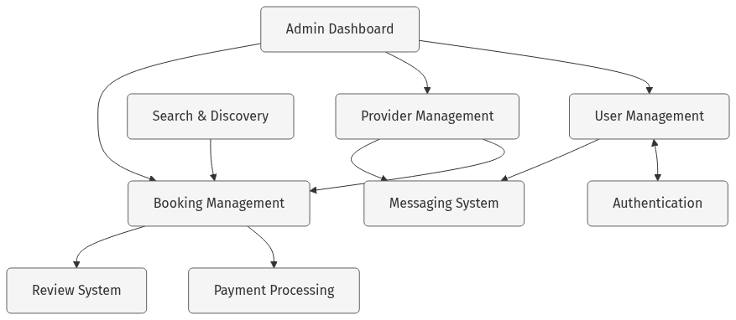
mermaid chart

3.1 User Management Subsystem
• Responsibility: Manages user accounts, profiles, and preferences
• Key Components: User model, profile pages, settings
• Interfaces: User API endpoints, authentication hooks

3.2 Authentication Subsystem
• Responsibility: Handles user authentication and authorization
• Key Components: NextAuth integration, JWT handling, middleware
• Interfaces: Login/logout endpoints, session management

3.3 Search & Discovery Subsystem
• Responsibility: Enables users to find services and providers
• Key Components: Search filters, category browsing, location-based search
• Interfaces: Search API, category listing

3.4 Booking Management Subsystem
• Responsibility: Handles the creation and management of service bookings
• Key Components: Calendar, booking form, booking history
• Interfaces: Booking API endpoints

3.5 Provider Management Subsystem
• Responsibility: Manages service provider profiles and services
• Key Components: Provider registration, business profile, service management
• Interfaces: Provider API endpoints

3.6 Review System Subsystem
• Responsibility: Handles customer reviews and ratings
• Key Components: Review form, rating display, review moderation
• Interfaces: Review API endpoints

3.7 Admin Dashboard Subsystem
• Responsibility: Provides platform administration capabilities
• Key Components: User management, business approval, analytics
• Interfaces: Admin API endpoints

3.8 Messaging System Subsystem
• Responsibility: Enables communication between users and providers
• Key Components: Chat interface, notifications, message history
• Interfaces: Socket.IO endpoints, message API

3.9 Payment Processing Subsystem
• Responsibility: Handles secure payment transactions
• Key Components: Payment form, transaction history, invoicing
• Interfaces: Payment API endpoints, Stripe integration

4. Component and Connector View
This view shows how components interact at runtime through connectors:
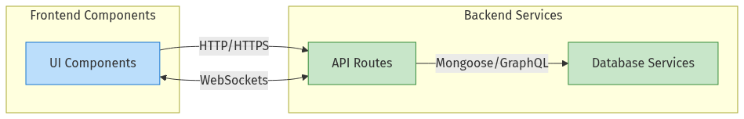
mermaid chart

4.1 Key Connectors
1. HTTP/HTTPS: RESTful communication between frontend and API routes
2. WebSockets: Real-time bidirectional communication for chat and notifications
3. Mongoose: Object-Document Mapping for MongoDB interactions
4. GraphQL: Query language for Hygraph CMS interactions

5. Deployment Architecture
The deployment architecture shows how the system components are distributed across physical infrastructure:
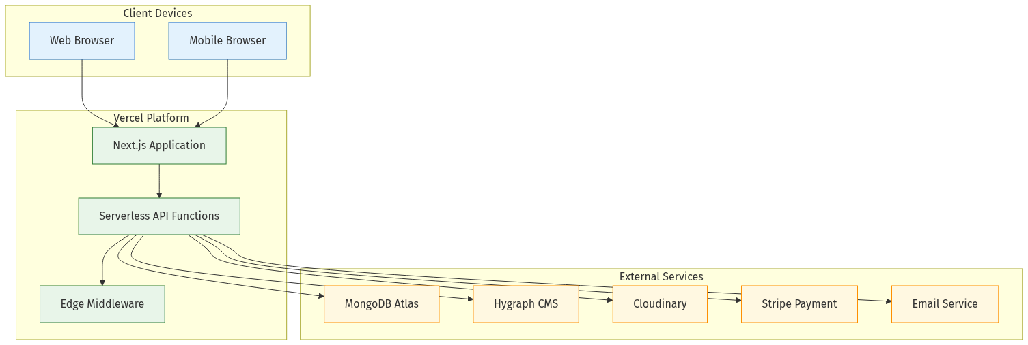
mermaid chart

6. Data Architecture
The data architecture illustrates the primary data entities and their relationships:
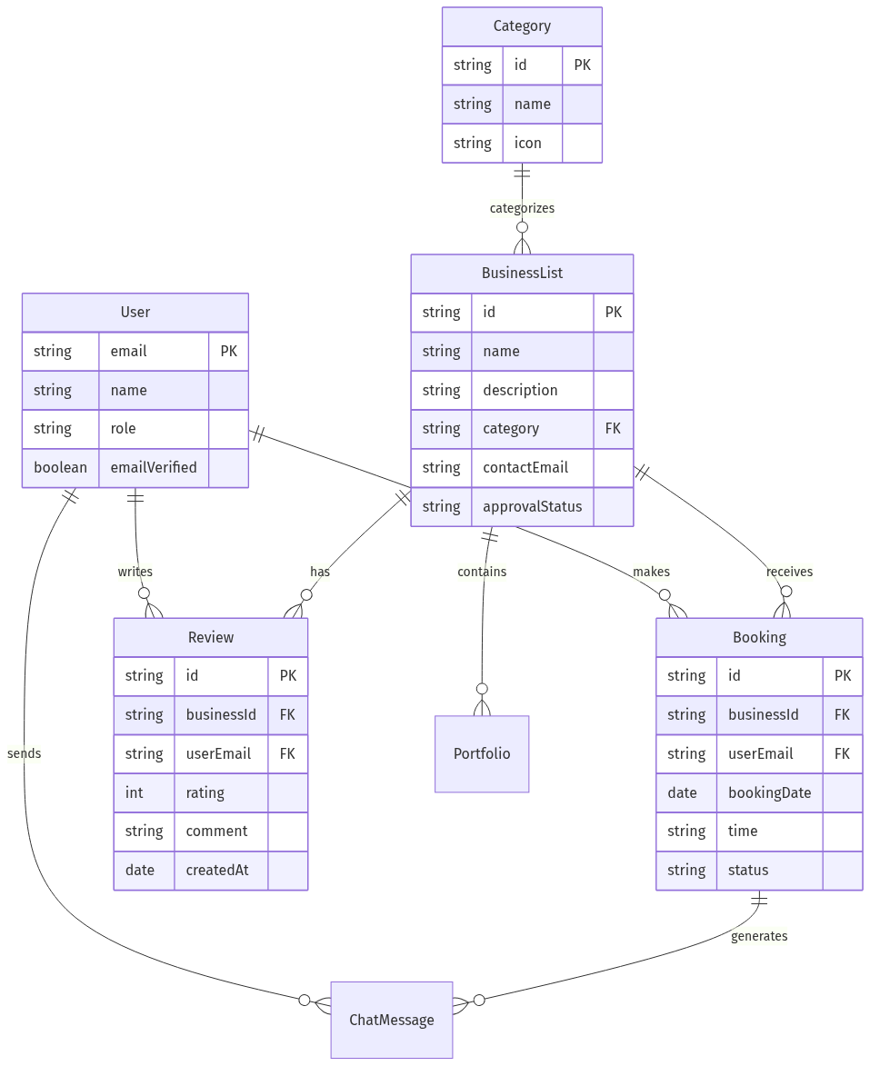
mermaid chart

7. Architectural Strategies

7.1 Security Strategy
• JWT-based authentication
• Role-based access control
• HTTPS for all communications
• Input validation and sanitization

7.2 Scalability Strategy
• Serverless architecture for automatic scaling
• Database connection pooling
• Optimized database queries with indexes
• Static generation for content-heavy pages

7.3 Performance Strategy
• Server-side rendering for SEO-critical pages
• Client-side rendering for interactive components
• Image optimization via Cloudinary
• Caching of frequent queries

7.4 Reliability Strategy
• Error boundary components
• Graceful degradation
• Automated backups
• Health checks and monitoring

8. Architectural Decisions
Decision | Options Considered | Selected Approach | Rationale
Frontend Framework | React, Vue, Angular | Next.js (React) | SEO requirements, developer familiarity, hybrid rendering
Database | PostgreSQL, MongoDB, Firebase | MongoDB | Schema flexibility, JSON document structure, scalability
Content Management | Custom CMS, Contentful, Hygraph | Hygraph CMS | GraphQL support, content modeling flexibility, developer experience
Authentication | Custom Auth, Firebase Auth, NextAuth | NextAuth | Integration with Next.js, multiple providers support, simplicity
Styling | CSS Modules, Styled Components, Tailwind | Tailwind CSS | Utility-first approach, rapid development, consistency
Deployment | AWS, Vercel, Netlify | Vercel | Optimized for Next.js, serverless functions, edge network

9. Quality Attribute Analysis
Quality Attribute | Architectural Support | Potential Risks
Performance | Server-side rendering, edge caching | Complex queries might slow response times
Security | Middleware for authentication, input validation | Session management complexity
Reliability | Error boundaries, graceful degradation | External service dependencies
Maintainability | Component-based structure, service layer | Knowledge transfer for complex patterns
Scalability | Serverless architecture, connection pooling | Database scaling limitations

10. Architecture Evolution
The architecture is designed to evolve in the following ways:
1. Microservices Transition: As the system grows, certain subsystems (e.g., messaging, payments) can be extracted into independent microservices.
2. API Gateway: Introduction of an API gateway to manage cross-cutting concerns as the number of services increases.
3. Caching Layer: Addition of Redis or similar caching solution for frequently accessed data.
4. Event-Driven Architecture: Evolution towards an event-driven architecture for better decoupling between services.
This architectural design provides a solid foundation that balances immediate needs with future scalability and maintainability.

