4. Project Design

目录
4. Project Design ........................ 2
II. Components Design ........................ 3
1. Class Diagram ........................ 4
2. Component Descriptions ........................ 5
3. Component Interactions ........................ 15
4. Design Patterns ........................ 19
5. Component Dependencies ........................ 24
6. Component Extensibility ........................ 25
[在Microsoft Word中，您可以右键点击上方目录区域并选择'更新域'来自动生成准确的页码]

4. Project Design

II. Components Design
This document outlines the component design of the ArtisanConnect platform, focusing on the class structure and relationships between key components.

1. Class Diagram
The following class diagram illustrates the core domain model of the ArtisanConnect platform, showing the relationships between major classes and their attributes and methods:
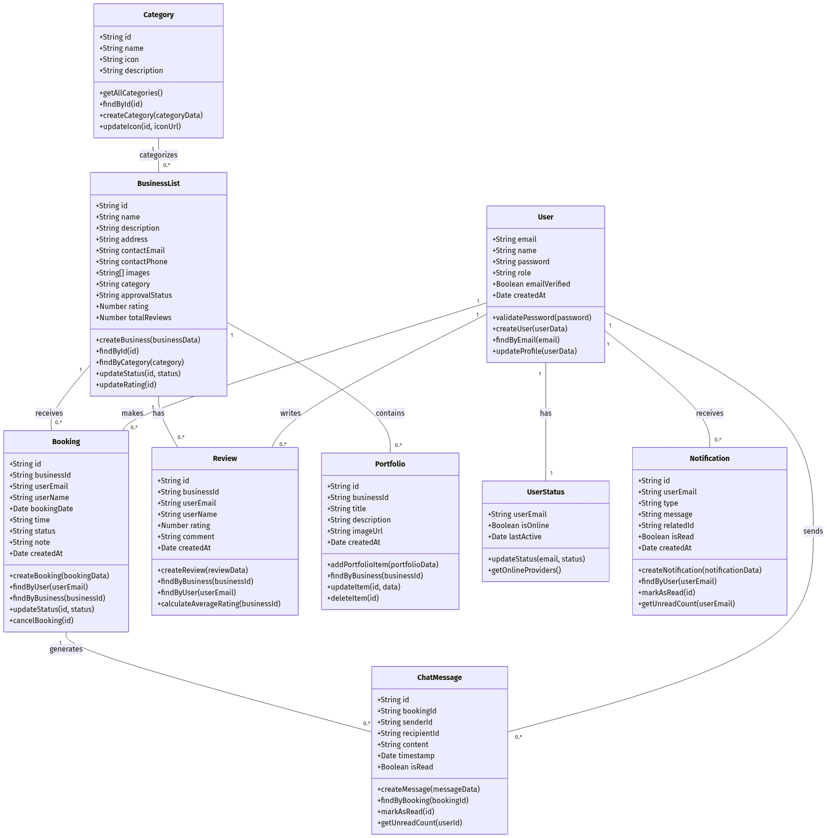
mermaid chart

2. Component Descriptions

2.1 User Component
The User component represents individuals interacting with the platform in different roles (Customer, Provider, Admin).
Key Responsibilities:
• User authentication and authorization
• Profile management
• Role-based access control
Key Methods:
• validatePassword(password): Verifies user credentials during login
• createUser(userData): Creates a new user account
• findByEmail(email): Retrieves user information by email
• updateProfile(userData): Updates user profile information
Implementation Files:
• models/User.js: Mongoose schema and model definition
• app/api/auth/[...nextauth]/route.js: NextAuth authentication implementation
• app/(routes)/profile/page.jsx: User profile management UI

2.2 BusinessList Component
The BusinessList component represents service providers’ businesses listed on the platform.
Key Responsibilities:
• Business profile management
• Service listing
• Business discovery and search
Key Methods:
• createBusiness(businessData): Creates a new business listing
• findById(id): Retrieves business details by ID
• findByCategory(category): Finds businesses in a specific category
• updateStatus(id, status): Updates approval status (PENDING, APPROVED, REJECTED)
Implementation Files:
• models/BusinessList.js: Mongoose schema and model definition
• app/api/businesses/route.js: API endpoints for business management
• app/(routes)/details/[businessId]/page.jsx: Business detail page

2.3 Booking Component
The Booking component handles service appointments between customers and providers.
Key Responsibilities:
• Appointment scheduling
• Booking management
• Status tracking
Key Methods:
• createBooking(bookingData): Creates a new booking
• findByUser(userEmail): Retrieves bookings for a specific user
• findByBusiness(businessId): Retrieves bookings for a specific business
• updateStatus(id, status): Updates booking status
Implementation Files:
• models/Booking.js: Mongoose schema and model definition
• app/api/bookings/route.js: API endpoints for booking management
• app/(routes)/details/_components/BookingSection.jsx: Booking UI component

2.4 Review Component
The Review component manages customer feedback and ratings for businesses.
Key Responsibilities:
• Rating collection
• Review management
• Rating calculation
Key Methods:
• createReview(reviewData): Creates a new review
• findByBusiness(businessId): Retrieves reviews for a specific business
• calculateAverageRating(businessId): Calculates average rating for a business
Implementation Files:
• models/Review.js: Mongoose schema and model definition
• app/api/reviews/route.js: API endpoints for review management
• app/_components/ReviewForm.jsx: Review submission UI component
• app/_components/ReviewList.jsx: Review display UI component

2.5 Category Component
The Category component organizes businesses into service categories.
Key Responsibilities:
• Category management
• Service classification
Key Methods:
• getAllCategories(): Retrieves all available categories
• findById(id): Retrieves category details by ID
• updateIcon(id, iconUrl): Updates category icon
Implementation Files:
• models/Category.js: Mongoose schema and model definition
• app/api/categories/route.js: API endpoints for category management
• app/_components/CategoryList.jsx: Category display UI component

2.6 ChatMessage Component
The ChatMessage component enables communication between customers and service providers.
Key Responsibilities:
• Message exchange
• Conversation history
• Read status tracking
Key Methods:
• createMessage(messageData): Creates a new message
• findByBooking(bookingId): Retrieves messages for a specific booking
• markAsRead(id): Marks a message as read
Implementation Files:
• models/ChatMessage.js: Mongoose schema and model definition
• app/api/chat/[bookingId]/route.js: API endpoints for chat management
• app/_components/ChatWindow.jsx: Chat UI component

2.7 Portfolio Component
The Portfolio component manages service providers’ work samples and project showcases.
Key Responsibilities:
• Portfolio management
• Image storage and retrieval
Key Methods:
• addPortfolioItem(portfolioData): Adds a new portfolio item
• findByBusiness(businessId): Retrieves portfolio items for a business
• updateItem(id, data): Updates portfolio item details
Implementation Files:
• models/Portfolio.js: Mongoose schema and model definition
• app/api/provider/portfolio/route.js: API endpoints for portfolio management
• app/_components/PortfolioGallery.jsx: Portfolio display UI component

2.8 UserStatus Component
The UserStatus component tracks user online/offline status for real-time features.
Key Responsibilities:
• Online status tracking
• Activity monitoring
Key Methods:
• updateStatus(email, status): Updates user online status
• getOnlineProviders(): Retrieves currently online service providers
Implementation Files:
• models/UserStatus.js: Mongoose schema and model definition
• app/api/socket/route.js: WebSocket implementation for status updates

2.9 Notification Component
The Notification component manages system notifications for users.
Key Responsibilities:
• Notification generation
• Notification delivery
• Read status tracking
Key Methods:
• createNotification(notificationData): Creates a new notification
• findByUser(userEmail): Retrieves notifications for a user
• markAsRead(id): Marks a notification as read
Implementation Files:
• models/Notification.js: Mongoose schema and model definition
• app/_services/EmailService.js: Email notification service

3. Component Interactions

3.1 Booking Flow
The booking flow illustrates how components interact during the booking process:
1. User (Customer) selects a BusinessList to book
2. BookingSection component collects booking details
3. Booking component creates a new booking record
4. Notification component generates notifications for both customer and provider
5. ChatMessage component enables communication about the booking

3.2 Review Flow
The review flow shows component interactions during the review process:
1. User (Customer) submits a review for a BusinessList
2. Review component creates a new review record
3. BusinessList component updates the average rating
4. Notification component alerts the business owner about the new review

3.3 Provider Registration Flow
The provider registration flow demonstrates component interactions during business registration:
1. User (Provider) submits business details
2. BusinessList component creates a new business with PENDING status
3. Notification component alerts admins about the new business
4. User component updates the user’s role to PROVIDER

4. Design Patterns
The component design incorporates several design patterns:

4.1 Repository Pattern
The models implement a repository pattern, encapsulating data access logic:
javascript

// Example from models/BusinessList.js
static async findByCategory(category) {
return this.find({ category: category, approvalStatus: 'APPROVED' }).sort({ rating: -1 });
}

4.2 Factory Pattern
The component creation follows a factory pattern, particularly in API services:
javascript

// Example from app/_services/GlobalApi.js
const getBusinessById = (id) => {
return ApiService.get(`/businesses/${id}`);
};

4.3 Observer Pattern
The notification system implements an observer pattern:
javascript

// Example from app/api/bookings/route.js
await Notification.create({
userEmail: provider.email,
type: 'NEW_BOOKING',
message: `New booking from ${booking.userName}`,
relatedId: booking._id
});

4.4 Strategy Pattern
The authentication system uses a strategy pattern with different providers:
javascript

// Example from app/api/auth/[...nextauth]/route.js
providers: [
CredentialsProvider({
// Authentication strategy implementation
}),
// Other potential auth providers
]

5. Component Dependencies
The component dependencies are managed through:
1. Direct Model References: Mongoose models reference each other through IDs
2. Service Layer: API services abstract data access for UI components
3. Context Providers: React context for sharing state between components
4. Event-based Communication: WebSockets for real-time updates

6. Component Extensibility
The components are designed for extensibility through:
1. Modular Structure: Components have single responsibilities
2. Clear Interfaces: Well-defined methods for interaction
3. Dependency Injection: Services are injected rather than hardcoded
4. Configuration-driven Behavior: Components adapt based on configuration
This component design provides a solid foundation for the ArtisanConnect platform, with clear responsibilities, relationships, and extension points.

