4. Project Design

目录
4. Project Design ........................ 2
III. Database Schemas ........................ 3
1. Database Architecture ........................ 4
2. MongoDB Schemas ........................ 5
3. Additional MongoDB Schemas ........................ 13
4. Database Relationships ........................ 15
5. Database Indexing Strategy ........................ 16
6. Data Migration Strategy ........................ 17
7. Database Security ........................ 18
8. Database Backup Strategy ........................ 19
[在Microsoft Word中，您可以右键点击上方目录区域并选择'更新域'来自动生成准确的页码]

4. Project Design

III. Database Schemas
This document outlines the database schemas for the ArtisanConnect platform, following Ian Sommerville’s approach to database design documentation. The diagrams are kept simple and focused on essential information to ensure clarity.

1. Database Architecture
The ArtisanConnect platform uses MongoDB as its primary database system:
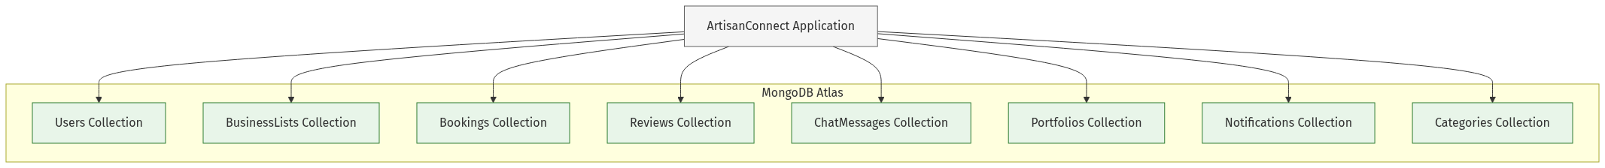
mermaid chart

2. MongoDB Schemas
MongoDB uses Mongoose schemas to define the structure of documents. The following diagrams illustrate the key schemas in the ArtisanConnect platform.

2.1 User Schema
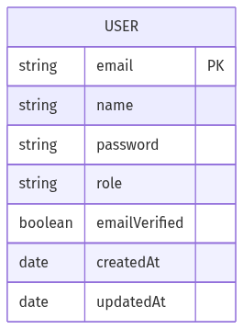
mermaid chart
Schema Definition:
javascript

// models/User.js
const UserSchema = new mongoose.Schema({
email: { type: String, required: true, unique: true },
name: { type: String, required: true },
password: { type: String, required: true },
role: {
type: String,
enum: ['CUSTOMER', 'PROVIDER', 'ADMIN'],
default: 'CUSTOMER'
},
emailVerified: { type: Boolean, default: false },
createdAt: { type: Date, default: Date.now },
updatedAt: { type: Date, default: Date.now }
});

2.2 BusinessList Schema
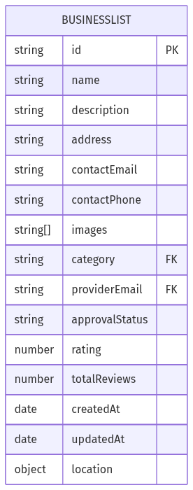
mermaid chart
Schema Definition:
javascript

// models/BusinessList.js
const BusinessListSchema = new mongoose.Schema({
name: { type: String, required: true },
description: { type: String, required: true },
address: { type: String, required: true },
contactEmail: { type: String, required: true },
contactPhone: { type: String, required: true },
images: [{ type: String }],
category: { type: String, required: true },
providerEmail: { type: String, required: true },
approvalStatus: {
type: String,
enum: ['PENDING', 'APPROVED', 'REJECTED'],
default: 'PENDING'
},
rating: { type: Number, default: 0 },
totalReviews: { type: Number, default: 0 },
createdAt: { type: Date, default: Date.now },
updatedAt: { type: Date, default: Date.now },
location: {
type: { type: String, default: 'Point' },
coordinates: [Number]
}
});

2.3 Booking Schema
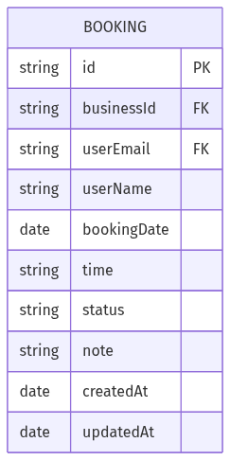
mermaid chart
Schema Definition:
javascript

// models/Booking.js
const BookingSchema = new mongoose.Schema({
businessId: { type: String, required: true },
userEmail: { type: String, required: true },
userName: { type: String, required: true },
bookingDate: { type: Date, required: true },
time: { type: String, required: true },
status: {
type: String,
enum: ['PENDING', 'CONFIRMED', 'COMPLETED', 'CANCELLED'],
default: 'PENDING'
},
note: { type: String },
createdAt: { type: Date, default: Date.now },
updatedAt: { type: Date, default: Date.now }
});

2.4 Review Schema
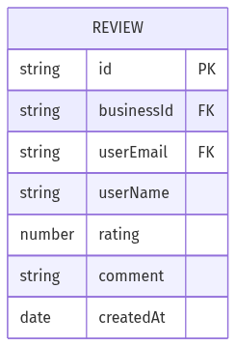
mermaid chart
Schema Definition:
javascript

// models/Review.js
const ReviewSchema = new mongoose.Schema({
businessId: { type: String, required: true },
userEmail: { type: String, required: true },
userName: { type: String, required: true },
rating: { type: Number, required: true, min: 1, max: 5 },
comment: { type: String },
createdAt: { type: Date, default: Date.now }
});

2.5 ChatMessage Schema
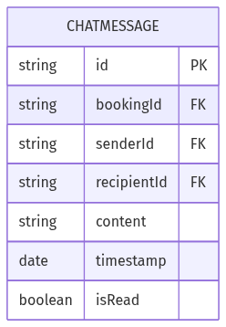
mermaid chart
Schema Definition:
javascript

// models/ChatMessage.js
const ChatMessageSchema = new mongoose.Schema({
bookingId: { type: String, required: true },
senderId: { type: String, required: true },
recipientId: { type: String, required: true },
content: { type: String, required: true },
timestamp: { type: Date, default: Date.now },
isRead: { type: Boolean, default: false }
});

2.6 Portfolio Schema
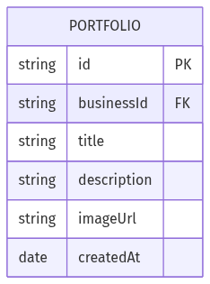
mermaid chart
Schema Definition:
javascript

// models/Portfolio.js
const PortfolioSchema = new mongoose.Schema({
businessId: { type: String, required: true },
title: { type: String, required: true },
description: { type: String },
imageUrl: { type: String, required: true },
createdAt: { type: Date, default: Date.now }
});

2.7 Notification Schema
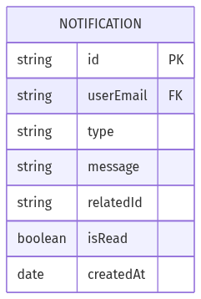
mermaid chart
Schema Definition:
javascript

// models/Notification.js
const NotificationSchema = new mongoose.Schema({
userEmail: { type: String, required: true },
type: {
type: String,
enum: ['NEW_BOOKING', 'BOOKING_UPDATE', 'NEW_REVIEW', 'APPROVAL_UPDATE', 'MESSAGE'],
required: true
},
message: { type: String, required: true },
relatedId: { type: String },
isRead: { type: Boolean, default: false },
createdAt: { type: Date, default: Date.now }
});

3. Additional MongoDB Schemas

3.1 Category Schema
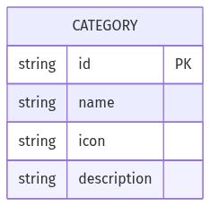
mermaid chart
Schema Definition:
javascript

// models/Category.js
const CategorySchema = new mongoose.Schema({
name: { type: String, required: true },
icon: { type: String, required: true },
description: { type: String },
});

4. Database Relationships
The following diagram illustrates the relationships between the main database entities:
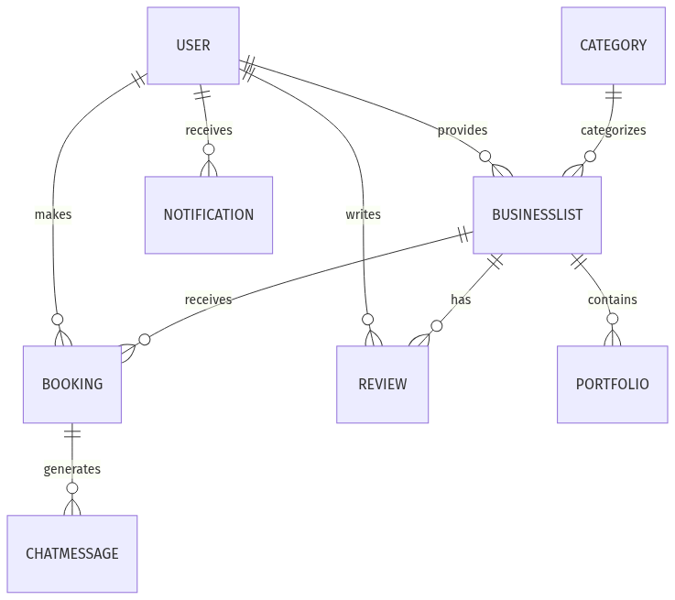
mermaid chart

5. Database Indexing Strategy
To optimize query performance, the following indexes are implemented:
Collection | Index Fields | Index Type | Purpose
Users | email | Unique | Fast user lookup by email
BusinessLists | category | Standard | Fast business lookup by category
BusinessLists | approvalStatus | Standard | Fast filtering of businesses by status
BusinessLists | location | Geospatial | Location-based search
Bookings | userEmail | Standard | Fast lookup of user’s bookings
Bookings | businessId | Standard | Fast lookup of business’s bookings
Reviews | businessId | Standard | Fast retrieval of business reviews
ChatMessages | bookingId | Standard | Fast retrieval of booking messages

6. Data Migration Strategy
For schema evolution and data migration, the platform follows these strategies:
1. Versioned Schemas: Schema versions are tracked in code
2. Migration Scripts: Dedicated scripts for data transformation
3. Backward Compatibility: New schemas maintain compatibility with old data
4. Incremental Updates: Migrations run incrementally to minimize downtime
Example migration script structure:
javascript

// migrations/20230601_add_location_to_businesses.js
module.exports = async function(db) {
const businesses = await db.collection('businesslists').find({}).toArray();

for (const business of businesses) {
if (!business.location) {
await db.collection('businesslists').updateOne(
{ _id: business._id },
{ $set: {
location: {
type: 'Point',
coordinates: [0, 0] // Default coordinates
}
}
}
);
}
}

console.log('Migration completed: Added location field to businesses');
};

7. Database Security
The database security strategy includes:
1. Network Security:
• MongoDB Atlas IP whitelisting
• VPC peering for cloud deployments
2. Authentication:
• Strong database user credentials
• Role-based database access
3. Authorization:
• Field-level encryption for sensitive data
• Document-level access controls
4. Data Validation:
• Schema validation rules
• Input sanitization before storage

8. Database Backup Strategy
The database backup strategy ensures data durability:
1. Automated Backups:
• Daily full backups
• Point-in-time recovery for MongoDB Atlas
2. Backup Retention:
• 7 days of daily backups
• 4 weeks of weekly backups
• 3 months of monthly backups
3. Backup Verification:
• Weekly automated restore tests
• Integrity verification
This database schema design provides a solid foundation for the ArtisanConnect platform, with clear entity definitions, optimized performance, and robust security and backup strategies.

