4. Project Design

目录
4. Project Design ........................ 2
IV. UI Design ........................ 3
1. Home Page ........................ 4
2. Search Results Page ........................ 5
3. Business Details Page ........................ 6
4. Booking Process ........................ 7
5. User Dashboard (Customer) ........................ 8
6. Provider Dashboard ........................ 9
7. Admin Dashboard ........................ 10
8. Mobile Responsive Design ........................ 11
9. UI Component Library ........................ 12
10. Design System ........................ 13
11. Implementation Notes ........................ 14
[在Microsoft Word中，您可以右键点击上方目录区域并选择'更新域'来自动生成准确的页码]

4. Project Design

IV. UI Design
This document presents the wireframes for the ArtisanConnect platform’s user interface. The wireframes illustrate the layout, content structure, and key interactions for the main pages of the application.

1. Home Page
The home page serves as the entry point to the platform, showcasing key service categories and featured service providers.
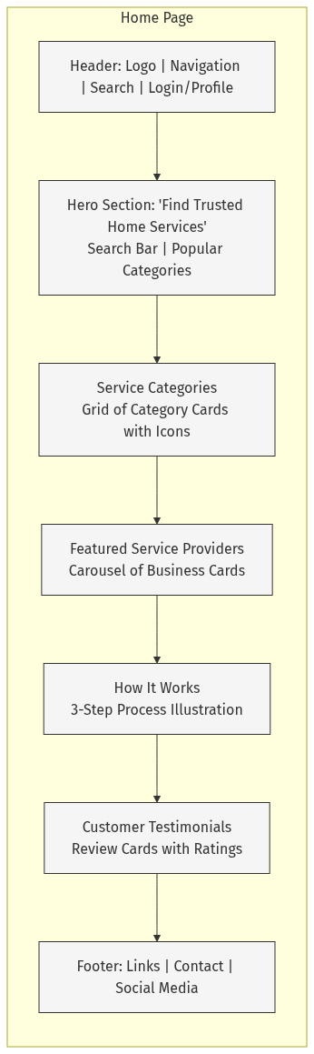
mermaid chart
Key Elements:
• Header: Navigation bar with logo, main menu items, search icon, and login/profile button
• Hero Section: Large banner with search functionality and quick access to popular categories
• Categories Section: Visual grid of service categories (Cleaning, Plumbing, Electrical, etc.)
• Featured Providers: Carousel showcasing top-rated service providers
• How It Works: Simple step-by-step guide explaining the platform’s process
• Testimonials: Social proof through customer reviews and ratings

2. Search Results Page
The search results page displays service providers based on category selection or search criteria, with filtering options.
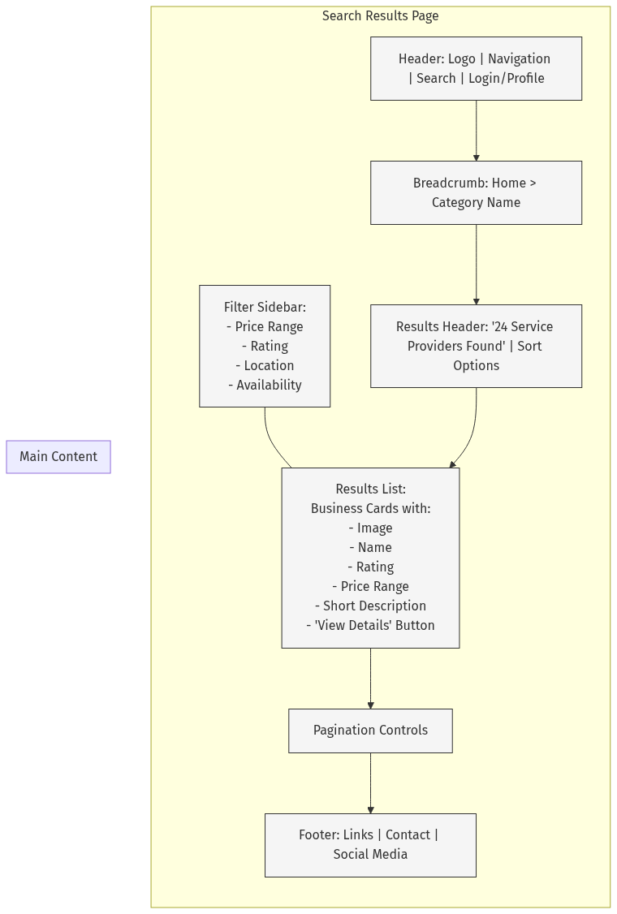
mermaid chart
Key Elements:
• Breadcrumb Navigation: Shows the user’s path through the site
• Filter Sidebar: Allows refinement of search results by various criteria
• Results Header: Shows the number of results and sorting options
• Results List: Cards displaying key information about each service provider
• Pagination: Controls for navigating through multiple pages of results

3. Business Details Page
The business details page provides comprehensive information about a service provider and allows booking services.
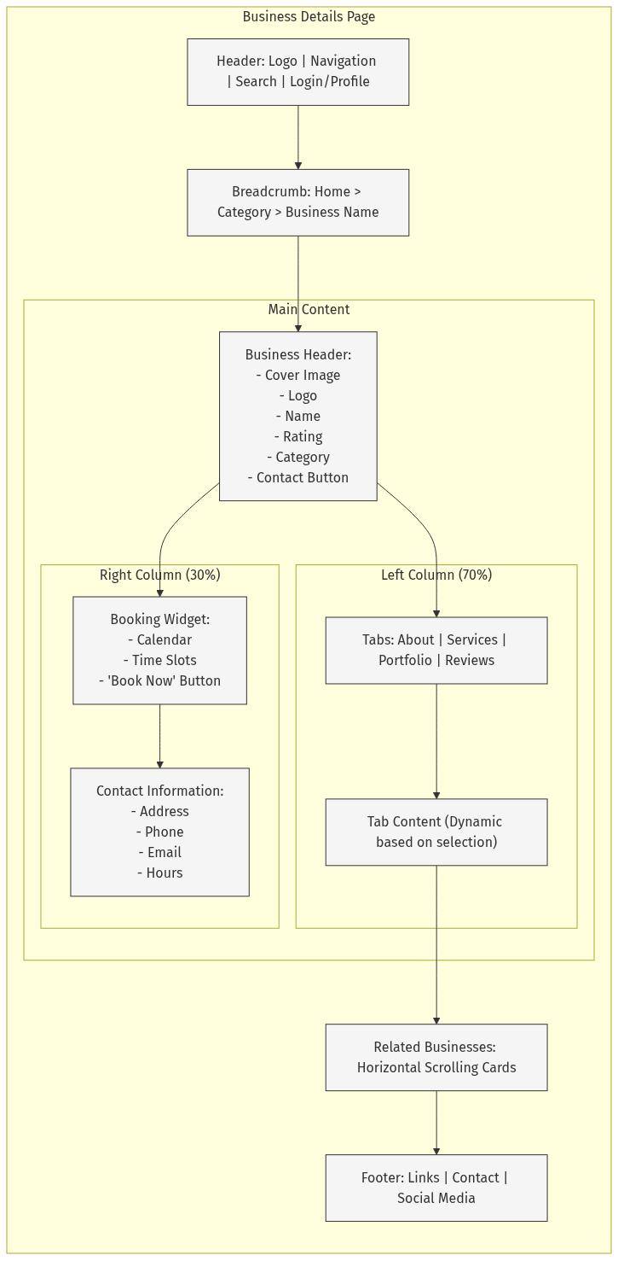
mermaid chart
Key Elements:
• Business Header: Visual introduction with key business information
• Tabbed Content: Organized sections for different types of business information
• Booking Widget: Calendar and time slot selection for scheduling services
• Contact Information: Essential contact details and business hours
• Related Businesses: Suggestions for similar service providers

4. Booking Process
The booking process guides users through selecting a service, choosing a date and time, and confirming their booking.
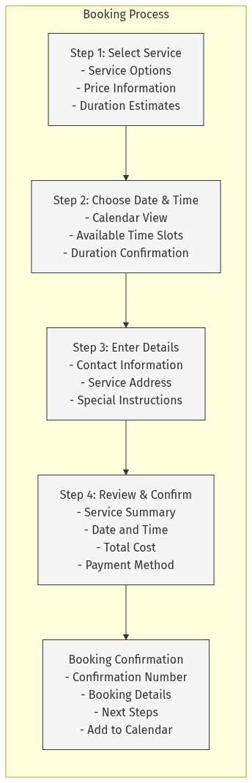
mermaid chart
Key Elements:
• Step 1: Service selection with pricing and duration information
• Step 2: Date and time selection with availability display
• Step 3: Collection of customer details and special requirements
• Step 4: Booking summary and payment information
• Confirmation: Successful booking acknowledgment with next steps

5. User Dashboard (Customer)
The customer dashboard provides access to booking history, messages, and account settings.
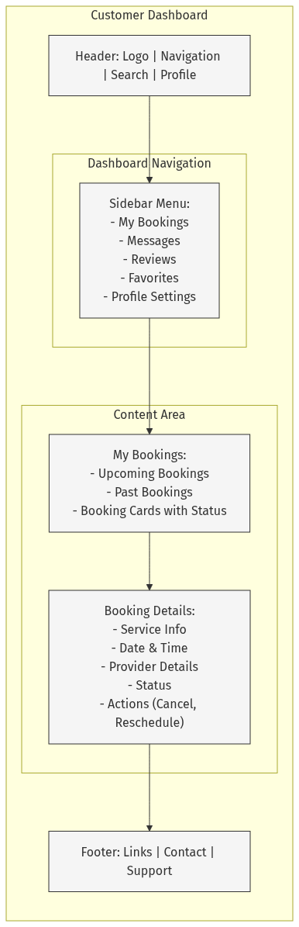
mermaid chart
Key Elements:
• Dashboard Navigation: Sidebar menu for accessing different sections
• My Bookings: List of upcoming and past service bookings
• Booking Details: Expanded view of a selected booking with action options
• Messages: Communication with service providers (not shown in diagram)
• Profile Settings: Account management options (not shown in diagram)

6. Provider Dashboard
The provider dashboard allows service providers to manage their business profile, bookings, and customer communications.
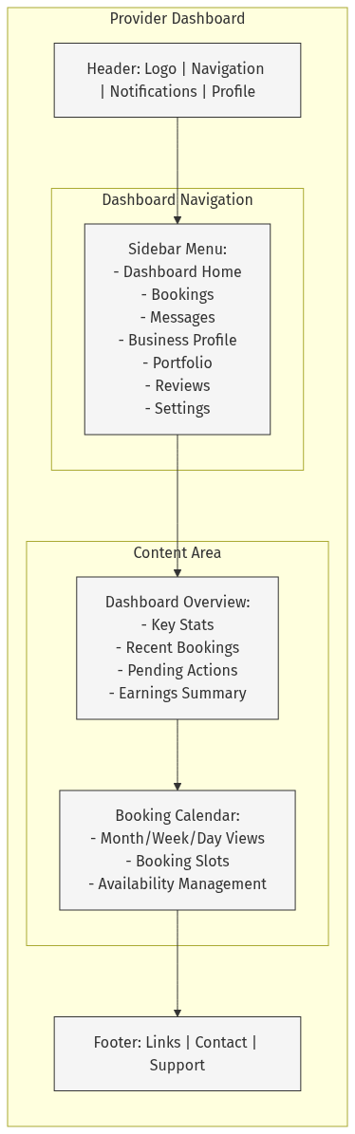
mermaid chart
Key Elements:
• Dashboard Navigation: Sidebar menu for accessing different sections
• Dashboard Overview: Summary of key business metrics and recent activity
• Booking Calendar: Visual calendar for managing appointments and availability
• Business Profile: Management of business information (not shown in diagram)
• Portfolio: Management of work samples and images (not shown in diagram)

7. Admin Dashboard
The admin dashboard provides platform administrators with tools for managing users, businesses, and system settings.
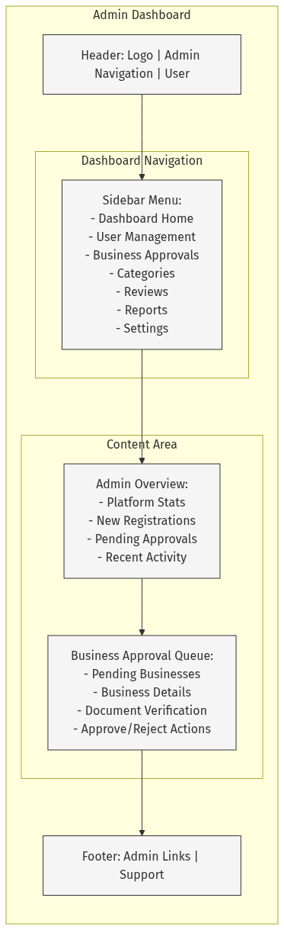
mermaid chart
Key Elements:
• Admin Navigation: Sidebar menu for accessing administrative functions
• Admin Overview: Summary of platform metrics and pending actions
• Business Approval Queue: Interface for reviewing and approving new businesses
• User Management: Tools for managing user accounts (not shown in diagram)
• Settings: System configuration options (not shown in diagram)

8. Mobile Responsive Design
The platform is designed to be fully responsive, adapting to different screen sizes for optimal user experience.
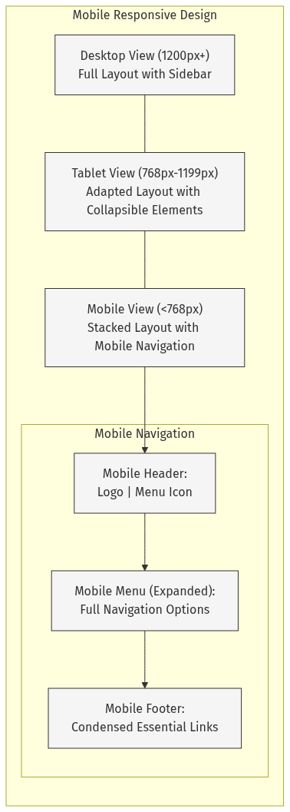
mermaid chart
Key Responsive Design Elements:
• Desktop View: Full layout with all elements visible
• Tablet View: Adapted layout with some elements collapsed or resized
• Mobile View: Stacked layout with hamburger menu navigation
• Touch-Friendly Elements: Larger tap targets for mobile users
• Optimized Images: Responsive images that load appropriately for device size

9. UI Component Library
The platform uses a consistent component library across all pages to maintain visual coherence.
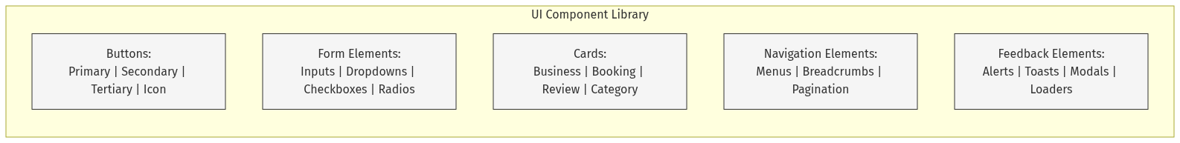
mermaid chart
Key UI Components:
• Buttons: Consistent button styles with clear visual hierarchy
• Form Elements: Standardized input fields and controls
• Cards: Reusable card components for displaying various content types
• Navigation Elements: Consistent navigation patterns across the platform
• Feedback Elements: Clear user feedback mechanisms for actions and states

10. Design System
The design system ensures consistency across the platform through standardized colors, typography, and spacing.
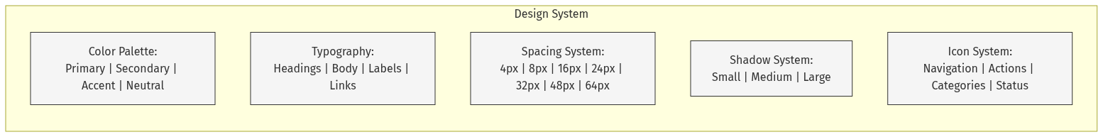
mermaid chart
Key Design System Elements:
• Color Palette: Consistent color scheme reflecting the brand identity
• Typography: Hierarchical type system for clear information architecture
• Spacing: Standardized spacing units for consistent layout
• Shadows: Elevation system to create visual hierarchy
• Icons: Cohesive icon set for intuitive visual communication

11. Implementation Notes
These wireframes represent the conceptual design of the ArtisanConnect platform’s user interface. The actual implementation uses:
• Next.js 14: For the application framework and routing
• React: For component-based UI development
• Tailwind CSS: For styling and responsive design
• Shadcn UI: For consistent UI components
• MongoDB: For data storage and retrieval
The wireframes follow the established design patterns in the existing codebase and align with the component structure defined in the project architecture. All designs prioritize mobile responsiveness, accessibility, and consistent user experience across devices.
For actual implementation, these wireframes should be used alongside the component library documentation and existing code patterns to ensure consistency with the established design system.

