5. Implementation

目录
5. Implementation ........................ 2
II. Algorithm Flowcharts ........................ 3
1. Service Provider Search Algorithm Flowchart ........................ 4
2. Booking Slot Availability Algorithm Flowchart ........................ 5
3. Service Provider Recommendation Algorithm Flowchart ........................ 6
4. Review Sentiment Analysis Algorithm Flowchart ........................ 7
5. Dynamic Pricing Algorithm Flowchart ........................ 8
6. Service Provider Matching Algorithm Flowchart ........................ 9
7. Real-time Chat Message Routing Algorithm Flowchart ........................ 10
8. Booking Conflict Resolution Algorithm Flowchart ........................ 11
9. Payment Processing Algorithm Flowchart ........................ 12
10. Service Provider Ranking Algorithm Flowchart ........................ 13
11. User Authentication and Authorization Algorithm Flowchart ........................ 14
12. Notification Dispatch Algorithm Flowchart ........................ 15
[在Microsoft Word中，您可以右键点击上方目录区域并选择'更新域'来自动生成准确的页码]

5. Implementation

II. Algorithm Flowcharts
This document presents flowcharts for the key algorithms implemented in the ArtisanConnect platform. These visual representations illustrate the logical flow and decision points of each algorithm.

1. Service Provider Search Algorithm Flowchart
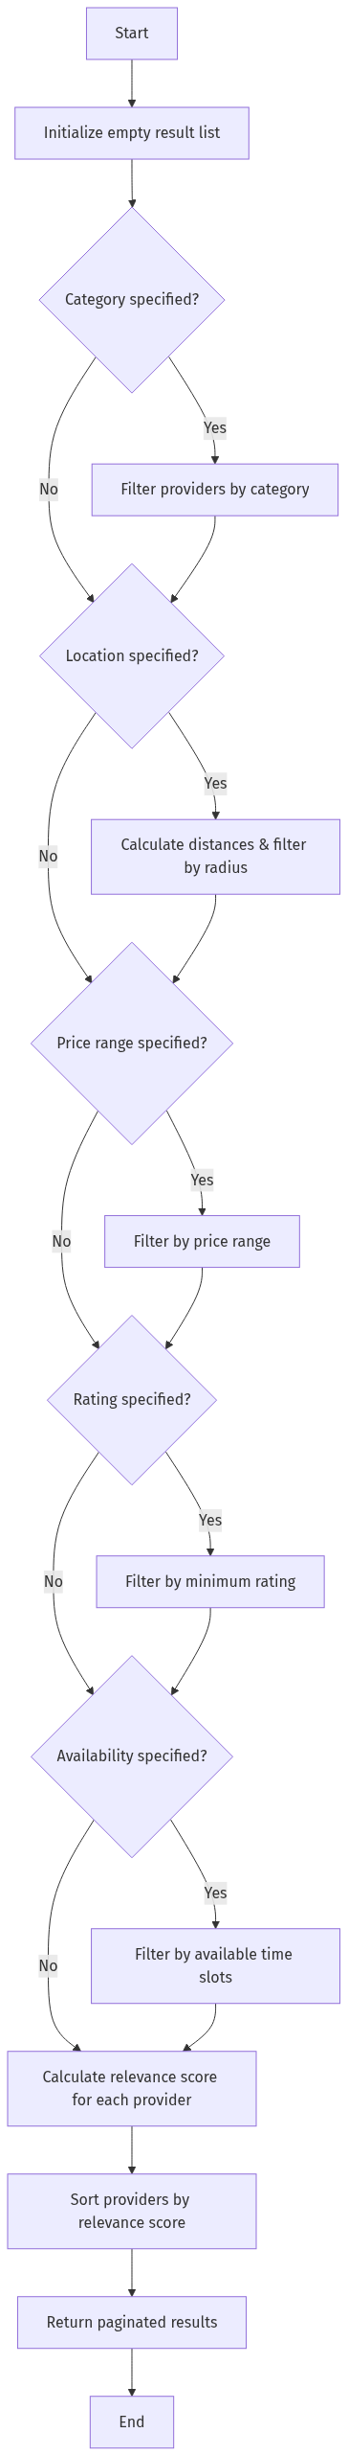
mermaid chart

2. Booking Slot Availability Algorithm Flowchart
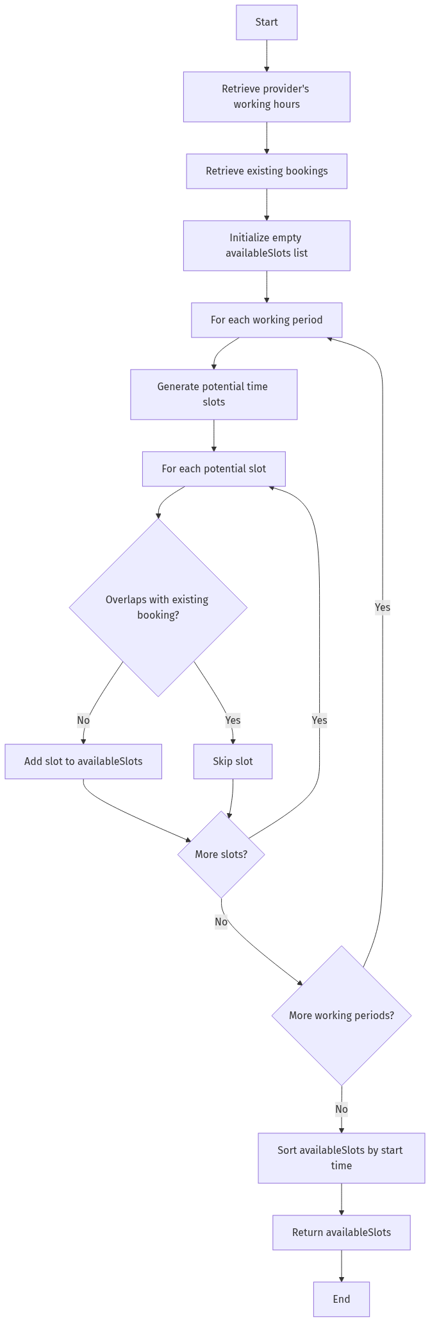
mermaid chart

3. Service Provider Recommendation Algorithm Flowchart
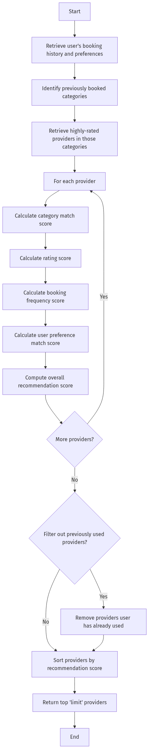
mermaid chart

4. Review Sentiment Analysis Algorithm Flowchart
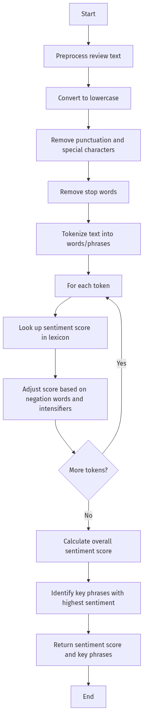
mermaid chart

5. Dynamic Pricing Algorithm Flowchart
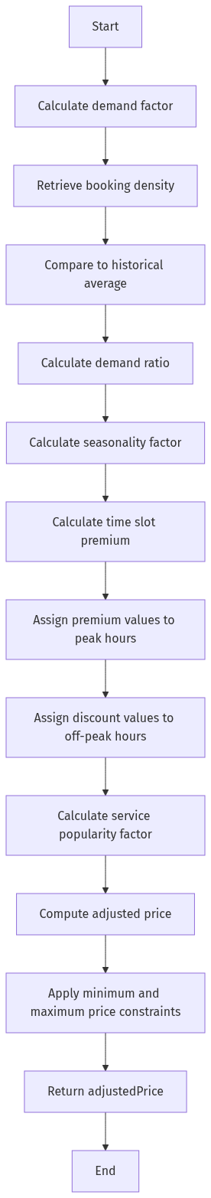
mermaid chart

6. Service Provider Matching Algorithm Flowchart
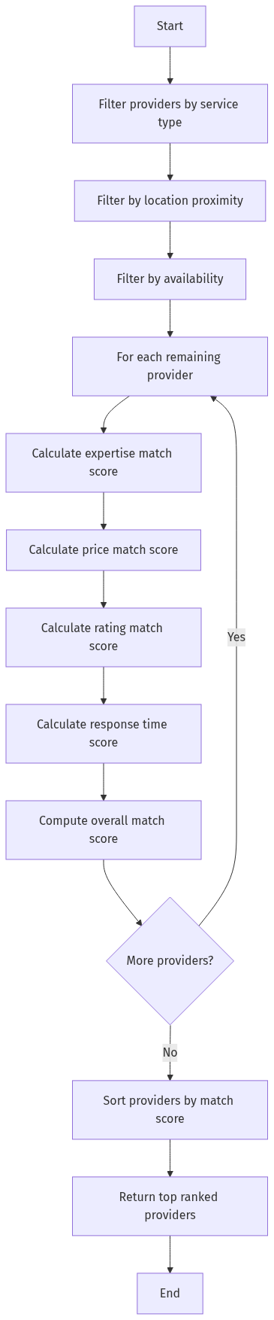
mermaid chart

7. Real-time Chat Message Routing Algorithm Flowchart
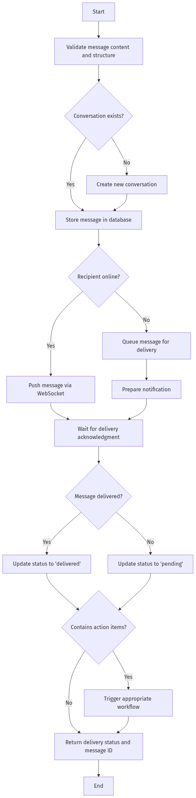
mermaid chart

8. Booking Conflict Resolution Algorithm Flowchart
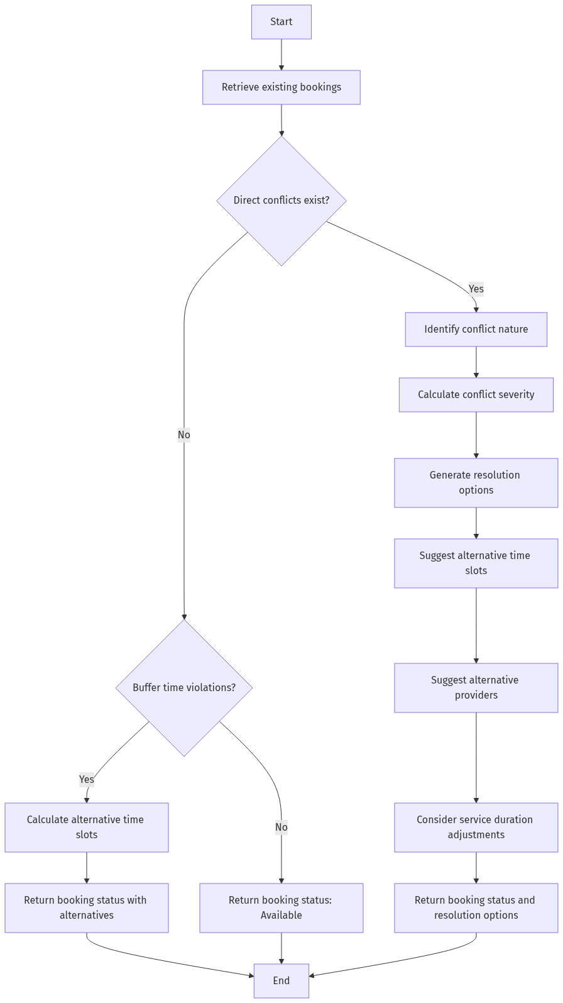
mermaid chart

9. Payment Processing Algorithm Flowchart
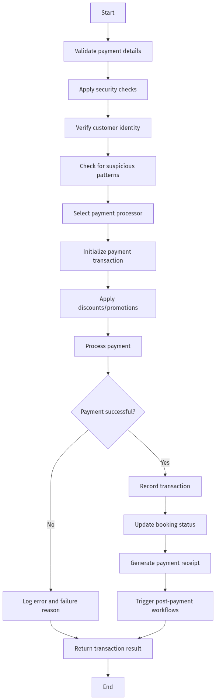
mermaid chart

10. Service Provider Ranking Algorithm Flowchart
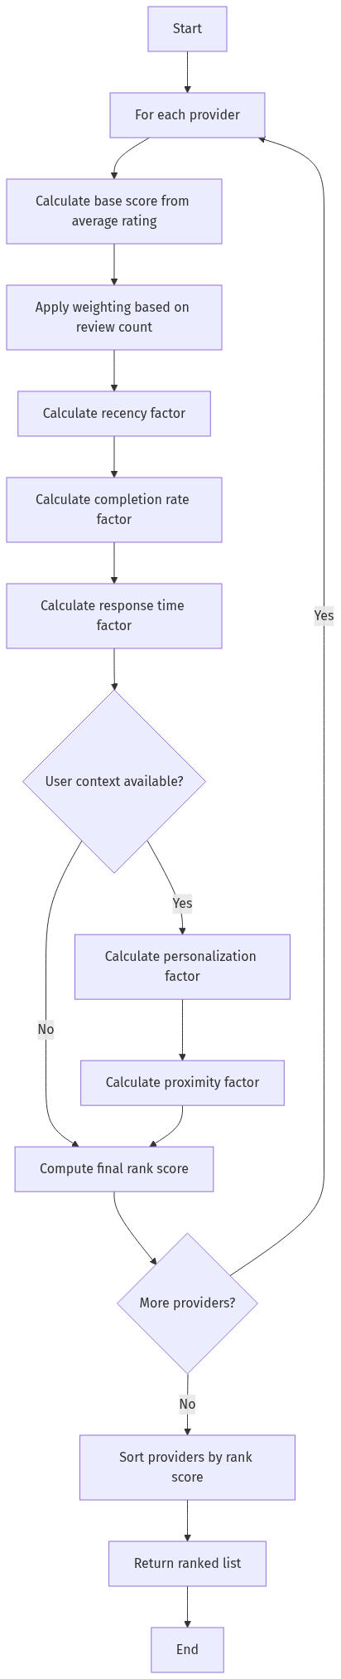
mermaid chart

11. User Authentication and Authorization Algorithm Flowchart
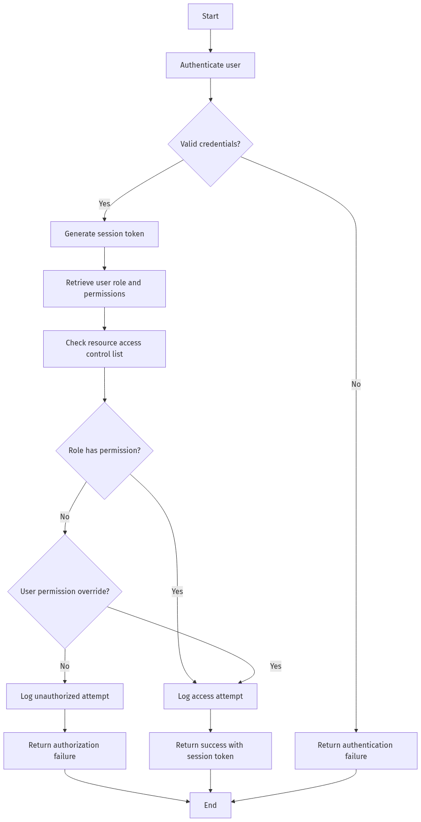
mermaid chart

12. Notification Dispatch Algorithm Flowchart
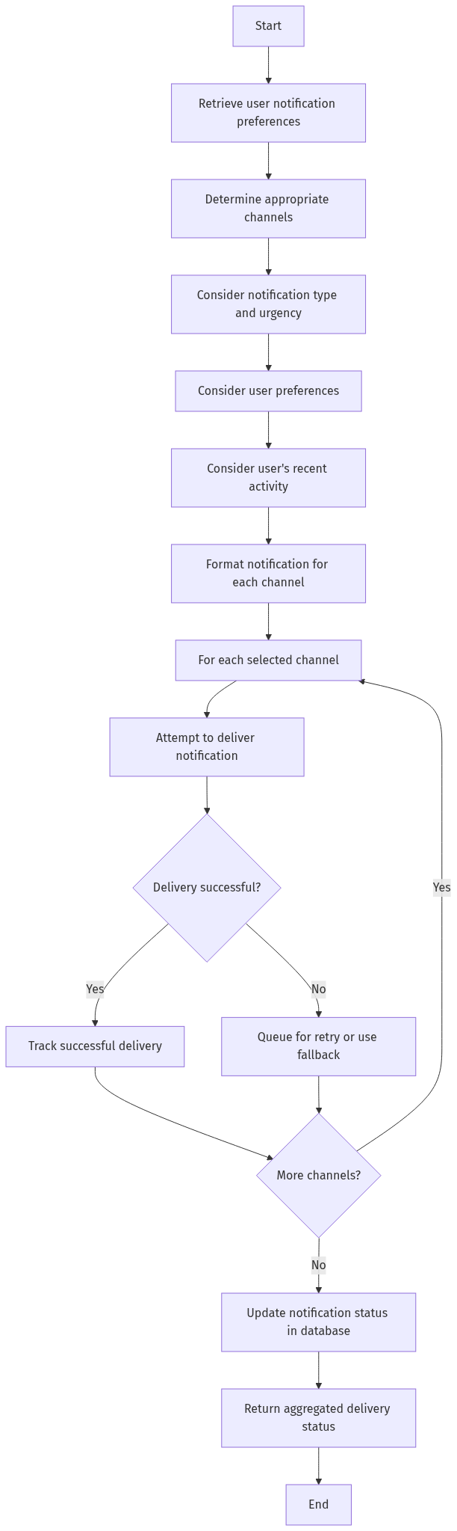
mermaid chart
These flowcharts provide visual representations of the key algorithms that power the ArtisanConnect platform. They illustrate the logical flow, decision points, and processes that enable the platform’s core functionality.

