DATASET TAKEN – BASKET.CSV(500 data rows)

CODE:

import pandas as pd

import numpy as np

from mlxtend.frequent_patterns import apriori, association_rules

import matplotlib.pyplot as plt

from sklearn.tree import DecisionTreeClassifier,plot_tree

from sklearn.model_selection import train_test_split

from sklearn import metrics

from sklearn.cluster import KMeans

from sklearn.preprocessing import StandardScaler

from sklearn.decomposition import PCA

#import seaborn as sns

data = pd.read_csv('basket.csv')

data=data.head(500)

data=data.fillna('None',inplace=False)

items=data['0'].unique()

itemset = set(items)

encoded_vals = []

for index, row in data.iterrows():

rowset = set(row)

labels = {}

uncommons = list(itemset - rowset)

commons = list(itemset.intersection(rowset))

for uc in uncommons:

labels[uc] = 0

for com in commons:

labels[com] = 1

encoded_vals.append(labels)

ohe_df = pd.DataFrame(encoded_vals)

ohe_df.head()

OUTPUT

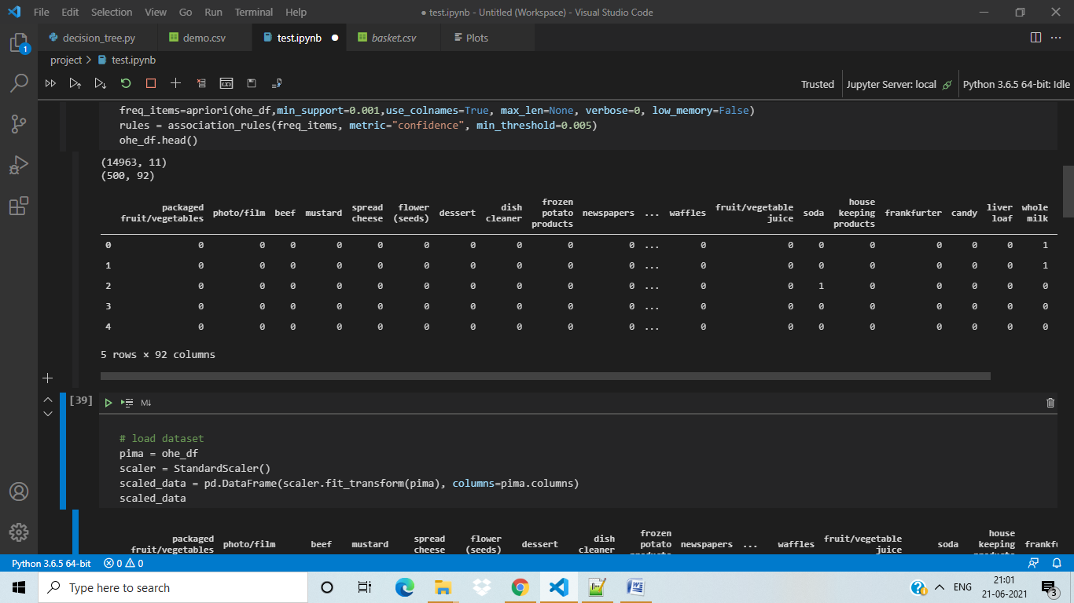

----------------------------------------------------------------------

#scaling and pca analysis

pima = ohe_df

scaler = StandardScaler()

scaled_data = pd.DataFrame(scaler.fit_transform(pima), columns=pima.columns)

scaled_data.head()

OUTPUT

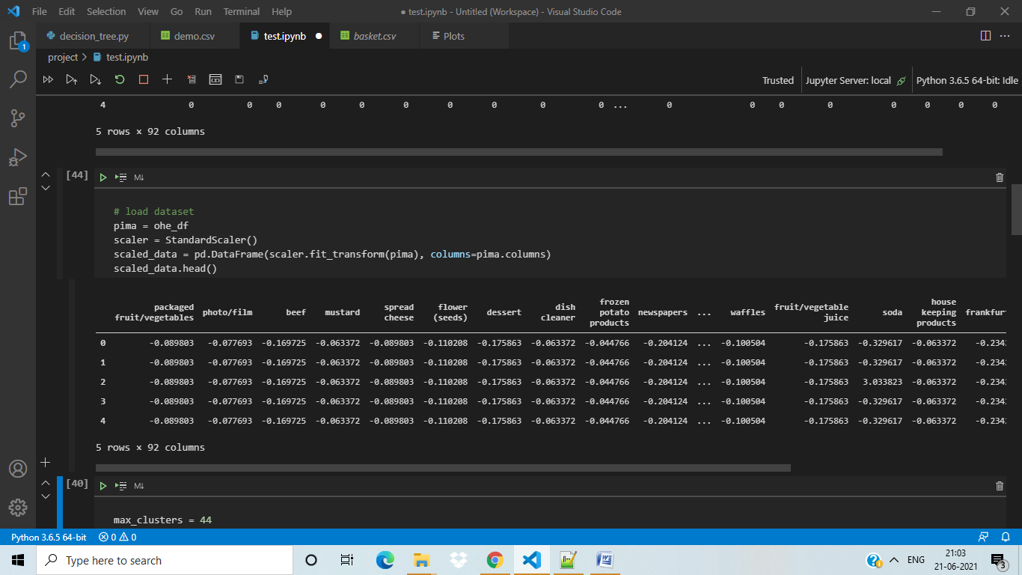

---------------------------------------------------------------------------

#clustering

kmeans = KMeans(n_clusters=7, n_init=10)

kmeans.fit(scaled_data)

clusters = kmeans.predict(scaled_data)

pca = PCA(n_components=8)

reduced_data = pd.DataFrame(pca.fit_transform(scaled_data), columns=['PC1', 'PC2','PC3','PC4','PC5','PC6','PC7','PC8'])

reduced_centers = pca.transform(kmeans.cluster_centers_)

reduced_data['cluster'] = clusters

reduced_data.head()

OUTPUT OF PCA ANALYSIS

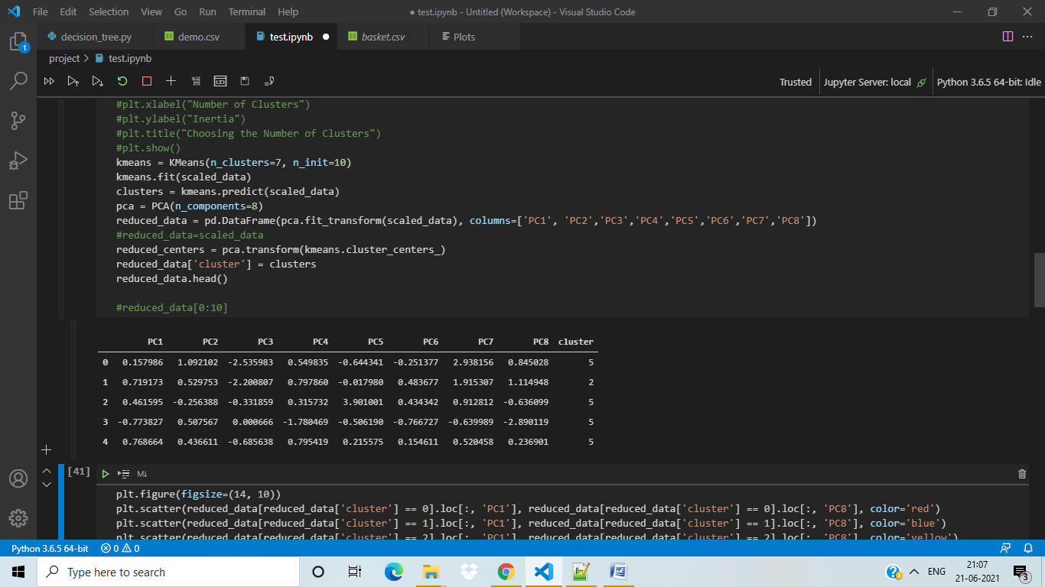

plt.figure(figsize=(14, 10))

plt.scatter(reduced_data[reduced_data['cluster'] == 0].loc[:, 'PC1'], reduced_data[reduced_data['cluster'] == 0].loc[:, 'PC8'], color='red')

plt.scatter(reduced_data[reduced_data['cluster'] == 1].loc[:, 'PC1'], reduced_data[reduced_data['cluster'] == 1].loc[:, 'PC8'], color='blue')

plt.scatter(reduced_data[reduced_data['cluster'] == 2].loc[:, 'PC1'], reduced_data[reduced_data['cluster'] == 2].loc[:, 'PC8'], color='yellow')

plt.scatter(reduced_data[reduced_data['cluster'] == 3].loc[:, 'PC1'], reduced_data[reduced_data['cluster'] == 3].loc[:, 'PC8'], color='orange')

plt.scatter(reduced_data[reduced_data['cluster'] == 4].loc[:, 'PC1'], reduced_data[reduced_data['cluster'] == 4].loc[:, 'PC8'], color='cyan')

plt.scatter(reduced_data[reduced_data['cluster'] == 5].loc[:, 'PC1'], reduced_data[reduced_data['cluster'] == 5].loc[:, 'PC8'], color='magenta')

plt.scatter(reduced_data[reduced_data['cluster'] == 6].loc[:, 'PC1'], reduced_data[reduced_data['cluster'] == 6].loc[:, 'PC2'], color='brown')

plt.scatter(reduced_centers[:, 0], reduced_centers[:, 1], color='black', marker='x', s=300)

plt.xlabel("PC1")

plt.ylabel("PC8")

plt.show()

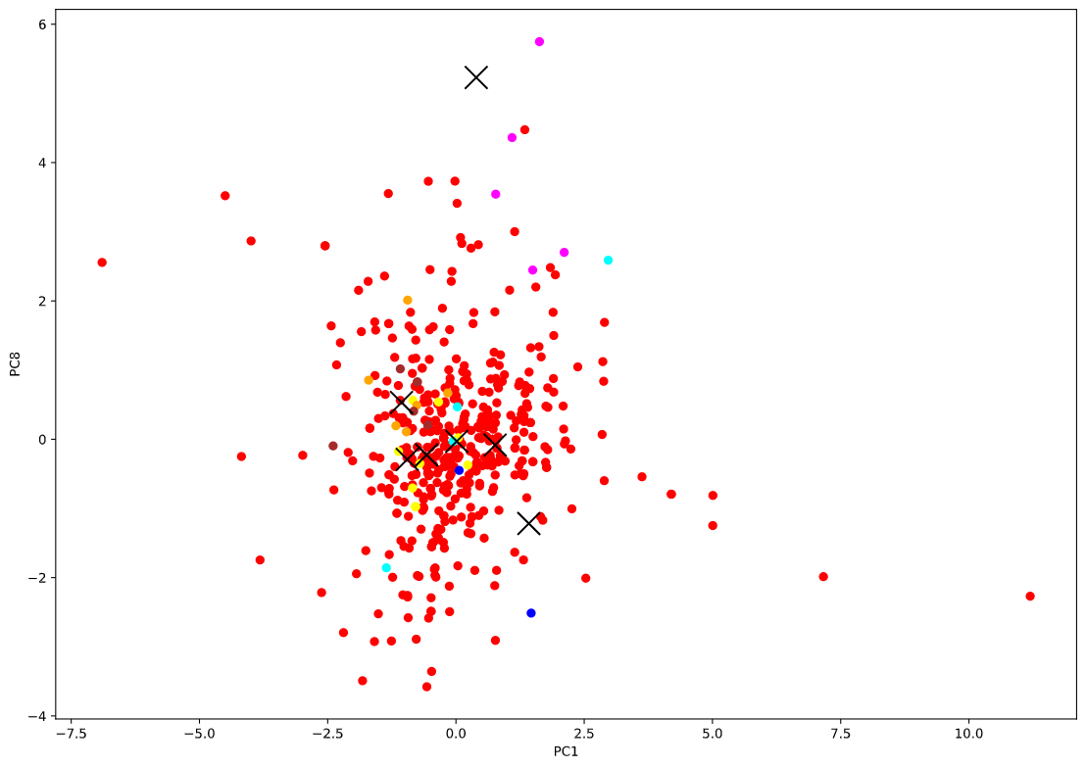

----------------------------------------------------

#Decision Tree

import sklearn

from sklearn import tree

X=reduced_data.loc[:,reduced_data.columns!='cluster']

y = reduced_data.cluster

X_train, X_test, y_train, y_test = train_test_split(X, y, test_size=0.3, random_state=1)

clf = DecisionTreeClassifier()

clf = clf.fit(X_train,y_train)

y_pred = clf.predict(X_test)

print("Accuracy:",metrics.accuracy_score(y_test, y_pred))

metrics.confusion_matrix(y_test,y_pred)

text_representation = tree.export_text(clf)

print(text_representation)

#_ = tree.plot_tree(clf)

plt=tree.plot_tree(clf)

plt

OUPUT

Accuracy: 0.9266666666666666

