Vocabulary:

Symbol: A symbol is a waveform of the communication channel that persists for a fixed period of time. A sending device places symbols on the channel at a fixed and known symbol rate, and the receiving device has the job of detecting the sequence of symbols in order to reconstruct the transmitted data. Ts = 1/Fs is the formula for symbol duration time, where Fs is symbol rate.

Intersymbol interference (ISI) The spreading of the pulse beyond its allotted time interval causes it to interfere with neighboring pulses. Another cause of intersymbol interference is the transmission of a signal through a bandlimited channel, i.e., one where the frequency response is zero above the cutoff frequency. Passing a signal through such a channel results in the removal of frequency components above this cutoff frequency. In addition, components of the frequency below the cutoff frequency may also be attenuated by the channel.

This filtering of the transmitted signal affects the shape of the pulse that arrives at the receiver. The effects of filtering a rectangular pulse not only change the shape of the pulse within the first symbol period, but it is also spread out over the subsequent symbol periods. When a message is transmitted through such a channel, the spread pulse of each individual symbol will interfere with following symbols.

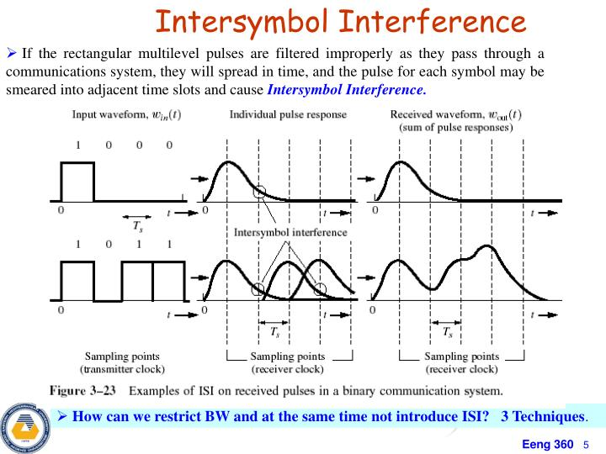

LTI System: In system analysis, among other fields of study, a **linear time-invariant** (**LTI**) **system** is a system that produces an output signal from any input signal subject to the constraints of linearity and time-invariance. These properties apply (exactly or approximately) to many important physical systems, in which case the response *y*(*t*) of the system to an arbitrary input *x*(*t*) can be found directly using convolution: *y*(*t*) = (*x* ∗ *h*)(*t*) where *h*(*t*) is called the system's impulse response and ∗ represents convolution (not to be confused with multiplication, as is frequently employed by the symbol in computer languages). What's more, there are systematic methods for solving any such system (determining *h*(*t*)), whereas systems not meeting both properties are generally more difficult (or impossible) to solve analytically. A good example of an LTI system is any electrical circuit consisting of resistors, capacitors, inductors and linear amplifiers.

Frequency/Time Domain: the frequency domain refers to the analysis of mathematical functions or signals with respect to frequency, rather than time. Put simply, a time-domain graph shows how a signal changes over time, whereas a frequency-domain graph shows how much of the signal lies within each given frequency band over a range of frequencies. A frequency-domain representation can also include information on the phase shift that must be applied to each sinusoid in order to be able to recombine the frequency components to recover the original time signal.

A given function or signal can be converted between the time and frequency domains with a pair of mathematical operators called transforms. An example is the Fourier transform, which converts a time function into a complex valued sum or integral of sine waves of different frequencies, with amplitudes and phases, each of which represents a frequency component. The "spectrum" of frequency components is the frequency-domain representation of the signal. The inverse Fourier transform converts the frequency-domain function back to the time-domain function.

Nyquist Criterion/Filter: The Nyquist criterion describes the conditions where there is no ISI. It provides a method for constructing band limited functions to overcome the effects of ISI. When consecutive symbols are transmitted over a channel by a linear modulation, the impulse response or frequency response of the channel causes the transmitted symbol to be spread in the time domain. This causes intersymbol interference because the previously transmitted symbols affect the currently received symbol, thus reducing tolerance for noise. The Nyquist theorem relates this time-domain condition to an equivalent frequency-domain condition.

SRRC: This is a root raised cosine filter. It is a filter used for pulse shaping, and it minimizes intersymbol

interface (ISI). It is an implementation of a lowpass Nyquist filter, i.e. The waveform exhibits off

symmetry about 1/2T where T is the symbol period.

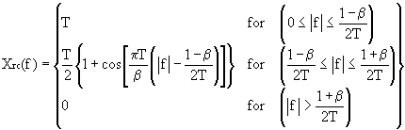

* f is the frequency.
* T is the symbol time.
* beta is the rolloff factor.

The impulse response of a root raised cosine filter.

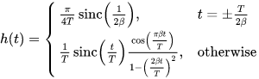

Where sinc is sin(πx)/(πx) i.e. the normalized sinc function.

The roll off factor is a measure of the excess bandwidth of the filter. i.e the bandwidth occupied beyond the Nyquist bandwidth of 1/2T. Some authors call alpha=beta.

Matched filter (DSP): In signal processing, a **matched filter** is obtained by correlating a known delayed signal, or *template*, with an unknown signal to detect the presence of the template in the unknown signal. This is equivalent to convolving the unknown signal with a conjugated time-reversed version of the template. The matched filter is the optimal linear filter for maximizing the signal-to-noise ratio (SNR) in the presence of additive stochastic noise.

Matched filters are commonly used in radar, in which a known signal is sent out, and the reflected signal is examined for common elements of the out-going signal. Pulse compression is an example of matched filtering. It is so called because the impulse response is matched to input pulse signals. Two-dimensional matched filters are commonly used in image processing, e.g., to improve the SNR of X-ray observations. Matched filtering is a demodulation technique with LTI (linear time invariant) filters to maximize SNR.

DSP Example:

Imagine we want to send the sequence "0101100100" coded in non polar non-return-to-zero (NRZ) through a certain channel. We can represent our message �(�)as the sum of shifted unit pulses:



If we model our noisy channel as an AWGN channel (**Additive white Gaussian noise** (**AWGN**) is a basic noise model used in information theory to mimic the effect of many random processes that occur in nature), white Gaussian noise is added to the signal. At the receiver end, for a Signal-to-noise ratio of 3 dB, this may look like:

A first glance will not reveal the original transmitted sequence. There is a high power of noise relative to the power of the desired signal (i.e., there is a low signal-to-noise ratio). If the receiver were to sample this signal at the correct moments, the resulting binary message could be incorrect.

To increase our signal-to-noise ratio, we pass the received signal through a matched filter. Precisely, the impulse response of the ideal matched filter, assuming white (uncorrelated) noise should be a time-reversed complex-conjugated scaled version of the signal that we are seeking. We choose



In this case due to symmetry, the time-reversed complex conjugate of h(t)ℎ(�)h(t) is in fact ℎ(�)h(t), allowing us to call h(t)ℎ(�)h(t) the impulse response of our matched filter convolution system. After convolving with the correct matched filter, which can now be safely sampled by the receiver at the correct sampling instants, and compared to an appropriate threshold, resulting in a correct interpretation of the binary message.

 �(�)=∑�=−∞∞��×Π(�−���).