AskDocs
Intelligent Document Query System

Software Requirements Specification (SRS)

Document Version: 1.0
Date: April 06, 2026
Course: Advanced Web Technology (AWT)
Semester: 6th Semester — B.Tech
Project Type: Full-Stack RAG Web Application
Technology: FastAPI · React · ChromaDB · Google Gemini

Table of Contents

1. Introduction
1.1 Purpose
1.2 Scope
1.3 Definitions, Acronyms, and Abbreviations
1.4 Document Overview
2. Overall Description
2.1 Product Perspective
2.2 Product Functions
2.3 User Classes and Characteristics
2.4 Operating Environment
2.5 Constraints and Assumptions
3. System Architecture
3.1 High-Level Architecture Diagram
3.2 Document Upload Pipeline
3.3 Query Processing Pipeline
4. Functional Requirements
4.1 Document Management
4.2 Text Extraction
4.3 Chunking and Embedding
4.4 Vector Search
4.5 Answer Generation
5. Non-Functional Requirements
6. External Interface Requirements (REST API)
6.1 API Endpoints
6.2 Data Schemas
6.3 Frontend–Backend Communication
7. Technology Stack
8. System Constraints
8.1 Technical Constraints
8.2 Business Constraints
8.3 Regulatory Constraints

1. Introduction

1.1 Purpose
This Software Requirements Specification (SRS) describes the complete functional and non-functional requirements for AskDocs — a privacy-first Intelligent Document Query System built on Retrieval-Augmented Generation (RAG). The document is the primary reference for developers, evaluators, and academic assessors reviewing this deliverable for the 6th Semester Advanced Web Technology course.

1.2 Scope
AskDocs enables users to upload documents in multiple formats (PDF, DOCX, XLSX, PNG, JPG) and query their content using natural language. The system extracts, chunks, embeds, and stores document content locally using ChromaDB, then answers questions by retrieving the most relevant text passages and generating grounded, cited responses via the Google Gemini API.
Key scope boundaries:
- All document data persists locally — only minimal retrieved context is transmitted to Gemini.
- Designed as a single-user local deployment; no cloud hosting or authentication is included.
- Multi-document queries are supported — answers may draw from several uploaded files.
- Out of scope: multi-user authentication, real-time collaboration, and cloud deployment.

1.3 Definitions, Acronyms, and Abbreviations
Term | Definition
RAG | Retrieval-Augmented Generation — LLM answers grounded in retrieved document context
IDP | Intelligent Document Processing — automated extraction and understanding of documents
ChromaDB | Open-source, embedded vector database for storing and querying text embeddings
Embedding | A fixed-length numerical vector representing the semantic meaning of a text passage
Chunk | A fixed-size segment of extracted document text (500 words, 100-word overlap)
top_k | Number of most-similar chunks retrieved per query (default: 5)
HNSW | Hierarchical Navigable Small World — fast approximate nearest-neighbour algorithm
OCR | Optical Character Recognition — converts image-based text to machine-readable text
LLM | Large Language Model — generates natural-language answers (Gemini 2.5 Flash)
REST API | HTTP interface between the React frontend and the FastAPI backend
FastAPI | Modern async Python framework for building REST APIs with OpenAPI docs
Vite | Frontend build tool and dev server for the React SPA
Cosine Similarity | Metric measuring the angle between two vectors to determine semantic closeness

1.4 Document Overview
Section 2 provides a high-level product description. Section 3 presents the system architecture with three flowcharts. Sections 4 and 5 detail functional and non-functional requirements. Section 6 specifies the REST API. Sections 7 and 8 cover the technology stack and system constraints.

2. Overall Description

2.1 Product Perspective
AskDocs is a standalone full-stack web application following a three-tier architecture: a React SPA (presentation), a FastAPI REST server (application logic), and a local ChromaDB instance (data persistence). The React frontend communicates exclusively with the FastAPI backend through HTTP REST calls. The backend orchestrates a complete RAG pipeline: extract -> chunk -> embed -> store -> retrieve -> generate. The only external dependency is the Google Gemini API for embeddings (text-embedding-004) and answer generation (Gemini 2.5 Flash).

2.2 Product Functions
- Document Ingestion — accept multi-format file uploads; save to local disk and process
- Text Extraction — extract text from PDF, DOCX, Excel, and images (with OCR fallback)
- Intelligent Chunking — split extracted text into overlapping 500-word semantic segments
- Vector Embedding — convert chunks to 768-dimensional vectors using Gemini text-embedding-004
- Semantic Storage — persist vectors and metadata in a local ChromaDB cosine-similarity index
- Natural-Language Querying — embed user questions and retrieve the top-5 similar chunks
- Grounded Answer Generation — produce cited, Markdown-formatted answers using Gemini 2.5 Flash
- Citation Tracking — surface source document and page number for every generated answer
- Document Management — list all uploaded documents; delete documents with full vector cleanup

2.3 User Classes and Characteristics
User Class | Description | Technical Level
End User | Uploads personal or professional documents; queries them conversationally | Non-technical
Student | Uses AskDocs to search study materials, notes, and research papers | Basic
Researcher | Queries large document corpora to extract specific factual information | Intermediate
Developer | Runs the application locally; may extend or modify the codebase | Advanced

2.4 Operating Environment
Component | Requirement
Operating System | Windows 10/11, macOS 12+, or Ubuntu 20.04+
Python | 3.10 or higher
Node.js | 18.x or higher (for frontend build and dev server)
Web Browser | Chrome 110+, Firefox 110+, or Edge 110+
Network Access | Active internet connection required for Gemini API calls
Disk Space | Minimum 500 MB free for ChromaDB, uploads, and Python venv
Gemini API Key | Valid Google Gemini API key stored in backend/.env

2.5 Constraints and Assumptions
Constraints:
- Gemini API rate limits apply; sustained batch embedding may be throttled.
- Very large documents (>50 MB) may cause slow processing or memory pressure.
- CORS policy restricts API access to localhost:5173 and localhost:3000.
- ChromaDB uses cosine similarity only; Euclidean or dot-product distance is not configured.
- No streaming — the frontend waits for the full LLM response before rendering.
Assumptions:
- The user supplies a valid GEMINI_API_KEY in backend/.env before starting the server.
- The system runs on a trusted local machine — no authentication layer is required.
- Uploaded documents are in one of the six supported formats.
- Questions are in English; multilingual support is not guaranteed.

3. System Architecture

3.1 High-Level Architecture Diagram
AskDocs follows a three-tier architecture. The React SPA (presentation tier) communicates with the FastAPI backend (logic tier) over HTTP REST. The backend delegates to six isolated service modules that interact with the ChromaDB vector store (data tier) and the Google Gemini API (external AI tier).
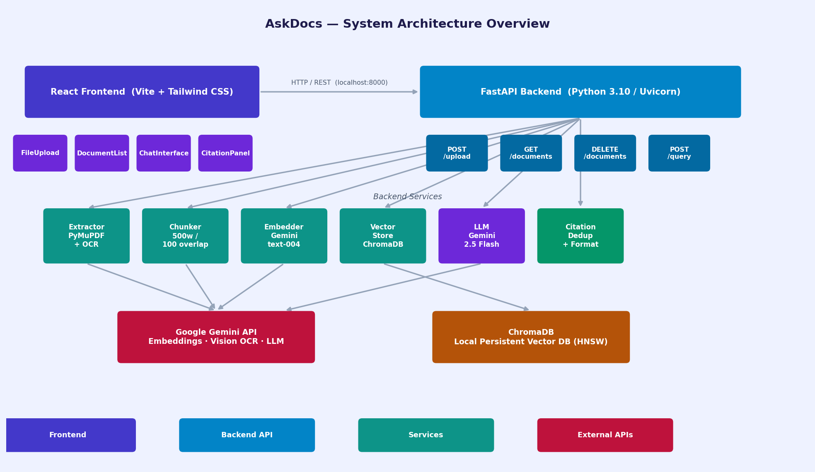
Figure 1 — AskDocs System Architecture Overview

3.2 Document Upload Pipeline
When the user uploads a file the system validates the extension, extracts raw text (falling back to Gemini Vision OCR for scanned PDFs and images), applies overlapping sliding-window chunking, calls the Gemini embedding API in a single batch, and stores all vectors and metadata in ChromaDB. Re-uploading the same filename first deletes the stale chunks, ensuring idempotent behaviour.
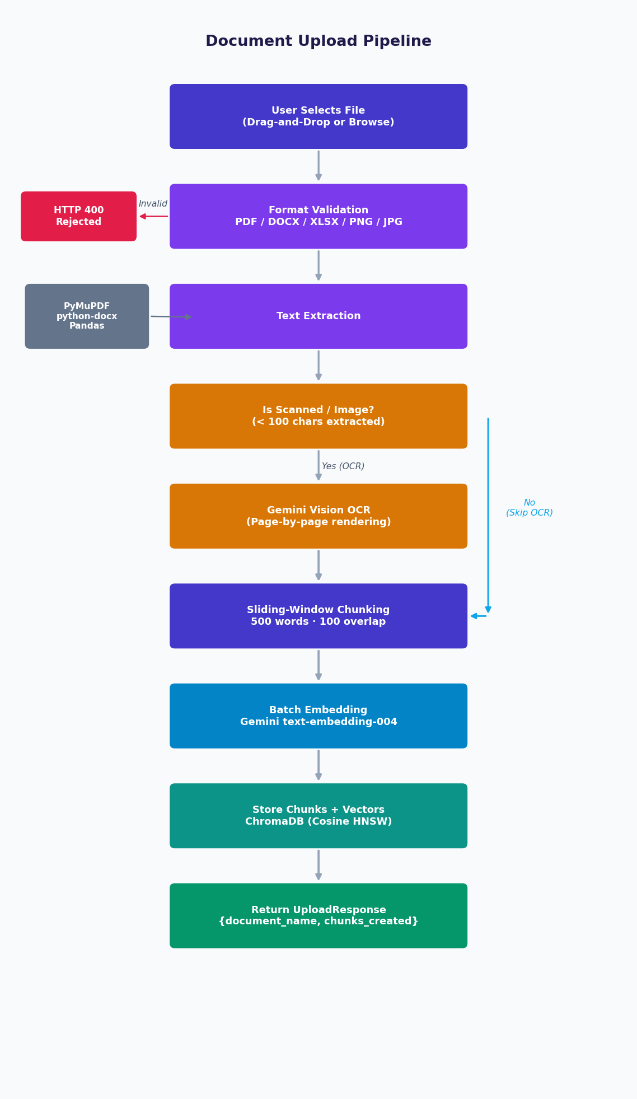
Figure 2 — Document Upload Pipeline Flowchart

3.3 Query Processing Pipeline
A user question is embedded using the same Gemini text-embedding-004 model, then used to perform a cosine similarity search across all stored chunks. The top-5 most relevant passages are injected into a grounded prompt alongside the original question. Gemini 2.5 Flash generates a cited, Markdown-formatted answer. The backend deduplicates citations by (document_name, page_number) before returning the response to the frontend.
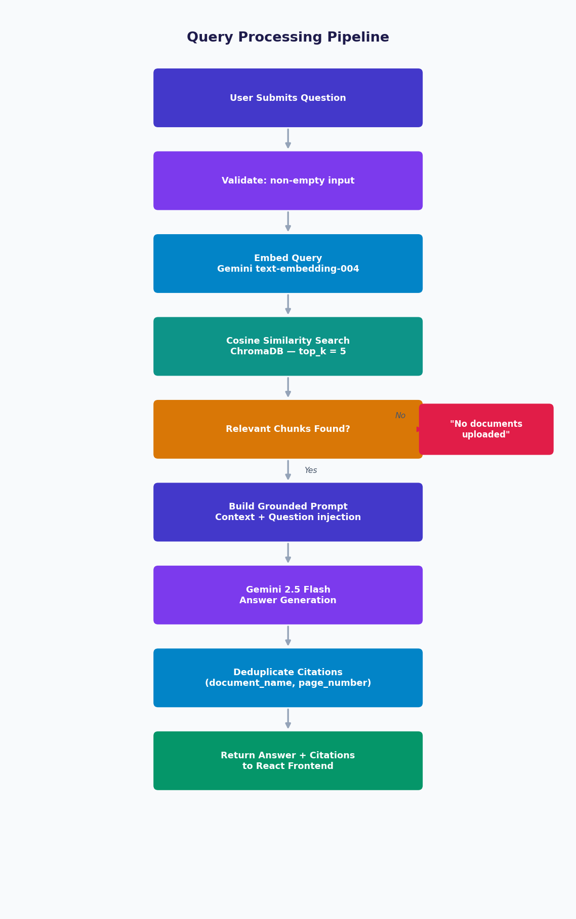
Figure 3 — Query Processing Pipeline Flowchart

4. Functional Requirements

4.1 Document Management
ID | Name | Description | Priority
FR-01 | Upload | System shall accept single-file uploads via drag-and-drop or file browser. | High
FR-02 | Format Support | System shall support PDF, DOCX, XLSX, XLS, PNG, JPG, and JPEG file types. | High
FR-03 | Validation | System shall reject unsupported file types with HTTP 400 and a descriptive message. | High
FR-04 | Re-upload | Re-uploading the same filename shall delete its previous vector chunks first. | Medium
FR-05 | List Docs | System shall provide GET /api/documents returning all document names in ChromaDB. | High
FR-06 | Delete Doc | System shall delete a document and all its vector chunks via DELETE /api/documents/{name}. | High

4.2 Text Extraction
ID | Name | Description | Priority
FR-07 | PDF Native | System shall extract selectable text from PDFs using PyMuPDF. | High
FR-08 | OCR Fallback | If <100 chars extracted from a PDF, system shall fall back to Gemini Vision OCR. | High
FR-09 | DOCX | System shall extract paragraph text from Word documents using python-docx. | High
FR-10 | Excel | System shall serialize all spreadsheet sheets, preserving sheet names and structure. | High
FR-11 | Image OCR | System shall extract text from PNG/JPG images via Gemini Vision OCR. | High
FR-12 | Empty Guard | If no text can be extracted, system shall return HTTP 422 with a clear message. | Medium

4.3 Chunking and Embedding
ID | Name | Description | Priority
FR-13 | Chunk Size | System shall produce word-based chunks of maximum 500 words per chunk. | High
FR-14 | Overlap | Adjacent chunks shall overlap by 100 words to preserve cross-boundary context. | High
FR-15 | Chunk UUID | Each chunk shall carry a unique UUID to support idempotent insertion and deletion. | High
FR-16 | Batch Embed | Embeddings shall be generated in a single batch API call to minimise latency. | Medium
FR-17 | Embed Model | Embedding model shall be Gemini text-embedding-004 producing 768-dim vectors. | High

4.4 Vector Search
ID | Name | Description | Priority
FR-18 | Cosine Search | Vector retrieval shall use cosine similarity via ChromaDB's HNSW index. | High
FR-19 | top_k Param | Default retrieval shall return 5 chunks; callers may override top_k per request. | High
FR-20 | No-Doc Guard | If no chunks exist, system shall return a friendly 'upload first' message. | High

4.5 Answer Generation
ID | Name | Description | Priority
FR-21 | Grounded LLM | LLM shall use ONLY retrieved context — no outside knowledge or hallucination. | High
FR-22 | Inline Cite | Every answer shall include inline citations: *(Source: filename, Page N)*. | High
FR-23 | Dedup Cite | The citations list shall deduplicate entries by (document_name, page_number). | Medium
FR-24 | Markdown | Answers shall be formatted in Markdown (headers, bold, bullet lists). | Medium
FR-25 | Not-Found Msg | If the answer is absent from context, system shall say so rather than fabricate. | High

5. Non-Functional Requirements

ID | Category | Description | Priority
NFR-01 | Performance | Document upload and processing shall complete within 30 seconds for files ≤ 10 MB. | High
NFR-02 | Performance | Query response (embed -> search -> generate) shall complete within 10 seconds. | High
NFR-03 | Reliability | Backend shall return structured JSON error responses (HTTP 4xx/5xx) for all failure modes. | High
NFR-04 | Reliability | ChromaDB shall persist data across server restarts without any data loss. | High
NFR-05 | Usability | Upload area shall display real-time progress percentage during processing. | Medium
NFR-06 | Usability | All user-facing error messages shall be human-readable — no raw Python tracebacks. | High
NFR-07 | Privacy | Document text shall not be stored on any external server; only API calls leave localhost. | High
NFR-08 | Privacy | The Gemini API key shall be stored only in backend/.env and never exposed to the frontend. | High
NFR-09 | Scalability | ChromaDB shall handle at least 50 documents (≈25,000 chunks) without performance degradation. | Medium
NFR-10 | Maintainability | Each backend service (extractor, chunker, embedder, vector_store, llm) shall be fully isolated. | High
NFR-11 | Portability | Application shall run unchanged on Windows 10/11, macOS 12+, and Ubuntu 20.04+. | Medium
NFR-12 | Security | CORS policy shall restrict API access to localhost origins (ports 5173 and 3000) only. | High
NFR-13 | Observability | Backend shall log all errors with stack traces for developer debugging. | Low

6. External Interface Requirements (REST API)

6.1 API Endpoints
Method | Endpoint | Description | Request Body | Success Response
POST | /api/upload | Upload and process a document | multipart/form-data: file | 200 UploadResponse
GET | /api/documents | List all stored documents | — | 200 DocumentListResponse
DELETE | /api/documents/{name} | Delete document + all its chunks | — | 200 {message: str}
POST | /api/query | Ask a natural-language question | QueryRequest {question, top_k} | 200 QueryResponse
GET | /health | Backend health check | — | 200 {status: 'ok'}
GET | / | Root readiness check | — | 200 {status, message}

6.2 Data Schemas
Schema | Fields
UploadResponse | message: str · document_name: str · chunks_created: int
DocumentListResponse | documents: List[str]
QueryRequest | question: str · top_k: int = 5
Citation | document_name: str · page_number: int · chunk_text: str (≤ 200 chars)
QueryResponse | answer: str (Markdown) · citations: List[Citation]

6.3 Frontend–Backend Communication
The React frontend communicates with the backend using the Axios HTTP client. All API calls target http://localhost:8000/api. The Vite dev server runs on http://localhost:5173. CORS is pre-configured in main.py to permit both localhost:5173 and localhost:3000 origins. All request and response bodies use JSON (Content-Type: application/json) except file uploads, which use multipart/form-data.

7. Technology Stack

Layer | Technology | Version | Purpose
Frontend | React | 18.x | UI component library (SPA)
Frontend | Vite | 5.x | Build tool and HMR dev server
Frontend | Tailwind CSS | 3.x | Utility-first CSS framework
Frontend | React Dropzone | 14.x | Drag-and-drop file upload
Frontend | Axios | 1.x | HTTP client for REST API calls
Backend | Python | 3.10+ | Primary backend language
Backend | FastAPI | 0.111+ | Async REST API framework
Backend | Uvicorn | 0.30+ | ASGI server for FastAPI
Backend | Pydantic v2 | 2.7+ | Request / response schema validation
Backend | python-dotenv | 1.0+ | Environment variable management
AI / ML | Google Gemini 2.5 Flash | — | LLM for grounded answer generation
AI / ML | Gemini text-embedding-004 | — | 768-dimensional semantic embeddings
AI / ML | Gemini Vision (2.5 Flash) | — | OCR for scanned PDFs and images
Data | ChromaDB | 0.5+ | Local vector DB with cosine HNSW index
Extraction | PyMuPDF (fitz) | 1.24+ | Fast PDF text extraction
Extraction | python-docx | 1.1+ | Word document (.docx) parsing
Extraction | Pandas + openpyxl | 2.2+ | Excel spreadsheet parsing
Extraction | Pillow | 10.0+ | Image loading and preprocessing

8. System Constraints

8.1 Technical Constraints
- Gemini API is subject to Google's usage quotas; sustained high-volume usage may be throttled.
- ChromaDB is a single-process embedded database — concurrent write access is not supported.
- The system has no user-session isolation; all uploaded documents are accessible to any browser client on the same localhost.
- Scanned PDF OCR consumes one Gemini Vision API call per page, which may be cost-intensive for long documents.
- Responses are not streamed — the React frontend waits for the full LLM completion before rendering.
- The Gemini text-embedding-004 model produces 768-dimensional vectors; this dimension is fixed and cannot be changed without rebuilding the ChromaDB collection.

8.2 Business Constraints
- AskDocs is an academic deliverable for the 6th Semester Advanced Web Technology course.
- All Google Gemini API usage is subject to Google's Terms of Service and acceptable use policy.
- The system is not intended for production deployment without additional security hardening (authentication, rate limiting, HTTPS).

8.3 Regulatory Constraints
- Users are responsible for ensuring they have the legal right to process the documents they upload.
- Minimal data is transmitted externally: only retrieved text chunks are sent to Gemini for embedding/generation; no personally identifiable information is stored beyond what the user uploads.
- The system stores uploaded files on local disk; users should ensure compliance with any applicable data protection regulations for their use case.

