# 报告内容

## 项目概述

完成一个由C语言，glade图形开发，gtk+库互相配合运作的计算器程序。实现简单的点击数字和运算符，文本框同步显示输入字符，最终运算出结果。

## **相关技术**

C语言：使用C语言作为程序的核心开发语言，负责实现计算器的基本逻辑与功能。

Glade：利用Glade设计计算器的GUI界面，快速构建图形化用户界面，减少手动编写GTK代码的工作量。

GTK+：使用GTK+库来实现计算器的图形界面，处理按钮点击事件和文本框显示等操作。

编译工具：利用GCC进行C语言程序的编译，并使用Makefile管理项目的构建过程。

## **需求分析**

该项目要求开发一个基本的计算器应用程序，具备以下主要功能：

完成基本的加、减、乘、除运算。

通过图形用户界面（GUI）与用户交互，用户点击相应按钮输入数字和运算符。

在文本框中动态显示用户输入的数字、运算符及结果，包括支持小数点输入和运算。

提供清除功能，允许用户清空输入的表达式。

## **设计过程**

先使用glade创建一个计算器页面，页面布局如表格所示，创建一个main_window窗口，加入一个表格，在表格中分别加入button和entry。

|  |  |  |  |
| --- | --- | --- | --- |
| Entry_display:输出界面 | | | = |
| 1 | 2 | 3 | + |
| 4 | 5 | 6 | - |
| 7 | 8 | 9 | * |
| c | 0 | . | / |

思路：鼠标点击相关按钮，输入正确的数字或者运算符号，最后点击等号完成运算，并且将运算结果输出到文本框中。支持小数点后两位的运算，点击C按钮清零界面。

## **实现过程**

安装C语言和开发工具包，安装Glade+GTK+图形界面开发技术。

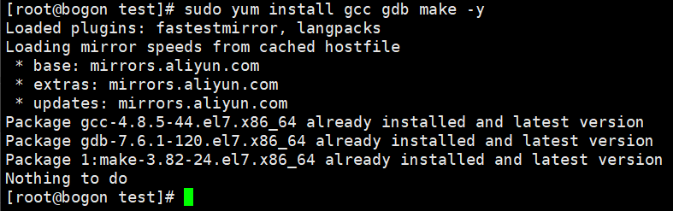

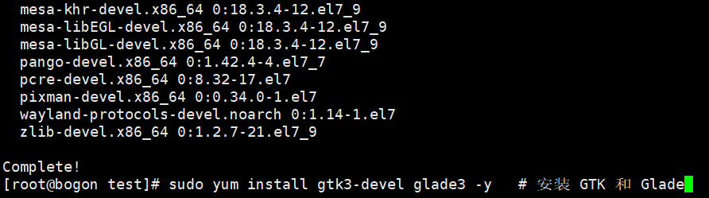

写一个简单C语言程序，输出两个变量相加之和。

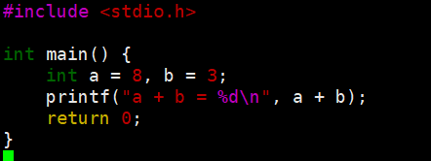

使用gcc命令编译：



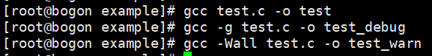



运行程序：



用gdb命令调试编译后的c语言程序：

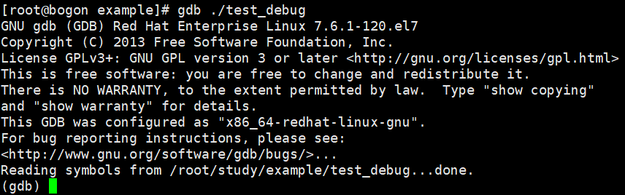

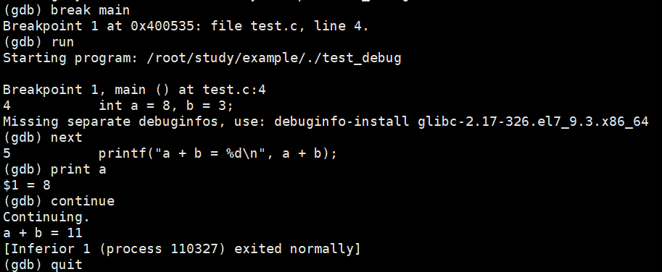

至此，正式进入编写一个计算器的C程序项目。

创建一个glade图形界面：

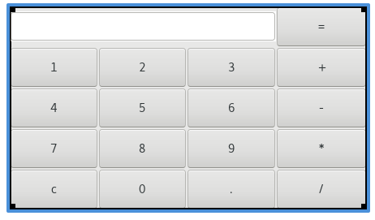

编写main.c文件:



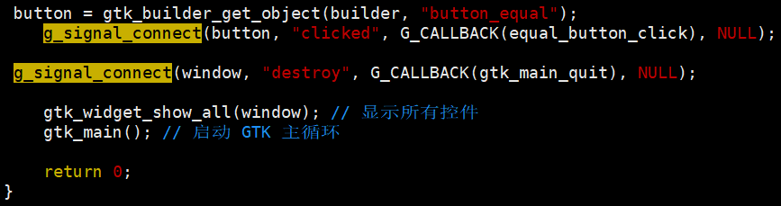

编写完成后编译代码，运行结果：





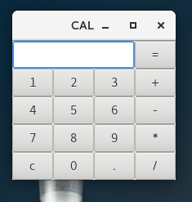

## **测试和总结**

测试功能1+1=2：

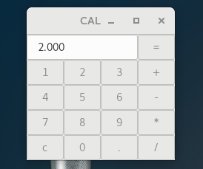

问题：不显示运算符，还有除了加和乘是正确的，其他运算符是错误的，修改代码。

计算5/5=1：

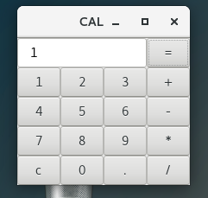

结果正确，但是不显示运算符，导致我无法确认我输入的原数字和运算符。

继续修改代码：显示运算符

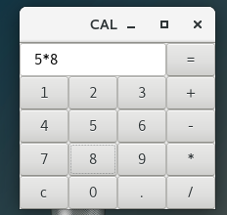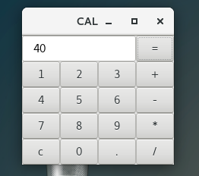

测试小数点运算；

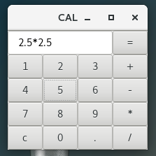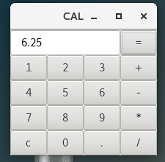

总结：本项目通过C语言、Glade、GTK+的组合，成功实现了一个功能简单、界面友好的计算器。通过图形界面与用户的交互，用户能够方便地进行数字输入和运算符选择，程序能够实时显示输入的数字和运算符，并执行准确的运算。通过小数点输入的支持，程序能够进行更为精确的计算。

项目代码：

#include <gtk/gtk.h>

#include <string.h>

#include <stdlib.h>

GtkWidget *entry_display;

void on_button_clicked(GtkButton *button, gpointer user_data) {

const gchar *label = gtk_button_get_label(button);

const gchar *current = gtk_entry_get_text(GTK_ENTRY(entry_display));

gchar *new_text = g_strconcat(current, label, NULL);

gtk_entry_set_text(GTK_ENTRY(entry_display), new_text);

}

void on_button_clear_clicked(GtkButton *button, gpointer user_data) {

gtk_entry_set_text(GTK_ENTRY(entry_display), "");

}

void on_button_equal_clicked(GtkButton *button, gpointer user_data) {

const gchar *expr = gtk_entry_get_text(GTK_ENTRY(entry_display));

double result = 0;

char op;

double a, b;

if (sscanf(expr, "%lf%c%lf", &a, &op, &b) == 3) {

switch (op) {

case '+': result = a + b; break;

case '-': result = a - b; break;

case '*': result = a * b; break;

case '/': result = b != 0 ? a / b : 0; break;

default: result = 0;

}

char buf[64];

snprintf(buf, sizeof(buf), "%g", result);

gtk_entry_set_text(GTK_ENTRY(entry_display), buf);

}

}

int main(int argc, char *argv[]) {

GtkBuilder *builder;

GtkWidget *window;

GtkWidget *button_0, *button_1, *button_2, *button_3, *button_4, *button_5, *button_6, *button_7, *button_8, *button_9;

GtkWidget *button_plus, *button_minus, *button_multiply, *button_divide, *button_clear, *button_point, *button_equal;

gtk_init(&argc, &argv);

builder = gtk_builder_new_from_file("/root/study/CAL/cal.glade");

gtk_builder_connect_signals(builder, NULL);

window = GTK_WIDGET(gtk_builder_get_object(builder, "main_window"));

entry_display = GTK_WIDGET(gtk_builder_get_object(builder, "entry_display"));

button_0 = GTK_WIDGET(gtk_builder_get_object(builder, "button_0"));

button_1 = GTK_WIDGET(gtk_builder_get_object(builder, "button_1"));

button_2 = GTK_WIDGET(gtk_builder_get_object(builder, "button_2"));

button_3 = GTK_WIDGET(gtk_builder_get_object(builder, "button_3"));

button_4 = GTK_WIDGET(gtk_builder_get_object(builder, "button_4"));

button_5 = GTK_WIDGET(gtk_builder_get_object(builder, "button_5"));

button_6 = GTK_WIDGET(gtk_builder_get_object(builder, "button_6"));

button_7 = GTK_WIDGET(gtk_builder_get_object(builder, "button_7"));

button_8 = GTK_WIDGET(gtk_builder_get_object(builder, "button_8"));

button_9 = GTK_WIDGET(gtk_builder_get_object(builder, "button_9"));

button_plus = GTK_WIDGET(gtk_builder_get_object(builder, "button_plus"));

button_minus = GTK_WIDGET(gtk_builder_get_object(builder, "button_minus"));

button_multiply = GTK_WIDGET(gtk_builder_get_object(builder, "button_multiply"));

button_divide = GTK_WIDGET(gtk_builder_get_object(builder, "button_divide"));

button_clear = GTK_WIDGET(gtk_builder_get_object(builder, "button_clear"));

button_point = GTK_WIDGET(gtk_builder_get_object(builder, "button_point"));

button_equal = GTK_WIDGET(gtk_builder_get_object(builder, "button_equal"));

g_signal_connect(button_0, "clicked", G_CALLBACK(on_button_clicked), NULL);

g_signal_connect(button_1, "clicked", G_CALLBACK(on_button_clicked), NULL);

g_signal_connect(button_2, "clicked", G_CALLBACK(on_button_clicked), NULL);

g_signal_connect(button_3, "clicked", G_CALLBACK(on_button_clicked), NULL);

g_signal_connect(button_4, "clicked", G_CALLBACK(on_button_clicked), NULL);

g_signal_connect(button_5, "clicked", G_CALLBACK(on_button_clicked), NULL);

g_signal_connect(button_6, "clicked", G_CALLBACK(on_button_clicked), NULL);

g_signal_connect(button_7, "clicked", G_CALLBACK(on_button_clicked), NULL);

g_signal_connect(button_8, "clicked", G_CALLBACK(on_button_clicked), NULL);

g_signal_connect(button_9, "clicked", G_CALLBACK(on_button_clicked), NULL);

g_signal_connect(button_plus, "clicked", G_CALLBACK(on_button_clicked), NULL);

g_signal_connect(button_minus, "clicked", G_CALLBACK(on_button_clicked), NULL);

g_signal_connect(button_multiply, "clicked", G_CALLBACK(on_button_clicked), NULL);

g_signal_connect(button_divide, "clicked", G_CALLBACK(on_button_clicked), NULL);

g_signal_connect(button_point, "clicked", G_CALLBACK(on_button_clicked), NULL);

g_signal_connect(button_clear, "clicked", G_CALLBACK(on_button_clear_clicked), NULL);

g_signal_connect(button_equal, "clicked", G_CALLBACK(on_button_equal_clicked), NULL);

gtk_widget_show_all(window);

gtk_main();

return 0;

}