Project 15

Developing Two-Transmit Channel SDR with Beamforming Capabilities

Peyton Adkins, Gabriel Faro, Alexandra Calvo, Joel Brigida, Jason Kurth

February 8th, 2024

• • • Uniform Circular Array Beamforming • • •

References

1. [[Fundamentals of a Circular Array](https://www.raymaps.com/index.php/fundamentals-of-a-circular-array-mathematical-model-and-code/)]{https://www.raymaps.com/index.php/fundamentals-of-a-circular-array-mathematical-model-and-code/}
2. [[Circular Array Beamforming Using Phase Modes](https://apps.dtic.mil/sti/trecms/pdf/AD1091149.pdf)] {https://apps.dtic.mil/sti/trecms/pdf/AD1091149.pdf}
3. [[Kraken SDR DoA GitHub Repo](https://github.com/krakenrf/krakensdr_doa)] {https://github.com/krakenrf/krakensdr_doa}
4. [[Kraken Vehicle Radio Direction Finding Demonstrations](https://www.youtube.com/watch?v=OY16y1Rl86g)] {https://www.youtube.com/watch?v=OY16y1Rl86g}
5. [[Tutorials for Learning About the Array Factor](https://www.youtube.com/@emviso)] {https://www.youtube.com/@emviso}
6. [[About UCAs](https://www.telecomtrainer.com/uca-uniform-circular-array/)] {https://www.telecomtrainer.com/uca-uniform-circular-array/}
7. [[DOA Estimation Method for Uniform Circular Arrays](https://ieeexplore.ieee.org/stamp/stamp.jsp?arnumber=9520393)] {https://ieeexplore.ieee.org/stamp/stamp.jsp?arnumber=9520393}

Summary of UCA Concepts and Math

In phase array-based beamforming, there are two primary orientations for a software-defined radio array: Uniform Linear Array (ULA) and Uniform Circular Array (UCA). In our progress in the project so far, we’ve referenced and worked with a ULA as initially referenced by Jon Kraft’s various algorithms and works done through the Pluto SDR. As for the end goal of our project, however, we aim to work with a 5-node circular array (which would be considered a UCA). This is the method for which the Kraken SDR has shown to be capable of performing under with its [Vehicle Radio Direction Finding Demonstrations](https://www.youtube.com/watch?v=OY16y1Rl86g).

As a precursor to understanding the algorithms behind the Kraken SDR’s radio direction finding, we must first investigate the math behind beamforming (and beam steering) within the confines of a UCA.

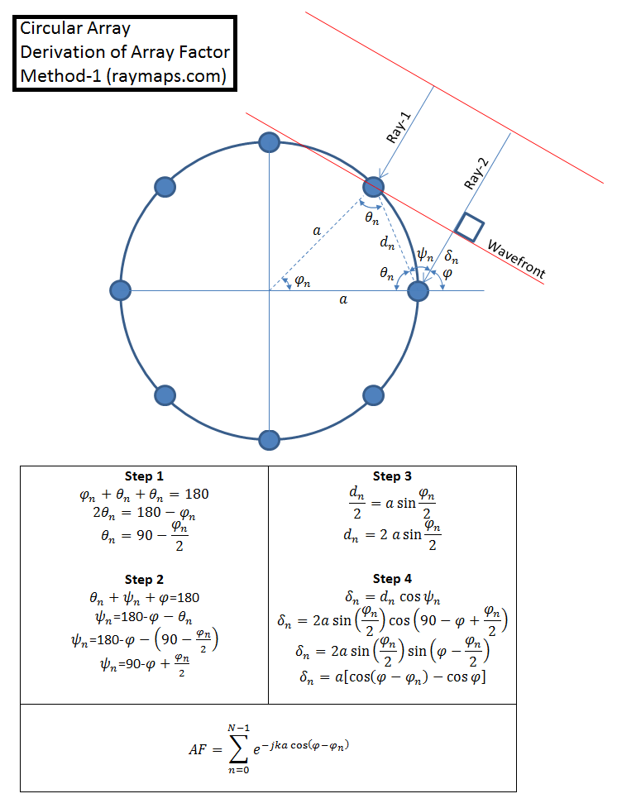

<https://www.raymaps.com/index.php/fundamentals-of-a-circular-array-mathematical-model-and-code/>

Above is a diagram illustrating what occurs in a UCA as a wavefront reaches the closest node to it. Unlike a ULA, each node depends on its own relative position to both the center of the array and the node to which the wave first contacts. Much of the trigonometric calculations are listed in the boxes below, with the end goal of the calculation being the Array Factor (AF) for each node.

The array factor is the measure of magnitude of the electric field of a given array; it is different from the radiation of the combined array, which is limited by the arrangement of the array or by the antennas used in the array. Below is an example of the difference between the array factor (denoted in red) of a ULA angled to a horizontal direction parallel to its axis versus the actual radiation range (denoted in dotted black):

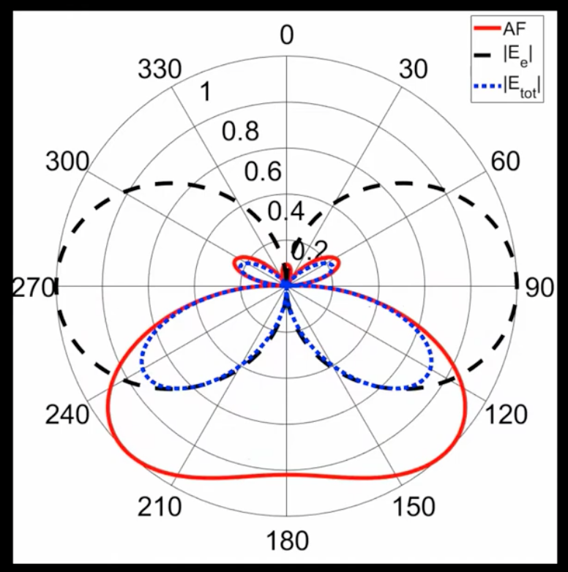

<https://www.youtube.com/watch?v=ZTtNAgpRX-g>

Similarly to ULAs, though, the way to steer a beam is through applying individual phase delays between each element in the array that corresponds to a given desired steering angle. Unlike ULAs, the math behind finding this phase delay is variable, though it is beneficial in that it can be computed with a desired steering angle as an argument in the equation. Below is an equation for generally finding the phase delay of a given node:

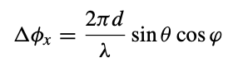

<https://ieeexplore.ieee.org/stamp/stamp.jsp?arnumber=9520393>

Where:  
 d = distance between each element in the circular array  
 λ = wavelength of the signal  
 θ = desired steering angle

In this equation, however, the end portion involving the cosine function is **not necessary** as this example assumes specificity of the Y axis as opposed to just the X axis, which can be thought of as azimuth angular control. In our practice, we are giving focus to a single axis of steering control.