
Department of Information Technology
COLLEGE OF ENGINEERING
CENTRAL LUZON STATE UNIVERSITY
Science City of Muñoz, Nueva Ecija

A.E.G.I.S: AI-ENHANCED GRANT INFORMATION SYSTEM WITH DOCUMENT FORENSICS AND
AUTOMATED NOTIFICATION FOR THE
OFFICE OF STUDENT AFFAIRS

A Capstone Project
Presented to the
Department of Information Technology

In Partial Fulfillment
of the Requirements for the Degree

BACHELOR OF SCIENCE IN INFORMATION TECHNOLOGY

By:
Carillo, John Andrei
Gadiano, Noriel S.
Razon, Joshua A.

April 2026

DISCLAIMER
This Capstone Project is submitted to the Department of Information Technology, College of Engineering, in partial fulfillment of the requirements for the degree of Bachelor of Science in Information Technology at the Central Luzon State University, Science City of Muñoz, Nueva Ecija. It is a product of our own work except where indicated in the text. The project report or any portion thereof, including the source code or any section, may be freely copied and distributed, provided that the source is acknowledged.

APPROVAL SHEET

This capstone project proposal, entitled “A.E.G.I.S: AI-ENHANCED GRANT INFORMATION SYSTEM WITH DOCUMENT FORENSICS AND AUTOMATED NOTIFICATION FOR THE OFFICE OF STUDENT AFFAIRS,” prepared and submitted by JOHN ANDREI CARILLO, NORIEL S. GADIANO, and JOSHUA A. RAZON in partial fulfillment of the requirements for the degree BACHELOR OF SCIENCE IN INFORMATION TECHNOLOGY, has been examined and is hereby endorsed.

Louise Gwendolyn B. Hidalgo
Adviser

CAPSTONE 1 PROJECT ORAL PRESENTATION COMMITTEE

Inigo Gabriel M. Balmadrid |  | Joseph Ariel J. Barza
Chair |  | Member
Date Signed |  | Date Signed

Accepted and approved in partial fulfillment of the requirements for the degree BACHELOR OF SCIENCE IN INFORMATION TECHNOLOGY, School Year 2025-2026.

DR. ANJELA C. TOLENTINO
Head, Department of Information Technology
_______________
Date Signed

DR. ROY SEARCA JOSE P. DELA CRUZ
Acting Dean, College of Engineering
_______________
Date Signed

CERTIFICATION OF MANUSCRIPT PROOFREADING

This is to certify that the undersigned has reviewed and edited the manuscript of CARILLO, JOHN ANDREI; GADIANO, NORIEL S.; and RAZON, JOSHUA, entitled "A.E.G.I.S.: AI-ENHANCED GRANT INFORMATION SYSTEM WITH DOCUMENT FORENSICS AND AUTOMATED NOTIFICATION FOR THE OFFICE OF STUDENT AFFAIRS". This further certifies that the scope of editing is for proper English language, grammar, punctuation, spelling, and overall writing style.

Issued this ______ day of _____________, 2026, at Science City of Muñoz, Nueva Ecija.

________________________________
FULL NAME OF CRITIC
Position/Designation
Name of Institution/School

ABSTRACT
The Office of Student Affairs (OSA) of Central Luzon State University (CLSU) currently administers multiple government-funded scholarship programs through a manual, paper-based workflow. This approach has resulted in persistent operational problems, including disorganized record management, slow application processing, vulnerability to fraudulent document submissions, unreliable communication with applicants, and the absence of timely compliance reporting. These limitations hinder the OSA's ability to manage scholarship programs efficiently and securely, particularly as the volume of applicants continues to increase each academic year.
Hence, to address these issues, a web-based scholarship management system, A.E.G.I.S. (AI-Enhanced Grant Information System), is proposed for the CLSU OSA. The system will provide a centralized digital platform for managing scholarship applications from submission to approval. It will feature an online student application portal, an AI-powered module for verifying document authenticity, an automated email notification system, and an administrative reporting interface. The document verification component will serve as an additional layer of security to help OSA staff detect potentially altered Certificates of Grades submitted by applicants. The system will be evaluated through User Acceptance Testing with OSA personnel using the ISO/IEC 25010 software quality standard. A.E.G.I.S. is expected to reduce manual workload, improve the integrity of the scholarship process, and support the OSA's compliance with national directives on digital government service delivery.

TABLE OF CONTENTS
TITLE PAGE .................................................................................................................... i DISCLAIMER ................................................................................................................. ii
APPROVAL SHEET……………………………………………………………………iii
MANUSCRIPT PROOFREADING……………………………….…………………..iv
ABSTRACT .......................................................................................................................v
TABLE OF CONTENTS ............................................................................................... vi
LIST OF TABLES ..........................................................................................................vii
LIST OF FIGURES ...................................................................................................... viii
CHAPTER I 1
INTRODUCTION 1
Background of the Study 1
Company/Client Profile 2
STATEMENT OF THE PROBLEM 2
Specific Problems 2
OBJECTIVES 3
General Objective 3
Specific Objectives 3
SCOPE AND LIMITATIONS 4
Scope 4
Limitations 5
SIGNIFICANCE OF THE STUDY 5
DEFINITION OF TERMS 6
CHAPTER II 8
REVIEW OF RELATED LITERATURE AND EXISTING ALTERNATIVES 8
CHAPTER III 19
METHODOLOGY 19
I. Research Design 19
II. Requirements 19
Feasibility Study 20
III. Design 23
System Architecture 23
Flowchart 24
Use Case Diagram 24
OSA Staff Review and Notification Workflow 25
Database Design 26
Relational Schema 27
Data Flow Diagram 27
User Interface Design 28
Algorithms and Techniques 28
ELA-CNN Fraud Detection Pipeline 29
Pseudocode: ELA-CNN Fraud Detection Pipeline 30
OSA Staff Guidance and AI-Assisted Decision Making 31
IV. Development 31
Work Item 1, Database Architecture and Authentication 32
Work Item 2, Student Application Portal 32
Work Item 3, AI Document Fraud Detection Module 33
Work Item 4, Administrator Dashboard and SMTP Notification 34
Work Item 5, Reporting Module 34
Project Timeline 36
Data Collection and Processing 37
COG Document Dataset 37
Image Preprocessing Pipeline 38
V. Testing 39
AI Module Accuracy Testing 39
User Acceptance Testing 39
VI. Ethical Considerations 41
VII. Deployment and Post-Deployment Review 42
REFERENCES 44
APPENDICES 46
Appendix A: User Stories and Requirements Specification 46
Appendix B: Tables and Figures 48
Appendix C: Wireframe for A.E.G.I.S. 58
LIST OF TABLES
Table 1 Comparative Analysis of Prior Research and Existing Alternatives 16
Table 2 AI Module Performance Benchmarks and A.E.G.I.S. Target Metrics 20
Table 3 Hardware Requirements and Justification 21
Table 4 Software Technology Stack 22
Table 5 Representative UAT Questionnaire Items by ISO/IEC 25010 Dimension 23
Table 6 User Stories 46
Table 9 Tools Used in Software Development 48

LIST OF FIGURES
Figure 1 Kanban Board Workflow 52
Figure 2 Three-Tier System Architecture of A.E.G.I.S 53
Figure 3 Entity Relationship Diagram 54
Figure 4 Use Case Diagram of A.E.G.I.S. Showing Student, OSA Administrator, and Super Admin Actors along with System-initiated Use Cases 55
Figure 5 Data Flow Diagram 56
Figure 6 Flow Chart 57
Figure 7 Landing Page and Login Page Wireframes 58
Figure 8 Application Form Wireframe 58
Figure 9 Application Status Tracker Wireframe 59
Figure 10 Scholarship Manager – Create Scholarship Modal Wireframe 59
Figure 11 Scholarship Manager Wireframe 60
Figure 12 Application Manager Wireframe 60
Figure 13 Application Fraud Detection Manager Wireframe 61

CHAPTER I

INTRODUCTION

Background of the Study
The Office of Student Affairs at Central Luzon State University serves as the primary administrative unit overseeing all student welfare initiatives through its scholarship management activities, which reach all university colleges. The OSA handles government-funded scholarship programs, such as CHED's Student Financial Assistance Programs (StuFAPs), including the Tertiary Education Subsidy (TES) and the Free Higher Education program, as well as DOST-SEI scholarships, which support science and engineering students. The OSA processes scholarship applications, which number in the hundreds, from students pursuing different programs across various academic years.
Filipino students receive financial assistance through scholarships, which help them achieve their educational goals. According to CHED (2022), around 58% of Philippine families depend on scholarship funding, indicating widespread financial hardship among students in state universities such as CLSU. Processing errors and delayed verification result in scholarship losses, creating an educational barrier by forcing applicants to stop their studies. The organization requires accurate and swift scholarship processing as an essential operational duty that extends beyond basic administrative tasks. CLSU's Office of Student Affairs continued using physical records for administrative work, including processing printed forms and organizing manual files, while other universities adopted digital solutions. The OSA processes scholarship applications every semester and requires a Certificate of Grade (COG) as its main documentation requirement.
Hence, to address these issues, a web-based scholarship management system, A.E.G.I.S. (AI-Enhanced Grant Information System), is proposed for the CLSU OSA. The system will provide a centralized digital platform for managing scholarship applications from submission to approval. It will feature an online student application portal, an AI-powered module for verifying document authenticity, an automated email notification system, and an administrative reporting interface. The document verification component will serve as an additional layer of security to help OSA staff detect potentially altered Certificates of Grades submitted by applicants. The system will be evaluated through User Acceptance Testing with OSA personnel using the ISO/IEC 25010 software quality standard. A.E.G.I.S. is expected to reduce manual workload, improve the integrity of the scholarship process, and support the OSA's compliance with national directives on digital government service delivery.

Company/Client Profile

The Office of Student Affairs (OSA) of Central Luzon State University, located in Science City of Muñoz, Nueva Ecija, serves as the client of this study. The OSA operates under the Office of the Vice-President for Academic Affairs and is responsible for managing government-funded and institutional scholarship programs every academic term.

STATEMENT OF THE PROBLEM

Specific Problems
- Paper-Based Application Submission.Slow processing of physical forms and documents makes OSA's reliability of paper-based systems difficult.
- Lack of Academic Document Verification. Certificates of grades are reviewed solely by visual inspection, so fake documents, such as tampered COGs, can still pass through the office undetected.
- Manual Email for Status Updates . Staff members send individual emails to each applicant, causing delays in communication and leaving students uninformed about their application status.
- Filing and Storage Issues. All scholarship records stored in physical folders limited the office's ability to quickly access and analyze data.
- Informal Evaluation/Assessment.Has no formal system to evaluate its administrative tools; the reliability and performance of its processes remain unmeasured and unverified.

OBJECTIVES

General Objective
The project aims to develop a web-based scholarship management system for the CLSU OSA. There are three main components of the system: AI-based document verification, automatic notification, and centralized record management.

Specific Objectives
- Build a Scholarship Management System. A centralized scholarship system that will handle the scholarship application process for all users.
- Integrate an AI-Based COG Verification Module.Fraud Probability Score is assigned to each uploaded Document of for tampering verification.
- Build an Automatic Email Notification System - When OSA administrators modify an application, an automatic email will be sent to the applicant.
- Add a Record Export Feature for Compliance Use - Scholarship records would be contained in and could be made available online in CSV or PDF format for exporting.
- Assess the System Using ISO/IEC 25010 Standards - OSA personnel will evaluate the system using a Likert-scale survey. The system's acceptability is determined by the system's mean scores, with 4.00 as the lowest acceptable value.

SCOPE AND LIMITATIONS

Scope
The CLSU Office of Student Affairs will receive an online scholarship management system called A.E.G.I.S., which will serve as a web-based platform. The system has three user types, each with different access levels.
- Students can register for a destination, upload documents for their scholarship application, and track its progress.
- OSA Staff can review submitted applications, verify the uploaded documents with the use of an AI fraud detection tool, update students about their application status, and generate compliance reports.
- Super Administrator has full system access to A.E.G.I.S., including the ability to manage user accounts and scholarship program configurations.
The system offers five features:
- Some of the most common formats for submitting applications include JPEG and PNG.
- A trial run of AI that reviews all submitted documents and returns an Anomaly Visualizing Fraud Probability Score.
- Notifications will be sent through email to applicants about their application status.
- The dashboard provides an administrative team with access to monitoring applications.
- CSV and PDF are supported as export formats.

Limitations
- No Integration with CLSU Institutional Databases. The system operates as a standalone system, which does not establish any connections to CLSU grading or institutional databases.
- Document Verification as Decision-Support Only. The fraud detection module assists OSA employees in assessing document authenticity without automatically approving or rejecting any submission.
- No Financial or Disbursement Functions. Scholarship-related financial calculations or fund accounting services are outside the system's scope.
- Limited Document Format Support. Submission formats can be uploaded only as JPEG or PNG images.
- No Dedicated Mobile Application. Mobile app development is not part of the current scope; however, the system is available on mobile devices via a web browser.

SIGNIFICANCE OF THE STUDY
The stakeholders will benefit from the successful development and deployment of A.E.G.I.S.
- Student Applicants. The application portal is accessible from any device. With the email alerts, students can stay informed about changes to their application status.
- OSA Administrative Staff. The centralized system stores scholarship records, eliminating the need for physical document storage. The AI verification module also helps staff assess document authenticity when reviewing applications.
- CLSU Institutional Administration. The system generates compliance reports for CHED and DOST-SEI, which users can export to simplify the auditing process by providing a clearer path to complete audits.
- Future Researchers and Developers. The study provides a reference point for AI document verification research that Philippine universities can use in their verification processes. The upcoming research will investigate institutional database connections to enhance the system's ability to detect fraudulent activities.

Philippine HEI Sector. A.E.G.I.S. serves as a reference tool for other state universities to solve their scholarship administration challenges. The system supports the digital government service delivery objectives established by the implementation of R.A. 11032.

DEFINITION OF TERMS
The succeeding terms are defined the way this study uses them:
- Artificial Intelligence (AI). The simulation of human cognitive functions by computer systems, including learning, reasoning, and problem-solving. In A.E.G.I.S., AI refers specifically to the Convolutional Neural Network-based pipeline used to detect signs of tampering in uploaded Certificates of Grades documents.
- Certificate of Grades (COG). Maintained by the Office of Admissions and Records at CLSU, it provides a complete record of a student's grades for a given grading period, along with the General Weighted Average.
- Convolutional Neural Network (CNN). The deep learning model processes images through advanced algorithms. The system employs convolutional filters to extract spatial features from images, enabling it to identify genuine document sections and their modified counterparts.
- Error Level Analysis (ELA). The preprocessing technique used in digital forensics, through analysis of JPEG and PNG images, identifies areas that exhibit inconsistent behavior during re-compression testing.
- Fraud Probability Score. To assess the extent to which an uploaded document has been manipulated by AI, a classifier value ranging from 0 to 100 might serve as a predictor.
- Laravel. The PHP web framework implements the model-view-controller design pattern. A.E.G.I.S. uses the framework to manage its database connections and user authentication, control website navigation, and process email messages.
- Role-Based Access Control (RBAC). It is a security mechanism that limits what a user can see and do based on their role.
- SMTP (Simple Mail Transfer Protocol). Over time, A.E.G.I.S. sends automated SMTP notifications whenever an application status is updated using PHPMailer or Laravel Mail.
- User Acceptance Testing (UAT). The structured evaluation process requires end users to test the functional system in controlled conditions to assess its compliance with operational and usability standards.
- Web-Based System. A software application accessed through a web browser without local installation.

CHAPTER II

REVIEW OF RELATED LITERATURE AND EXISTING ALTERNATIVES

The Philippines relie on physical records for administrative processing, using forms, grade sheets, and manual signatures for approval. This manual process is applicable, but only until an increase in scholarship applications, which makes it hard to distinguish forged from genuine documents. The old method worked only for a few students and later became unreliable as more people applied. This chapter examines the research and technologies that will serve as the basis for A.E.G.I.S., covering studies on detecting forged documents, scholarship management, and software available from both local and international sources to address gaps in the current system.
Previous Studies and Findings
Scholarship Management Systems
According to the findings of Blancaflor et al. (2022), digitization can make scholarship systems more efficient, but the system they developed lacked a mechanism to verify forged documents. A.E.G.I.S. fills this gap by adding an AI-based fraud detection module.
Secugal et al. (2021) used a different method to solve the problem. Their scholarship system used QR codes for tracking and status updates, rather than changing the entire process. The system they built automatically sent updates to students, eliminating the need for staff to progress manually. Real-time feedback helps address an operational gap at CLSU OSA, as applicants do not receive updates on their application processes. The system includes an automated notification module to address this issue.
Prijayanti et al. (2020) documented a recurring problem in university scholarship offices: physical documents are frequently lost, duplicated, or misfiled. The solution to this problem was developed through a web-based scholarship monitoring system, which operates at Universitas Muhammadiyah Magelang in Indonesia. The system stored all records as digital documents, enabling faster retrieval while reducing duplicate records. The CLSU OSA faces the same conditions. The physical COG submissions continue to increase, while the identification of verified and unverified documents creates ongoing difficulties for tracking. A.E.G.I.S. addresses this issue through its core operational functions.
Hazizi et al. (2024) used the Simple Additive Weighting method to develop a scholarship selection system that ranks applicants at Universitas Negeri Jakarta. The present study is relevant to two elements: the ranking algorithm remains important, while the technology stack uses Laravel and MySQL as its fundamental components. A.E.G.I.S. adopted the same combination that was used in this project. The system demonstrates its technical capabilities through an existing, published system that uses the same technology stack and has completed both black-box functional testing and a usability assessment. The academic application demonstrates its effectiveness as a scholarship management system through successful pairing.
Mansoor et al. (2022) conducted a systematic review of digital transformation efforts across higher education institutions. The study found that paper-based workflows consistently led to operational delays. The most severely disrupted sectors were identified as scholarship processing and financial aid processing. Manual document handling led to a backlog, resulting in documentation errors and lower staff and student satisfaction. The CLSU OSA enrollment process faces similar bottlenecks, making these results directly applicable to their operations. The A.E.G.I.S design team decided to automate document submission and verification processes for their system.
AI-Driven Document Fraud Detection
The A.E.G.I.S. document verification system is founded on a problem that Boonkrong documented in his 2024 research: academic institution staff members lack forensic examination training. Modern image editing software has made document forgery accessible enough that forged submissions can pass standard visual checks. Human inspection needs to work alongside AI verification systems because human inspection processes lack sufficient power to complete their verification tasks. The CLSU OSA system operates in accordance with this established conclusion. Staff members who lack document authentication expertise currently review COG documents, creating a need for automated forensic support.
Convolutional Neural Networks (CNNs) are the primary method for detecting fake images. Meepaganithage et al. (2024) compared different CNN models and found that ResNet-101 performed best, achieving 93.46% accuracy and 95.08% precision. The research by Maamouli et al. (2022) is also important because their model was trained on administrative documents rather than standard images, achieving a 97.30% recall rate, which is useful for the Certificate of Grades (COG), which uses a similar format. The high recall rate is important to A.E.G.I.S. because failing to recognize a fake document is more dangerous than a false alarm.
A.E.G.I.S. uses ELA-CNN for document verification. Error Level Analysis (ELA) finds inconsistencies in image compression. As a document is edited and saved again, the changed area shows a different compression level than the original parts. Combining ELA with a CNN classifier outperforms using each model alone, as Idlbek et al. (2024) found. Gorle and Guttavelli (2025) tested this process on the CASIA v2.0 dataset and reported an accuracy of 96.21%. The findings were replicated independently by Kasim and Ebraheem (2024) on CASIA V0.1 and V0.2. Lacca et al. (2025) expanded the system design by developing a multitask CNN that simultaneously detects both splicing and copy-move tainting. The two most common methods used in the fabrication of academic documents involve these two types of manipulation.
Automated Notification Systems in Education
The two studies investigating automated notifications in educational environments arrived at identical conclusions. Automated delivery of information allowed students to receive their content more quickly, while the system delivered results with greater accuracy than manual delivery methods. Charishma et al. (2024) created the Data Me student information platform, which evaluators used to compare automated notifications with standard manual email delivery methods. The automated notification system exceeded all performance metrics, as assessed by both timeliness and reliability. The research conducted by Johnson et al. (2021) assessed an SMS-based clearance notification system that provided users with an additional advantage by reducing the number of staff needed to transmit information, thereby decreasing administrative errors and misinformation. The two studies establish that automated notification systems function as process integrity controls which operate beyond their role as user-friendly da.
Existing Alternatives
National and Institutional Platforms
The CHED and DOST-SEI portals serve as the main national scholarship platforms in the Philippines (CHED 2022, DOST-SEI 2023). The systems were created to operate at high capacity because they collect data from more than 100 higher education institutions across the nation. CLSU OSA does not make scaling its main priority. The OSA administers a defined set of programs under institution-specific eligibility criteria, document requirements, and verification workflows. National portals cannot be configured to accommodate these conditions. The system does not perform screening procedures to verify the authenticity of submitted documents. The system does not provide a dashboard that allows users to examine individual applications at the institutional level. The platforms operate as tools for collecting data rather than as systems for institutional management.
Commercial International Platforms
The two commercial platforms, Blackbaud Award Management and WizeHive, provide more extensive scholarship management solutions than their competitors. The system provides three functions: applicant tracking, fund matching, and automated notifications through its unified platform. The system has two restrictions that make it unsuitable for use in Philippine state universities. The pricing structures of both systems were established without consideration for government-funded educational institutions. The system lacks a mechanism to verify the validity of submitted academic documents. The system treats all submitted files as authentic documents. The CLSU OSA office currently faces its main challenge: A.E.G.I.S. was created to resolve it.
There are independent AI document verification services that evaluate uploaded documents and create heatmaps of their results. The company operating the service needs to change its business model because it currently limits the service's ability to operate in real-world settings. The verification process needs to be paid for through subscription pricing, which becomes too expensive at high volumes. The university's internal systems cannot use these tools because they were built as standalone products. The systems operate as separate solutions rather than as fully integrated systems. Implementing these tools would require manual steps across different systems, creating the same operational delays the system aims to eliminate.
Manual Visual Inspection Protocols
The CLSU OSA system uses verification processes that require staff members to evaluate submitted COG documents through their personal judgment. The team examines documents to identify problems, including font discrepancies, misaligned text, incorrectly positioned seals, and signature patterns that deviate. The process requires no technological expenses.
There is a limit to how much staff can identify a fake document. According to Boonkrong (2024), people without expertise in detecting fake documents can only see the obviously fake ones. There is also no record of how they decide to flag a document as a forgery. This method does not fix the problem, as more applications are submitted each term, requiring manual tracking, sending individual emails to applicants, and using the spreadsheet to generate reports.
Open-Source Scholarship Management Tools
For schools with limited budgets, open-source tools such as OpenSIS and Moodle are a great option, offering basic data-collection and record-keeping systems. Neither tool has a document-checking feature that could detect a tampered COG. For notifications, both have the basic system alert, but these are not the automatic status emails that the OSA needs to send to applicants.
Institutional Form-and-Email Workflows
Some universities in the Philippines, including CLSU, use Google Forms to accept scholarship applications and Gmail or Outlook to send updates to applicants. While this allows students to apply online and keeps records in Google Sheets, which is better than a full paper-based process, it is still not a real scholarship management system.
A few things are missing from this setup. Students have no way to track their applications in real time; staff still have to send each email update manually; and reports are stored in separate spreadsheets that are hard to organize and retrieve. Also, no access control, meaning anyone in the shared Google Workspace can see all scholarship records regardless of their role. This kind of setup was never really designed for what the OSA needs, and it can not keep up with the increasing number of applications they handle each semester.
Gaps in Existing Research
This chapter compares previous research with the current system, highlighting the gaps shown in Table 1. This study shows that no existing system combines scholarship management, AI document verification, and automated notifications in a single platform used in Philippine universities. While some tools improve processing speed, they lack the AI features or the specific workflows needed by institutions like CLSU. The identified gap functions as the basis for creating the A.E.G.I.S. system.
Table 1. Comparative Analysis of Prior Research and Existing Alternatives
Reference | Key Contribution | Gap or Limitation | How A.E.G.I.S. Responds
Blancaflor et al. (2022) | Web-based scholarship platforms produce significant gains in processing efficiency and user satisfaction. | No AI document verification; not evaluated against ISO/IEC 25010; limited to non-government scholarships | Extends the digital platform approach with AI fraud detection and ISO/IEC 25010 evaluation for CHED/DOST-SEI programs
Secugal et al. (2021) | The Philippine scholarship system, with QR-Code tracking and automated SMS notification, reduced communication lag | QR/SMS-based only; no AI document fraud detection; no administrative dashboard or reporting module | Extends automated notification with SMTP email, AI document verification, admin evaluation interface, and reporting
Prijayanti et al. (2020) | Centralized digital systems reduce record duplication and data loss compared to physical document collection. | No document authenticity verification; no automated notification; Indonesian university context | Adds ELA-CNN fraud detection and SMTP notification to the centralized management model
Hazizi et al. (2024) | Laravel + MySQL confirmed effective for scholarship management; passed functional and usability testing. | No image forensics; no automated notification; SAW-only decision support | Builds on the same technology stack with integrated AI document forensics and automated status notification
Mansoor et al. (2022) | Systematic review confirms paper-based HEI workflows consistently cause processing delays and low satisfaction. | Broad review; does not address document authentication or scholarship-specific AI verification. | Addresses both digitization and document fraud verification within a single integrated scholarship platform
Gorle & Guttavelli (2025) | ELA-CNN achieves 96.21% accuracy on CASIA v2.0, outperforming standalone CNN models | Validated on benchmark data only; not deployed in a live administrative system with real non-technical users | Deploys ELA-CNN in a live scholarship portal used by OSA staff, bridging research and operational practice
CHED StuFAPs / DOST-SEI Portal | Proven national-scale digital scholarship data collection across Philippine HEIs | No institutional-level document verification; no configurable university-specific workflows | Provides institution-level AI verification and workflow management outside the national portal scope
Blackbaud / WizeHive | Comprehensive grant workflow automation, including applicant tracking and notification features | Prohibitive pricing for Philippine state universities; no AI image forensics for uploaded academic documents | Zero-licensing-cost platform with integrated AI document forensics tailored to COG images

The research evaluated in this chapter demonstrates that all required elements exist and have successfully undergone technical validation. The research shows that digital transformation leads to faster processing speeds, improved administrative performance, and higher user satisfaction. The ELA-CNN pipeline has been demonstrated to be capable of detecting document forgeries with accuracy levels sufficient for operational deployment. The existing platforms do not provide a complete solution because they fail to create a unified system that works in the context of a Philippine state university. The OSA operational problems can be solved through national portals and commercial platforms, open-source tools, and form-and-email workflows, which together provide all available solutions. The reviewed systems do not meet all three requirements because they fail to support scholarship workflow management, AI-based document verification, and automated applicant notification. The existing environment has a gap because this element is missing. To address it A.E.G.I.S. was developed.

CHAPTER III

METHODOLOGY
The chapter demonstrates A.E.G.I.S. design and construction through its system structure, technology selection process, and development timeline, which the team use for project work. The team manage this work using a Kanban workflow, as detailed in the Research Design section below.

Research Design
The researchers conduct their study using a method that combines solution creation and evaluation to address one specific problem. The development team create A.E.G.I.S. to address all scholarship management issues OSA currently experiences. The development team use Kanban as its development method. The team handle work through card movements across six columns: Backlog, To Do, In Progress (WIP ≤ 3), Review (WIP ≤ 2), Testing (WIP ≤ 2), and Deployment. Daily stand-up meetings support active development, while OSA stakeholders review progress at the Review stage as requested. The diagram show the complete Kanban board layout and its WIP-limited columns (See Appendix B, Figure 1, Page 51).

Requirements

The team collect and document system requirements during the requirements phase and need approval from the OSA head. The project obtain requirements through two main approaches, which include (1) research team structured interviews with OSA personnel to discover existing workflow issues and (2) research team structured observation of scholarship application processing at the OSA office. The task produce two main deliverables: User Stories (See Appendix A, Table 2, Page 45) that describe system requirements for different user roles, and a Requirements Specification Document, which the OSA head approve before any design work begins.

Feasibility Study
The team conduct technical, economic, and operational feasibility studies for A.E.G.I.S. to determine the hardware capacity, economic resources, and the client's operational capabilities.
Technical Feasibility
Through the hardware and software requirements specified in the AI module performance benchmarks, the researchers l demonstrate that A.E.G.I.S. meets its technical requirements.
Table 2 AI Module Performance Benchmarks and A.E.G.I.S. Target Metrics
Study | Method / Dataset | Accuracy | Precision | Recall
Gorle & Guttavelli (2025) | ELA + CNN / CASIA v2.0 | 96.21% | N/A | N/A
Kasim & Ebraheem (2024) | ELA + CNN / CASIA V0.2 | 95.00% | N/A | N/A
Meepaganithage et al. (2024) | ResNet-101 / Multi-dataset | 93.46% | 95.08% | 92.10%
Maamouli et al. (2022) | CNN / Administrative Documents | 73.95% | N/A | 97.30%
A.E.G.I.S. (Target) | ELA + CNN / CASIA v2.0 + COG-specific dataset | ≥ 90.00% | ≥ 85.00% | ≥ 85.00%

Economic Feasibility
The researchers confirm the economic feasibility of A.E.G.I.S. through the use of open-source technologies specified in and the minimum cloud infrastructure requirements outlined in, which together demonstrate that the system can be developed and maintained at a low cost without requiring specialized or proprietary software licenses.
Table 3. Hardware Requirements and Justification
Component | Minimum Specification | Justification
Cloud Server | 2 vCPU cores, 4 GB RAM, 50 GB SSD storage | Accommodates concurrent HTTP requests and the asynchronous AI inference queue without performance degradation under expected operational load
GPU (Training Only) | CUDA-compatible GPU | Accelerates initial CNN model training; not required for inference once the trained model is deployed to the production server
OSA Administrator Workstation | Standard desktop or laptop, 4 GB RAM, modern web browser | No local computation required; all processing is handled server-side
Student Client Device | Any device with a modern web browser | Ensures broad accessibility; the student portal will be fully responsive to both mobile and desktop form factors.
.

Table 4. Software Technology Stack
Layer | Technology | Purpose
Front-End | HTML5, CSS3, Bootstrap 5, JavaScript | Responsive student portal and OSA administrator dashboard interface
Back-End | PHP 8.x with Laravel 10 | Server-side MVC routing, Eloquent ORM database access, SMTP email integration, RBAC middleware enforcement
AI Processing | Python 3.10+, TensorFlow 2.x / Keras, OpenCV | ELA preprocessing pipeline and CNN inference microservice, exposed as a REST API endpoint
Database | MySQL 8.x | Relational data management for application records, AI analysis results, and notification logs
Email | PHPMailer via Laravel Mail (SMTP) | Automated application status notification delivery to applicants
Security | SSL/TLS certificate, bcrypt password hashing, AES-256 field-level encryption | Encryption in transit and at rest; secure user authentication
Testing | PHPUnit (server-side), Jest (JavaScript), Python unittest (AI module) | Unit and integration testing across all system tiers

Operational Feasibility
The researchersconfirm the operational feasibility of A.E.G.I.S. through the structured Kanban-based development workflow, the OSA staff user acceptance testing outlined in (See Appendix B, Table 7, Page 50), and the deployment and post-deployment review plan. The three testing methods show that the system can be implemented, operated, and maintained throughout its entire lifecycle in the CLSU OSA environment. The system development and maintenance require only basic cloud infrastructure specifications, which together demonstrate that the system can be developed and maintained at a low cost without requiring specialized or proprietary software licenses.
Table 5. Representative UAT Questionnaire Items by ISO/IEC 25010 Dimension
ISO/IEC 25010 Dimension | Representative Item
Functional Suitability | The system correctly processes and records scholarship applications without omitting required information.
Usability | The navigation from the application queue to the document evaluation screen was straightforward.
Usability | The Fraud Probability Score and color-coded risk indicator aided document review decisions.
Reliability | The system dispatched email notifications promptly after each application status update.
Performance Efficiency | The system responded within an acceptable time when report exports were requested.
Security | Student data in the system is accessible only to authorized OSA personnel.

Design
The team design the system after the OSA head approves the Requirements Specification Document. The design processresults in three essential design documents: the system architecture diagram, the database schema entity-relationship diagram, and the user interaction use case diagram.

System Architecture
A.E.G.I.S. operate through a three-tier web application design. The system presents its Presentation Layer, which serves as its topmost tier for user access. The student portal and OSA dashboard use HTML/Bootstrap 5 interfaces that run directly in web browsers. The Application Layer consists of two components: a PHP/Laravel web server that handle authentication and routing, RBAC enforcement, database access, and SMTP email sending; and a Python AI microservice that provide a REST API endpoint dedicated to document fraud analysis. A student upload a COG through an internal HTTP POST request, which sends the file path to the Python microservice from the Laravel backend. The microservice executes ELA preprocessing and CNN inference and produce a JSON response containing the fraud probability score and classification label, along with the file path to the generated heatmap. The Data Layer include a MySQL relational database and a secure server-side folder for storing uploaded document images (See Appendix B, Figure 2, Page 52).

Flowchart
The system flowchart (See Appendix B, Figure 6, Page 56) shows the complete procedure, from student application submission to the OSA decision. A student submits an application and upload a COG; the system validates the file format and size before securely storing the COG. The AI microservice processes the uploaded image and return a fraud probability score, along with a heatmap overlay. The OSA staff examines both the flagged result and the original document to determine the status of the decision. The system sends an email notification to the applicant based on the recorded status. It ensures that each application undergoes an AI-centered document review before a final decision is made.

Use Case Diagram
The use case diagram (See Appendix B, Figure 4, Page 54) defines three primary actors: Student, OSA Staff, and Super Administrator. Students complete their registration and application submission, including uploading documents and tracking application status.OSA staff members fulfill their responsibilities by reviewing application submissions as they verify AI fraud detection outcomes and proceed with application status updates and compliance document creation. The Super Administrator have complete system access rights, encompassing both user account administration and scholarship program setup. The diagram confirms that each actor's capabilities are strictly bounded by their assigned RBAC role, preventing them from accessing other users' records.

OSA Staff Review and Notification Workflow
The workflow proceeds to the OSA staff evaluation stage after the AI microservice produces both a fraud probability score and a heatmap for the submitted COG. The OSA staff access the administrator dashboard to view the queued application, which includes its AI-generated fraud probability score, color-coded risk indicator, and Grad-CAM heatmap overlay. The staff member compares the AI output against the physical COG document before making an independent authenticity decision. The staff determines the decision status through three options, which include Approved, Under Review, and Rejected, together with optional remarks. The system updates the application record in the database and send an automated email notification to the student applicant via SMTP, confirming the new status and any accompanying remarks. The StatusLogs and EmailLogs tables track every status change and notification event, creating a complete audit trail.

Database Design
The database design establishes nine fundamental entities, all normalized during development. All user types need to authenticate using credentials, which users manage along with their assigned RBAC roles. StudentProfiles store demographic information and academic records of applicants who have a one-to-one relationship with Users. Scholarship Programs maintain program details, which include funding source information and eligibility requirements that specify minimum GWA standards. Academic Terms maintain semester divisions, which enable accurate historical data retrieval for CLSU reviewers who need to compare applicants across different academic periods. The Applications table serves as the main hub that connects all activities in the system while tracking their current status. The Documents table store document paths for requirement documents, COGs, ITRs, and ID Cards, using a document_type column to support future file types without requiring schema updates.
Figure SEQ Figure \* ARABIC 3 Entity-Relationship Diagram of the A.E.G.I.S. relational database showing all primary entities and their relationships
The Python ResNet-50 fraud detection microservice outputs store in AIAnalysisResults, which contains the fraud probability score, classification label, and Grad-CAM heatmap path for each document analyzed. OSA administrators create non-editable status entries with timestamps in StatusLogs, as these records serve as essential evidence for audit compliance. The system records every email it generates, storing information about who received it, what it contained, and when it was sent. The system serves two purposes: assisting with debugging and creating compliance reports. The system implement access control using Laravel middleware that restricts user role visibility to system-approved content, with students able to access their own records and OSA administrators able to view and modify all system data (See Appendix B, Figure 3, Page 53).

Relational Schema
The relational schema (See Appendix B, Figure 3, Page 53) shows how the nine entities are linked through primary and foreign key relationships. The Users table serve as the main connection point, connecting to StudentProfiles through a one-to-one relationship and to Applications through a one-to-many relationship, because one student can submit multiple scholarship applications across different terms. Applications use foreign keys to connect to Documents AIAnalysisResults, StatusLogs, and EmailLogs, enabling tracking of all document submissions, fraud analysis results, status decisions, and notification records within specific applications. The Applications table join with ScholarshipPrograms and AcademicTerms because these two tables serve as reference tables that enable filtered reporting by program and semester.

Data Flow Diagram
The DFD (See Appendix B, Figure 5, Page 55) shows how data flow between three main actors: Student, OSA Staff, and the A.E.G.I.S. system, through their essential processes. The student application process starts when students submit their applications and upload required documents, which the system saves in the database while sending COG information to the AI microservice for fraud detection. The AI microservice sends fraud analysis results back to the application store, which the OSA staff then retrieve from the administrator dashboard. The OSA staff record a status decision, which wtriggers the email notification process, and the system dispatches the status update to the student. The DFD shows that data transformations occur in sequence, allowing complete tracking of all transformations at every process stage.

User Interface Design
Designers determine all wireframe design choices through their assessment of the design's usability. The student portal uses a step-by-step application form that guides users through personal information, program selection, and document uploads. The OSA side displays the uploaded COG image, the fraud probability score, a color-coded risk-tier badge, and the Grad-CAM heatmap, which highlights suspicious document areas. The system uses three color-coded risk tiers to categorize each submission: 0-39% = green (Low Risk), 40-69% = yellow (Moderate Risk), and 70-100% = red (High Risk). OSA reviewers can make risk-level decisions because they do not require any statistical expertise to understand the information (See Appendix C, Figures 7–13, Pages 56-59).

Algorithms and Techniques
The document forensics module operates through a unified two-stage pipeline, which combines Error Level Analysis (ELA) preprocessing with a Convolutional Neural Network (CNN) classifier. The combined approach outperforms both methods when used separately (Idlbek et al., 2024; Gorle & Guttavelli, 2025).

ELA-CNN Fraud Detection Pipeline
The ELA process starts by re-saving the image at a specified compression level with a fixed quality setting of Q95. The process creates an error map by subtracting the recompressed image from the original image pixel by pixel. The map displays different compression results because tampered regions exhibit different compression rates than their original, unmodified sections. The clean image parts maintain a steady error rate after re-compression. At the same time, the modified sections with swapped names, duplicated seals, replaced text fields, and copied content show distinct visual differences.
Formally, for an input image I and its re-compressed counterpart I’, the ELA map E is computed as:
E(x, y) = |I(x, y) − I’(x, y)|
where (x, y) denotes each pixel coordinate. The resulting map E is then normalized and used as input to the CNN classifier.
Research shows that ELA maps provide better input for CNN systems than raw image data, achieving superior results when testing modified documents (Idlbek et al., 2024; Gorle & Guttavelli, 2025).
The error map then proceeds to a ResNet-50 model that the team develop within its specific binary document forensics system. The model uses its residual skip connections to maintain gradient flow across multiple layers, enabling it to identify both detailed pixel-level information and large-scale patterns indicative of CLSU document tampering. The system produces continuous output, with p-values ranging from 0 to 1, indicating the probability that the document has been tampered with.
The score transforms into a Fraud Probability Score (FPS), which ranges from 0 to 100 and is divided into three distinct risk categories: Low Risk (FPS 0-39), Moderate Risk (FPS 40-69), and High Risk (FPS 70-100). The system uses a classification threshold that sets p=0.50 as the boundary for distinguishing Authentic documents from tampered documents.
The classification process uses Grad-CAM to generate a heatmap showing the image regions that most influenced the classification outcome. OSA staff members can see the exact points where the model found suspicious elements, as the heatmap is displayed on the COG image that presents the FPS data in the administrator dashboard, with no machine learning knowledge required.

Pseudocode: ELA-CNN Fraud Detection Pipeline
INPUT: uploaded_image (JPEG or PNG)
OUTPUT: fraud_probability_score (0–100), classification_label, gradcam_heatmap_path
1. Load uploaded_image from the secure server directory
2. Re-compress uploaded_image at quality Q=95 → compressed_image
3. Compute ela_map = absolute difference (uploaded_image, compressed_image)
4. Normalize ela_map to range [0, 255]
5. Resize ela_map to 224×224 pixels (ResNet input size)
6. Pass ela_map through pre-trained ResNet-50 model → raw_score p ∈ [0,1]
7. fraud_probability_score = round(p × 100)
8. IF p < 0.50 THEN classification_label = 'Authentic'
ELSE classification_label = 'Tampered'
9. Apply Grad-CAM to ResNet-50 final convolutional layer → heatmap
10. Overlay heatmap on uploaded_image → gradcam_heatmap
11. Save gradcam_heatmap to server directory → gradcam_heatmap_path
12. RETURN fraud_probability_score, classification_label, gradcam_heatmap_path

OSA Staff Guidance and AI-Assisted Decision Making
The A.E.G.I.S. systempresent AI outputs as decision support tools, not as final verdicts. When an OSA staff member reviews a flagged application, the dashboard display the fraud probability score alongside a visual threshold indicator. A score below 40 percent e marked as Low Risk, between 40 and 70 percent as Moderate Risk, and above 70 percent as High Risk. The system require staff members to examine the Grad-CAM heatmap, which shows the specific image regions that contributed to the increased score, for cases that reach High Risk status. The staff member retains full power to reject AI suggestions and to approve or deny a flagged document, but must provide a reason for each decision. The design enables OSA staff to make accountable decisions while the AI system handles document screening and identifies the most suspicious areas for human examination. The workflow reduces the average time required to review documents for each application by eliminating the need for OSA staff to manually check all submitted COG documents, enabling them to spend their time on cases that require their professional skills.

Development
The build is organized into five work items, each delivering a dedicated system module. The team use the Kanban board to manage their work, which starts with Backlog items that move to To Do when they are ready for work. The team work on In Progress tasks, with a maximum of 3 concurrent tasks, until they complete their work on Review and Testing, then proceed to Deployment. The team use daily stand-up meetings to maintain alignment, while OSA stakeholders conduct checks during the Review stage as needed. The work itemadvance to the next column only after the exit criteria of the previous column are satisfied, preventing work from accumulating when it remains incomplete.

Work Item 1Database Architecture and Authentication
The initial Work Item establishes the fundamental framework, serving as the foundation for the entire project. The team establishes all database components and security authentication systems for the project. The database schema includes bcrypt-hashed passwords for the Student OSA Administrator and Super Administrator roles. The system uses RBAC to maintain complete data separation between user roles and require users to verify their email addresses during account registration to prevent unauthorized account creation.

Work Item 2. Student Application Portal
The student-facing component of Work Item 2 includes registration and login functionality, as well as the multi-step application form and document upload module. The file upload process uses three security measures, which include: (1) server-side MIME type validation, (2) a strict file size cap of 10 MB, and (3) UUID-based file renaming on upload to prevent any traceable filename from reaching the server validation, and a 5 MB size limit and SHA-256 UUID renaming. The student dashboard retrieves and displays real-time application status from the StatusLogs table, with each status transition timestamped.

Work Item 3. AI Document Fraud Detection Module
Work Item 3 covers the Python AI microservice. The fraud detection system operates through two distinct phases.
Stage 1, ELA Preprocessing. Each uploaded COG image is re-saved as a JPEG at a controlled compression quality of 95 percent. Subtracting the recompressed image from the original at each pixel yields an error map that shows the areas that have been tampered with. The map displays grade swaps, text overlays, and clone-stamped areas as visually distinct elements because they exhibit different compression patterns from the rest of the document (Idlbek et al., 2024).
Stage 2, CNN Classification. The ResNet-based CNN classifier examines the map to identify spatial document anomalies and produces two outputs: authentication results and a continuous fraud probability assessment ranging from 0.0 to 1.0. The Gradient-weighted Class Activation Mapping (Grad-CAM) algorithm generates a heatmap that overlays the original image, highlighting the regions that most strongly influenced the classification results.
Training Dataset. The CNN will use the CASIA v2.0 benchmark dataset for its training, which includes 7491 genuine and fake images that display various types of image manipulation, including copy-move, splicing, and removal operations (Gorle & Guttavelli, 2025). The research team create base training materials from a custom dataset of COG-format dummy documents that contains both unmodified documents and documents intentionally altered to include representative manipulation techniques, combining grade field text replacement with GWA modification and clone-stamping. The training, validation, and testing processes involve any actual student academic records. The team begin all dataset preparation after receiving ethical approval from the IRB committee.

Work Item 4. Administrator Dashboard and SMTP Notification
The OSA component of the system is the exclusive focus of Work Item 4. The administrator dashboard displays a queue of all pending applications; selecting any entry opens the full document evaluation screen, showing the COG image, the fraud score badge, and the Grad-CAM overlay in a single view. The administrator reviews the document, then uses the logs to record their decision, which includes the Pending, Under Review, Approved, and Rejected statuses. The two Blade email templates automatically insert the applicant's name, scholarship program details, and reference number when the emails are dispatched. Internal status changes, such as Under Review, do not trigger email notifications.

Work Item 5. Reporting Module
The reporting and data export module is completed during the final Work Item. OSA staff filters reports using three criteria: scholarship program, academic period, and application status. The system provides export functionality that supports two formats: CSV for downstream data analysis and processing, and PDF for official submission requirements for CHED, DOST-SEI, and other funding agencies. The PDF document displays CLSU's letterhead, a summary statistics section, and a scholar list, presented in tables, with blank spaces for the certifying administrator to sign and date.

Project Timeline
Table 8 A.E.G.I.S. Development Timeline
Phase / Milestone | Key Activities | Duration | Target Period
Requirements | Stakeholder interviews, user story documentation, IRB clearance application, Requirements Specification sign-off | 2 weeks | Weeks 1–2
Design | System architecture diagram, ERD, use case diagram, UI wireframes, privacy-by-design review | 2 weeks | Weeks 3–4
Work Item 1 | Database schema creation, user authentication for all roles, and RBAC implementation | 2 weeks | Weeks 5–6
Work Item 2 | Student portal, application form, secure document upload module | 2 weeks | Weeks 7–8
Work Item 3 | Python AI microservice: ELA pipeline, CNN training, inference API, Grad-CAM heatmap integration | 3 weeks | Weeks 9–11
Work Item 4 | OSA admin dashboard, Super Admin interface, SMTP notification system integration | 2 weeks | Weeks 12–13
Work Item 5 | Reporting module, CSV/PDF export, full system integration testing | 2 weeks | Weeks 14–15
Testing | Unit/integration testing, security penetration testing, and AI accuracy evaluation | 2 weeks | Weeks 16–17
UAT | Evaluator recruitment, UAT sessions, Likert data collection, and analysis | 1 week | Week 18
Deployment | Production cloud deployment, OSA staff training seminar | 1 week | Week 19
Post-Deployment Review | 30-day system monitoring, post-deployment survey, and evaluation report submission | 5 weeks | Weeks 20–24
Manuscript Finalization | Full capstone paper writing, formatting, and pre-defense preparation | 2 weeks | Weeks 23–24

Data Collection and Processing
The fraud detection module needs two data sources for its training: a public benchmark that provides typical image forgery patterns, and a dedicated dataset containing Certificate of Grades documents that the system needs to assess.
The main training dataset consists of CASIA v2.0, a popular benchmark for image forensics assessment. The dataset contains 7491 authentic photos and modified images that exhibit three image-alteration techniques: copy-move, splicing, and object removal (Gorle & Guttavelli, 2025). The dataset is publicly available and is used by researchers as a fundamental standard for evaluating image forensic evidence. The team requires one task per image, which involves creating an ELA map that must be resized to 224×224 pixels before entering the model training process.

COG Document Dataset
The team develop a COG dummy dataset to create additional training material for CLSU-specific model development, which they use to enhance their current CASIA database. The team create the dataset by using actual CLSU COG templates to generate fake student records. The team produce two types of document versions. The document seal and signature block undergo three types of manipulation, which represent actual scholarship fraud manipulation methods: (1) grade field text replacement using image editing software, (2) General Weighted Average value modification, and (3) clone-stamp operations on the document seal or signature block. The dataset creation process, the model training process, the model validation process, and the model testing process include any actual student academic records as data. The CLSU Research Ethics Committee has granted ethical clearance for all activities related to dataset preparation through its IRB process. The custom COG dataset include 400 images, consisting of 200 authentic and 200 modified images, as this quantity matches the established standard dataset size used in document forensics research (Maamouli et al., 2022). The minimum requirement guarantees that, after the domain-specific subset undergoes stratified splitting, at least 60 training samples, 20 validation samples, and 20 test samples will remain for each class. The model needs this minimum requirement because it contains COG-specific information that helps it learn to recognize the unique features of Philippine academic grade documents.

Image Preprocessing Pipeline
The training process for each image begins with four specific steps that the system uses to process images across all available datasets. The steps include (1) ELA map generation as described in the Algorithms and Techniques section, and (2) resizing to 224×224 pixels to conform to the ResNet-50 input specification and (3) pixel value normalization to the range [0, 1] and (4) data augmentation through random horizontal flipping and rotation (±15°) which the system applies only to the training subset to reduce overfitting. The dataset is divided into three parts: 70% for training, 15% for validation, and 15% for held-out testing. The stratified sampling method maintains class balance across all dataset divisions. The model training process uses class weights to address potential class imbalance between authentic and fraudulent samples, assigning higher penalties to the minority class to prevent the classifier from showing bias toward the majority class.

Testing
The system is evaluated according to two primary testing criteria: AI module accuracy testing, user acceptance testing, security performance testing, COG document tampering detection capabilities, and user experience testing. The microservice must return its JSON response to the Laravel backend via the correct portal. The test suite performs two main functions: testing the proper operation of SMTP email alerts that occur during status changes and the normal functioning of CRUD operations under typical operational conditions.

AI Module Accuracy Testing
The team create a test set with real COG documents and fake documents that show fraudulent activity to evaluate the fraud detection system. The standard set of classification metrics will be used to score it. The most important metric people closely examine is the false-negative rate. The model requires you to detect at least 85 percent of all altered documents while maintaining a false-negative rate of 15 percent or lower, because letting a forged document go undetected causes greater damage to educational integrity. The organization needs to maintain its false-positive rate below 20 percent. Table 6 aligns those targets with published findings from comparable studies (See Appendix B, Table 6, Page 49).

User Acceptance Testing
The User Acceptance Testing stage assesses system efficiency by testing it with actual users. The OSA staff selects five to eight team members with diverse technical skills for project evaluation. The participant pool consists of the OSA head, scholarship officers, and administrative staff directly involved in the scholarship application review process, ensuring that the evaluators represent the actual end users of the system. The group size functions as a complete census because Creswell and Creswell (2018) define it as both ethical and scientifically valid when researchers can fully access a small target population. The findings show that A.E.G.I.S. functions properly at CLSU OSA, but the findings do not extend to all Philippine HEI scholarship offices. Each evaluator uses their personal browser to navigate the system at their own pace.
The evaluators assess the fixed document set through testing that uses 30 preloaded dummy COG documents, some containing real documents and others containing altered documents. The evaluation follows a blind-first sequence: reviewers make their own authenticity judgment before the AI fraud probability score and heatmap become visible. The design enables the team to assess two aspects: the agreement between human assessments and AI results, and the impact of AI score visibility on assessor performance in upcoming tasks. The performance assessment process uses a standardized questionnaire that follows the ISO/IEC 25010 product quality framework to evaluate five different quality dimensions. The responses use a five-point Likert scale ranging from 1 (Strongly Disagree) to 5 (Strongly Agree). The team create questionnaire items that establish a coherent system that enables assessments of both single features and total system performance.

Ethical Considerations
The actual student information is used in this project because OSA personnel serves as evaluators, which requires all ethical safeguards to be mandatory. The project implements multiple protective measures that begin in the initial development phase and continue through to final deployment.
- IRB Clearance. The team seek formal ethical clearance from the CLSU Research Ethics Committee before any data collection involving real users. The project can not use actual student records at any stage until it receives this clearance.
- Informed Consent. The OSA staff members and all UAT student participants receive an Informed Consent Form, which they must sign. This form contains details about the study objectives, the data collection process, and the methods for data management and use, and explains participants' right to stop participating at any time without facing any penalties.
- Data Anonymization. The team does not use any real student academic records for AI training, validation, or testing at any stage. The research team created dummy documents that serve as COG samples for their testing procedure.
- Data Minimization. The system collects only the information strictly required for scholarship processing functions, in compliance with the data minimization principle established in the implementing rules of R.A. 10173.
- Access Control and Encryption. All production and test data are protected through RBAC, with sensitive database fields encrypted at rest using AES-256 and all network transmissions encrypted via SSL/TLS. The system implements role-based access control to protect all production and testing data, and sensitive database fields are encrypted using AES-256, and network traffic is secured using SSL/TLS.
- Secure Data Disposal. The project results in the secure deletion of all development and testing datasets, together with dummy documents and intermediate data files. The A.E.G.I.S. project complies with the R.A. 10173 together with CLSU Research Ethics Committee ethical standards according to these protective measures, which safeguard all project participants, stakeholders, and data subjects throughout the project.

Deployment and Post-Deployment Review
The OSA head provides written sign-off after UAT testing before deployment begins. The production cloud server operates under an active SSL/TLS certificate, which allows server firewall rules to accept only HTTPS traffic on port 443. At the same time, the system performs its nightly automated database backups. The research team conduct a structured half-day training session for OSA staff, covering system navigation, application processing, AI fraud score and heatmap interpretation, report generation, and basic troubleshooting.
The A.E.G.I.S. system begins its first month of operation with 30 days of continuous monitoring. The team conduct weekly reviews of error logs to implement specific patches that address critical bugs and usability problems as they arise. The review period ends with the delivery of a complete post-deployment evaluation report to both the OSA head and the CLSU Research Office, which includes system performance data, post-deployment user survey results, and all applied patches. The monitoring period requires the team to track essential system metrics, including AI module prediction accuracy, server uptime, average page response time, and the false-positive rate requiring manual review, which help them identify performance issues on time.
The research team establish a formal handover agreement together with CLSU OSA and the College of Engineering to ensure A.E.G.I.S. maintains its operations after project completion. The agreement identifies a dedicated system custodian, who should be an IT staff member from the college or the OSA head. It outlines server hosting procedures and backup methods, and define the process for handling major system outages. The final project deliverables include a System Administration Manual, which assist the designated custodian in their responsibilities. The AI classification module requires yearly revalidation through testing with new dummy COG documents, which l serve as its evaluation method. The model maintains accuracy because document formatting, scanning equipment, and manipulation techniques have evolved since the original training data was collected.

REFERENCES
Blackbaud. (2023). Award management software. https://www.blackbaud.com/award-management
Blancaflor, E., Caseñas, P. A. I., Rocamora, L. J. H., Rosete, J. I. Y., & Rey, W. (2022). APPly: A design of an online tertiary level scholarship application management system. 2022 International Communication Engineering and Cloud Computing Conference (CECCC). https://doi.org/10.1109/CECCC56460.2022.10069218
Boonkrong, S. (2024). Design of an academic document forgery detection system. International Journal of Information Technology, 17, 5175–5187. https://doi.org/10.1007/s41870-024-02006-6
Charishma, C. J., Khan, R. A., Rakshitha, S., Mouna, V. M., & Hamsaveni, M. (2024). Data Me: Your journey to information excellence. International Conference on Design, Engineering and Computer Sciences. https://doi.org/10.1109/ICDECS59733.2023.10503444
Commission on Higher Education (CHED). (2022). Revised guidelines for the Student Financial Assistance Programs (StuFAPs). https://www.ched.gov.ph
DeLone, W. H., & McLean, E. R. (2003). The DeLone and McLean model of information systems success: A ten-year update. Journal of Management Information Systems, 19(4), 9–30. https://doi.org/10.1080/07421222.2003.11045748
Department of Science and Technology – Science Education Institute (DOST-SEI). (2023). Science and technology e-scholarship application system. https://www.sei.dost.gov.ph
Gorle, R., & Guttavelli, A. (2025). Enhanced image tampering detection using error level analysis and CNN. Engineering, Technology & Applied Science Research. https://doi.org/10.48084/etasr.9593
Hazizi, A. A., Arafiah, R., & Mulyono. (2024). Scholarship selection system using simple additive weighting method. Jurnal Ilmu Komputer dan Aplikasi, 2(1). https://doi.org/10.21009/j-koma.v2i1.47275
Idlbek, R., Pešić, M., & Solic, K. (2024). Enhancing digital image forensics with error level analysis (ELA). International Convention on Information and Communication Technology, Electronics and Microelectronics (MIPRO). https://doi.org/10.1109/MIPRO60963.2024.10569232
Johnson, F. C., Adeyemi, A. O., & Okonkwo, R. U. (2021). Design and implementation of a web-based SMS-notification clearance system. Federal Polytechnic, Ile-Oluji Journal of Research, 7(2), 45–58.
Kasim, A. T., & Ebraheem, S. (2024). Tamper image detection using error level analysis and convolutional neural networks. AIP Conference Proceedings. https://doi.org/10.1063/5.0202365
Lacca, S., Nikam, P., Joshi, M., & Bhimanpallewar, R. N. (2025). Hybrid multi-task CNN framework with expert labels for advanced document forgery detection. 2025 IC3ECSBHI. https://doi.org/10.1109/IC3ECSBHI63591.2025.10991080
Maamouli, K., Benhamza, H., Djeffal, A., & Cheddad, A. (2022). A CNN-based architecture for forgery detection in administrative documents. 2022 ISNIB. https://doi.org/10.1109/ISNIB57382.2022.10076089
Mansoor, S. K., Bhanot, R., & Ranjan, J. (2022). Digital transformation in higher education: A systematic review of the literature. International Journal of Educational Management, 36(5), 1002–1015. https://doi.org/10.1108/IJEM-03-2021-0091
Meepaganithage, A., Rath, S., Nicolescu, M., Nicolescu, M., & Sengupta, S. (2024). Image forgery detection using convolutional neural networks. International Symposium on Digital Forensics and Security. https://doi.org/10.1109/ISDFS60797.2024.10527268
National Privacy Commission. (2012). Republic Act No. 10173: Data Privacy Act of 2012. https://privacy.gov.ph
Prijayanti, D., Artha, E. U., & Arumi, E. R. (2020). Web-based monitoring information system for scholarship holder. Proceedings of the 1st BIS-HESS 2019. https://doi.org/10.2991/assehr.k.200529.256
Secugal, K. A. S., Sermeno, J. P., & Mistio, N. E. (2021). QR-Code tracking and SMS notification transaction interface for scholarship management system. International Journal of Applied Science and Engineering, 18(4), 1–8. https://doi.org/10.6703/IJASE.202106_18(4).004
Thakur, R., & Rohilla, R. (2020). Recent advances in digital image manipulation detection techniques: A brief review. Forensic Science International, 312, 110311. https://doi.org/10.1016/j.forsciint.2020.110311
Tyagi, S., & Yadav, D. (2023). ForensicNet: Modern convolutional neural network-based image forgery detection network. Journal of Forensic Sciences. https://doi.org/10.1111/1556-4029.15210
Widyaningrum, T., Sholihah, Q., & Haryono, B. S. (2024). The DeLone and McLean information system success model: Investigating user satisfaction in learning management system. Journal of Education Technology, 8(1), 86–94. https://doi.org/10.23887/jet.v8i1.71080
WizeHive. (2023). Grant management software. https://www.wizehive.com

APPENDICES

Appendix A: User Stories and Requirements Specification
Table A.1 lists the user stories that served as the basis for the functional requirements gathered during the Requirements Phase. Each story follows the standard format: As a [role], I want to [action], so that [benefit]. Stories are grouped by user role and prioritized using the MoSCoW framework as documented during stakeholder interviews.
Table 6. User Stories
ID | User Role | User Story | Priority
US-01 | Student Applicant | As a student applicant, I want to create an account and log in securely to access my personal scholarship application records. | Must-Have
US-02 | Student Applicant | As a student applicant, I want to complete and submit a scholarship application online, so I do not need to visit the OSA in person. | Must-Have
US-03 | Student Applicant | As a student applicant, I want to upload my Certificate of Grades as a JPEG or PNG image so that the OSA can evaluate my academic eligibility. | Must-Have
US-04 | Student Applicant | As a student applicant, I want to track my application status in real time so that I know whether it is Pending, Under Review, Approved, or Rejected. | Must-Have
US-05 | Student Applicant | As a student applicant, I want to receive an automated email whenever my application status changes, so I am informed without having to check the portal repeatedly. | Must-Have
US-06 | OSA Administrator | As an OSA administrator, I want to view a queue of all submitted applications with status indicators to prioritize review tasks efficiently. | Must-Have
US-07 | OSA Administrator | As an OSA administrator, I want to see an AI-generated Fraud Probability Score and anomaly heatmap for each uploaded COG so that I can make more informed authenticity decisions. | Must-Have
US-08 | OSA Administrator | As an OSA administrator, I want to update an application's status and have the system automatically notify the student, so I do not need to compose and send emails manually. | Must-Have
US-09 | OSA Administrator | As an OSA administrator, I want to generate and export scholarship reports in CSV and PDF formats to meet CHED and DOST-SEI reporting requirements. | Must-Have
US-10 | OSA Administrator | As an OSA administrator, I want to filter reports by scholarship program, academic period, and status so that each report is directly usable for a specific compliance submission. | Should-Have
US-11 | OSA Administrator | As an OSA administrator, I want the system to maintain a complete audit log of all status changes so that I can reconstruct the review history of any application if needed. | Should-Have
US-12 | System | As the system, I need to enforce role-based access controls so that students can only see their own records, protecting data privacy in compliance with R.A. 10173. | Must-Have

Appendix B: Tables and Figures

Table 9Tools Used in Software Development
Category | Tools
Programming Languages | PHP 8.x (back-end web application), Python 3.10+ (AI microservice), JavaScript (front-end interactivity)
Frameworks and Libraries | Laravel 10 (PHP MVC web framework), Bootstrap 5 (responsive front-end UI), TensorFlow 2.x / Keras (CNN model training and inference), OpenCV (image preprocessing for ELA)
Database Management | MySQL 8.x (relational database), phpMyAdmin (database administration interface)
Development Tools | Visual Studio Code (code editor), Git and GitHub (version control and collaboration), Postman (API testing and documentation), XAMPP or Laragon (local development environment)
AI and Data Tools | Python PIL/Pillow (ELA image processing), NumPy (numerical computation), Grad-CAM utilities (heatmap generation for model interpretability)
Testing Tools | PHPUnit (Laravel unit and integration testing), Jest (JavaScript module testing), Python unittest (AI microservice testing)
Deployment | Cloud hosting platform (Linux VPS), Certbot (SSL/TLS certificate management), Supervisor (process management for AI microservice)

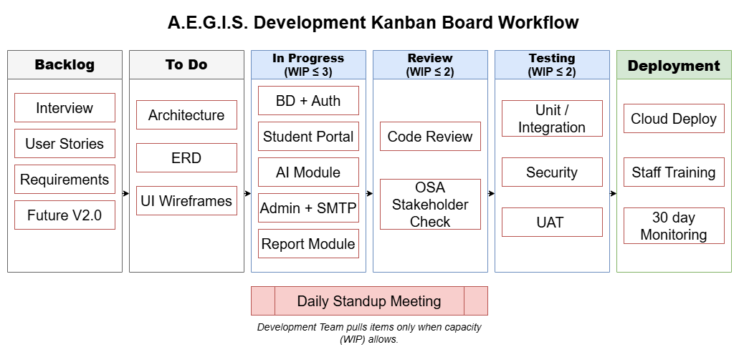
Figure SEQ Figure \* ARABIC 1 Kanban Board Workflow

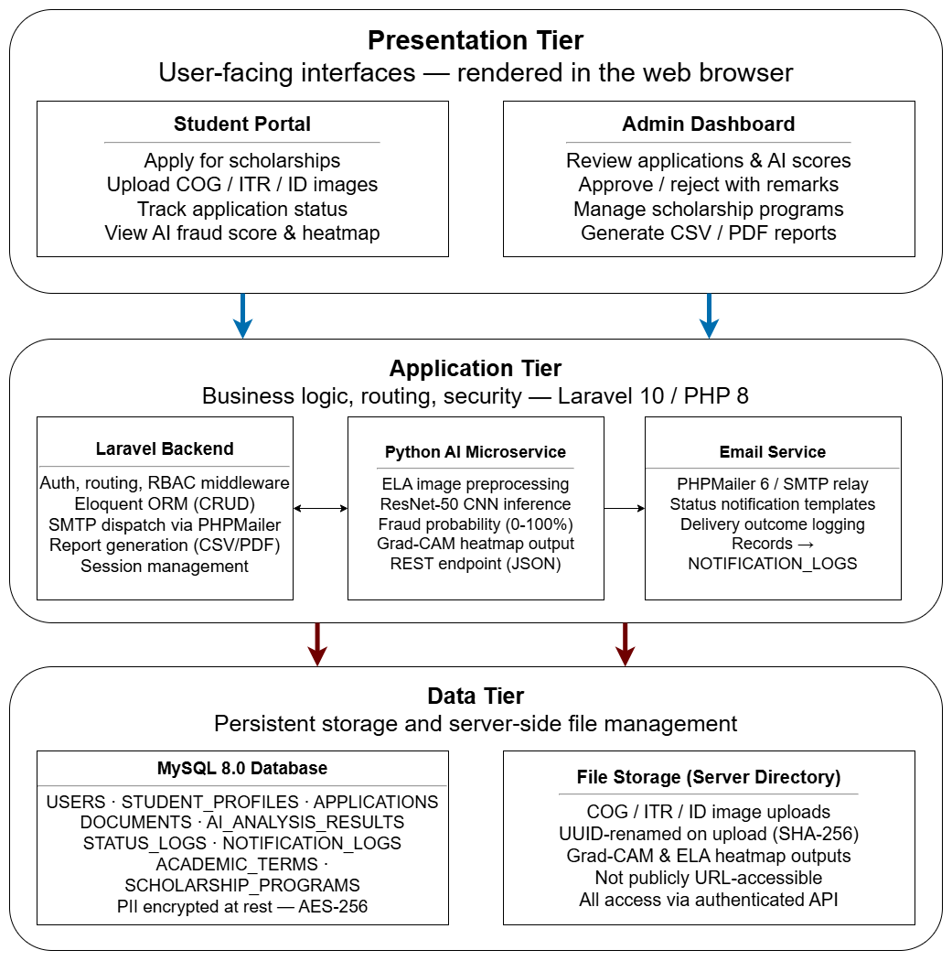
Figure SEQ Figure \* ARABIC 2 Three-Tier System Architecture of A.E.G.I.S
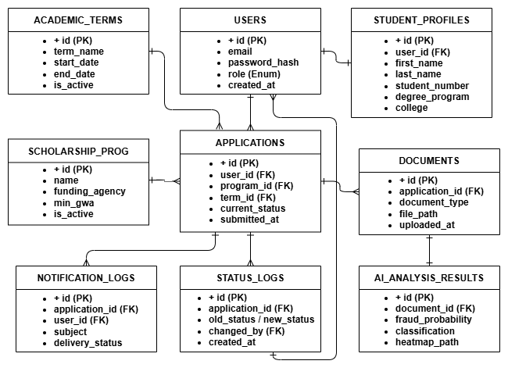
Figure 3. Entity Relationship Diagram

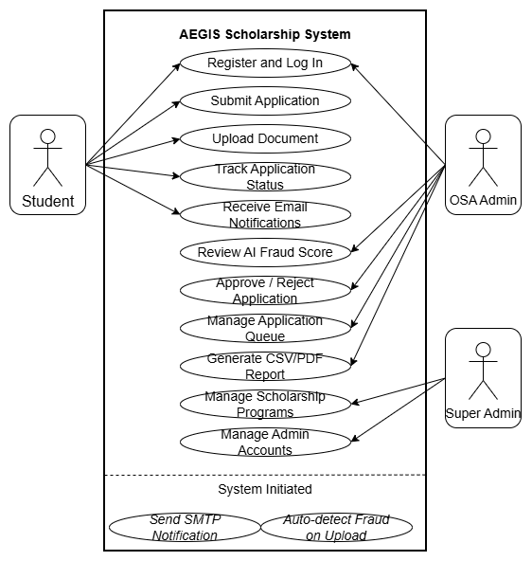
Figure 4. Use case diagram of A.E.G.I.S. showing Student, OSA Administrator, and Super Admin actors along with system-initiated use cases

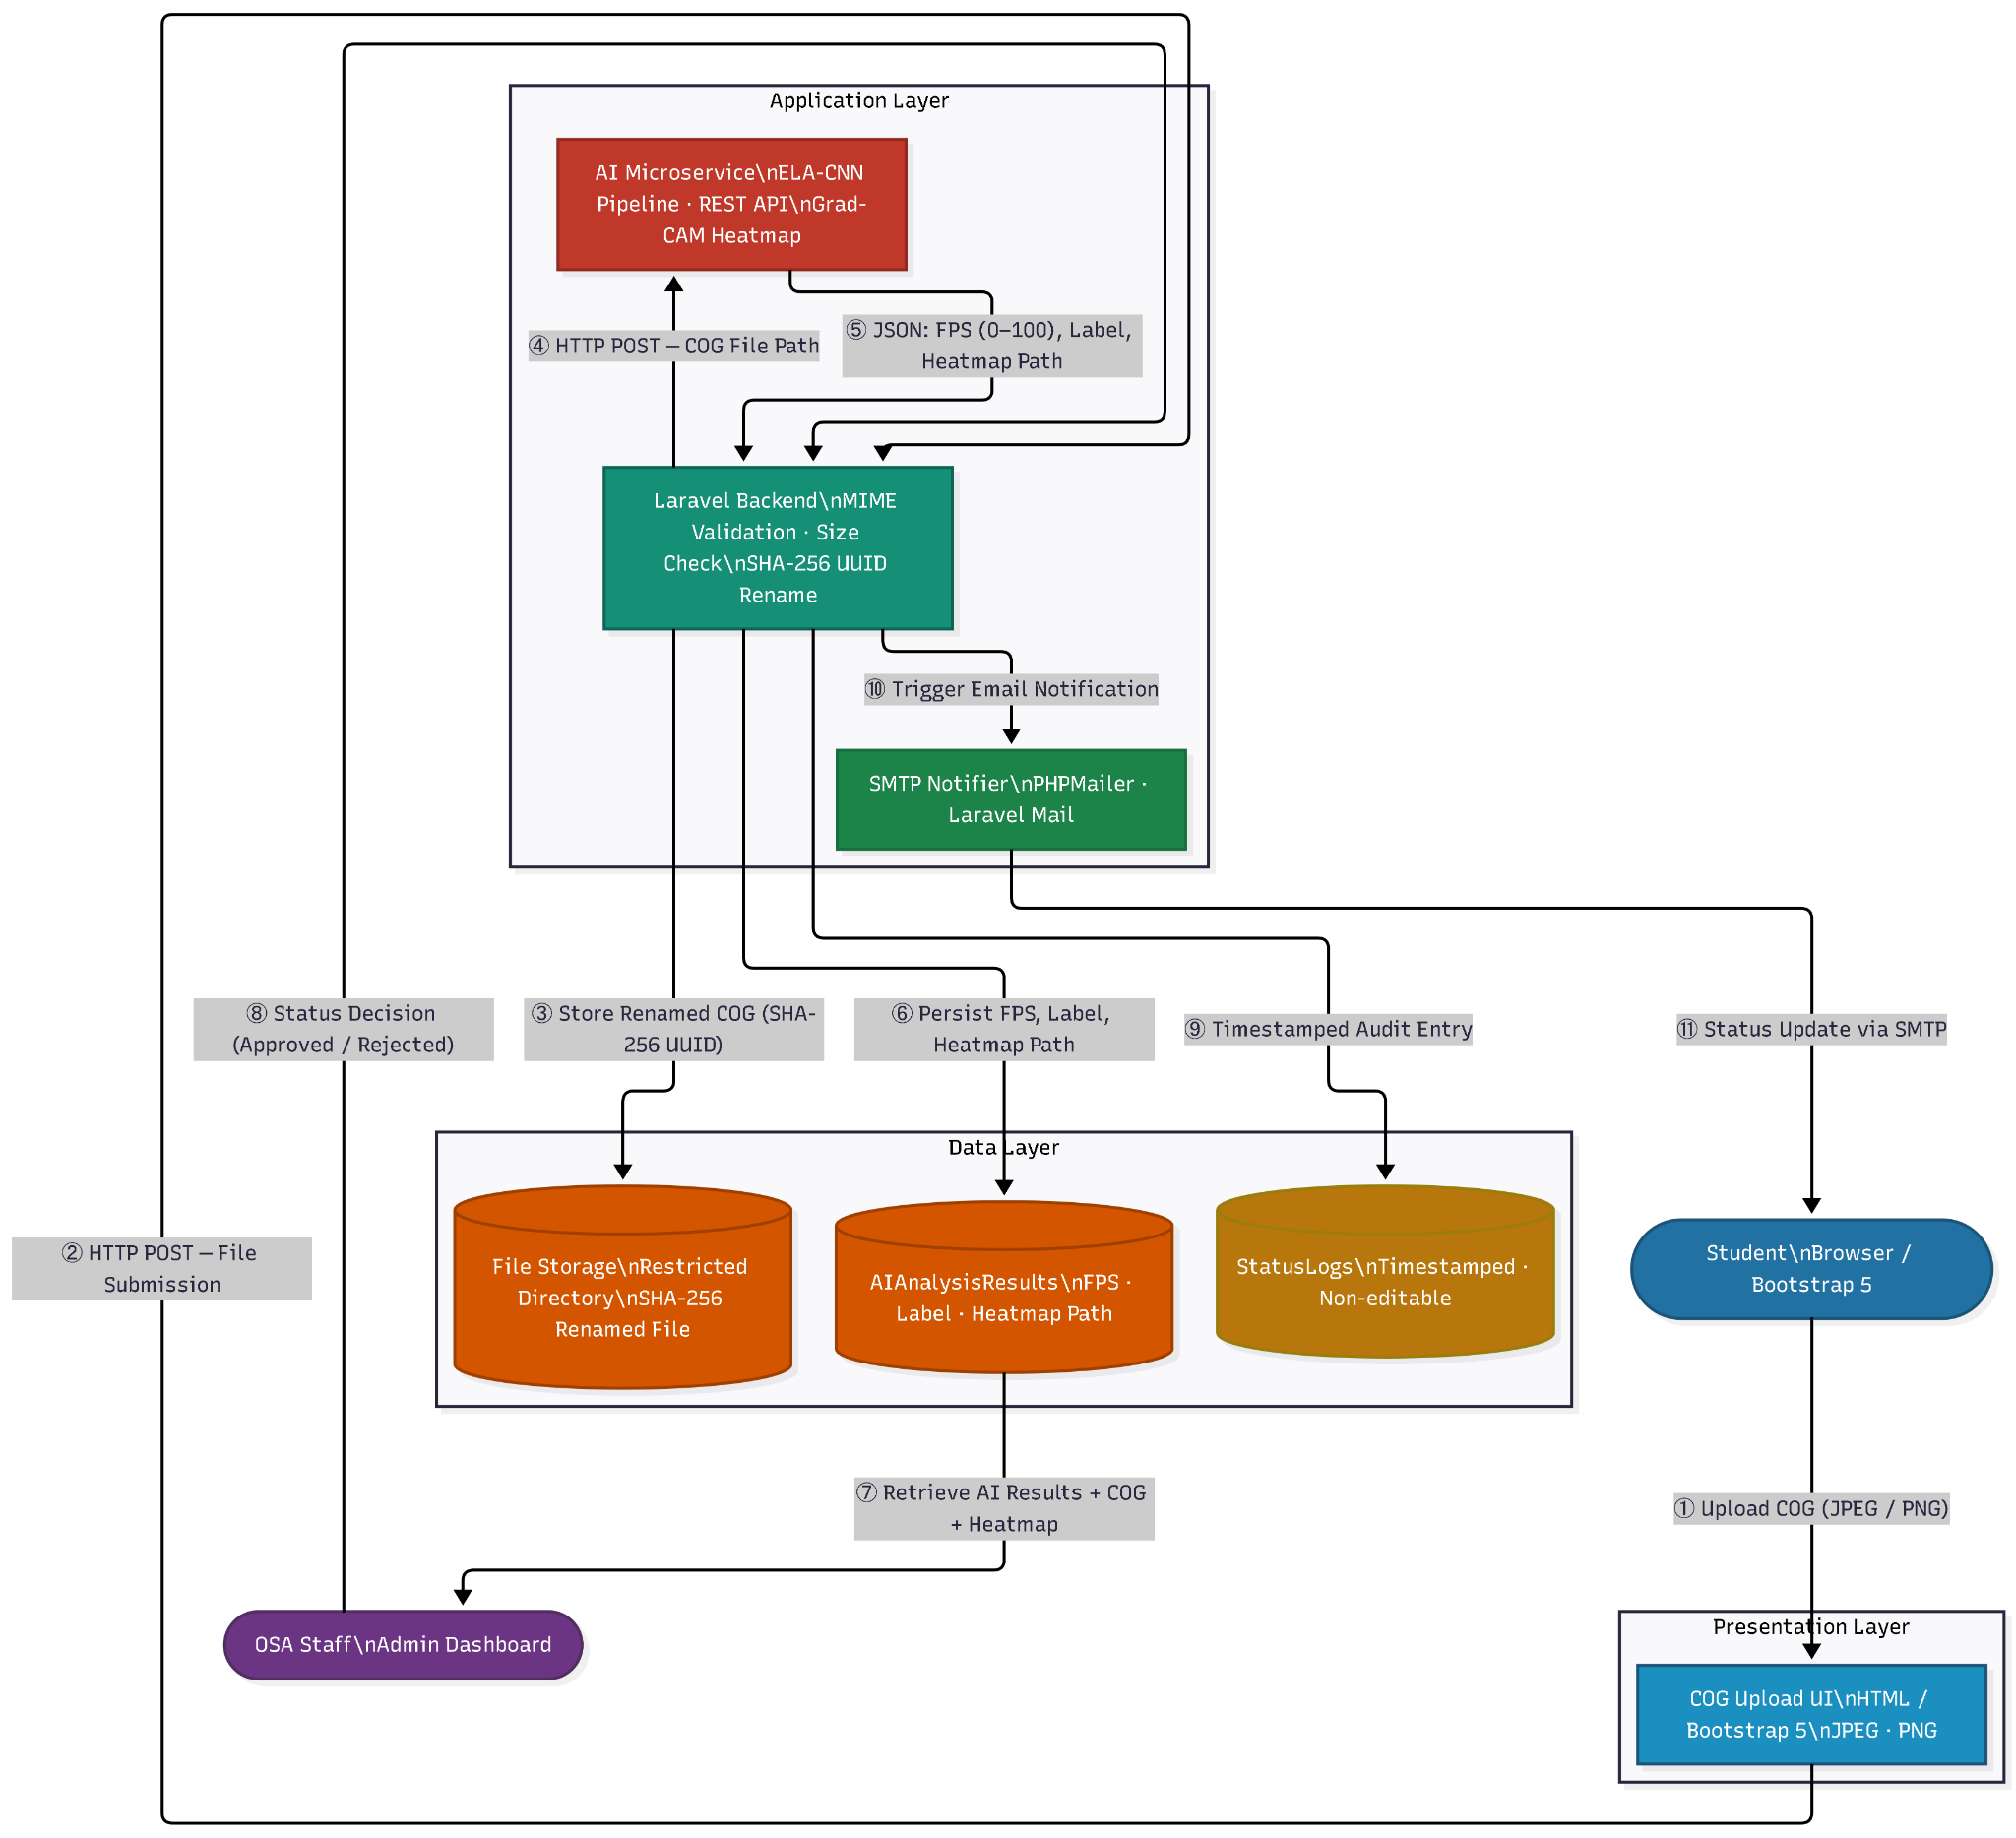
Figure SEQ Figure \* ARABIC 5 Data Flow Diagram
.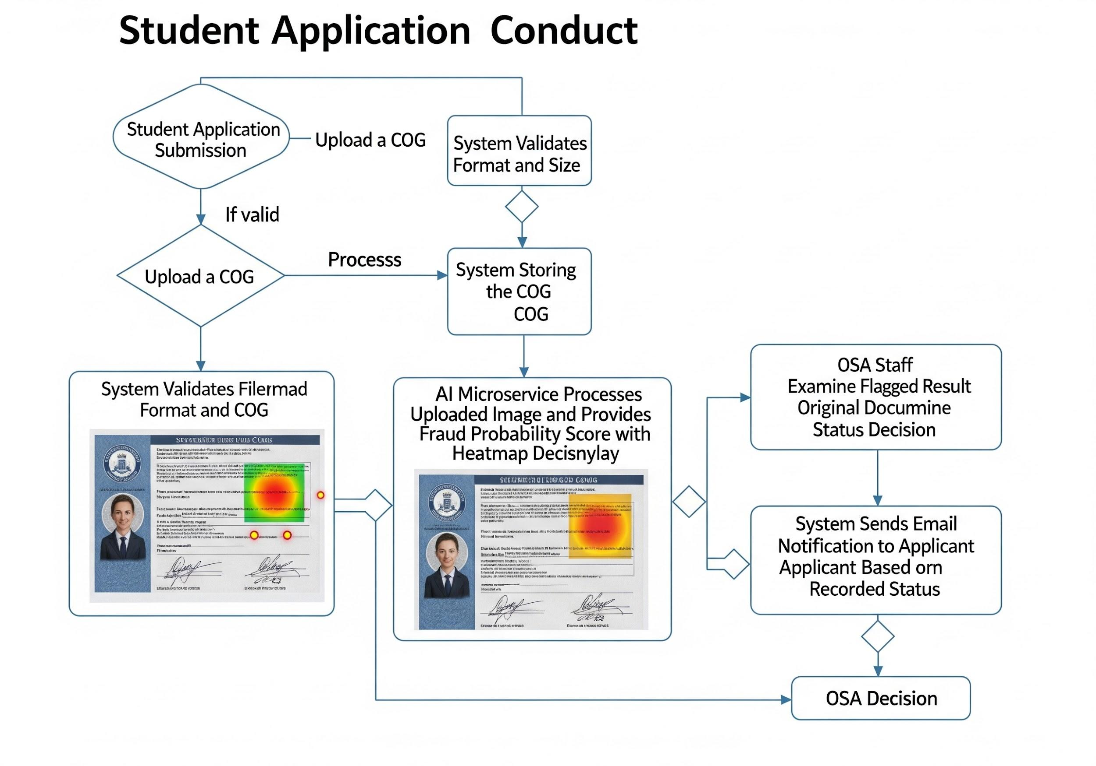
Figure 6 Flow Chart

Appendix C: Wireframe for A.E.G.I.S.
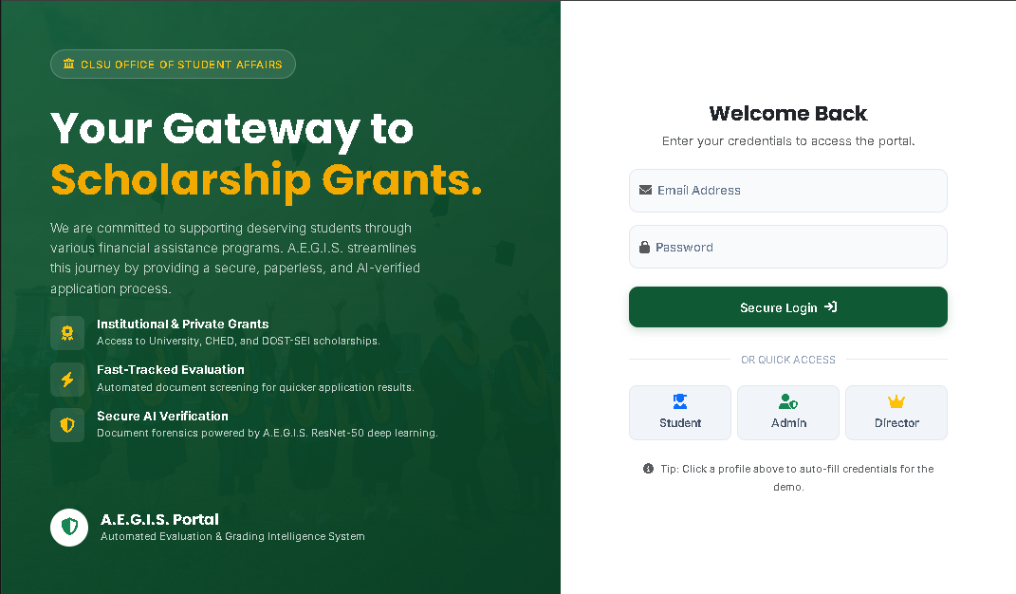
Figure 7. Landing Page and Login Page Wireframes
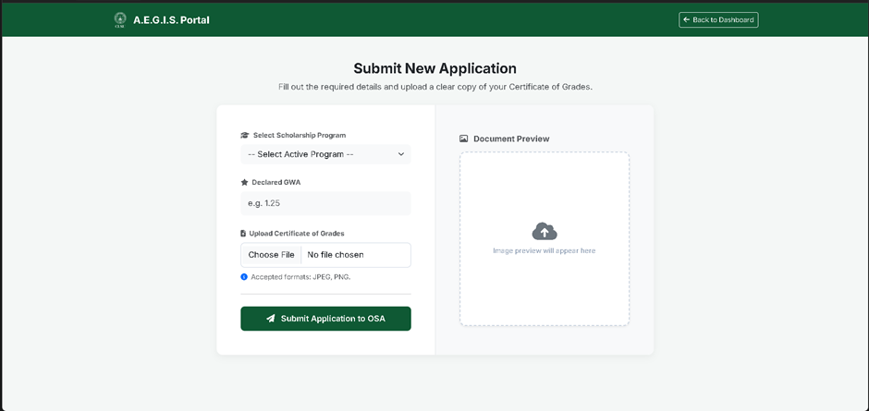
Figure 8. Application Form Wireframe
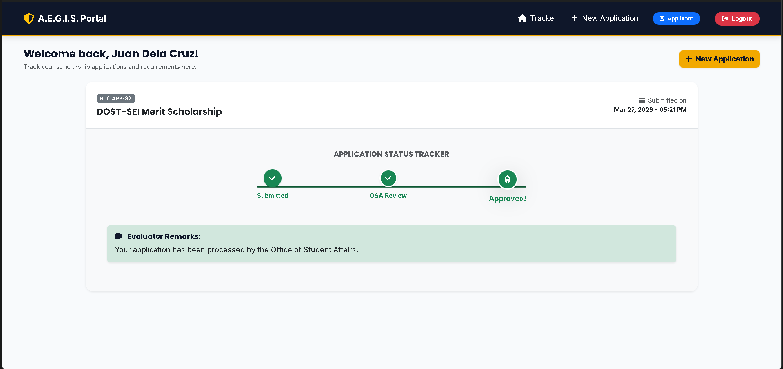
Figure 9. Application Status Tracker Wireframe
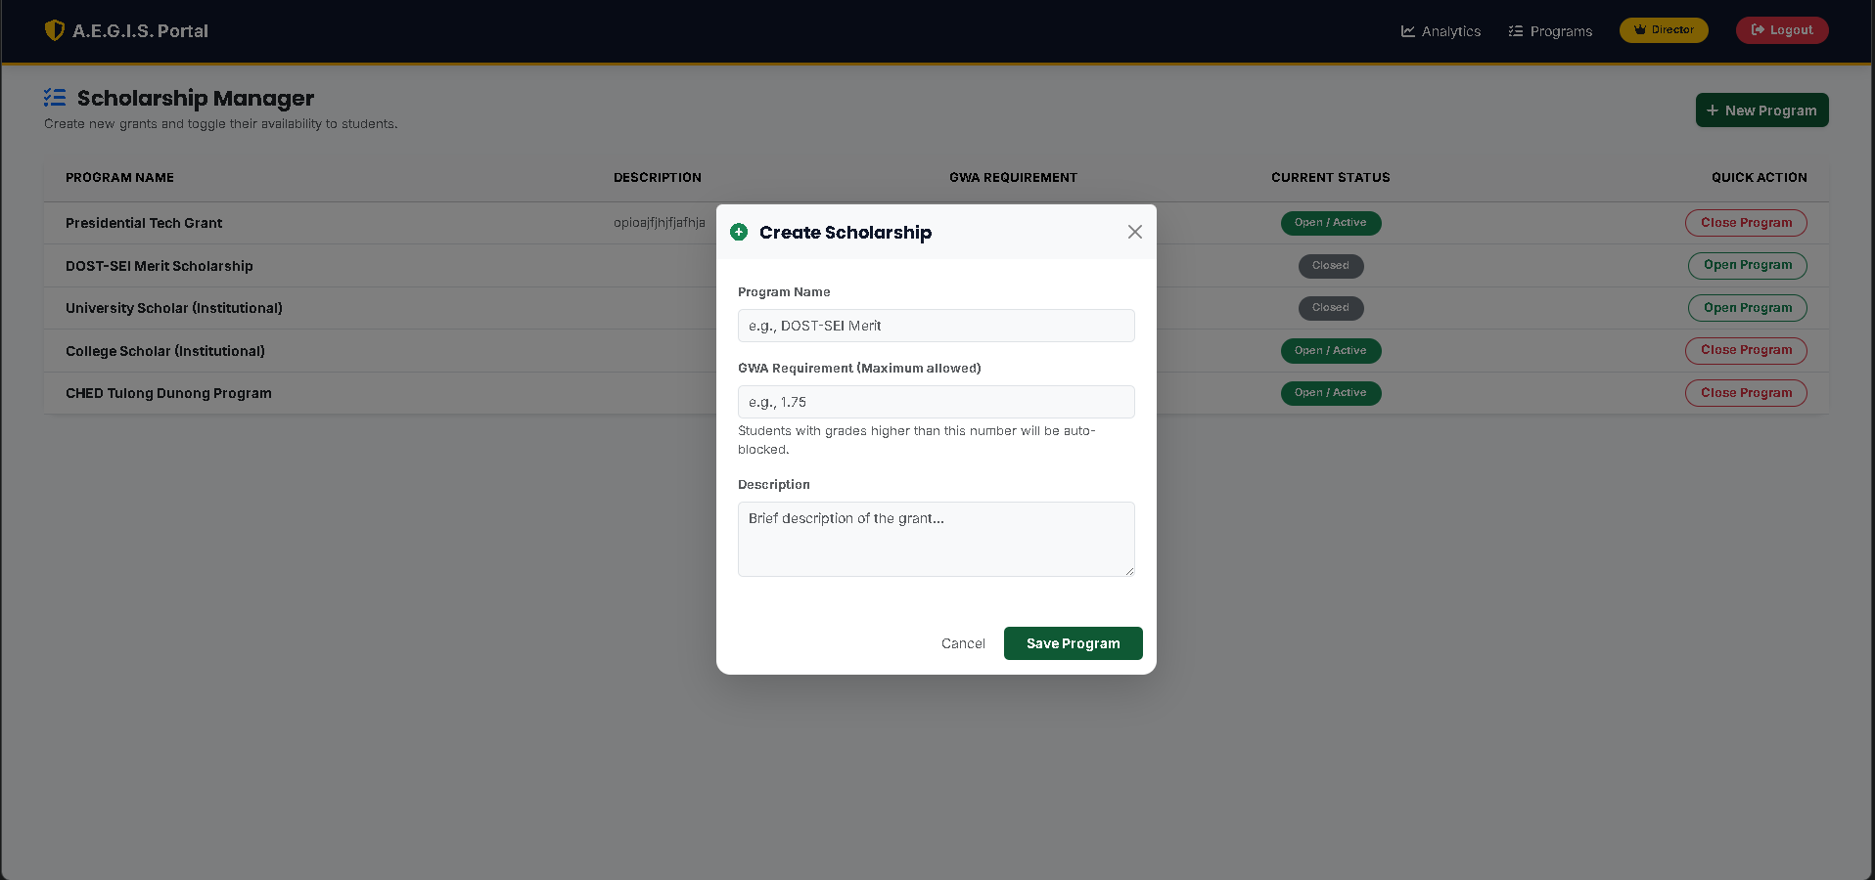
Figure 10. Scholarship Manager – Create Scholarship Modal Wireframe
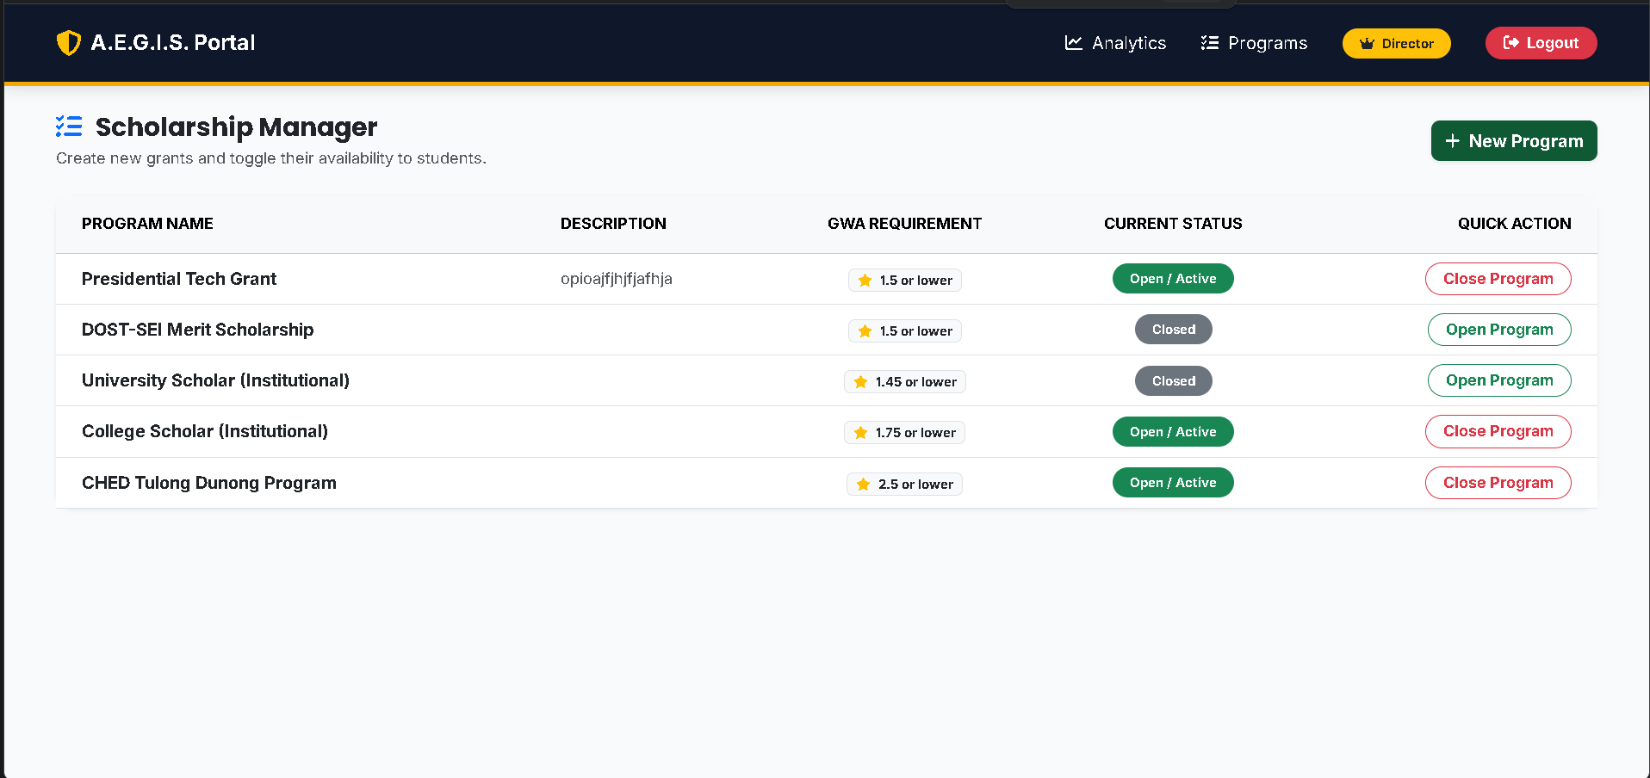
Figure 11. Scholarship Manager Wireframe
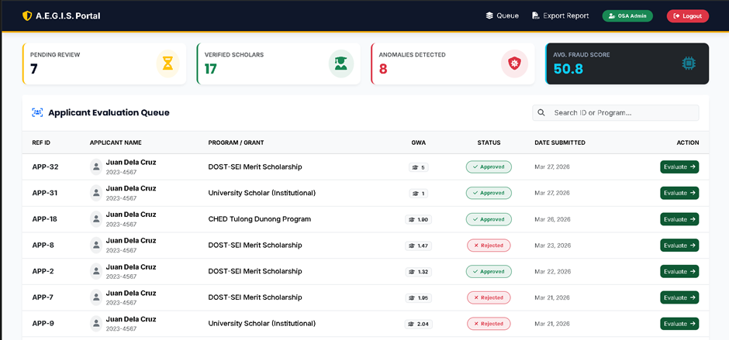
Figure 12. Application Manager Wireframe
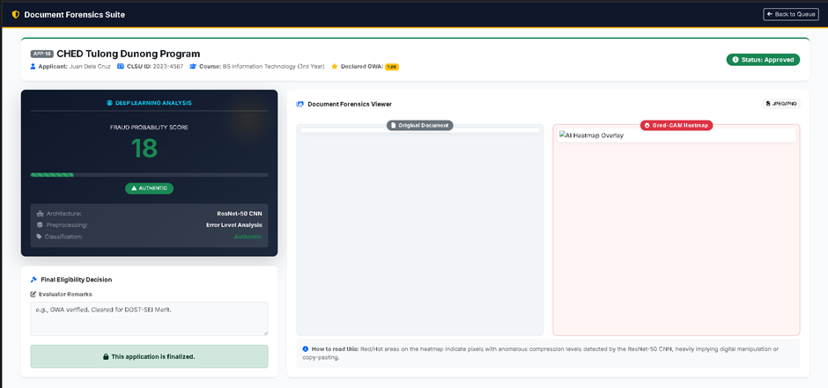
Figure 13. Application Fraud Detection Manager Wireframe

