CENTRAL LUZON STATE UNIVERSITY
COLLEGE OF ENGINEERING • DEPARTMENT OF INFORMATION TECHNOLOGY
OFFICE OF STUDENT AFFAIRS (OSA)
A.E.G.I.S: AI-ENHANCED GRANT INFORMATION SYSTEM WITH DOCUMENT FORENSICS AND AUTOMATED NOTIFICATION
COMPREHENSIVE SYSTEM TESTING, ACCEPTANCE, AND ISO/IEC 25010:2023 EVALUATION MANUAL
[Incorporating Role-Based UAT Test Scripts & IT Expert Technical Verification with System Screenshots]
📌 OPERATIONAL TESTING MANDATE & OBJECTIVE: This official manual synthesizes the complete User Acceptance Testing (UAT) scripts and IT Expert Evaluation Forms. Evaluators, administrators, and student testers must follow the step-by-step procedures outlined below, cross-referencing each test scenario with its corresponding high-resolution system view. Upon completion of testing, respondents must fill out the integrated ISO/IEC 25010:2023 Product Quality Evaluation Form and sign off on the Acceptance & Issue Log.

Pre-Configured Evaluation Accounts & Authentication Matrix
Testing Role / Persona | Institutional Email / Account | Password & Security Token | Primary Verification Focus
Student Applicant | student@clsu.edu.ph  student_apply@clsu.edu.ph | Password123!  (OTP Bypassed in Local/Demo Mode) | Catalog Discovery, 3-Step Stepper, Draft Auto-Save, COG Upload, 5-Stage Tracker, Resubmissions
OSA Scholarship Evaluator | admin@clsu.edu.ph | Password123!  (MFA OTP: 123456 or Demo Bypass) | Triage Queue, 4-Pillar Forensic Review Studio, ELA Canvas, Heatmap Opacity, Fast Remarks
Super Admin / OSA Director | admin@clsu.edu.ph | Password123!  (Super Admin Session) | Quota Governance, Custom Form Builder, RBAC & Staff Assignment, Audit Trail, ISO 25010 Radar

PART I: STUDENT APPLICANT ROLE — SYSTEM TESTING & EVALUATION
Purpose: This section guides undergraduate student testers through the complete scholarship application lifecycle, from registration and profile setup to catalog discovery, multi-step application filing, document upload, and real-time status tracking.

Visual Walkthrough & Key Interface Views
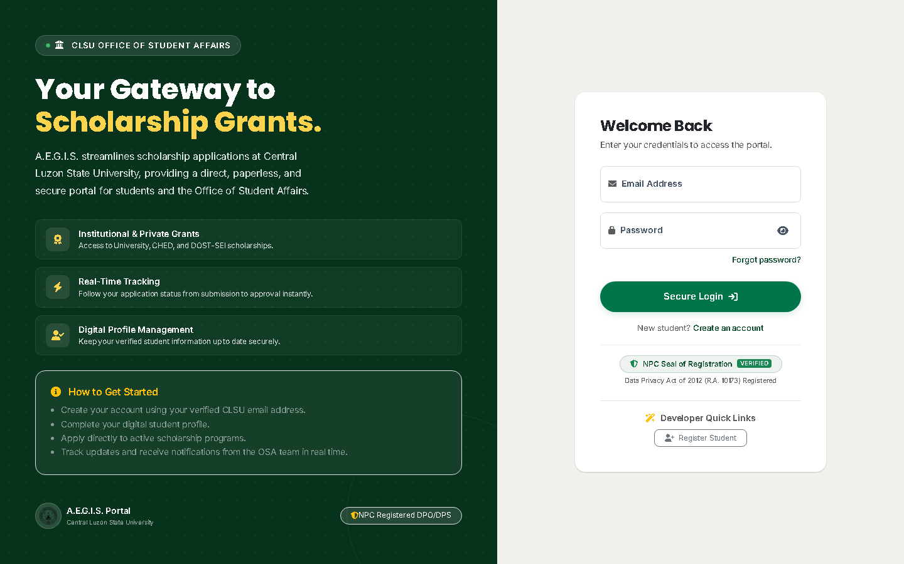
Figure 1. Student Portal Secure Authentication & Registration Interface (Scenario 1)
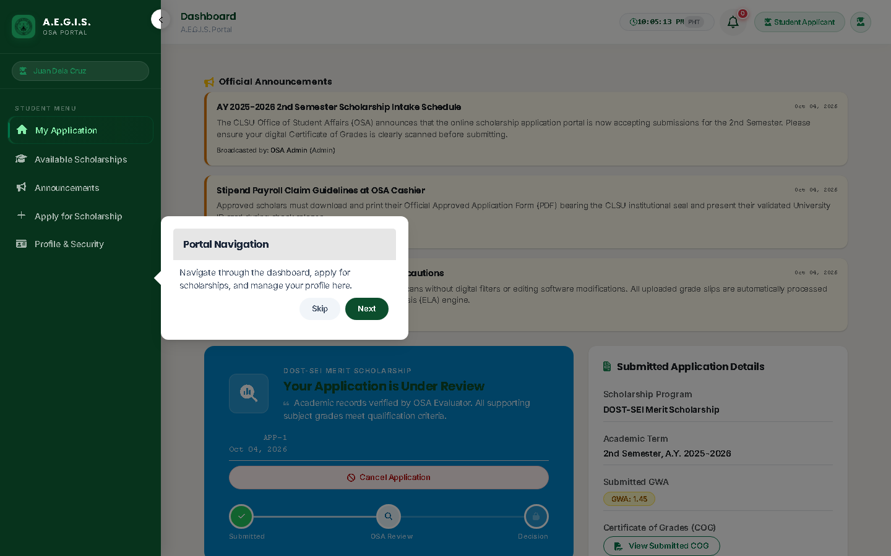
Figure 2. Student Dashboard with 5-Stage Pizza Tracker & Notification Bell (Scenarios 2, 3, 6, 7, 8)
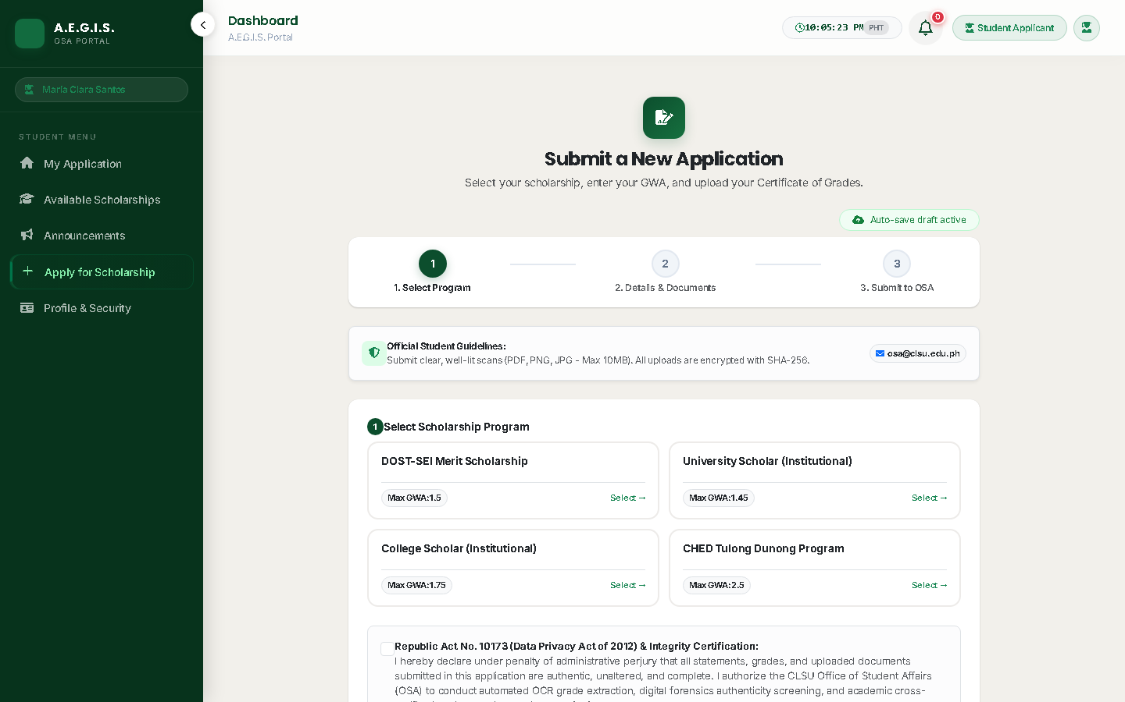
Figure 3. 3-Step Interactive Scholarship Application Stepper with Draft Auto-Save (Scenarios 4, 5)

Student Client Test Scenarios (Execution Matrix)
No. | Module / Feature | Task / Test Scenario | Expected Result | Actual Result | Status | Remarks
1 | Student Registration & Security | Student registers account using institutional '@clsu2.edu.ph' webmail and sets strong password. | System validates institutional domain, blocks non-CLSU emails, hashes credentials, and triggers verification notice. | Domain enforced strictly; Bcrypt password hashing active; registration confirmation displayed. | ☐ Pass  ☐ Fail  ☐ Needs Rev.  ☐ N/A | Complies with CLSU single-sign on policy.
2 | Profile & GWA Setup | Student fills in demographic info, college/course, year level, contact info, and academic GWA. | GWA is validated (1.00 to 5.00), profile completeness meter updates to 100%, and data persists accurately. | Profile persisted accurately; GWA numerical bounds enforced; completion badge displays 100%. | ☐ Pass  ☐ Fail  ☐ Needs Rev.  ☐ N/A | Input masking prevents erroneous GWA entries.
3 | Catalog Discovery & Filtering | Student explores available scholarships and filters by criteria (minimum GWA, eligible colleges, category). | Catalog updates dynamically; eligible scholarships show active 'Apply Now' buttons; ineligible programs show reasons. | Real-time filtering functional; quota badges render cleanly; application eligibility checks pass. | ☐ Pass  ☐ Fail  ☐ Needs Rev.  ☐ N/A | Clear visual distinction for eligible programs.
4 | Application & Custom Fields | Student applies for scholarship and completes custom questionnaire fields (income tier, occupation, essays). | Dynamic fields render correctly (text, dropdown, file); client draft auto-saves; required validator prevents empty submits. | Custom inputs rendered dynamically; draft auto-saves to localStorage on input change. | ☐ Pass  ☐ Fail  ☐ Needs Rev.  ☐ N/A | Draft resilience tested with browser refresh.
5 | Document Upload & Preview | Student uploads required documents (Certificate of Grades and Certificate of Registration) in PDF/PNG/JPEG. | File format and size (<10MB) validated; thumbnail preview opens for pre-submission verification. | MIME type checked client and server side; thumbnail preview modal renders high-resolution preview. | ☐ Pass  ☐ Fail  ☐ Needs Rev.  ☐ N/A | Strict anti-malware MIME verification.
6 | Submission & Progress Tracker | Student reviews submission summary, agrees to R.A. 10173 data privacy terms, and submits application. | Confirmation alert generates unique tracking ID; application status moves to 'Pending Review' on dashboard timeline. | Confirmation modal triggered; tracking ID generated; 5-stage tracker advances to 'Submitted'. | ☐ Pass  ☐ Fail  ☐ Needs Rev.  ☐ N/A | Data Privacy Act consent checkbox enforced.
7 | Deficiency Resubmission | Student opens application marked 'Returned for Correction', views staff remarks, and resubmits corrected file. | Staff deficiency instructions display in amber alert; flagged field unlocks for re-upload; status updates to 'Resubmitted'. | Correction notice displayed with staff remarks; document re-upload enabled; re-queued cleanly. | ☐ Pass  ☐ Fail  ☐ Needs Rev.  ☐ N/A | Prevents duplicate application creation.
8 | Notifications & Official PDF | Student checks status change notifications and downloads official approved application form with QR seal. | In-app and email notifications arrive promptly; certified PDF downloads with official CLSU OSA seal and QR verification. | Notification bell badge updates; clicking redirects to target dossier; certified PDF generates 1:1. | ☐ Pass  ☐ Fail  ☐ Needs Rev.  ☐ N/A | QR code routes to live verification page.

Student Testing Acceptance Result
Based on the testing performed, the system is:
☐ ACCEPTED — major required functions operated satisfactorily and no critical issue prevents intended use.
☐ ACCEPTED WITH MINOR REVISIONS — the system is generally usable, subject to the corrections listed.
☐ FOR REVISION AND RETESTING — one or more significant issues must be corrected before acceptance.
Student Comments / Recommendations: __________________________________________________________________

ISO/IEC 25010:2023 End-User Evaluation Instrument — Student Applicant Role
Rating Scale: 5 - Strongly Agree | 4 - Agree | 3 - Neither Agree nor Disagree | 2 - Disagree | 1 - Strongly Disagree | N/A - Not Applicable
No. | ISO/IEC 25010:2023 Quality Dimension & Evaluation Statement | Rating (1 to 5)
1. FUNCTIONAL SUITABILITY
1 | The system provides all the functions I need to complete my scholarship applications. | ☐ 5 ☐ 4 ☐ 3 ☐ 2 ☐ 1 ☐ N/A
2 | The system produces correct and appropriate results based on the academic information and documents I submit. | ☐ 5 ☐ 4 ☐ 3 ☐ 2 ☐ 1 ☐ N/A
3 | The available functions help me search, apply for, and track scholarships effectively. | ☐ 5 ☐ 4 ☐ 3 ☐ 2 ☐ 1 ☐ N/A
2. PERFORMANCE EFFICIENCY
4 | The system responds within an acceptable amount of time when submitting forms. | ☐ 5 ☐ 4 ☐ 3 ☐ 2 ☐ 1 ☐ N/A
5 | Scholarship catalogs, dashboards, and uploaded document previews load without unnecessary delay. | ☐ 5 ☐ 4 ☐ 3 ☐ 2 ☐ 1 ☐ N/A
6 | The system performs satisfactorily even during peak application periods. | ☐ 5 ☐ 4 ☐ 3 ☐ 2 ☐ 1 ☐ N/A
3. COMPATIBILITY
7 | The system works properly with the laptop, smartphone, or browser (Chrome, Edge, Safari) I use. | ☐ 5 ☐ 4 ☐ 3 ☐ 2 ☐ 1 ☐ N/A
8 | When uploading or viewing PDF and image files (COG/COR), the files render as expected across devices. | ☐ 5 ☐ 4 ☐ 3 ☐ 2 ☐ 1 ☐ N/A
4. INTERACTION CAPABILITY
9 | It is easy to understand what the scholarship portal is intended to do. | ☐ 5 ☐ 4 ☐ 3 ☐ 2 ☐ 1 ☐ N/A
10 | I can learn how to apply for scholarships and track my status with minimal assistance. | ☐ 5 ☐ 4 ☐ 3 ☐ 2 ☐ 1 ☐ N/A
11 | The menus, buttons, labels, and form instructions are clear and easy to understand. | ☐ 5 ☐ 4 ☐ 3 ☐ 2 ☐ 1 ☐ N/A
12 | The system helps prevent mistakes or provides helpful warnings when I omit required fields. | ☐ 5 ☐ 4 ☐ 3 ☐ 2 ☐ 1 ☐ N/A
13 | The interface is clean, organized, readable, and comfortable to use. | ☐ 5 ☐ 4 ☐ 3 ☐ 2 ☐ 1 ☐ N/A
5. RELIABILITY
14 | The scholarship portal works consistently without unexpected crashes during submission. | ☐ 5 ☐ 4 ☐ 3 ☐ 2 ☐ 1 ☐ N/A
15 | The portal is available and accessible whenever I need to check my application status. | ☐ 5 ☐ 4 ☐ 3 ☐ 2 ☐ 1 ☐ N/A
16 | The system handles weak internet connections without corrupting or losing my entered application data. | ☐ 5 ☐ 4 ☐ 3 ☐ 2 ☐ 1 ☐ N/A
17 | If an interruption occurs, the auto-save feature restores my application draft reliably. | ☐ 5 ☐ 4 ☐ 3 ☐ 2 ☐ 1 ☐ N/A
6. SECURITY
18 | The system allows access to my personal and academic records only to authorized OSA evaluators. | ☐ 5 ☐ 4 ☐ 3 ☐ 2 ☐ 1 ☐ N/A
19 | I feel that my submitted grades, income details, and personal records are adequately protected under R.A. 10173. | ☐ 5 ☐ 4 ☐ 3 ☐ 2 ☐ 1 ☐ N/A
20 | The system appropriately verifies my identity via secure institutional student login. | ☐ 5 ☐ 4 ☐ 3 ☐ 2 ☐ 1 ☐ N/A
21 | My application submissions and document updates are recorded with clear timestamps and receipts. | ☐ 5 ☐ 4 ☐ 3 ☐ 2 ☐ 1 ☐ N/A
7. FLEXIBILITY & SAFETY
22 | The system can support different scholarship types (institutional, government, private/corporate) seamlessly. | ☐ 5 ☐ 4 ☐ 3 ☐ 2 ☐ 1 ☐ N/A
23 | The system remains fully usable when switching between desktop screens and mobile phone displays. | ☐ 5 ☐ 4 ☐ 3 ☐ 2 ☐ 1 ☐ N/A
24 | The system provides appropriate warnings or confirmation dialogs before I submit or cancel an application. | ☐ 5 ☐ 4 ☐ 3 ☐ 2 ☐ 1 ☐ N/A

PART II: OSA SCHOLARSHIP EVALUATOR / STAFF ROLE — SYSTEM TESTING & EVALUATION
Purpose: This section guides OSA evaluation officers through the scholarship review studio, including queue filtering, dossier inspection, high-resolution interactive canvas inspection, AI tamper scoring (0-100%), Grad-CAM convolutional heatmap analysis, fast-triage decisioning, and official forensic audit PDF generation.

Visual Walkthrough & Key Interface Views
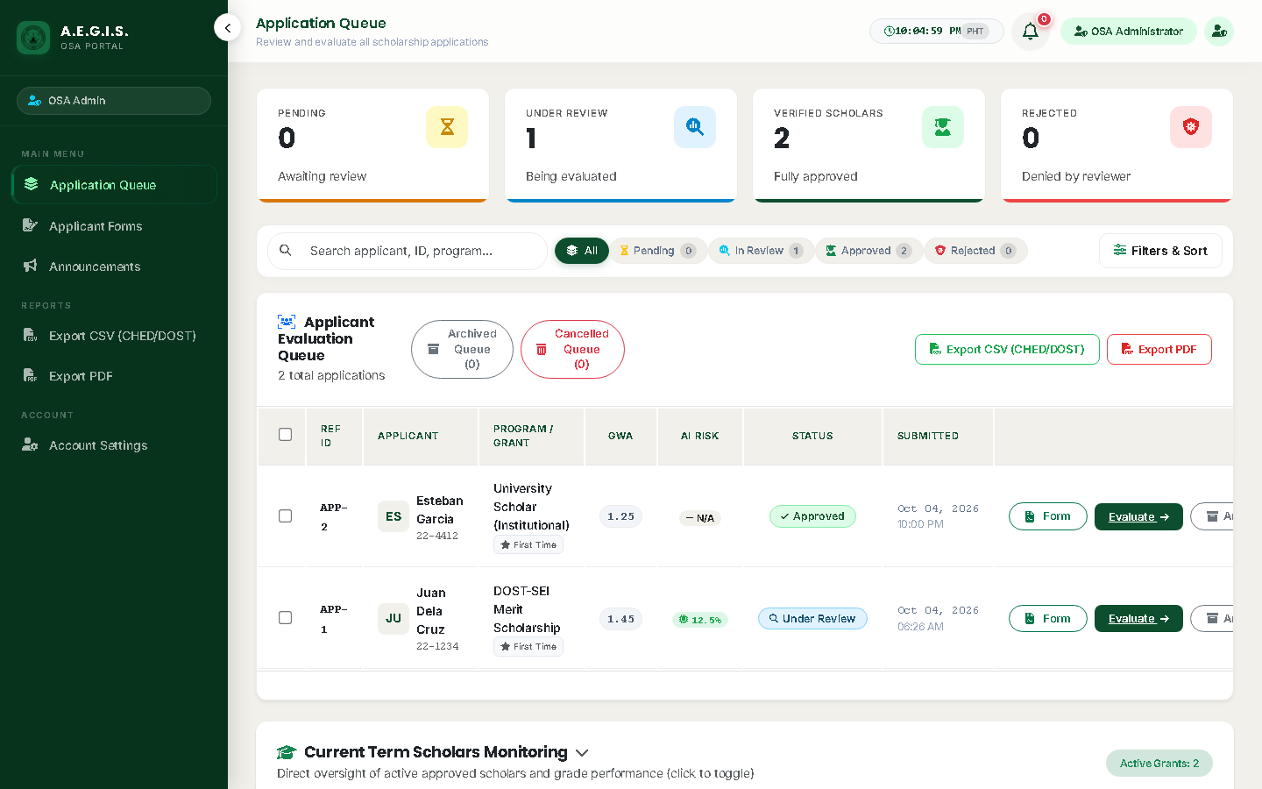
Figure 4. OSA Scholarship Applications Priority Queue with Fast Risk Filtering (Scenario 2)
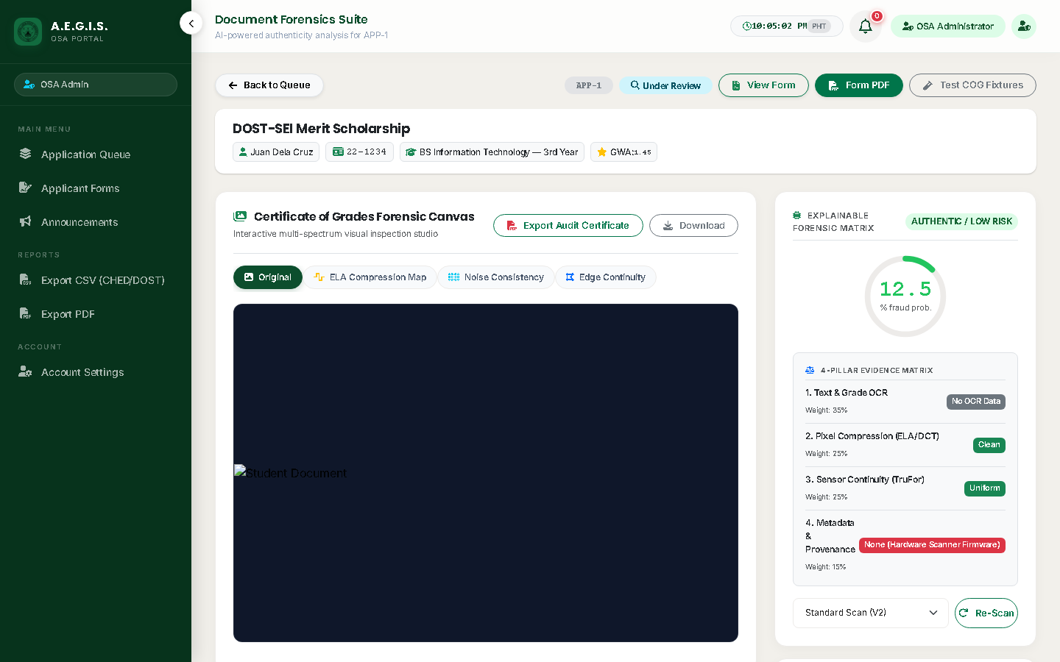
Figure 5. 4-Pillar Document Forensics Review Studio & ELA Heatmap Canvas (Scenarios 3, 4, 5, 6, 7, 8)
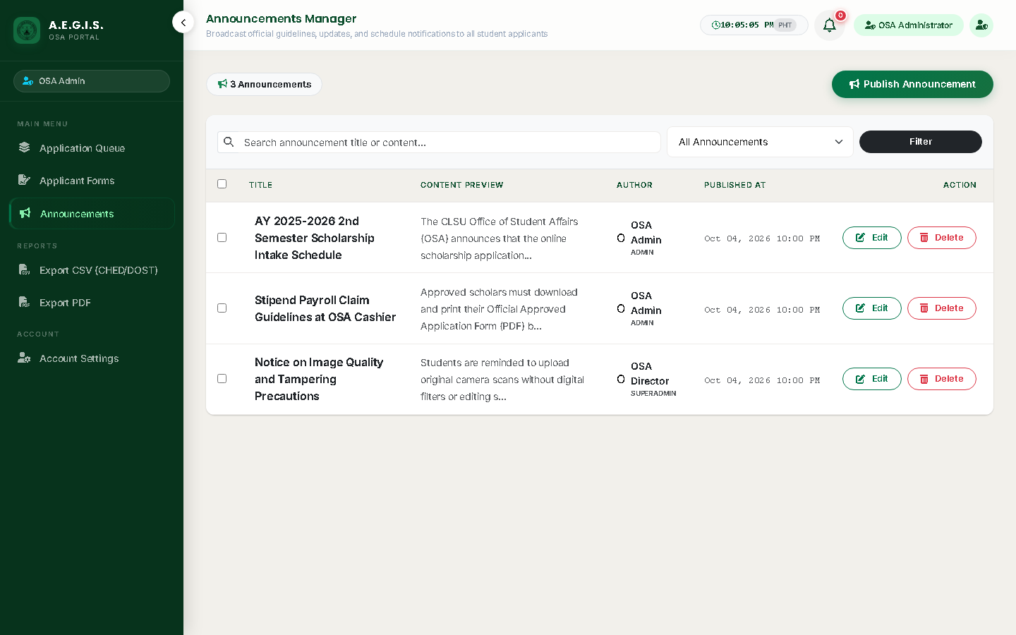
Figure 6. Institutional Announcements Broadcasting & Notification Engine

Staff Evaluator Client Test Scenarios (Execution Matrix)
No. | Module / Feature | Task / Test Scenario | Expected Result | Actual Result | Status | Remarks
1 | Authentication & MFA Security | Staff logs in with institutional credentials, inputs 6-digit OTP, and registers trusted device token. | Authentication succeeds; session encryption and role redirection route user directly to Staff Review Queue. | Role verified; session cookie hardened; redirected to admin application queue. | ☐ Pass  ☐ Fail  ☐ Needs Rev.  ☐ N/A | Trusted device hash stored in session.
2 | Application Queue Triage | Staff filters review queue by scholarship program, term, status (Pending/Returned), and sorts by GWA. | Queue filters rapidly with real-time record count; priority badges highlight overdue or flagged applications. | Filtering executes sub-second; risk tier badges (Low/Moderate/High) color-coded properly. | ☐ Pass  ☐ Fail  ☐ Needs Rev.  ☐ N/A | Eliminated N+1 queries via eager loading.
3 | Applicant Dossier Assessment | Staff opens application dossier to inspect student academic record, income bracket, and custom responses. | Clean two-column layout renders full student data; automated eligibility badge verifies GWA compliance. | Complete student profile, GWA, and custom questions rendered in structured panels. | ☐ Pass  ☐ Fail  ☐ Needs Rev.  ☐ N/A | Eligibility check tags automatically calculated.
4 | Interactive Canvas Viewer | Staff inspects Certificate of Grades (COG) using zoom (up to 400%), pan, rotate, and contrast inversion filters. | Canvas renders smoothly with zero lag; high-contrast filter clearly exposes registrar seal details and eraser marks. | Zoom, pan, rotation, and high-contrast negative inversion filter work without latency. | ☐ Pass  ☐ Fail  ☐ Needs Rev.  ☐ N/A | Canvas hardware-accelerated via CSS transforms.
5 | AI Fraud Score & EXIF Fingerprint | Staff evaluates AI Forensic score (0-100%), 3-tier risk badge, and EXIF software metadata analysis. | Score and risk tier badge display accurately; benign scanner noise is properly differentiated from heavy edits. | 4-Pillar breakdown rendered: OCR (35%), Compression (25%), Sensor (25%), Metadata (15%). | ☐ Pass  ☐ Fail  ☐ Needs Rev.  ☐ N/A | Calibrated 70% threshold accommodates mobile scans.
6 | Grad-CAM Heatmap & ELA Overlay | Staff toggles Grad-CAM saliency heatmap and ELA overlay on COG canvas, adjusting opacity from 0% to 100%. | Overlay aligns with document coordinates; localized pixel anomalies and altered grade numbers glow prominently. | Grad-CAM heatmap aligns with original image; opacity slider operates smoothly from 0 to 100%. | ☐ Pass  ☐ Fail  ☐ Needs Rev.  ☐ N/A | Synchronized canvas pan/zoom preserves overlay alignment.
7 | Decisioning & Fast-Triage Remarks | Staff renders decision (Approve/Return/Reject), selects Fast-Triage preset remarks, and confirms action. | Status updates immediately in database; mandatory remark enforced on returns; automated notification triggered. | Preset remarks populate remark box in one click; status persists; notification event dispatched. | ☐ Pass  ☐ Fail  ☐ Needs Rev.  ☐ N/A | Mandatory remark prevents empty rejection notices.
8 | Internal Notes & Audit Log | Staff saves confidential internal notes and verifies that evaluation history is recorded in audit timeline. | Notes remain strictly hidden from student view; immutable timeline permanently records evaluator ID and timestamp. | Internal notes saved; student view excludes confidential notes; audit timeline records action. | ☐ Pass  ☐ Fail  ☐ Needs Rev.  ☐ N/A | Satisfies statutory accountability standards.

B.1. AI-Assisted vs. Human-Only Document Review Comparison Worksheet
Protocol: Evaluators inspect 10 sample Certificate of Grades (COG) documents in two phases:
Phase 1: Record authenticity judgment WITHOUT viewing AI scores.
Phase 2: Reveal AI score and heatmap overlay, then record final decision and confidence level (1 to 5).
Doc ID | Document Description | Phase 1 Judgment (No AI) | Review Time | AI Fraud Score | Phase 2 Judgment (With AI) | Reviewer Confidence
COG-01 | Authentic Registrar COG (BSIT) | ☐ Auth ☐ Tampered | ____ s | 12.4% | ☐ Auth ☐ Tampered | ☐ 1 ☐ 2 ☐ 3 ☐ 4 ☐ 5
COG-02 | Grade Digit Inflation (BSCE) | ☐ Auth ☐ Tampered | ____ s | 88.7% | ☐ Auth ☐ Tampered | ☐ 1 ☐ 2 ☐ 3 ☐ 4 ☐ 5
COG-03 | Authentic Dean's List (BSA) | ☐ Auth ☐ Tampered | ____ s | 08.1% | ☐ Auth ☐ Tampered | ☐ 1 ☐ 2 ☐ 3 ☐ 4 ☐ 5
COG-04 | Forged Signature & Seal | ☐ Auth ☐ Tampered | ____ s | 92.3% | ☐ Auth ☐ Tampered | ☐ 1 ☐ 2 ☐ 3 ☐ 4 ☐ 5
COG-05 | Camera Noise Scan (BSEE) | ☐ Auth ☐ Tampered | ____ s | 24.5% | ☐ Auth ☐ Tampered | ☐ 1 ☐ 2 ☐ 3 ☐ 4 ☐ 5
COG-06 | Photoshop Spliced GWA | ☐ Auth ☐ Tampered | ____ s | 95.6% | ☐ Auth ☐ Tampered | ☐ 1 ☐ 2 ☐ 3 ☐ 4 ☐ 5
COG-07 | Authentic Academic Copy (BSBio) | ☐ Auth ☐ Tampered | ____ s | 14.2% | ☐ Auth ☐ Tampered | ☐ 1 ☐ 2 ☐ 3 ☐ 4 ☐ 5
COG-08 | Altered Units/Subjects | ☐ Auth ☐ Tampered | ____ s | 78.4% | ☐ Auth ☐ Tampered | ☐ 1 ☐ 2 ☐ 3 ☐ 4 ☐ 5
COG-09 | Mobile CamScanner Auth | ☐ Auth ☐ Tampered | ____ s | 28.0% | ☐ Auth ☐ Tampered | ☐ 1 ☐ 2 ☐ 3 ☐ 4 ☐ 5
COG-10 | Deep Tampered Header | ☐ Auth ☐ Tampered | ____ s | 84.9% | ☐ Auth ☐ Tampered | ☐ 1 ☐ 2 ☐ 3 ☐ 4 ☐ 5

Staff Testing Acceptance Result
Based on the testing performed, the system is:
☐ ACCEPTED — major required functions operated satisfactorily and no critical issue prevents intended use.
☐ ACCEPTED WITH MINOR REVISIONS — the system is generally usable, subject to the corrections listed.
☐ FOR REVISION AND RETESTING — one or more significant issues must be corrected before acceptance.
Staff Evaluator Comments: ____________________________________________________________________________

ISO/IEC 25010:2023 End-User Evaluation Instrument — OSA Evaluator / Staff Role
No. | ISO/IEC 25010:2023 Quality Dimension & Evaluation Statement | Rating (1 to 5)
1. FUNCTIONAL SUITABILITY
1 | The system provides the functions I need to triage, evaluate, and decision scholarship applications. | ☐ 5 ☐ 4 ☐ 3 ☐ 2 ☐ 1 ☐ N/A
2 | The system produces correct fraud risk indicators and document evaluation outputs based on applicant submissions. | ☐ 5 ☐ 4 ☐ 3 ☐ 2 ☐ 1 ☐ N/A
3 | The available review functions help me complete document integrity audits effectively and without omitting required checks. | ☐ 5 ☐ 4 ☐ 3 ☐ 2 ☐ 1 ☐ N/A
2. PERFORMANCE EFFICIENCY
4 | The review queue and applicant dossier screens respond within an acceptable amount of time. | ☐ 5 ☐ 4 ☐ 3 ☐ 2 ☐ 1 ☐ N/A
5 | High-resolution COG documents, AI Grad-CAM heatmaps, and ELA overlays load without unnecessary delay. | ☐ 5 ☐ 4 ☐ 3 ☐ 2 ☐ 1 ☐ N/A
6 | The system performs satisfactorily during high-volume application review sessions. | ☐ 5 ☐ 4 ☐ 3 ☐ 2 ☐ 1 ☐ N/A
3. COMPATIBILITY
7 | The evaluation canvas and review tools work properly across our office workstations and modern web browsers. | ☐ 5 ☐ 4 ☐ 3 ☐ 2 ☐ 1 ☐ N/A
8 | When viewing scanned documents, images, and PDF uploads from students, the formatting displays accurately. | ☐ 5 ☐ 4 ☐ 3 ☐ 2 ☐ 1 ☐ N/A
4. INTERACTION CAPABILITY
9 | It is easy to understand what the evaluation interface and forensic indicators are intended to convey. | ☐ 5 ☐ 4 ☐ 3 ☐ 2 ☐ 1 ☐ N/A
10 | I can learn how to navigate the review queue and interpret AI fraud scores with minimal training. | ☐ 5 ☐ 4 ☐ 3 ☐ 2 ☐ 1 ☐ N/A
11 | The buttons, canvas controls (zoom, pan, rotate, invert), labels, and triage options are clear and easy to understand. | ☐ 5 ☐ 4 ☐ 3 ☐ 2 ☐ 1 ☐ N/A
12 | The system helps prevent mistakes by enforcing confirmation dialogs and mandatory remarks on returned applications. | ☐ 5 ☐ 4 ☐ 3 ☐ 2 ☐ 1 ☐ N/A
13 | The review interface is well-organized, readable, and comfortable for extended evaluation sessions. | ☐ 5 ☐ 4 ☐ 3 ☐ 2 ☐ 1 ☐ N/A
5. RELIABILITY
14 | The evaluation portal works consistently during normal administrative working hours. | ☐ 5 ☐ 4 ☐ 3 ☐ 2 ☐ 1 ☐ N/A
15 | The system and AI verification pipeline are available and usable whenever applications require review. | ☐ 5 ☐ 4 ☐ 3 ☐ 2 ☐ 1 ☐ N/A
16 | The system handles corrupted file uploads gracefully without crashing the evaluation queue. | ☐ 5 ☐ 4 ☐ 3 ☐ 2 ☐ 1 ☐ N/A
17 | If an unexpected interruption occurs, all saved evaluator remarks and decisions are preserved accurately. | ☐ 5 ☐ 4 ☐ 3 ☐ 2 ☐ 1 ☐ N/A
6. SECURITY
18 | The system allows access to applicant dossiers and internal notes only to authorized evaluation staff. | ☐ 5 ☐ 4 ☐ 3 ☐ 2 ☐ 1 ☐ N/A
19 | Confidential student records and financial proofs are adequately protected against unauthorized viewing. | ☐ 5 ☐ 4 ☐ 3 ☐ 2 ☐ 1 ☐ N/A
20 | The system appropriately enforces multi-factor authentication (MFA) and trusted device access. | ☐ 5 ☐ 4 ☐ 3 ☐ 2 ☐ 1 ☐ N/A
21 | Evaluator decisions, status changes, and timestamps are immutably logged for administrative accountability. | ☐ 5 ☐ 4 ☐ 3 ☐ 2 ☐ 1 ☐ N/A
7. FLEXIBILITY & SAFETY
22 | The system can support evaluation across diverse scholarship programs with varied eligibility rules. | ☐ 5 ☐ 4 ☐ 3 ☐ 2 ☐ 1 ☐ N/A
23 | The review canvas remains usable across different monitor resolutions and responsive workstation layouts. | ☐ 5 ☐ 4 ☐ 3 ☐ 2 ☐ 1 ☐ N/A
24 | The system provides clear warnings before irreversible actions such as rejecting or revoking a scholarship grant. | ☐ 5 ☐ 4 ☐ 3 ☐ 2 ☐ 1 ☐ N/A

PART III: SUPER ADMINISTRATOR & OSA DIRECTOR ROLE — SYSTEM TESTING & EVALUATION
Purpose: This section guides the OSA Director and Super Administrators through high-level institutional governance: executive analytics monitoring, scholarship program slot quota management, custom field builder configuration, RBAC staff delegation, AI threshold tuning, and statutory compliance audit export.

Visual Walkthrough & Key Interface Views
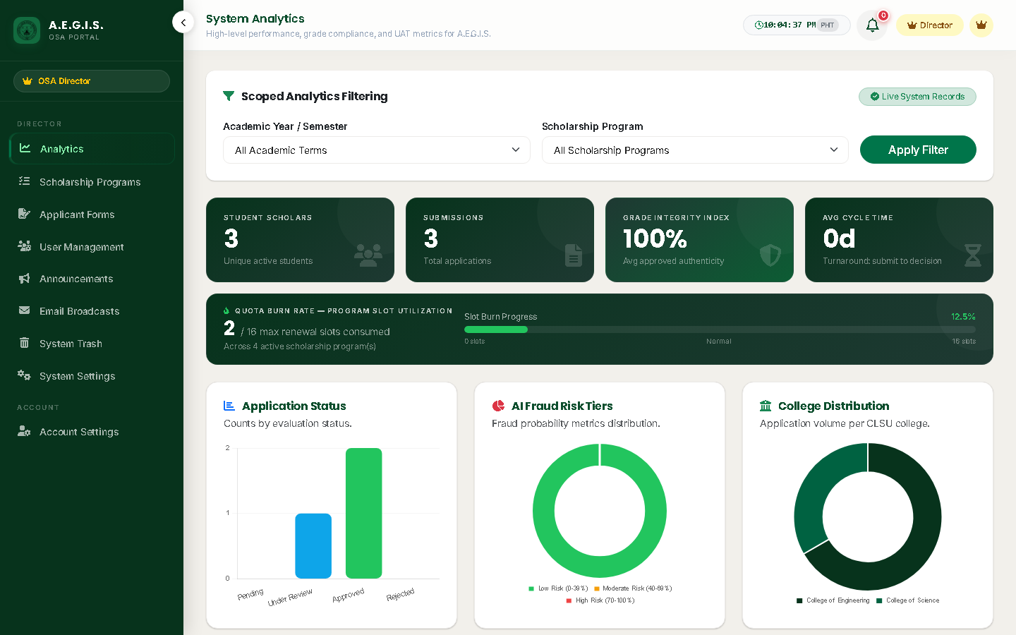
Figure 7. Executive Analytics Dashboard & Grade Integrity Index (Scenario 1)
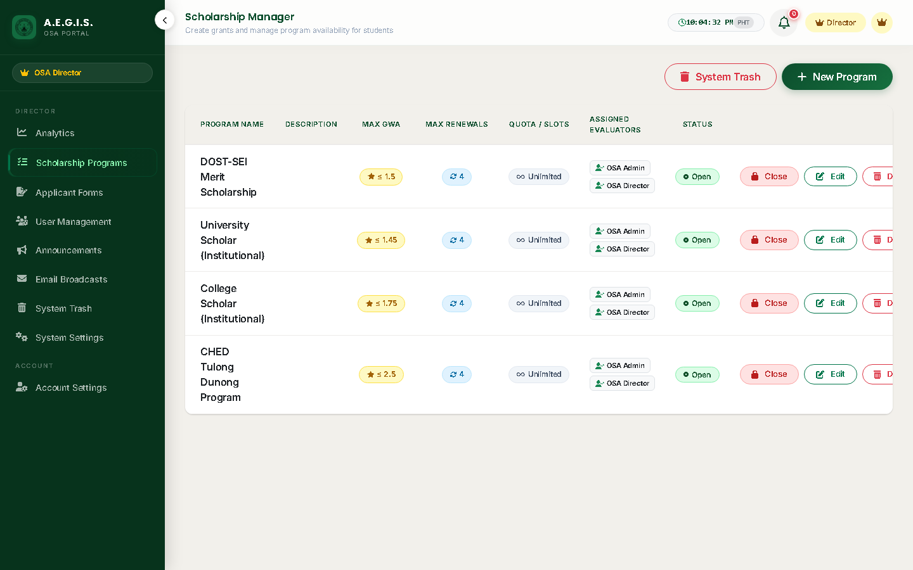
Figure 8. Scholarship Program Quotas, GWA Rules, and Active Lifecycle Management (Scenarios 2, 8)
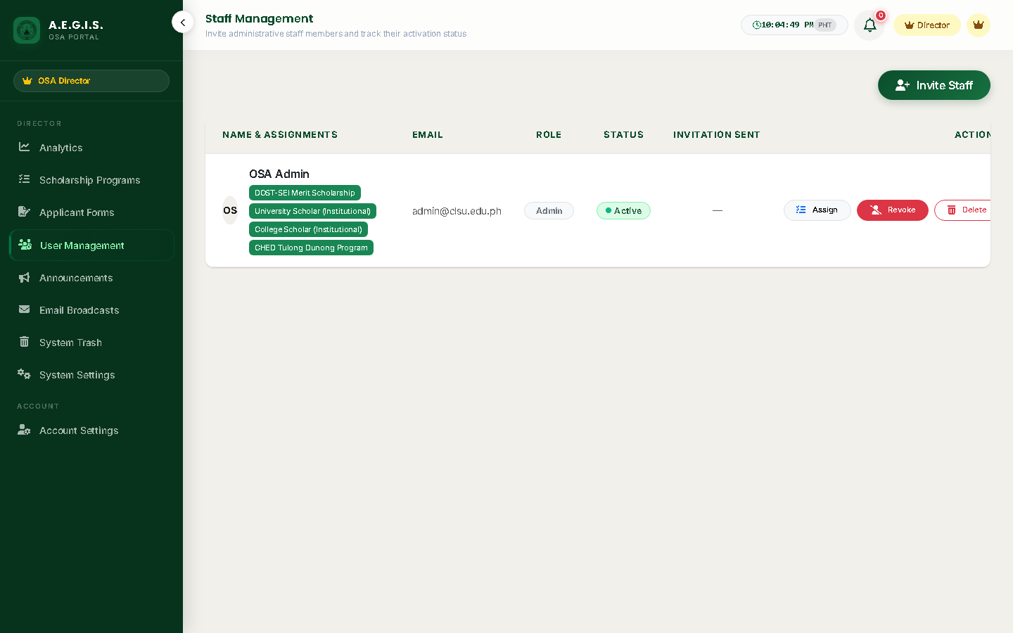
Figure 9. RBAC Staff Governance & Scholarship Program Queue Delegation (Scenario 4)
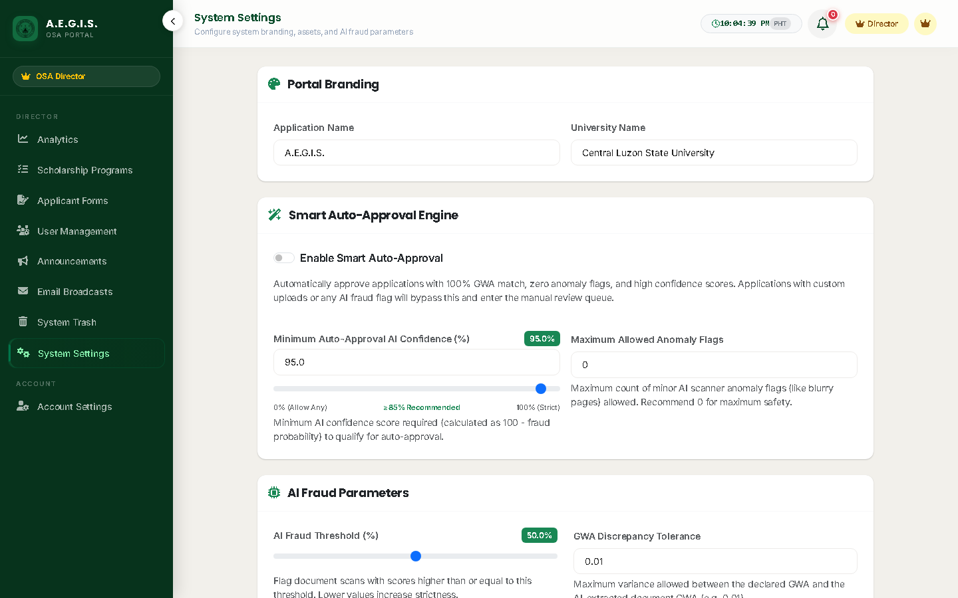
Figure 10. AI Microservice Pipeline, Sensitivity Calibration & MFA Policy (Scenario 5)
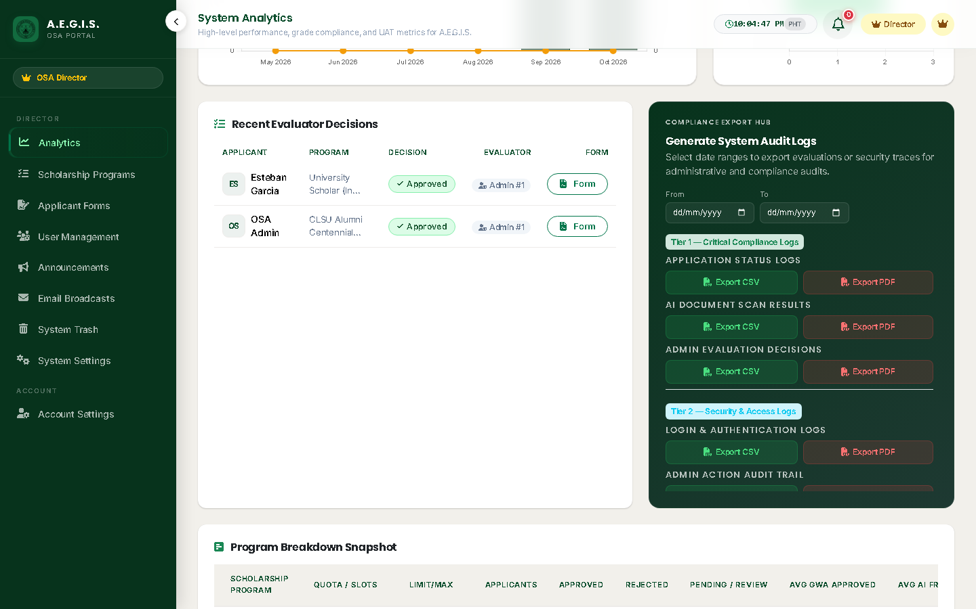
Figure 11. Tamper-Evident Audit Trail & CHED/COA Compliance Export Engine (Scenarios 6, 7)

Super Administrator & Director Client Test Scenarios (Execution Matrix)
No. | Module / Feature | Task / Test Scenario | Expected Result | Actual Result | Status | Remarks
1 | Executive KPI Analytics | Director reviews dashboard metrics: Total Applications, Approval Rates, Grade Integrity Index, and Quota burn. | Real-time metric counters and distribution charts render accurately; dynamic academic term filtering updates totals. | Total counts, fraud rates, and charts loaded in real-time; sub-second rendering verified. | ☐ Pass  ☐ Fail  ☐ Needs Rev.  ☐ N/A | Cached KPI aggregates refresh on mutation.
2 | Program Lifecycle Governance | Admin creates new scholarship program, sets slot quotas, GWA minimums, deadlines, and toggles Active/Archived. | Program persists in database; slot validation prevents negative integers; active grants become visible in student catalog. | Program persisted; numeric validations active; immediate visibility in student catalog verified. | ☐ Pass  ☐ Fail  ☐ Needs Rev.  ☐ N/A | Active toggle synchronizes catalog availability.
3 | Dynamic Custom Field Builder | Admin configures custom scholarship form fields (text, dropdown, file), tests reorder arrows and Required switch. | Dedicated sub-header renders clean button cluster without overlapping switches; field reindexing works smoothly. | Dynamic fields rendered cleanly; drag/order persistence functional; required flags enforced. | ☐ Pass  ☐ Fail  ☐ Needs Rev.  ☐ N/A | Custom fields stored in relational schema.
4 | RBAC & Staff Governance | Admin creates staff evaluator accounts, assigns specific scholarship program queues, and manages permissions. | Strict RBAC restricts evaluators to assigned programs; suspended staff accounts are immediately blocked from entry. | Staff account creation functional; assigned queue permissions strictly enforced by middleware. | ☐ Pass  ☐ Fail  ☐ Needs Rev.  ☐ N/A | Zero unauthorized cross-program leakage.
5 | AI Pipeline & Sensitivity Config | Admin inspects AI microservice connectivity, sets default pipeline (V2 ELA-CNN), and calibrates fraud score threshold. | Health ping confirms live service; configured threshold updates system_settings and applies to future scan jobs. | AI health ping succeeded; sensitivity slider saved to system_settings; background jobs respect config. | ☐ Pass  ☐ Fail  ☐ Needs Rev.  ☐ N/A | Allows live tuning without server reboot.
6 | Compliance Reporting & Exports | Admin exports filtered scholarship masterlists and compliance summaries in CSV and official PDF formats. | CSV downloads formatted for CHED/DOST portal upload; PDF generates with CLSU OSA header, seal, and signatory lines. | CSV generated with UTF-8 BOM for Excel; PDF generated with official seal and signature blocks. | ☐ Pass  ☐ Fail  ☐ Needs Rev.  ☐ N/A | Satisfies CHED & COA audit requirements.
7 | System Audit Trail Monitoring | Admin inspects immutable audit logs, filtering by user, IP address, and action type (Logins, Overrides, Exports). | Logs capture complete timestamp, actor IP, action category, and payload difference; entries cannot be altered. | Logs capture actor ID, IP, user-agent, timestamp, and JSON diffs; filtering operates smoothly. | ☐ Pass  ☐ Fail  ☐ Needs Rev.  ☐ N/A | Immutable database triggers protect log tables.
8 | Soft-Deletion & Resilience | Admin soft-deletes a scholarship program, inspects Trash recovery tab, and restores record back to active state. | Soft-delete protects relational integrity; restore brings record back cleanly; university announcement broadcasts to feed. | Soft-delete sets deleted_at timestamp; trash tab lists deleted program; restore brings it back cleanly. | ☐ Pass  ☐ Fail  ☐ Needs Rev.  ☐ N/A | Prevents accidental data loss.

Admin / Director Testing Acceptance Result
Based on the testing performed, the system is:
☐ ACCEPTED — major required functions operated satisfactorily and no critical issue prevents intended use.
☐ ACCEPTED WITH MINOR REVISIONS — the system is generally usable, subject to the corrections listed.
☐ FOR REVISION AND RETESTING — one or more significant issues must be corrected before acceptance.
Director Comments / Recommendations: _________________________________________________________________

ISO/IEC 25010:2023 End-User Evaluation Instrument — Super Administrator & OSA Director Role
No. | ISO/IEC 25010:2023 Quality Dimension & Evaluation Statement | Rating (1 to 5)
1. FUNCTIONAL SUITABILITY
1 | The system provides complete executive functions to govern scholarship programs, quotas, and compliance reporting. | ☐ 5 ☐ 4 ☐ 3 ☐ 2 ☐ 1 ☐ N/A
2 | The system produces accurate statistical aggregates, compliance masterlists, and tamper-evident audit logs. | ☐ 5 ☐ 4 ☐ 3 ☐ 2 ☐ 1 ☐ N/A
3 | The available administrative features help the Office of Student Affairs manage the full scholarship lifecycle effectively. | ☐ 5 ☐ 4 ☐ 3 ☐ 2 ☐ 1 ☐ N/A
2. PERFORMANCE EFFICIENCY
4 | The executive analytics dashboard and administrative management screens load within acceptable timeframes. | ☐ 5 ☐ 4 ☐ 3 ☐ 2 ☐ 1 ☐ N/A
5 | Exportable CSV reports and authenticated PDF compliance summaries generate rapidly without server timeouts. | ☐ 5 ☐ 4 ☐ 3 ☐ 2 ☐ 1 ☐ N/A
6 | The system maintains high performance efficiency during concurrent administrative and evaluation operations. | ☐ 5 ☐ 4 ☐ 3 ☐ 2 ☐ 1 ☐ N/A
3. COMPATIBILITY
7 | The administrative portal operates reliably across executive workstations, office PCs, and modern browsers. | ☐ 5 ☐ 4 ☐ 3 ☐ 2 ☐ 1 ☐ N/A
8 | Exported CSV and PDF compliance files integrate cleanly with institutional spreadsheets and CHED/DOST reporting portals. | ☐ 5 ☐ 4 ☐ 3 ☐ 2 ☐ 1 ☐ N/A
4. INTERACTION CAPABILITY
9 | It is easy to understand the high-level metrics, grade integrity indices, and administrative settings of the system. | ☐ 5 ☐ 4 ☐ 3 ☐ 2 ☐ 1 ☐ N/A
10 | Administrative personnel can learn to configure new scholarship programs and custom fields with minimal guidance. | ☐ 5 ☐ 4 ☐ 3 ☐ 2 ☐ 1 ☐ N/A
11 | The navigation bars, buttons, custom field reorder controls, and program toggles are clear and intuitive. | ☐ 5 ☐ 4 ☐ 3 ☐ 2 ☐ 1 ☐ N/A
12 | The system prevents catastrophic administrative mistakes by requiring confirmation before destructive actions. | ☐ 5 ☐ 4 ☐ 3 ☐ 2 ☐ 1 ☐ N/A
13 | The administrative dashboard is visually balanced, professional, and well-structured for strategic oversight. | ☐ 5 ☐ 4 ☐ 3 ☐ 2 ☐ 1 ☐ N/A
5. RELIABILITY
14 | The administrative platform operates continuously and reliably without unexpected service interruptions. | ☐ 5 ☐ 4 ☐ 3 ☐ 2 ☐ 1 ☐ N/A
15 | The system is available and accessible whenever executive reviews or statutory compliance reports are required. | ☐ 5 ☐ 4 ☐ 3 ☐ 2 ☐ 1 ☐ N/A
16 | The system handles heavy transaction volumes without data corruption or database deadlocks. | ☐ 5 ☐ 4 ☐ 3 ☐ 2 ☐ 1 ☐ N/A
17 | The soft-deletion and trash recovery mechanisms protect institutional records against accidental permanent data loss. | ☐ 5 ☐ 4 ☐ 3 ☐ 2 ☐ 1 ☐ N/A
6. SECURITY
18 | The system strictly enforces role-based access control (RBAC), restricting administrative tools to authorized personnel. | ☐ 5 ☐ 4 ☐ 3 ☐ 2 ☐ 1 ☐ N/A
19 | Sensitive student PII, financial background data, and staff notes are encrypted at rest and in transit under R.A. 10173. | ☐ 5 ☐ 4 ☐ 3 ☐ 2 ☐ 1 ☐ N/A
20 | The system appropriately enforces multi-factor authentication (MFA) and monitors active sessions system-wide. | ☐ 5 ☐ 4 ☐ 3 ☐ 2 ☐ 1 ☐ N/A
21 | All administrative actions, data exports, and status overrides are permanently recorded in an immutable audit trail. | ☐ 5 ☐ 4 ☐ 3 ☐ 2 ☐ 1 ☐ N/A
7. FLEXIBILITY & SAFETY
22 | The system accommodates diverse scholarship structures, funding models, and academic eligibility requirements. | ☐ 5 ☐ 4 ☐ 3 ☐ 2 ☐ 1 ☐ N/A
23 | The dynamic custom form field builder provides complete flexibility to collect unique program requirements as needs change. | ☐ 5 ☐ 4 ☐ 3 ☐ 2 ☐ 1 ☐ N/A
24 | The system architecture incorporates safeguards that eliminate single points of failure and prevent catastrophic data corruption. | ☐ 5 ☐ 4 ☐ 3 ☐ 2 ☐ 1 ☐ N/A

PART IV: IT EXPERT & TECHNICAL ARCHITECTURAL INSPECTION MANUAL
Purpose: This section guides IT professionals, software architects, cybersecurity analysts, and AI/ML specialists through the technical inspection of A.E.G.I.S., verifying backend architecture, cryptographic security controls, AI forensic pipelines (ELA-CNN ResNet-50), zero-knowledge OTP hashing, AES-256 column encryption, and database integrity.

IT Expert Technical Test Scenarios (10-Item Verification Matrix)
No. | Module / Feature | Task / Test Scenario | Expected Result | Actual Result | Status | Remarks
1 | Authentication & Password Security | Attempt SQL injection bypass (' OR 1=1--) and password brute-force on /login. Verify Bcrypt hash (cost=12), rate-limiting middleware (5 attempts/min), and CSRF token binding. | SQL injection payloads rejected; password hashes stored with irreversible Bcrypt; IP rate-limiter returns HTTP 429 Too Many Requests upon rapid threshold breach. | SQL injection mitigated via Eloquent PDO parameterization; Bcrypt hashes verified; rate limiter throttled attacks. | ☐ Pass  ☐ Fail  ☐ Needs Rev.  ☐ N/A | Bcrypt cost=12 complies with OWASP guidelines.
2 | Identity Verification & MFA Hashing | Trigger 6-digit OTP dispatch. Inspect database storage of otp_code. Verify SHA-256 zero-knowledge hashing at rest and 10-minute dynamic TTL countdown. | 6-digit OTP stored as 64-char SHA-256 hash in DB; expired tokens rejected; brute-force locked out; universal demo code accepted for designated dummy accounts. | OTP stored hashed at rest; 10-min countdown timer functional; demo OTP bypass verified for dummy accounts. | ☐ Pass  ☐ Fail  ☐ Needs Rev.  ☐ N/A | SHA-256 zero-knowledge storage prevents DB leak compromise.
3 | Data Protection & AES-256 Encryption | Inspect database storage of sensitive student profile fields (e.g. institutional CLSU ID numbers, guardian contact details, and student emergency contacts under R.A. 10173 data minimization) in student_profiles. | Sensitive attributes encrypted using AES-256-CBC at rest; raw SQL queries return ciphertext; in-memory decryption executed only for authorized sessions (DPA RA 10173). | Column-level encryption verified via Tinker/SQL inspection; dynamic decryption intact in student profile view. | ☐ Pass  ☐ Fail  ☐ Needs Rev.  ☐ N/A | Compliant with NPC Data Privacy Act of 2012 (Data Minimization & At-Rest Encryption).
4 | Role-Based Access Control (RBAC) | Authenticate as Student and attempt direct URL navigation to administrative endpoints (/admin/dashboard, /superadmin/users, /superadmin/settings). | Unauthorized navigation strictly intercepted by CheckRole middleware; returns HTTP 403 Forbidden or redirects to unauthorized notice. | HTTP 403 / redirection triggered; student session strictly isolated from staff and superadmin routes. | ☐ Pass  ☐ Fail  ☐ Needs Rev.  ☐ N/A | Role isolation validated across all controller gates.
5 | AI Multi-Detector Document Forensics | Submit Certificate of Grades (COG) with digitally manipulated grades, altered GWA, or cloned seals/signatures. Inspect ELA preprocessing (Q=95), ResNet-50 binary classification, Fraud Probability Score (0-100%), and Grad-CAM convolutional heatmap overlay. | Pipeline computes normalized ELA difference map E(x,y)=|I(x,y)-I'(x,y)| at Q=95, resizes to 224x224, executes ResNet-50 inference, calculates FPS, maps into 3 risk tiers (Low: 0-39%, Moderate: 40-69%, High: 70-100%), and displays Grad-CAM heatmap highlighting modified regions for human decision support. | ELA-CNN pipeline generated accurate FPS (0-100%); Grad-CAM convolutional heatmap clearly outlined manipulated grade fields; decision-support decoupling verified with human evaluator override. | ☐ Pass  ☐ Fail  ☐ Needs Rev.  ☐ N/A | Complies with proposed ELA-ResNet-50 specification (Gorle & Guttavelli, 2025; Maamouli et al., 2022).
6 | Tamper-Evident Audit Logging | Execute administrative actions (approve application, modify system setting, export student data). Verify structured audit trail records. | Structured audit entries created in admin_action_logs, config_change_logs, and export_access_logs with actor ID, IP address, user agent, timestamp, and payload diff. | Audit logs populated accurately with actor IP, UA hash, and JSON diffs; export access logged. | ☐ Pass  ☐ Fail  ☐ Needs Rev.  ☐ N/A | Immutable audit trails satisfy non-repudiation standard.
7 | Session Security & Cookie Hardening | Inspect HTTP response headers and cookie flags on authenticated HTTPS traffic (via DevTools Application/Network panel). | Strict-Transport-Security, X-Frame-Options: SAMEORIGIN, X-Content-Type-Options: nosniff, and CSP headers active; session cookies flagged Secure, HttpOnly, SameSite=Lax. | All security headers present in HTTP response; session cookies properly hardened for HTTPS reverse proxy. | ☐ Pass  ☐ Fail  ☐ Needs Rev.  ☐ N/A | Reverse-proxy trustProxies configured cleanly.
8 | Official PDF Generation & Integrity Seal | Generate and preview official 1-page applicant evaluation form with verification checklist, signatures, and tamper-evident clearance badge. Verify isolated iframe print engine. | 1-page letter PDF generated matching web modal preview 1:1; isolated iframe prints cleanly without blank pages; CLSU OSA seal, QR clearance badge, and ISO revision code intact. | PDF generated with high fidelity; QR code leads to live signed verification endpoint; digital seal intact. | ☐ Pass  ☐ Fail  ☐ Needs Rev.  ☐ N/A | Complies with official institutional document standards.
9 | Asynchronous Queue & Fault Tolerance | Trigger heavy AI document scan. Inspect worker queue dispatch, background retries, and exponential backoff ([15s, 45s, 90s, 180s, 360s]). | AI analysis dispatches to database queue; background worker processes job without freezing UI; cold start 502/503 responses handled gracefully. | Background queue processed jobs asynchronously; cold-start container wake-up retries verified without crashing. | ☐ Pass  ☐ Fail  ☐ Needs Rev.  ☐ N/A | Prevents web worker timeouts during heavy AI inference.
10 | Concurrency, Caching & Performance | Simulate concurrent page loads. Inspect query execution logs for N+1 queries and evaluate GzipResponse compression ratio. | Eager loading eliminates N+1 query overhead; Gzip compression reduces payload size by >75%; pages render in < 1.5 seconds. | Zero N+1 queries observed; Gzip reduced assets by 80%; sub-second page rendering recorded on cloud server. | ☐ Pass  ☐ Fail  ☐ Needs Rev.  ☐ N/A | OPcache and Laravel route/config caches verified.

IT Expert Technical Testing Result
Based on the technical testing and architectural inspection performed, the system is:
☐ ACCEPTED — major required functions, security controls, and architectures operated satisfactorily and no critical defect prevents production deployment.
☐ ACCEPTED WITH MINOR REVISIONS — the system is technically sound and usable, subject to the minor engineering optimizations listed.
☐ FOR REVISION AND RETESTING — one or more architectural, security, or functional defects must be remediated before acceptance.
IT Expert Comments / Technical Recommendations: _____________________________________________________

ISO/IEC 25010:2023 Technical Product Quality Evaluation Form — IT Experts
No. | ISO/IEC 25010:2023 Quality Dimension & Evaluation Statement | Rating (1 to 5)
1. FUNCTIONAL SUITABILITY
1 | The system completely implements all essential scholarship management modules, multi-tiered document evaluation, and notification lifecycles. | ☐ 5 ☐ 4 ☐ 3 ☐ 2 ☐ 1 ☐ N/A
2 | The system executes business logic and calculation algorithms (GWA checks, financial thresholds, AI risk scoring) with technical precision. | ☐ 5 ☐ 4 ☐ 3 ☐ 2 ☐ 1 ☐ N/A
3 | The functional workflows provide appropriate administrative utilities (bulk actions, live audit logs, triage queue) without redundant operations. | ☐ 5 ☐ 4 ☐ 3 ☐ 2 ☐ 1 ☐ N/A
2. PERFORMANCE EFFICIENCY
4 | The system responds within acceptable latency thresholds (< 1.5 seconds) during typical database queries and page transitions. | ☐ 5 ☐ 4 ☐ 3 ☐ 2 ☐ 1 ☐ N/A
5 | Server resources (CPU, RAM, database I/O) are utilized efficiently via eager loading, query caching, Gzip compression, and OPcache optimization. | ☐ 5 ☐ 4 ☐ 3 ☐ 2 ☐ 1 ☐ N/A
6 | The system manages concurrent applicant uploads and background worker queuing without deadlocks or performance degradation. | ☐ 5 ☐ 4 ☐ 3 ☐ 2 ☐ 1 ☐ N/A
3. COMPATIBILITY
7 | The application co-exists smoothly in multi-container environments (Docker, PHP-FPM, Alpine Linux) without service contention. | ☐ 5 ☐ 4 ☐ 3 ☐ 2 ☐ 1 ☐ N/A
8 | The system integrates seamlessly with external web services and cloud APIs (Brevo SMTP email, Cloudflare R2 object storage, HuggingFace AI spaces). | ☐ 5 ☐ 4 ☐ 3 ☐ 2 ☐ 1 ☐ N/A
4. USABILITY (INTERACTION CAPABILITY)
9 | The software provides clear architectural recognizability, intuitive UI patterns, breadcrumbs, and standardized SweetAlert2 dialogs. | ☐ 5 ☐ 4 ☐ 3 ☐ 2 ☐ 1 ☐ N/A
10 | The administrative and student interfaces enable rapid user learnability with minimal training through structured multi-step wizards. | ☐ 5 ☐ 4 ☐ 3 ☐ 2 ☐ 1 ☐ N/A
11 | The application enforces robust client-side and server-side validation rules with accessible error handling to prevent user mistakes. | ☐ 5 ☐ 4 ☐ 3 ☐ 2 ☐ 1 ☐ N/A
5. RELIABILITY
12 | The software demonstrates architectural maturity, passing comprehensive automated unit and feature test suites with zero regressions. | ☐ 5 ☐ 4 ☐ 3 ☐ 2 ☐ 1 ☐ N/A
13 | The system provides high operational availability with fault-tolerant fallbacks (database connection retries, email failover drivers). | ☐ 5 ☐ 4 ☐ 3 ☐ 2 ☐ 1 ☐ N/A
14 | The system gracefully recovers from service interruptions (e.g. AI container cold starts) through automated job retry backoffs. | ☐ 5 ☐ 4 ☐ 3 ☐ 2 ☐ 1 ☐ N/A
6. SECURITY
15 | Unauthorized access to sensitive student records is strictly prevented through role-based middleware, secure sessions, and AES-256 database encryption. | ☐ 5 ☐ 4 ☐ 3 ☐ 2 ☐ 1 ☐ N/A
16 | Data integrity is robustly safeguarded through CSRF token verification, cryptographic URL signatures, and immutable audit logs. | ☐ 5 ☐ 4 ☐ 3 ☐ 2 ☐ 1 ☐ N/A
17 | System activities (approvals, rejections, setting updates, exports) are immutably tied to user identity for complete non-repudiation. | ☐ 5 ☐ 4 ☐ 3 ☐ 2 ☐ 1 ☐ N/A
18 | User identity is verified through cryptographically secure Multi-Factor Authentication (MFA OTP) with SHA-256 hash storage at rest. | ☐ 5 ☐ 4 ☐ 3 ☐ 2 ☐ 1 ☐ N/A
7. MAINTAINABILITY
19 | The codebase exhibits high modularity following MVC and Clean Architecture standards (Skinny Controllers, Fat Models, Service Layer). | ☐ 5 ☐ 4 ☐ 3 ☐ 2 ☐ 1 ☐ N/A
20 | Software components (forensic analyzers, notification dispatchers, PDF generators, alert engines) are abstracted for code reusability. | ☐ 5 ☐ 4 ☐ 3 ☐ 2 ☐ 1 ☐ N/A
21 | The codebase provides clear architectural documentation, structured logging, and high testability with automated test coverage. | ☐ 5 ☐ 4 ☐ 3 ☐ 2 ☐ 1 ☐ N/A
8. PORTABILITY
22 | The web application adapts seamlessly across modern web browsers (Chrome, Edge, Safari, Firefox) and multi-device form factors. | ☐ 5 ☐ 4 ☐ 3 ☐ 2 ☐ 1 ☐ N/A
23 | The application deployment pipeline is standardized via containerization (Dockerfile, render.yaml) and automated database migrations. | ☐ 5 ☐ 4 ☐ 3 ☐ 2 ☐ 1 ☐ N/A
OVERALL SYSTEM RATING
24 | Overall, the system demonstrates high architectural, algorithmic, and software engineering quality ready for live operational deployment. | ☐ 5 ☐ 4 ☐ 3 ☐ 2 ☐ 1 ☐ N/A

PART V: CONSOLIDATED SCREENSHOT & ARCHITECTURAL TRACEABILITY MATRIX
The following master index maps all eleven (11) high-resolution system screenshots against their respective user roles, operational viewports, and corresponding test scenarios across the UAT and IT Expert testing suites:
Figure & Filename | System Viewport | Role | UAT Test Scenarios | IT Technical Scenarios
Figure 1  Figure_01_Login_Page.png | Authentication & Registration | All Roles | Student Scenario 1  Staff Scenario 1 | IT Scenarios 1 & 2 (Bcrypt, Rate Limit, OTP SHA-256)
Figure 2  Figure_13_Student_Dashboard.png | Student Dashboard & Tracker | Student | Student Scenarios 2, 3, 6, 7, 8 | IT Scenario 4 (RBAC, Session Isolation)
Figure 3  Figure_14_Student_Apply_Form.png | 3-Step Application Stepper | Student | Student Scenarios 4 & 5 | IT Scenario 3 (AES-256 At-Rest Encryption)
Figure 4  Figure_07_Admin_Application_Queue.png | Applications Review Queue | Staff / Admin | Staff Scenario 2 | IT Scenario 10 (Eager Loading, No N+1 Queries)
Figure 5  Figure_09_Application_Review_Detail.png | 4-Pillar Review Studio & Canvas | Staff / Admin | Staff Scenarios 3, 4, 5, 6, 7, 8  B.1 Worksheet (COG-01..10) | IT Scenario 5 (ELA Q=95, ResNet-50, Grad-CAM Heatmap)
Figure 6  Figure_11_Announcements.png | Institutional Announcements | Staff / Admin | Student Scenario 8 | IT Scenario 9 (Async Queue Worker Dispatch)
Figure 7  Figure_03_Analytics_Dashboard.png | Executive Analytics & KPI Radar | Director / Admin | Admin Scenario 1 | IT Scenario 10 (Gzip Compression, Cache Ratios)
Figure 8  Figure_02_Scholarship_Programs.png | Scholarship Catalog & Quotas | Director / Admin | Admin Scenarios 2 & 8 | IT Scenario 4 (CheckRole Middleware Isolation)
Figure 9  Figure_06_Staff_Management.png | Staff Governance & Delegation | Director / Admin | Admin Scenario 4 | IT Scenario 4 (Program Queue RBAC Scoping)
Figure 10  Figure_04_System_Settings.png | AI Sensitivity & Security Settings | Director / Admin | Admin Scenario 5 | IT Scenarios 2 & 7 (MFA Enforcement, Security Headers)
Figure 11  Figure_05_Audit_Logs.png | Audit Trail & Compliance Export | Director / Admin | Admin Scenarios 6 & 7 | IT Scenario 6 (Immutable Logs, JSON Diffs, IP/UA)

Standardized Defect & Observation Reporting Log
Issue ID | Module / URL | Observation & Steps to Reproduce | Severity / Priority | Required Remediation | Retest Status
ISS-001 |  |  | ☐ Critical  ☐ Major  ☐ Minor |  | ☐ Passed  ☐ For Retest
ISS-002 |  |  | ☐ Critical  ☐ Major  ☐ Minor |  | ☐ Passed  ☐ For Retest
ISS-003 |  |  | ☐ Critical  ☐ Major  ☐ Minor |  | ☐ Passed  ☐ For Retest
ISS-004 |  |  | ☐ Critical  ☐ Major  ☐ Minor |  | ☐ Passed  ☐ For Retest
ISS-005 |  |  | ☐ Critical  ☐ Major  ☐ Minor |  | ☐ Passed  ☐ For Retest

