CENTRAL LUZON STATE UNIVERSITY
COLLEGE OF ENGINEERING • DEPARTMENT OF INFORMATION TECHNOLOGY
OFFICE OF STUDENT AFFAIRS (OSA)
A.E.G.I.S.
Academic Evaluation & Grant Integrity System
SYSTEM TESTER & EVALUATOR VISUAL OPERATIONS MANUAL
Document Reference: CLSU-OSA-AEGIS-TEG-2026-V1 │ Production Release v1.0.0
Evaluation Purpose | User Acceptance Testing (UAT), Capstone Defense Evaluation, & ISO/IEC 25010 Verification
Target Evaluators | Thesis Defense Panelists, IT Expert Evaluators, OSA Staff Evaluators, Student Testers
Quality Standard | ISO/IEC 25010:2023 Systems and Software Quality Requirements and Evaluation (SQuaRE)
Testing Host / URL | Local Server: http://127.0.0.1:8000 │ Cloud Portal: https://clsu.osa.scholarship
Evaluation Period | Academic Year 2025-2026 │ Production Release v1.0.0

1. Evaluator Architecture & Pre-Configured Test Accounts
A.E.G.I.S. is an automated scholarship administration and integrity auditing portal developed for the Central Luzon State University (CLSU) Office of Student Affairs (OSA). It streamlines application intake, verifies General Weighted Averages (GWA) via Optical Character Recognition (OCR), and detects digital document tampering using Error Level Analysis (ELA) combined with ResNet-50 Convolutional Neural Networks.
📌 PRE-PROVISIONED DEMO ENVIRONMENT: All test accounts listed below are pre-provisioned in the test database with completed student profiles, assigned scholarship portfolios, and sample evaluation records. Evaluators can sign in directly using the standard password: password. In demo mode, MFA two-factor email verification is automatically passed.

Testing Role | Login Email | Password | Pre-Configured State & Objective
Student (Active) | student@clsu.edu.ph | password | Active Application #1 ('Under Review'). Tests 5-stage Pizza Tracker & active grant card.
Student (Applicant) | student_apply@clsu.edu.ph | password | Zero active applications. Tests 3-step interactive application form & document upload.
OSA Staff (Evaluator) | admin@clsu.edu.ph | password | Assigned to all 4 scholarships. Tests Priority Queue, 4-pillar forensic review canvas, & actions.
Director (SuperAdmin) | director@clsu.edu.ph | password | Full executive role. Tests Quotas, Executive Analytics Radar, Compliance Logs, & Staff.

2. Test Track 1: Student Scholarship Portal Walkthrough

2.1 Test Scenario S-1: Secure Authentication & Trusted Device Binding
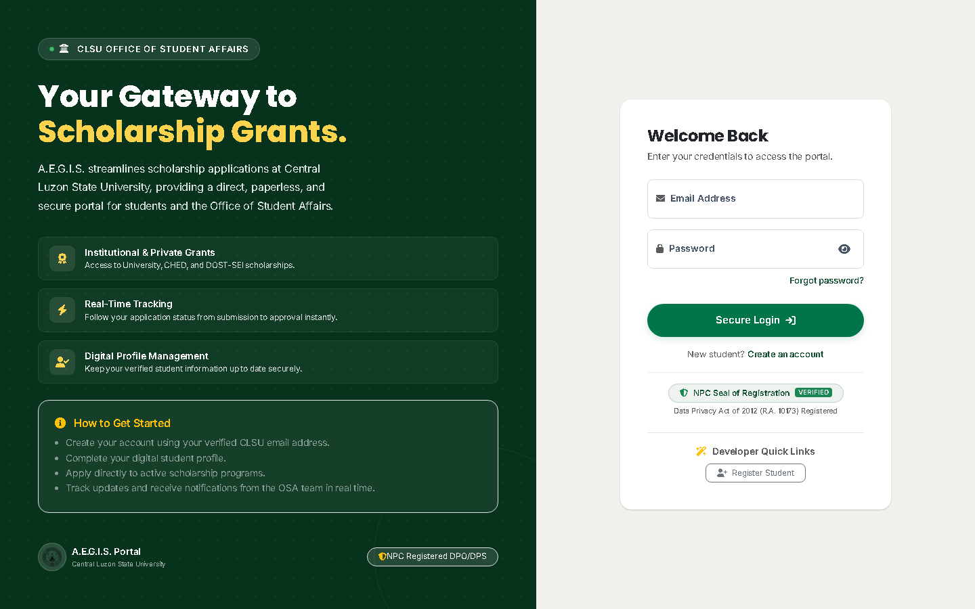
Figure 1: Institutional Login Portal & Security Options
Operational Verification for Figure 1:
• [1] Credentials Entry: Enter student@clsu.edu.ph and password.
• [2] Animated Feedback: Observe the 'Authenticating...' spinner and automatic button disable preventing duplicate submissions.
• [3] Trusted Device Checkbox: In production, checking 'Remember this device for 30 days' binds an encrypted cookie to the browser's User-Agent hash.

2.2 Test Scenario S-2: Lifecycle Progress Stepper (Pizza Tracker)
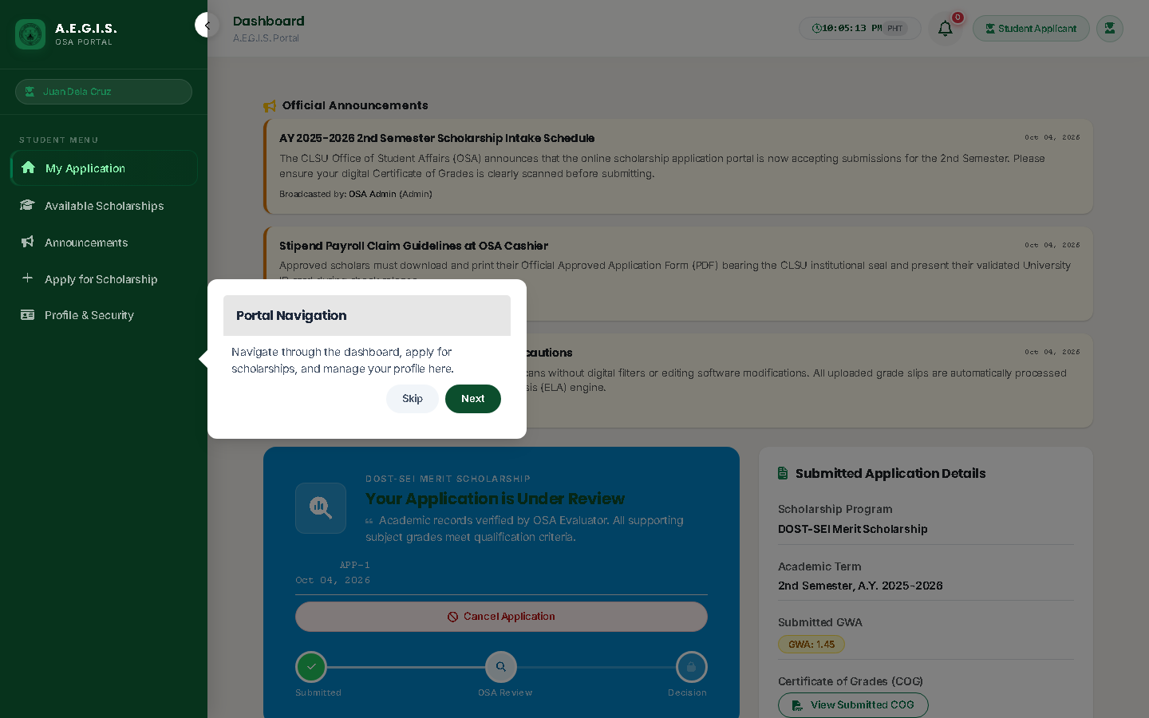
Figure 2: Student Dashboard & Real-Time Lifecycle Pizza Tracker
Operational Verification for Figure 2:
• [1] Pizza Tracker Stepper: Verify real-time milestone progress across 5 stages: Submitted (✓) → Under Review (Active Pulse) → Integrity Scanned → Approved → Disbursed.
• [2] Active Grant Card: Verify grant details for DOST-SEI Merit Scholarship, 2nd Semester AY 2025-2026, and verified GWA (1.45).
• [3] Evaluator Remarks Card: Review official feedback from OSA evaluators without requiring physical in-person office visits.

2.3 Test Scenario S-3: 3-Step Interactive Application Stepper
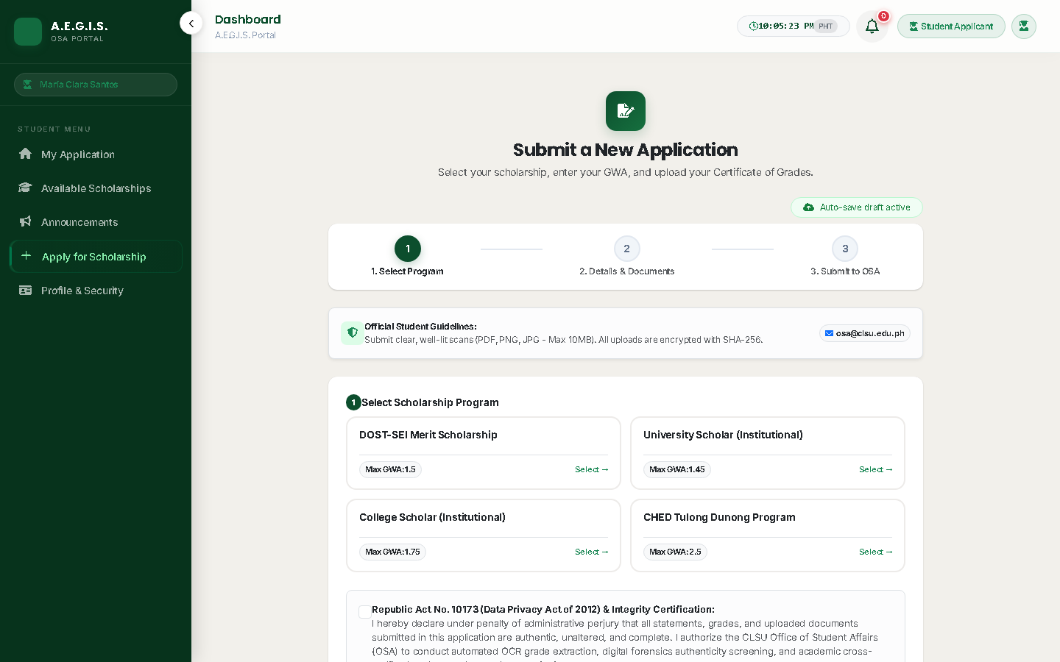
Figure 3: Student 3-Step Interactive Application Stepper
Operational Verification for Figure 3 (Sign in as student_apply@clsu.edu.ph):
• [1] Step 1 (Program Selection): Select desired scholarship program and observe dynamic criteria and renewal caps.
• [2] Step 2 (Academic Declarations): Enter declared GWA (e.g. 1.45) with client-side validation enforcing the 1.00–3.00 scale.
• [3] Step 3 (Document Upload): Attach Certificate of Grades (COG) with 10 MB limit check and automatic draft saving.
• [4] After-Hours Guard: Applications submitted after 5:00 PM PHT display the 'Queued for Next Business Day' operational badge.

3. Test Track 2: OSA Evaluator (Staff) Console Walkthrough

3.1 Test Scenario E-1: Priority Risk Queue & Workload Triage
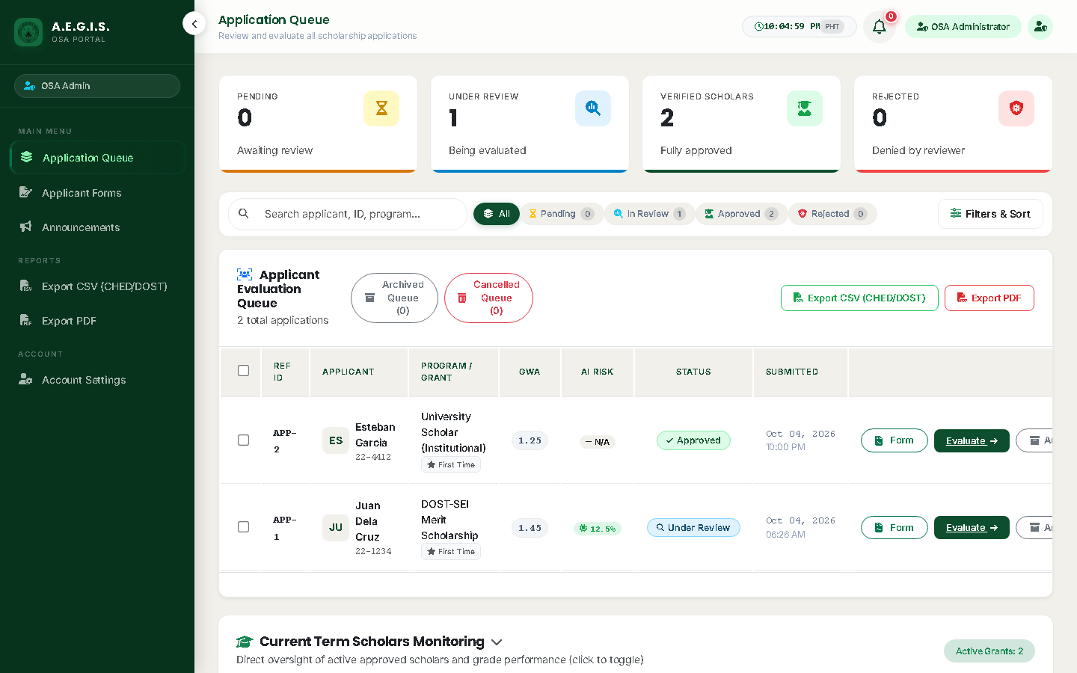
Figure 4: OSA Evaluator Application Queue & Triage Console
Operational Verification for Figure 4 (Sign in as admin@clsu.edu.ph):
• [1] Metrics Summary Bar: View real-time counters for Pending, Under Review, Approved, Rejected, and Archived applications.
• [2] Workload Filtering: Filter between 'Assigned to Me' and 'All Applications' across assigned scholarship portfolios.
• [3] Priority Risk Sorting: Choose 'Priority Risk' to bubble high fraud score applications (≥ 70.0%) to the top of the queue.
• [4] Review Applicant: Click 'Review Applicant' on Application #1 to open the forensic review studio.

3.2 Test Scenario E-2: 4-Pillar Forensic Review Studio & ELA Canvas
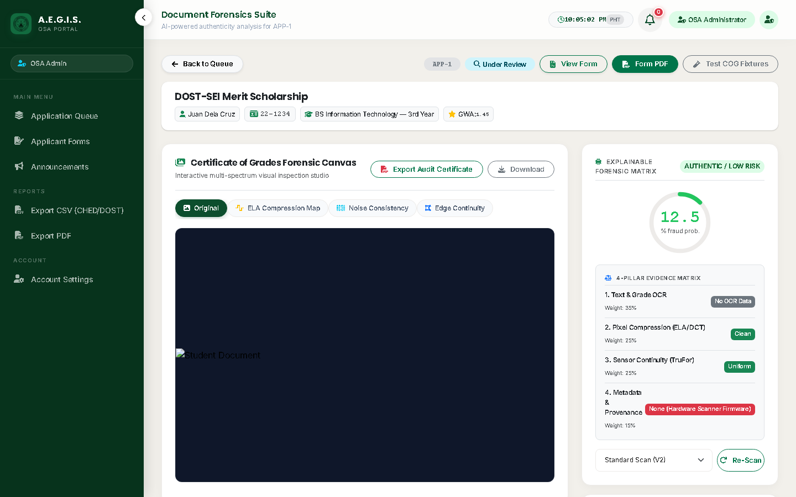
Figure 5: 4-Pillar Forensic Review Studio & ELA Heatmap Canvas
Operational Verification for Figure 5:
• [1] Forensic Canvas Layers: Toggle between Original, Annotated (CAM), ELA Compression Map, and Noise Consistency.
• [2] Opacity Slider: Adjust blending slider (0% to 100%) to overlay the thermal ELA heatmap directly onto the student transcript.
• [3] 4-Pillar Decision Framework: Review Pillar 1 (Syntax Gate), Pillar 2 (OCR GWA Consistency 35%), Pillar 3 (Compression 50%), and Pillar 4 (Metadata Provenance 15%).
• [4] Triage Decision: Select Approved or Rejected, add private staff notes, and save with non-repudiation audit logging.

3.3 Test Scenario E-3: Institutional Announcement Management
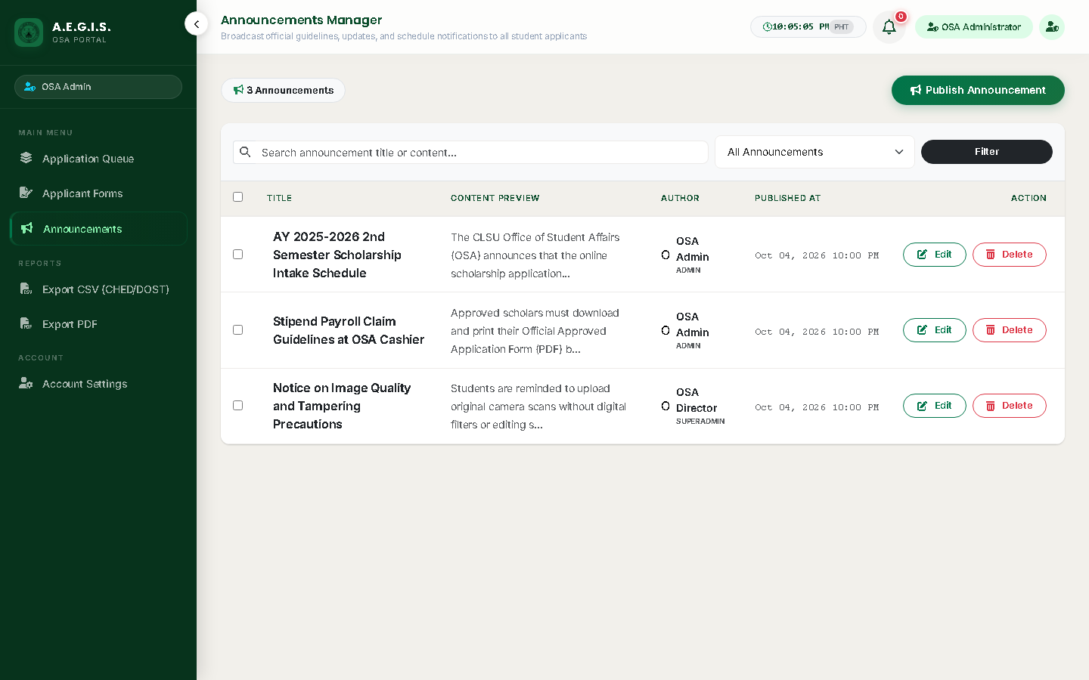
Figure 6: Institutional Announcement Management Console
Operational Verification for Figure 6:
• [1] Broadcast Notifications: Evaluators can broadcast deadline notices, missing grade slip warnings, and stipend release schedules.
• [2] Audience Targeting: Filter announcements between 'All Users' or 'Students Only'.

4. Test Track 3: OSA Director (SuperAdmin) Governance Walkthrough

4.1 Test Scenario D-1: Scholarship Program & Quota Management
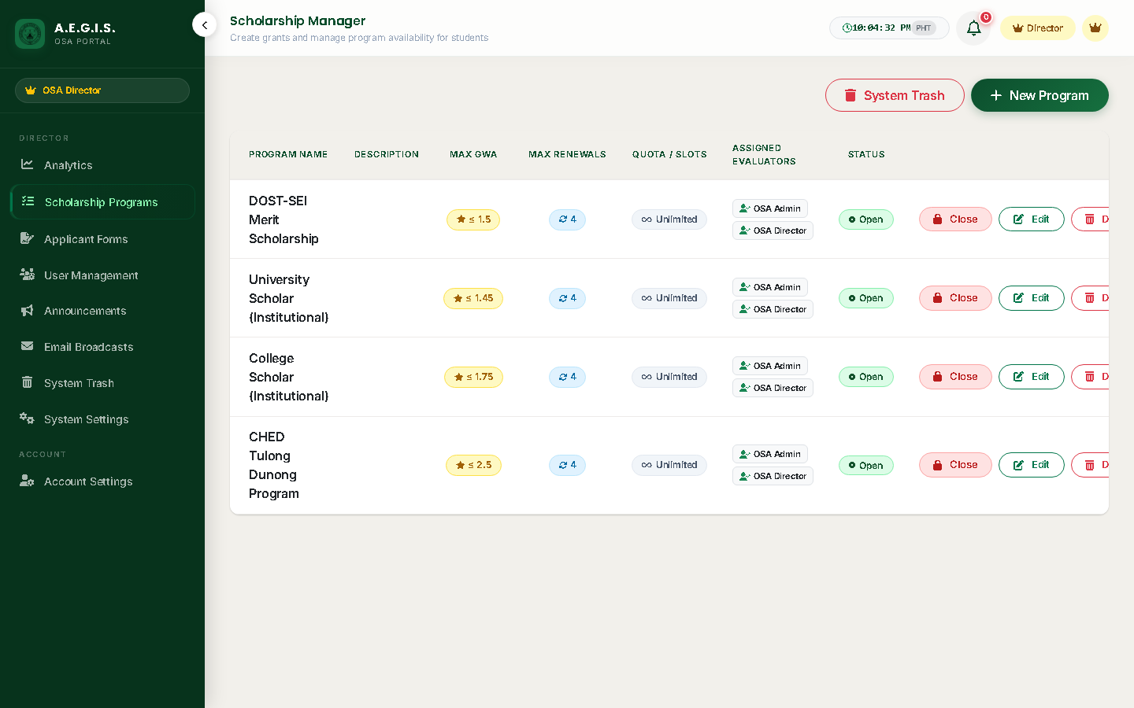
Figure 7: Scholarship Program Configuration & Quotas
Operational Verification for Figure 7 (Sign in as director@clsu.edu.ph):
• [1] Program Creation: Define funding sources, minimum GWA cutoffs, and maximum renewal counts.
• [2] Quota Caps: Set maximum beneficiaries per academic term or leave open.
• [3] Status Toggling: Toggling a program off immediately hides it from new student intake options.

4.2 Test Scenario D-2: Executive Analytics & ISO/IEC 25010 Quality Radar
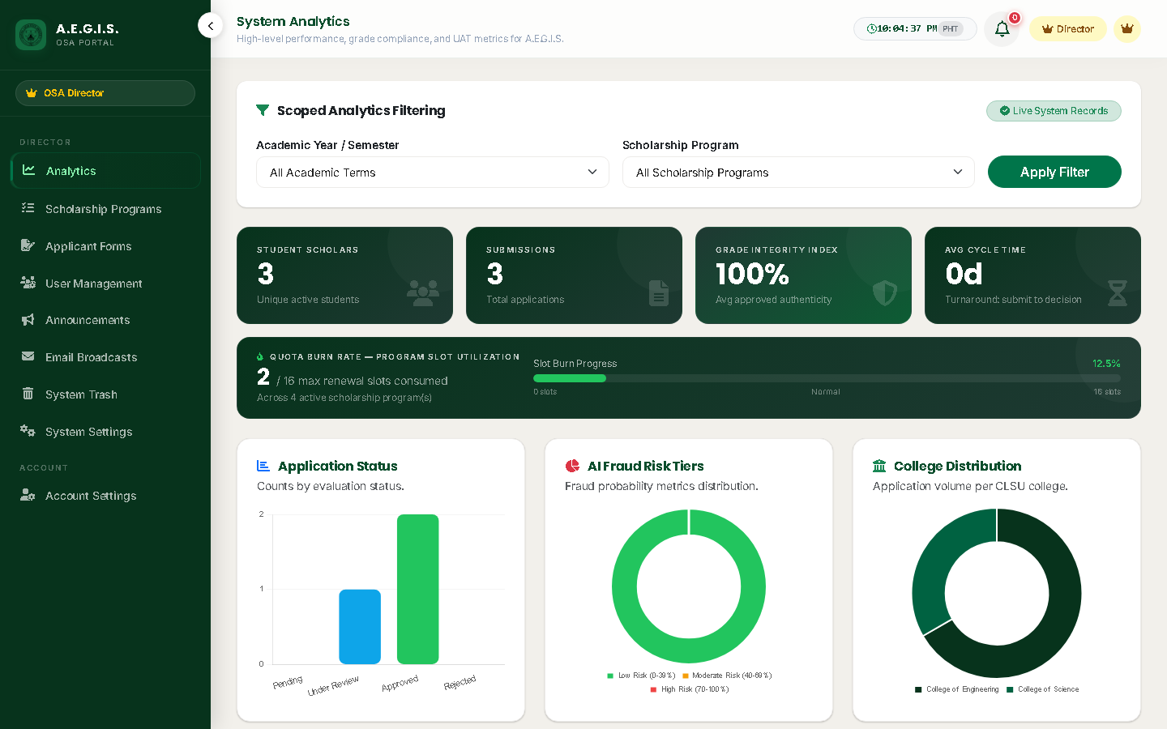
Figure 8: Executive Analytics Dashboard & ISO 25010 Quality Radar
Operational Verification for Figure 8:
• [1] Executive KPIs: Grade Integrity Index, Turnaround Velocity in days, and total disbursed grants.
• [2] College Distribution: Allocation breakdown across all 9 CLSU academic colleges.
• [3] ISO 25010 Quality Radar: Live radar chart aggregating evaluator satisfaction across Functional Suitability, Usability, Reliability, and Security.

4.3 Test Scenario D-3: Compliance Export Hub & 7-Tier Audit Trail
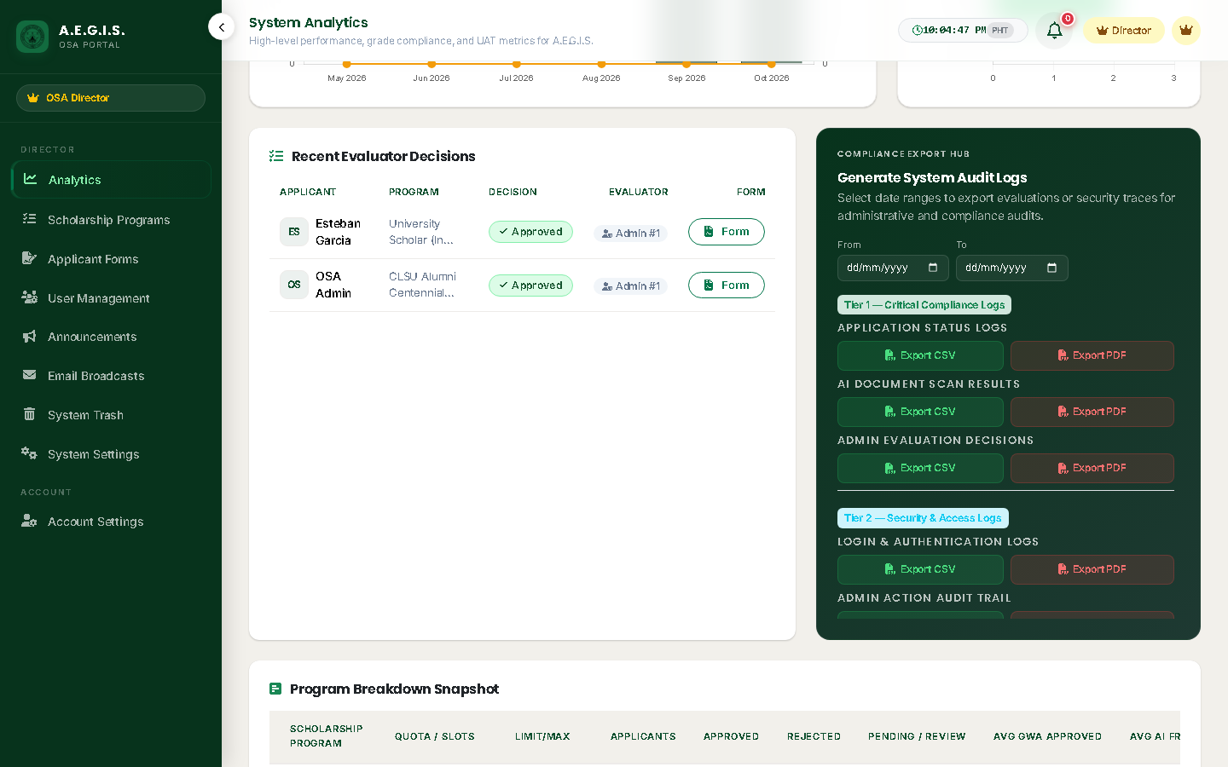
Figure 9: Compliance Export Hub & Evaluator Audit Table
Operational Verification for Figure 9:
• [1] Compliance Export Hub: Generate official CSV and PDF audit logs across 7 security tiers.
• [2] Recent Evaluator Decisions: Audit evaluator actions with timestamp, decision badge, and link to authentic applicant PDF forms.

4.4 Test Scenario D-4: Dynamic System Settings & Universal Controls
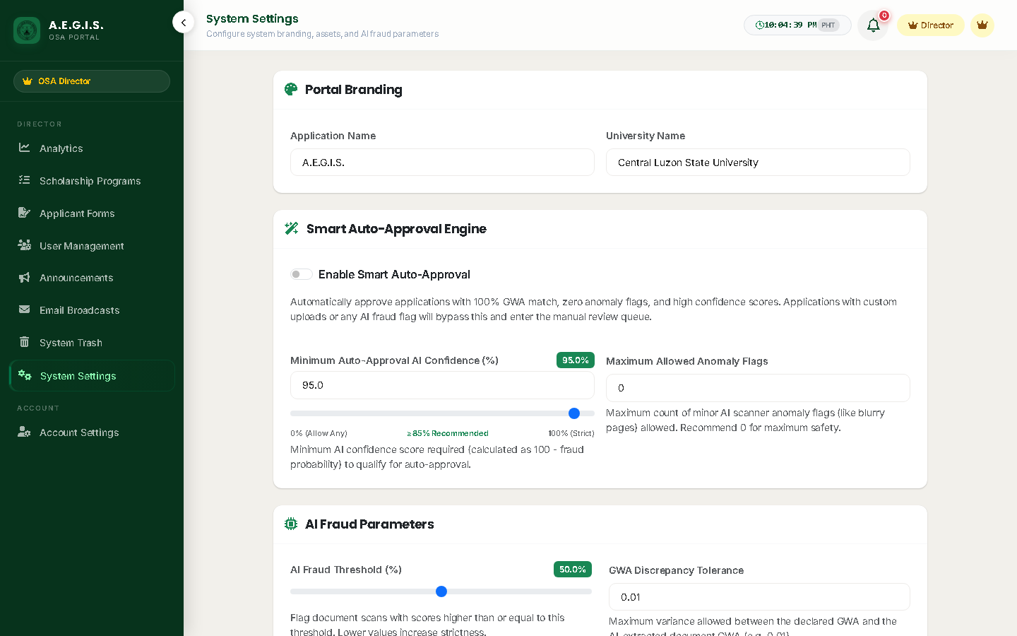
Figure 10: Dynamic System Settings & Forensics Calibration
Operational Verification for Figure 10:
• [1] AI Sensitivity Threshold: Calibrate default fraud threshold (70.0%) and GWA tolerance (0.01).
• [2] Universal Device Revocation: Instantly terminate all remembered 30-day browser sessions across the university.

4.5 Test Scenario D-5: Staff Delegation & Role Management
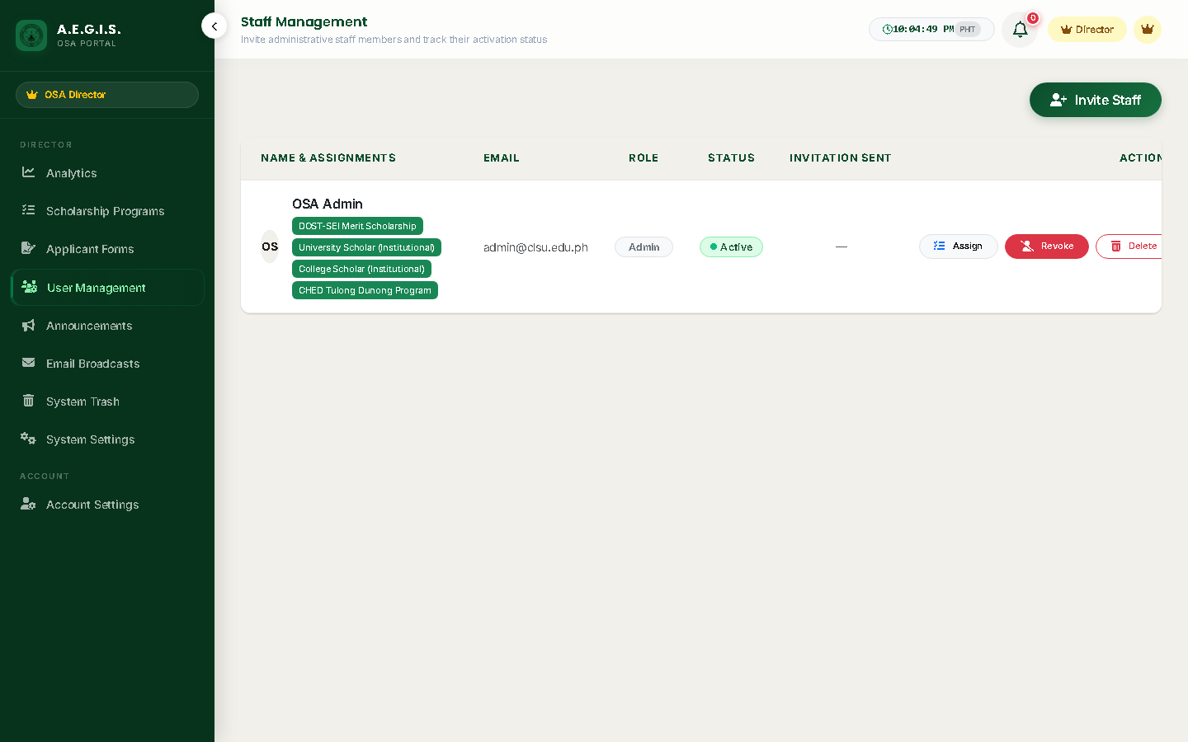
Figure 11: Staff Delegation & Role Management Console
Operational Verification for Figure 11:
• [1] Staff Portfolio Assignment: Partition application volume by assigning specific scholarship programs to evaluators.
• [2] Secure Invitation Tokens: Provision new staff via cryptographically signed single-use invitation emails.

5. Standardized ISO/IEC 25010:2023 Evaluator Rating Form
Evaluators are requested to rate the software quality across the eight (8) standard characteristics defined in ISO/IEC 25010:2023. Use the 5-point Likert scale: 5 = Strongly Agree (SA) │ 4 = Agree (A) │ 3 = Neutral (N) │ 2 = Disagree (D) │ 1 = Strongly Disagree (SD).
ISO/IEC 25010 Characteristic | Evaluation Statement | Rating (1–5)
1. Functional Suitability | The system provides all required functions for scholarship intake, AI document verification, evaluator triage, and director governance.
2. Performance Efficiency | The system responds rapidly (page load < 1.5s), processes AI document scans asynchronously, and handles queue loads without UI freezing.
3. Compatibility | The web portal operates consistently across modern web browsers (Chrome, Edge, Firefox, Safari) and renders cleanly on mobile viewports.
4. Usability | The user interface is visually polished, intuitive, and easy to navigate with the 5-stage Pizza Tracker, 3-step application form, and clear callouts.
5. Reliability | The system exhibits high fault tolerance, gracefully handles offline/cold-start AI scenarios, and auto-saves student form drafts.
6. Security | The system enforces strong role-based access control (RBAC), multi-factor authentication, AES-256 student data encryption, and tamper-evident audit trails.
7. Maintainability | The system follows modern MVC architecture with modular controllers, reusable Blade components, and comprehensive automated test suites.
8. Portability | The application is containerized with Docker multi-stage builds and deploys reliably across local, staging, and cloud production environments.

Evaluator Signature over Printed Name:  _________________________________________  Date: ________________________ | Project Leaders / Researchers:  JOHN ANDREI CARILLO / NORIEL S. GADIANO / JOSHUA A. RAZON  Date: October 2026

