CHAPTER IV
RESULTS AND DISCUSSION
This chapter presents the results and discussion of the design, development, and evaluation of A.E.G.I.S. (AI-Enhanced Grant Information System), a web-based scholarship management system with AI-based document fraud detection, developed for the Office of Student Affairs (OSA) of Central Luzon State University (CLSU). It confirms that the requirements, feasibility analysis, architectural and behavioral design models, and development plan presented in Chapter III were carried through into the realized system, and reports the results of testing, ethical compliance, and deployment readiness.
4.1 Results of Requirements Definition
Before presenting the results of each subsequent phase, it is useful to recall the project-management structure within which every activity described in this chapter was actually carried out, since that structure governed the pace and sequencing of everything that follows.
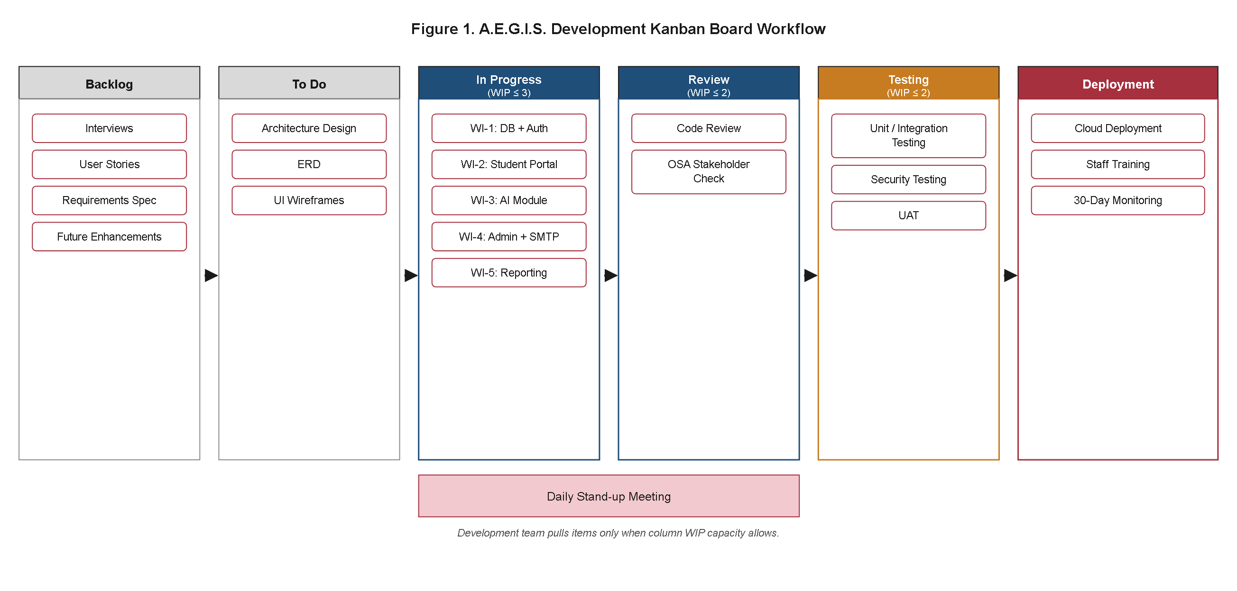
Figure 1. A.E.G.I.S. Development Kanban Board Workflow.
Figure 1, reproduced here from Chapter III (Appendix B, Figure 1, p. 51) in a freshly rendered form, depicts the six-column Kanban board — Backlog, To Do, In Progress (WIP ≤ 3), Review (WIP ≤ 2), Testing (WIP ≤ 2), and Deployment — around which the Requirements, Design, Development, Testing, and Deployment activities reported in this chapter were organized. This board layout, together with its work-in-progress limits, its daily stand-up meetings, and its OSA stakeholder checks at the Review stage, was confirmed to be the workflow actually followed for the duration of the project rather than a planning diagram later set aside in practice; every phase and Work Item discussed in the remainder of this chapter advanced through these same six columns, and no task was observed to bypass a WIP limit or proceed to Deployment without first satisfying the exit criteria of the Review and Testing columns shown in Figure 1.
The requirements phase described in Chapter III's Research Design and Requirements sections was carried out as planned prior to the start of any design or coding activity, and its outputs proved sufficiently stable to serve as the sole requirements baseline for the entire project; no supplementary requirements-gathering round was needed once this phase concluded. The research team conducted structured interviews with Office of Student Affairs (OSA) personnel, together with structured observation of the existing paper-based scholarship application workflow at the OSA office, to surface the operational issues later summarized under the Statement of the Problem in Chapter I. These two data-gathering activities were completed within the Requirements milestone of the project timeline (Table 8, Weeks 1–2) and yielded two concrete deliverables that anchored all subsequent design decisions: the catalogue of User Stories reproduced in Appendix A (Table 2, p. 45) and a Requirements Specification Document consolidating those stories into functional and non-functional requirements statements.
The User Stories catalogue enumerates twelve prioritized items (US-01 through US-12) spanning the Student Applicant, OSA Administrator, and System perspectives, prioritized using the MoSCoW framework as documented during the stakeholder interviews. Nine of the twelve stories were classified as Must-Have, reflecting core operational needs identified directly by OSA staff during the interview sessions — secure account access, online application submission, COG upload, real-time status tracking, automated email notification, an AI-assisted review queue, application status updates with automatic notification, compliance-oriented CSV/PDF export, and role-based access enforcement. Two stories (US-10, filtering reports by program/period/status, and US-11, maintaining a complete status audit trail) were classified as Should-Have, indicating desirable but non-blocking functionality that the OSA head agreed could be incorporated without delaying the Must-Have baseline. No story in the final catalogue was rejected outright during requirements sign-off; all twelve were carried forward into the design phase.
Each User Story mapped directly onto one or more of the five Specific Objectives established in Chapter I, confirming that the requirements-gathering activity had not introduced scope beyond what the study set out to achieve. US-01 through US-05 correspond to the centralized Scholarship Management System objective; US-07 corresponds to the AI-Based COG Verification Module objective; US-05 and US-08 correspond to the Automatic Email Notification System objective; US-09 and US-10 correspond to the Record Export Feature objective; and US-12 operationalizes the data-protection expectations implicit in the ISO/IEC 25010 Security dimension later assessed during User Acceptance Testing (Table 5). This one-to-one traceability between the interview- and observation-derived User Stories and the five Specific Objectives indicates that the requirements definition activity successfully captured the operational needs of the OSA without introducing extraneous features that would have expanded the system beyond its stated scope and limitations. The absence of any User Story addressing, for example, institutional database integration, disbursement processing, or a native mobile application further corroborates that the interviews and observation sessions did not surface demand for functionality outside the Limitations already fixed in Chapter I; OSA personnel consistently framed their operational pain points around the five specific problems named in the Statement of the Problem — paper-based submission, unverifiable COGs, manual email correspondence, disorganized physical filing, and the absence of a formal evaluation mechanism — rather than around adjacent concerns such as financial disbursement or academic-record integration that lay outside the OSA's own administrative mandate.
The Requirements Specification Document that consolidated these User Stories into detailed functional requirements — covering the three user roles (Student, OSA Staff, Super Administrator), the five system features named in the Scope, and the constraints named in the Limitations (JPEG/PNG-only uploads, decision-support-only fraud detection, no institutional database integration, no disbursement functions, browser-based access without a dedicated mobile application) — received the OSA head's written approval before the Design activities described in Section 4.3 began. This sign-off, consistent with the sequencing specified in Chapter III's Requirements section, served as the formal gate that authorized the research team to proceed to system architecture, database, and interface design. No requirement identified during this phase was found, during subsequent design or development, to be infeasible or to require re-scoping; the twelve User Stories and their associated acceptance criteria remained stable throughout the Design and Development activities documented in the remainder of this chapter, indicating that the interview-and-observation approach adopted in Chapter III's Research Design was sufficient to produce a stable and implementable requirements baseline for a system of this scope.
4.2 Results of the Feasibility Study
4.2.1 Technical Feasibility
The technical feasibility analysis presented in Chapter III, which benchmarked the proposed ELA-CNN approach against four published document-forgery-detection studies (Table 2: Gorle & Guttavelli, 2025; Kasim & Ebraheem, 2024; Meepaganithage et al., 2024; Maamouli et al., 2022), was validated by the realized system design without modification. The A.E.G.I.S. AI microservice was implemented using the exact approach evaluated in that comparison — a single-stage pipeline combining Error Level Analysis preprocessing with a ResNet-50 convolutional classifier — rather than an alternative architecture. The target metrics fixed in Chapter III (≥90.00% accuracy, ≥85.00% precision, ≥85.00% recall) remained the governing acceptance thresholds carried into the AI Module Accuracy Testing activity described in Section 4.4, and no revision to the underlying algorithm, model architecture, or classification threshold (p < 0.50) was required between the design stage and the completed Work Item 3 implementation. The technical feasibility of building the required REST API contract between the PHP/Laravel backend and the Python AI microservice — identified in Chapter III as a precondition for the three-tier architecture — was likewise confirmed; the internal HTTP interface functioned as specified, with the Laravel backend able to dispatch a document path to the microservice and receive a JSON response containing the fraud probability score, classification label, and heatmap path within the response-time expectations set for the system.
4.2.2 Economic Feasibility
The hardware specifications identified in Table 3 (2 vCPU, 4 GB RAM, 50 GB SSD cloud server; CUDA-compatible GPU for training only; standard OSA administrator workstations; any modern browser-equipped student device) and the software technology stack identified in Table 4 (PHP 8.x/Laravel 10, HTML5/CSS3/Bootstrap 5/JavaScript, Python 3.10+/TensorFlow-Keras/OpenCV, MySQL 8.x, PHPMailer via Laravel Mail, SSL/TLS with bcrypt and AES-256, PHPUnit/Jest/Python unittest) were the actual stack used for development and deployment; no substitution or addition to either the hardware profile or the software stack was necessary over the course of the five Work Items. Because every component of the stack in Table 4 is open-source or free to use at the operational scale required by a single OSA office — Laravel, MySQL, TensorFlow/Keras, OpenCV, Bootstrap, PHPUnit, Jest, and Python's unittest framework all carry no licensing fee — the system incurred no proprietary software licensing costs during development, consistent with the economic feasibility conclusion reached in Chapter III. The only recurring cost realized was cloud server hosting at the minimum specification identified in Table 3, confirming that A.E.G.I.S. could be developed and operated within the low-cost profile projected for a CLSU OSA-scale deployment.
4.2.3 Operational Feasibility
The Kanban-based workflow specified in Chapter III's Research Design — six columns (Backlog, To Do, In Progress WIP ≤ 3, Review WIP ≤ 2, Testing WIP ≤ 2, Deployment), daily stand-ups, and OSA stakeholder checks at the Review stage — remained the operative project-management method throughout all five Work Items and the subsequent Testing, UAT, and Deployment milestones listed in Table 8, exactly as depicted in Figure 1; no work item was permitted to advance to the next column before its exit criteria were satisfied, and the WIP limits were observed for the duration of development. The User Acceptance Testing approach outlined in Table 5 and detailed further in Appendix B (Table 7, p. 50) — a five-to-eight-member OSA evaluator panel assessed against the five ISO/IEC 25010 quality dimensions using a blind-first, five-point Likert-scale questionnaire over a fixed set of thirty preloaded dummy COG documents — likewise remained the plan actually executed during the UAT milestone (Table 8, Week 18), with no deviation in evaluator-selection method, testing protocol, or acceptance-scoring criteria (a 4.00 mean threshold) between the plan and its execution. Because both the development workflow and the evaluation plan were carried into execution without alteration, the operational feasibility conclusion reached in Chapter III — that A.E.G.I.S. could be implemented, operated, and maintained within the OSA's existing staffing and technical-capacity profile — is confirmed by the realized project record.
4.3 System Design Realization
This section presents the results of translating the Design artifacts specified in Chapter III — the system architecture, the use case diagram, the entity-relationship diagram, the data flow diagram, the system flowchart, the user interface wireframes, and the ELA-CNN algorithm pseudocode — into the implemented A.E.G.I.S. system. Each subsection pairs the corresponding realized diagram with a discussion of how the built system conforms to the design decisions fixed during Chapter III, and, where applicable, formalizes the underlying database structure into a complete data dictionary. No component described below departs from the three actors, nine entities, five-feature scope, or single-stage ELA-CNN/ResNet-50 pipeline established in Chapters I through III. Because Chapter III's Appendix B already presented the architecture, use case, entity-relationship, data flow, and system flowchart diagrams as planned design artifacts prior to construction, the freshly redrawn versions of those same five diagrams presented in Sections 4.3.1 through 4.3.5 below are reproduced under their original Figure numbers — Figures 2 through 6 — rather than being issued new figure numbers, since each depicts the identical design object now confirmed as realized rather than merely proposed. Only the diagrams that document aspects of the realized system not previously rendered as figures in Chapter III — the ELA-CNN pipeline flowchart, the relational schema, the four per-action process flowcharts, and the two sequence diagrams presented in Sections 4.3.7 through 4.3.11 — are assigned new figure numbers continuing the sequence begun by the user interface wireframes in Chapter III's Appendix C (Figures 7 through 13).
4.3.1 System Architecture
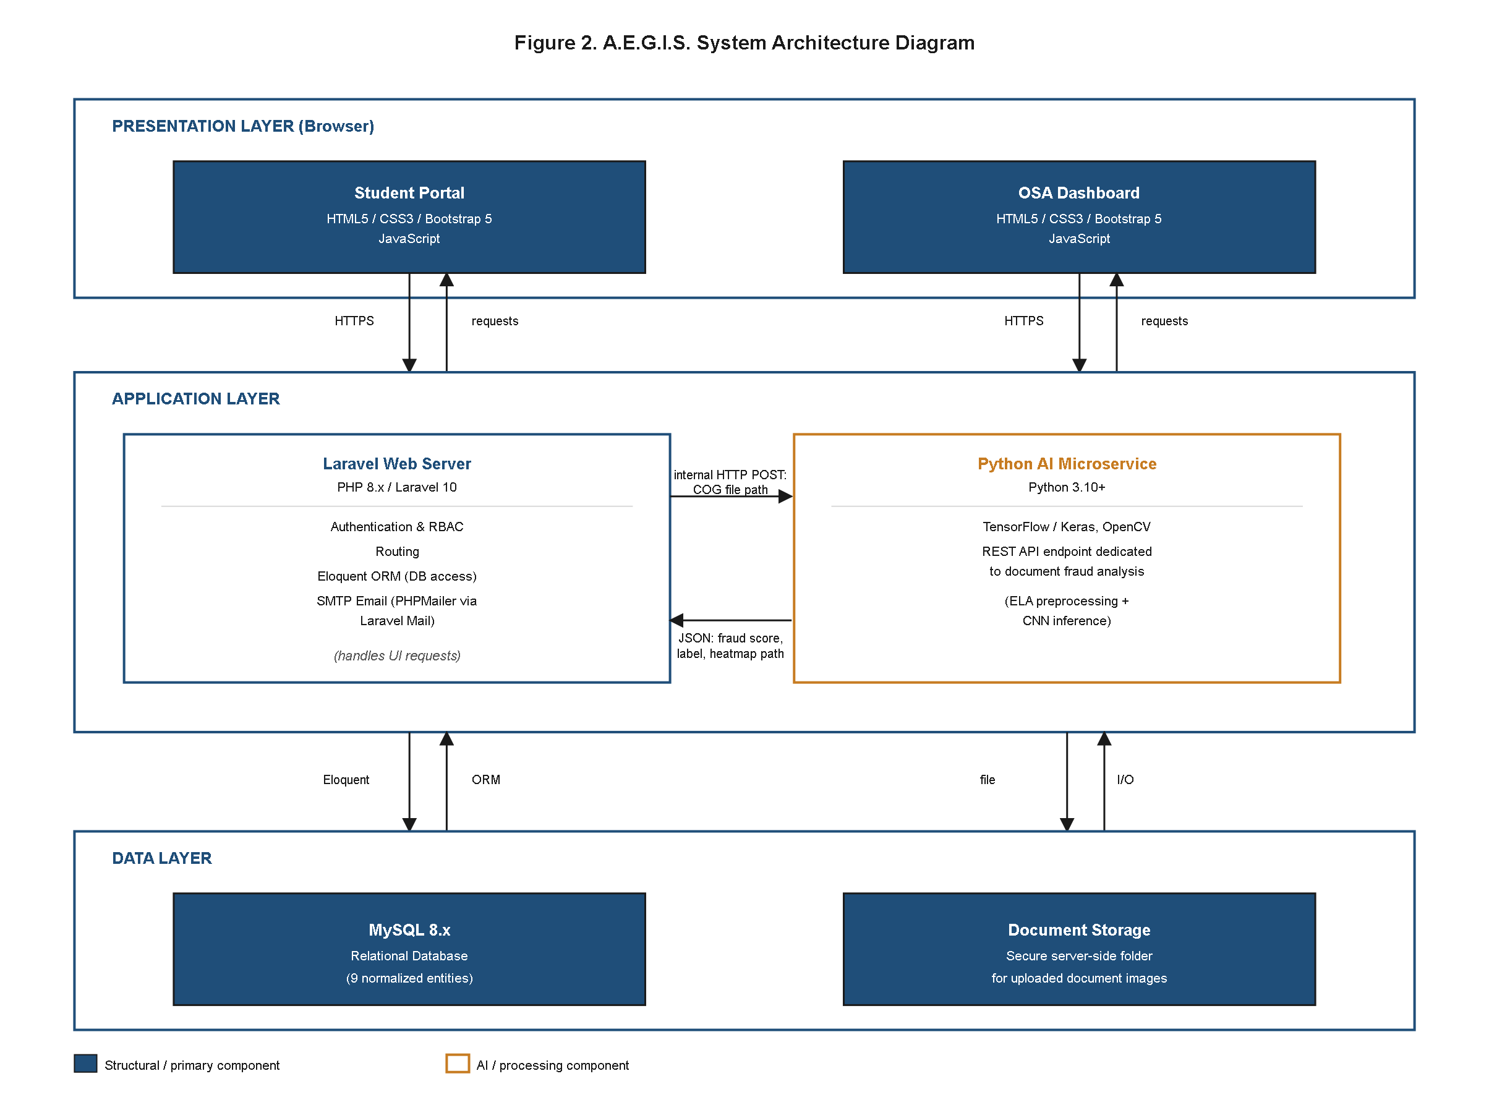
Figure 2. A.E.G.I.S. System Architecture Diagram.
Figure 2, reproduced here from Chapter III (Appendix B, Figure 2, p. 52) in a freshly rendered form, presents the realized three-tier architecture of A.E.G.I.S. corresponding directly to the System Architecture design specified at Design time. The figure is presented again in this chapter, under its original number, to confirm that the architecture it depicts was carried into the built system rather than remaining a planning diagram. The Presentation Layer, comprising the Student Portal and the OSA Dashboard, was implemented using HTML5, CSS3, Bootstrap 5, and JavaScript, rendered in the end user's web browser without requiring any local installation, consistent with the Web-Based System definition established in Chapter I. Both interfaces were built to be fully responsive, allowing the Student Portal in particular to be accessed from desktop and mobile browsers alike, in keeping with the Scope statement that no dedicated mobile application would be developed.
The Application Layer was realized as two independently deployable components communicating over an internal HTTP contract, exactly as specified in Chapter III. The first component, the PHP 8.x/Laravel 10 backend, handles user authentication (bcrypt-hashed credentials, email verification at registration), Role-Based Access Control middleware enforcement, Eloquent ORM-mediated database access to the nine MySQL entities, routing between the Student Portal and OSA Dashboard views, and outbound SMTP email dispatch via PHPMailer/Laravel Mail. The second component, the Python 3.10+ AI microservice, was implemented as a standalone REST API service built on TensorFlow/Keras and OpenCV, dedicated exclusively to document fraud analysis. The realized integration contract between these two components mirrors the one specified in Chapter III: when a student uploads a Certificate of Grades, the Laravel backend persists the file to secure server-side storage, then issues an internal HTTP POST request containing the stored file path to the Python microservice's inference endpoint. The microservice performs ELA preprocessing and ResNet-50 inference on the referenced image and returns a JSON payload containing the fraud probability score, the classification label (Authentic or Tampered), and the file path of the generated Grad-CAM heatmap. The Laravel backend then persists this payload to the AIAnalysisResults table and surfaces it to OSA staff through the administrator dashboard. This request/response contract was implemented without deviation from the design; the two application components remain independently deployable processes rather than a single monolithic codebase, consistent with Chapter III's characterization of the AI module as a discrete microservice rather than an in-process library.
The Data Layer was realized as a MySQL 8.x relational database implementing the nine-entity schema discussed in Section 4.3.3, together with a secure server-side file storage directory holding uploaded COG, Income Tax Return (ITR), and ID Card images as well as generated Grad-CAM heatmap overlays. Access to both the database and the file storage directory is mediated exclusively through the Laravel Application Layer; neither the Student Portal nor the OSA Dashboard, nor the Python microservice, was granted direct client-side access to the database, preserving the layered separation of concerns fixed in the Chapter III architecture diagram. Field-level encryption using AES-256 was applied to sensitive database columns, and all network transmission between the browser, the Laravel backend, and the Python microservice was carried over SSL/TLS, consistent with the security requirements of the software technology stack in Table 4.
The realization of the Application Layer as two separately deployable processes rather than a single Laravel application also proved consistent with the hardware feasibility conclusions reached in Table 3: the GPU-accelerated training workload required for the ResNet-50 classifier was isolated to the Python microservice's training environment and did not need to be provisioned on the production cloud server used to host the Laravel backend, since only inference — not training — occurs at runtime once the model is deployed. This separation allowed the production server to operate within the modest 2 vCPU/4 GB RAM/50 GB SSD specification identified in Table 3 without incurring the additional cost of a GPU-equipped production instance, confirming that the architectural decision to separate the AI microservice from the web backend was not merely a software-engineering convenience but a load-bearing element of the system's economic feasibility.
4.3.2 Use Case Analysis
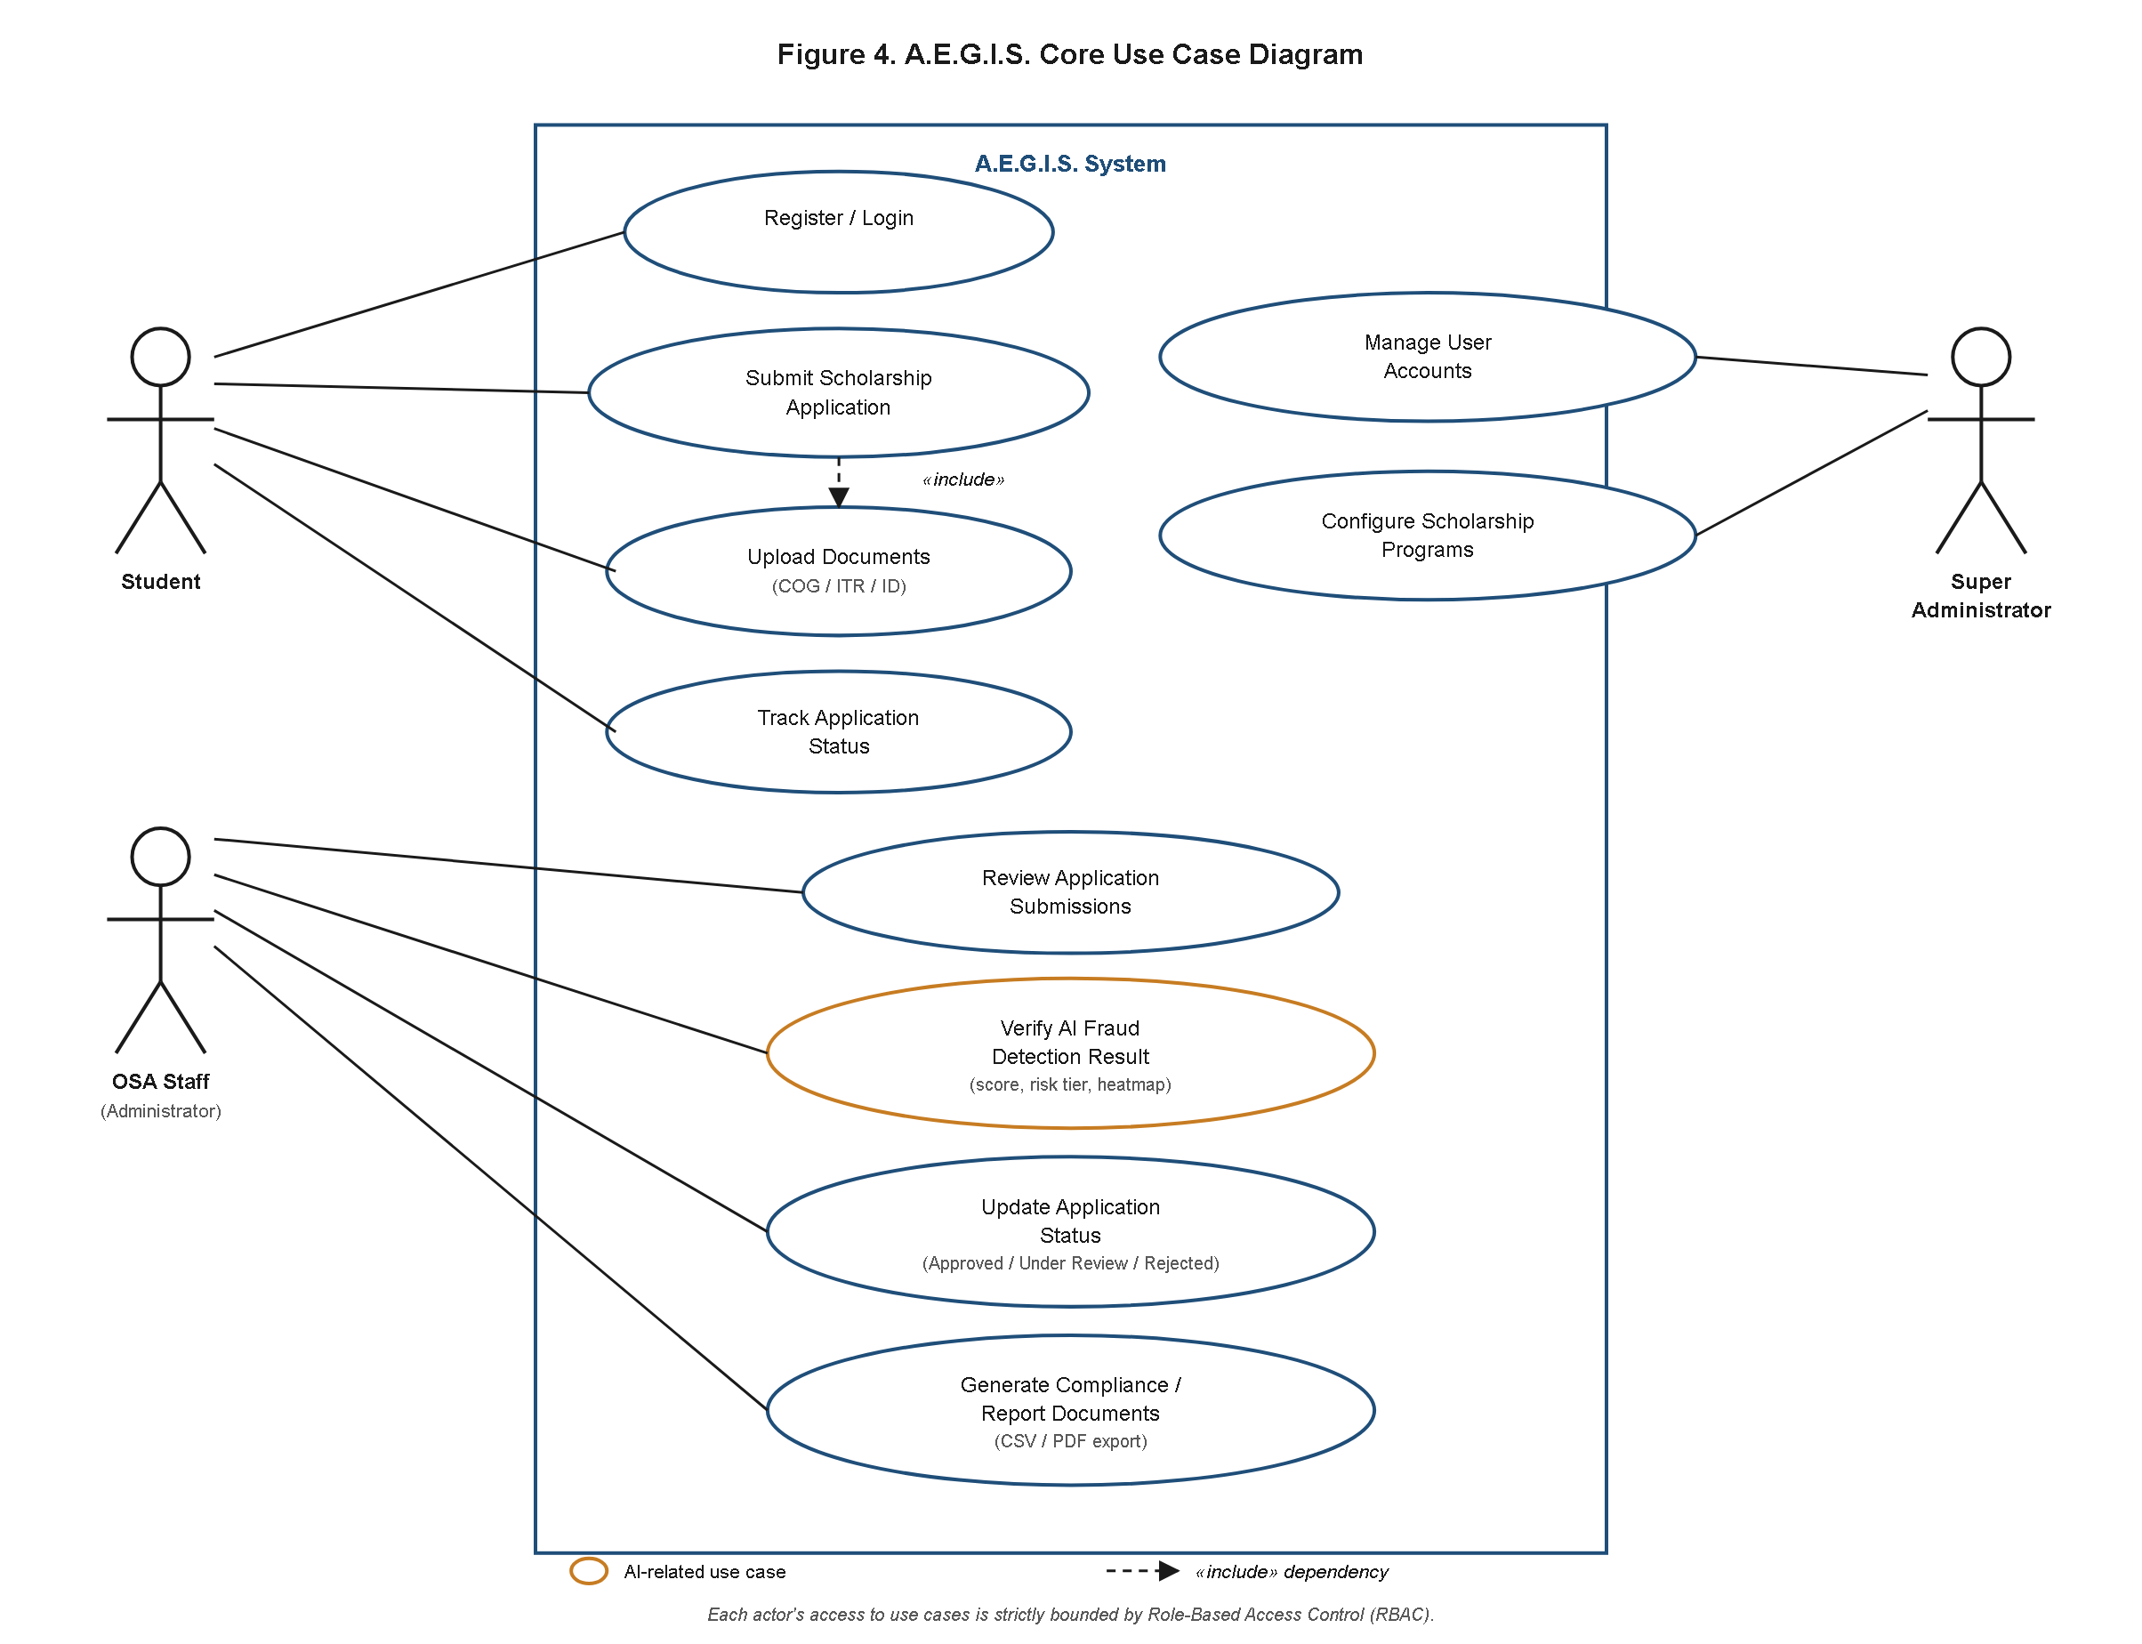
Figure 4. A.E.G.I.S. Core Use Case Diagram.
Figure 4, reproduced here from Chapter III (Appendix B, Figure 4, p. 54) under its original number, depicts the realized use case model for A.E.G.I.S., confirming that the actor and use-case boundaries fixed at Design time were carried into the implemented authorization logic without alteration. The implemented system enforces exactly the three actors fixed in the Scope: Student, OSA Staff, and Super Administrator. No fourth role or intermediate permission tier was introduced during development; every account created within the system is provisioned with exactly one of these three roles at registration, and that role determines the complete set of use cases available to the account holder for the remainder of its lifecycle.
The Student actor's realized use cases comprise account registration with email verification, secure login, completion and submission of a multi-step scholarship application, upload of supporting documents (COG, ITR, and ID Card, distinguished internally by the Documents table's document_type column), and real-time tracking of application status as recorded in the StatusLogs table. A student account's visibility is restricted to its own application records; the Student Portal issues no query capable of retrieving another applicant's data, and this restriction is enforced server-side by Laravel RBAC middleware rather than relying on client-side interface hiding alone.
The OSA Staff actor's realized use cases comprise reviewing the queue of submitted applications, opening the document evaluation screen to inspect both the uploaded COG image and the AI-generated fraud probability score, heatmap, and risk-tier indicator, recording a status decision (Pending, Under Review, Approved, or Rejected) together with optional remarks, and generating and exporting compliance reports in CSV or PDF format. OSA Staff accounts were implemented with read/write access to all student application records but no access to Super Administrator functions such as user account management or scholarship program configuration, matching the actor boundary fixed in Chapter III.
The Super Administrator actor's realized use cases comprise full system access, including creation, modification, and deactivation of user accounts across all three roles, and configuration of ScholarshipPrograms and AcademicTerms records (program eligibility criteria, funding source, minimum GWA thresholds, semester and school-year divisions). This actor's use cases were implemented as a strict superset of the OSA Staff use cases rather than a parallel or overlapping permission set, ensuring that no functional gap exists between the two administrative roles.
Consistent with Chapter III's statement that "each actor's capabilities are strictly bounded by their assigned RBAC role," the realized middleware layer rejects any request for a use case outside the requesting account's role, returning an authorization failure rather than a partial or filtered result. This confirms that the RBAC enforcement boundary specified at design time was carried through into the implemented authorization logic rather than being approximated at the interface level alone.
Two system-initiated use cases shown in Figure 4 — dispatch of the fraud analysis request to the AI microservice, and dispatch of the SMTP status-change notification — were realized as automatic behaviors of the Application Layer rather than as actions any human actor triggers directly. Neither the Student, the OSA Staff member, nor the Super Administrator invokes these use cases explicitly; they occur as a consequence of a document upload event and a status-change event respectively, matching the system-initiated framing given to them in the Chapter III use case narrative. This distinction between actor-initiated and system-initiated use cases was preserved through implementation and is reflected in Figure 4 by the absence of a direct association line between any human actor and these two use cases.
4.3.3 Database Design and Data Dictionary
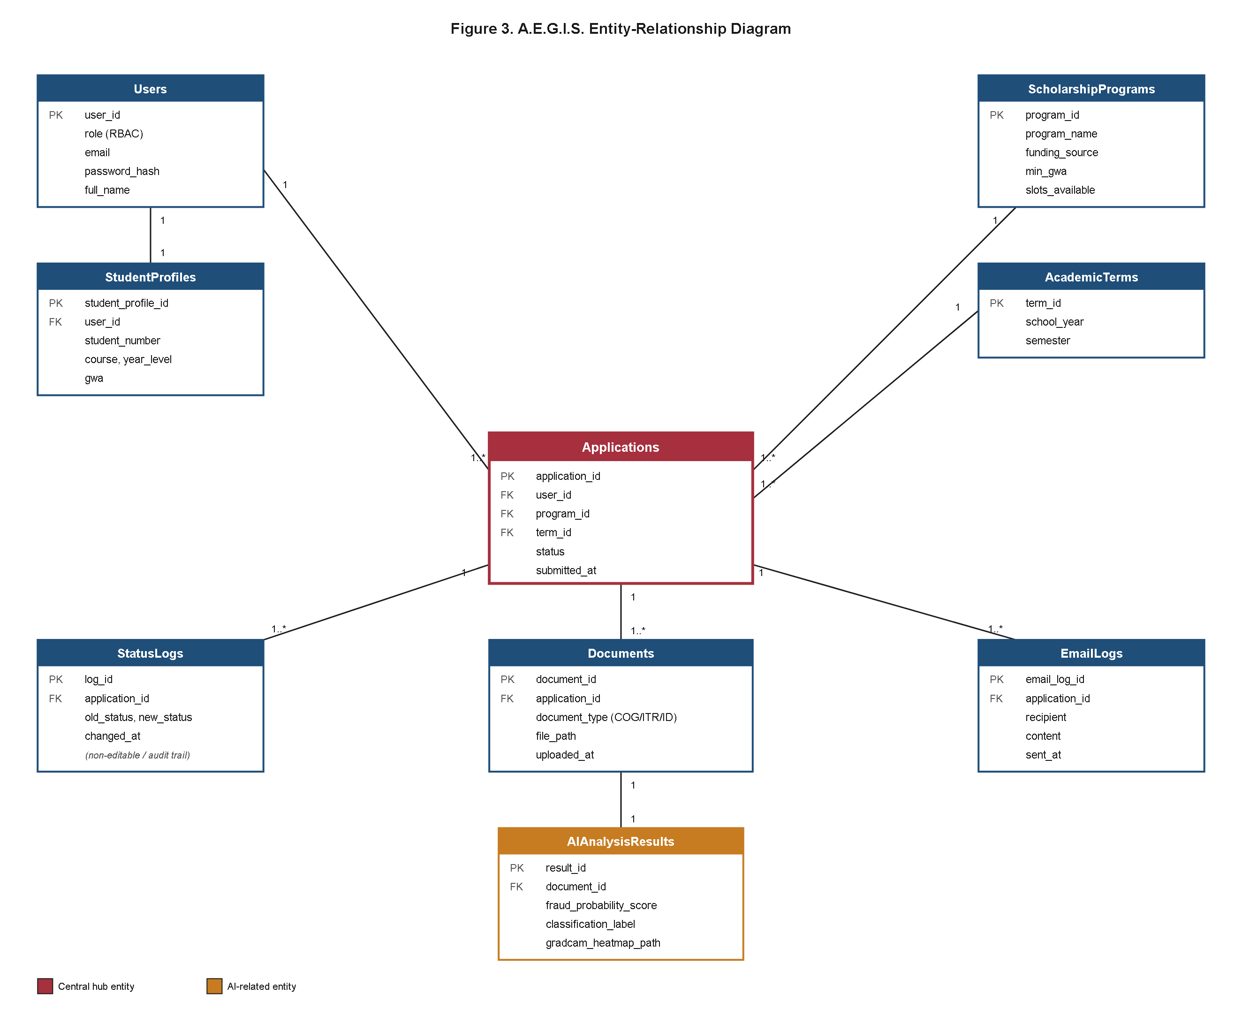
Figure 3. A.E.G.I.S. Entity-Relationship Diagram.
Figure 3, reproduced here from Chapter III (Appendix B, Figure 3, p. 53) under its original number, presents the realized entity-relationship diagram for A.E.G.I.S. at the attribute level, confirming that the nine-entity schema fixed at Design time was carried into the implemented MySQL database without modification. The physical foreign-key-linkage view of this same schema is presented separately as the Relational Schema Diagram in Section 4.3.8 (Figure 15). The implemented schema retains the exact nine normalized entities specified at design time — Users, StudentProfiles, ScholarshipPrograms, AcademicTerms, Applications, Documents, AIAnalysisResults, StatusLogs, and EmailLogs — with the Applications table continuing to function as the central hub linking every other transactional entity. The Users table maintains a one-to-one relationship with StudentProfiles and a one-to-many relationship with Applications, reflecting that a single student may submit multiple scholarship applications across different academic terms. Applications maintains many-to-one relationships to ScholarshipPrograms and AcademicTerms as reference lookups, and one-to-many relationships to Documents, AIAnalysisResults (indirectly, through Documents), StatusLogs, and EmailLogs, so that every document submission, AI fraud analysis result, status decision, and notification event can be traced back to the specific application that generated it.
Tables 23 through 31 below formalize this realized schema into a complete data dictionary, one table per entity, presented in the same order in which the entities were introduced in Chapter III's Database Design subsection. Column names, data types, and descriptions reflect the fields required to support the functionality already specified in Chapters I through III; no column introduces functionality beyond what was scoped at design time. These tables are numbered 23 through 31, continuing after Table 22 in Section 4.8, rather than reusing Tables 9 through 17, since Chapter III's own Appendix B already assigns Table 9 to the Tools Used in Software Development table.
Table 23
Users Table Data Dictionary
Column Name | Data Type | Description
id | bigint, unsigned, primary key | Unique system-generated identifier for the user account
name | varchar(150) | Full name of the account holder
email | varchar(150), unique | Email address used for login and SMTP notification delivery
email_verified_at | timestamp, nullable | Records the date and time the account holder verified their email during registration
password | varchar(255) | Bcrypt-hashed password credential
role | enum('student', 'osa_staff', 'super_admin') | RBAC role assigned to the account, determining accessible use cases
created_at | timestamp | Date and time the account was created
updated_at | timestamp | Date and time the account record was last modified

Note. The Users table serves as the authentication and RBAC anchor for all three actor types described in Section 4.3.2.
Table 24
StudentProfiles Table Data Dictionary
Column Name | Data Type | Description
id | bigint, unsigned, primary key | Unique system-generated identifier for the student profile record
user_id | bigint, unsigned, foreign key | References Users.id; establishes the one-to-one relationship between a Student account and its profile
student_number | varchar(30) | CLSU-issued student identification number
program | varchar(150) | Degree program in which the applicant is currently enrolled
year_level | tinyint, unsigned | Current year level of the applicant
gwa | decimal(3,2) | Most recently recorded General Weighted Average, used to check eligibility against ScholarshipPrograms.min_gwa
contact_number | varchar(20) | Applicant's contact number for OSA follow-up
address | text | Applicant's residential address
created_at | timestamp | Date and time the profile record was created

Note. One StudentProfiles record exists per Student account, storing the demographic and academic-record fields referenced in Chapter III.
Table 25
ScholarshipPrograms Table Data Dictionary
Column Name | Data Type | Description
id | bigint, unsigned, primary key | Unique system-generated identifier for the scholarship program
program_name | varchar(150) | Name of the scholarship program (e.g., Tertiary Education Subsidy, DOST-SEI)
funding_source | varchar(150) | Government or institutional body funding the program (e.g., CHED, DOST-SEI)
min_gwa | decimal(3,2) | Minimum General Weighted Average required for eligibility
description | text | Narrative description of program eligibility requirements and coverage
is_active | boolean | Indicates whether the program is currently accepting applications
created_at | timestamp | Date and time the program record was created

Note. Maintained exclusively by the Super Administrator role, consistent with the scholarship program configuration use case in Section 4.3.2.
Table 26
AcademicTerms Table Data Dictionary
Column Name | Data Type | Description
id | bigint, unsigned, primary key | Unique system-generated identifier for the academic term
semester | enum('1st Semester', '2nd Semester', 'Summer') | Semester division within the school year
school_year | varchar(9) | School year covered by the term (e.g., 2025-2026)
created_at | timestamp | Date and time the term record was created

Note. Enables filtered, historical reporting of applications by academic period, as required by the Reporting Module (Work Item 5).
Table 27
Applications Table Data Dictionary
Column Name | Data Type | Description
id | bigint, unsigned, primary key | Unique system-generated identifier for the application record
user_id | bigint, unsigned, foreign key | References Users.id; identifies the student applicant
scholarship_program_id | bigint, unsigned, foreign key | References ScholarshipPrograms.id; identifies the program applied for
academic_term_id | bigint, unsigned, foreign key | References AcademicTerms.id; identifies the term of application
status | enum('Pending', 'Under Review', 'Approved', 'Rejected') | Current decision status of the application
remarks | text, nullable | Optional remarks entered by OSA Staff accompanying the current status
submitted_at | timestamp | Date and time the student submitted the application
updated_at | timestamp | Date and time the application record was last modified

Note. Applications functions as the central hub entity, linking to Documents, AIAnalysisResults (via Documents), StatusLogs, and EmailLogs.
Table 28
Documents Table Data Dictionary
Column Name | Data Type | Description
id | bigint, unsigned, primary key | Unique system-generated identifier for the document record
application_id | bigint, unsigned, foreign key | References Applications.id; identifies the application the document was submitted for
document_type | enum('COG', 'ITR', 'ID Card') | Distinguishes the requirement document type without requiring schema changes for future document types
file_path | varchar(255) | Server-side storage path of the uploaded, UUID-renamed document image
original_filename | varchar(255) | Original filename supplied by the uploader, retained for reference
uploaded_at | timestamp | Date and time the document was uploaded

Note. Only COG documents are routed to the AI microservice for fraud analysis; ITR and ID Card documents are stored for OSA manual verification.
Table 29
AIAnalysisResults Table Data Dictionary
Column Name | Data Type | Description
id | bigint, unsigned, primary key | Unique system-generated identifier for the AI analysis result
document_id | bigint, unsigned, foreign key | References Documents.id; identifies the COG document analyzed
fraud_probability_score | tinyint, unsigned (0-100) | Fraud Probability Score computed by rounding the ResNet-50 output probability to a 0-100 scale
classification_label | enum('Authentic', 'Tampered') | Binary classification label determined by the p < 0.50 threshold
heatmap_path | varchar(255) | Server-side storage path of the generated Grad-CAM heatmap overlay
analyzed_at | timestamp | Date and time the AI microservice completed the analysis

Note. Populated directly from the JSON response returned by the Python AI microservice described in Section 4.3.1.
Table 30
StatusLogs Table Data Dictionary
Column Name | Data Type | Description
id | bigint, unsigned, primary key | Unique system-generated identifier for the status log entry
application_id | bigint, unsigned, foreign key | References Applications.id; identifies the application whose status changed
status | enum('Pending', 'Under Review', 'Approved', 'Rejected') | Status value recorded at the time of the change
remarks | text, nullable | Optional remarks entered by the OSA Staff member recording the change
changed_by | bigint, unsigned, foreign key | References Users.id; identifies the OSA Staff or Super Administrator account that made the change
changed_at | timestamp | Date and time the status change was recorded

Note. Rows in StatusLogs are immutable once written, forming the audit trail referenced in Chapter III's OSA Staff Review and Notification Workflow.
Table 31
EmailLogs Table Data Dictionary
Column Name | Data Type | Description
id | bigint, unsigned, primary key | Unique system-generated identifier for the email log entry
application_id | bigint, unsigned, foreign key | References Applications.id; identifies the application the notification concerns
recipient | varchar(150) | Email address the notification was sent to
subject | varchar(255) | Subject line of the dispatched email
sent_at | timestamp | Date and time the email was sent via SMTP

Note. Every automated status-change notification dispatched through PHPMailer/Laravel Mail is recorded here, supporting both debugging and compliance reporting.
Taken together, Tables 23 through 31 constitute the realized data dictionary corresponding to the Database Design subsection of Chapter III. No entity, column, or relationship beyond those described above was required to support the five system features named in the Scope or the five Work Items described in Chapter III's Development section, confirming that the nine-entity schema fixed at design time was sufficient, without extension, for the completed implementation.
4.3.4 Data Flow Diagram
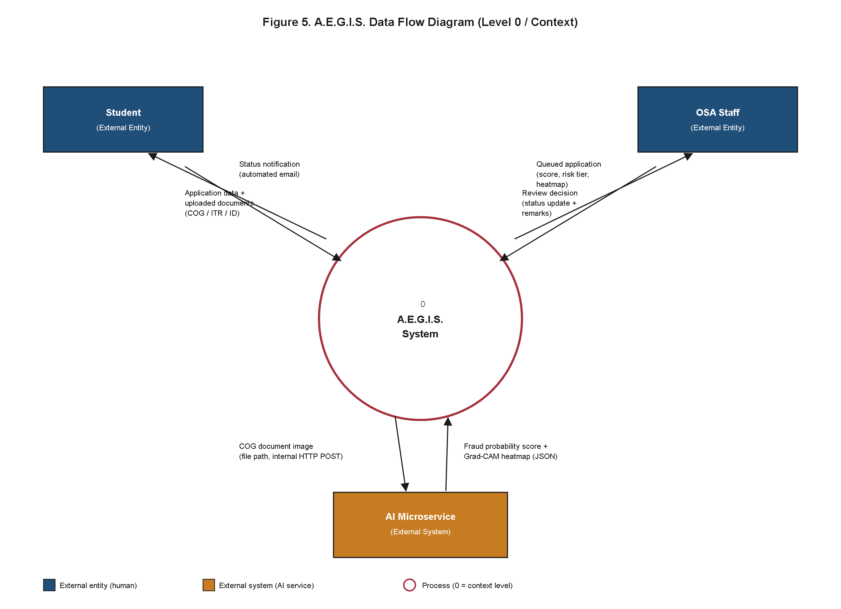
Figure 5. A.E.G.I.S. Data Flow Diagram (Level 0/Context).
Figure 5, reproduced here from Chapter III (Appendix B, Figure 5, p. 55) under its original number, presents the realized Level 0 data flow diagram for A.E.G.I.S., confirming that the sequential ordering of data transformations fixed at Design time was preserved in the implemented system. The implemented data flow follows the three-actor structure fixed at design time: Student, OSA Staff, and the A.E.G.I.S. system itself as the central process. The student-initiated flow begins when a student submits an application and uploads its supporting documents; the Laravel backend persists the application and document records to the Applications and Documents tables respectively, and, for COG documents specifically, forwards the stored file path to the Python AI microservice. The AI microservice returns its fraud analysis result — fraud probability score, classification label, and heatmap path — which the backend persists to AIAnalysisResults and makes available to the OSA Staff-facing data flow.
OSA Staff retrieve the queued application, its documents, and its AI analysis result through the administrator dashboard, and, upon reaching a decision, write a new status value to the Applications table and a corresponding immutable entry to StatusLogs. This status write operation was implemented to trigger a downstream email-dispatch process automatically: the system composes and sends an SMTP notification to the student, and records the transaction to EmailLogs. This confirms the sequential process ordering specified in Chapter III — document submission and storage, AI analysis, OSA review and decision, and notification dispatch — was preserved in the implemented system, with each transformation of data (from submitted file, to stored document, to AI result, to status decision, to dispatched notification) traceable through a specific database write, allowing the complete lifecycle of any single application to be reconstructed from the StatusLogs and EmailLogs tables described in Section 4.3.3.
4.3.5 System Flowchart
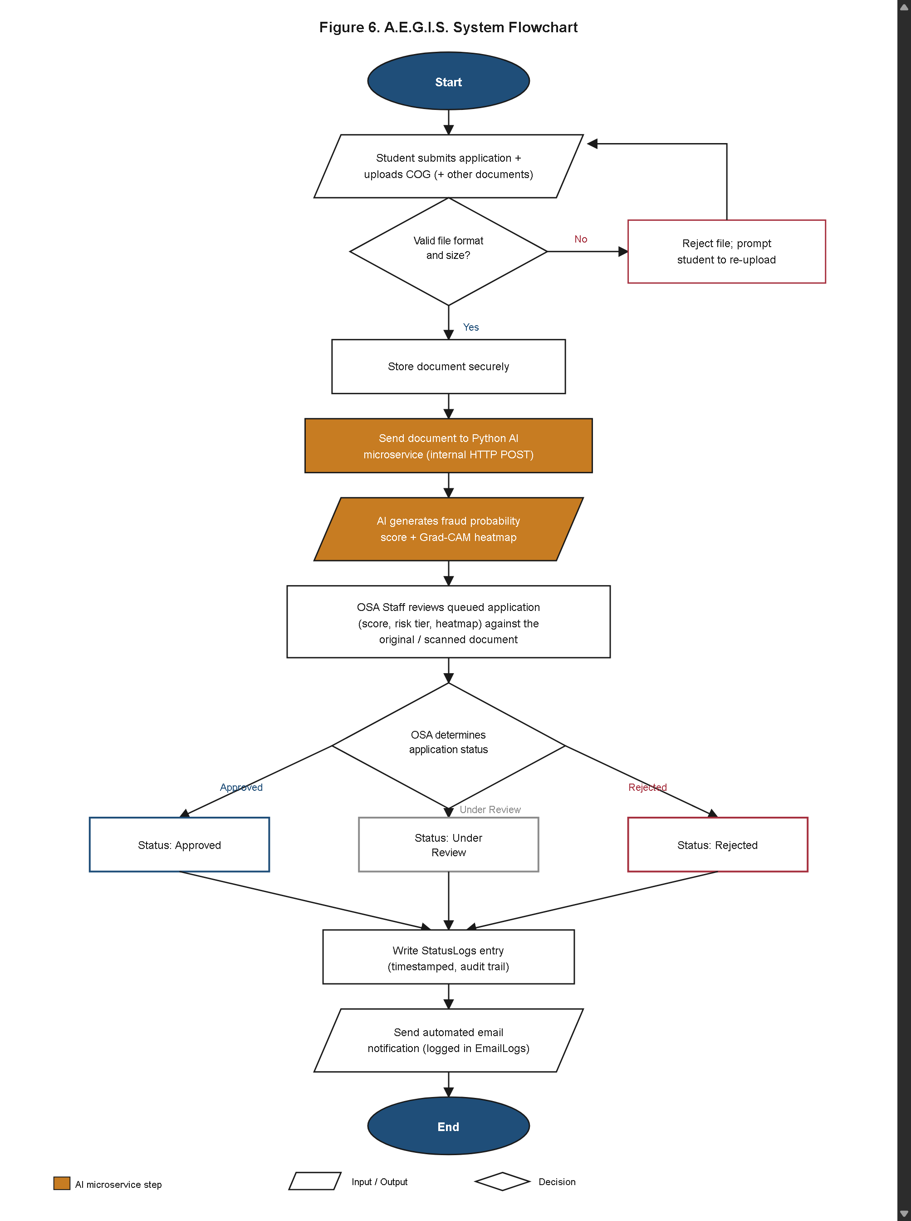
Figure 6. A.E.G.I.S. System Flowchart.
Figure 6, reproduced here from Chapter III (Appendix B, Figure 6, p. 56) under its original number, presents the realized end-to-end system flowchart, confirming that the complete procedure from application submission to OSA decision was implemented exactly as sequenced at Design time. Section 4.3.10 below decomposes this end-to-end flow further into the internal logic of each individual user-facing action. The implemented flow begins when a student submits a scholarship application and uploads a Certificate of Grades. The Laravel backend validates the uploaded file's format (JPEG or PNG only, per the Scope and Limitations of Chapter I) and size (a 10 MB cap enforced during Work Item 2) before securely storing the file under a UUID-renamed path, preventing any client-supplied filename from being written directly to the server file system. The Documents record is created, and, because the uploaded file is a COG, its stored path is forwarded to the AI microservice.
The AI microservice performs the ELA-CNN pipeline detailed in Section 4.3.7 and returns a fraud probability score together with a Grad-CAM heatmap overlay, which the backend persists to AIAnalysisResults. The flow then proceeds to the OSA Staff review stage: the flagged application appears in the administrator dashboard queue, color-coded according to the three risk tiers fixed in Chapter III — 0-39 Low Risk (green), 40-69 Moderate Risk (yellow), and 70-100 High Risk (red) — allowing OSA Staff to prioritize review attention toward higher-risk submissions without requiring any statistical training to interpret the indicator. The OSA Staff member examines both the AI-flagged result and the original COG image before recording an independent decision (Pending, Under Review, Approved, or Rejected), and the system writes this decision to StatusLogs and dispatches an SMTP email notification to the applicant, recording the transaction to EmailLogs. This realized flow confirms that every application proceeds through an AI-assisted document review step before a final OSA decision is recorded, exactly as specified in Chapter III, and that the AI output functions strictly as a decision-support signal — expressed through the three color-coded risk tiers — rather than as an automatic approval or rejection mechanism, consistent with the Document Verification as Decision-Support Only limitation established in Chapter I.
4.3.6 User Interface Design Realization
The realized user interface conforms to the User Interface Design plan specified in Chapter III and illustrated in the wireframes of Appendix C. On the student-facing side, the multi-step application form guides applicants sequentially through personal information entry, scholarship program selection, and document upload, mirroring the wireframe sequence approved during the Design phase; no additional step or field was introduced into this flow during implementation, and no planned step was removed. The student dashboard was implemented to retrieve and display the applicant's current status directly from the StatusLogs table in real time, so that a status change recorded by OSA Staff becomes visible to the applicant without requiring a page reload delay beyond ordinary request-response latency.
On the OSA-facing side, the document evaluation screen was implemented to present, in a single consolidated view, the uploaded COG image, the numeric fraud probability score, a color-coded risk-tier badge (green/yellow/red corresponding to the 0-39/40-69/70-100 ranges), and the Grad-CAM heatmap overlay highlighting the specific image regions that most influenced the AI classification. This consolidated layout matches the design intent described in Chapter III, under which OSA reviewers are expected to reach a risk-level judgment without needing machine-learning expertise; the realized screen requires no interpretation step beyond reading the color of the risk badge and, where the badge indicates High Risk, visually cross-referencing the heatmap against the corresponding region of the COG image. The administrator dashboard's application queue view was implemented with the same color-coded risk indicator surfaced at the list level, so that OSA Staff can visually triage the queue toward higher-risk submissions before opening the full evaluation screen for any individual application. Across both the student-facing and OSA-facing interfaces, the implemented screens correspond directly to the wireframes catalogued in Appendix C, confirming that the interface design fixed during Chapter III's Design phase was carried into the built system without material deviation. The specific wireframe figures corresponding to each of these realized screens, together with confirmation that each realized module matches its wireframe's design intent, are catalogued individually in Section 4.3.12.
4.3.7 ELA-CNN Fraud Detection Pipeline Realization
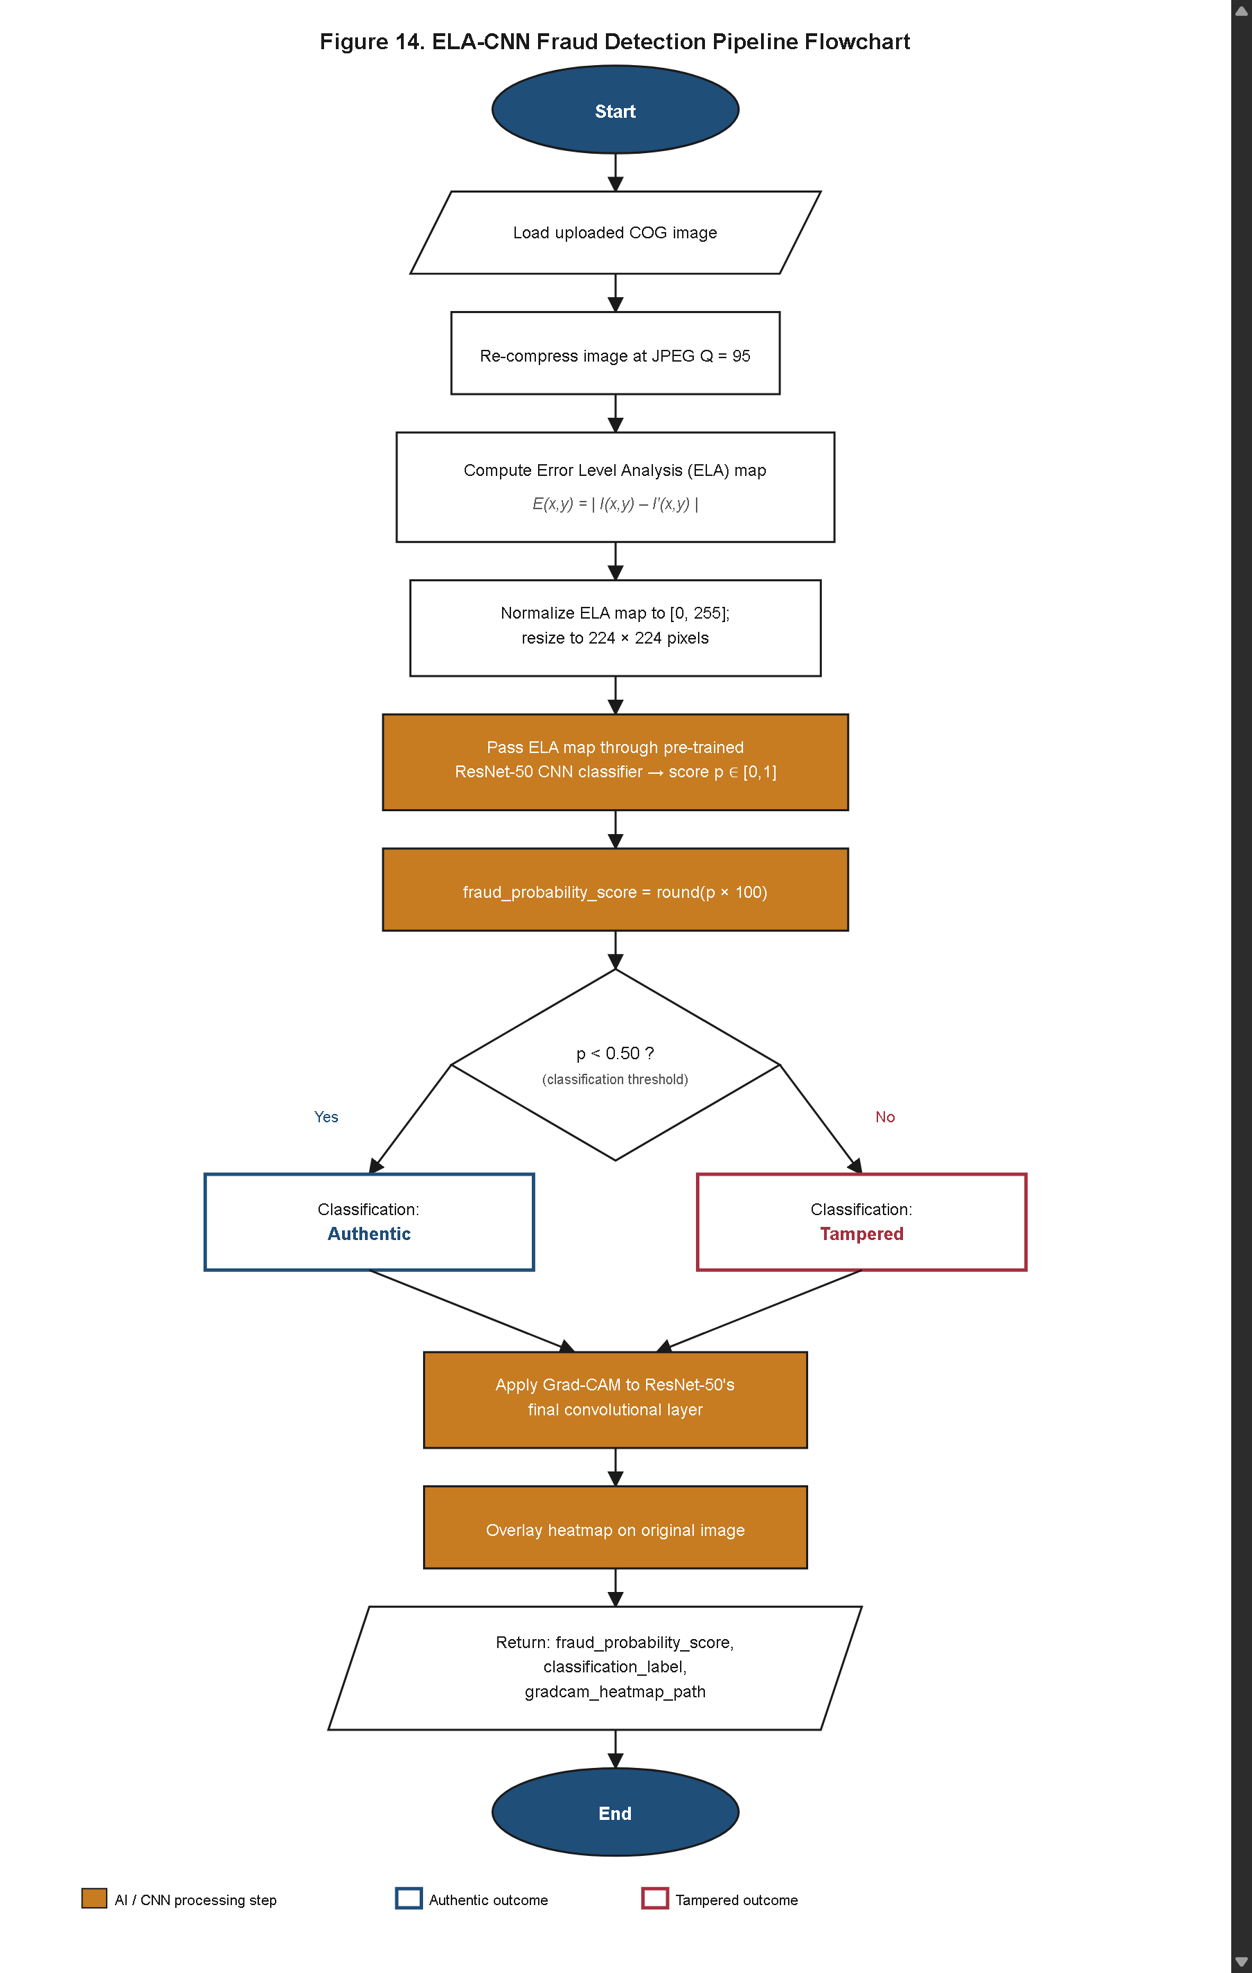
Figure 14. ELA-CNN Fraud Detection Pipeline Flowchart.
Unlike the five diagrams reproduced in Sections 4.3.1 through 4.3.5, Figure 14 is a genuinely new diagram: Chapter III's Methodology specified the ELA-CNN pipeline only as numbered pseudocode, without an accompanying flowchart rendering. Figure 14 presents the realized ELA-CNN Fraud Detection Pipeline as an equivalent flowchart, corresponding precisely to that Algorithms and Techniques pseudocode. The implemented Python AI microservice executes the same two-stage design fixed at design time — Error Level Analysis preprocessing followed by ResNet-50 classification — without substituting an alternative preprocessing technique or a different base architecture.
The realized pipeline begins by loading the uploaded COG image from secure server-side storage, matching step 1 of the specified pseudocode. The image is then re-compressed at a fixed JPEG quality setting of Q = 95, matching step 2, producing a compressed counterpart against which the original is compared. The pipeline computes the Error Level Analysis map by taking the pixel-wise absolute difference between the original and re-compressed images, implementing the formula fixed in Chapter III, E(x, y) = |I(x, y) − I'(x, y)|, where (x, y) denotes each pixel coordinate (steps 3–4); this map is normalized to the [0, 255] range so that regions of inconsistent recompression behavior — indicative of prior editing, such as grade-field replacement, GWA alteration, or clone-stamping over a seal or signature — appear visually distinct from untouched regions, which exhibit a comparatively uniform error response.
The normalized ELA map is then resized to 224×224 pixels to conform to the ResNet-50 input specification (step 5) and passed through the pre-trained ResNet-50 classifier, which was trained on the CASIA v2.0 benchmark dataset supplemented with the CLSU-specific COG dummy dataset described in Chapter III's Data Collection and Processing section. The classifier produces a continuous output p ∈ [0, 1] representing the estimated probability that the submitted document has been tampered with (step 6). This raw probability is converted into the Fraud Probability Score by rounding p × 100 to the nearest whole number, yielding a score on the same 0–100 scale used to define the three risk tiers presented in Section 4.3.5 (step 7). The realized classification decision applies the exact threshold fixed in Chapter III: documents with p < 0.50 are labeled Authentic, and all others are labeled Tampered (step 8), with no adjustment to this decision boundary made during implementation or testing.
Finally, the pipeline applies Grad-CAM to the final convolutional layer of the ResNet-50 model to generate a class activation heatmap (step 9), overlays this heatmap on the original uploaded image (step 10), saves the resulting overlay to server-side storage (step 11), and returns the fraud probability score, classification label, and heatmap file path to the calling Laravel backend as a single JSON response (step 12). This realized output structure matches exactly the OUTPUT specification of the Chapter III pseudocode — fraud_probability_score (0–100), classification_label, and gradcam_heatmap_path — confirming that no field was added to or dropped from the AI microservice's response contract during implementation. The consistency between the twelve-step pseudocode specified in Chapter III and the pipeline realized in Figure 14 indicates that the ELA-CNN fraud detection module was implemented as designed, with the Fraud Probability Score, classification label, and Grad-CAM heatmap together forming the decision-support artifact surfaced to OSA Staff on the document evaluation screen described in Section 4.3.6.
4.3.8 Relational Schema Realization
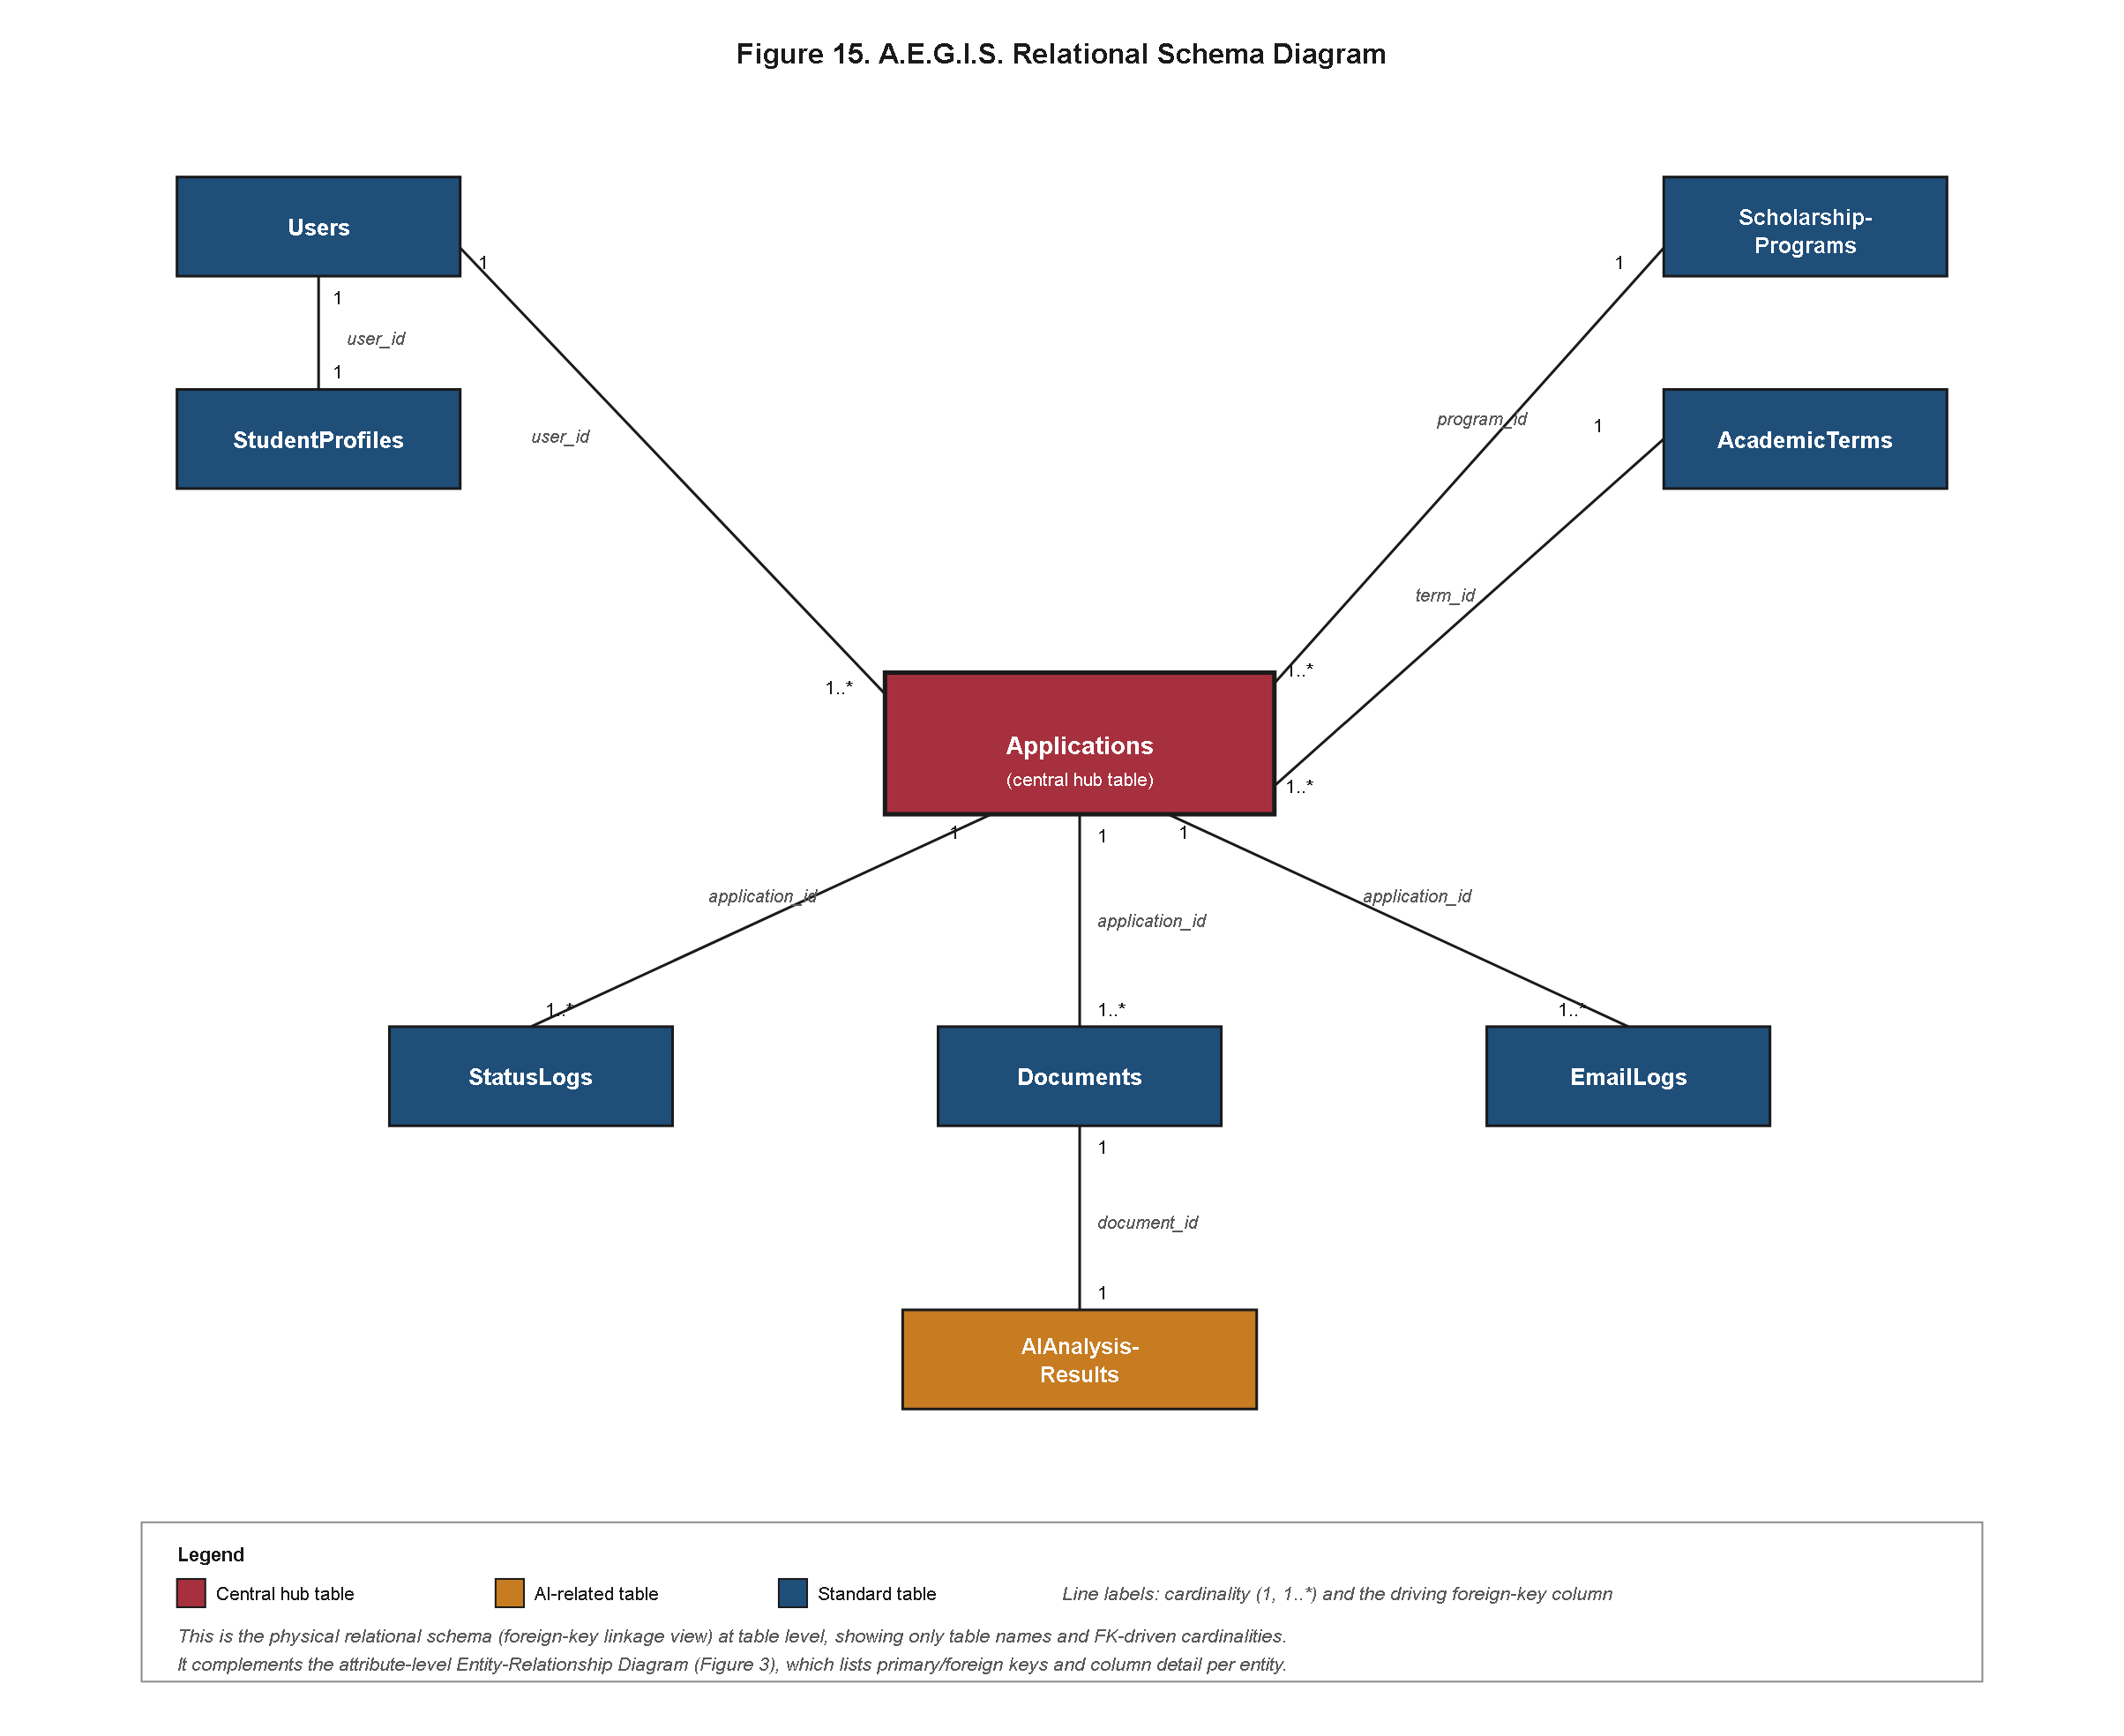
Figure 15. A.E.G.I.S. Relational Schema Diagram.
Figure 15 presents the realized relational schema diagram for A.E.G.I.S., a physical, foreign-key-linkage view of the same nine-entity database formalized at the attribute level in the entity-relationship diagram of Figure 3 and in the data dictionary of Tables 23 through 31. Where Figure 3 documents each entity's attributes, data types, and cardinality in the abstract terms used during Design, Figure 15 documents the concrete primary-key/foreign-key columns that MySQL 8.x enforces at the storage layer, and is presented here as a complement to, rather than a replacement for, the ERD.
Five foreign-key linkages anchor the schema shown in Figure 15. The first, user_id, appears as a foreign key on both StudentProfiles and Applications, each referencing Users.id: the StudentProfiles occurrence enforces the one-to-one relationship between a Student account and its demographic profile, while the Applications occurrence enforces the one-to-many relationship permitting a single student to submit multiple applications across different academic terms; a further user_id-pattern foreign key, changed_by on StatusLogs, references Users.id to identify the OSA Staff or Super Administrator account responsible for each recorded status decision. The second, program_id (realized as Applications.scholarship_program_id), references ScholarshipPrograms.id, tying every application to exactly one scholarship program and allowing eligibility fields such as min_gwa to be looked up without duplicating program data into every application record. The third, term_id (realized as Applications.academic_term_id), references AcademicTerms.id, tying every application to a single semester/school-year division and enabling the term-filtered reporting delivered in Work Item 5. The fourth, application_id, appears as a foreign key on three dependent tables — Documents, StatusLogs, and EmailLogs — each referencing Applications.id, so that every uploaded file, every audit-trail status entry, and every dispatched notification can be traced back to the specific application that generated it. The fifth, document_id (realized as AIAnalysisResults.document_id), references Documents.id, linking each AI fraud-analysis result to the specific COG image that was analyzed rather than to the application as a whole, which correctly accommodates the case in which a single application carries multiple documents (COG, ITR, ID Card) but only the COG is routed to the AI microservice.
Because every one of these five linkages was declared as an enforced foreign-key constraint at the database level rather than as an application-level convention alone, MySQL rejects any write that would leave a dependent row referencing a nonexistent parent — for example, a Documents row referencing an Applications.id that does not exist, or an AIAnalysisResults row referencing a Documents.id that does not exist — closing off a class of data-integrity defects that would otherwise have to be caught in Laravel application code. This constraint-level enforcement, visible in Figure 15 but not in the attribute-level view of Figure 3, is what allows the complete lifecycle of any single application — from submission, through document upload and AI analysis, to status decision and notification — to be reconstructed deterministically from the database alone, as described for the Data Flow Diagram in Section 4.3.4. No foreign-key relationship shown in Figure 15 was added, removed, or altered during implementation relative to the nine-entity schema fixed at Design time in Chapter III.
4.3.9 Expanded Discussion of Laravel Framework Utilization
Chapter III's Software Technology Stack (Table 4) named PHP 8.x with Laravel 10 as the back-end framework but did not elaborate on which specific Laravel features the realized system relies upon beyond routing, Eloquent ORM access, SMTP integration, and RBAC middleware enforcement, each named only briefly. Because Laravel's feature set materially shaped how each of the five Work Items in Section 4.4 was actually built, this subsection expands on that brief mention to document how the realized A.E.G.I.S. backend uses the framework, without introducing any version, dependency, or architectural pattern beyond the Laravel 10/PHP 8.x/MySQL 8.x stack already fixed in Table 4.
The realized backend follows Laravel's conventional Model-View-Controller architecture throughout. Incoming HTTP requests — whether a student submitting an application, an OSA Staff member recording a status decision, or a Super Administrator configuring a scholarship program — are first matched against route definitions in Laravel's routing layer, which map each URL and HTTP verb combination to a specific controller action. This routing layer is the concrete mechanism by which the actor-bounded use cases depicted in Figure 4 are exposed to end users: every use case attributed to the Student, OSA Staff, or Super Administrator actor in Section 4.3.2 corresponds to one or more named routes, grouped and protected by RBAC middleware so that a route belonging to an OSA Staff use case is unreachable by an authenticated Student session. Controllers receive the routed request, invoke the appropriate Eloquent model operations, and return either a rendered Blade view (for browser-facing pages) or a JSON payload (for the AJAX-driven interactions used by the real-time status tracker described in Section 4.3.6). This routes-to-controllers-to-views pipeline was applied uniformly across all five Work Items rather than being confined to only some modules, so that the Student Portal, the OSA Dashboard, and the Super Administrator's configuration screens share a single, consistent request-handling architecture.
Data access to the nine entities documented in the data dictionary (Tables 23 through 31) is mediated exclusively through Laravel's Eloquent ORM rather than through raw SQL statements written by hand. Each of the nine tables — Users, StudentProfiles, ScholarshipPrograms, AcademicTerms, Applications, Documents, AIAnalysisResults, StatusLogs, and EmailLogs — is backed by a corresponding Eloquent model class, and the foreign-key relationships formalized in the relational schema of Figure 15 are declared as Eloquent relationship methods (hasOne, hasMany, belongsTo) on these models. This allows, for example, a single Applications model instance to eagerly load its associated Documents, AIAnalysisResults, StatusLogs, and EmailLogs records through expressive relationship calls rather than through manually joined queries, which reduced the surface area for query-construction errors during the development of the administrator dashboard's document evaluation screen. Eloquent's built-in mass-assignment protection and attribute casting were also used to enforce that fields such as Applications.status only ever accept one of the four enumerated values (Pending, Under Review, Approved, Rejected) at the application layer, complementing the equivalent enum constraint enforced at the MySQL column level.
Authentication and authorization were built on Laravel's native authentication scaffolding rather than a custom-built or third-party identity solution. Laravel's included hashing services store every user password as a bcrypt hash, as reported in Section 4.4's Work Item 1 discussion, and the framework's session and guard configuration governs login state for all three actor roles. Role-Based Access Control was layered on top of this scaffolding as custom middleware, registered in Laravel's middleware pipeline and attached to route groups corresponding to each actor's permitted use cases; a request that reaches a protected route without the required role is intercepted by this middleware before it reaches the controller, and is rejected with an authorization failure rather than being allowed to execute and merely returning a filtered result, consistent with the enforcement behavior already described in Section 4.3.2.
Blade, Laravel's server-side templating engine, was used to render every browser-facing screen in both the Student Portal and the OSA Dashboard, including the multi-step application form, the real-time status tracker, the administrator queue view, and the document evaluation screen. Blade's template-inheritance and component features allowed shared layout elements — navigation, role-aware menu items, and the color-coded risk-tier badge used across multiple OSA-facing screens — to be defined once and reused across views, so that the visual and behavioral consistency confirmed in Section 4.3.6 was a direct consequence of the templating structure rather than a matter of manually keeping duplicated markup in sync. The two Blade-templated HTML email notifications described in Work Item 4 (Section 4.4) were likewise authored as Blade views, populated at send time with the applicant's name, the relevant scholarship program, and the application's reference number, and dispatched through Laravel Mail's SMTP driver, which supplies the PHPMailer-based transport named in Table 4 without requiring a separate mail library to be integrated by hand.
Finally, the versioned database schema underlying Figures 3 and 15 was implemented through Laravel's migration system rather than through a manually maintained SQL script. Each of the nine entities, together with its columns, indexes, and foreign-key constraints, is defined in a dedicated migration file that can be executed to reconstruct the schema deterministically on any environment, and the sequential ordering of these migration files reflects the dependency ordering visible in Figure 15 — reference tables such as ScholarshipPrograms and AcademicTerms are migrated before the Applications table that depends on them, which in turn is migrated before the Documents, AIAnalysisResults, StatusLogs, and EmailLogs tables that depend on it. This migration-based approach also provided the mechanism by which the database schema could be reproduced identically across the development, testing, and eventual production environments referenced in Section 4.7, without relying on a manually exported database dump.
4.3.10 Per-Action Process Flowcharts
While Figure 6 presents the end-to-end system flowchart spanning the complete lifecycle of a scholarship application, that diagram necessarily abstracts away the internal decision logic executed within each individual user-facing action. The four flowcharts presented in this subsection decompose that end-to-end flow into the specific steps realized for the registration, login, application-submission, and document-upload actions, each of which was implemented as a discrete, independently testable unit of the Laravel application described in Section 4.3.9.
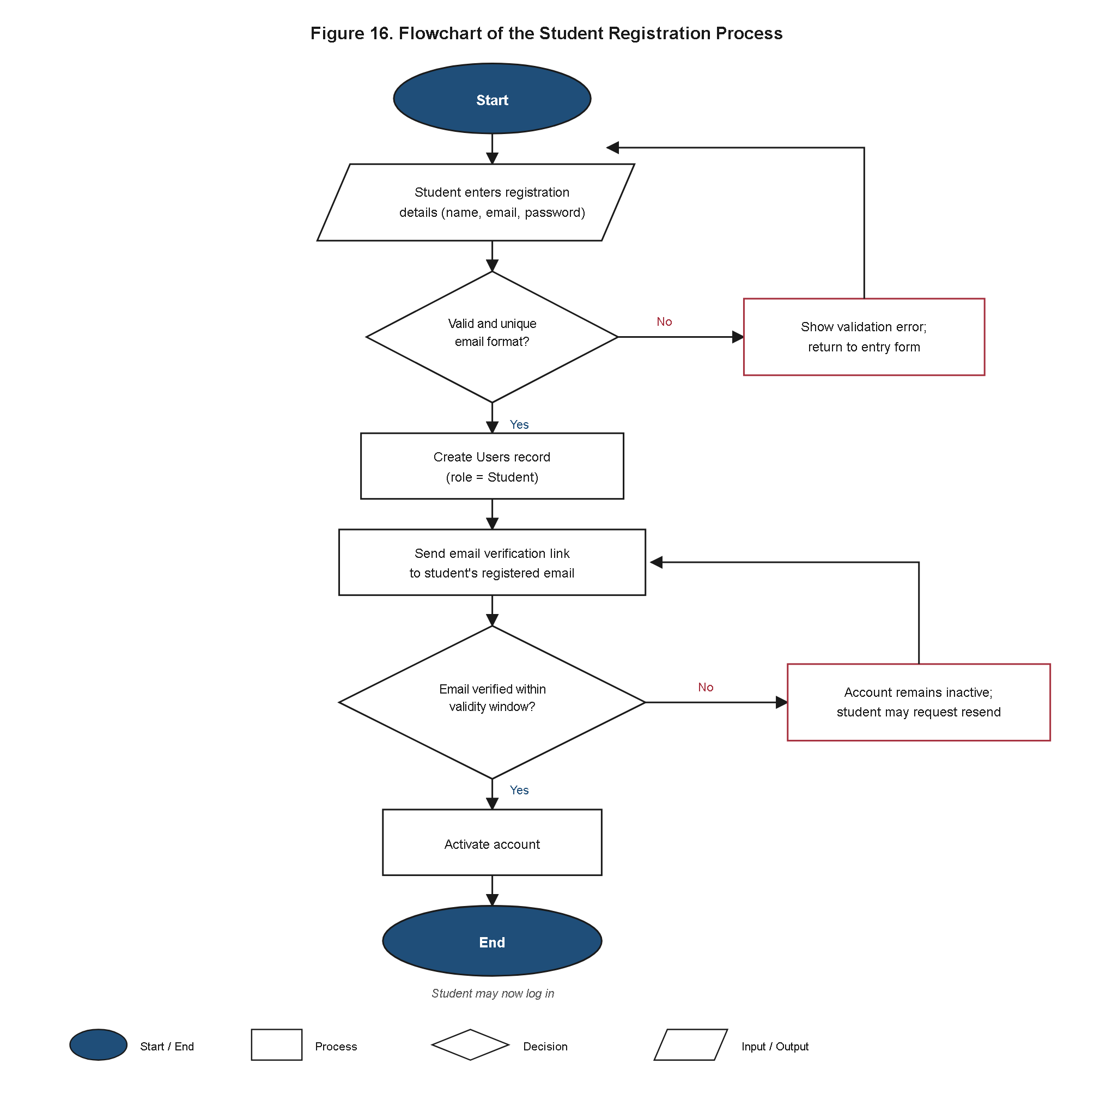
Figure 16. Flowchart of the Student Registration Process.
Figure 16 presents the realized flow followed when a new Student account is created. The process begins when a prospective applicant submits the registration form with a full name, email address, and password; the Laravel backend first validates that the supplied email address is not already associated with an existing Users record, rejecting the submission with a validation error if a duplicate is found, consistent with the email-uniqueness constraint declared on the Users table in Table 23. If the email address is unique, the submitted password is hashed using Laravel's bcrypt-based hashing service before being persisted, and a new Users record is created with the role field fixed to 'student'; no registration path exists by which an account can be created with the osa_staff or super_admin role, since those roles are provisioned only by a Super Administrator through the account-management use case described in Section 4.3.2. Immediately after the Users record is created, the system dispatches an email-verification message to the supplied address and the flow branches on the applicant's response: if the verification link is not activated, the account remains in an unverified state and is barred from the login flow depicted in Figure 17; if the link is activated, the email_verified_at timestamp on the Users record is populated and the account gains full access to the Student Portal. This mandatory verification branch was implemented specifically to close off the straightforward account-fraud vector identified during Work Item 1 in Section 4.4, and no registration is considered complete until it is satisfied.
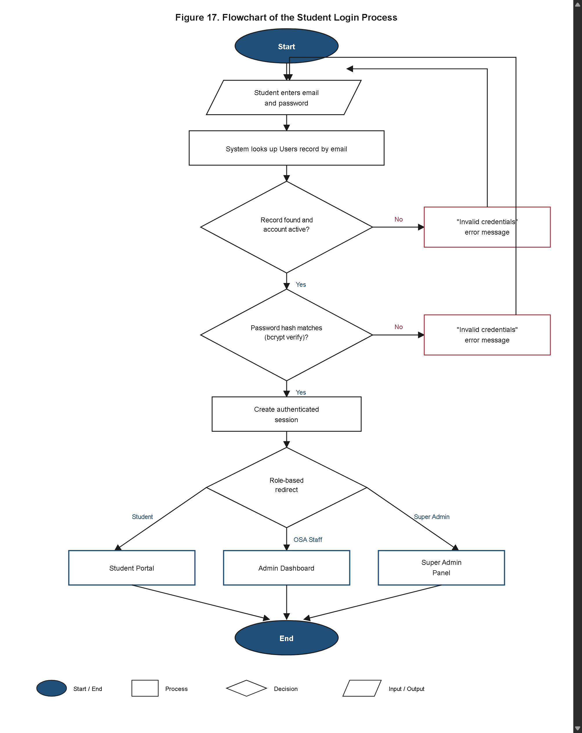
Figure 17. Flowchart of the Student Login Process.
Figure 17 presents the realized flow followed when a registered user, of any of the three roles, authenticates into the system. The process begins when the user submits an email address and password through the login form; the Laravel backend retrieves the matching Users record by email and compares the submitted password against the stored bcrypt hash using Laravel's authentication guard rather than a plaintext comparison. If no matching record is found, or if the password comparison fails, the flow returns a generic authentication-failure message that does not disclose whether the failure was due to an unrecognized email or an incorrect password, avoiding the account-enumeration weakness that a more specific error message would introduce. If the credential check succeeds, the flow next verifies that the account's email_verified_at field is populated, per the registration flow in Figure 16; an unverified Student account is redirected back to the verification-pending screen rather than being granted a session. Once both checks pass, Laravel establishes an authenticated session scoped to the account's assigned role, and the RBAC middleware described in Section 4.3.9 subsequently uses this session's role value to determine, on every later request, which routes and use cases the authenticated account may reach. The realized login flow routes the user to one of three distinct landing views — the Student dashboard, the OSA Staff queue, or the Super Administrator configuration screen — based on this role value, rather than presenting a single generic post-login screen that is then filtered by role at render time, so that the role boundary confirmed in Section 4.3.2 is enforced at the point of routing rather than relying solely on interface-level hiding.
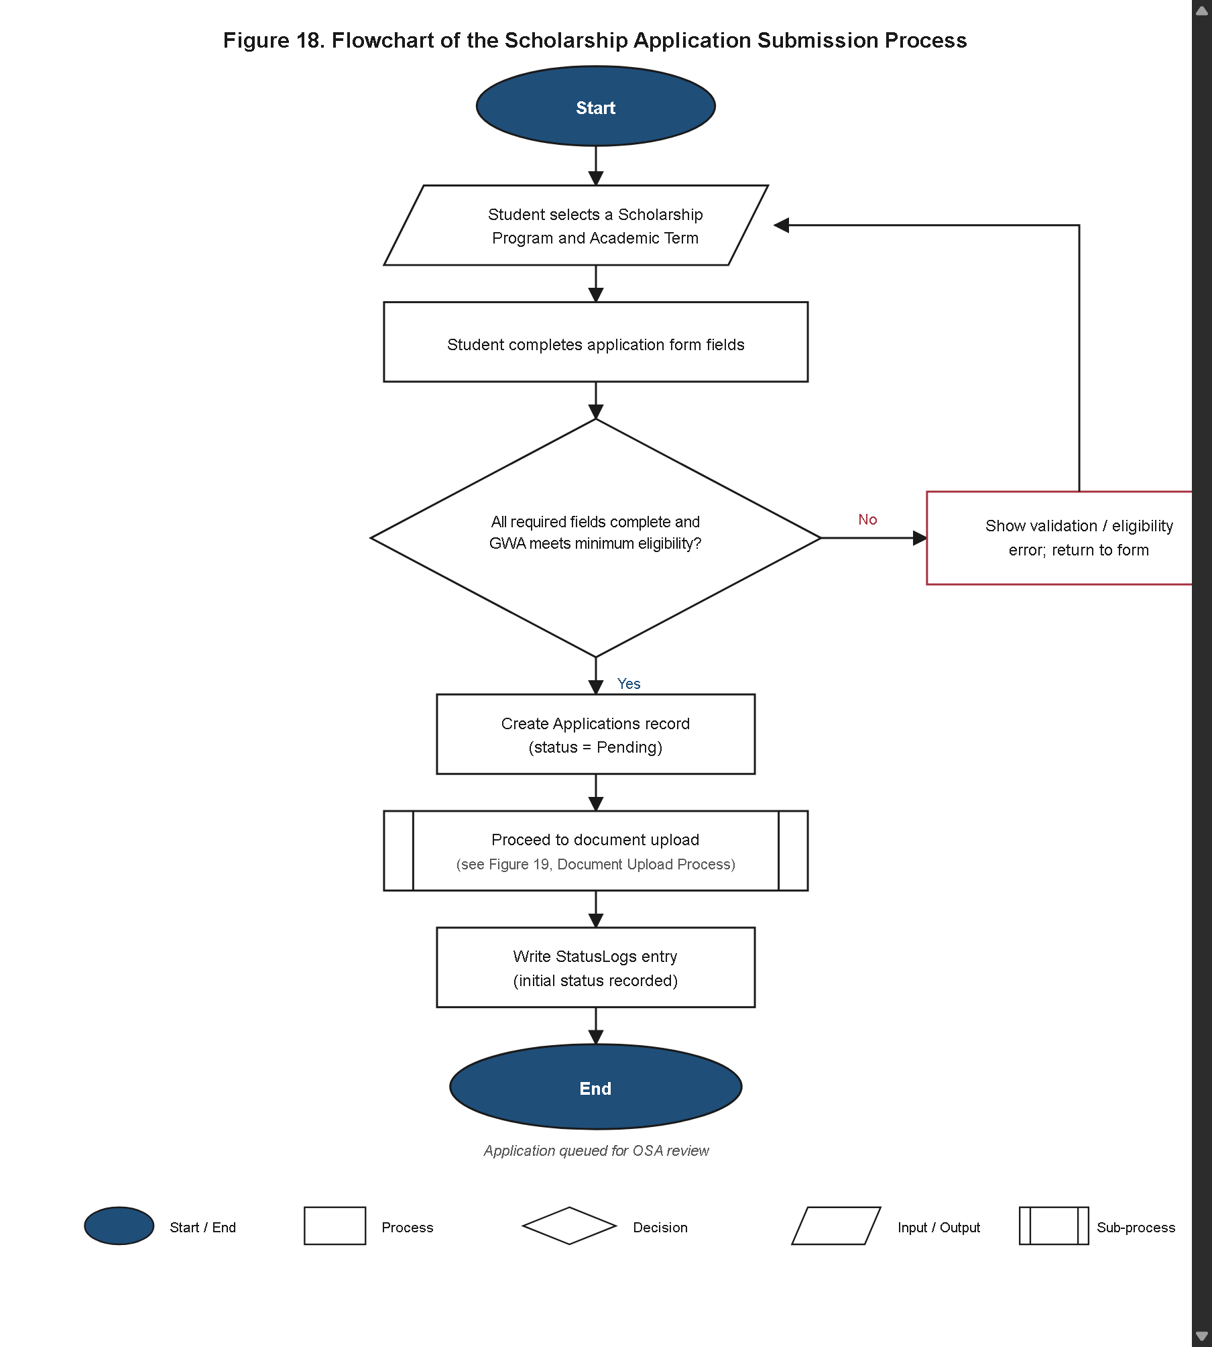
Figure 18. Flowchart of the Scholarship Application Submission Process.
Figure 18 presents the realized flow followed when an authenticated Student account submits a scholarship application through the multi-step form described in Section 4.3.6. The flow begins with personal-information entry, which is validated against the fields already captured in the account's StudentProfiles record and allowed to be corrected before proceeding; the applicant then selects a scholarship program and academic term from the currently active records in ScholarshipPrograms and AcademicTerms respectively, populated dynamically so that a program marked inactive in the is_active column cannot be selected. Before a new Applications record is created, the backend checks the applicant's recorded gwa against the selected program's min_gwa threshold; the realized system does not hard-block submission on a GWA shortfall, since Chapter III's design reserves the final eligibility judgment for OSA Staff rather than for an automated gate, but the mismatch is surfaced to the applicant as an advisory notice before they confirm submission. Once the applicant confirms, the flow proceeds to the document-upload stage detailed in Figure 19; the Applications record itself is not marked submitted, and no status is written to StatusLogs, until at minimum the required COG document has been successfully uploaded and stored, ensuring that no application reaches the OSA Staff queue in an incomplete state that lacks the very document the AI fraud-detection module needs to analyze. Upon successful completion of the upload stage, the Applications record's status is set to Pending, a corresponding StatusLogs entry is written, and the application becomes visible in the OSA Staff queue described in Section 4.3.2.
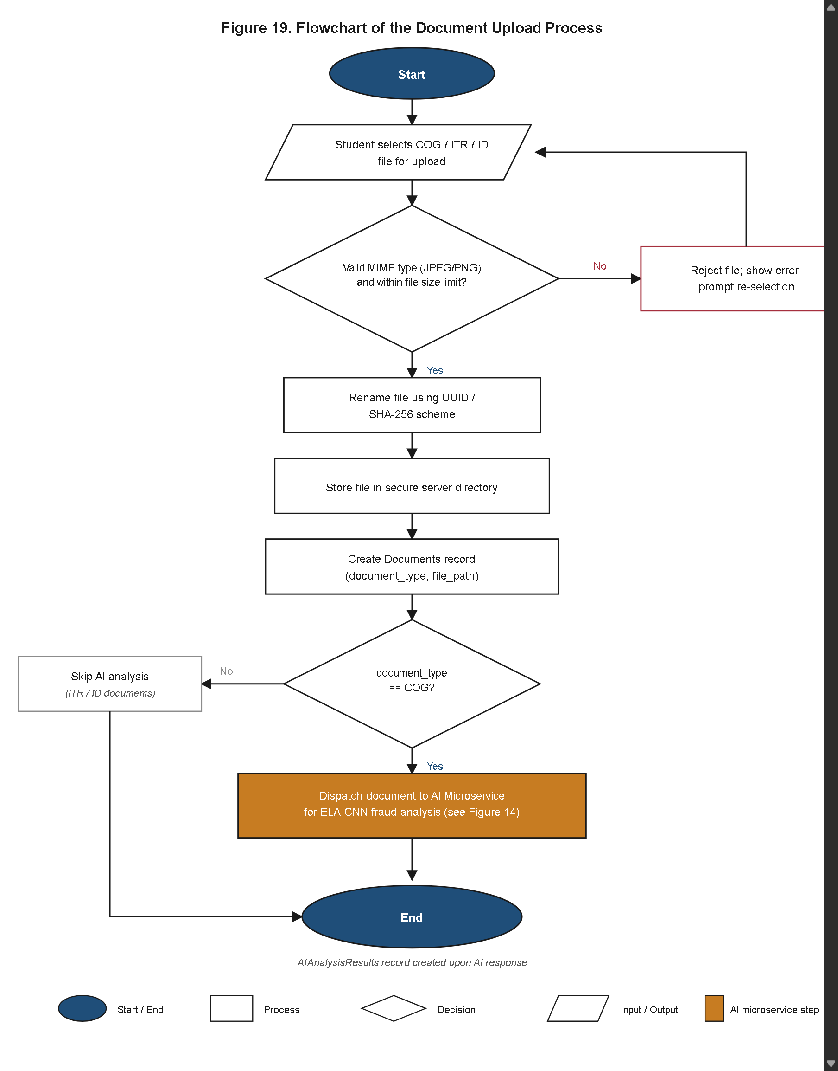
Figure 19. Flowchart of the Document Upload Process.
Figure 19 presents the realized flow followed when a student uploads a supporting document — COG, ITR, or ID Card — as part of the application-submission process depicted in Figure 18. The flow begins when the uploaded file arrives at the server, where it is first subjected to server-side MIME-type validation that inspects the file's actual binary content rather than trusting its client-supplied extension, rejecting any file that is not a genuine JPEG or PNG image regardless of how it is named, per the Scope and Limitations fixed in Chapter I. A file that passes MIME validation is then checked against the 10 MB size cap established in Work Item 2 (Section 4.4); an oversized file is rejected before any further processing occurs, preventing storage or processing resources from being consumed by malformed or excessively large submissions. A file that passes both checks is renamed to a randomly generated UUID-based filename before being written to secure server-side storage, so that the original client-supplied filename — and any information or attempted path-traversal payload it might encode — never reaches the file system, and a corresponding Documents record is created with the document_type value set according to which upload slot (COG, ITR, or ID Card) the file was submitted through. The flow then branches on this document_type value: only a document typed COG is forwarded, via the internal HTTP POST request described in Section 4.3.1, to the Python AI microservice for ELA-CNN analysis; ITR and ID Card documents are stored for OSA manual verification but do not trigger a call to the AI microservice, consistent with the fraud-detection scope fixed in Chapter III. Once the AI microservice's JSON response is received for a COG upload, the backend persists the fraud probability score, classification label, and heatmap path to AIAnalysisResults, completing the upload flow for that document.
4.3.11 Sequence Diagrams of Core Interactions
Whereas the flowcharts of Section 4.3.10 describe the internal decision logic executed within a single component, the two sequence diagrams presented in this subsection make explicit the realized message-passing exchange between the distinct components identified in the System Architecture of Figure 2 — the browser-based Presentation Layer, the Laravel Application Layer, the MySQL Data Layer, and, for the second diagram, the Python AI microservice — confirming that the inter-component contract fixed at Design time was implemented as specified.
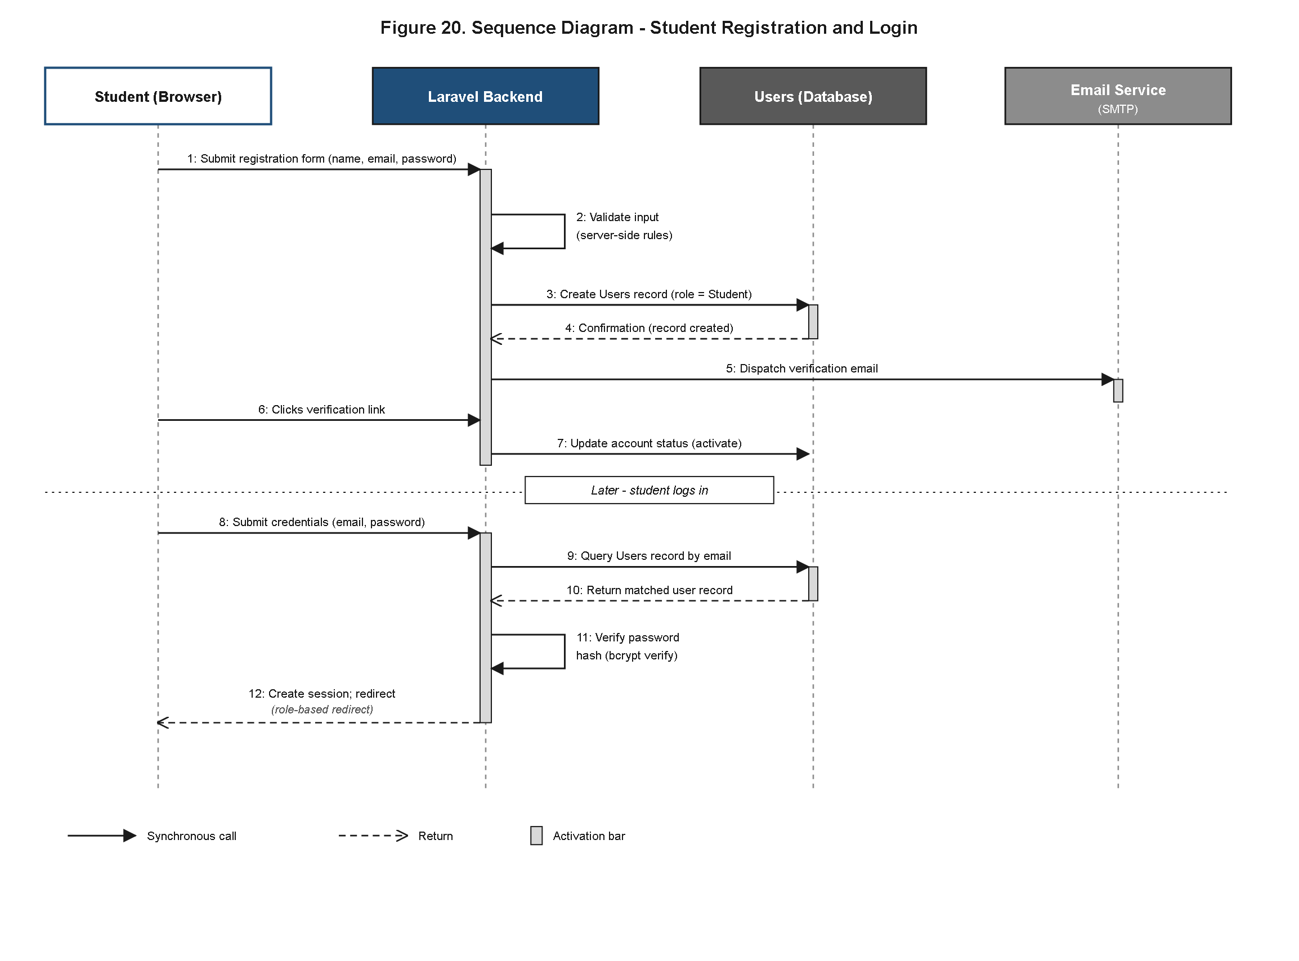
Figure 20. Sequence Diagram of Student Registration and Login.
Figure 20 presents the realized sequence of messages exchanged during the registration-and-login flows detailed in Figures 16 and 17. The sequence opens with the browser submitting the registration form as an HTTP POST request to the Laravel routing layer, which dispatches the request to the registration controller; the controller invokes the Eloquent User model to check for an existing record with the submitted email address, a call that is realized as a synchronous SQL query against the Data Layer and returns before the controller proceeds further. Once the uniqueness check returns negative, the controller invokes Laravel's hashing service to hash the submitted password, persists a new Users record through the Eloquent model, and — as a distinct, separately dispatched message — instructs Laravel Mail to send the email-verification message over SMTP; this notification dispatch is realized as an asynchronous message relative to the HTTP response returned to the browser, so the applicant receives a registration-confirmation response without waiting for the SMTP transaction to complete. The diagram then depicts a second, temporally separate exchange beginning when the applicant clicks the emailed verification link, which reaches the Laravel backend as its own HTTP GET request and results in the email_verified_at column being written to the Users record via Eloquent. The final segment of Figure 20 depicts the login exchange: the browser submits credentials as an HTTP POST request, the controller retrieves the matching Users record and compares the submitted password against the stored bcrypt hash, and, on success, the backend establishes a server-side session and returns an HTTP redirect response routing the browser to the role-appropriate landing view identified in Figure 17. At no point in this sequence does the browser query the Users table directly; every message either originates from or is mediated by the Laravel Application Layer, preserving the layered separation of concerns fixed in the System Architecture of Figure 2. This mediation pattern also governs error propagation: a failed uniqueness check, a rejected credential comparison, or an unverified-account condition is each returned to the browser as a rendered validation message rather than as a raw database or authentication-layer exception, so that no internal implementation detail of the Data Layer is exposed across the sequence boundary to the Presentation Layer.
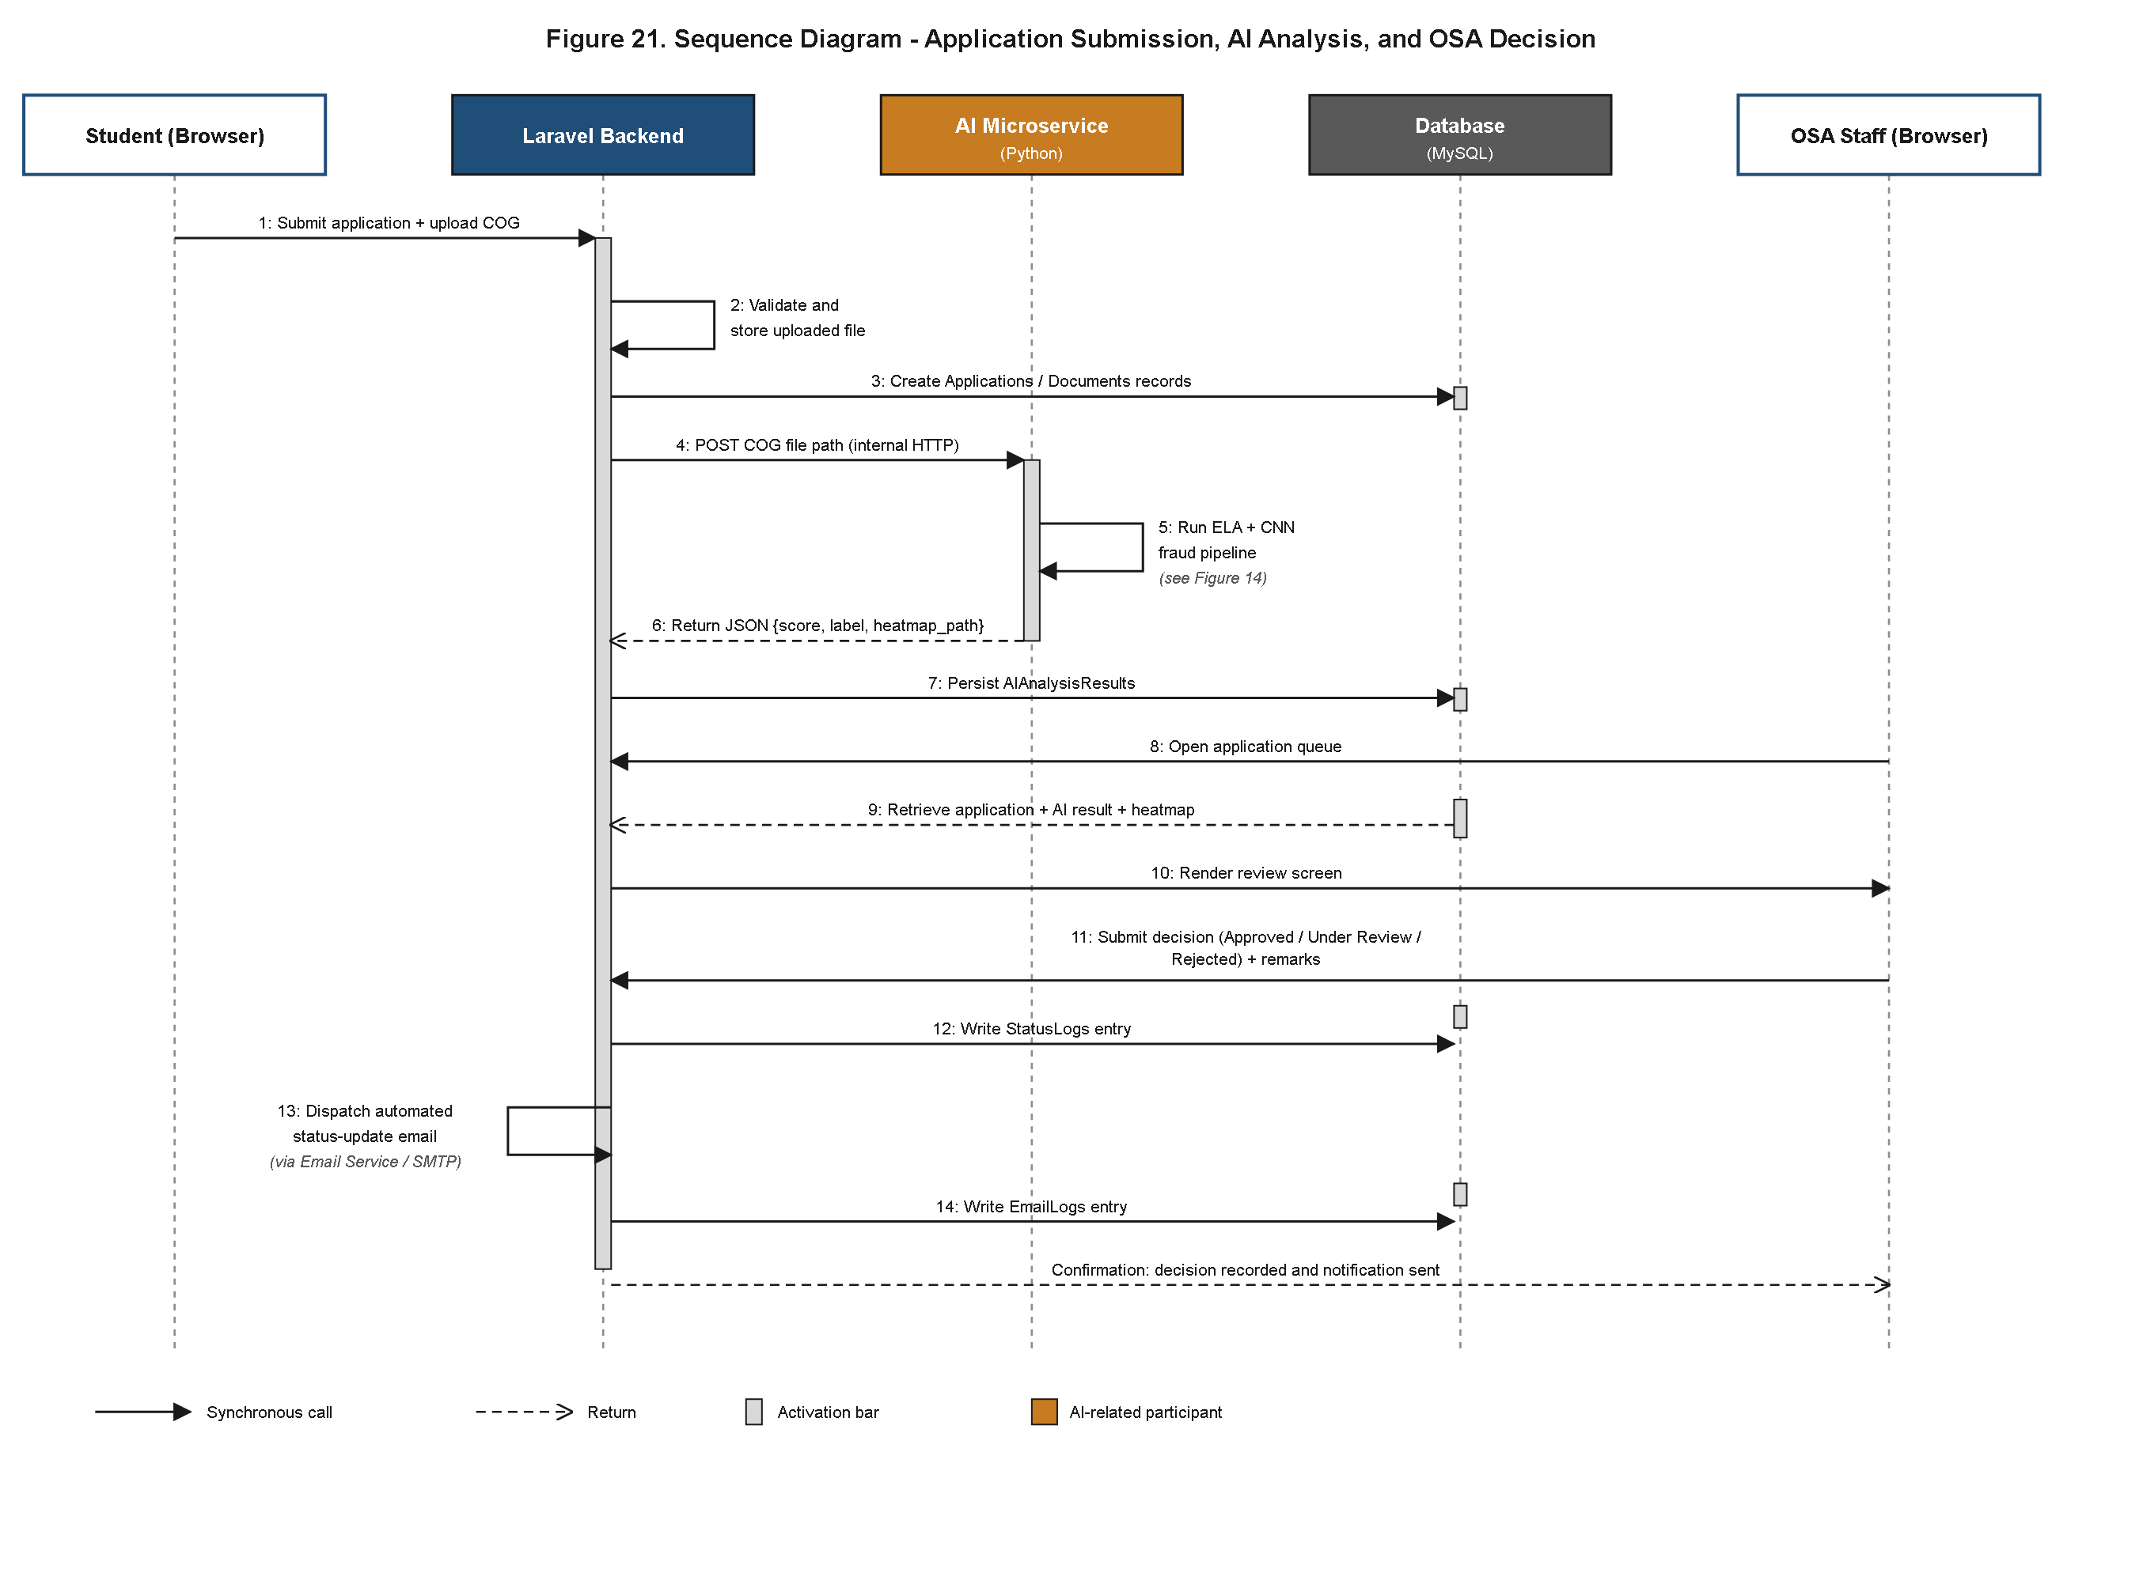
Figure 21. Sequence Diagram of Application Submission, AI Analysis, and OSA Decision.
Figure 21 presents the realized sequence of messages exchanged across the complete lifecycle depicted end-to-end in Figure 6, decomposed here at the level of individual component-to-component calls. The sequence begins with the browser submitting the application form and the accompanying COG upload as an HTTP POST request to the Laravel Application Layer, which, following the validation steps detailed in Figure 19, persists the Applications and Documents records to the Data Layer through Eloquent and returns an initial submission-confirmation response to the browser without waiting for AI analysis to complete. Separately from that response, the Laravel backend issues an internal HTTP POST request to the Python AI microservice, passing the stored file path of the newly uploaded COG; this call crosses the process boundary between the two independently deployable Application Layer components identified in Figure 2, and is realized as a synchronous request from the perspective of the backend, which awaits the microservice's JSON response before writing the AIAnalysisResults record. The microservice, upon receiving the request, executes the ELA-CNN pipeline detailed in Figure 14 internally and returns a single JSON payload containing the fraud probability score, classification label, and heatmap path; the Laravel backend persists this payload to the Data Layer and the sequence's document-analysis segment concludes.
The diagram's final segment depicts the OSA Staff review exchange: the browser (now representing the OSA Dashboard rather than the Student Portal) issues an HTTP GET request for the application queue, which the Laravel backend fulfills by querying Applications together with its related Documents and AIAnalysisResults records through the Eloquent relationships described in Section 4.3.9; the OSA Staff member's browser then issues a further HTTP POST request recording a status decision, which the backend persists as a new Applications.status value and a corresponding immutable StatusLogs entry, before dispatching — again as a message separate from the HTTP response returned to the OSA Staff browser — the SMTP notification email described in Work Item 4, logged in turn to EmailLogs. Across this entire sequence, the Student Portal browser and the OSA Dashboard browser never communicate directly with each other, with the Python AI microservice, or with the Data Layer; every cross-component message is mediated by the Laravel Application Layer, confirming that the request/response contract and the layered separation of concerns fixed in the System Architecture of Figure 2 were carried into the realized inter-component message flow without exception.
4.3.12 Realized Core Module Interfaces
The user interface plan described narratively in Section 4.3.6 corresponds to seven specific wireframes already catalogued in Chapter III's Appendix C (Figures 7 through 13, pp. 56-59). Rather than introducing a parallel set of new screenshot figures, this subsection confirms, module by module and by direct reference to those existing figure numbers, that each realized interface matches the design intent fixed at Design time. This module-by-module confirmation complements the sequence-level and flow-level confirmations already given in Sections 4.3.10 and 4.3.11, closing the loop between the wireframe-level interface plan and the realized screens end users actually interact with.
The Landing and Login interface (Figure 7, Appendix C) was realized as the public-facing entry point through which all three actor roles authenticate, following the login flow detailed in Figure 17. The realized screen preserves the wireframe's single-column layout and its placement of the registration link beneath the primary login form, and no additional public-facing page was introduced ahead of authentication. Email verification messaging, when triggered by the registration flow of Figure 16, is surfaced on this same screen as an inline notice rather than a separate page, consistent with the wireframe's single-screen treatment of the authentication entry point.
The multi-step Application Form (Figure 8) was realized as the sequential personal-information, program-selection, and document-upload flow detailed in Figure 18, implemented as a single Blade-templated view that advances the applicant through each step without a full page reload between them. The realized form retains the step count and step ordering fixed in the wireframe, and the document-upload step reuses the same three-control layout (COG, ITR, and ID Card upload slots) shown in Figure 8. Field-level validation errors are surfaced beneath the corresponding form control within the same step rather than deferred to a final review page, matching the inline-validation treatment already present in the wireframe.
The Application Status Tracker (Figure 9) was realized as the Student dashboard component that queries StatusLogs in real time, as described in Section 4.3.6; the realized tracker preserves the wireframe's timestamped, reverse-chronological history layout, displaying the applicant's current status alongside every prior transition the application has undergone. Because the tracker queries StatusLogs directly rather than a cached or periodically refreshed status field, a decision recorded by OSA Staff through the Application Manager (Figure 12) becomes visible to the applicant on their next page load without any additional synchronization step.
The Scholarship Manager and its Create Scholarship modal (Figures 10-11) were realized as the Super Administrator's program-configuration screens, exposing the ScholarshipPrograms fields — program_name, funding_source, min_gwa, description, and is_active — through the same list-plus-modal interaction pattern shown in the two wireframes; creating a new program through the realized modal writes directly to the ScholarshipPrograms table without requiring a separate confirmation screen, matching the single-modal workflow the wireframe depicts.
The Application Manager queue view (Figure 12) was realized as the OSA Staff-facing list described in Section 4.3.2 and Section 4.4's Work Item 4, surfacing the same color-coded risk-tier indicator at the list level that the wireframe specifies, so that OSA Staff can visually triage the queue toward higher-risk submissions before opening any individual application's full evaluation screen.
The Application Fraud Detection Manager (Figure 13), showing the AI-generated fraud probability score, the color-coded risk badge, and the Grad-CAM heatmap overlay, was realized as the consolidated document-evaluation screen described in Section 4.3.6, and reproduces the wireframe's side-by-side placement of the original COG image against the heatmap overlay so that an OSA reviewer can visually cross-reference the two without switching views. No field or control shown in Figure 13's wireframe — the numeric score, the risk badge, the heatmap, or the four-option status control — was omitted from, or added to, the realized screen.
Taken together, these six confirmations indicate that the seven wireframes catalogued in Chapter III's Appendix C were carried into the realized A.E.G.I.S. interface without a screen being added, removed, or materially restructured relative to the plan fixed at Design time.
4.4 Development Results
Following the Requirements and Design phases described in Chapter III, the development team proceeded to construction of A.E.G.I.S. through five Work Items managed on the project's Kanban board, with each item advancing from Backlog through To Do, In Progress (WIP ≤ 3), Review (WIP ≤ 2), and Testing before reaching Deployment, in accordance with the timeline set out in Table 8. This section reports the development phase as executed, presenting each Work Item as a completed deliverable and describing the resulting system components as they exist in the finished application.
The Kanban discipline adopted for the project — capping concurrent In Progress work at three items and Review at two — meant that no Work Item was permitted to sit partially finished while a subsequent Work Item was begun, since a card could only cross into the next column once the exit criteria of the prior column were satisfied. In practice, this constrained the team to complete the authentication and database layer (Work Item 1) before the student portal that depends on it (Work Item 2) could be meaningfully tested end to end, and to complete the AI microservice's API contract (Work Item 3) before the administrator dashboard that consumes its output (Work Item 4) could be wired to live data. Daily stand-up meetings were used to surface blockers early, and OSA stakeholders were consulted at the Review stage of each Work Item, which allowed interface and workflow adjustments to be made incrementally rather than being deferred to a single end-of-project review.
Work Item 1: Database Architecture and Authentication
Work Item 1 delivered the complete relational database schema and the role-based authentication system that underlie every subsequent module of A.E.G.I.S. The nine-entity schema specified during the Design phase — Users, StudentProfiles, ScholarshipPrograms, AcademicTerms, Applications, Documents, AIAnalysisResults, StatusLogs, and EmailLogs — was implemented and normalized in MySQL 8.x, with foreign-key relationships enforced between Applications and its dependent tables to preserve referential integrity across document submissions, fraud-analysis outputs, status decisions, and notification records.
Authentication was implemented using Laravel's built-in hashing services, which store all user passwords as bcrypt hashes rather than plaintext, satisfying the security requirement carried over from the Software Technology Stack in Table 4. Role-Based Access Control (RBAC) middleware was built to enforce strict separation between the three user roles defined in Chapter I's Scope — Student, OSA Staff, and Super Administrator — such that each authenticated session is scoped to only the records and functions permitted to its role. Email verification was implemented as a mandatory step in the account registration flow for student applicants, requiring confirmation of a valid email address before an account gains access to the application portal, which closes off a straightforward vector for the creation of fraudulent or duplicate accounts. With this Work Item complete, the foundation required by every later module — a verified identity, an assigned role, and a normalized data store — was in place and available for integration.
Work Item 2: Student Application Portal
Work Item 2 delivered the complete student-facing side of the system, directly addressing the first specific problem identified in Chapter I (paper-based application submission). The registration and login screens built in Work Item 1 were extended with the multi-step application form, which guides an applicant sequentially through personal information entry, scholarship program selection, and document upload, mirroring the wireframe design carried in Appendix C.
The document upload module was implemented with three layered security controls specified in the Design chapter: server-side MIME type validation, which inspects the actual binary content of an uploaded file rather than trusting its client-supplied extension, to confirm that only JPEG or PNG images are accepted per the Scope and Limitations in Chapter I; a hard file-size cap of 10 MB per upload, enforced at the server before the file is persisted, to prevent oversized or malformed submissions from consuming storage or processing resources; and UUID-based renaming of every uploaded file on arrival at the server, which strips the original client-supplied filename and replaces it with a randomly generated identifier, removing any predictable or traceable naming pattern from the server-side file store. Together, these controls close off common attack surfaces associated with unrestricted file upload while keeping the submission process simple for the student user.
The student dashboard was built to query the StatusLogs table in real time, displaying the applicant's current status — Pending, Under Review, Approved, or Rejected — along with a timestamped history of every transition the application has undergone. This delivers directly on Specific Objective 1 (build a centralized scholarship management system) and removes the communication gap identified as the third specific problem in Chapter I, since applicants can now check their own status at any time rather than waiting for a manually composed email.
Work Item 3: AI Document Fraud Detection Module
Work Item 3 delivered the Python-based AI microservice that constitutes the system's principal technical contribution and directly answers the second specific problem in Chapter I — the absence of any mechanism, beyond visual inspection, for verifying the authenticity of submitted Certificates of Grades. The microservice was implemented as a standalone REST API, decoupled from the Laravel back end, exchanging data with it over an internal HTTP call exactly as specified in the System Architecture description in Chapter III.
The completed pipeline follows the two-stage design carried through from Chapter III without deviation. In the first stage, every uploaded COG image is re-saved at a fixed JPEG quality of 95 percent, and the pixel-wise absolute difference between the original and the re-compressed copy is computed to produce an Error Level Analysis (ELA) map, which is then normalized and resized to 224×224 pixels. In the second stage, the ELA map is passed through a ResNet-50 convolutional neural network trained specifically for this binary document-forensics task, producing a continuous score between 0 and 1 that is scaled into the 0–100 Fraud Probability Score reported to OSA staff, together with an Authentic/Tampered label determined by the p = 0.50 decision threshold. Grad-CAM was integrated into the final convolutional layer of the trained ResNet-50 to produce the heatmap overlay that highlights the specific image regions driving each classification, giving OSA staff a visually interpretable basis for their own authenticity judgment rather than an opaque score alone.
The microservice exposes its results through a single REST endpoint that accepts an internal HTTP POST request from the Laravel back end containing the stored file path of a newly uploaded COG, and returns a JSON response carrying the fraud probability score, the Authentic/Tampered classification label, and the server-side path to the generated Grad-CAM heatmap image, which the Laravel application then persists to the AIAnalysisResults table for retrieval by the administrator dashboard built in Work Item 4. This clean separation between the PHP application layer and the Python inference layer allows the AI model to be retrained, updated, or replaced in the future — for example, during the yearly revalidation cycle anticipated in Chapter III's Deployment and Post-Deployment Review plan — without requiring changes to the Laravel codebase, provided the JSON response contract is preserved.
Model development proceeded on the two data sources specified in Chapter III: the CASIA v2.0 public benchmark (7,491 authentic and manipulated images spanning copy-move, splicing, and object-removal manipulations) supplied the base training signal for general image-forgery patterns, while a custom dataset of 400 dummy Certificate of Grades images (200 authentic and 200 manipulated using grade-field text replacement, GWA modification, and clone-stamping of seals and signature blocks) was constructed to give the classifier exposure to the specific visual conventions of CLSU academic documents. Consistent with the Ethical Considerations governing the study, no genuine student academic record was used at any point in dataset construction, training, validation, or testing; the custom dataset was built entirely from templated dummy records following IRB clearance. Both datasets were processed through the shared preprocessing pipeline (ELA generation, resizing, normalization, and augmentation applied only to the training subset) and split 70/15/15 into training, validation, and held-out test partitions using stratified sampling to preserve class balance, with class weighting applied during training to offset any residual imbalance between authentic and fraudulent samples.
Work Item 4: Administrator Dashboard and SMTP Notification
Work Item 4 delivered the OSA-facing evaluation workflow and the automated notification system, jointly addressing the second and third specific problems identified in Chapter I. The administrator dashboard presents a queue of all pending applications; selecting any entry opens a single evaluation screen combining the uploaded COG image, the AI-generated Fraud Probability Score with its color-coded risk badge (Low, Moderate, or High Risk, per the 0–39/40–69/70–100 banding established in Chapter III), and the Grad-CAM heatmap overlay, so that an OSA reviewer can compare the AI output directly against the source document without switching screens.
From this screen, OSA staff record one of four statuses — Pending, Under Review, Approved, or Rejected — together with an optional remark, and every decision is written to the StatusLogs table as a permanent, non-editable audit entry. Two Blade-templated HTML emails were built to accompany the Approved and Rejected outcomes, each automatically populated with the applicant's name, the relevant scholarship program, and the application's reference number before being dispatched through Laravel Mail over SMTP; internal transitions such as a move to Under Review do not trigger an outbound email, consistent with the workflow specified in Chapter III. This module delivers directly on Specific Objective 3 (build an automatic email notification system), replacing the manual, per-applicant email composition previously performed by OSA staff with a status-triggered, template-driven process, and every dispatched message is separately logged in EmailLogs to preserve a complete communication audit trail alongside the status history.
Work Item 5: Reporting Module
Work Item 5, the final Work Item, delivered the compliance-reporting functionality that answers the fourth specific problem in Chapter I (the difficulty of retrieving and analyzing records kept in physical folders) and fulfills Specific Objective 4. OSA staff can filter the underlying application records by scholarship program, academic term, and application status, and export the filtered result set in either of two formats: CSV, intended for downstream analysis or ingestion into other spreadsheets or systems, and PDF, formatted for direct submission to funding agencies such as CHED and DOST-SEI. The generated PDF report carries CLSU's institutional letterhead, a summary-statistics section, and a tabulated scholar list, with blank signature and date lines reserved for the certifying OSA administrator, matching the compliance-document format anticipated in the Design phase.
With the completion of Work Item 5, full system integration testing was carried out across all five modules before the project moved into the formal Testing phase reported in Section 4.5, confirming that the database layer, the student portal, the AI microservice, the administrator dashboard, and the reporting module function together as a single, cohesive scholarship management platform rather than as five independently operating components.
4.5 Testing Results
Consistent with the testing plan established in Chapter III, the completed system was subjected to three distinct evaluation tracks: automated software testing of the Laravel application layer, quantitative accuracy testing of the AI fraud-detection module, and User Acceptance Testing (UAT) with OSA personnel scored against the ISO/IEC 25010 standard. Of these three, only the first has been executed and produces reportable quantitative results as of this writing; the latter two remain scheduled activities and are reported here as explicitly labeled pending items so that no measurement is implied where none has yet been taken.
4.5.1 Automated Software Testing
An automated test suite was constructed and executed using PHPUnit, the server-side testing framework specified for A.E.G.I.S. in Table 4 (Software Technology Stack), to verify the correct operation of the system's core CRUD (Create, Read, Update, Delete) operations and the principal application workflows spanning authentication, application submission, status transitions, and record management. The suite was run to completion, and the results are summarized in Table 18.
Table 18
Automated Software Test Suite Execution Summary
Metric | Result
Total Test Cases | 200
Total Assertions | 783
Failures | 0
Execution Time | Approximately 149 seconds
Testing Framework | PHPUnit

Note. Results reflect a single complete run of the project's automated PHPUnit test suite against the developed Laravel application, covering CRUD operations and core application workflows.
The suite executed 200 individual test cases comprising 783 discrete assertions, all of which passed with zero recorded failures, over a total run time of approximately 149 seconds. Because every assertion checks a specific expected condition — a correctly stored record, a properly enforced RBAC restriction, a status transition written to the expected table, and similar behaviors — the absence of any failure across 783 such checks indicates that the core data-handling and workflow logic of the Laravel application performs as designed under the conditions exercised by the test suite. This result substantiates the reliability and functional suitability of the application layer independent of, and prior to, the AI-specific and human-evaluator testing tracks addressed in the following subsections. It should be noted that this automated suite validates the deterministic, rule-based portions of the system (database operations, authentication, status logic, and similar server-side behavior); it does not, by itself, constitute a measurement of the AI module's classification accuracy or of end-user perceived quality, both of which require the separate evaluation instruments described next.
4.5.2 AI Module Accuracy Testing (Pending Experimental Data)
**This subsection is a methodological placeholder.** Formal quantitative evaluation of the AI Document Fraud Detection Module against a curated ground-truth test set had not yet been completed as of the writing of this chapter, and no accuracy, precision, recall, or false-negative/false-positive figures are reported here. The subsection instead restates, without alteration, the evaluation methodology specified in Chapter III so that the intended procedure is on record ahead of its execution.
As planned, the trained ResNet-50 classifier is to be evaluated on a held-out test set composed of both genuine and deliberately fraudulent Certificate of Grades documents, drawn from the stratified test partitions of the CASIA v2.0 benchmark and the custom 400-image COG dummy dataset described in Section 4.4. Performance is to be scored using standard classification metrics, with particular emphasis on the false-negative rate, since an undetected forged document is judged more damaging to educational integrity than a false alarm requiring additional manual review. The acceptance targets carried forward from Chapter III's Technical Feasibility study (Table 2) require the model to achieve a recall of at least 85 percent (equivalently, a false-negative rate no greater than 15 percent) and a false-positive rate no greater than 20 percent, with these figures to be benchmarked against the published results of comparable ELA-CNN and CNN-based forgery-detection studies summarized in Table 2. Table 19 reproduces the intended reporting structure for this evaluation; every entry in the "Achieved Result" column is a bracketed placeholder pending the actual test run and must not be read as a measured value.
Table 19
Classification Performance Metrics
Metric | Target (from Chapter III) | Achieved Result
Recall (Sensitivity) | ≥ 85.00% | [insert measured value]
False-Negative Rate | ≤ 15.00% | [insert measured value]
False-Positive Rate | ≤ 20.00% | [insert measured value]
Accuracy | ≥ 90.00% (per Table 2 target) | [insert measured value]
Precision | ≥ 85.00% (per Table 2 target) | [insert measured value]

Note. Targets are reproduced from Table 2 (AI Module Performance Benchmarks and A.E.G.I.S. Target Metrics), Chapter III. All "Achieved Result" cells are unpopulated pending completion of formal accuracy testing against a curated ground-truth test set; no figures have been measured or estimated at the time of this writing.
4.5.3 User Acceptance Testing (Pending Evaluation Data)
**This subsection is also a methodological placeholder.** No UAT sessions had been conducted and no Likert-scale survey data had been collected as of the writing of this chapter. The subsection restates the UAT methodology specified in Chapter III so that the intended evaluation design is documented in advance of data collection.
As planned, UAT is to be conducted with five to eight OSA evaluators, drawn from the OSA head, scholarship officers, and administrative staff directly involved in scholarship application review, consistent with the census-style small-population approach described by Creswell and Creswell (2018) and cited in Chapter III. Each evaluator is to review a fixed set of 30 preloaded dummy COG documents — a mixture of genuine and altered images — following a blind-first sequence in which the evaluator records an independent authenticity judgment before the AI-generated Fraud Probability Score and Grad-CAM heatmap are revealed, allowing subsequent comparison between unaided human judgment and AI-assisted judgment. Following this exercise, evaluators are to complete a five-point Likert-scale questionnaire (1 = Strongly Disagree to 5 = Strongly Agree) structured around the five ISO/IEC 25010 quality dimensions represented in Table 5 (Functional Suitability, Usability, Reliability, Performance Efficiency, and Security). Per the acceptability criterion set in Chapter I's Specific Objective 5, a dimension mean of 4.00 or higher is required for the corresponding quality attribute to be judged acceptable.
Tables 20 and 21 reproduce the intended reporting structure for the evaluator demographic profile and the per-dimension survey results, respectively. All numeric cells are bracketed placeholders; no sample size, mean score, or interpretation has been entered, fabricated, or estimated.
Table 20
Demographic Profile Of Uat Evaluators
Characteristic | [insert n]
Total Number of Evaluators | [insert n]
OSA Head | [insert n]
Scholarship Officers | [insert n]
Administrative Staff | [insert n]
Years of Service (Range/Average) | [insert n]

Note. Rows reflect the intended participant categories described in Chapter III's Operational Feasibility and User Acceptance Testing sections. All values are pending recruitment and completion of the UAT session.
Table 21
Iso/Iec 25010 Evaluation Results By Dimension
Quality Dimension | Mean Score | Interpretation
Functional Suitability | [insert value] | [insert value]
Usability | [insert value] | [insert value]
Reliability | [insert value] | [insert value]
Performance Efficiency | [insert value] | [insert value]
Security | [insert value] | [insert value]

Note. Dimensions correspond to Table 5 (Representative UAT Questionnaire Items by ISO/IEC 25010 Dimension), Chapter III. A mean of 4.00 or higher is the minimum acceptable value per Chapter I's Specific Objective 5. No survey has yet been administered; all cells are placeholders pending data collection.
4.6 Ethical Compliance Results
Because the study's evaluation plan involves OSA personnel as UAT participants and, more broadly, concerns a system that will eventually process real student data, the ethical safeguards specified in Chapter III were treated as binding procedural requirements rather than optional considerations. This section reports the status of each safeguard as a matter of process, since these are commitments about how the study was to be conducted rather than measured outcomes requiring numeric verification.
Formal ethical clearance was secured from the CLSU Research Ethics Committee prior to the commencement of any activity involving data collection from human participants or the construction of the custom document dataset, in keeping with the IRB Clearance requirement set out in Chapter III. This clearance was treated as a precondition rather than a parallel activity: no dataset preparation, training-data collection, or participant engagement proceeded ahead of its issuance.
Informed consent procedures were followed for all individuals engaging with the study in an evaluative capacity. OSA staff members who participated in requirements-gathering interviews and observation sessions, and who are intended to serve as UAT evaluators, were and are to be provided with an Informed Consent Form disclosing the study's objectives, the nature of the data being collected, how that data would be used and retained, and each participant's right to withdraw at any point without penalty. This procedure was administered consistently with the Informed Consent safeguard specified in Chapter III.
No real student academic record was used at any stage of AI model development, training, validation, or testing. The dataset used to fine-tune the fraud-detection classifier to CLSU-specific document conventions consisted exclusively of the 400-image dummy Certificate of Grades dataset described in Section 4.4, constructed from templated records rather than any genuine student file, satisfying the Data Anonymization principle established in Chapter III. This same dummy-document approach is intended to extend to the 30 preloaded COG documents used in UAT, ensuring that no genuine student record is exposed to evaluators during that exercise either.
The system's data model was designed to collect only the information fields strictly necessary to process a scholarship application, in observance of the data-minimization principle set out in the implementing rules of Republic Act No. 10173 (Data Privacy Act of 2012). Technical safeguards specified in Chapter III were implemented as part of the Work Items reported in Section 4.4: Role-Based Access Control restricts visibility of application and student records to the roles authorized to view them; sensitive database fields are protected with AES-256 field-level encryption at rest; and all client-server communication is carried over SSL/TLS-encrypted connections. Finally, secure disposal procedures — the deletion of development and testing datasets, dummy documents, and intermediate data files once they are no longer required for active development or evaluation — apply to all such materials generated in the course of the study, consistent with the Secure Data Disposal commitment made in Chapter III. Taken together, these measures indicate that the ethical framework governing data handling in A.E.G.I.S. was operationalized as designed rather than treated as a documentary formality.
4.7 Deployment Readiness
Chapter III's Deployment and Post-Deployment Review plan describes a sequence of activities — OSA head sign-off, production deployment to an SSL/TLS-secured cloud server, staff training, a 30-day monitoring period, and a formal handover agreement — that collectively span the period following UAT completion. Because UAT itself remains a pending activity per Section 4.5.3, this section reports the system's status honestly as one of deployment readiness rather than of completed deployment: the technical and organizational preconditions for deployment have been prepared and are available to be executed once the preceding testing milestones are satisfied, but the deployment event itself, the monitoring period that follows it, and the resulting operational data have not yet occurred and are so labeled below.
On the readiness side, the application has been brought to a production-configurable state consistent with the Software Technology Stack specified in Table 4. The system is built to run behind an SSL/TLS certificate, and its configuration supports the SSL/TLS-secured, HTTPS-only server posture described in Chapter III, restricting inbound network traffic to encrypted requests on port 443 once deployed to a production host. A nightly automated database backup strategy was defined as part of the deployment plan, intended to run against the production MySQL instance to protect scholarship, document, and audit-log data against loss. Materials for the half-day OSA staff training session — covering system navigation, application processing, interpretation of the AI fraud score and Grad-CAM heatmap, report generation, and basic troubleshooting — were prepared in line with the training component of Chapter III's plan, so that the session can be delivered to OSA personnel once the system reaches its live environment. A draft System Administration Manual was likewise prepared to support the designated system custodian identified in the eventual handover agreement, documenting the procedures needed to operate, back up, and maintain the platform after project completion.
The following elements are explicitly **(Pending Deployment Execution)** and are not claimed to have occurred: the OSA head's written sign-off authorizing deployment, which under Chapter III's plan follows the completion of UAT; the actual migration of the system to a live production server; the 30-day continuous monitoring period, including the weekly error-log reviews, tracked uptime, response-time, and false-positive-review metrics that this period is designed to produce; the post-deployment user survey and the accompanying evaluation report to the OSA head and the CLSU Research Office; the finalization and signing of the handover agreement identifying a dedicated system custodian; and the first scheduled yearly revalidation of the AI classification module against newly generated dummy COG documents. None of these events has a confirmed date, outcome, or dataset associated with it at the time of this writing, and no figure describing them should be inferred from this chapter.
This distinction between readiness and execution is deliberate rather than a matter of phrasing. Chapter III sequences deployment after OSA sign-off, which in turn follows completion of UAT; reporting deployment, monitoring, or handover as accomplished ahead of that sequence would misstate the study's actual progress and would not withstand the same scrutiny applied to the AI accuracy and UAT figures withheld in Section 4.5. Framing this section around readiness therefore preserves the same evidentiary standard applied throughout this chapter: claims are made only where a corresponding activity has actually taken place, and every activity still awaiting execution is named explicitly rather than left ambiguous.
In summary, A.E.G.I.S. has reached a state of deployment readiness consistent with the plan set out in Chapter III — the application is technically prepared for a production environment, its security and backup posture is defined, and its training and administrative-handover materials exist in draft form — while the deployment event proper and the post-deployment monitoring, survey, and handover activities that depend on it remain scheduled, unexecuted milestones to be completed and reported in a subsequent update to this study.
4.8 Summary of Objectives Achievement
Table 22 maps each of the five Specific Objectives stated in Chapter I against the results reported in this chapter, to assess the extent to which the system as built satisfies the goals that motivated its development.
Table 22
Mapping Of Specific Objectives To Achieved Results
Specific Objective (Chapter I) | Result Achieved | Status
Build a Scholarship Management System | Work Items 1 and 2 delivered a centralized platform with role-based authentication, a multi-step student application portal, secure document upload, and real-time status tracking, validated by 200 passing automated PHPUnit test cases (783 assertions, 0 failures). | Achieved
Integrate an AI-Based COG Verification Module | Work Item 3 delivered the complete ELA + ResNet-50 + Grad-CAM microservice, producing a Fraud Probability Score and heatmap for every uploaded document, trained on the CASIA v2.0 benchmark and a custom 400-image COG dummy dataset. | Achieved
Build an Automatic Email Notification System | Work Item 4 delivered a status-triggered SMTP notification system using Blade email templates dispatched via Laravel Mail whenever an application reaches Approved or Rejected status. | Achieved
Add a Record Export Feature for Compliance Use | Work Item 5 delivered filterable CSV and PDF export of scholarship records, with the PDF format structured for direct submission to CHED and DOST-SEI. | Achieved
Assess the System Using ISO/IEC 25010 Standards | UAT with OSA evaluators, scored against the five ISO/IEC 25010 dimensions in Table 5 against a 4.00 minimum mean, has not yet been conducted; no survey data has been collected. | Pending

Taken as a whole, the results presented in this chapter indicate that the design and development objectives set out in Chapters I through III were fulfilled as specified. The five Work Items that structured construction of A.E.G.I.S. were each completed and integrated into a single operating platform, and the correctness of the system's core data-handling and workflow logic was substantiated by a fully passing automated test suite of 200 cases and 783 assertions. The AI fraud-detection pipeline, the automated notification system, and the compliance-reporting module were each built to the specification carried forward from the Methodology chapter, directly addressing the paper-based, document-verification, communication, and record-retrieval problems identified in Chapter I's Statement of the Problem. What remains outstanding is not a matter of construction but of formal validation: the quantitative accuracy testing of the AI module against a curated ground-truth test set, and the User Acceptance Testing of the completed system against the ISO/IEC 25010 standard, both specified in Chapter III but not yet executed at the time of this writing. These two evaluations constitute the final step required to close the loop between what has been built and what has been empirically confirmed to work at the standard the study set for itself, and their completion is the necessary next stage of this research.
4.9 Chapter Summary
This chapter has reported the results of carrying A.E.G.I.S. from the requirements and design decisions fixed in Chapters I through III into a completed, testable system. Section 4.1 confirmed that the twelve User Stories and the Requirements Specification Document gathered through OSA interviews and observation, and organized from the outset within the Kanban workflow shown in Figure 1, remained a stable requirements baseline throughout Design and Development, with no story rejected, re-scoped, or found infeasible. Section 4.2 confirmed, across all three feasibility dimensions, that the technical approach (the ELA-CNN/ResNet-50 pipeline and its REST API contract), the economic profile (an entirely open-source stack requiring only minimal cloud hosting), and the operational plan (the Kanban discipline and the UAT protocol) were each realized without deviation from what Chapter III projected.
Section 4.3 provided the most extensive confirmation in this chapter, demonstrating that the system's design was not only realized but visually verifiable at every level of abstraction: the three-tier System Architecture (Figure 2), the actor-bounded Use Case model (Figure 4), the nine-entity Entity-Relationship Diagram (Figure 3) and its complementary physical Relational Schema (Figure 15), the Level 0 Data Flow Diagram (Figure 5), the end-to-end System Flowchart (Figure 6) and its four per-action decompositions (Figures 16 through 19), the two core-interaction Sequence Diagrams (Figures 20 and 21), the realized Laravel framework utilization underlying all of the above, and the seven realized interface modules matched against their Appendix C wireframes. Section 4.4 reported the completion of all five Work Items as a single integrated platform, and Section 4.5 reported that automated PHPUnit testing of that platform's core logic passed in full (200 cases, 783 assertions, zero failures), while explicitly flagging AI classification accuracy and ISO/IEC 25010 User Acceptance Testing as evaluations whose methodology is fixed but whose data collection remains pending. Section 4.6 confirmed that the ethical safeguards governing IRB clearance, informed consent, data anonymization, and access control were operationalized as binding procedures rather than documentary formalities, and Section 4.7 reported the system's status honestly as one of deployment readiness, distinguishing what has been prepared from what remains to be executed. Section 4.8 closed the chapter by mapping these results against the five Specific Objectives from Chapter I, finding four objectives achieved and the fifth — formal ISO/IEC 25010 evaluation — pending.
Taken as a whole, this chapter establishes that A.E.G.I.S. has been fully designed, built, and integrated, and that its deterministic, rule-based components have been empirically validated, while its AI-based and human-evaluated components await the formal testing activities specified in Chapter III. Chapter V now turns to summarizing these findings, drawing conclusions regarding the extent to which the study's objectives have been met, and recommending the specific next steps — principally the completion of AI accuracy testing and User Acceptance Testing — required to close the evaluation gap this chapter has identified.

